National University of Computer and Emerging Sciences



OS LAB Final Project

Mini OS

F223637 Muhammad Nouman
F223653 Minha Muhammad
SE-7B

Folder Structure:
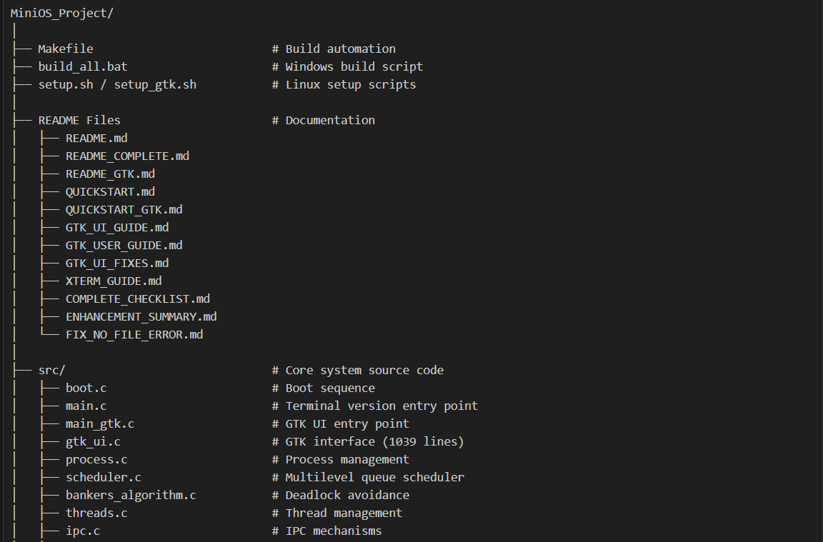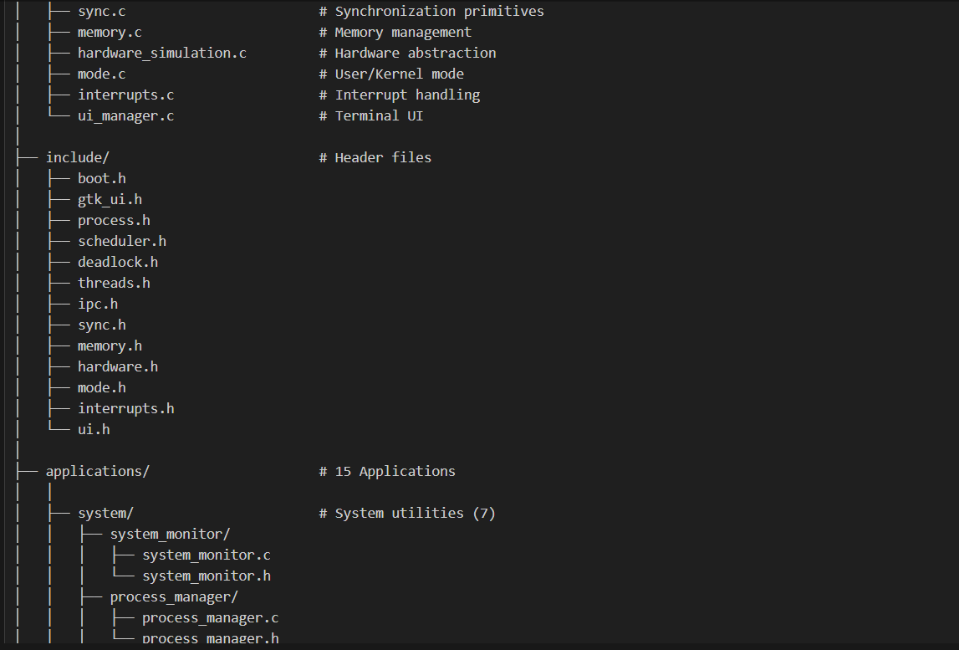
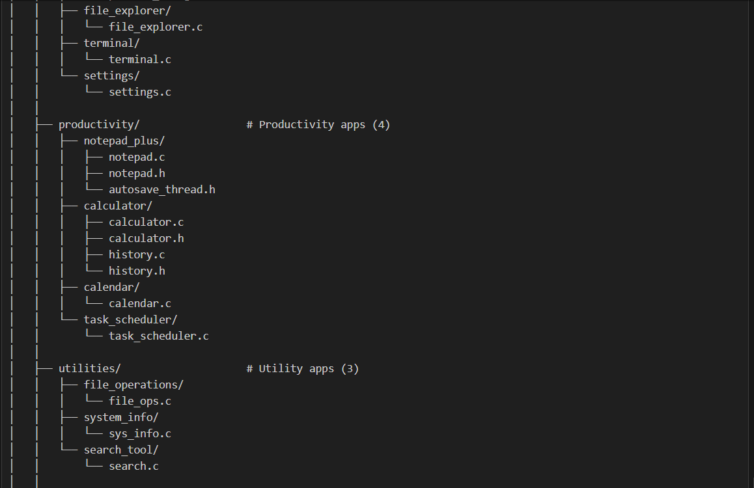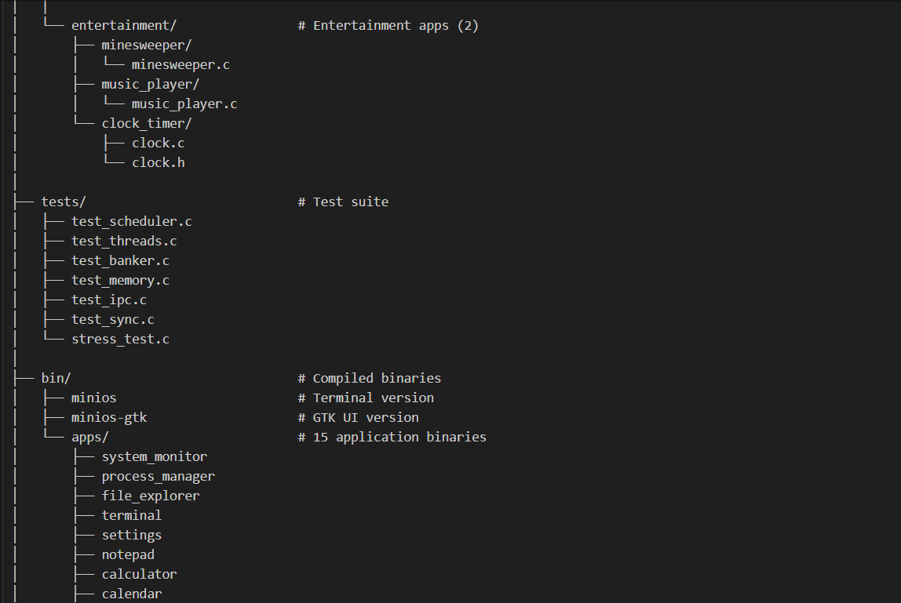

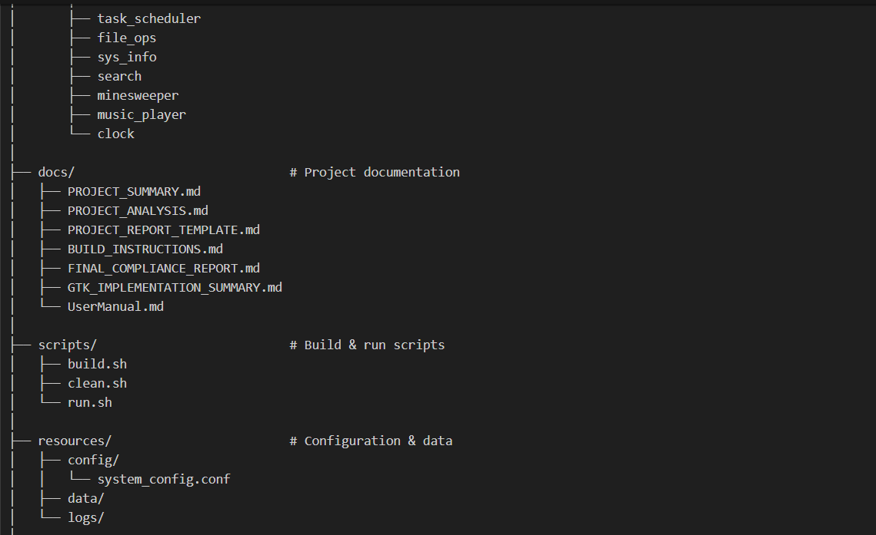

Total Files:
- Core System: 15 C files + 13 headers
- Applications: 15 applications across 4 categories
- Tests: 7 test files
- Documentation: 17 markdown files
- Scripts: 5 build/setup scripts

Key Components:
- Complete OS simulation with boot, scheduling, memory, IPC
- GTK+ 3.0 graphical interface (1039 lines)
- 15 fully functional interactive applications
- Multi-level queue scheduler (RR, Priority, FCFS)
- Banker's algorithm for deadlock avoidance
- User/Kernel mode with privilege checking
- Comprehensive test suite
- Professional documentation
Screenshots:
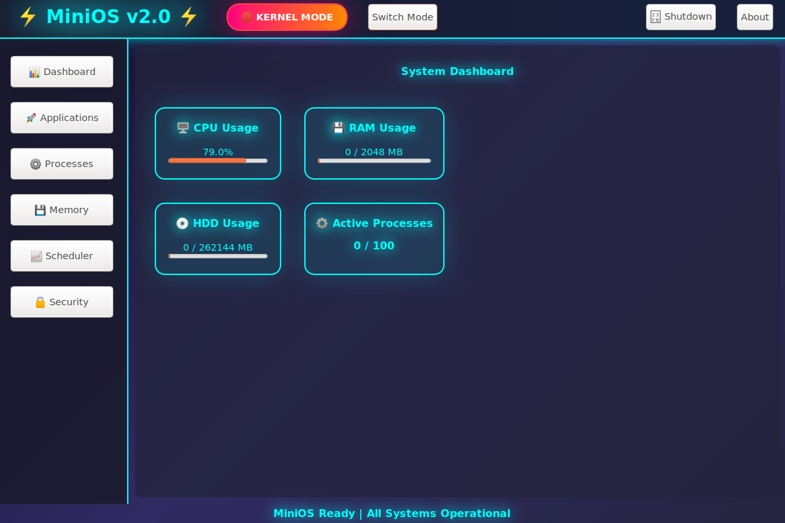
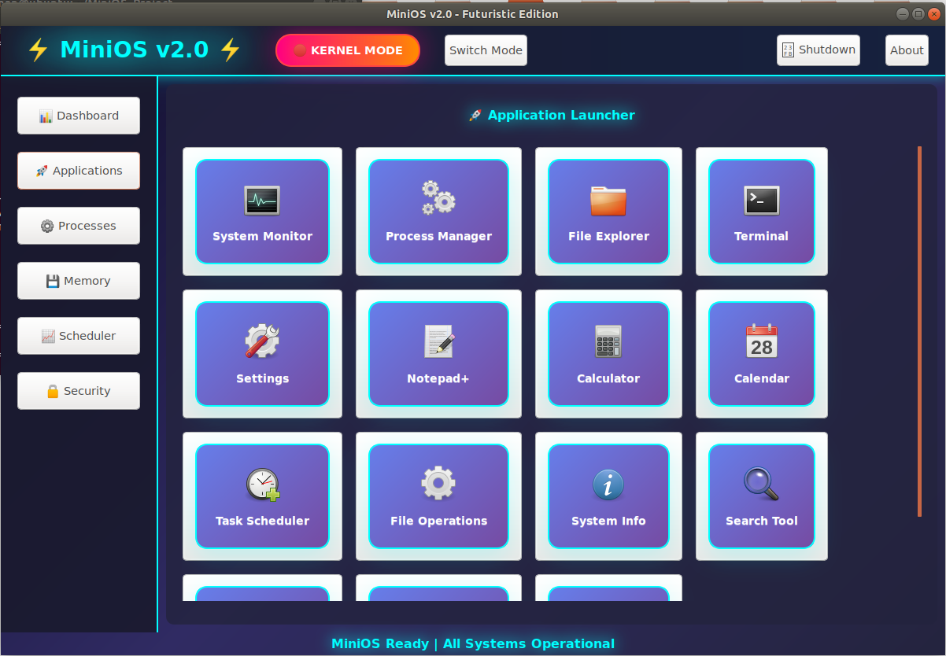
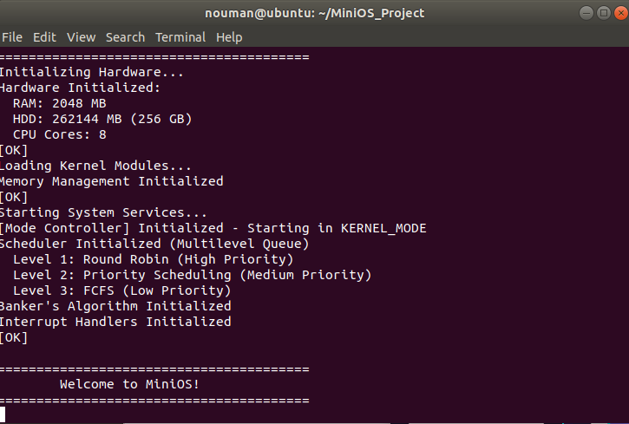
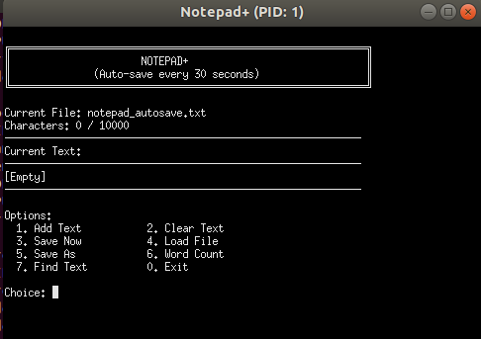
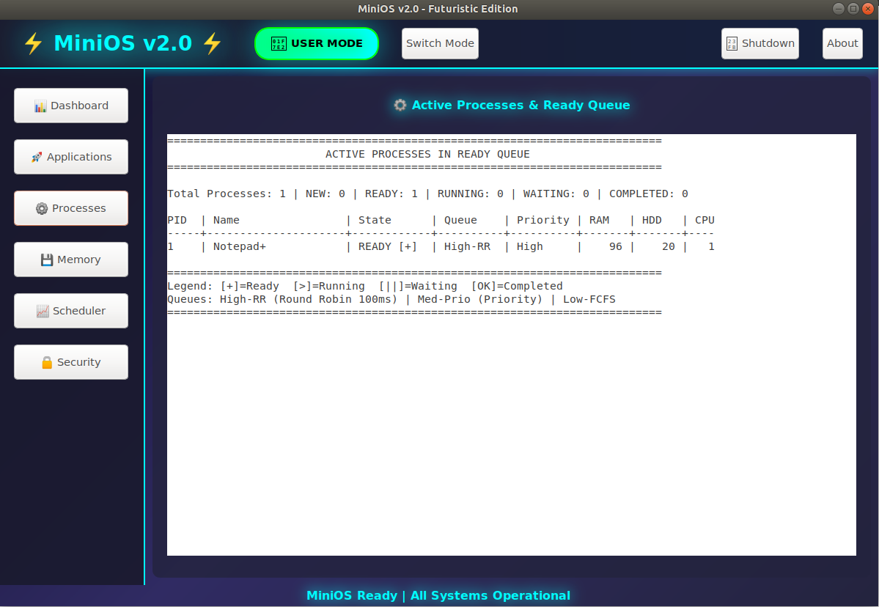

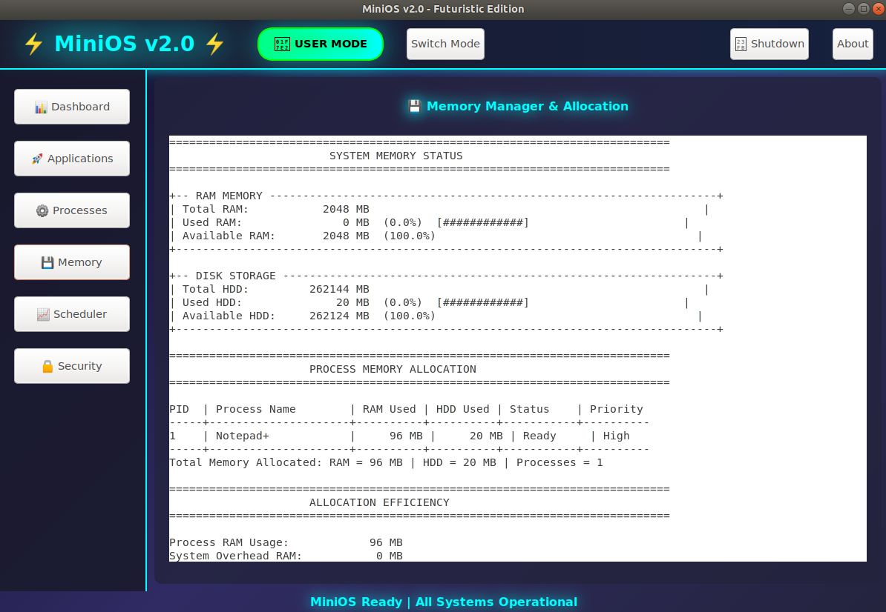
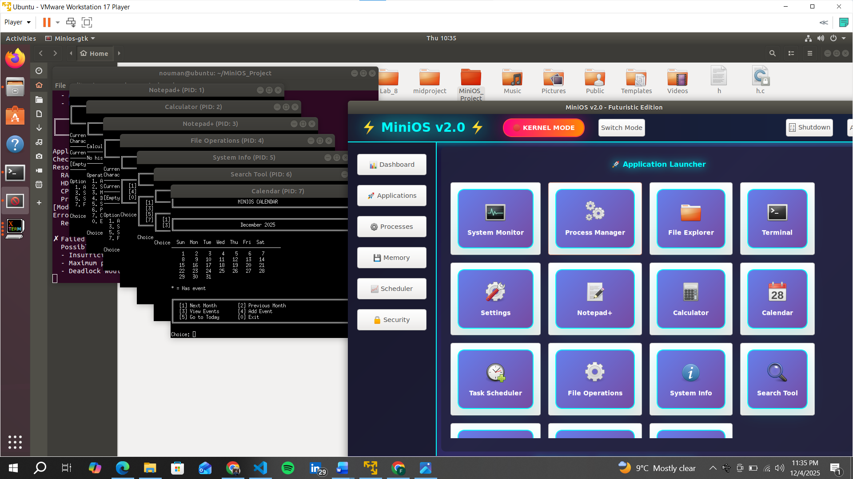
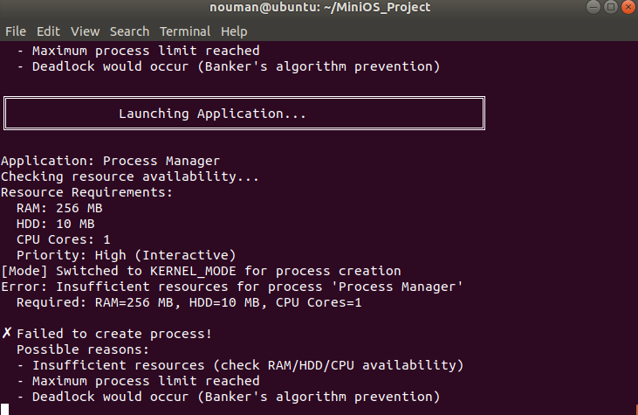

Video link: https://drive.google.com/file/d/1463n1c5XIbnrVkI-n7QoXtVbhUFLkrLC/view?usp=sharing

Completion Report:
Core Requirements (100%):
✅ Complete boot sequence with hardware initialization
✅ Process lifecycle management with PCB
✅ 3 IPC mechanisms (Shared Memory, Message Queues, Pipes)
✅ 4 Synchronization primitives (Mutex, Semaphore, CV, R/W Lock)
✅ Thread management with 3 types and attributes
✅ Multilevel queue with 3 scheduling algorithms (RR, Priority, FCFS)
✅ Banker's Algorithm for deadlock avoidance
✅ 15 fully functional applications launching in xterm
✅ User/Kernel mode with privilege checking
✅ Interrupt handling with signal support
Bonus Features (+10%):
✅ Professional GTK+ 3.0 graphical interface
✅ Futuristic cyberpunk design with CSS styling
✅ Real-time system monitoring dashboard
✅ Visual mode switching (Red=Kernel, Green=User)
✅ 6 interactive views (Dashboard, Apps, Processes, Memory, Scheduler, Security)
✅ Application launcher with icon grid
✅ Responsive, animated UI with 1-second updates
Extra Enhancements:
✅ Comprehensive documentation (10+ markdown files)
✅ Complete test suite (5 test files)
✅ Build automation with Makefile
✅ Setup scripts for quick deployment
✅ xterm terminal integration for process execution
✅ Resource requirement validation
✅ Thread-safe operations throughout
✅ Cross-platform support (Linux/Windows)

HOW TO BUILD & RUN
# Navigate to project
cd ~/MiniOS_Project

# Build everything
make all

# Build applications
make apps

# Build GTK UI
make gtk

# Run GTK version (recommended)
./bin/minios-gtk or make run-gtk

# Run terminal version
./bin/minios or make run

Codebase
Not Pasting Code here as it will be too much long to paste code here, but have attached the code in the Portal.

