Android App

The application works as a simple interface for the hardware to display the charge of the battery.

1. It starts with prompting the user to enter the connection information for the arduino.
2. On submitting, the application tries to connect to the arduino with timeout of 10 seconds.
3. After establishing the connection, the application starts to query the arduino for some information such as (the number of batteries, the max reading, the conversion factor and the reading for each battery.
4. The application then display the average reading for the batteries in the main view with the percentage of the charge.
5. On touching the view, the application displays the charge for each battery alone.

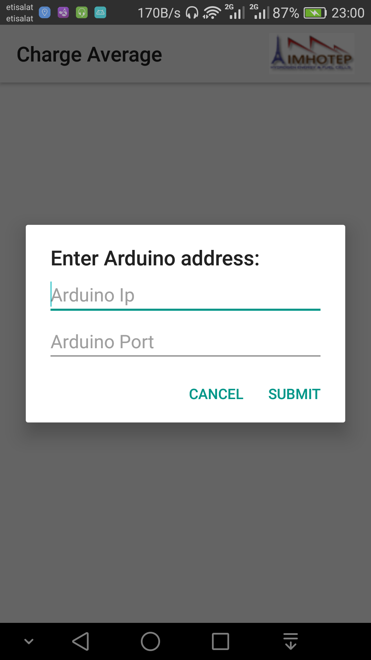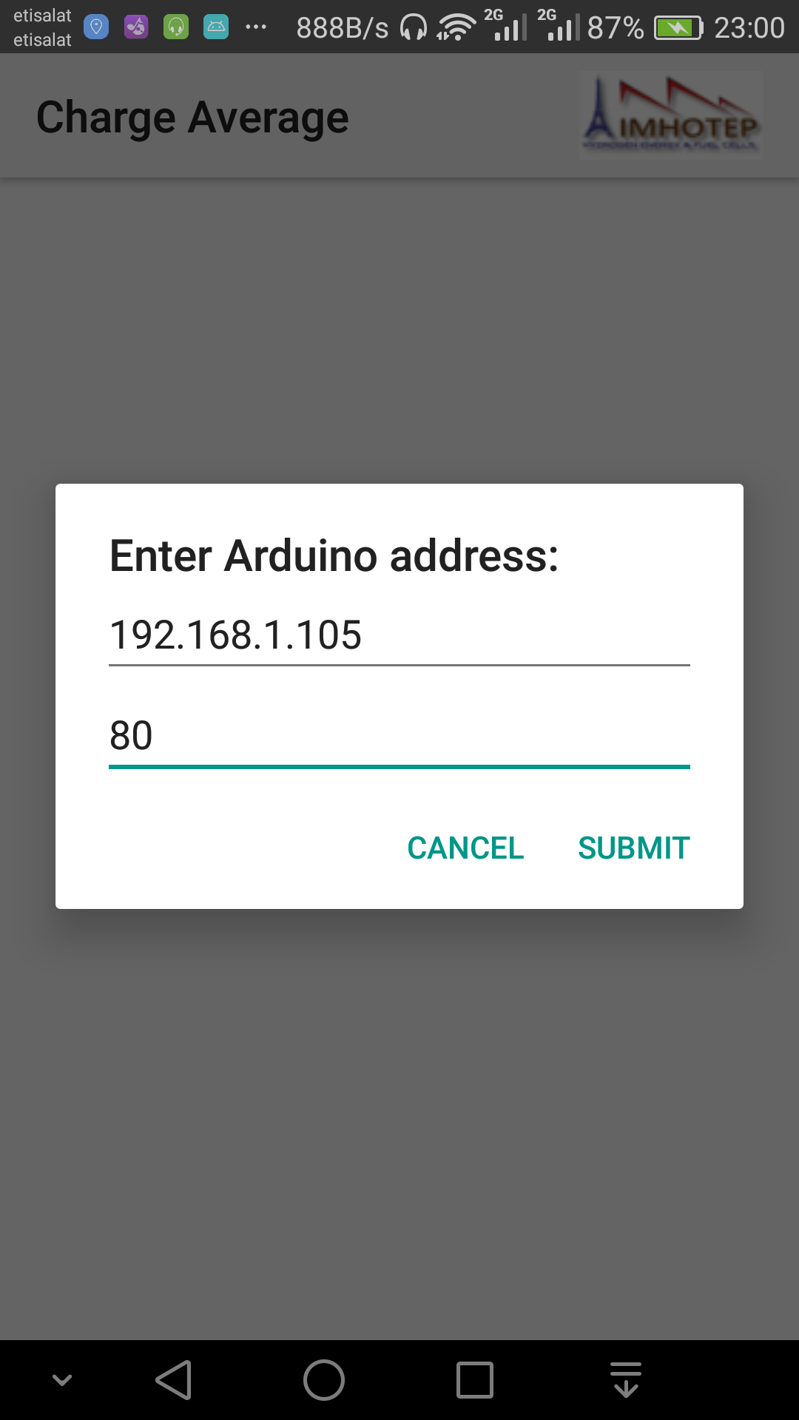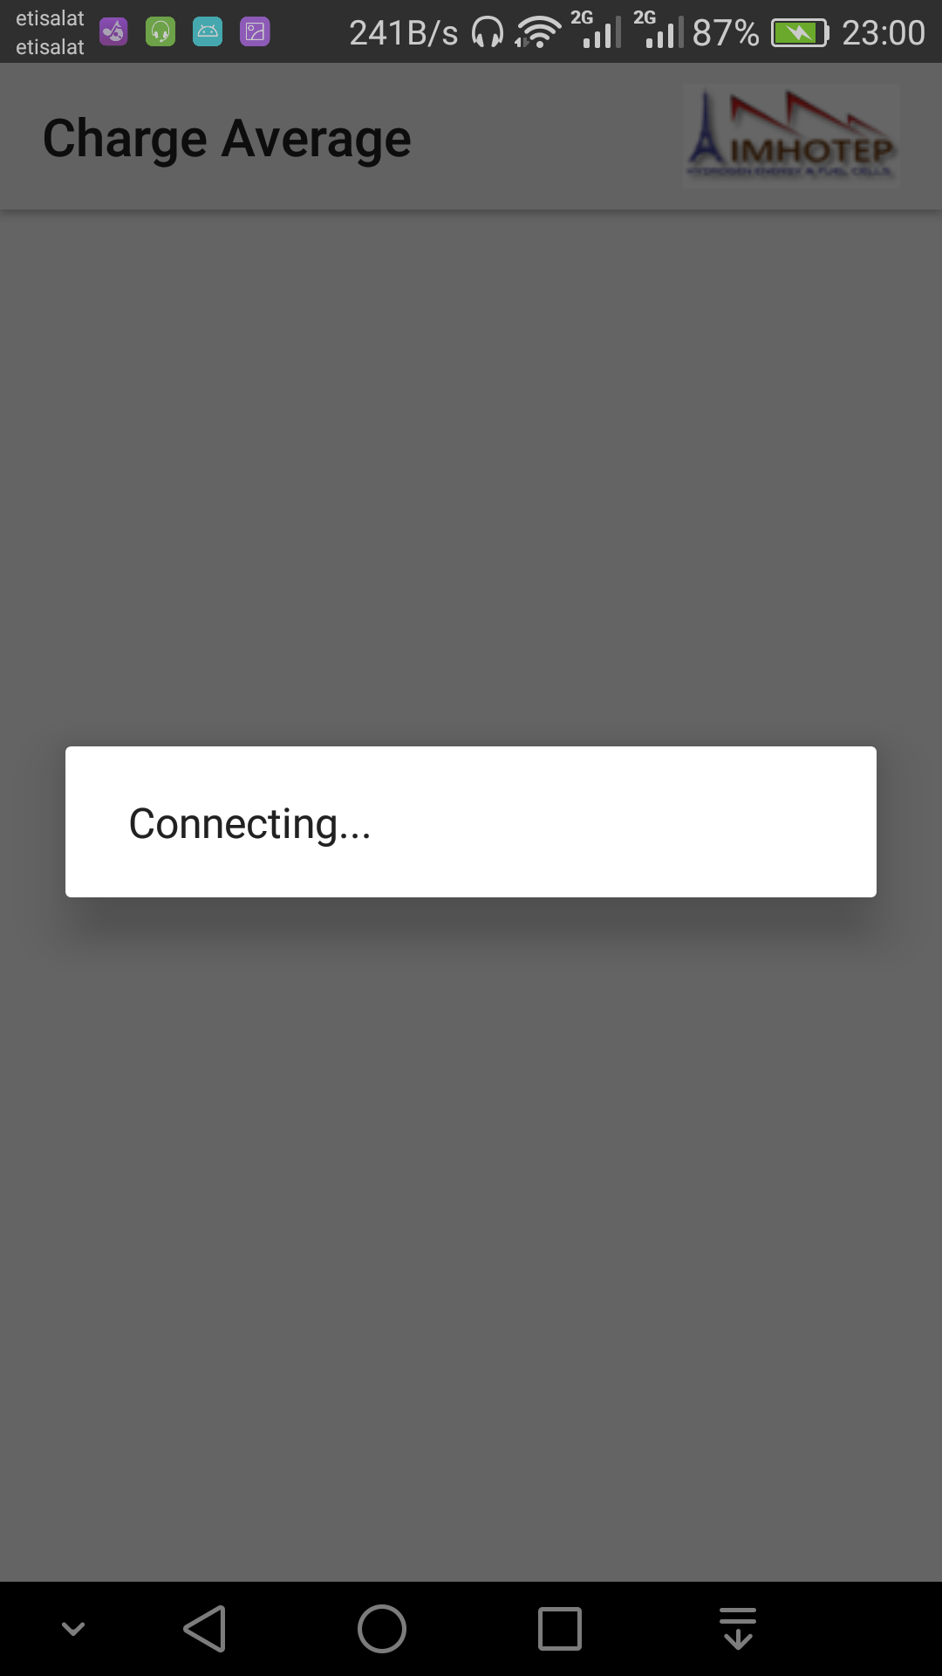

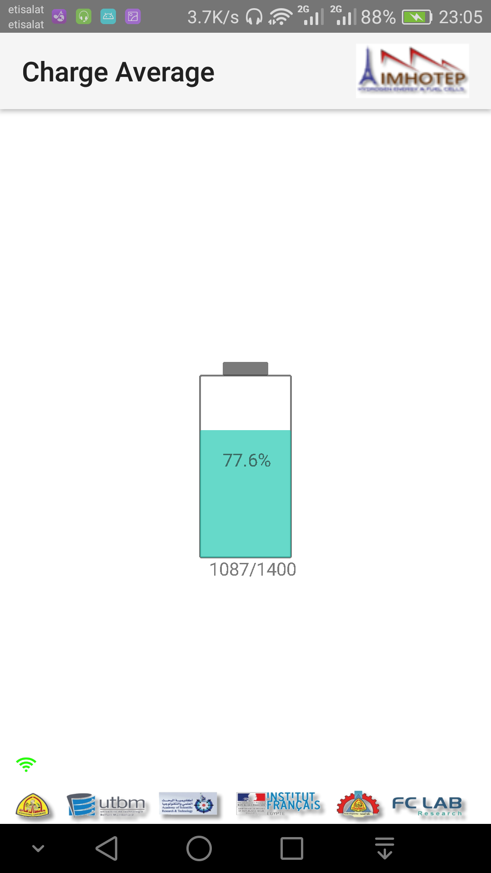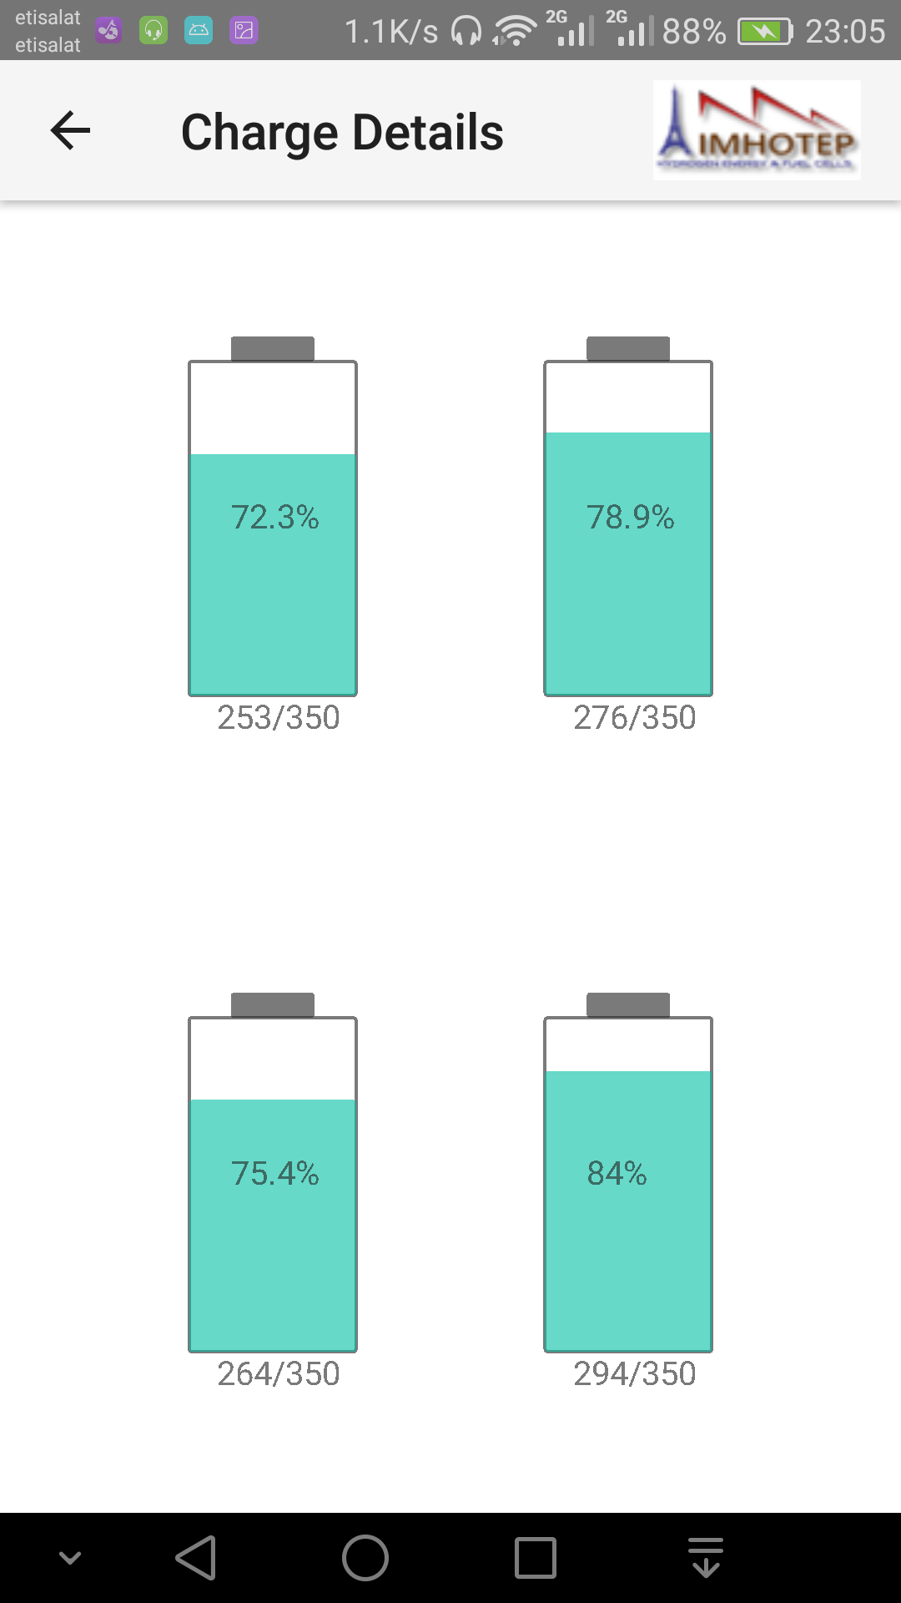

Flowchart:

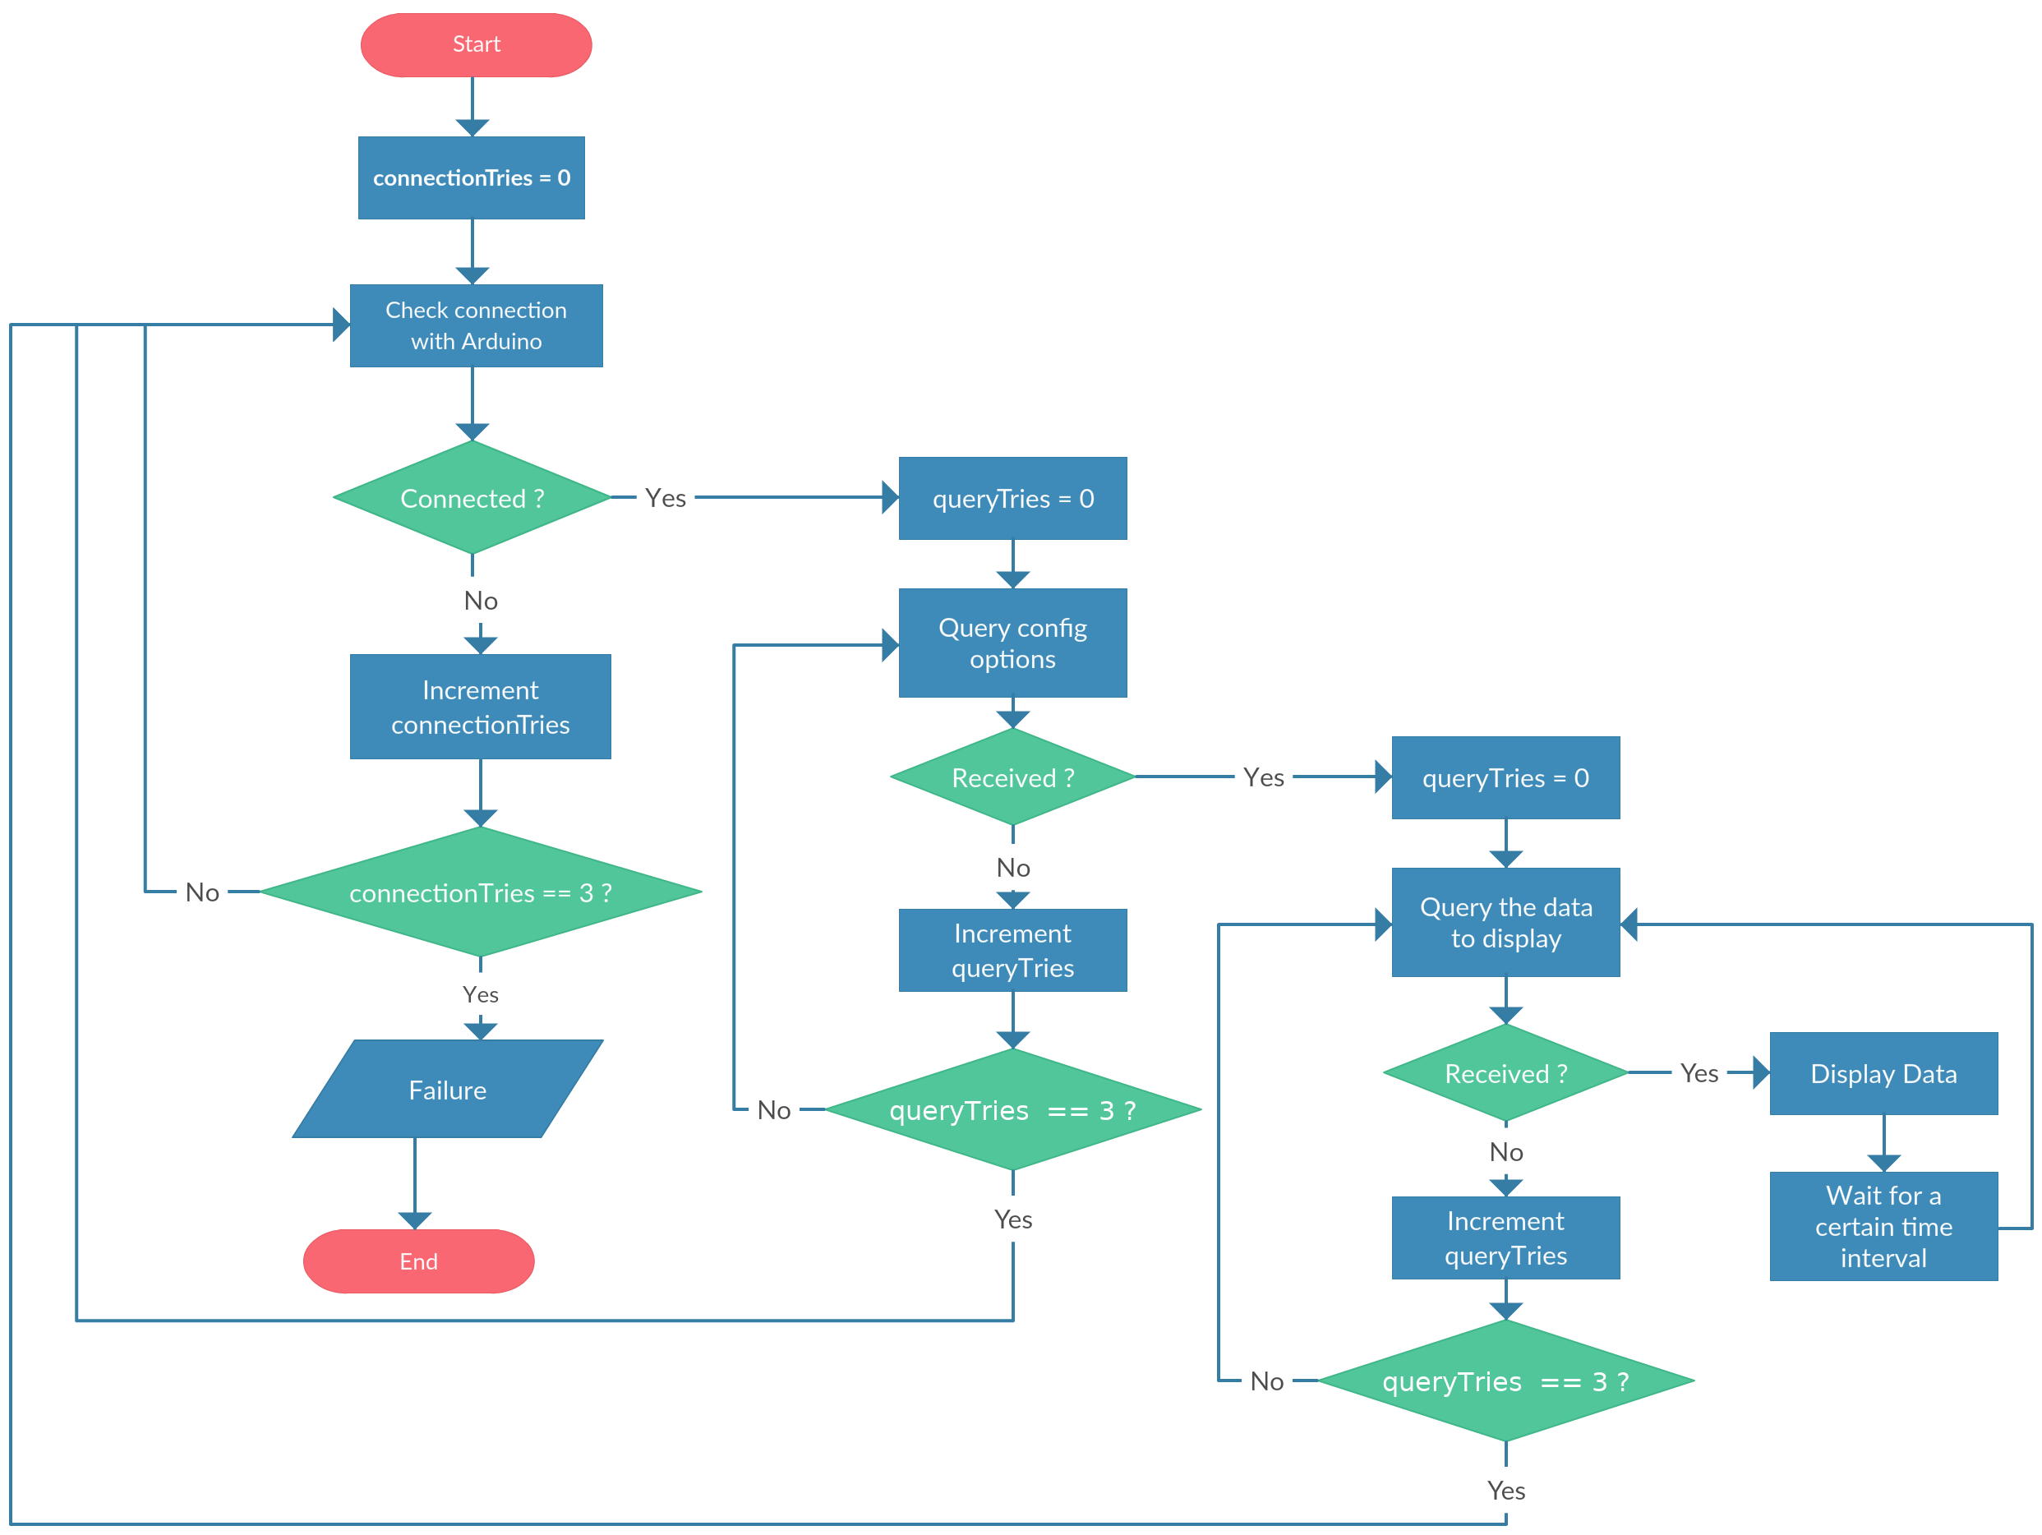

Flowchart for the application

To edit the code:

1. Open the code in Android Studio 3.0.1 or later.
2. Download the SDK versions 21 and 26 as the min. and max. APIs for the application to build from **File** > **Settings** > **Appearance & Behavior** > **System Settings** > **Android SDK** and mark the required APIs.

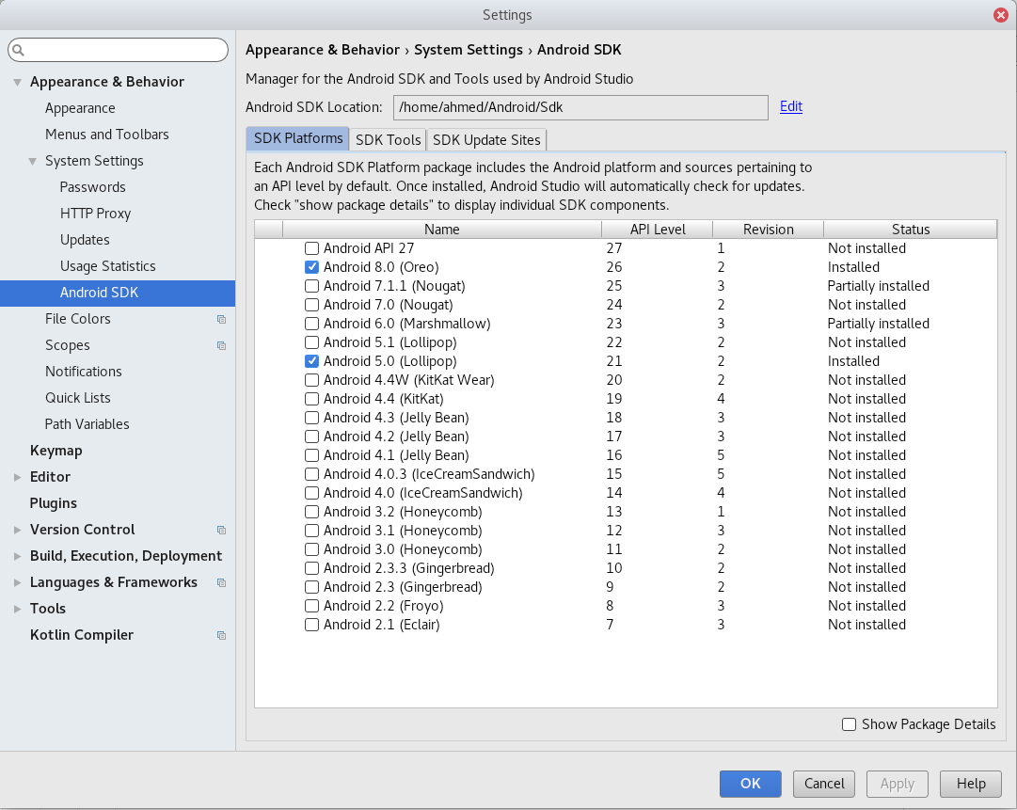

1. Download the gradle version 4.1 to build the application.
2. To run the apk, you need a device with Android OS version 5.0 (Lollipop) or later to version 8.0 (Oreo).