Supplemental Materials: Cultural Cognition, Environmental Orientation, and Pro-Environmental Behavior
These supplemental materials report the single-orientation structural equation models — cultural cognition predicting the Connectedness to Nature Scale (CNS) and the New Ecological Paradigm (NEP) separately — and the associated mediation analysis. The combined model that integrates both orientations is reported in the main text.
Single-orientation structural models
Figure 1: Measurement and structural model of cultural cognition, the Connectedness to Nature Scale, and public and private pro-environmental behaviors. Standardized coefficients shown; * p<0.05, ** p<0.01, *** p<0.001.
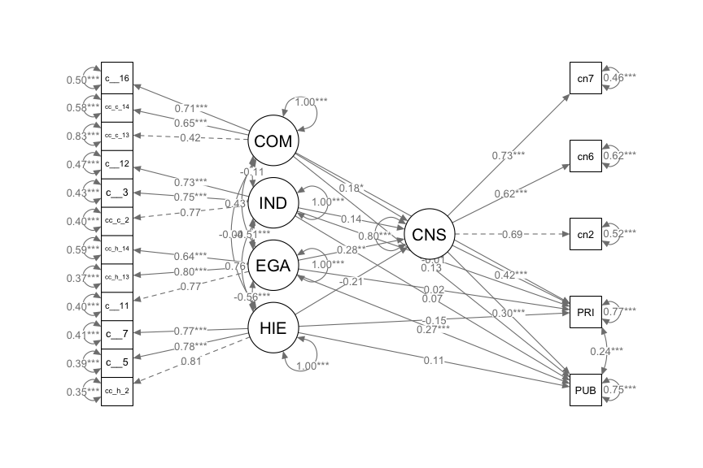
Figure 2: Measurement and structural model of cultural cognition, the New Ecological Paradigm, and public and private pro-environmental behaviors. Standardized coefficients shown; * p<0.05, ** p<0.01, *** p<0.001.
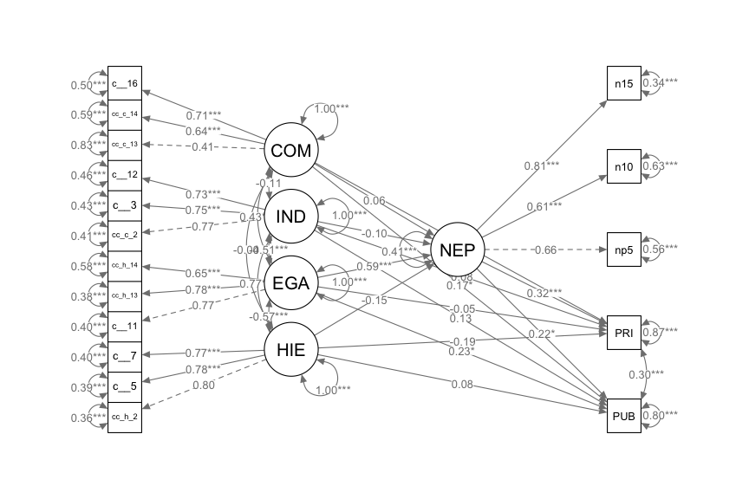
Table 1: Model fit statistics for the CNS and NEP single-orientation structural equation models
Model | N | df | Chi-sq | RMSEA | RMSEA 90% CI | CFI | TLI | SRMR
CNS | 501 | 100 | 227.27 | 0.050 | [0.042, 0.059] | 0.954 | 0.937 | 0.049
NEP | 501 | 100 | 371.14 | 0.074 | [0.066, 0.082] | 0.911 | 0.879 | 0.067

Full combined model with measurement detail
The main text reports the structural portion of the full combined model (cultural cognition → NEP → CNS → behavior, with direct paths). Figure S3 shows the same model with the full measurement model — the latent constructs and their indicators — included.
Figure 3: Full combined model including the measurement model (latent constructs and their indicators) and the structural paths: cultural cognition → New Ecological Paradigm → Connectedness to Nature → public and private pro-environmental behavior, with direct paths. Standardized coefficients shown; * p<0.05, ** p<0.01, *** p<0.001.
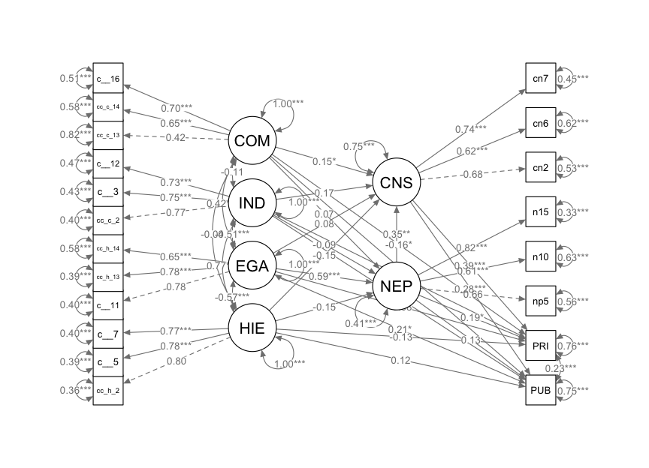
Mediation analysis
Table 2: Mediation analysis: standardized direct, indirect, and total effects of cultural cognition on public and private pro-environmental behavior († p<0.10, * p<0.05, ** p<0.01, *** p<0.001)
Path | Outcome | Direct | Indirect | Total
Egalitarianism → CNS | Public | 0.271*** | 0.085** | 0.356***
Egalitarianism → CNS | Private | 0.017 | 0.120** | 0.137†
Communitarianism → CNS | Public | 0.128* | 0.054* | 0.182**
Communitarianism → CNS | Private | -0.159* | 0.076* | -0.083
Egalitarianism → NEP | Public | 0.229* | 0.131* | 0.360***
Egalitarianism → NEP | Private | -0.051 | 0.191** | 0.139†
Communitarianism → NEP | Public | 0.167** | 0.014 | 0.182**
Communitarianism → NEP | Private | -0.105 | 0.021 | -0.085

References

