Who Does the Public Trust on Energy Issues?
Matthew C. Nowlin

Introduction
In this paper, I examine the patterns of whom the US public trusts with regard to energy policy. Specifically, I use Latent Class Analysis (LCA) to demonstrate those patterns. Next, I examine how demographics and political beliefs are associated with specific classes of trust who are highly trusted. Finally, I explore if demographics, political beliefs, and classes of trusted actors are associated with concern regarding several energy policy issues.

Public Trust in Policy Actors

Data and Methods

Latent Class Analysis
Table 1: Fit statistics for competing latent class solutions (k = 2-9)
Classes (k) | BIC | AIC | Log-Likelihood | Entropy | Smallest Class (%)
2 | 84724.8 | 84356.2 | -42117.1 | 0.854 | 39.9
3 | 81829.3 | 81273.3 | -40544.6 | 0.851 | 14.1
4 | 79640.5 | 78897.1 | -39325.6 | 0.853 | 15.5
5 | 78886.7 | 77956.0 | -38824.0 | 0.847 | 9.2
6 | 78283.5 | 77165.5 | -38397.7 | 0.845 | 8.7
7 | 77872.1 | 76566.7 | -38067.4 | 0.832 | 8.5
8 | 77598.0 | 76105.3 | -37805.7 | 0.835 | 7.5
9 | 77380.7 | 75700.7 | -37572.3 | 0.836 | 6.3

Results
Table 2: Latent class sizes
Class | N | Percent
Trust in Scientists & Environmental Groups | 1035 | 33.2
Broad Institutional Trust | 824 | 26.5
Generalized Low Trust | 770 | 24.7
Deep Distrust of All Actors | 484 | 15.5

Figure 1: Probability of high trust (7-10 on a 0-10 scale) in each actor, by latent class
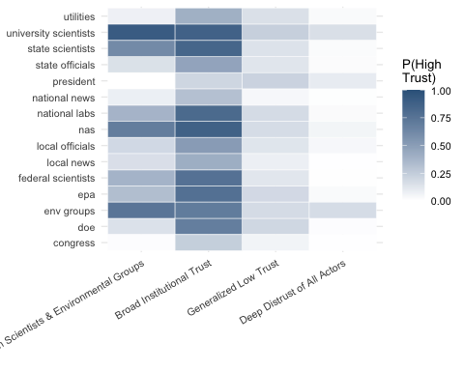
Table 3: Multinomial logit coefficient estimates predicting trust-class membership (reference class: Trust in Scientists & Environmental Groups, 33.2%). Standard errors are in parentheses.
 | Broad Institutional Trust (26.5%) | Generalized Low Trust (24.7%) | Deep Distrust of All Actors (15.5%)
(Intercept) | -1.991*** | -1.331*** | -0.813**
 | (0.290) | (0.282) | (0.296)
age | 0.007* | 0.008* | 0.004
 | (0.003) | (0.004) | (0.004)
male | 0.109 | -0.205† | -0.179
 | (0.108) | (0.113) | (0.125)
white | -0.425*** | -0.450*** | -0.186
 | (0.118) | (0.124) | (0.138)
college | -0.034 | -0.234† | -0.387**
 | (0.114) | (0.122) | (0.137)
inc | 0.003 | -0.055* | -0.086***
 | (0.021) | (0.023) | (0.026)
democrat | 0.304 | -0.657*** | -1.247***
 | (0.205) | (0.193) | (0.203)
republican | 0.693** | 0.495* | 0.351
 | (0.235) | (0.218) | (0.224)
trump.approval | 0.933*** | 1.083*** | 0.857***
 | (0.079) | (0.079) | (0.082)
Num.Obs. | 3113
R2 | 0.125
R2 Adj. | 0.119
AIC | 7510.4
BIC | 7673.6
RMSE | 0.40
† p < 0.1, * p < 0.05, ** p < 0.01, *** p < 0.001

Table 4: Validity check: weighted regression predicting concern about pollution from trust-class membership
 | Concern about Pollution
(Intercept) | 7.856***
 | (0.266)
age | 0.004
 | (0.004)
male | -0.516***
 | (0.112)
white | -0.124
 | (0.123)
college | 0.224*
 | (0.109)
inc | -0.034
 | (0.021)
democrat | 0.082
 | (0.164)
republican | -0.831***
 | (0.198)
trump.approval | -0.312***
 | (0.065)
trust_classBroad Institutional Trust | 0.118
 | (0.137)
trust_classGeneralized Low Trust | -0.835***
 | (0.153)
trust_classDeep Distrust of All Actors | -1.287***
 | (0.199)
Num.Obs. | 3113
R2 | 0.194
R2 Adj. | 0.191
AIC | 15144.8
BIC | 15223.4
RMSE | 2.42
† p < 0.1, * p < 0.05, ** p < 0.01, *** p < 0.001

Discussion

Conclusion

References

Associate Professor, Department of Political Science, University of Texas at Arlington. Email: matthew.nowlin@uta.edu

