Running Tests from XML file and generating HTML reports

1. Write Test Cases in Classes (1 Test Case = 1 Class, 1 Step = 1 Method with @Test Annotation)

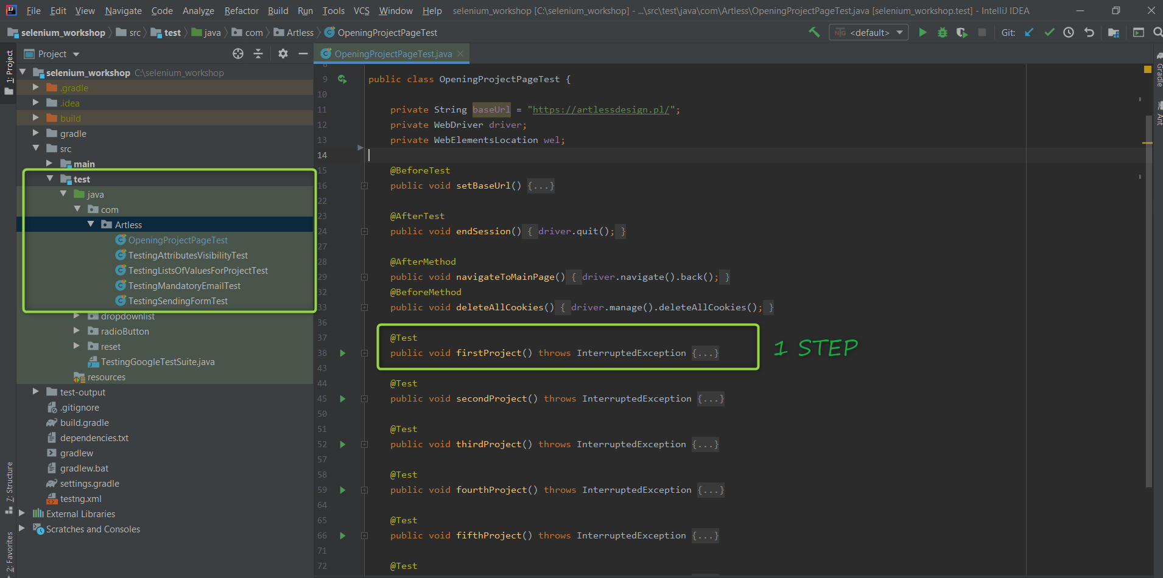

1. Add XML Plugin

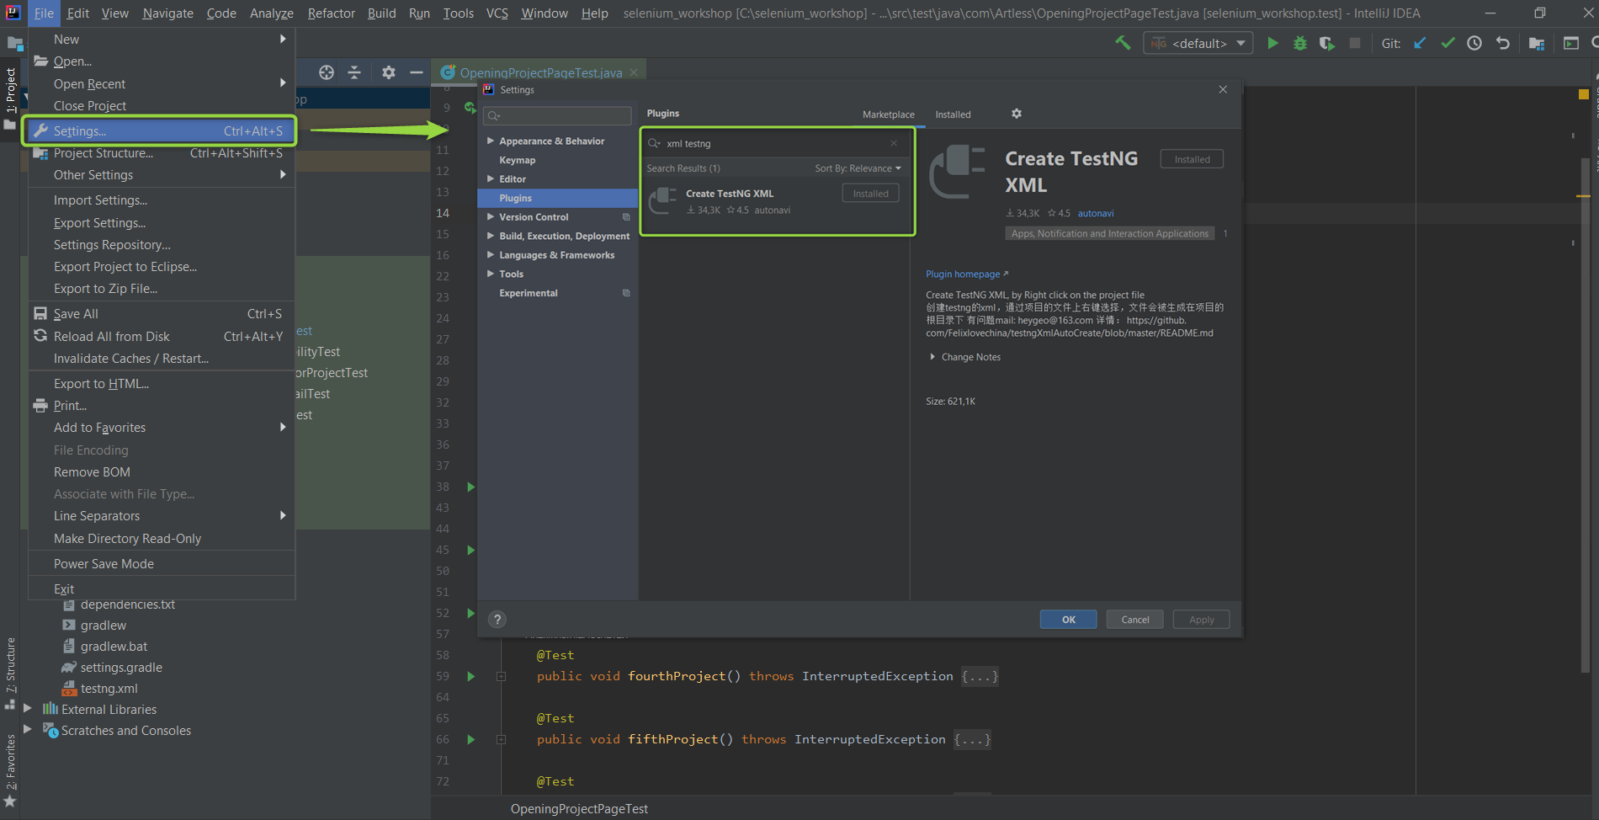

1. Creating TestNG XML

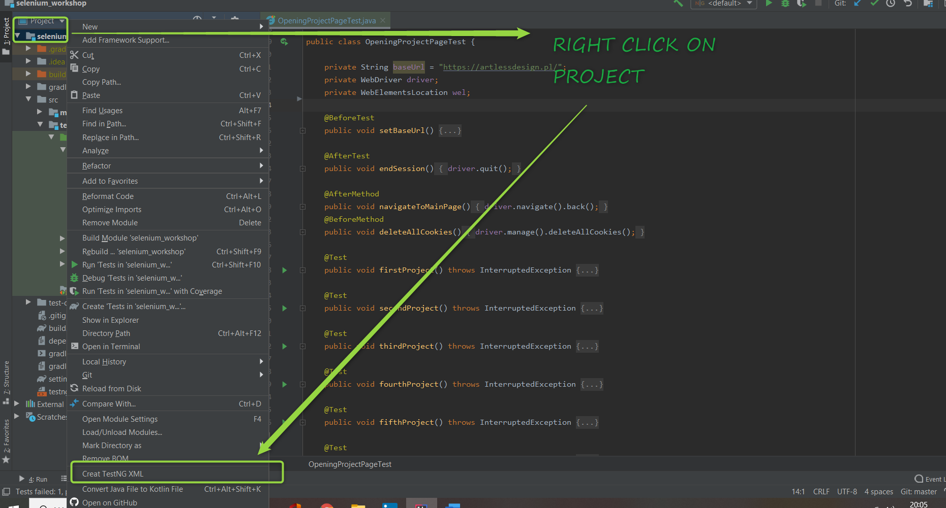

1. Add Reporting Tools to Configuration:

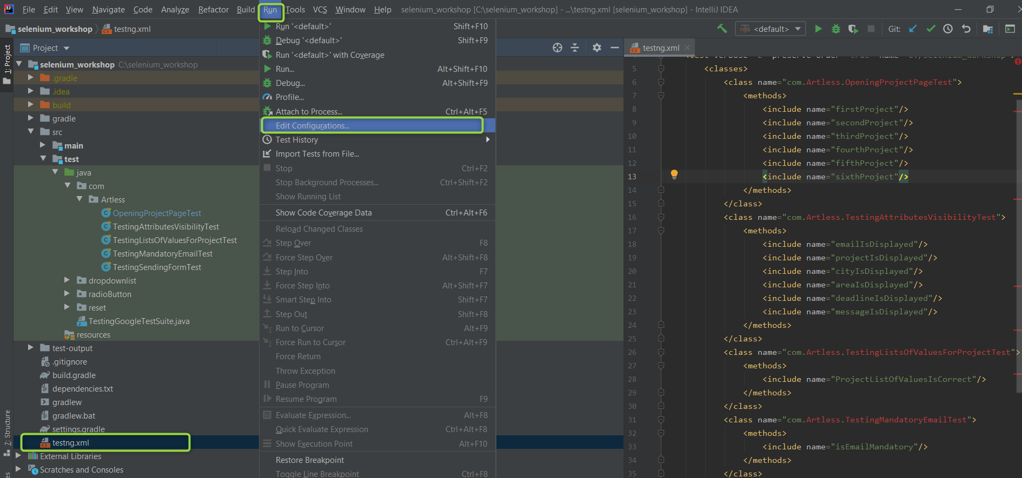

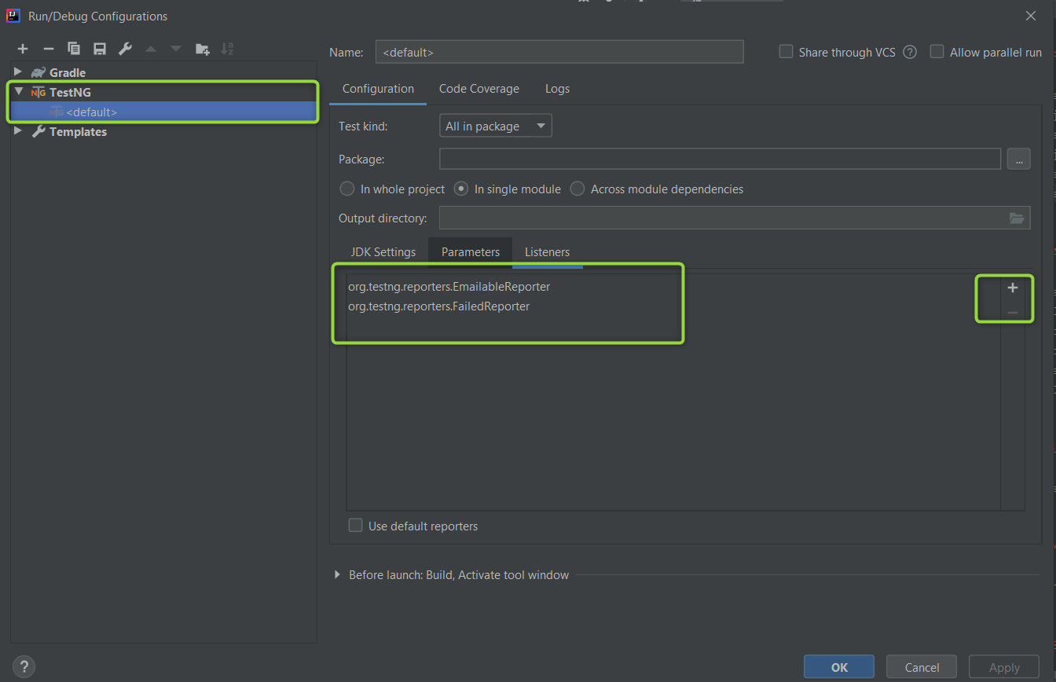

1. Set JDK Settings

VM options: -ea -Dtestng.dtd.http=true

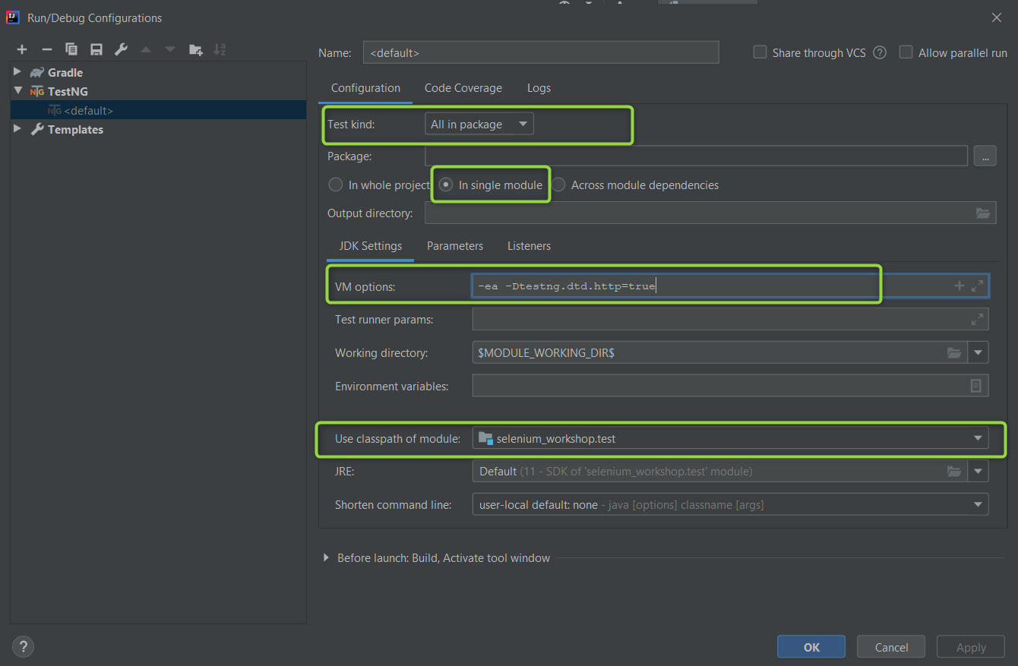

# Problem:

Exception in thread "main" java.lang.NoClassDefFoundError: org/testng/TestNG

