**Readme Instructions:** This template, created by Mark Coker, is a companion resource to the [Smashwords Style Guide](http://www.smashwords.com/books/view/52). This is my version 1.0, produced November 8 2013. I hope you find it useful. If you have feedback on this template, please click to [www.smashwords.com](http://www.smashwords.com/) and click on the top-of-the-page link labeled “questions/comments/feedback.” I expect this will be the first of many templates we share with our authors.

**For fiction and narrative non-fiction:** This template will help you create a professionally formatted book. It contains custom paragraph styles you can use to create a high-quality ebook. The examples shared here, as well as the custom styles embedded in this template, are intended for fiction and narrative non-fiction ebooks.

***What are Styles?*** *Think of styles as definitions for how text should look on the page. A chapter heading, for example, will have a different style (larger or different font, centered, etc) than the text of your body. Once you learn how to use or create custom paragraph styling, you’ll gain greater control over the look of your book, you’ll reduce errors, and you’ll save yourself a lot of time.* ***Oh, and you’ll produce a more professional-looking ebook!*** *If you’re new to Styles, or you want to learn more about them, definitely check out Step 7 in the Smashwords Style Guide.*

This template is probably more comprehensive than most ebook formatting templates. Part of the challenge of creating a good template is that every ebook is unique, and generic templates have a tendency to encourage generic books. In this template, I try to provide instructions that will help you make your book your own, and help you customize your book’s formatting and layout so you can maximize the accessibility and enjoyment of your book.

**How to use this template:**

Although I encourage you to browse this template at any time, I’d recommend you not start using it until after you’ve read the Smashwords Style Guide. Re-read Steps 1-3 in the Style Guide as good first steps before you use this template (make a backup, activate Word’s show/hide feature, and disable Word’s autocorrect and autoformat options).

When you’re ready to get started, take moment to read through this template from start to finish. It’ll show you how a formatted book will look in Word, and it’ll give you a sense of the flexible and professional ebook formatting options that are available to you. You’ll learn a lot about how to apply and manage styles.

It’ll also teach you how to use back matter (a.k.a. “end matter” discussed in Step 22 in the Style Guide) in conjunction with a Linked Table of Contents (Step 20 in the Style Guide) to help your book drive more sales of your other books, and drive the development of your personal author platform. When was the last time you saw a template that offered strategic marketing advice? Even if you’ve already published books with Smashwords, this template might give you ideas for how you can upgrade your books.

Next, put the template to work for you! You can write your book in this template (not that I would recommend that), or you can use the template as a reference guide as your format your book elsewhere. Or, you can copy and paste your book into this template so you can apply my styles to your book’s different sections.

If you’re going to copy and paste your book into this template, be careful how you paste because this template will work best if you don’t import other styles and settings into it. If you do copy and paste into this template, use Word’s “Paste Special” option, and then paste as unformatted text. You’ll find that up above in Word’s menu bar. Click **Paste**, then **Paste Special**, then select the option for “**unformatted text.**” That will cause your pasted text to adopt the Normal paragraph style as defined in this template. Here’s a screen shot of how the menu bar looks in Word 2007 and later versions.

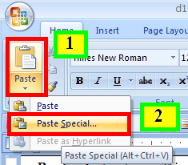

Each section at detailed instructions. Replace my words with your own.

If you’re using this template for your own book, remember to remove the instructions above and below, and remove the page break that follows here…

***Instructions for this section:*** *Enter your book title below by highlighting the text, “Book Title Goes Here.” Replace “Firstname Lastname” with your name. The “Smashwords Edition License Notes” paragraph is optional (Step 21 in the Style Guide). As I mention in the Style Guide, the license statement is a polite method of reminding readers of their legal and ethical obligation to support the writer. It’s a refreshing departure from the copyright notices of yesteryear that threatened $500,000 in fines and various forms of fire and brimstone. You don’t want your readers to think you’re a meanie! The book title text below is coded with a custom paragraph style I created called “BookTitle.” The style defines 16pt bold and centered Times New Roman with 60 pt line spacing above the title (so your title doesn’t hug the top of your ebook page) and 24pt spacing after the title (so your front matter looks neat and organized). Step 7 in the Style Guide teaches you how to create and manage custom styles. I created the Styles for you. To access, modify or apply my styles, or to create your own, click to Word’s ribbon menu above, then click Home: Change Styles.*

Book Title Goes Here

Copyright 2013 Firstname Lastname

Published by Firstname Lastname at Smashwords

Smashwords Edition License Notes

This ebook is licensed for your personal enjoyment only. This ebook may not be re-sold or given away to other people. If you would like to share this book with another person, please purchase an additional copy for each recipient. If you’re reading this book and did not purchase it, or it was not purchased for your enjoyment only, then please return to Smashwords.com or your favorite retailer and purchase your own copy. Thank you for respecting the hard work of this author.

Table of Contents

Acknowledgements

Prologue

Chapter One

Chapter Two

Chapter Three

About Firstname Lastname

Other books by Firstname Lastname

Connect with Firstname Lastname

***Instructions for this section:*** This is what a hyperlinked Table of Contents (Step 20 in the Style Guide) will look like. Before you use this template, you should right mouse click on the links above and select “remove hyperlink,” and then click to **Insert**: **Bookmark** and delete all my bookmarks. **My links above will not work for your book.**

A good ToC-building strategy is to create your Table of Contents last. First focus on formatting the other parts of your book. Then create your bookmarks. Bookmarks identify the sections that your linked Table of Contents will *link to*. Think of a bookmark as a target, a destination, or a bulls-eye. First you’ll tag your targets with bookmarks, and then you’ll aim at your targets from your ToC with hyperlinks that will take the reader to your target destination. Got that? Create the bookmark targets first, then link to them later from your ToC.

When you return to complete the Table of Contents above, start by typing out the text that corresponds with each of your target destinations.

As discussed in Step 20 of the Style Guide, a big advantage of creating a Linked Table of Contents (a.k.a. “Linked ToC’) is that the Smashwords Meatgrinder conversion system will use your linked ToC to generate your NCX navigation in your .epub and .mobi files. Navigation makes your ebook more accessible to readers. As mentioned in the Style Guide, the linked ToC provides internal navigation, so readers can click the link and go straight to their destination. The NCX is actually navigation that sits outside your book. The e-reading software or device will use it to point into your book. Both types of navigation are super-useful.

The text you link above will become the text label that Meatgrinder will use in the NCX of your .epub and .mobi files. For example, if your ToC has a line such as:

Chapter One – When Jack met Jill

…but the hyperlink you apply to that section only hyperlinks the text, “Chapter One,” then the text, “Chapter One” will appear in the NCX navigation file, as opposed to “Chapter One – When Jack met Jill.” As you become a ToC-building expert, there will be times when you want all the text of the line in your NCX, and other times when a shorter string is better. You’re in control. Have fun!

The next section will provide detailed instructions on how to create Bookmarks. Even novels can benefit from a linked Table of Contents, especially if you add the end matter sections of About the author, other books by the author, and connect with the author.

Acknowledgements

An acknowledgements section is optional. You could have just as easily labeled this section Chapter One, or Prologue, or whatever works for your book. I’ll use this section of the template to illustrate paragraph separation methods including a NoIndent first paragraph, a first line indent and also how to create bookmarks to the different sections of your book. Notice how the style of this paragraph is NoIndent. If your book uses the first-line indent paragraph separation method as described in Step 7 of the Style Guide, it’s a nice professional touch to make the first paragraph of each chapter or major section a no-indent paragraph. If you pick up any print novel, you’ll see the same technique used.

Here’s the second paragraph. Note the first line indent. This paragraph uses the Normal paragraph style, which in this template is coded for a first line indent of .3 inch with 12pt Times New Roman font and single line spacing. In Microsoft Word’s ribbon, click to **Home:** **Change Styles:** and then hover your mouse over Normal or click the down arrow then click **Modify** to view the settings for the Normal style.

In the image below, I’ll show you how to bookmark your “Acknowledgements” heading (or any heading or sub-heading for that matter) so you can later link it to your Table of Contents (Step 20 in the Style Guide).

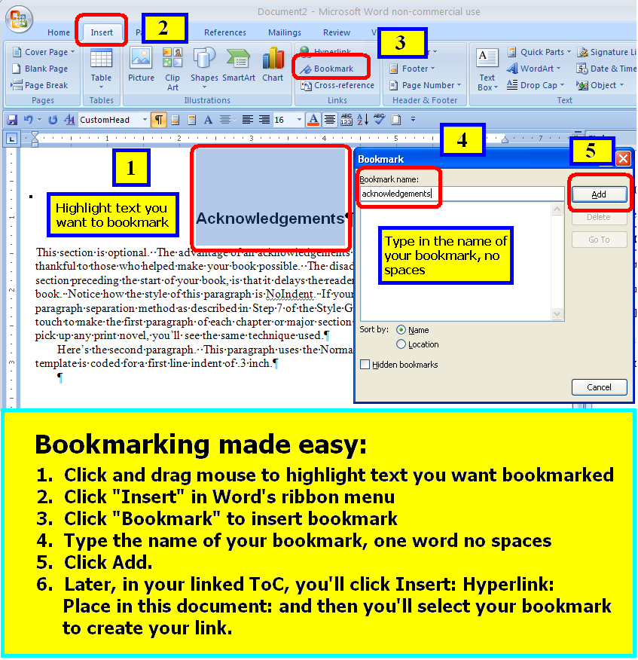

See how the image above is centered? I centered it by clicking once on the image, and then clicking to Change Styles. Then I clicked once on my custom style called “Centeredtext,” which applied that style to the image. This is the best method of centering the images in your book. Learn more about images in the Smashwords Style Guide.

Prologue

A prologue is optional. This section just as easily could have been labeled Chapter One, Chapter 1, Chapter 1 or the name of any other section. I typed in the label of my section heading, in this case Prologue, and then I clicked and dragged my mouse to highlight my heading, and then I clicked to **Change Styles** and then clicked on **CustomHead**, the name of the paragraph style I wanted to apply to this heading. Note that similar to the last section, I applied my NoIndent style to this first paragraph.

My “CustomHead” heading which I applied to my heading text above (Prologue) is coded to define 16 pt Arial bold with a preceding line spacing of 60pt and a following “after” line spacing of 18 pt. It also defines a preceding page break. These settings force my heading to appear at the start of a new page in the ebook. The 60pt preceding space causes my heading to sit slightly down the page so it’s not hugging the top of the page. I think this is great way to do your chapter headings. You can modify my style to increase or decrease my before and after spaces, or to change the font size, or to make it flush left or flush right.

Note that this paragraph is first line indented, as will be all subsequent body paragraphs in this section.

Chapter One

Put your chapters or sections here. I typed in “Chapter One” above, highlighted the text by clicking and dragging my mouse, and then applied my “CustomHead” style to it as I did in the Prologue section above. As you create new chapter or section headings, you can do the same. Note how I’m using my custom **NoIndent** style for this first paragraph of the chapter.

Now see how this paragraph is first-line indented. I configured my custom styles so they proactively know which style follows which. For example, the **CustomHead** style, which I applied above to Chapter One, knows that when I click the Enter key at the end of that text to start a new paragraph, that the next paragraph should be the **NoIndent** style because that’s the body style we want at the beginning of our chapters or sections when we’re using the first line indent method for the main body of our work (See Step 7 in the Style Guide if any of this is new or confusing to you). Here’s a screen shot of the underlying style.

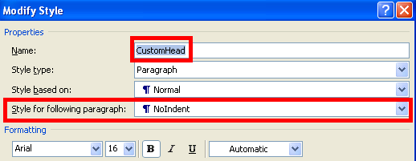

The next paragraph, as you can see at the top of this chapter, then begins in the **NoIndent** style. I configured my NoIndent style to define Normal as the next style for any subsequent paragraphs that follow Normal. Here’s a shot of my NoIndent style’s settings.

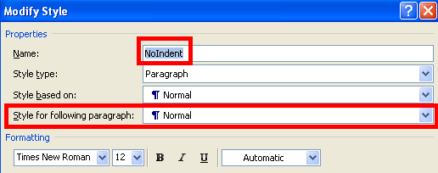

The next paragraph then begins in the Normal style. I configured my Normal style to define Normal as the next style for any subsequent paragraphs that follow Normal. This is because you want the body of your book to be the Normal style. Here’s a shot of my Normal style’s settings.

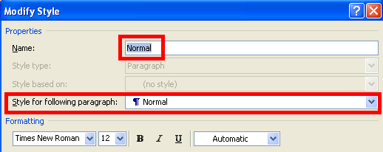

After the NoIndent style is used, and you click Enter to start the next paragraph, I configured it to automatically assign my customized Normal style which defines a first line indent.

Chapter Two

Your first paragraph goes here.

Your next paragraph goes here.

And so on…

And so on…

Chapter Three

Your first paragraph goes here.

And so on…

When you get the end of the book, added centered hashtags to let the reader know they’ve reached the end. Or, enter the words, “The End.” I added centering by highlighting the text and then assigning the text to my custom “Centeredtext” style. You’d be surprised how many writers don’t denote the end. By letting the reader know they’ve reached the end, it puts them in the mental mindset to read the important end matter sections that come next!

###

About the Author

***Instructions for this section:*** *This is the first section of your end matter, a.k.a. “back matter.” End matter helps you connect with the reader. This first section is the bio. Put a short bio here. The reader just finished your book, they think you’re super-awesome, and they’re curious to learn more about you. Short is important. You don’t want to beat them over the head with a long resume. If you created a Smashwords Interview, include a link to it at the end of your bio so they can learn more if they’re interest. I’ll use myself as an example. Note how I’ve applied the NoIndent style to this section. I think it looks better this way, but it’s totally up to you.*

Mark Coker is the founder of Smashwords, the world’s largest distributor of indie ebooks. In 2010, The Wall Street Journal named him one of the “Eight Stars of Self-Publishing.” His three books about ebook publishing best practices have been downloaded over 500,000 times. When he’s not running Smashwords, he’s probably hiking, gardening or traveling. Read Mark’s Smashwords Interview at <https://www.smashwords.com/interview/mc>

Other books by this author

***Instructions for this section:*** *The reader just finished your book, and they love it. They read your short bio and they think you’re cool beans. Now they want to read your other books. Simply list your other books. If you write series, organize your listing around series. If you have upcoming books, mention them. If you have a preorder, definitely mention it because they can go reserve a copy now! Don’t include marketing language or hyperlinks that direct a reader to a specific retailer, and don’t mention any retailers by name. Note that I’m using my NoIndent paragraph style for this section because lists usually look neater flush left rather than first line indented.*

Please visit your favorite ebook retailer to discover other books by [Firstname Lastname]:

***The Smashwords Guides Series***

Smashwords Style Guide

Smashwords Book Marketing Guide

The Secrets to Ebook Publishing Success

***The SuperFab Thriller Serie****s*

Book One

Book Two

Book Three

Book Four (Coming July 4 2014, available now on preorder at select retailers!)

Connect with [Firstname Lastname]

***Instructions for this section:*** *The reader just finished your book, your bio didn’t scare them, and now they think you’re the most super-awesome author ever. Make it easy for them to connect with you on social media. This here is one of the most powerful secrets of author platform building. Simply by listing your social media coordinates below, your book will drive the growth of your author platform at the very moment your reader is smitten with you. The more coordinates you list, the easier you make if for them to connect with you. Some readers might only want to follow you on Twitter, or on Facebook, whereas others might want to follow you everywhere. Add a short sentence in your voice that encourages them to connect with you. Note howI preceded each coordinate with a call to action, such as ‘friend me,” or “follow me.” It’s not necessary to do that, though it does subtly remind the reader what you’re inviting them to do once they click the link. Note how for this section, like the previous section, I’m using the NoIndent paragraph style. Also note that although I arranged my back matter in the order of bio, books and connect, you’re welcome to rearrange the order. You can also add other sections, such as sample chapters of your other books.*

I really appreciate you reading my book! Here are my social media coordinates:

Friend me on Facebook: <http://facebook.com/markcoker>

Follow me on Twitter: <http://twitter.com/markcoker>

Favorite my Smashwords author page: <https://www.smashwords.com/profile/view/mc>

Subscribe to my blog: [http://blog.smashwords.com](http://blog.smashwords.com/)

Connect on LinkedIn: <http://www.linkedin.com/in/markcoker>

Visit my website: [http://www.smashwords.com](http://www.smashwords.com/)

***Final instructions:*** *Before you publish your book, triple check that you’ve removed all my instructions above. Also remember to save your Word file as a Word .doc, not .docx. In Word 2007 and later versions, you’ll click on circular* ***Office button*** *in the upper left hand corner of Word, then click* ***Save as****: and then click* ***Word ’97-2003****.*