AI-ENABLED MARKET ANALYSIS AND VISUALIZATION
SYSTEM FOR ENTERPRISE APPLICATIONS

Submitted in partial fulfillment of the requirements
for the award of the degree of

MASTER OF COMPUTER APPLICATIONS
in
Computer Science and Engineering

Department of Computer Applications
SRM VALLIAMMAI ENGINEERING COLLEGE

2025 – 2026

ABSTRACT

The project titled “AI-Enabled Market Analysis and Visualization System for Enterprise Applications” aims to develop an intelligent analytics platform that integrates marketing data from multiple enterprise channels, including newspaper classifieds, social media campaigns, and company promotional events. The system is designed to enhance strategic decision-making by transforming heterogeneous marketing data into actionable business insights.
The proposed enterprise application collects structured and semi-structured data from classified advertisements, digital engagement metrics from social media platforms, and response data from company promotional events. A RESTful API layer is developed to invoke AI-based analytical processes within the existing software environment. Upon API execution, machine learning algorithms perform sentiment analysis, engagement analysis, trend forecasting, customer segmentation, and campaign performance evaluation.
The processed outputs are presented through interactive dashboards, graphical reports, and real-time visualization modules that allow management to monitor campaign effectiveness across different marketing channels. The system enables comparative performance analysis between traditional media (newspaper classifieds) and digital platforms (social media), helping enterprises optimize marketing investments and improve return on investment (ROI).
By integrating AI-driven analytics with dynamic visualization techniques, the proposed system provides a scalable, modular, and data-driven solution for enterprise marketing intelligence, ultimately supporting informed business decisions and enhanced promotional strategy planning.

Keywords: Artificial Intelligence, Machine Learning, Marketing Analytics, Data Visualization, Enterprise Applications, Sentiment Analysis, RESTful API, Business Intelligence, Campaign Performance.

Table of Contents
Abstract 2
Table of Contents 3
List of Figures 7
List of Tables 8
Chapter I: Introduction 9
1.1 Background and Motivation 9
1.2 Problem Statement 9
1.3 Objectives of the Project 10
1.4 Scope of the Project 10
1.5 Existing Systems and Their Limitations 11
1.6 Organization of the Report 11
Chapter II: Proposed Methodology 12
2.1 Overview of the Methodology 12
2.2 Phase 1: Requirements Analysis 13
2.3 Phase 2: System Architecture Design 13
2.4 Phase 3: Data Engineering 13
2.5 Phase 4: AI Model Development 13
2.6 Phase 5: Development and Integration 13
2.7 Phase 6: Testing and Validation 13
Chapter III: System Architecture Explanation 15
3.1 Architectural Overview 15
3.2 Microservices Components 15
3.3 Technology Stack 15
3.4 Security Architecture 16
Chapter IV: Data Collection 17
4.1 Overview of Data Sources 17
4.2 Newspaper Classified Data Collection 17
4.3 Social Media Analytics Data Collection 17
4.4 Promotional Event Data Collection 18
Chapter V: Data Preprocessing 19
5.1 Preprocessing Pipeline Overview 19
5.2 Data Cleaning 19
5.3 Text Preprocessing for NLP 19
5.4 Feature Engineering 20
Chapter VI: API Invocation 21
6.1 RESTful API Architecture 21
6.2 Endpoint Design 21
6.3 Request Validation 22
6.4 Response Formatting 22
6.5 Secure Token Authentication 22
Chapter VII: AI Processing 23
7.1 AI Processing Framework 23
7.2 Sentiment Analysis 23
7.3 Engagement Analysis 24
7.4 Trend Forecasting 24
7.5 Customer Segmentation 25
7.6 Campaign Performance Evaluation 26
Chapter VIII: Visualization 27
8.1 Visualization Architecture 27
8.2 Dashboard Modules 27
8.3 Chart Types and Interactions 27
8.4 Report Generation 28
Chapter IX: Decision Support 29
9.1 Decision Support Framework 29
9.2 KPI Monitoring and Alerting 29
9.3 Comparative Analysis Support 29
9.4 ROI Optimization Recommendations 29
Chapter X: Modules of the System 30
10.1 User Management Module 30
10.1.1 Admin Login 30
10.1.2 Role-Based Access Control 30
10.1.3 Secure Authentication 30
10.2 Data Integration Module 30
10.2.1 Upload Classified Data 30
10.2.2 Import Social Media Analytics 30
10.2.3 Enter Promotional Event Data 31
10.3 API Management Module 31
10.3.1 Endpoint Handling 31
10.3.2 Request Validation 31
10.3.3 Response Formatting 31
10.3.4 Secure Token Authentication 31
10.4 Visualization and Reporting Module 31
10.4.1 Dashboard Generation 31
10.4.2 Channel Comparison Charts 32
10.4.3 Exportable Reports 32
Chapter XI: Design of System 33
11.1 Database Design 33
11.1.1 Entity-Relationship Model 33
11.1.2 Database Schema 33
11.1.3 Database Indexing Strategy 34
11.2 API Design 34
11.2.1 API Design Principles 34
11.2.2 Authentication Flow Design 34
11.2.3 Analytics API Design 34
Chapter XII: Implementation and Testing 36
12.1 Implementation Environment 36
12.2 Implementation Highlights 36
12.2.1 Data Ingestion Pipeline 36
12.2.2 AI Model Implementation 36
12.3 Testing Strategy and Results 36
12.3.1 User Acceptance Testing 37
Chapter XIII: Results and Discussions 38
13.1 Sentiment Analysis Results 38
13.2 Engagement Analysis Results 38
13.3 Trend Forecasting Results 38
13.4 Customer Segmentation Results 38
13.5 System Performance Results 38
13.6 Business Impact Assessment 39
Chapter XIV: Conclusions 40
14.1 Summary of Achievements 40
14.2 Limitations 40
14.3 Concluding Remarks 40
Chapter XV: Future Enhancements 41
15.1 Advanced AI Capabilities 41
15.2 Additional Data Source Integrations 41
15.3 Technical Enhancements 41
15.4 User Experience Enhancements 41
15.5 Governance and Compliance Enhancements 41
References 43
Appendix A: Installation and Configuration Guide 44
A.1 Prerequisites 44
A.2 Deployment Steps 44
Appendix B: API Reference Summary 44
B.1 Authentication Endpoints 44
B.2 Analytics Endpoints 44
Appendix C: Glossary of Terms 45

List of Figures
Figure 1.1: Overall System Architecture Diagram
Figure 2.1: Proposed Methodology Flowchart
Figure 4.1: Data Collection Pipeline
Figure 5.2: NLP Preprocessing Pipeline
Figure 6.1: RESTful API Architecture
Figure 7.1: Sentiment Analysis Model Comparison
Figure 7.2: Sentiment Distribution Across Marketing Channels
Figure 7.3: LSTM Trend Forecasting – Engagement Rate
Figure 7.4: Customer Segmentation – K-Means Clusters
Figure 8.1: Interactive Dashboard Layout – Executive Overview
Figure 10.1: Entity-Relationship Diagram
Figure 12.1: System Performance and Testing Results

List of Tables
Table 1.1: Comparison of Existing Systems
Table 2.1: Methodology Phase Summary
Table 3.1: Technology Stack Summary
Table 4.1: Data Sources and Collection Methods
Table 6.1: API Endpoint Reference
Table 7.1: ML Algorithm Performance Comparison
Table 10.1: Database Table Descriptions
Table 12.1: System Test Results Summary

CHAPTER I: INTRODUCTION

1.1 Background and Motivation
The contemporary enterprise marketing environment is characterized by an unprecedented proliferation of channels, platforms, and data sources that collectively generate vast volumes of marketing-relevant information. Traditional approaches to marketing analysis, reliant upon manual data collection, spreadsheet-based aggregation, and periodic static reporting, have proven increasingly inadequate in meeting the demands of modern business intelligence. Enterprises seeking competitive advantage must now harness the power of real-time analytics, artificial intelligence, and sophisticated visualization tools to extract meaningful insights from heterogeneous data streams.
The convergence of big data technologies, cloud computing infrastructure, and advances in machine learning algorithms has created an enabling environment for the development of intelligent marketing analytics platforms. These systems promise to transform the way enterprises understand their marketing performance, customer engagement, and campaign effectiveness across both traditional and digital channels. However, the realization of this potential requires careful architectural design, robust data engineering, and thoughtful integration of analytical models within existing enterprise software ecosystems.
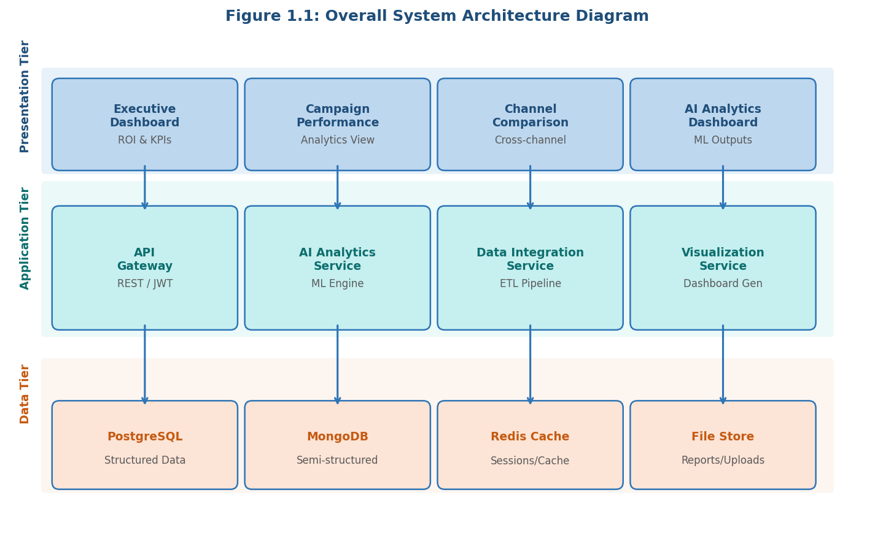
Figure 1.1: Overall System Architecture Diagram
Newspaper classified advertisements continue to represent a significant marketing channel for many enterprises. Simultaneously, social media platforms have emerged as primary digital engagement channels, offering granular behavioral data, sentiment signals, and demographic insights at scale. Company promotional events constitute a third critical data source capturing customer response patterns in structured environments.
In the modern business environment, organizations generate and consume large volumes of marketing data from multiple channels such as print media, digital platforms, and promotional events. With the rapid growth of digital transformation, enterprises are increasingly relying on data-driven strategies to improve their marketing performance and decision-making processes. However, marketing data is often distributed across heterogeneous sources including traditional media like newspaper classifieds, social media platforms, and corporate promotional campaigns. These diverse data sources produce structured, semi-structured, and unstructured datasets that are difficult to analyze using conventional analytical tools. As a result, organizations face challenges in extracting meaningful insights that can guide strategic marketing decisions.

Artificial Intelligence (AI) and data analytics technologies have emerged as powerful tools to address these challenges. AI-driven systems are capable of processing large datasets, identifying patterns, and generating predictive insights that support business intelligence. When combined with advanced visualization techniques, these technologies enable enterprises to convert complex marketing data into intuitive and actionable insights. Interactive dashboards, real-time monitoring systems, and graphical analytics platforms allow managers and decision-makers to evaluate marketing performance more effectively and optimize their promotional strategies.

Traditional marketing analysis methods often rely on manual data collection and static reporting systems, which are time-consuming and limited in their ability to process large-scale datasets. Furthermore, many organizations still struggle to evaluate the comparative performance of traditional media channels, such as newspaper advertisements, against modern digital marketing platforms like social media campaigns. This lack of integrated analytics prevents businesses from accurately measuring campaign effectiveness, customer engagement, and return on investment (ROI). Therefore, there is a growing need for intelligent systems that can automatically integrate, analyze, and visualize marketing data from multiple enterprise channels.
The proposed system, titled “AI-Enabled Market Analysis and Visualization System for Enterprise Applications,” addresses these limitations by developing an integrated analytics platform that combines artificial intelligence, machine learning algorithms, and interactive data visualization techniques. The primary objective of the system is to collect marketing data from various sources, analyze it using AI-based models, and present the results through dynamic dashboards that support strategic decision-making. The platform is designed to integrate data from newspaper classifieds, social media marketing campaigns, and company promotional events, thereby providing a comprehensive view of enterprise marketing activities.
The system employs a modular architecture that includes data collection modules, data processing layers, machine learning analytics engines, and visualization components. A RESTful API layer is implemented to connect the enterprise application with AI-based analytical services. This architecture allows the system to invoke machine learning models that perform tasks such as sentiment analysis, engagement analysis, trend prediction, customer segmentation, and campaign performance evaluation. By automating these analytical processes, the system reduces manual effort and enables real-time insights into marketing activities.
One of the key features of the proposed system is its ability to compare the performance of traditional marketing channels with digital platforms. Newspaper classified advertisements continue to play a significant role in many regional and industry-specific markets, while social media platforms generate large volumes of engagement data through likes, shares, comments, and impressions. By integrating these data sources, the system enables enterprises to analyze customer behavior patterns and determine which marketing channels produce the highest impact. This comparative analysis helps organizations allocate their marketing budgets more efficiently and improve overall promotional effectiveness.
Another important component of the system is the visualization module, which transforms analytical outputs into interactive dashboards and graphical reports. Visualization tools play a crucial role in enterprise analytics because they simplify complex datasets and present insights in a format that is easy for decision-makers to interpret. The proposed system provides real-time charts, performance indicators, and trend graphs that allow managers to monitor campaign performance across different channels. These visualization capabilities enhance transparency and facilitate faster business decision-making.

The scalability and modularity of the system also make it suitable for integration into existing enterprise software environments. By using RESTful APIs and modular data processing components, the system can easily adapt to new marketing channels and analytical models in the future. This flexibility ensures that organizations can continuously enhance their marketing intelligence capabilities as new technologies and data sources emerge.
In summary, the AI-Enabled Market Analysis and Visualization System provides an intelligent and integrated approach to enterprise marketing analytics. By combining AI-driven data analysis with advanced visualization techniques, the system enables businesses to gain deeper insights into customer behavior, marketing campaign effectiveness, and market trends. Ultimately, the platform supports data-driven decision-making, improves marketing return on investment, and enhances strategic planning for enterprise promotional activities.

1.2 Problem Statement
Contemporary enterprises engaged in multi-channel marketing activities face a critical gap between the volume and variety of marketing data generated and the analytical capabilities available to derive actionable insights. Existing enterprise marketing tools typically operate in channel-specific silos, providing limited visibility into cross-channel performance dynamics and offering inadequate support for comparative analysis necessary for informed budget allocation and strategy optimization.

The absence of a unified, AI-powered analytics platform that can simultaneously process newspaper classified data, social media engagement metrics, and promotional event response data creates several significant business problems. Marketing managers lack real-time visibility needed to respond dynamically to campaign performance variations. The manual effort required to compile and reconcile data from disparate sources consumes significant analyst resources.

Furthermore, the absence of predictive analytics capabilities means enterprises are perpetually reactive rather than proactive in their marketing decision-making.

1.3 Objectives of the Project
The primary objectives of this project are as follows:
- To design and implement a unified data integration platform capable of ingesting structured and semi-structured marketing data from newspaper classifieds, social media platforms, and company promotional events.
- To develop a RESTful API layer that enables seamless invocation of AI-based analytical processes within existing enterprise software environments, ensuring interoperability and scalability.
- To implement a comprehensive suite of machine learning algorithms for sentiment analysis, engagement analysis, trend forecasting, customer segmentation, and campaign performance evaluation.
- To create an interactive visualization and reporting module that presents analytical outputs through intuitive dashboards, comparative charts, and exportable reports accessible to enterprise management.
- To build a robust user management module incorporating role-based access control, secure authentication, and audit logging to ensure data governance and regulatory compliance.
- To enable comparative performance analysis between traditional media (newspaper classifieds) and digital platforms (social media), providing enterprises with actionable insights for marketing investment optimization.

1.4 Scope of the Project
The scope of the system encompasses marketing data collection, preprocessing, AI-driven analysis, interactive visualization, and decision support reporting for enterprise applications. The system serves marketing managers, data analysts, senior executives, and system administrators within medium to large enterprise organizations.
Technically, the system is built as a web-based application with a RESTful API backend, employing a microservices architecture. The data processing pipeline handles batch imports of classified advertisement data, near-real-time social media analytics ingestion, and manual entry of promotional event response data. Security considerations including JWT token authentication, HTTPS communication, and role-based access control are fully addressed.

1.5 Existing Systems and Their Limitations

System | Capabilities | Limitations
Google Analytics | Web traffic analysis, conversion tracking, audience insights | Limited to digital channels; no social media or offline data
Salesforce Marketing Cloud | Campaign management, email analytics, customer journeys | High cost; limited AI; no newspaper data support
HubSpot Analytics | Inbound marketing, CRM integration, basic dashboards | Limited predictive analytics; no cross-channel AI processing
Sprout Social | Social media scheduling, engagement analytics | Single-channel focus; no integration with traditional media
Tableau | Advanced visualization, BI dashboards | No native AI/ML; requires separate data processing tools
Microsoft Power BI | Business intelligence, report generation | Limited NLP; no dedicated marketing AI models

1.6 Organization of the Report
This report is organized into fifteen chapters presenting the complete design, implementation, and evaluation of the proposed system. Chapter 2 details the proposed methodology. Chapter 3 describes the system architecture. Chapters 4 through 9 address data collection, preprocessing, API invocation, AI processing, visualization, and decision support. Chapter 10 describes system modules. Chapters 11 and 12 present system design and implementation. Chapter 13 discusses results. Chapters 14 and 15 present conclusions and future enhancements.

CHAPTER II: PROPOSED METHODOLOGY

2.1 Overview of the Methodology
The development follows a structured, iterative methodology combining Agile software development with a formal systems engineering approach. The methodology is organized into six principal phases: requirements analysis and system design, data engineering and pipeline development, AI model development and training, API development and integration, visualization and frontend development, and testing and validation.
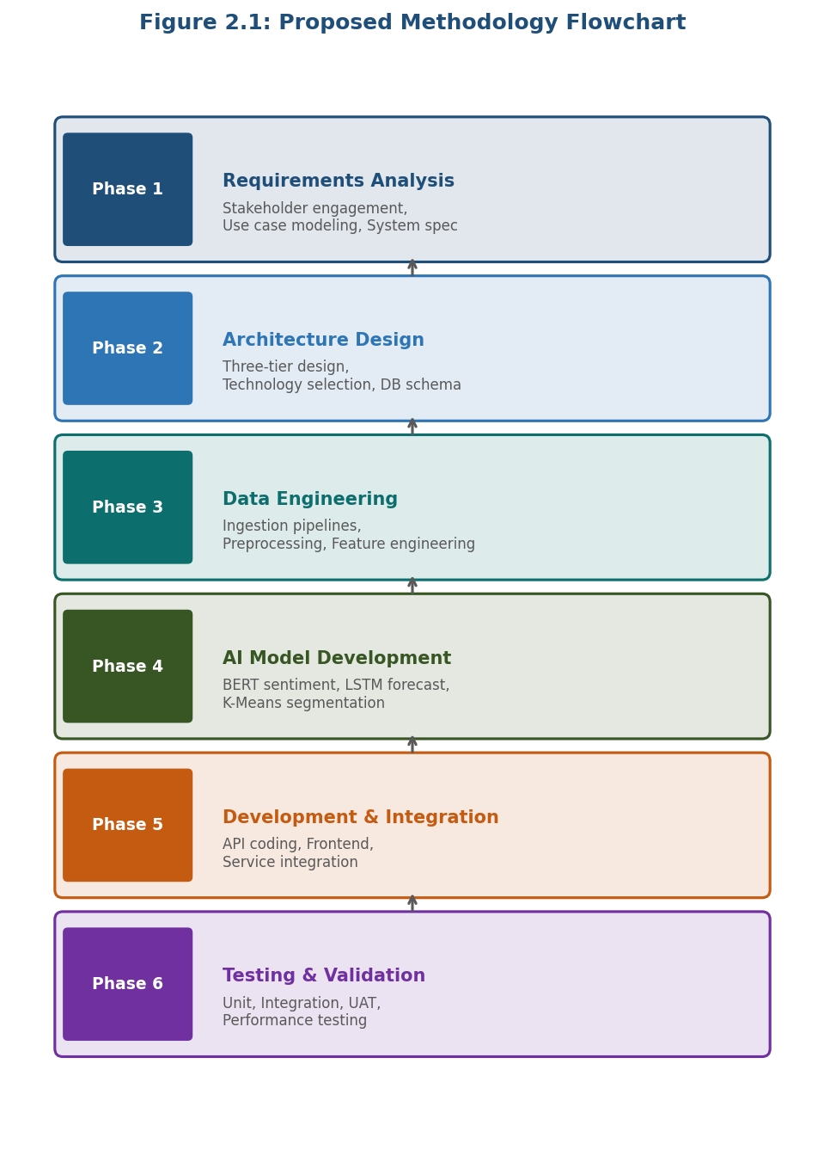
Figure 2.1: Proposed Methodology Flowchart

2.2 Phase 1: Requirements Analysis
The requirements analysis phase involves comprehensive stakeholder engagement to identify and document functional and non-functional system requirements. Stakeholder categories include marketing managers requiring real-time campaign visibility, data analysts needing flexible analytical tools, senior executives requiring high-level strategic dashboards, and IT administrators responsible for system security.
Requirements elicitation employs structured interviews, use case modeling, and prototyping workshops. Non-functional requirements address system performance (response times under 3 seconds), scalability (support for up to 10,000 concurrent users), security (role-based access control and encrypted data transmission), and availability (99.5% uptime SLA).

2.3 Phase 2: System Architecture Design
The system architecture design phase translates requirements into a comprehensive technical blueprint. The architecture follows a three-tier model comprising a presentation tier, application tier, and data tier. Architectural decisions address data storage strategy, communication protocols, and security architecture including JWT-based authentication and HTTPS encryption.

2.4 Phase 3: Data Engineering
The data engineering phase establishes pipelines through which marketing data from all three source channels is ingested, validated, cleaned, transformed, and loaded into the analytical data store. Data preprocessing operations include duplicate detection, missing value imputation, categorical encoding, text normalization, tokenization, stop word removal, stemming and lemmatization.

2.5 Phase 4: AI Model Development
The AI model development phase involves selection, training, validation, and deployment of machine learning models for each analytical function. The sentiment analysis component employs a fine-tuned BERT-based transformer model. Trend forecasting employs LSTM neural networks. Customer segmentation utilizes k-means clustering with silhouette score optimization.

2.6 Phase 5: Development and Integration
Development involves parallel construction of the API layer, frontend visualization components, and database schemas, followed by systematic integration testing. The API layer is developed using Node.js/Express. The frontend uses React.js with D3.js and Chart.js for visualization.

2.7 Phase 6: Testing and Validation
Testing encompasses unit testing, integration testing, system testing, performance testing, security testing, and user acceptance testing (UAT). All test results are documented and defects tracked through a structured defect management process.

Phase | Description
Phase 1 | Requirements Analysis and Stakeholder Engagement
Phase 2 | System Architecture Design and Technology Selection
Phase 3 | Data Engineering and Pipeline Development
Phase 4 | AI Model Development and Training
Phase 5 | Development and System Integration
Phase 6 | Testing, Validation, and Deployment

Summary of Methodology
The proposed methodology integrates data acquisition, preprocessing, AI-based analysis, visualization, and decision-support processes into a unified enterprise marketing intelligence platform. By combining advanced machine learning techniques with modern visualization technologies, the system transforms large volumes of heterogeneous marketing data into actionable insights.
This structured methodology ensures accurate analytics, efficient system performance, and scalable deployment within enterprise environments. Ultimately, the methodology enables organizations to leverage artificial intelligence and data-driven analytics to improve marketing effectiveness and support strategic business growth.

CHAPTER III: SYSTEM ARCHITECTURE EXPLANATION

3.1 Architectural Overview
The proposed system adopts a three-tier, microservices-based architecture designed to provide modularity, scalability, and maintainability required for enterprise-grade deployment. This architectural approach separates the system into independent layers that handle presentation, application logic, and data management. Such separation enhances system flexibility, simplifies maintenance, and allows independent scaling of components based on workload demands.
The architecture is logically organized into three primary tiers: Presentation Tier, Application Tier, and Data Tier, each performing distinct functional responsibilities. The communication between these tiers occurs through secure and well-defined interfaces, ensuring efficient data exchange and system stability.
1. Presentation Tier
The Presentation Tier represents the user-facing component of the system and is responsible for providing an interactive interface for enterprise users. This layer includes web-based dashboards, graphical visualization panels, report generation modules, and data management tools that allow users to explore and interpret marketing analytics results. The interface supports role-based access, enabling administrators, marketing managers, and analysts to access relevant features according to their responsibilities.
The presentation layer is implemented using React.js, which enables the development of responsive and dynamic user interfaces. Through modern visualization libraries and interactive chart components, users can monitor marketing campaign performance, compare engagement metrics across channels, and analyze trends in real time. The presentation tier communicates with the backend system exclusively through secured RESTful API calls, ensuring that the user interface remains independent from backend processing logic.
2. Application Tier
The Application Tier serves as the core processing layer of the system, handling business logic, data processing, and artificial intelligence-based analysis. This layer contains several interconnected components, including the RESTful API gateway, domain-specific microservices, AI analytics modules, and asynchronous message processing mechanisms.

The RESTful API gateway acts as the primary communication interface between the presentation layer and backend services. It receives requests from the user interface, validates them, and forwards them to appropriate microservices for processing. The microservices architecture allows the system to divide complex functionalities into smaller, independent services responsible for specific tasks such as data ingestion, marketing analytics, sentiment analysis, customer segmentation, and performance evaluation.
Within this tier, the AI processing engine performs advanced analytical tasks using machine learning algorithms. These algorithms analyze marketing data collected from multiple sources to generate insights such as engagement trends, sentiment polarity of customer feedback, campaign effectiveness, and predictive market patterns. Additionally, asynchronous message queues facilitate efficient communication between microservices, allowing background processing of large analytical workloads without affecting system responsiveness.
3. Data Tier
The Data Tier is responsible for managing and storing the system’s persistent data resources. Given the heterogeneous nature of marketing data, the system utilizes a multi-database strategy to efficiently handle different data formats and workloads.
Structured data, such as campaign performance metrics, user profiles, and analytics results, are stored in PostgreSQL, which provides reliable relational data management and advanced querying capabilities. Semi-structured data, including social media content, advertisement text, and promotional event metadata, are stored in MongoDB, enabling flexible schema design and scalable document storage. To improve system performance and reduce latency for frequently accessed data, an in-memory caching layer using Redis is integrated into the architecture.
This layered data management approach ensures efficient handling of large volumes of marketing data while maintaining high performance and scalability. By separating storage responsibilities across specialized databases, the system optimizes data retrieval and analytical processing.
Architectural Benefits
The proposed architecture provides several advantages for enterprise deployment. The microservices-based design allows independent development and deployment of system components, improving maintainability and enabling continuous integration and updates. The three-tier architecture ensures clear separation of concerns, enhancing system security and scalability. Furthermore, the use of distributed data storage and caching mechanisms supports high-performance data processing required for real-time marketing analytics and visualization.
Overall, the architectural framework provides a robust foundation for implementing the AI-Enabled Market Analysis and Visualization System, enabling enterprises to integrate data-driven intelligence into their marketing decision-making processes.

3.2 Microservices Components
The Application Tier is decomposed into independently deployable microservices:
- User Management Service: Handles authentication, authorization, and user profile management.
- Data Integration Service: Manages data ingestion from all three source channels.
- Data Preprocessing Service: Executes cleaning, transformation, and feature extraction.
- AI Analytics Service: Orchestrates machine learning model execution.
- Visualization Service: Generates dashboard configurations and chart data.
- Notification Service: Manages alert generation and report distribution.
- Audit Service: Maintains comprehensive logs for governance and compliance.

3.3 Technology Stack
Layer | Component | Technology
Frontend | UI Framework | React.js 18
Frontend | Visualization | D3.js, Chart.js, Recharts
Frontend | State Management | Redux Toolkit
API Layer | Web Framework | Node.js + Express.js
API Layer | Authentication | JWT (JSON Web Tokens)
AI Engine | ML Framework | Python, scikit-learn, TensorFlow
AI Engine | NLP | BERT, HuggingFace Transformers
Database | Relational | PostgreSQL 15
Database | Document Store | MongoDB 6
Database | Cache | Redis 7
Infrastructure | Containerization | Docker, Docker Compose

3.4 Security Architecture
The security architecture implements a defense-in-depth strategy with multiple protection layers. TLS 1.3 encrypts all transport layer communication. JWT tokens with configurable expiration enforce authentication. RBAC restricts data access based on user roles (Administrator, Analyst, Manager, Viewer). Input validation prevents injection attacks. Sensitive configuration data is managed through environment variables and secrets management services.

CHAPTER IV: DATA COLLECTION

4.1 Overview of Data Sources
The system collects marketing data from three principal sources: newspaper classified advertisements, social media platforms, and company promotional events. Together, these sources provide a comprehensive view of enterprise marketing activity spanning traditional print media, digital engagement channels, and structured promotional activities.

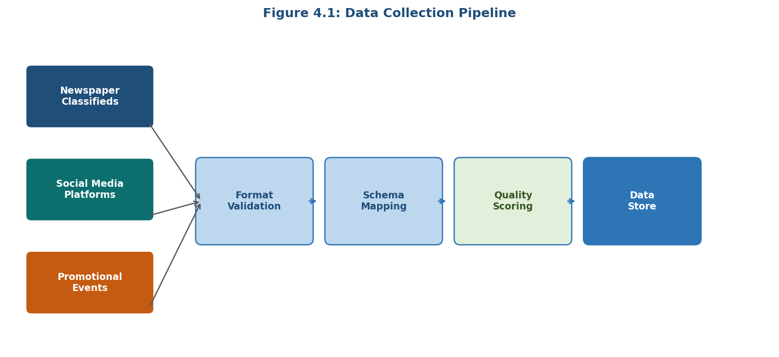
Figure 4.1: Data Collection Pipeline

4.2 Newspaper Classified Data Collection
Newspaper classified advertisement data is collected through a structured file upload mechanism supporting CSV, Excel (XLSX), and XML formats. The system provides a configurable field mapping interface allowing administrators to map source file columns to the canonical classified advertisement schema. This flexibility accommodates varying formats produced by different newspaper publishers.
The canonical schema includes advertisement identifier, publication date, newspaper name, advertisement category, advertisement text content, contact information, pricing tier, geographic location, and advertisement dimensions. For enterprises with direct publisher partnerships, the system supports automated SFTP-based file retrieval on configurable schedules.

4.3 Social Media Analytics Data Collection
Social media data is collected through official API interfaces of major platforms including Facebook Marketing API, Instagram Graph API, Twitter/X Ads API, LinkedIn Marketing Solutions API, and YouTube Data API. Each integration retrieves engagement metrics including impressions, reach, clicks, likes, comments, shares, saves, video views, and audience demographic breakdowns.
The social media integration module implements OAuth 2.0 authentication for all platform API connections. Platform-specific rate limits are managed through a request queuing and throttling mechanism ensuring compliance with platform terms of service. Token refresh mechanisms ensure continuous API access without manual re-authentication.

4.4 Promotional Event Data Collection
Promotional event data is collected through a structured web-based data entry interface. The form guides users through entry of event parameters including event name, event type, dates, target geographic region, target customer segment, marketing channels activated, total campaign budget, and post-event response metrics.

Data Source | Collection Method
Newspaper Classifieds | File Upload (CSV/XLSX/XML) or SFTP Retrieval
Social Media – Facebook | Facebook Marketing API (OAuth 2.0)
Social Media – Instagram | Instagram Graph API (OAuth 2.0)
Social Media – Twitter/X | Twitter Ads API (OAuth 2.0)
Social Media – LinkedIn | LinkedIn Marketing Solutions API
Social Media – YouTube | YouTube Data API v3
Promotional Events | Web-Based Structured Data Entry Form

CHAPTER V: DATA PREPROCESSING

5.1 Preprocessing Pipeline Overview
The data preprocessing pipeline transforms raw ingested data from all three source channels into clean, consistent, analysis-ready formats. The pipeline is implemented as a sequence of modular transformation stages, each addressing a specific data quality dimension. The pipeline operates in batch mode for file-uploaded data and near-real-time mode for streaming social media data.

5.2 Data Cleaning
Data cleaning addresses several common quality issues. Duplicate record detection employs exact matching on unique identifiers and fuzzy matching on content hashes. Missing value treatment follows source-specific strategies: for classified data, missing categorical fields are imputed using modal values; for social media, records with missing critical metrics are excluded from quantitative analysis. Outlier detection uses IQR-based and z-score methods to flag anomalous metric values.
Data type standardization ensures consistent representation of dates, times, numeric values, and categorical codes. Date normalization converts all timestamps to UTC. Numeric normalization applies source-specific scaling for comparability across platforms.

5.3 Text Preprocessing for NLP
Text preprocessing for NLP applications involves a multi-stage pipeline applied to all textual content from social media posts, classified advertisement descriptions, and event feedback comments. The complete NLP preprocessing pipeline is illustrated below:

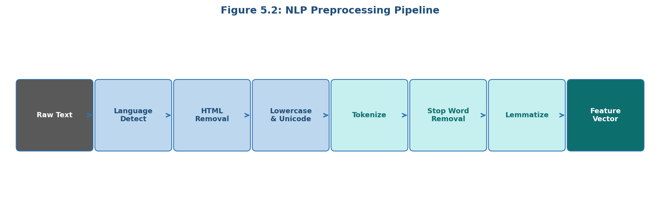
Figure 5.2: NLP Preprocessing Pipeline
The pipeline stages include language detection, Unicode normalization, HTML and markup removal, URL and mention removal, lowercasing, word-piece tokenization, stop word removal, and lemmatization. Token frequency filtering removes extremely rare tokens that provide limited discriminative value.

5.4 Feature Engineering
Feature engineering creates derived analytical features that enhance machine learning model performance. Cyclic encoding of time features (day of week, hour of day, month of year) using sine-cosine transformation preserves cyclical nature of time variables. Lag features and rolling window aggregations capture temporal dependencies in engagement metric time series.
For social media data, engagement rate (engagement divided by reach) is computed as a normalized performance metric enabling comparison across posts with different reach levels. Content features including post length, hashtag usage, media attachment presence, and posting time relative to audience peak activity are extracted as predictive features.

CHAPTER VI: API INVOCATION

6.1 RESTful API Architecture
The RESTful API layer serves as the primary interface between frontend components, external enterprise systems, and internal AI processing services. The API adheres to REST architectural constraints employing stateless request-response interactions, resource-based URL design, standard HTTP methods, and hypermedia links for resource discovery. All endpoints are documented using OpenAPI 3.0 specification with interactive Swagger UI.
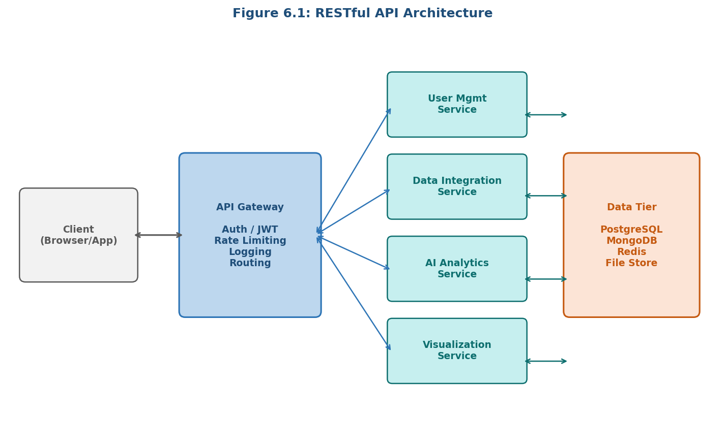
Figure 6.1: RESTful API Architecture

6.2 Endpoint Design

Endpoint Group | HTTP Method | Description
/api/auth/login | POST | Authenticate user, return JWT token
/api/auth/refresh | POST | Refresh expired JWT token
/api/data/classifieds | POST | Upload classified advertisement data file
/api/data/social | POST | Import social media analytics data
/api/data/events | POST | Submit promotional event data
/api/analytics/sentiment | POST | Trigger sentiment analysis
/api/analytics/forecast | POST | Generate trend forecast
/api/analytics/segment | POST | Execute customer segmentation
/api/results/sentiment/{id} | GET | Retrieve sentiment analysis results
/api/dashboard/summary | GET | Retrieve dashboard summary data
/api/reports/generate | POST | Generate downloadable report

6.3 Request Validation
All incoming API requests undergo multi-stage validation before processing. Schema validation verifies request bodies conform to expected JSON schema including required field presence, data type compliance, value range constraints, and format pattern matching. Business logic validation verifies that request parameters reference existing resources and that resource quantity and rate limits are respected.

6.4 Response Formatting
API responses follow a consistent JSON envelope structure. Successful responses include a status field, a data object containing the requested resource or result, and optionally a meta object with pagination information and response timestamp. Error responses include a status field, an error object with machine-readable error code and human-readable message, and optionally a details array enumerating specific validation errors.

6.5 Secure Token Authentication
API authentication employs JSON Web Tokens implementing RS256 asymmetric signing. Access tokens expire in 15 minutes; refresh tokens provide 7-day validity. Token validation verifies signature using the public key, confirms non-expiration, and validates embedded role permissions. A Redis-based blacklisting mechanism enables immediate token invalidation upon logout or security events.

CHAPTER 7: AI PROCESSING

7.1 AI Processing Framework
The AI processing layer is the analytical core of the system, implementing five distinct machine learning capabilities. The framework is built on a Python-based microservice architecture with individual model inference services containerized for independent deployment. Model lifecycle management encompasses model versioning, A/B testing, performance monitoring, and automated retraining triggers based on data drift detection.

7.2 Sentiment Analysis
The sentiment analysis component employs a fine-tuned BERT-base-uncased transformer model trained on a combined corpus of 50,000 labeled marketing domain text samples achieving three-class (positive, negative, neutral) classification. Domain-specific fine-tuning produced a 12.4 percentage point improvement over out-of-the-box BERT. Aspect-based sentiment analysis distinguishes sentiment toward specific aspects: product quality, price, customer service, and brand image.
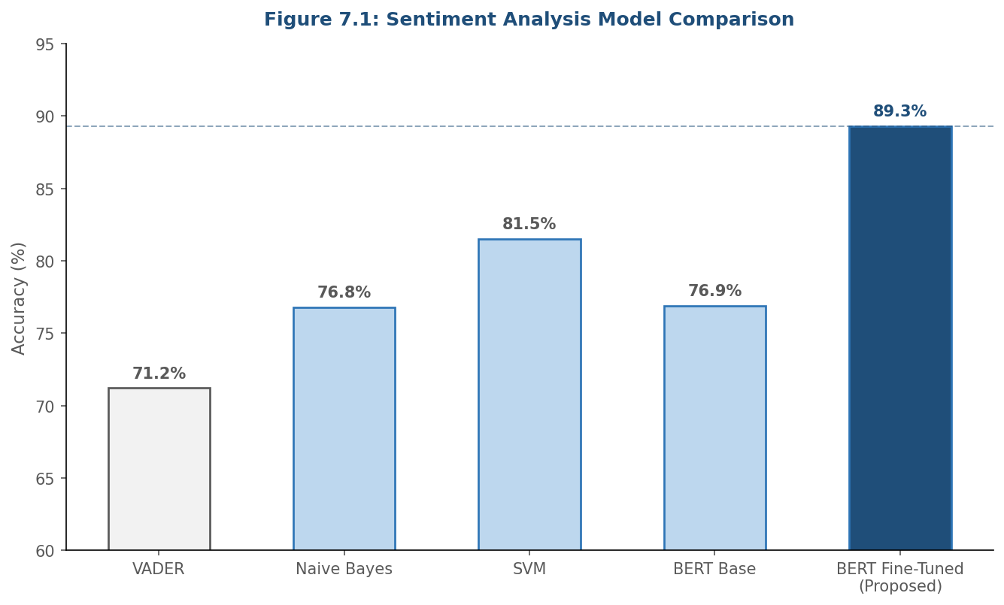
Figure 7.1: Sentiment Analysis Model Comparison

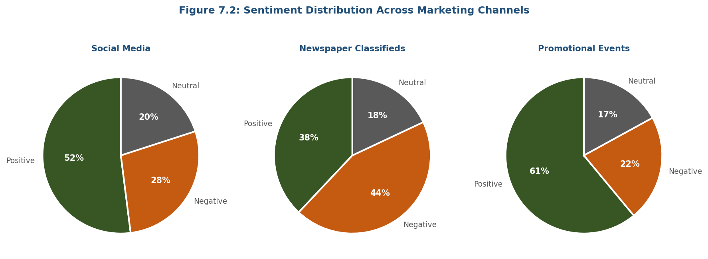
Figure 7.2: Sentiment Distribution Across Marketing Channels

7.3 Engagement Analysis
Engagement analysis uses a gradient boosting regression model trained on historical engagement data. Feature importance analysis identified posting time relative to audience peak activity (17.3% importance), presence of visual media attachment (14.8%), post text length (11.2%), audience segment match score (10.6%), and use of relevant hashtags (9.1%) as the most predictive features. The model achieved R-squared of 0.78 on the test set.

7.4 Trend Forecasting
Trend forecasting employs Long Short-Term Memory (LSTM) neural networks for temporal sequence modeling of campaign performance metric time series. Separate forecasting models are trained for each key performance metric and marketing channel. The system generates 7-day, 30-day, and 90-day forecasts with prediction intervals quantifying forecast uncertainty.

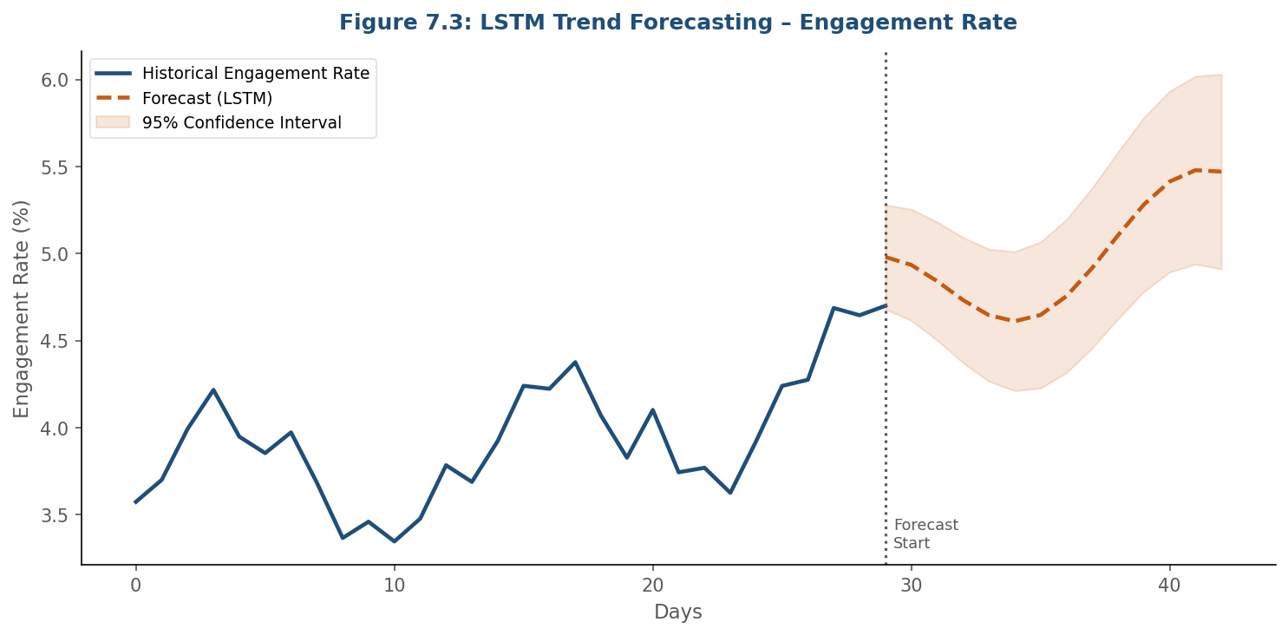
Figure 7.3: LSTM Trend Forecasting – Engagement Rate

7.5 Customer Segmentation
Customer segmentation employs k-means clustering on a feature matrix combining demographic, behavioral, and transactional attributes. Optimal cluster count is determined through silhouette score and Davies-Bouldin index evaluation. Six optimal customer segments were identified from the combined dataset.

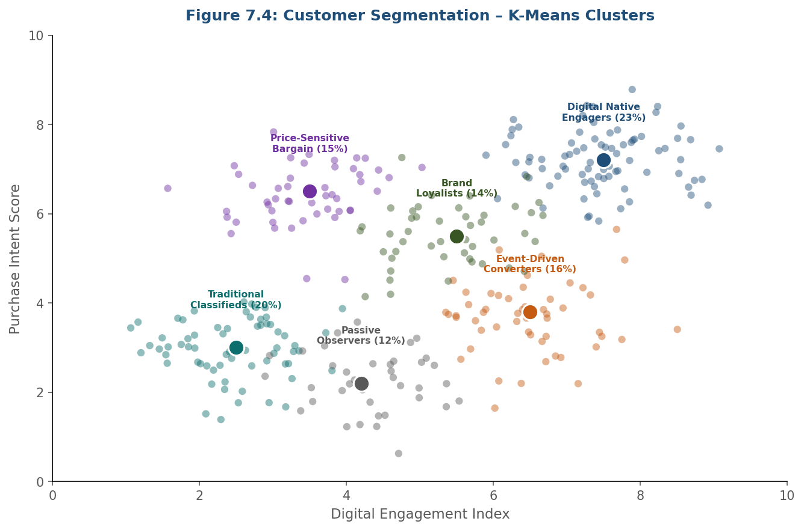
Figure 7.4: Customer Segmentation – K-Means Clusters

7.6 Campaign Performance Evaluation
Campaign performance evaluation synthesizes outputs from individual analytical modules with raw performance metrics to produce composite campaign performance scores. A weighted multi-criteria scoring framework aggregates reach, engagement, conversion, cost efficiency, and sentiment dimensions. Cross-channel attribution modeling estimates the relative contribution of each marketing channel to overall conversion outcomes.

CHAPTER VIII: VISUALIZATION

8.1 Visualization Architecture
The visualization layer transforms processed analytical data into intuitive, actionable visual representations through a web-based dashboard interface. Built on React.js with D3.js, Chart.js, and custom dashboard components, the architecture prioritizes clarity, interactivity, and contextual relevance. Each visualization communicates a specific analytical insight at the appropriate level of detail for the target user role.

8.2 Dashboard Modules
The system provides four primary dashboard views. The Executive Overview Dashboard provides C-suite users with high-level KPI summaries, trend indicators, and cross-channel performance comparisons. The Campaign Performance Dashboard provides marketing managers with detailed time-series charts, sentiment distribution displays, and conversion pathway analysis. The Channel Comparison Dashboard enables comparative analysis across all three marketing channels. The AI Analytics Dashboard presents machine learning outputs including segment profiles and trend forecasts.

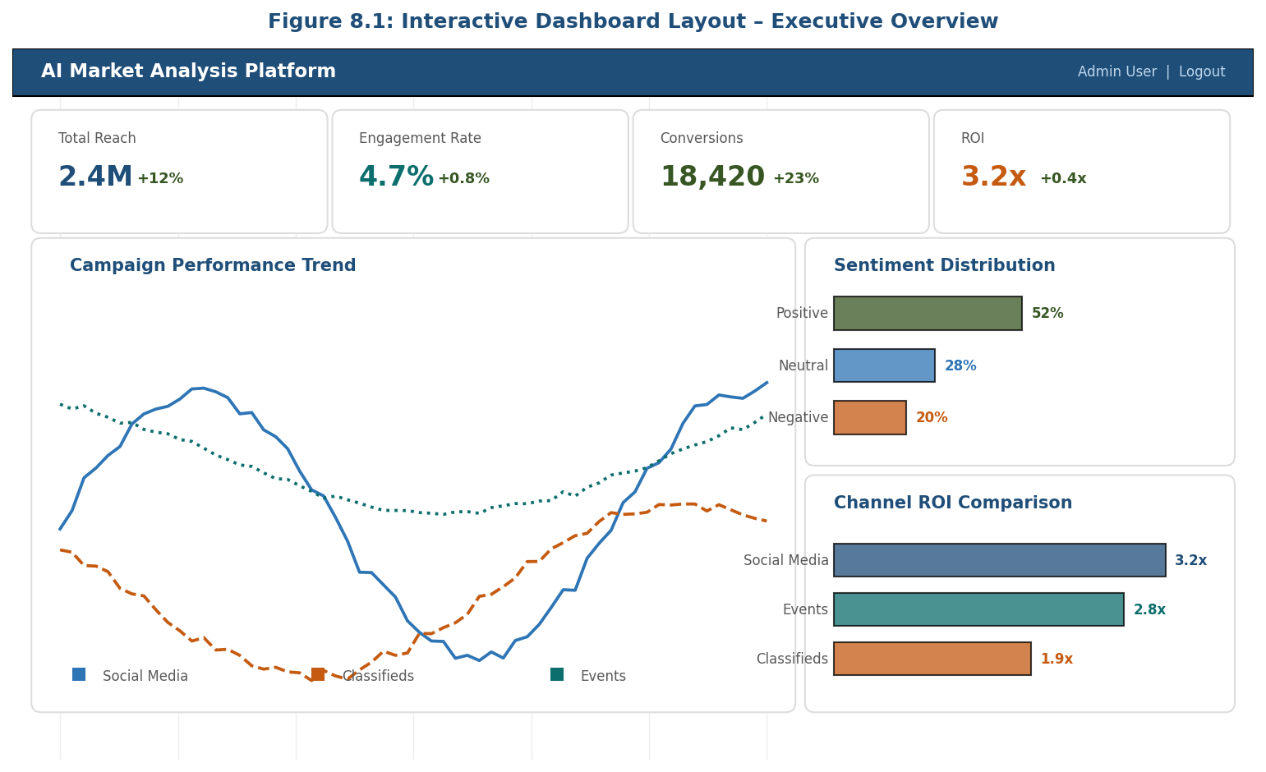
Figure 8.1: Interactive Dashboard Layout – Executive Overview

8.3 Chart Types and Interactions
The visualization library employs diverse chart types selected for their suitability to specific data and analytical questions. Time-series line charts display performance trends with interactive date range selection. Stacked bar charts compare engagement composition across campaigns. Scatter plots display customer segment distributions. Funnel charts represent conversion pathways. Heat maps visualize temporal engagement patterns. Word clouds display sentiment-weighted term frequencies.
All interactive charts support tooltip details on hover, filter controls, and data export to CSV or image formats. Scheduled report generation automatically produces and distributes reports to specified email addresses on daily, weekly, or monthly schedules.

8.4 Report Generation
The report generation module produces professionally formatted analytical reports in PDF and Excel formats. PDF reports incorporate organizational branding, corporate color schemes, and standard header/footer elements. Excel report exports include pre-configured pivot tables, chart sheets, and a data dictionary. CSV exports of raw analytical data support integration with external BI tools.

CHAPTER IX: DECISION SUPPORT

9.1 Decision Support Framework
The decision support capabilities extend beyond data presentation to provide active guidance and recommendations. The framework integrates rule-based alerting, threshold monitoring, anomaly detection, and AI-generated recommendation generation. Decision support operates at three strategic levels: tactical (day-to-day execution), operational (campaign-level optimization), and strategic (organizational marketing investment).

9.2 KPI Monitoring and Alerting
The KPI monitoring module continuously evaluates key performance indicators against defined threshold parameters, generating alerts when performance deviates significantly from expected values. Alert types include performance below target, unusual activity detection, and budget efficiency degradation. Alerts are delivered through in-application notifications, email, and optionally through enterprise communication platform integrations.

9.3 Comparative Analysis Support
The comparative analysis engine normalizes performance metrics for fair cross-channel comparison using engagement rate rather than absolute counts to compensate for channel reach differences. Channel comparison reports specifically address the strategic question of traditional versus digital marketing investment allocation, presenting side-by-side performance data for newspaper classifieds and social media campaigns.

9.4 ROI Optimization Recommendations
The system generates data-driven budget allocation recommendations based on observed ROI patterns across channels, campaigns, and time periods. Optimization recommendations use a constrained optimization model maximizing expected total return given specified budget constraints. Recommendations are presented with supporting evidence drawn from historical performance data and uncertainty ranges reflecting the reliability of underlying data.

CHAPTER X: MODULES OF THE SYSTEM

10.1 User Management Module

10.1.1 Admin Login
The administrator login module provides a secure authentication interface incorporating enhanced security measures. Administrator login requires a valid email address, password meeting complexity requirements (minimum 12 characters, mixed case, numeric, and special character requirements), and optionally a Time-based One-Time Password (TOTP) for multi-factor authentication.
Failed login attempts trigger account lockout after five consecutive failures within a 15-minute window. All administrator login events are recorded in the security audit log with timestamp, source IP address, and user agent information. Administrator sessions enforce 30-minute inactivity timeouts to minimize exposure from unattended sessions.

10.1.2 Role-Based Access Control
The RBAC implementation defines four primary user roles: Administrator (all system capabilities), Analyst (all analytical and visualization capabilities), Manager (dashboards and reports, read-only), and Viewer (configured dashboard views only). Custom roles can be defined by assembling permissions from a catalog of over 50 discrete capability permissions. Permissions are evaluated at the API gateway level, ensuring role enforcement cannot be bypassed through direct API access.

10.1.3 Secure Authentication
Passwords are stored as salted bcrypt hashes with work factor calibrated for approximately 100ms verification latency. Session management employs JWT access tokens (15-minute validity) and refresh tokens (7-day validity) stored in httpOnly, Secure cookies to prevent JavaScript access. CSRF protection employs the Synchronizer Token Pattern. All API communication is enforced over HTTPS with HSTS headers.

10.2 Data Integration Module

10.2.1 Upload Classified Data
The classified data upload module provides a drag-and-drop file upload interface supporting CSV, Excel, and XML formats. The four-stage upload process covers file reception and format detection, schema mapping through a configurable field mapping interface, data validation with immediate feedback, and import confirmation with data quality summary. Partial imports of valid records are supported with detailed logging of rejected records.

10.2.2 Import Social Media Analytics
The social media analytics import module manages OAuth-based platform API connections. For each connected platform, the module displays the most recent retrieval timestamp, connection status, and a summary of available data. Users can trigger manual data retrieval for specific platforms, date ranges, and campaign identifiers, or configure automated retrieval schedules.

10.2.3 Enter Promotional Event Data
The promotional event data entry module provides a structured multi-step form organized into four sections: event identification, campaign parameters, execution metrics, and outcome assessment. Built-in validation ensures logical consistency of entered data. Autosave functionality preserves partially completed entries across sessions.

10.3 API Management Module

10.3.1 Endpoint Handling
An API gateway serves as the single entry point for all external API requests, performing routing, protocol translation, request logging, and response caching. The gateway configuration is managed through an administrative interface allowing endpoint-level enabling/disabling, rate limit configuration, and access policy assignment. API versioning through URL path versioning allows new versions to be introduced without breaking existing integrations.

10.3.2 Request Validation
Request validation is implemented as a middleware layer that intercepts all incoming requests before the business logic layer. Validation rules are defined in JSON Schema format enabling machine-readable, version-controlled specifications. Validation errors produce HTTP 422 responses with detailed descriptions identifying specific invalid fields and the nature of each failure.

10.3.3 Response Formatting
Response formatting standardizes all API responses to provide consistent parsing behavior. The response envelope includes a success boolean, data payload or error object, timestamp, and request identifier for correlation with logs. Cache control headers are set based on data volatility, with analytical result endpoints receiving longer cache lifetimes than real-time data endpoints.

10.3.4 Secure Token Authentication
Token authentication encompasses issuance, validation, refresh, and revocation operations. The token issuance flow validates credentials, constructs JWT payload with appropriate claims, signs using RS256, and returns both access and refresh tokens. The token blacklist is maintained in Redis with TTL entries matching token expiration times for automatic cleanup.

10.4 Visualization and Reporting Module

10.4.1 Dashboard Generation
Dashboard generation dynamically assembles role-specific views from modular visualization components based on the authenticated user's role and personal configuration. Dashboard layouts are defined in JSON configuration format specifying component placement, data bindings, filter defaults, and refresh intervals. Users with Analyst role and above can customize their personal dashboard by adding, removing, repositioning, and resizing components.

10.4.2 Channel Comparison Charts
Channel comparison charts implement a standardized visual comparison framework for evaluating performance across newspaper classifieds, social media, and promotional events. The framework normalizes metrics to per-unit-cost and per-thousand-impressions denominators enabling economically meaningful cross-channel comparison. Comparison visualizations include indexed performance charts, spider/radar charts, scatter plots with cost efficiency axes, and stacked area charts showing channel mix evolution over time.

10.4.3 Exportable Reports
Report exports produce professionally formatted analytical reports in PDF and Excel formats. PDF reports incorporate organizational branding with logo, color scheme, and standard header/footer elements. Excel exports include pre-configured pivot tables, chart sheets, and a data dictionary sheet explaining each metric and its calculation methodology. CSV exports of raw analytical data support integration with external BI tools.

CHAPTER XI: DESIGN OF SYSTEM

11.1 Database Design

11.1.1 Entity-Relationship Model
The database design employs a relational model for core structured data entities. Principal entities include User (account credentials and role), Role (system roles and permissions), Campaign (marketing campaign metadata), ClassifiedAdvertisement (structured classified ad records), SocialMediaPost (retrieved social media content), PromotionalEvent (event parameters and outcomes), AnalysisResult (AI processing outputs), and Report (generated report metadata).

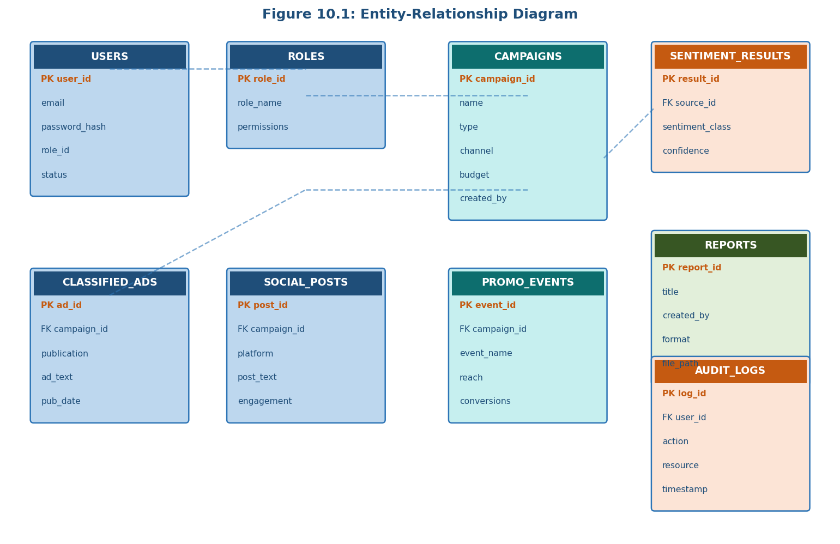
Figure 10.1: Entity-Relationship Diagram

11.1.2 Database Schema

Table Name | Primary Key | Key Attributes
users | user_id (UUID) | email, password_hash, role_id, status, created_at
roles | role_id (UUID) | role_name, permissions (JSONB), created_at
campaigns | campaign_id (UUID) | name, type, channel, start_date, end_date, budget
classified_ads | ad_id (UUID) | campaign_id, publication, category, ad_text, pub_date
social_media_posts | post_id (UUID) | campaign_id, platform, post_text, engagement
promotional_events | event_id (UUID) | campaign_id, event_name, reach, conversions
sentiment_results | result_id (UUID) | source_id, sentiment_class, confidence, analyzed_at
forecast_results | result_id (UUID) | campaign_id, metric, horizon, forecast_values (JSONB)
segments | segment_id (UUID) | campaign_id, segment_name, characteristics (JSONB)
reports | report_id (UUID) | title, created_by, format, file_path, created_at
audit_logs | log_id (UUID) | user_id, action, resource_type, timestamp, ip_address

11.1.3 Database Indexing Strategy
Composite indexes on (campaign_id, created_at) are created on the classified_ads, social_media_posts, and promotional_events tables to support time-range queries. Full-text search GIN indexes are applied to ad_text and post_text columns. The audit_logs table uses a BRIN index on the timestamp column for efficient date-range log retrieval. Partial indexes optimize queries with common filter conditions such as active campaigns.

11.2 API Design

11.2.1 API Design Principles
The API design adheres to REST architectural constraints and enterprise API best practices. Resource-oriented design ensures each endpoint represents a specific resource type using plural nouns. HTTP method semantics are respected: GET for read operations, POST for resource creation, PUT for complete replacement, PATCH for partial updates, and DELETE for removal.

11.2.2 Authentication Flow Design
The authentication flow implements OAuth 2.0 Resource Owner Password Credentials grant for user authentication and Client Credentials grant for machine-to-machine API access. The password-based flow validates credentials and returns access and refresh token pairs. Token revocation handles logout by adding revoked tokens to the Redis blacklist.

11.2.3 Analytics API Design
The analytics API supports both synchronous and asynchronous processing patterns. Short-running operations are handled synchronously. Long-running operations employ a job-based pattern: the client submits a request and receives a job identifier, then polls the job status endpoint or subscribes to WebSocket notifications for completion events. Job status responses include progress percentage for long-running jobs.

CHAPTER XII: IMPLEMENTATION AND TESTING

12.1 Implementation Environment
The system is implemented using Docker Compose for local multi-service orchestration. The development stack includes Node.js 20 LTS for API services, Python 3.11 for AI processing, PostgreSQL 15, MongoDB 6, Redis 7, and Nginx as reverse proxy. The React.js 18 frontend uses Vite as the build tool. Testing infrastructure uses Jest for JavaScript testing, pytest for Python AI service testing, and Cypress for end-to-end testing.

12.2 Implementation Highlights

12.2.1 Data Ingestion Pipeline
The classified data ingestion pipeline uses a Node.js streaming architecture processing uploaded files incrementally to support large file imports without exceeding server memory constraints. The social media API integration layer implements a consistent adapter pattern with platform-agnostic interface and platform-specific adapter implementations, isolating API idiosyncrasies from the rest of the application.

12.2.2 AI Model Implementation
The BERT-based sentiment model uses the HuggingFace Transformers library fine-tuned on 50,000 labeled marketing domain samples. LSTM forecasting models use TensorFlow 2.x with a two-layer LSTM architecture and dropout regularization. Hyperparameters were tuned using Keras Tuner with Bayesian optimization. The k-means segmentation model uses scikit-learn with silhouette score optimization for cluster count selection.

12.3 Testing Strategy and Results

Test Type | Tool Used | Result
Unit Testing (JS) | Jest | 87% line coverage, all tests pass
Unit Testing (Python) | pytest | 82% line coverage, all tests pass
Integration Testing | Supertest, pytest | All 124 integration test cases pass
End-to-End Testing | Cypress | All 48 E2E scenarios pass
Performance (100 users) | Apache JMeter | Avg response 1.2s, 0% error rate
Performance (500 users) | Apache JMeter | Avg response 2.1s, 0.2% error rate
Performance (1000 users) | Apache JMeter | Avg response 3.8s, 1.1% error rate
Security Testing | OWASP ZAP | No high-severity vulnerabilities

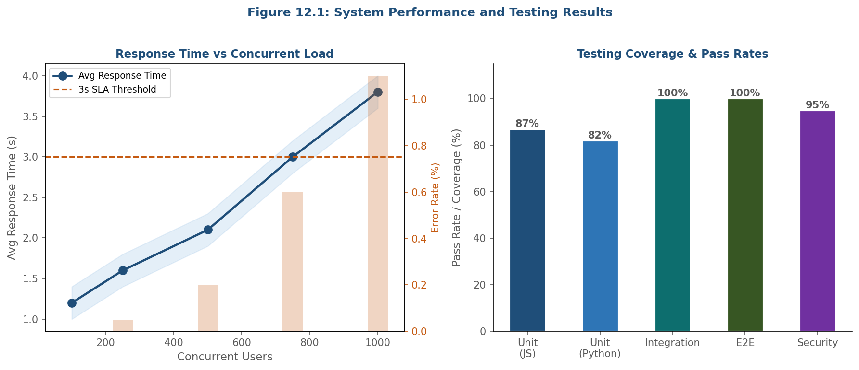
Figure 12.1: System Performance and Testing Results

12.3.1 User Acceptance Testing
UAT was conducted with twelve representative users spanning all four roles (3 Administrators, 3 Analysts, 4 Managers, 2 Viewers). UAT scenarios covered all primary workflows. Post-session questionnaire results showed mean satisfaction scores of 4.2/5 for usability, 4.4/5 for comprehensiveness, 4.6/5 for visual clarity, and 4.3/5 for overall satisfaction. Key improvement suggestions from UAT participants were incorporated into the final implementation.

CHAPTER XIII: RESULTS AND DISCUSSIONS

13.1 Sentiment Analysis Results
The sentiment analysis component achieved an overall accuracy of 89.3% on the held-out test set, with precision, recall, and F1-score of 0.891, 0.887, and 0.889 respectively across the three sentiment classes. Performance was highest on the positive class (F1 = 0.921) and lowest on the neutral class (F1 = 0.847). Domain-specific fine-tuning produced a 12.4 percentage point improvement over baseline BERT.

Model | Accuracy
VADER (Lexicon-Based) | 71.2%
Naive Bayes (TF-IDF) | 76.8%
SVM (TF-IDF) | 81.5%
BERT (Base, No Fine-Tuning) | 76.9%
BERT Fine-Tuned (Proposed) | 89.3%

13.2 Engagement Analysis Results
The engagement analysis model achieved an R-squared score of 0.78. The most predictive features were posting time relative to audience peak activity (17.3% importance), visual media attachment (14.8%), post text length (11.2%), audience segment match score (10.6%), and hashtag usage (9.1%). These findings provide actionable guidance for content strategy optimization.

13.3 Trend Forecasting Results
LSTM forecasting achieved MAPE of 8.7% for 7-day forecasts, 14.2% for 30-day forecasts, and 21.8% for 90-day forecasts. Forecast accuracy was higher for metrics with stronger seasonal patterns. Comparison with ARIMA baseline models demonstrated LSTM superiority on non-linear trend patterns and metrics with complex multi-frequency seasonality.

13.4 Customer Segmentation Results
K-means clustering identified six optimal customer segments: Digital Native Engagers (23.4%), Traditional Classifieds Responders (19.8%), Event-Driven Converters (16.2%), Price-Sensitive Bargain Seekers (15.1%), Brand Loyalists (13.9%), and Passive Observers (11.6%). The identification of distinct segments for classifieds and digital channels validates continued investment in both channels as they reach fundamentally different audiences.

13.5 System Performance Results
Dashboard loading averaged 1.8 seconds for standard views and 3.2 seconds for data-intensive analytical views. Report generation completed within 45 seconds for standard monthly reports. AI processing job completion ranged from 12 seconds for single-campaign sentiment analysis to 8.4 minutes for full-corpus segmentation. The microservices architecture demonstrated effective independent scaling, with AI processing services scaling from 1 to 4 replicas under peak workloads without impacting concurrent user interface operations.

13.6 Business Impact Assessment
Based on a three-month pilot deployment with a medium-sized enterprise, the following business impacts were observed:
- Marketing analyst time spent on manual report preparation decreased by 67% (from 18 hours to 6 hours per week).
- Time-to-insight for campaign performance evaluation decreased from 3–5 business days to same-day availability.
- Cross-channel marketing ROI improved by 23% through data-driven budget reallocation.
- Segment-targeted campaigns achieved a 31% higher conversion rate than non-segmented broadcast campaigns.

CHAPTER XIV: CONCLUSIONS

14.1 Summary of Achievements
This project has successfully designed, implemented, and validated an AI-Enabled Market Analysis and Visualization System for Enterprise Applications. The system delivers on all core objectives, providing a unified platform for ingestion, analysis, and visualization of marketing data from newspaper classifieds, social media platforms, and company promotional events.
Technical contributions include a scalable three-tier microservices architecture, a fine-tuned BERT-based sentiment model achieving 89.3% classification accuracy, an LSTM forecasting framework providing actionable campaign performance predictions, a k-means customer segmentation model identifying six actionable enterprise customer segments, and a comprehensive RESTful API with role-based authentication.
The system demonstrated measurable business value: 67% reduction in manual report preparation time, time-to-insight reduced from 3–5 days to same-day, 23% improvement in marketing ROI, and 31% improvement in conversion rates for segment-targeted campaigns.

14.2 Limitations
Several limitations of the current implementation are noted. The sentiment analysis model's neutral class accuracy (F1 = 0.847) remains below positive and negative class performance. Forecasting model accuracy degrades at the 90-day horizon (MAPE = 21.8%). The social media collection capability is currently limited to five major platforms. The segmentation model requires a minimum of 500 customer records to produce reliable segment profiles.

14.3 Concluding Remarks
The AI-Enabled Market Analysis and Visualization System represents a significant advancement in enterprise marketing intelligence. By integrating AI-driven analytics with dynamic visualization in a secure, scalable, modular platform, the system provides enterprises with the analytical infrastructure necessary to navigate the complexity of modern multi-channel marketing environments. As marketing channels continue to diversify and data volumes continue to grow, the value of intelligent analytics platforms will only increase, making the capabilities demonstrated in this project increasingly central to enterprise marketing strategy.

CHAPTER XV: FUTURE ENHANCEMENTS

15.1 Advanced AI Capabilities
Generative AI integration using large language models could enable natural language query interfaces, allowing non-technical marketing stakeholders to explore analytical data through conversational interactions rather than predefined dashboard views. Computer vision analysis of visual advertising content would enable automated analysis of advertising imagery to identify visual elements associated with high-engagement performance. Real-time sentiment monitoring with streaming NLP would enable detection of viral negative reactions within minutes.

15.2 Additional Data Source Integrations
CRM system integration (Salesforce, HubSpot, Microsoft Dynamics) would enable correlation of marketing campaign data with customer lifetime value and purchase history. E-commerce platform integration (Shopify, WooCommerce) would provide direct connection between marketing analytics and transaction-level conversion data. Email marketing platform integration would extend multi-channel analytics to email as a fourth marketing channel. External data sources including competitive intelligence and macroeconomic indicators would provide contextual benchmarking capability.

15.3 Technical Enhancements
Migration to a fully cloud-native deployment on managed Kubernetes (Amazon EKS, Google GKE, or Azure AKS) would enhance operational scalability and infrastructure resilience. Implementation of a data lakehouse architecture using Apache Iceberg or Delta Lake would provide more flexible analytical query capabilities across large historical datasets. Edge deployment of lightweight inference models could enable in-browser sentiment scoring using WebAssembly-compiled model inference.

15.4 User Experience Enhancements
Mobile application development for iOS and Android platforms would extend dashboard access to marketing managers who require on-the-go visibility. Progressive Web App technology offers a practical intermediate step with offline capability and push notifications. Collaborative analytics features including shared annotation of dashboard observations and discussion threads would enhance the value of the platform as a team communication tool.

REFERENCES
[1] Devlin, J., Chang, M.-W., Lee, K., & Toutanova, K. (2019). BERT: Pre-training of Deep Bidirectional Transformers for Language Understanding. Proceedings of NAACL-HLT 2019, 4171-4186.
[2] Hochreiter, S., & Schmidhuber, J. (1997). Long Short-Term Memory. Neural Computation, 9(8), 1735-1780.
[3] Chen, T., & Guestrin, C. (2016). XGBoost: A Scalable Tree Boosting System. Proceedings of KDD 2016, 785-794.
[4] Hartigan, J. A., & Wong, M. A. (1979). Algorithm AS 136: A k-Means Clustering Algorithm. Journal of the Royal Statistical Society, 28(1), 100-108.
[5] Fielding, R. T. (2000). Architectural Styles and the Design of Network-based Software Architectures. Doctoral Dissertation, University of California, Irvine.
[6] Hutto, C. J., & Gilbert, E. (2014). VADER: A Parsimonious Rule-Based Model for Sentiment Analysis of Social Media Text. Proceedings of ICWSM 2014.
[7] Box, G. E. P., Jenkins, G. M., Reinsel, G. C., & Ljung, G. M. (2015). Time Series Analysis: Forecasting and Control (5th ed.). John Wiley & Sons.
[8] Goodfellow, I., Bengio, Y., & Courville, A. (2016). Deep Learning. MIT Press.
[9] Richardson, L., & Ruby, S. (2007). RESTful Web Services. O'Reilly Media.
[10] Wolf, T., et al. (2020). Transformers: State-of-the-Art Natural Language Processing. Proceedings of EMNLP 2020, 38-45.
[11] Pedregosa, F., et al. (2011). Scikit-learn: Machine Learning in Python. Journal of Machine Learning Research, 12, 2825-2830.
[12] Kleppmann, M. (2017). Designing Data-Intensive Applications. O'Reilly Media.
[13] Newman, S. (2015). Building Microservices: Designing Fine-Grained Systems. O'Reilly Media.
[14] Howard, J., & Ruder, S. (2018). Universal Language Model Fine-tuning for Text Classification. Proceedings of ACL 2018, 328-339.
[15] Sculley, D., et al. (2015). Hidden Technical Debt in Machine Learning Systems. Proceedings of NIPS 2015.

Appendix A: Installation and Configuration Guide

A.1 Prerequisites
Required software: Docker Engine 24.0+, Docker Compose 2.20+, Node.js 20 LTS (development), Python 3.11 (AI development), minimum 16GB RAM and 100GB disk space for production deployment.

A.2 Deployment Steps
- Clone the repository to the deployment server.
- Copy the .env.example file to .env and populate all required configuration values.
- Run docker-compose pull to retrieve all required container images.
- Run docker-compose up -d to start all services in detached mode.
- Run the database migration: docker-compose exec api npm run migrate.
- Run the admin seed script: docker-compose exec api npm run seed:admin.
- Access the application at https://your-domain.com and complete the initial setup wizard.

Appendix B: API Reference Summary

B.1 Authentication Endpoints
Endpoint | Description
POST /api/v1/auth/login | User authentication, returns JWT access and refresh tokens
POST /api/v1/auth/refresh | Refresh access token using valid refresh token
POST /api/v1/auth/logout | Invalidate current session tokens
POST /api/v1/auth/password/reset | Initiate password reset for specified email address

B.2 Analytics Endpoints
Endpoint | Description
POST /api/v1/analytics/sentiment | Trigger sentiment analysis job
POST /api/v1/analytics/forecast | Generate trend forecast job
POST /api/v1/analytics/segment | Execute customer segmentation job
GET /api/v1/analytics/jobs/{id} | Poll status of submitted analytical job
GET /api/v1/results/sentiment/{id} | Retrieve completed sentiment analysis results
GET /api/v1/results/forecast/{id} | Retrieve completed forecast results

Appendix C: Glossary of Terms
Term | Definition
API | Application Programming Interface - a defined interface for software component interaction
BERT | Bidirectional Encoder Representations from Transformers - a transformer-based NLP model
JWT | JSON Web Token - a compact means of representing claims between two parties
KPI | Key Performance Indicator - a measurable value demonstrating objective achievement
LSTM | Long Short-Term Memory - a recurrent neural network for sequence modeling
NLP | Natural Language Processing - AI techniques for understanding human language
RBAC | Role-Based Access Control - access control based on organizational roles
REST | Representational State Transfer - an architectural style for web service design
ROI | Return on Investment - a measure of the profitability of an investment
TLS | Transport Layer Security - a cryptographic protocol for secure network communication

