**Blog**

**Delhi Technological University**

**Department of Information Technology**



**Semester:** January 2021 – May 2021

**Project Report for Database Management Systems**

**Submitted to:** Mrs. Swati Sharda

**Submitted by:** Mustafa Noman Rashid (2K19/IT/083)

Mehul Jain(2K19/IT/078)

**Class:** IT – B

**DELHI TECHNOLOGICAL UNIVERSITY**

**Declaration**

We, declare that is our original work. The work submitted by us in partial fulfilment of the requirement for the award of degree Bachelor of Technology in Information Technology is our own; it has not previously been presented for another assessment. Wherever work form other source has been used, all debts (for words data, arguments and ideas) have been appropriately acknowledged and referenced. We have not used work previously produced by another student or any other person to submit it as my own. We have not permitted, and will not permit, anybody to copy our work with the purpose of passing it off as his or her own work.

Date: -------------

**DEPARTMENT OF INFORMATION TECHNOLOGY**

**DELHI TECHNOLOGICAL UNIVERSITY**

**Certificate**

Certified that this report titled “Blog” is prepared based on the Project undertaken by us in Delhi Technological University for the Semester of January 2021 - May 2021, under the able guidance of Mrs. Swati Sharda in partial fulfilment of the requirement for award of degree of Bachelors of Technology from Delhi Technological University, Delhi.

Date: ------------- Swati Sharda

**DEPARTMENT OF INFORMATION TECHNOLOGY**

**DELHI TECHNOLOGICAL UNIVERSITY**

**Acknowledgment**

To make a project, proper guidance and references are an essential. We are thankful to our teacher, Mrs. Swati Sharda who has provided us an opportunity to gain such knowledge and whose valuable guidance has been the one that helped us patch this project and make it full proof success. Her suggestions and instructions has served as the major contributor towards the completion of this project. The experience from this project will help us in our future.

**Abstract**

In this time of life, technological advancements gave taken a huge leap. People have become more and more tech savvy all around the world and have started preferring online resources more often than the available offline ones.

In olden times, people used to have and maintain their own diary, but now people have started blogging. It may be something personally related such as a random daily blog, food blog etc. Even businesses have started creating and using blogs to keep their users updated with everything going on.

Similarly, the expectations for this project is to create a blog which can be used for various purposes and along with that, the complete data of the blog will be stored in the database.

**INDEX**

|  |  |  |
| --- | --- | --- |
| **Serial Number** | **Topic** | **Page Number** |
| 1. | Abstract | 5 |
| 2. | Index | 6 |
| 3. | Objective | 7 |
| 4. | Introduction | 8 |
| 5. | Database implemented | 9 |
| 6. | Languages used and their implementation | 10 |
| 6. | Preview | 12 |
| 6. | Conclusion | 14 |
| 6. | Github Link | 15 |

**Objective**

To create a platform for the blog which has certain features such as updation and deletion of articles as well as taking in contact information of the users using an efficient database creation.

**Introduction**

A “Weblog”, more often known as a “Blog” these days is an online journal or an informational website which displays information in reverse chronological order, i.e, the latest posts appearing first, at the top and the rest at the bottom.

It is basically a platform where a writer or a group of writers share their views on various subjects which may be personal or business related.

The main purpose of this blog will be to connect to the blog owners target audience more efficiently and keep the users updated with whatever it may be. The more frequent your blog posts are, the higher are the chances for it to get reviewed and noticed by your target audience.

**Database Implemented**

We have used MongoDB and Mongoose for the working of the database. The coding for the mongoDB and mongoose is done using nodeJs and EJS. Mongoose is used for the ease of using mongoDB. And we are using mongoDB Atlas for the User Interface of viewing the data in a simple and nice manner.

The database features we have created in our project using mongoDB and mongoose are such as insertion of the articles into the database which will be shown on the website as well. Then there will be options such as the deletion of the articles as well. If there needs some changes to be done to the article then there is options for the updation/editing of the article as well. And finally, the people/audience viewing the blog will have the options to contact or drop messeges to the blogger as well which will also be stored in the database.

**Languages Used**

**Frontend used-**

HTML - Hyper Text Markup Language is used to structure the web page and its content. For example, the content is structured within a set of paragraphs, a list of bulleted points, or using images and data tables.

CSS – It is used for describing the presentation of Web pages, including colors, layout, and fonts. It allows to adapt the presentation to different types of devices, such as large screens, small screens, or printers.

**Backend used-**

Javascript – We used javascript to add dynamic behaviour to the webpage and add special effects to the webpage. On websites, it is mainly used for validation purposes and helps in execution of complex actions and also helped us in enabling the interaction with the visitors.

NodeJS – we used this for the non-blocking, event-driven servers, due to its single-threaded nature. It’s used for traditional websites and back end API services, but was designed with real time, oush-based architectures in mind.

EJS – It allowed us to generate full blown HTML pages which certainly enables proper front-end. It is basically a tool for generating web pages.

MongoDB – This is a document oriented database which stores data in JSON-like documents with dynamic schema. This helped us in the storing of records without worrying about our data structure such as the number of fields or types of fields to store values.

Mongoose – This is an Object Data Modeling (ODM) library for MongoDB and nodeJS. It helped us in managing relationships between the data,provides schema validation and is used to translate between objects in code and the representation of those objects in mongoDB. It is a schema-less NoSQL document database.

**Preview**

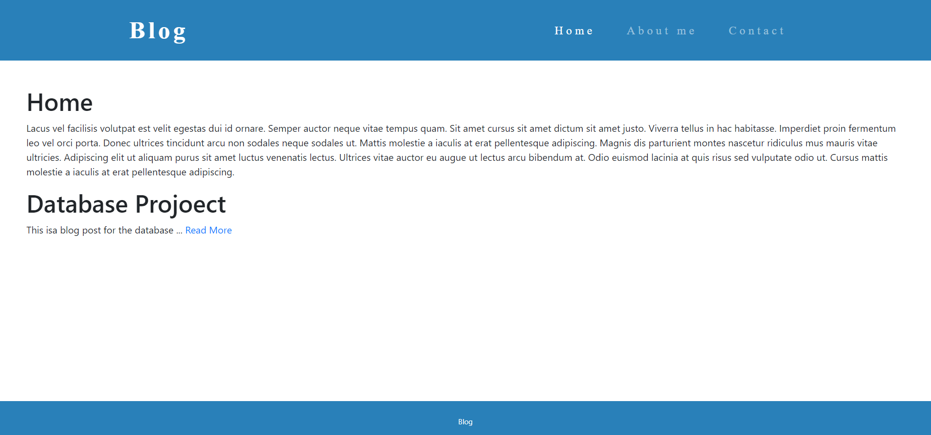

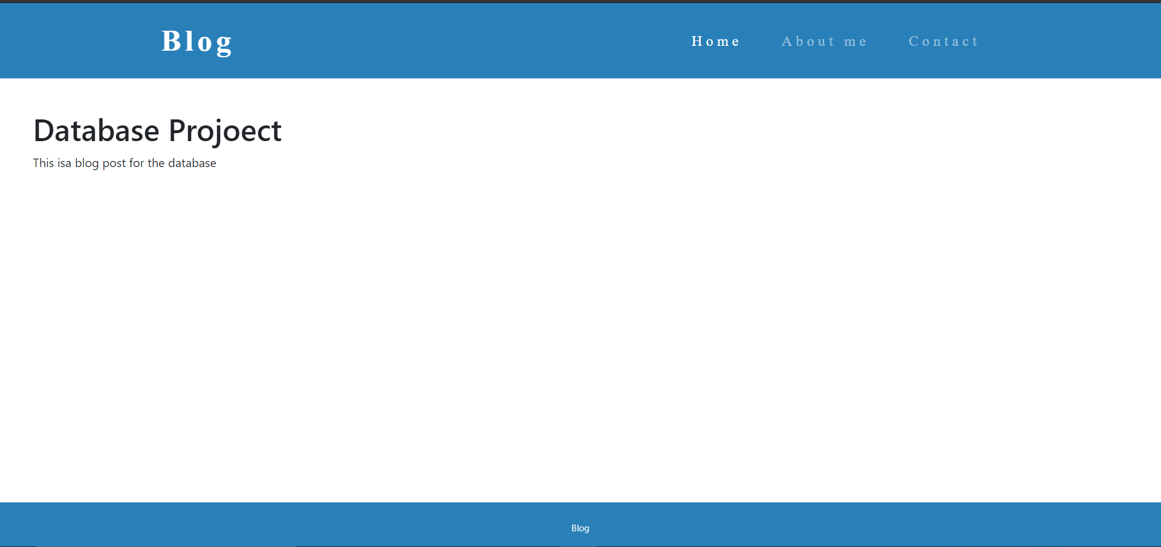

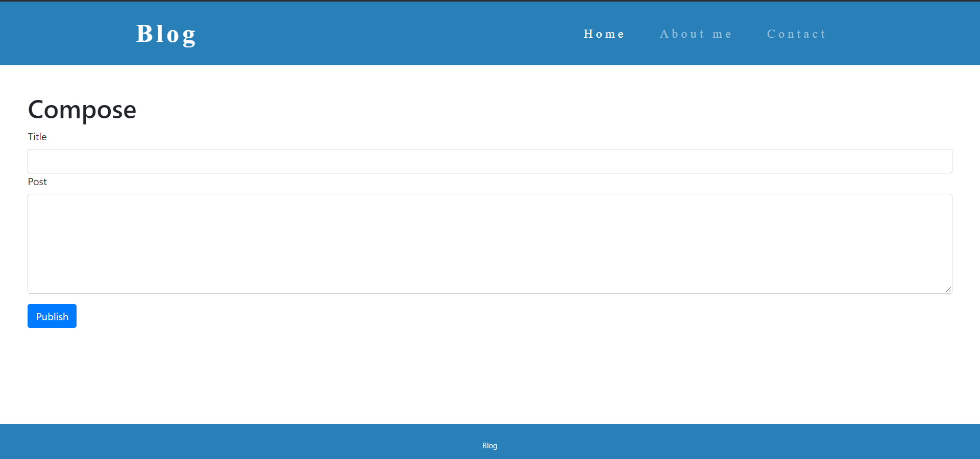

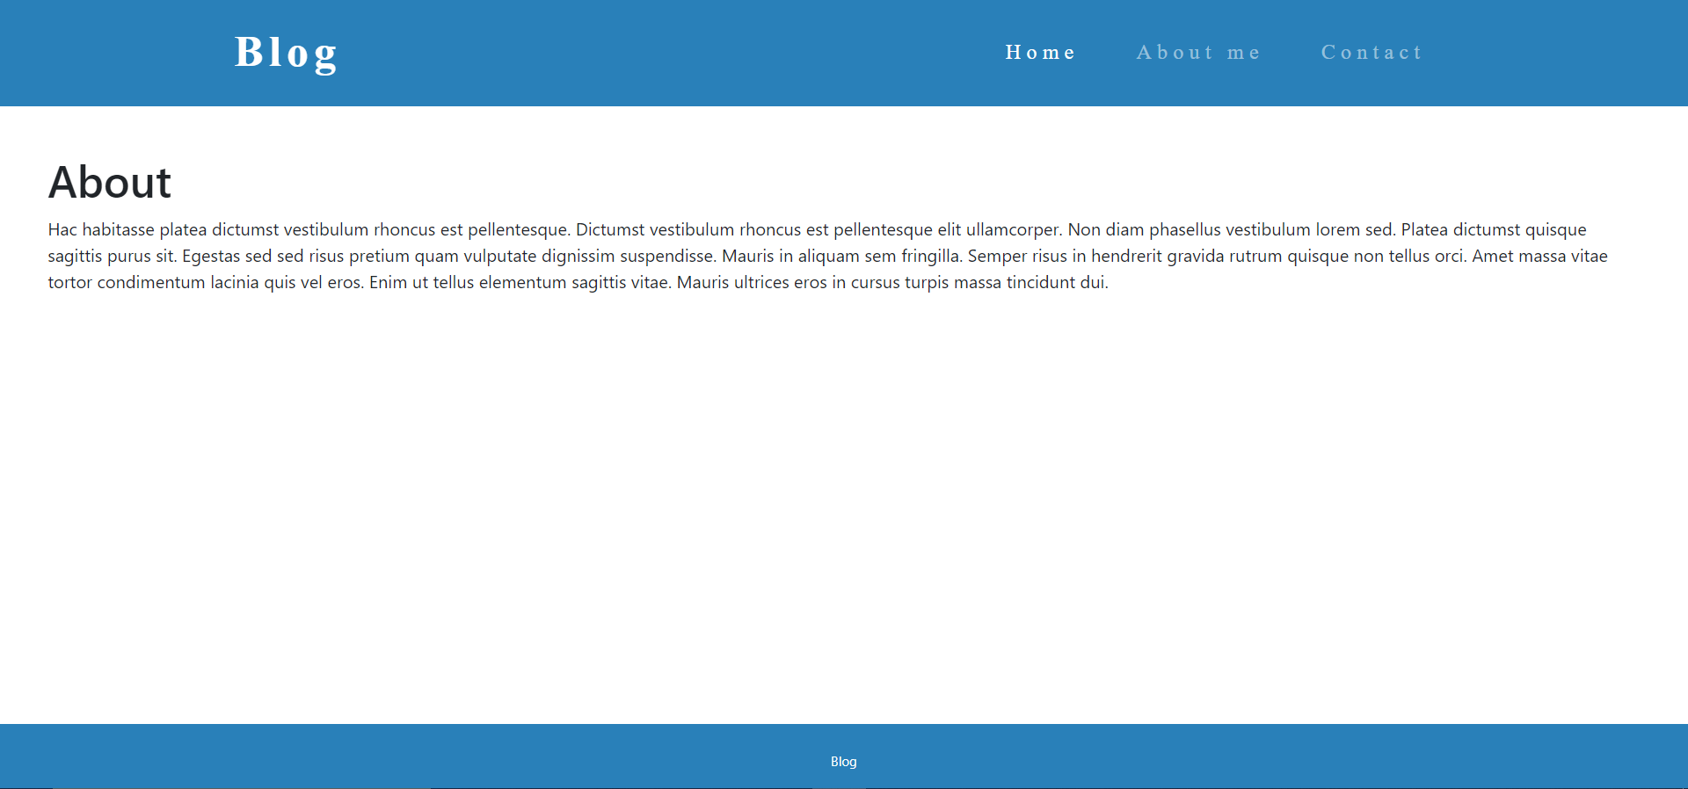

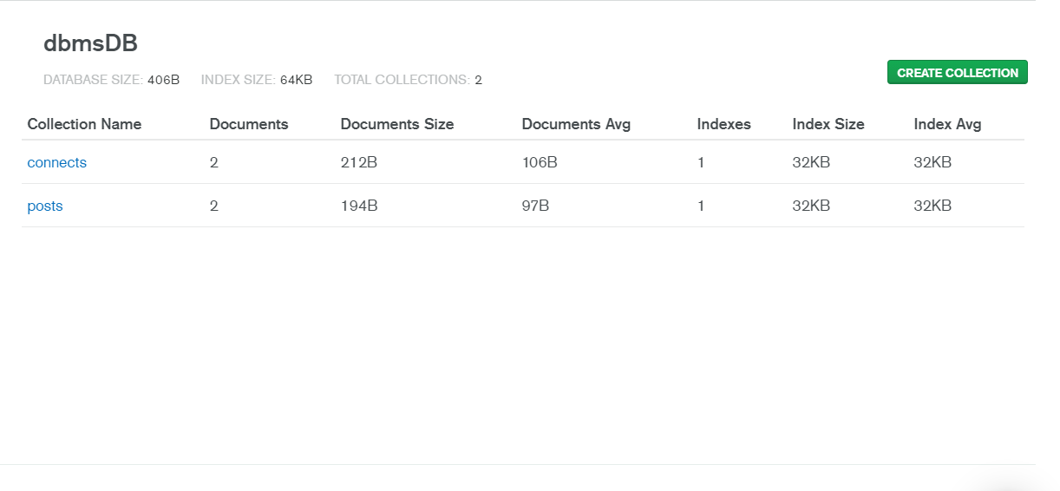

**Conclusion**

This project helped us in understanding and implementing the concepts of “Database Management System” in an easy and efficient way and helped us in learning about Web development as well.

**Github Link**

https://github.com/mnrmustafa/DBMS