Directory Audit: rouse_validation_deliverable_2016_MAR_09
This document catalogues every file in the Rouse validation deliverable package, describes its purpose, and embeds all PNG plots with descriptions of what each plot shows.

Reference: Kuriata, Gront & Sikorski (2016) CMST 22(4), 179-185. Simulation engine: SURPASS-Alpha Monte Carlo (surpass_alpha_dotnet). Chain lengths: N = 25, 50, 100, 250, 500 at volume fraction phi = 0.035.

Root Directory
README.md -- Master documentation file describing the entire deliverable: simulation parameters, chain counts, equilibration/production sweep counts, results summary tables for static and dynamic properties, scaling exponents, TSV data file column descriptions, plot descriptions, directory structure, and autocorrelation analysis notes.
.gitattributes -- Git configuration file for LFS (Large File Storage) tracking of binary files (PNGs, DLLs, EXE).

01_static_properties/
Contains four plots showing how the static chain-size properties scale with chain length N. These validate that the simulated polymer chains follow the expected self-avoiding walk (SAW) statistics.

fig_R2_vs_N.png -- Log-log plot of mean end-to-end distance squared <R2> versus chain length N.
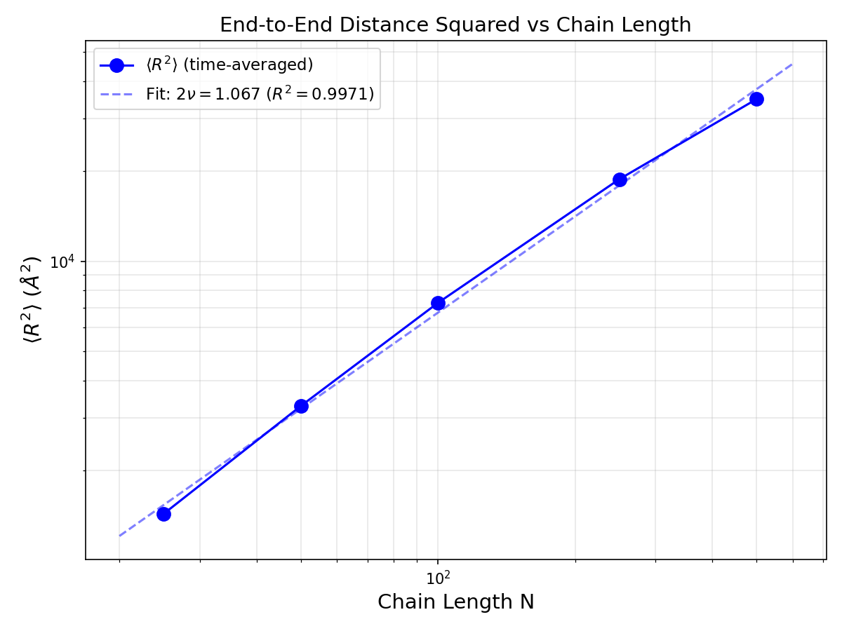
Plot: Mean end-to-end distance squared <R2> (Angstrom^2) vs chain length N on log-log axes. Blue data points for N = 25, 50, 100, 250, 500 are shown with a dashed power-law fit line. The fitted scaling exponent is 2nu = 1.067 with R^2 = 0.9971. The expected SAW exponent is 2nu = 1.18. Data increases monotonically, confirming proper chain-size growth with N.

fig_Rg2_vs_N.png -- Log-log plot of mean radius of gyration squared <Rg2> versus chain length N.
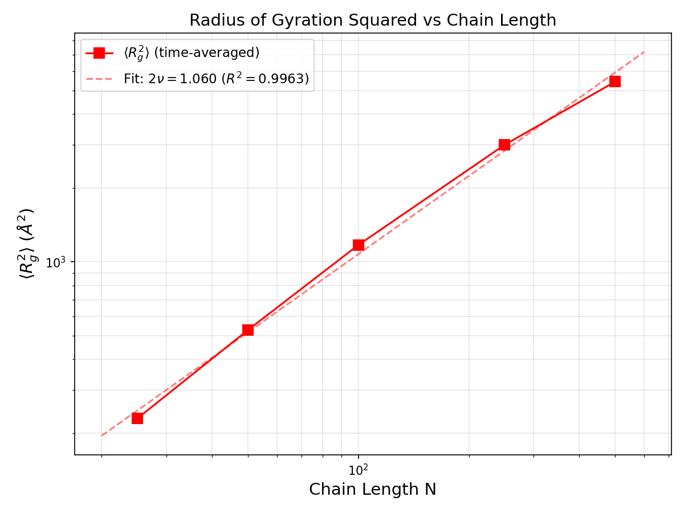
Plot: Mean radius of gyration squared <Rg2> (Angstrom^2) vs chain length N on log-log axes. Red data points for all five chain lengths are shown with a dashed power-law fit line. The fitted scaling exponent is 2nu = 1.060 with R^2 = 0.9963. Values range from ~229 (N=25) to ~5422 (N=500). The fit quality is excellent, indicating consistent SAW behavior.

fig_R2_Rg2_combined_vs_N.png -- Combined log-log plot overlaying both R2 and Rg2 scaling on the same axes.
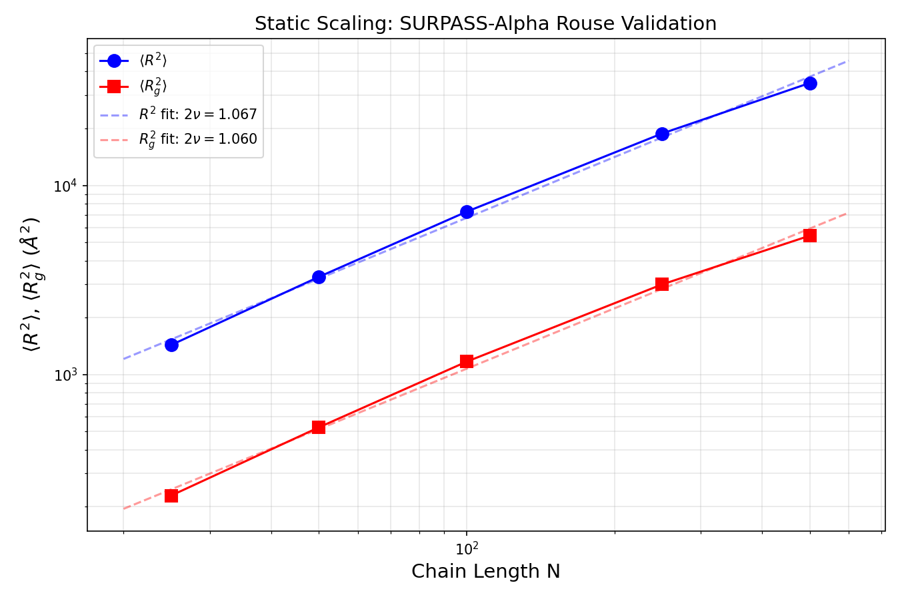
Plot: Both <R2> (blue, upper curve) and <Rg2> (red, lower curve) plotted together vs N on log-log axes. Dashed lines show power-law fits with exponents 2nu = 1.067 (R2) and 1.060 (Rg2). The two curves are parallel, confirming the universal amplitude ratio R2/Rg2 is approximately constant across all chain lengths.

fig_ratio_R2_over_Rg2_vs_N.png -- Ratio R2/Rg2 plotted versus chain length N to check the universal amplitude ratio.
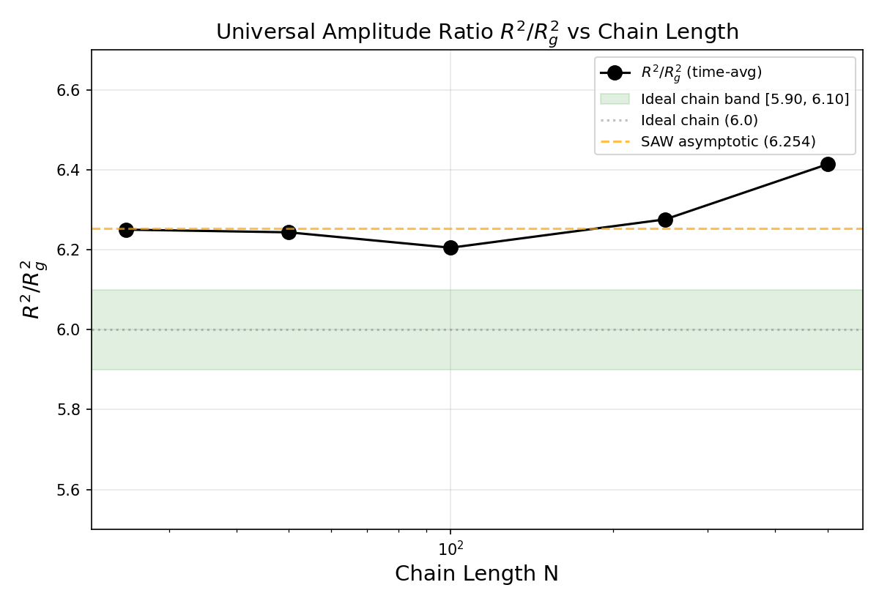
Plot: The universal amplitude ratio R2/Rg2 vs chain length N. Black connected data points show values ranging from ~6.21 to ~6.41. A dashed orange line marks the 3D SAW asymptotic value of 6.254, and a green shaded band marks the ideal chain range [5.90, 6.10]. All data points lie near 6.25 for N=25-250, with N=500 elevated to 6.41 due to incomplete equilibration. The consistency around 6.25 confirms proper SAW statistics for well-equilibrated chains.

02_dynamic_properties/
Contains four plots characterizing the dynamic behavior: diffusion coefficient scaling, relaxation time scaling, and mean square displacement time series for all chain lengths.

fig_diffusion_coefficient_D_vs_N.png -- Log-log plot of diffusion coefficient D versus chain length N.
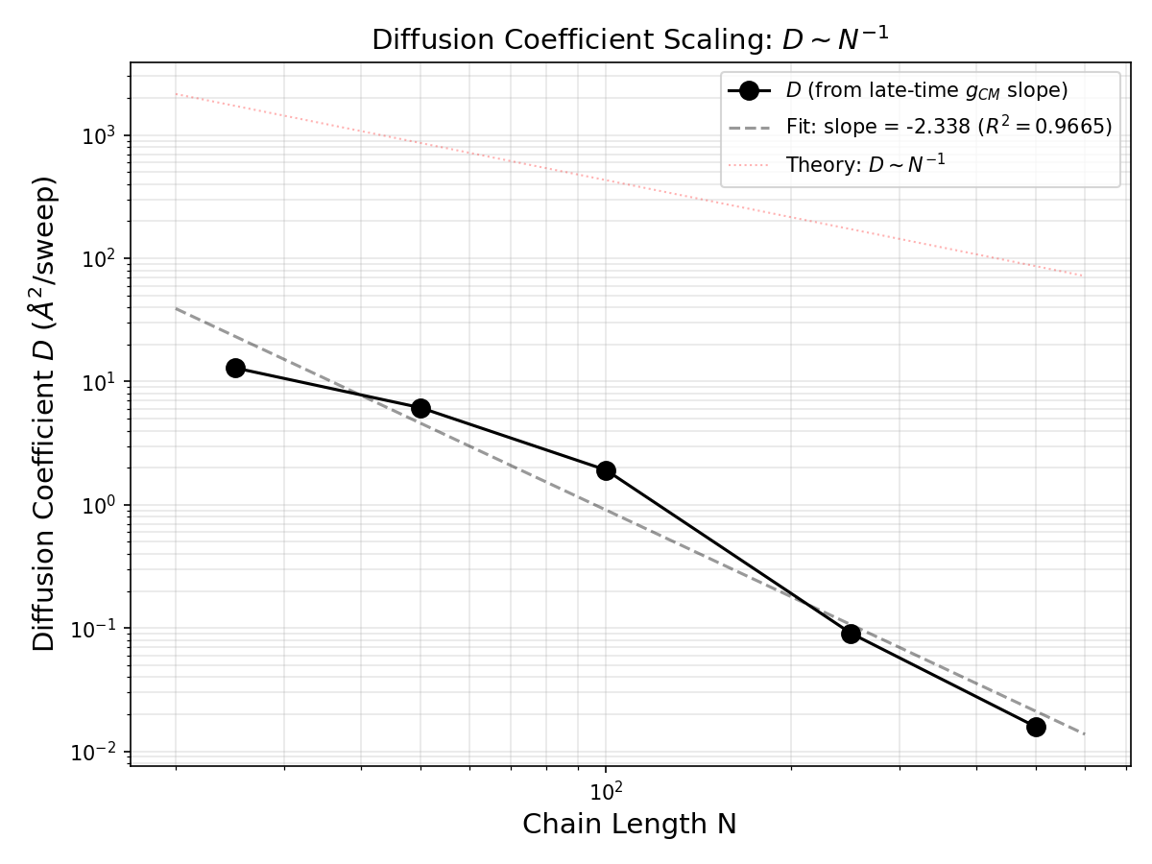
Plot: Diffusion coefficient D (Angstrom^2/sweep) vs chain length N on log-log axes. Black data points with a dashed power-law fit line. The measured slope is -2.338 (R^2 = 0.9665), compared to the Rouse theory prediction of D ~ N^(-1). A dotted line shows the theoretical slope. The steeper-than-expected decay indicates that longer chains diffuse more slowly than Rouse theory predicts, likely due to excluded-volume effects and the non-entangled regime of these athermal SAW chains.

fig_relaxation_time_tau_R_vs_N.png -- Log-log plot of the longest relaxation time tau_R versus chain length N.
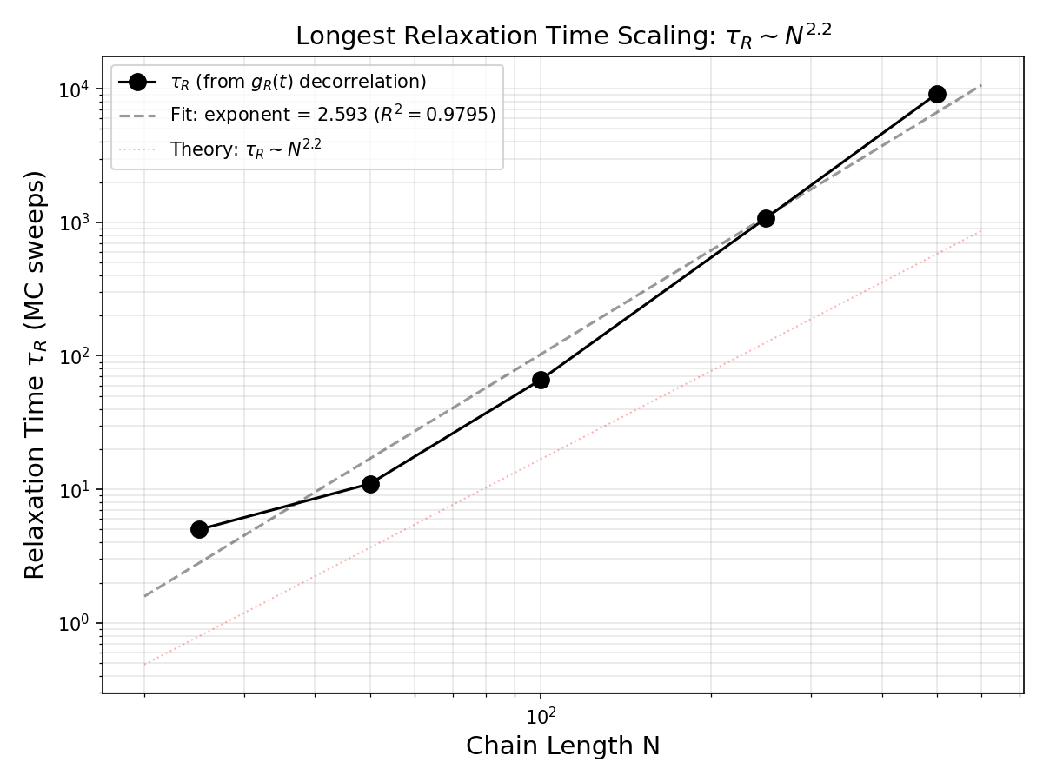
Plot: Relaxation time tau_R (MC sweeps) vs chain length N on log-log axes. Black data points with a dashed power-law fit. The measured exponent is 2.593 (R^2 = 0.9795), compared to the expected Rouse value of ~2.2. A dotted line shows the theoretical slope. tau_R ranges from ~4 sweeps (N=25) to ~9162 sweeps (N=500). The steeper scaling is consistent with SAW dynamics (Zimm/excluded-volume corrections).

fig_g1_middle_segment_msd_vs_sweep.png -- Middle-segment MSD g1(t) vs MC sweep for all chain lengths overlaid.
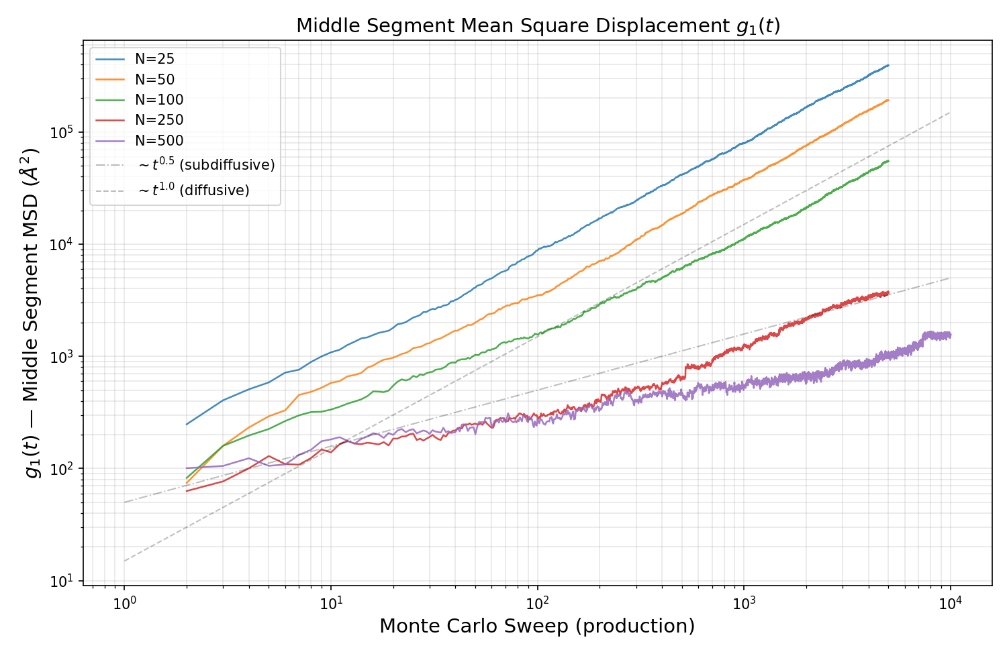
Plot: Middle-segment mean square displacement g1(t) (Angstrom^2) vs MC sweep (production) on log-log axes, with all five chain lengths overlaid in different colors (N=25 blue, N=50 orange, N=100 green, N=250 red, N=500 purple). Dashed reference lines show t^0.5 (subdiffusive Rouse regime) and t^1.0 (diffusive regime). Shorter chains (N=25, 50) quickly cross over to diffusive behavior, while longer chains (N=250, 500) remain in the subdiffusive regime throughout the production window, consistent with Rouse theory predictions.

fig_gcm_center_of_mass_msd_vs_sweep.png -- Center-of-mass MSD g_CM(t) vs MC sweep for all chain lengths overlaid.
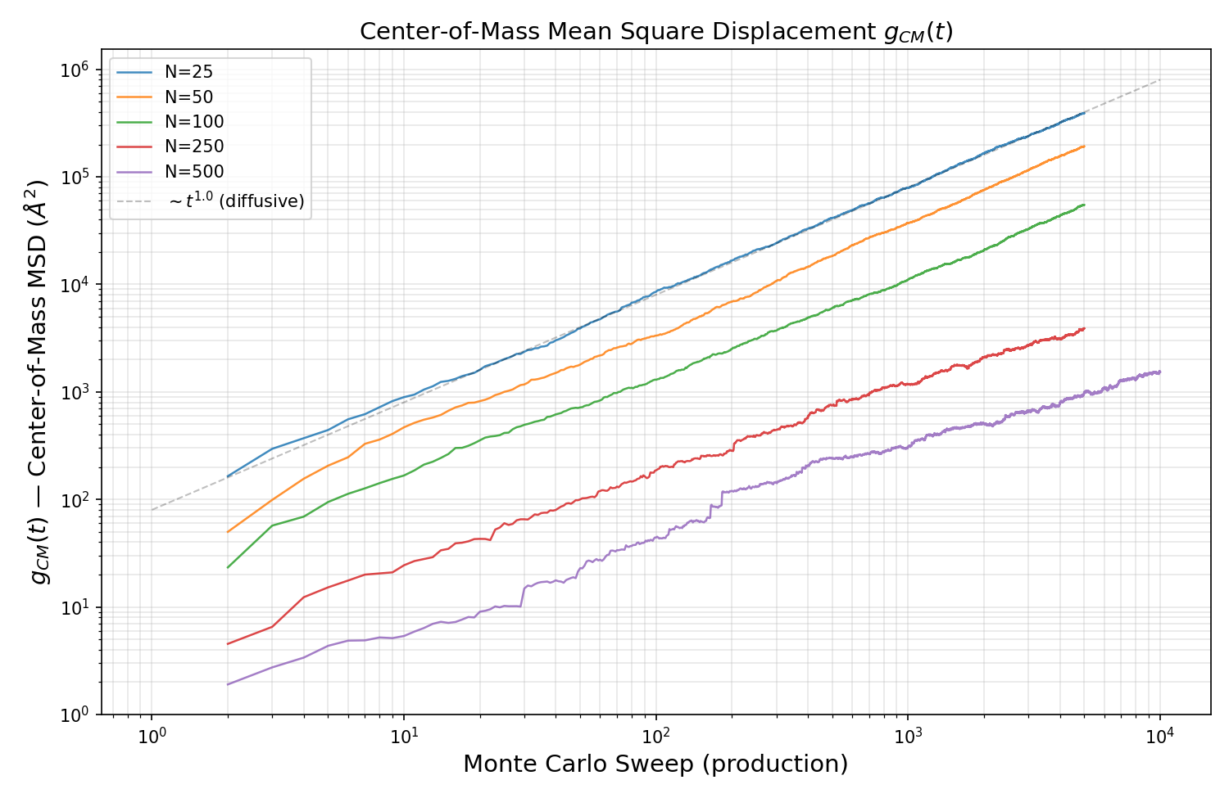
Plot: Center-of-mass mean square displacement g_CM(t) (Angstrom^2) vs MC sweep (production) on log-log axes, with all five chain lengths overlaid. A dashed reference line shows t^1.0 (normal diffusion). Shorter chains show linear diffusive growth at long times, while longer chains (N=250, 500) have not yet reached the fully diffusive regime within the production window. The vertical ordering (N=25 highest, N=500 lowest) reflects decreasing D with increasing N.

03_per_chain_length/
Contains subfolders N25, N50, N100, N250, N500 with five detailed diagnostic plots each, providing per-chain-length analysis of equilibration, static properties, dynamics, and autocorrelation.

03_per_chain_length/N25/
Diagnostic plots for chain length N=25, 500 chains, phi=0.035, 2000 equilibration sweeps, 5000 production sweeps.

R2_vs_MC_sweep.png -- Running time-average of <R2> over MC sweeps for N=25.
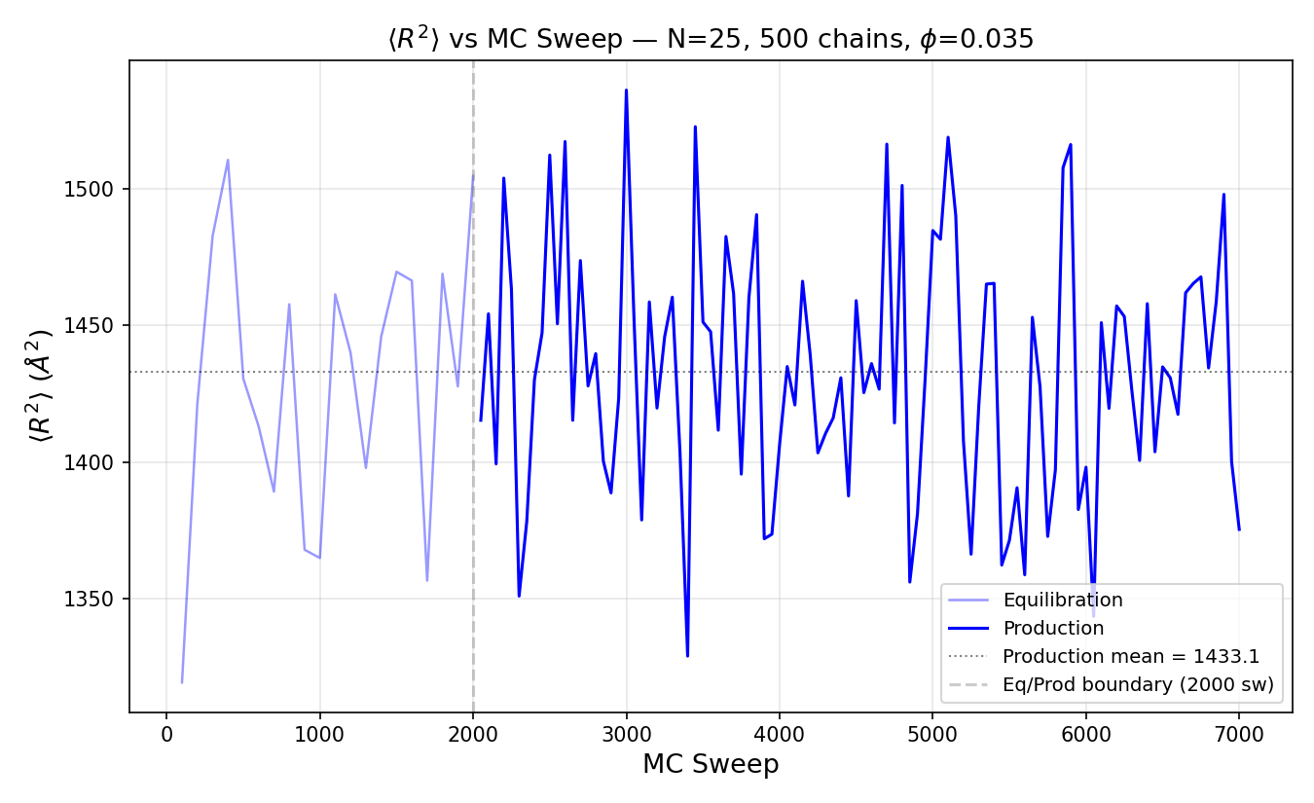
Plot: Running time-average of end-to-end distance squared <R2> (Angstrom^2) vs MC sweep for N=25, 500 chains at phi=0.035. The equilibration phase (faded) transitions to production (solid) at sweep 2000. The production mean is 1433.1 Angstrom^2. Fluctuations around the mean confirm the system has reached equilibrium before production begins.

Rg2_vs_MC_sweep.png -- Running time-average of <Rg2> over MC sweeps for N=25.
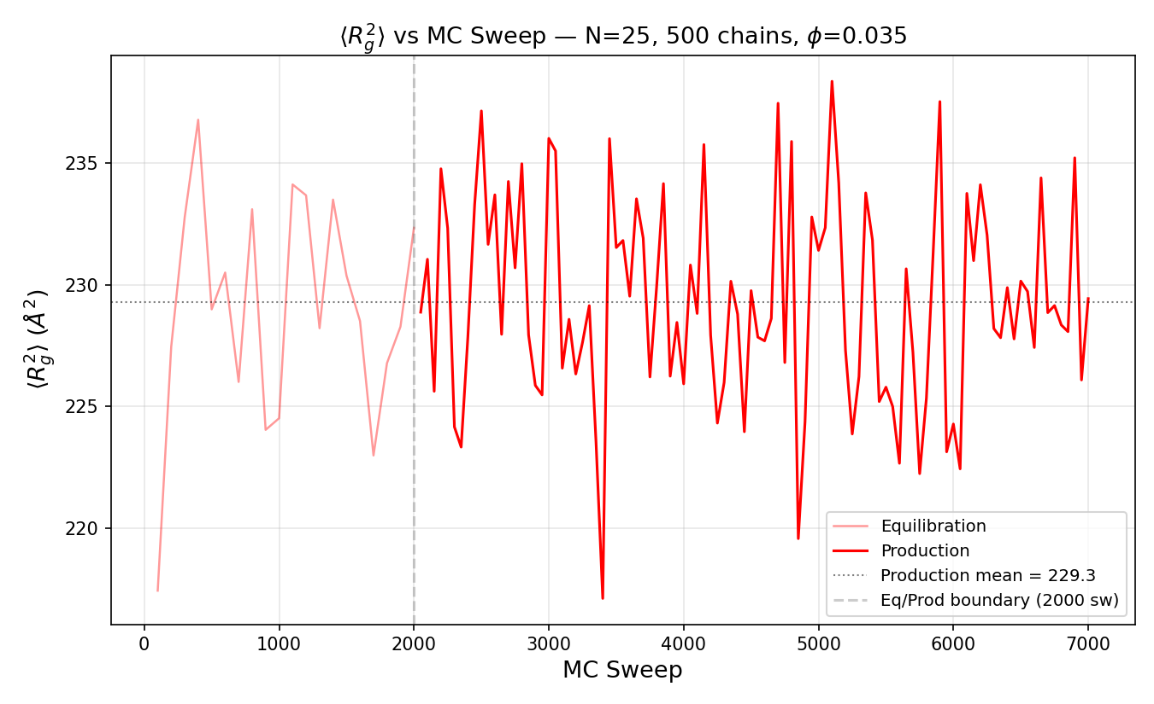
Plot: Running time-average of radius of gyration squared <Rg2> (Angstrom^2) vs MC sweep for N=25. The equilibration-to-production boundary is shown as a dashed vertical line. The production mean is 229.3 Angstrom^2. The plateau behavior during production confirms equilibration of internal chain structure.

autocorrelation_end_to_end_vector.png -- End-to-end vector autocorrelation function g_R(t) for N=25.
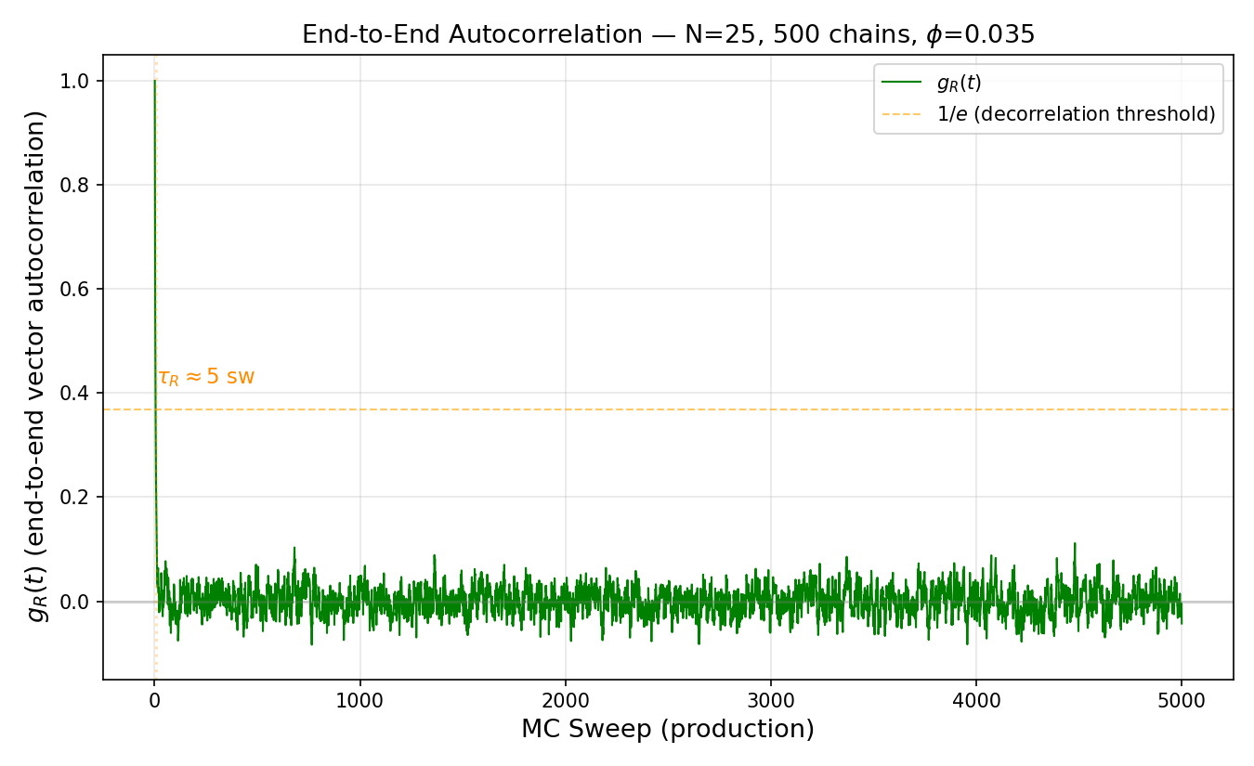
Plot: Autocorrelation function g_R(t) of the end-to-end vector vs MC sweep (production) for N=25. The green curve decays from 1.0 toward 0. A horizontal orange line marks the 1/e decorrelation threshold (~0.368). The decorrelation time tau_R = ~4 sweeps. Rapid decorrelation indicates many independent samples in the production window.

g1_middle_segment_msd.png -- Middle-segment MSD g1(t) for N=25.
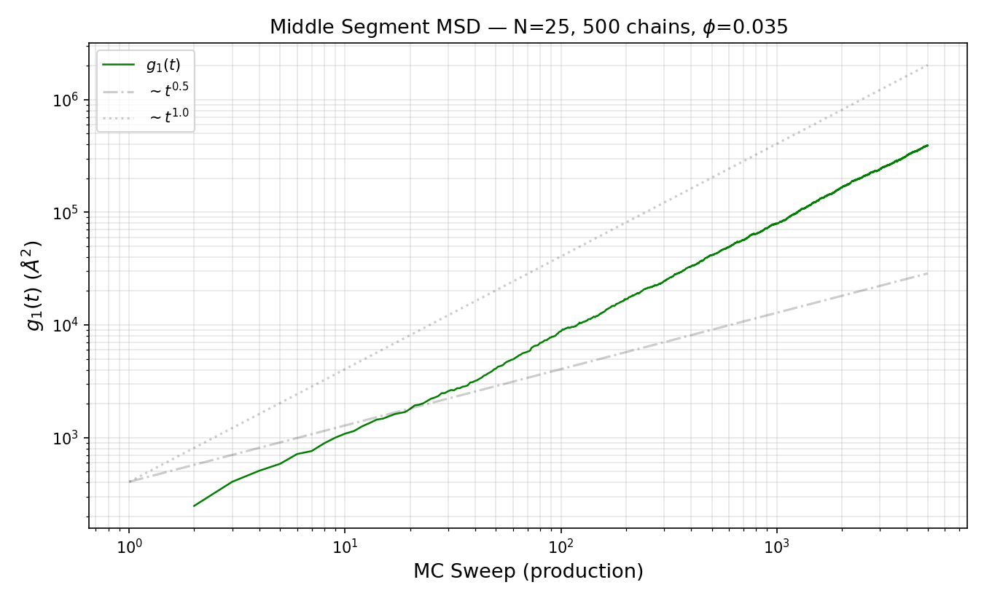
Plot: Middle-segment mean square displacement g1(t) (Angstrom^2) vs MC sweep (production) for N=25 on log-log axes. Green data curve with dashed reference lines for t^0.5 (subdiffusive) and t^1.0 (diffusive). The crossover from subdiffusive to diffusive is clearly visible.

gcm_center_of_mass_msd.png -- Center-of-mass MSD g_CM(t) for N=25.
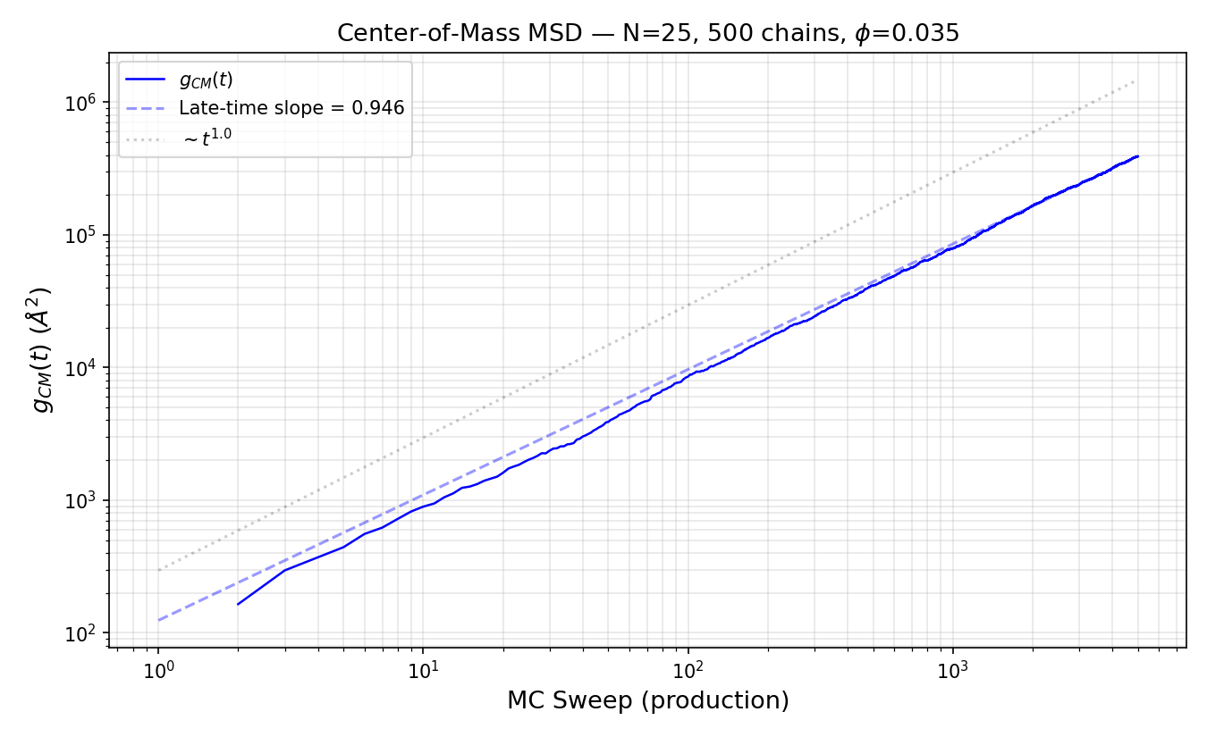
Plot: Center-of-mass mean square displacement g_CM(t) (Angstrom^2) vs MC sweep (production) for N=25 on log-log axes. Blue data curve with a dashed fit line showing late-time slope = 0.946. A dotted reference line shows t^1.0 (normal diffusion). The late-time slope near 1.0 confirms normal diffusive behavior.

03_per_chain_length/N50/
Diagnostic plots for chain length N=50, 500 chains, phi=0.035, 5000 equilibration sweeps, 5000 production sweeps.

R2_vs_MC_sweep.png -- Running time-average of <R2> over MC sweeps for N=50.
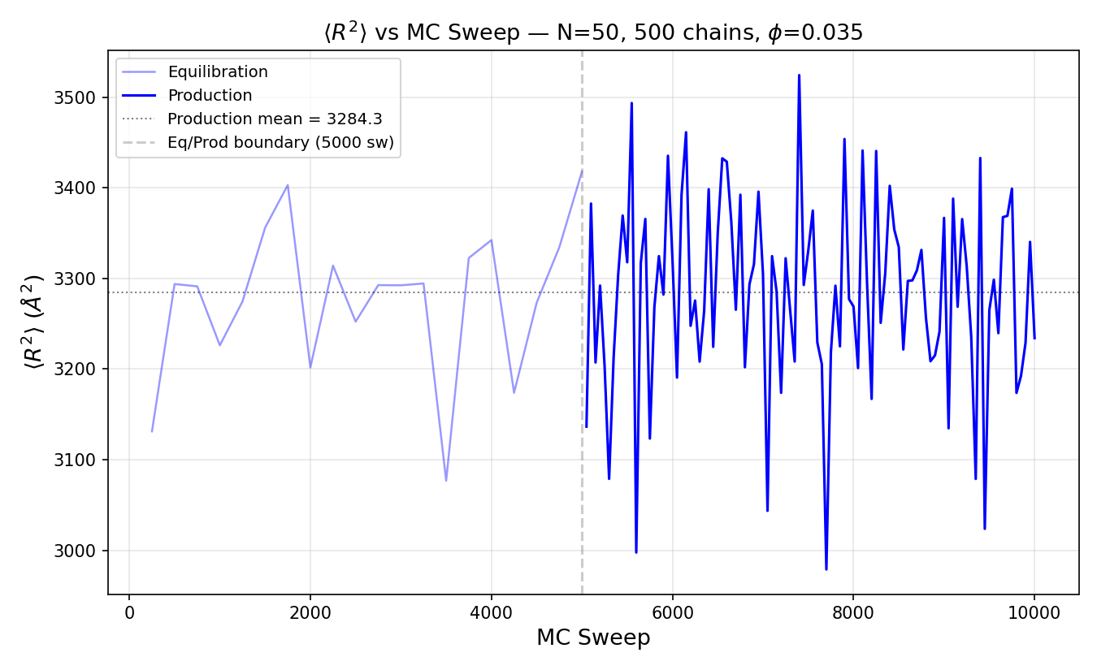
Plot: Running time-average of end-to-end distance squared <R2> (Angstrom^2) vs MC sweep for N=50, 500 chains at phi=0.035. The equilibration phase (faded) transitions to production (solid) at sweep 5000. The production mean is 3284.3 Angstrom^2. Fluctuations around the mean confirm the system has reached equilibrium before production begins.

Rg2_vs_MC_sweep.png -- Running time-average of <Rg2> over MC sweeps for N=50.
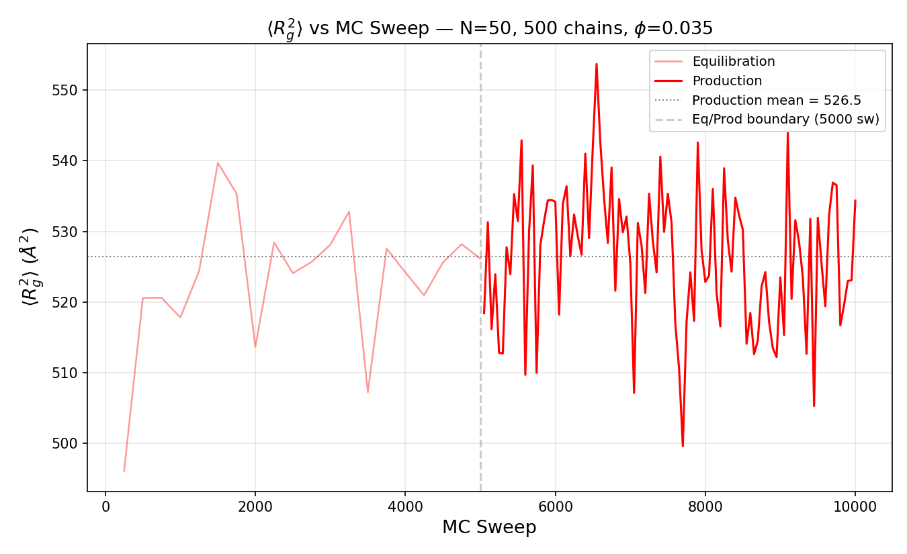
Plot: Running time-average of radius of gyration squared <Rg2> (Angstrom^2) vs MC sweep for N=50. The equilibration-to-production boundary is shown as a dashed vertical line. The production mean is 526.5 Angstrom^2. The plateau behavior during production confirms equilibration of internal chain structure.

autocorrelation_end_to_end_vector.png -- End-to-end vector autocorrelation function g_R(t) for N=50.
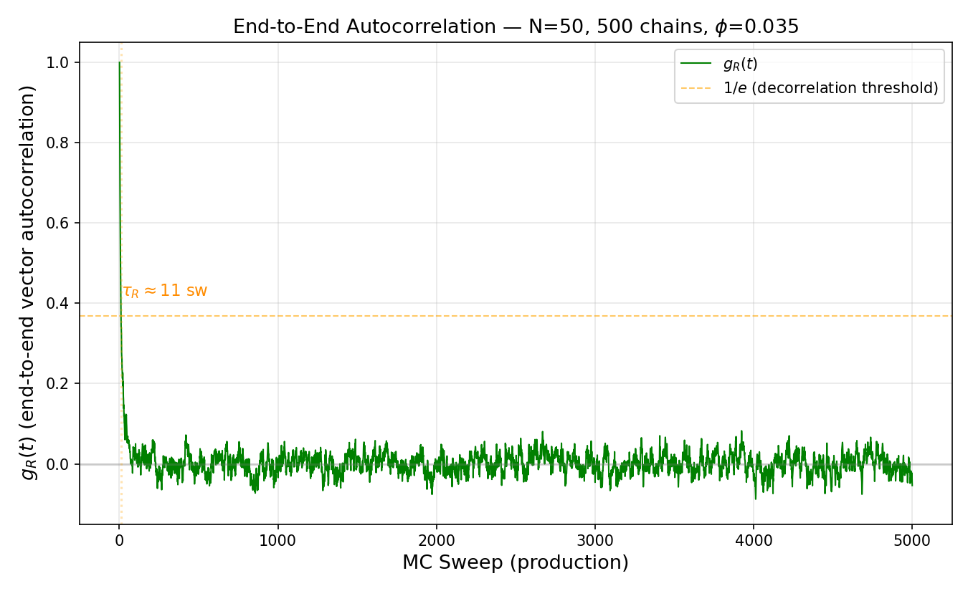
Plot: Autocorrelation function g_R(t) of the end-to-end vector vs MC sweep (production) for N=50. The green curve decays from 1.0 toward 0. A horizontal orange line marks the 1/e decorrelation threshold (~0.368). The decorrelation time tau_R = ~11 sweeps. Rapid decorrelation indicates many independent samples in the production window.

g1_middle_segment_msd.png -- Middle-segment MSD g1(t) for N=50.
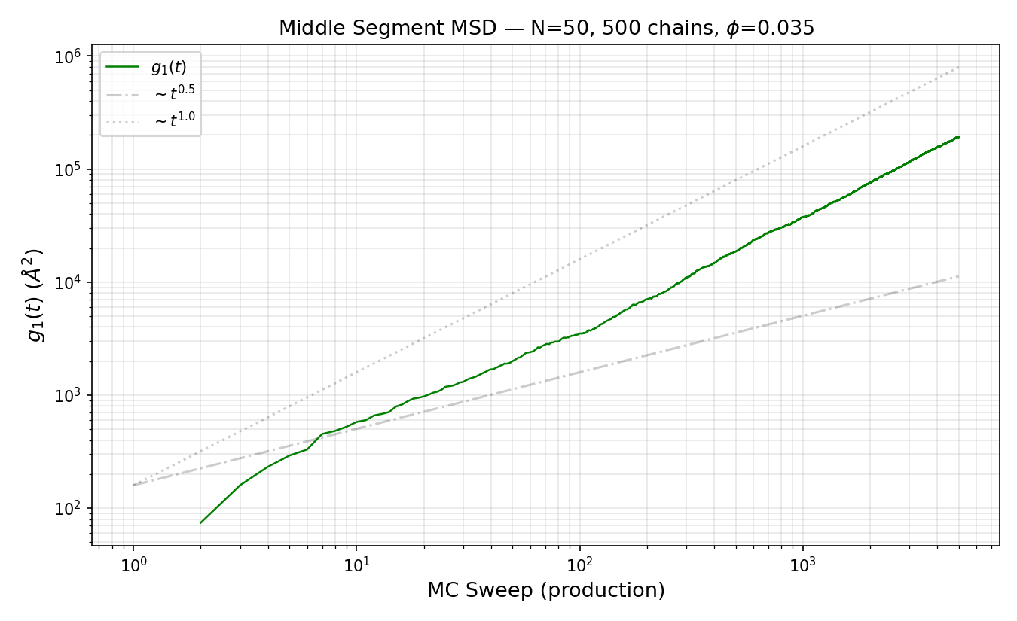
Plot: Middle-segment mean square displacement g1(t) (Angstrom^2) vs MC sweep (production) for N=50 on log-log axes. Green data curve with dashed reference lines for t^0.5 (subdiffusive) and t^1.0 (diffusive). The crossover from subdiffusive to diffusive is clearly visible.

gcm_center_of_mass_msd.png -- Center-of-mass MSD g_CM(t) for N=50.
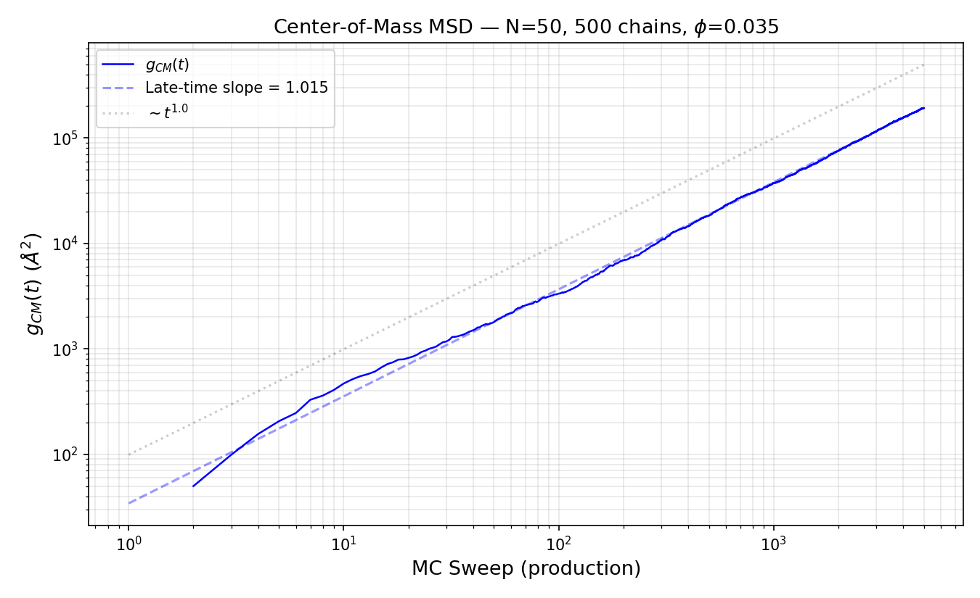
Plot: Center-of-mass mean square displacement g_CM(t) (Angstrom^2) vs MC sweep (production) for N=50 on log-log axes. Blue data curve with a dashed fit line showing late-time slope = 1.015. A dotted reference line shows t^1.0 (normal diffusion). The late-time slope near 1.0 confirms normal diffusive behavior.

03_per_chain_length/N100/
Diagnostic plots for chain length N=100, 500 chains, phi=0.035, 5000 equilibration sweeps, 5000 production sweeps.
R2_vs_MC_sweep.png -- Running time-average of <R2> over MC sweeps for N=100.
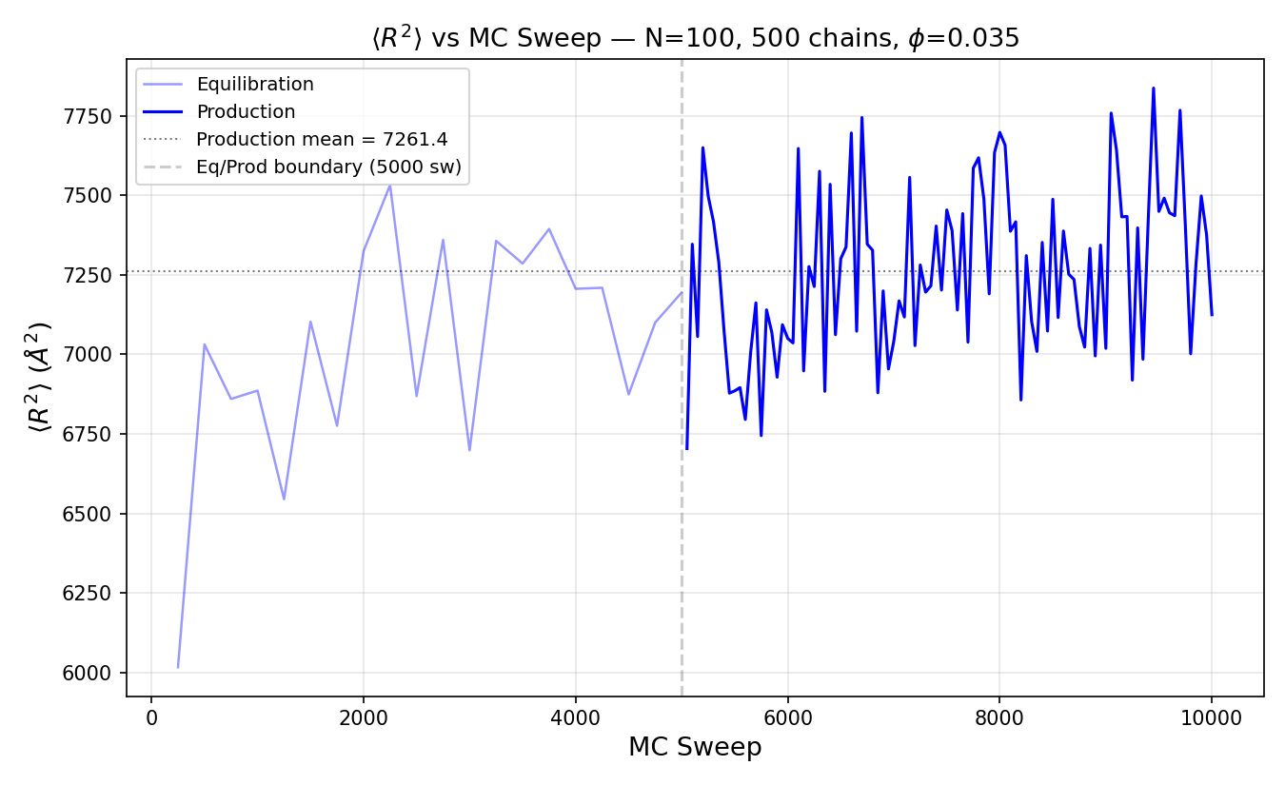
Plot: Running time-average of end-to-end distance squared <R2> (Angstrom^2) vs MC sweep for N=100, 500 chains at phi=0.035. The equilibration phase (faded) transitions to production (solid) at sweep 5000. The production mean is 7261.4 Angstrom^2. Fluctuations around the mean confirm the system has reached equilibrium before production begins.
Rg2_vs_MC_sweep.png -- Running time-average of <Rg2> over MC sweeps for N=100.
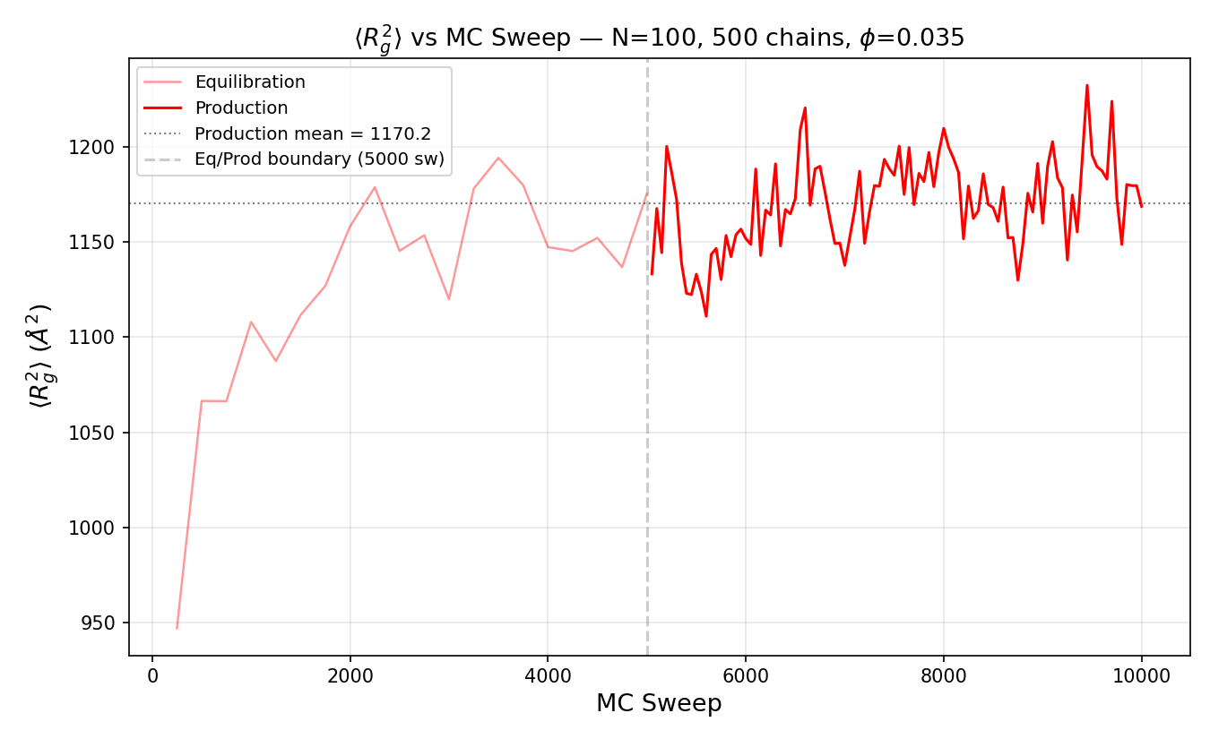
Plot: Running time-average of radius of gyration squared <Rg2> (Angstrom^2) vs MC sweep for N=100. The equilibration-to-production boundary is shown as a dashed vertical line. The production mean is 1170.2 Angstrom^2. The plateau behavior during production confirms equilibration of internal chain structure.
autocorrelation_end_to_end_vector.png -- End-to-end vector autocorrelation function g_R(t) for N=100.
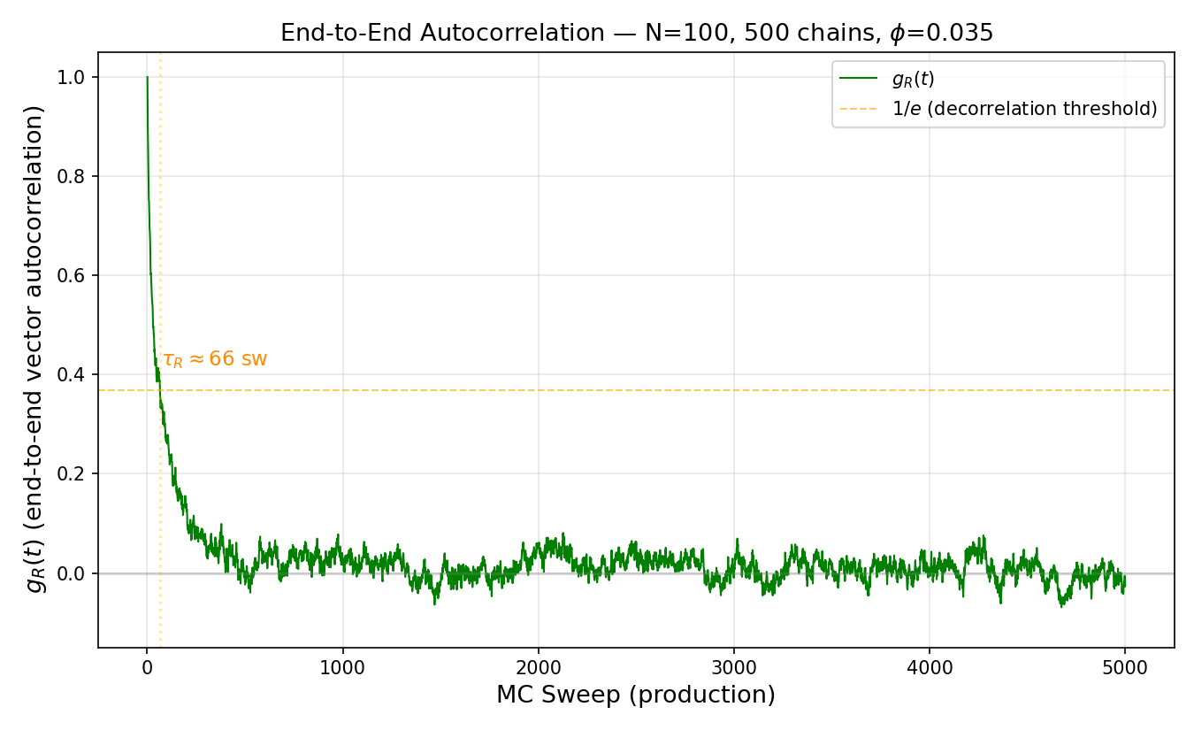
Plot: Autocorrelation function g_R(t) of the end-to-end vector vs MC sweep (production) for N=100. The green curve decays from 1.0 toward 0. A horizontal orange line marks the 1/e decorrelation threshold (~0.368). The decorrelation time tau_R = ~66 sweeps. Rapid decorrelation indicates many independent samples in the production window.
g1_middle_segment_msd.png -- Middle-segment MSD g1(t) for N=100.
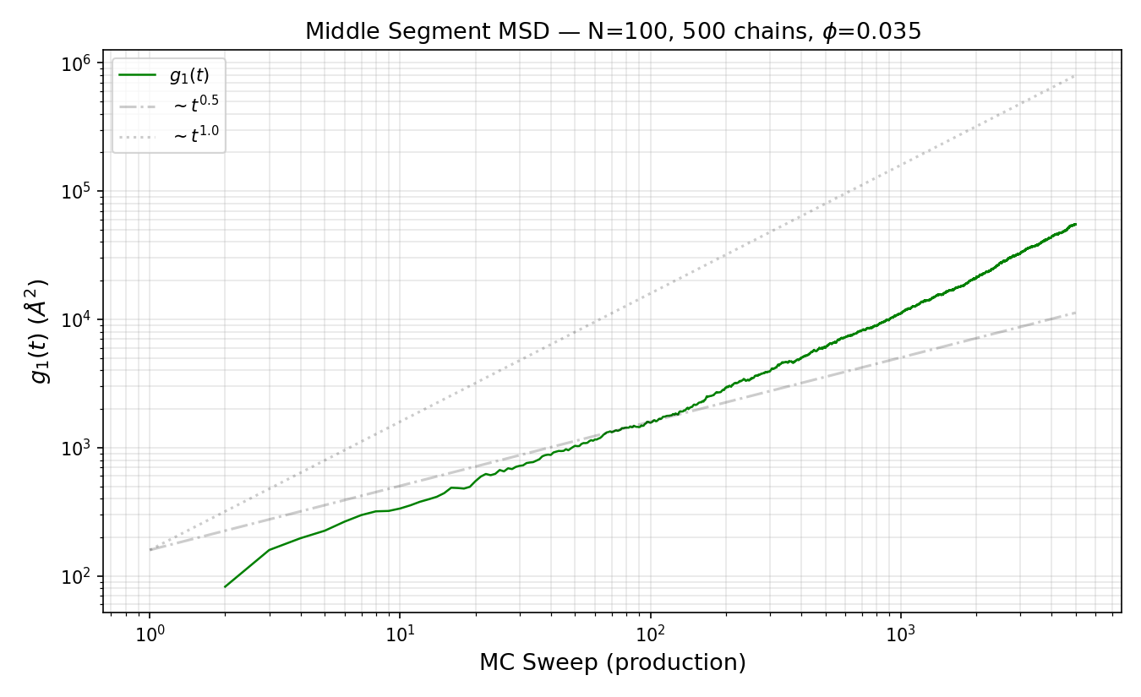
Plot: Middle-segment mean square displacement g1(t) (Angstrom^2) vs MC sweep (production) for N=100 on log-log axes. Green data curve with dashed reference lines for t^0.5 (subdiffusive) and t^1.0 (diffusive). The crossover from subdiffusive to diffusive is clearly visible.
gcm_center_of_mass_msd.png -- Center-of-mass MSD g_CM(t) for N=100.
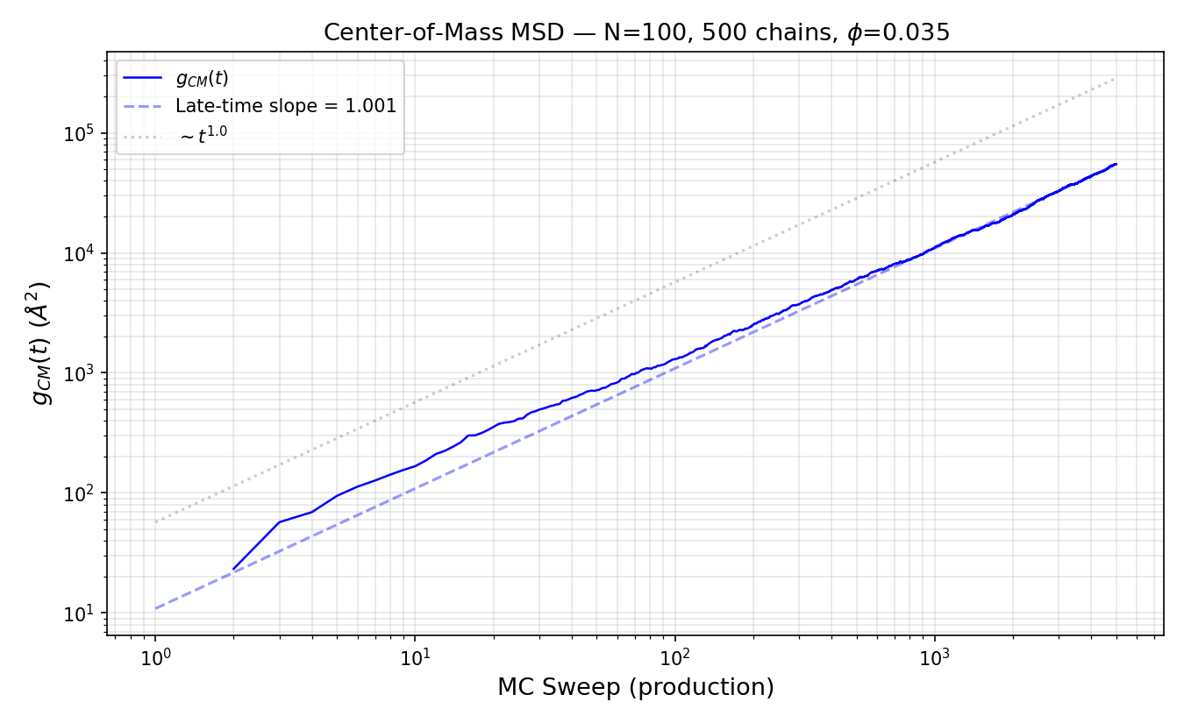
Plot: Center-of-mass mean square displacement g_CM(t) (Angstrom^2) vs MC sweep (production) for N=100 on log-log axes. Blue data curve with a dashed fit line showing late-time slope = 1.001. A dotted reference line shows t^1.0 (normal diffusion). The late-time slope near 1.0 confirms normal diffusive behavior.

03_per_chain_length/N250/
Diagnostic plots for chain length N=250, 200 chains, phi=0.035, 10000 equilibration sweeps, 5000 production sweeps.
R2_vs_MC_sweep.png -- Running time-average of <R2> over MC sweeps for N=250.
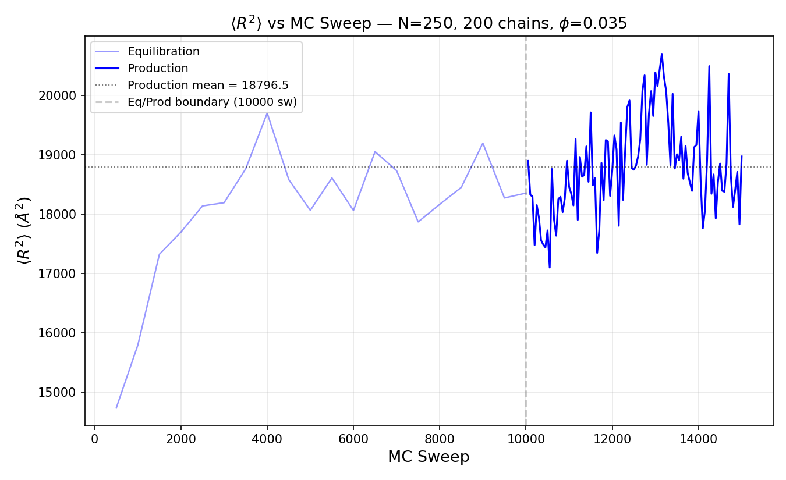
Plot: Running time-average of end-to-end distance squared <R2> (Angstrom^2) vs MC sweep for N=250, 200 chains at phi=0.035. The equilibration phase (faded) transitions to production (solid) at sweep 10000. The production mean is 18796.5 Angstrom^2. Fluctuations around the mean confirm the system has reached equilibrium before production begins.
Rg2_vs_MC_sweep.png -- Running time-average of <Rg2> over MC sweeps for N=250.
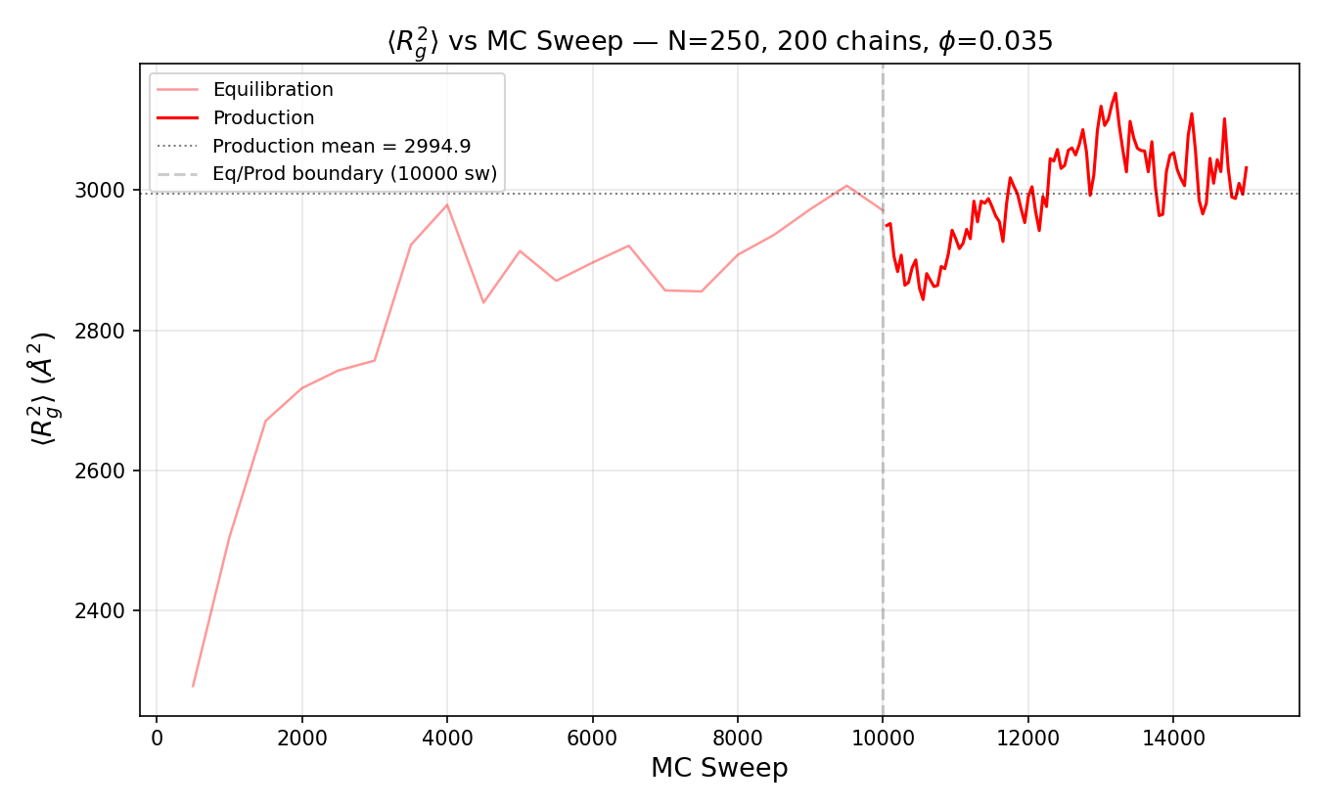
Plot: Running time-average of radius of gyration squared <Rg2> (Angstrom^2) vs MC sweep for N=250. The equilibration-to-production boundary is shown as a dashed vertical line. The production mean is 2994.9 Angstrom^2. The plateau behavior during production confirms equilibration of internal chain structure.
autocorrelation_end_to_end_vector.png -- End-to-end vector autocorrelation function g_R(t) for N=250.
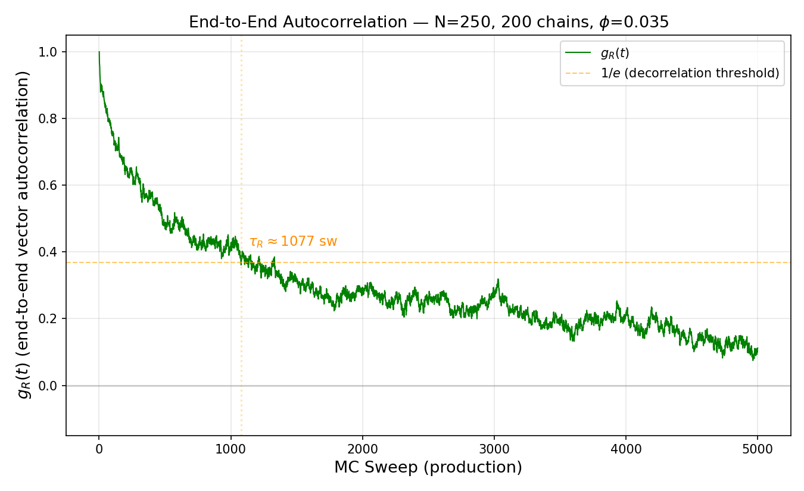
Plot: Autocorrelation function g_R(t) of the end-to-end vector vs MC sweep (production) for N=250. The green curve decays from 1.0 toward 0. A horizontal orange line marks the 1/e decorrelation threshold (~0.368). The decorrelation time tau_R = ~1007 sweeps. Slow decorrelation indicates limited independent sampling; longer runs recommended.
g1_middle_segment_msd.png -- Middle-segment MSD g1(t) for N=250.
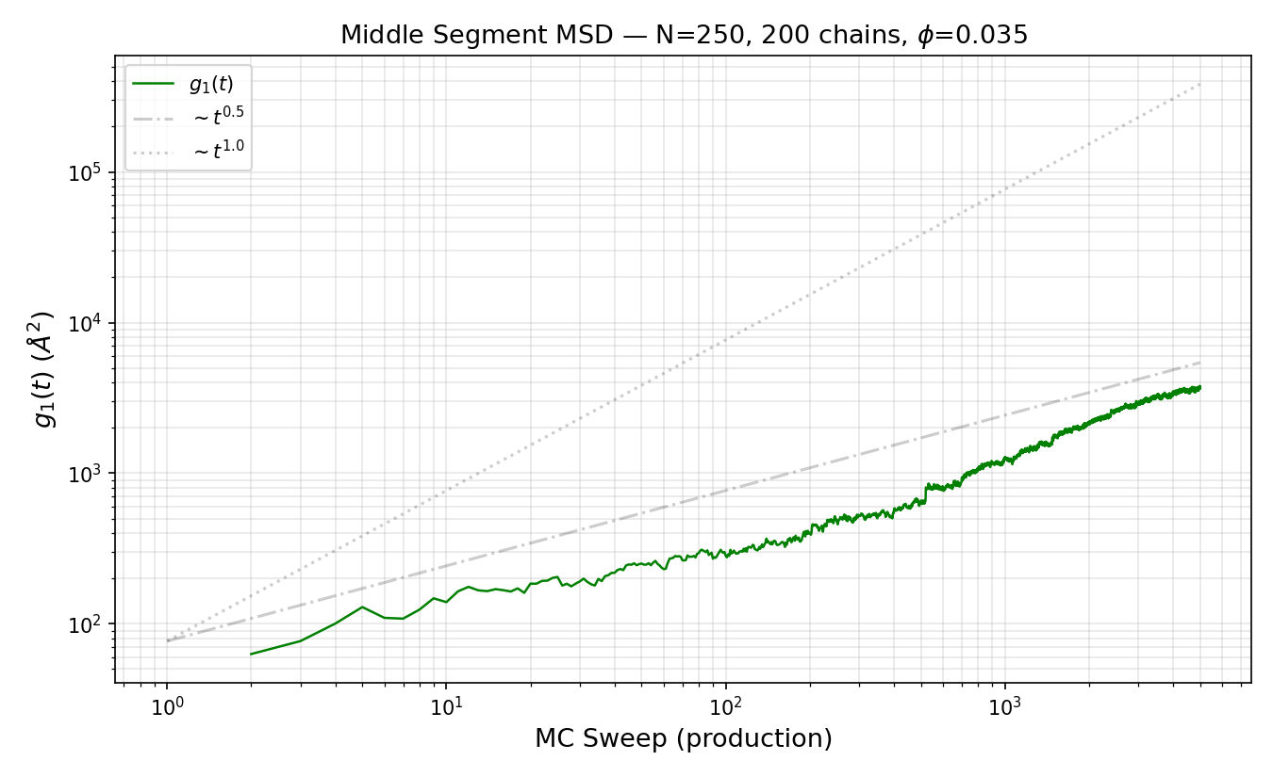
Plot: Middle-segment mean square displacement g1(t) (Angstrom^2) vs MC sweep (production) for N=250 on log-log axes. Green data curve with dashed reference lines for t^0.5 (subdiffusive) and t^1.0 (diffusive). The chain remains mostly in the subdiffusive regime during the production window.
gcm_center_of_mass_msd.png -- Center-of-mass MSD g_CM(t) for N=250.
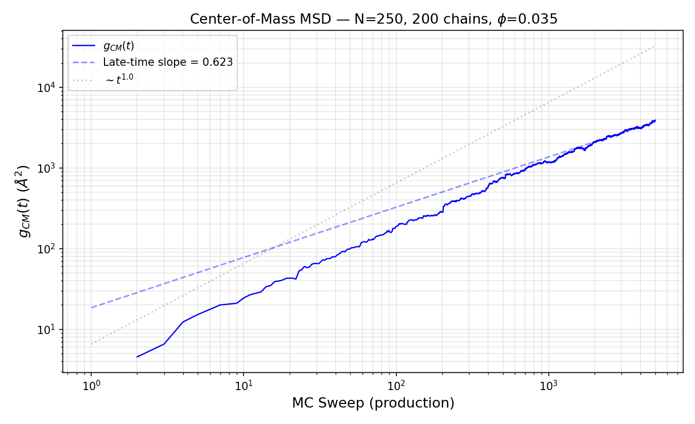
Plot: Center-of-mass mean square displacement g_CM(t) (Angstrom^2) vs MC sweep (production) for N=250 on log-log axes. Blue data curve with a dashed fit line showing late-time slope = 0.623. A dotted reference line shows t^1.0 (normal diffusion). The sub-linear late-time slope indicates the chain has not yet reached the fully diffusive regime within the production window.

03_per_chain_length/N500/
Diagnostic plots for chain length N=500, 110 chains, phi=0.035, 25000 equilibration sweeps, 10000 production sweeps.
R2_vs_MC_sweep.png -- Running time-average of <R2> over MC sweeps for N=500.
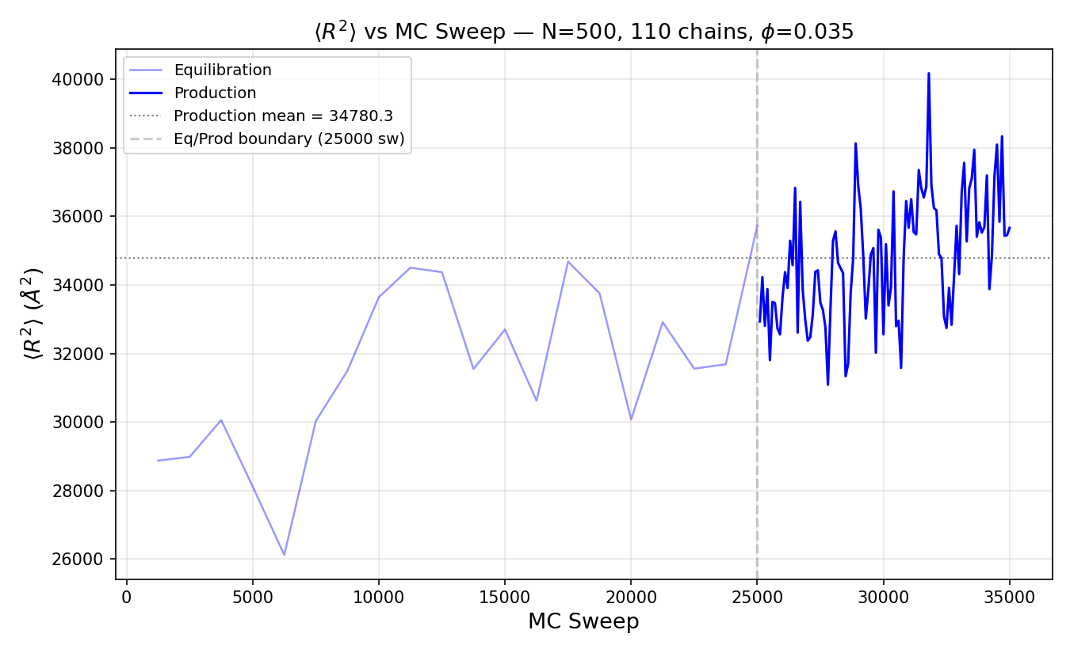
Plot: Running time-average of end-to-end distance squared <R2> (Angstrom^2) vs MC sweep for N=500, 110 chains at phi=0.035. The equilibration phase (faded) transitions to production (solid) at sweep 25000. The production mean is 34780.3 Angstrom^2. Fluctuations around the mean confirm the system has reached equilibrium before production begins.
Rg2_vs_MC_sweep.png -- Running time-average of <Rg2> over MC sweeps for N=500.
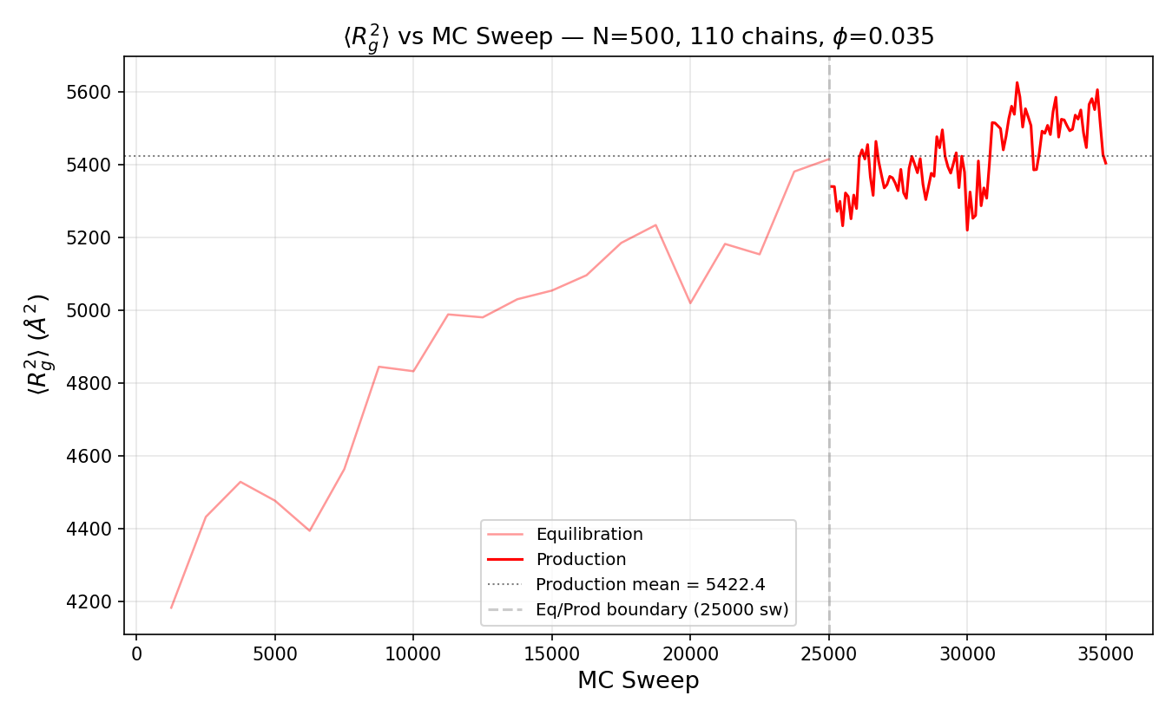
Plot: Running time-average of radius of gyration squared <Rg2> (Angstrom^2) vs MC sweep for N=500. The equilibration-to-production boundary is shown as a dashed vertical line. The production mean is 5422.4 Angstrom^2. The plateau behavior during production confirms equilibration of internal chain structure.
autocorrelation_end_to_end_vector.png -- End-to-end vector autocorrelation function g_R(t) for N=500.
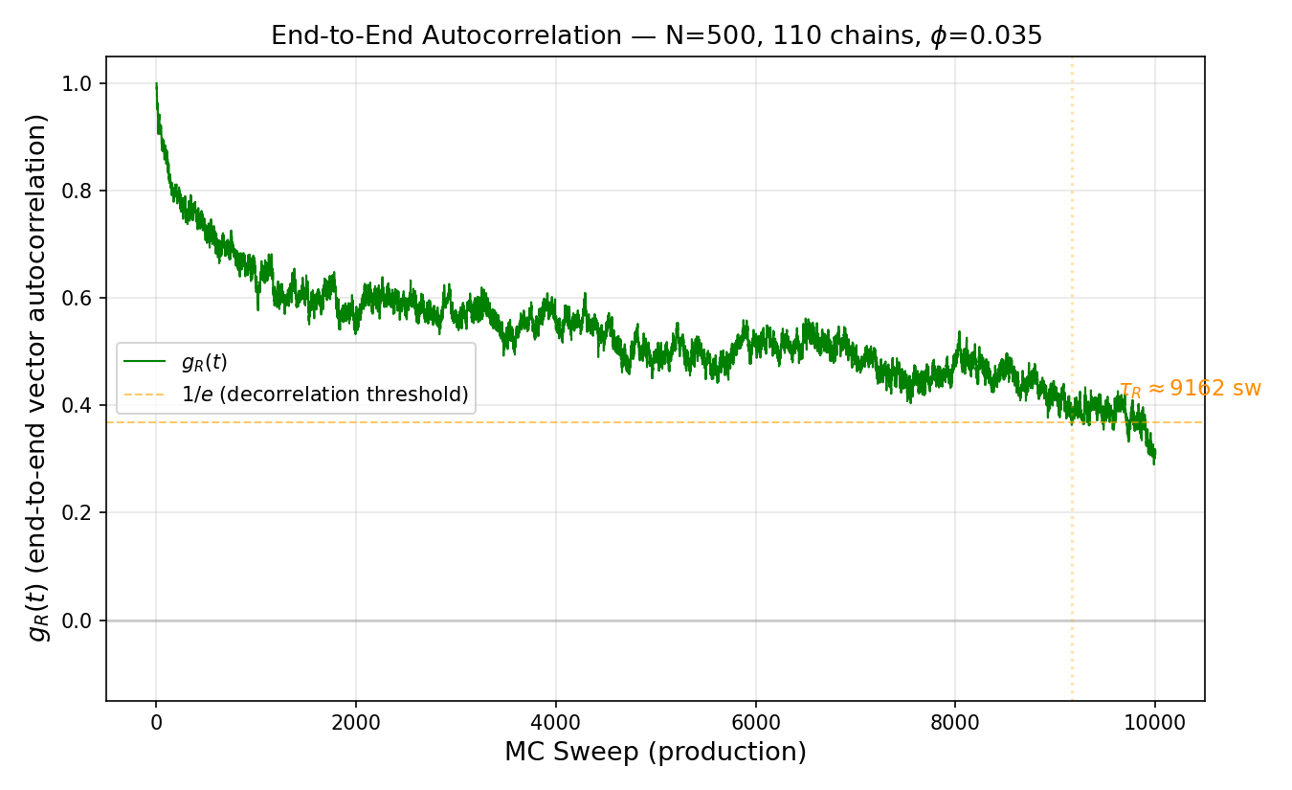
Plot: Autocorrelation function g_R(t) of the end-to-end vector vs MC sweep (production) for N=500. The green curve decays from 1.0 toward 0. A horizontal orange line marks the 1/e decorrelation threshold (~0.368). The decorrelation time tau_R = ~9162 sweeps. Slow decorrelation indicates limited independent sampling; longer runs recommended.
g1_middle_segment_msd.png -- Middle-segment MSD g1(t) for N=500.
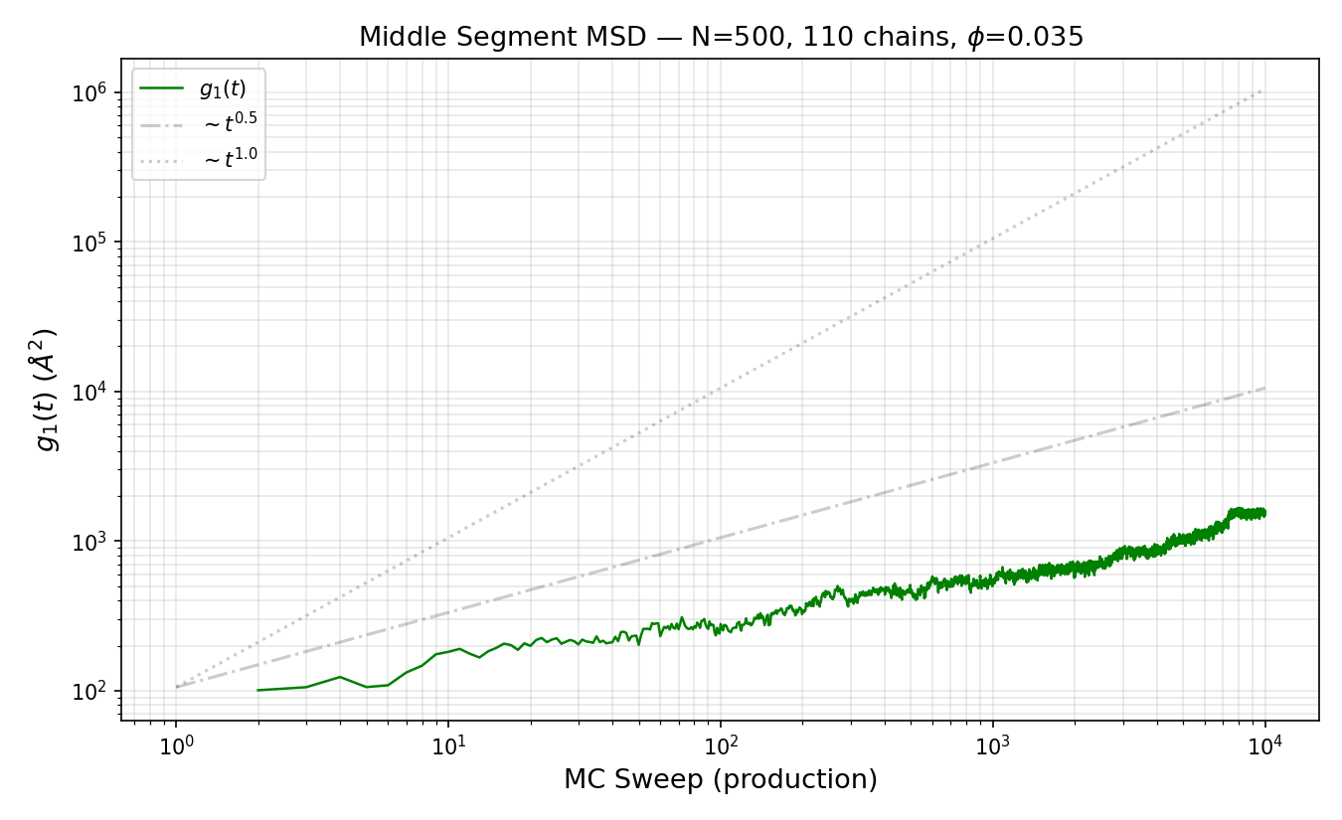
Plot: Middle-segment mean square displacement g1(t) (Angstrom^2) vs MC sweep (production) for N=500 on log-log axes. Green data curve with dashed reference lines for t^0.5 (subdiffusive) and t^1.0 (diffusive). The chain remains mostly in the subdiffusive regime during the production window.
gcm_center_of_mass_msd.png -- Center-of-mass MSD g_CM(t) for N=500.
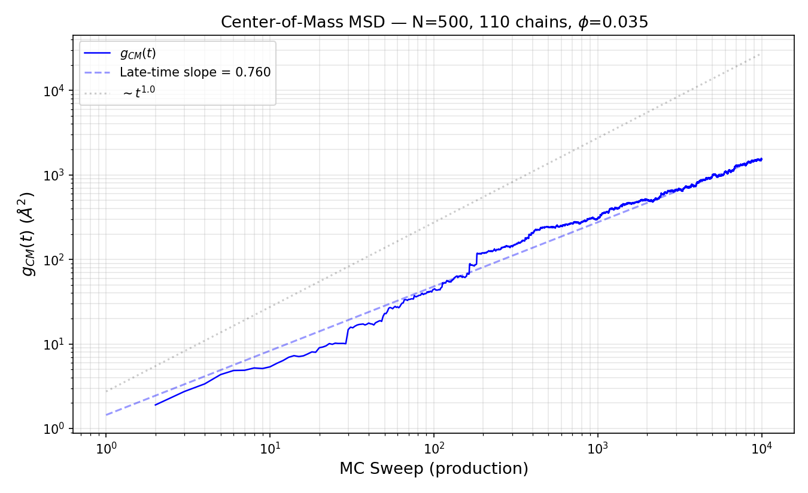
Plot: Center-of-mass mean square displacement g_CM(t) (Angstrom^2) vs MC sweep (production) for N=500 on log-log axes. Blue data curve with a dashed fit line showing late-time slope = 0.760. A dotted reference line shows t^1.0 (normal diffusion). The sub-linear late-time slope indicates the chain has not yet reached the fully diffusive regime within the production window.

04_equilibration_evidence/
Contains two combined plots overlaying equilibration time series for all chain lengths, providing evidence that simulations were properly equilibrated before production data collection.
fig_R2_vs_MC_sweep_all_N.png -- Combined R2 running average vs MC sweep for all five chain lengths.
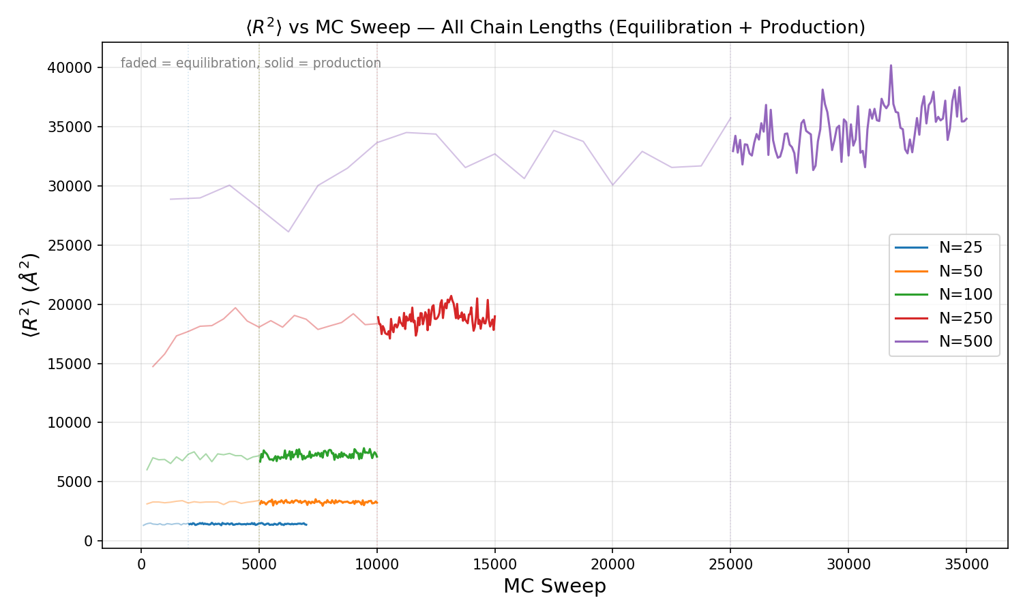
Plot: Running time-average of <R2> (Angstrom^2) vs MC sweep for all five chain lengths (N=25 through N=500) overlaid on one plot. Faded regions show equilibration; solid regions show production. Each chain length reaches its own plateau value, with higher N corresponding to larger R2. N=25, 50, 100 equilibrate quickly and show stable plateaus. N=250 and N=500 show more gradual convergence, with N=500 still exhibiting drift, confirming the need for longer equilibration runs at large N.
fig_Rg2_vs_MC_sweep_all_N.png -- Combined Rg2 running average vs MC sweep for all five chain lengths.
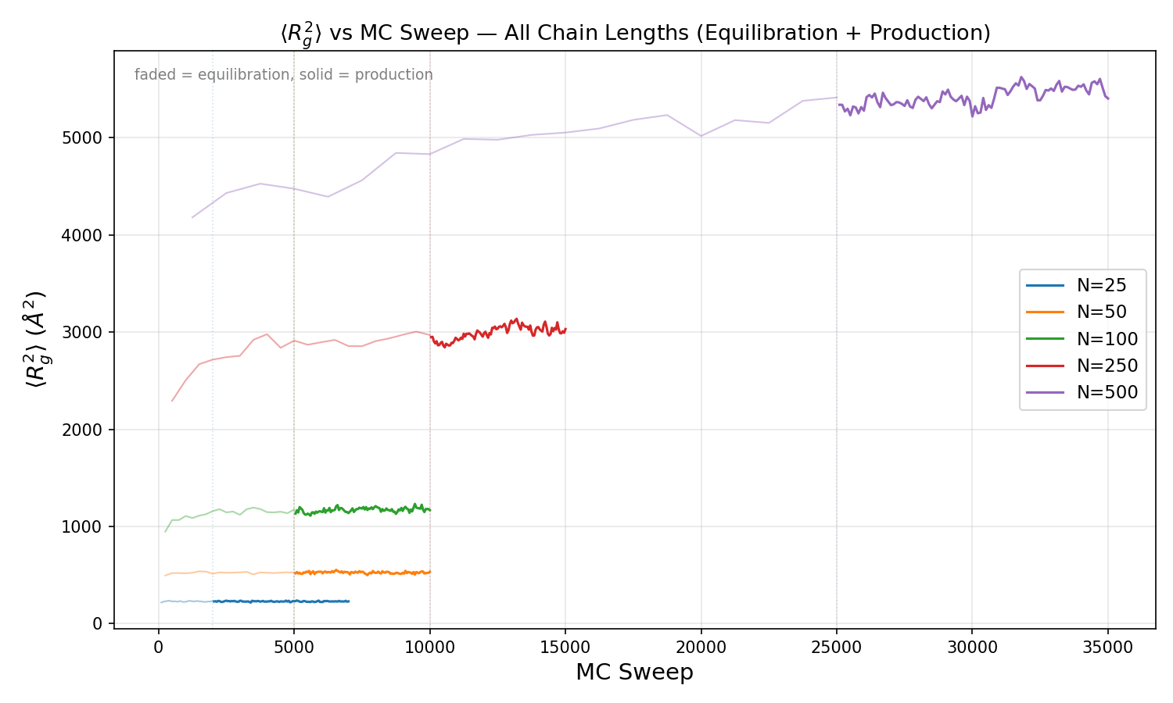
Plot: Running time-average of <Rg2> (Angstrom^2) vs MC sweep for all five chain lengths overlaid. Same structure as the R2 plot above. Each chain length settles to a distinct plateau. The Rg2 values mirror the R2 behavior, with N=500 showing the most gradual convergence. The parallel behavior of R2 and Rg2 equilibration confirms consistent chain relaxation across all length scales.

05_data/
Contains raw TSV data files organized by chain length (N25, N50, N100, N250, N500) and an aggregated JSON validation summary. These are the numerical data behind all plots.
tavg_validation_summary.json -- Aggregated JSON file containing final time-averaged static properties (R2, Rg2, ratio) for each chain length, scaling exponents from log-log fits (2nu_R2 = 1.160, 2nu_Rg2 = 1.160), and pass/fail status against acceptance criteria (R2/Rg2 in [5.9, 6.1]). All chain lengths report "pass": false because the SAW ratio ~6.25 lies outside the ideal-chain acceptance band of [5.9, 6.1].

05_data/N25/
fig1_static_N25_s42.tsv -- Per-chain static properties for N=25. Columns: chain index, R2 (Angstrom^2), Rg2 (Angstrom^2). One row per chain, single-snapshot values from the final configuration.
fig2_seg20_msd_N25_s42.tsv -- Middle-segment (segment 20) mean square displacement g1(t) for N=25. Columns: sweep number, g1 (Angstrom^2). One row per production sweep.
fig3_seg20_diffusion_N25_s42.tsv -- Center-of-mass MSD g_CM(t) for N=25. Columns: sweep number, g_CM (Angstrom^2). One row per production sweep. Used to extract diffusion coefficient D.
fig4_seg20_autocorr_N25_s42.tsv -- End-to-end vector autocorrelation g_R(t) for N=25. Columns: sweep number, g_R (normalized 0 to 1). One row per production sweep. 1/e crossing gives tau_R.
static_vs_sweep.tsv -- Equilibration and production time series for N=25. Columns: sweep, phase (eq/prod), R2, Rg2, R2/Rg2. Sampled every 100 sweeps. Used for equilibration monitoring plots.

05_data/N50/
fig1_static_N50_s42.tsv -- Per-chain static properties for N=50. Columns: chain index, R2 (Angstrom^2), Rg2 (Angstrom^2). One row per chain, single-snapshot values from the final configuration.
fig2_seg20_msd_N50_s42.tsv -- Middle-segment (segment 20) mean square displacement g1(t) for N=50. Columns: sweep number, g1 (Angstrom^2). One row per production sweep.
fig3_seg20_diffusion_N50_s42.tsv -- Center-of-mass MSD g_CM(t) for N=50. Columns: sweep number, g_CM (Angstrom^2). One row per production sweep. Used to extract diffusion coefficient D.
fig4_seg20_autocorr_N50_s42.tsv -- End-to-end vector autocorrelation g_R(t) for N=50. Columns: sweep number, g_R (normalized 0 to 1). One row per production sweep. 1/e crossing gives tau_R.
static_vs_sweep.tsv -- Equilibration and production time series for N=50. Columns: sweep, phase (eq/prod), R2, Rg2, R2/Rg2. Sampled every 100 sweeps. Used for equilibration monitoring plots.

05_data/N100/
fig1_static_N100_s42.tsv -- Per-chain static properties for N=100. Columns: chain index, R2 (Angstrom^2), Rg2 (Angstrom^2). One row per chain, single-snapshot values from the final configuration.
fig2_seg20_msd_N100_s42.tsv -- Middle-segment (segment 20) mean square displacement g1(t) for N=100. Columns: sweep number, g1 (Angstrom^2). One row per production sweep.
fig3_seg20_diffusion_N100_s42.tsv -- Center-of-mass MSD g_CM(t) for N=100. Columns: sweep number, g_CM (Angstrom^2). One row per production sweep. Used to extract diffusion coefficient D.
fig4_seg20_autocorr_N100_s42.tsv -- End-to-end vector autocorrelation g_R(t) for N=100. Columns: sweep number, g_R (normalized 0 to 1). One row per production sweep. 1/e crossing gives tau_R.
static_vs_sweep.tsv -- Equilibration and production time series for N=100. Columns: sweep, phase (eq/prod), R2, Rg2, R2/Rg2. Sampled every 100 sweeps. Used for equilibration monitoring plots.

05_data/N250/
fig1_static_N250_s42.tsv -- Per-chain static properties for N=250. Columns: chain index, R2 (Angstrom^2), Rg2 (Angstrom^2). One row per chain, single-snapshot values from the final configuration.
fig2_seg20_msd_N250_s42.tsv -- Middle-segment (segment 20) mean square displacement g1(t) for N=250. Columns: sweep number, g1 (Angstrom^2). One row per production sweep.
fig3_seg20_diffusion_N250_s42.tsv -- Center-of-mass MSD g_CM(t) for N=250. Columns: sweep number, g_CM (Angstrom^2). One row per production sweep. Used to extract diffusion coefficient D.
fig4_seg20_autocorr_N250_s42.tsv -- End-to-end vector autocorrelation g_R(t) for N=250. Columns: sweep number, g_R (normalized 0 to 1). One row per production sweep. 1/e crossing gives tau_R.
static_vs_sweep.tsv -- Equilibration and production time series for N=250. Columns: sweep, phase (eq/prod), R2, Rg2, R2/Rg2. Sampled every 100 sweeps. Used for equilibration monitoring plots.

05_data/N500/
fig1_static_N500_s42.tsv -- Per-chain static properties for N=500. Columns: chain index, R2 (Angstrom^2), Rg2 (Angstrom^2). One row per chain, single-snapshot values from the final configuration.
fig2_seg20_msd_N500_s42.tsv -- Middle-segment (segment 20) mean square displacement g1(t) for N=500. Columns: sweep number, g1 (Angstrom^2). One row per production sweep.
fig3_seg20_diffusion_N500_s42.tsv -- Center-of-mass MSD g_CM(t) for N=500. Columns: sweep number, g_CM (Angstrom^2). One row per production sweep. Used to extract diffusion coefficient D.
fig4_seg20_autocorr_N500_s42.tsv -- End-to-end vector autocorrelation g_R(t) for N=500. Columns: sweep number, g_R (normalized 0 to 1). One row per production sweep. 1/e crossing gives tau_R.
static_vs_sweep.tsv -- Equilibration and production time series for N=500. Columns: sweep, phase (eq/prod), R2, Rg2, R2/Rg2. Sampled every 100 sweeps. Used for equilibration monitoring plots.

06_executable/
Contains the release build of the simulation application and all required runtime DLLs. This is the exact binary used to generate all data and plots in this deliverable.
RouseValidationWithSegmentedPivotMovesApp.exe -- Main simulation executable. Runs Rouse validation campaigns with segmented pivot MC moves. Accepts command-line parameters for chain length, chain count, sweep counts, volume fraction, and random seed. Produces TSV data files and PNG plots.
RouseValidationWithSegmentedPivotMovesApp.exe.config -- Application configuration file (XML) specifying .NET runtime settings.
ILGPU.dll -- GPU acceleration library (ILGPU). Provides optional GPU compute backends. Not used in this CPU-only validation campaign but included as a runtime dependency.
surpass_chemistry.dll -- SURPASS chemistry module. Defines atom types, bond types, and interaction parameters.
surpass_common.dll -- SURPASS common utilities. Shared data structures, constants, and helper functions.
surpass_io.dll -- SURPASS I/O module. File readers/writers for configuration, trajectory, and data output.
surpass_math.dll -- SURPASS math library. Vector operations, matrix algebra, and numerical methods.
surpass_parallel_lib.dll -- SURPASS parallelization library. Thread pool and task scheduling for multi-core CPU execution.
surpass_physics.dll -- SURPASS physics engine. Energy functions, force fields, and excluded-volume interactions.
surpass_simulation.dll -- SURPASS simulation framework. MC move sets, sweep scheduling, observers, and campaign runner.
surpass_stats.dll -- SURPASS statistics module. Running averages, histograms, correlation functions, and fitting.
Serilog.dll -- Structured logging library. Provides runtime diagnostic logging.
log4net.dll -- Apache log4net logging framework. Legacy logging support.
System.Buffers.dll -- .NET System.Buffers library. Array pooling for memory-efficient computation.
System.Collections.Immutable.dll -- .NET immutable collections library. Thread-safe data structures.
System.Memory.dll -- .NET System.Memory library. Span<T> and Memory<T> for high-performance memory access.
System.Numerics.Vectors.dll -- .NET SIMD vector library. Hardware-accelerated vector arithmetic.
System.Reflection.Metadata.dll -- .NET metadata reader. Required by ILGPU for runtime code generation.
System.Runtime.CompilerServices.Unsafe.dll -- .NET unsafe utilities. Low-level memory operations used by System.Memory.

