Indian PAper currency detection Sysytem

End Semester Project for Algorithm Design 2

By
Saket Kumar Singh
Registration No.1741012089

Abhishek Suren
Registration No.1741012076

Suman Raj Panda
Registration No.1741012154

CSE-C



DEPARTMENT OF COMPUTER SCIENCE AND ENGINEERING
INSTITUTE OF TECHNICAL EDUCATION AND RESEARCH
SIKSHA ‘O’ ANUSANDHAN DEEMED TO BE UNIVERSITY
BHUBANESWAR, ODISHA, INDIA
2019

CONTENT

1.Abstract
2.Introduction
3.Design
4.Initial Algorithm
5.Result
6.Acknowledgement
7.Code
8.Refrence

1.ABSTRACT

One of the most essential issues confronting visual hindered individuals is cash
acknowledgment particularly for paper money. This work presents the development of
real time paper currency identification system for visually challenged. It allows
identifying the demonetization new Indian banknotes for visually challenged persons,
to autonomously deal with new Indian banknotes, particularly while accepting their
money back when looking for their day by day needs. The real time
bank notes are captured and processed through different image processing techniques
like edge detection, segmentation, and feature extraction and classification. In this
proposed work the classification algorithms such as k-Nearest Neighbours (k-NN) for
recognizing each classes of banknote are used. These algorithms are implemented in
Python language with OpenCV .

2. INTRODUCTION
As per the WHO, an expected 253 million individuals live with vision debilitation: 36
million are visually impaired and 217 million have direct to extreme vision weakness and
81% of individuals who are visually impaired or have direct or serious vision hindrance are
matured 50 years or more [2]. Among this number, highest percentage of 15 million people
from India. It is very difficult to do daily routines independently for visually impaired and To
identify Indian banknotes, particularly while accepting their money back when shopping for
their daily needs is a challenging task. On 8th November 2016, the Government of India
reported the demonetization of all ₹500 and ₹1,000 and proclaimed that utilization of all ₹500
and ₹1000 banknotes of the Mahatma Gandhi Series would be invalid past midnight, and
declared the issuance of new ₹500 and ₹2000 banknotes of the Mahatma Gandhi New Series
in return for the old banknotes. It is challenging task for a blind person to identify the new
banknotes, modify the old bank notes with new Indian currency and to do other money
transactions independently. To address these type problems so many research papers are
published from a decade of years for recognizing different countries’ currencies. As of now
there is no optimized system for new Indian bank note recognition in India. To identify or
recognize a bank note, it should be processed through a machine which can detect the bank
notes. Such systems use different image processing techniques to complete this process. All in all there are two patterns in Money acknowledgment inquire about field, Scanner-based and Camera-based frameworks.

3. DESIGN
The proposed work has been done by applying different image processing techniques like
image acquisition, edge detection, segmentation, classification and feature extraction etc…
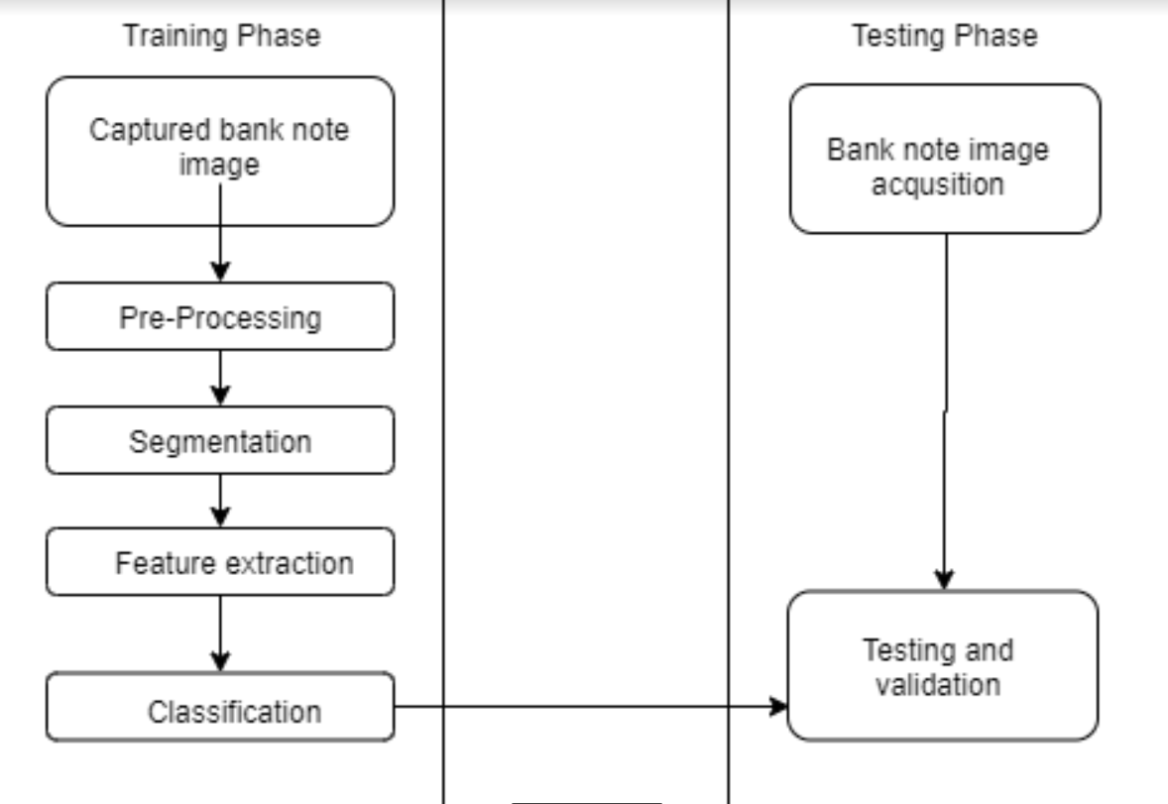

4.INITIAL ALGORITHM
- Image acquisition.
The picture is caught by system’s camera picture and is changed over to grey
scale form. Figure 6 shows different input bank note image samples of 10, 20, 50, 100 and
500 Indian rupee notes.
- Pre-processing.
For noise removal on the picture and enhance the quality, Gaussian obscuring is utilized. The
equation of a Gaussian unction in two dimensions
- Segmentation
With a specific end goal to remove the cash paper from the background , the picture is
changing over to binary form. Canny edge is used to extract the regions;
the mathematical representation is shown in equation. Discovering Intensity Gradient of the
Image
Smoothened picture is then separated with a Sobel kernel in both flat and vertical heading
to get first derivative level way and vertical bearing. From these two pictures, we can discover
edge gradient and heading

- Feature extraction
Feature extraction is the particular type of dimensionality reduction technique. It is the
technique for catching the visual substance of picture for recovery and indexing. At the point
when contribution to the calculation is too extensive to continue and it is having much
information yet not more data. At that point input information will be changed over into
lessened portrayal set of highlights. Feature extraction makes straightforward the measure of
assets required to portray the vast arrangement of information.
- Classification
The information comprises of the k nearest training cases in the feature
space. The yield relies upon whether k-NN is utilized for classification or relapse.
The result is either valid or false is depends on the testing inputs Text-to-speech (TTS) is utilized to tell the client by the estimation of the paper note
which gives simple comprehension and coordination be-tween the client and the application

5. RESULTS
In this paper, a basic Indian currency identification system has been proposed. The proposed
system starts with catching still monitory bank note pictures. A straightforward image
processing methods like thresholding, noise removal, edge detection and segmentation are
used to extract the ROI and facilitate the template matching procedure. KNN is used to
classification after that to find the ROI in the dataset images. The system has been composed in Python 3language and OpenCV library. The correctness’s
of banknote location and banknote esteem acknowledgment are 88% and 100%, individually
6.ACKNOWLEDGEMENT
IT is a great pleasure for us to undertake this project Indian currency recognition system. We would like to express our special thanks to Mr. Paresh Badiya for his able guidance and support in completing this project and providing us with all the facility that we required. This project would not have been completed without his help.

7.Code
Camera.py

import cv4
key = cv2.waitKey(1)
webcam = cv2.VideoCapture(0)
while True:
try:
check, frame = webcam.read()
print(check)
print(frame)
cv2.imshow("Capturing", frame)
key = cv2.waitKey(1)
if key == ord('s'):
cv2.imwrite(filename='saved_img.jpg', img=frame)
webcam.release()
img_new = cv2.imread('saved_img.jpg', cv2.IMREAD_GRAYSCALE)
img_new = cv2.imshow("Captured Image", img_new)
cv2.waitKey(1650)
cv2.destroyAllWindows()
print("Processing image...")
img_ = cv2.imread('saved_img.jpg', cv2.IMREAD_ANYCOLOR)
print("Image saved!")
break
elif key == ord('q'):
print("Turning off camera.")
webcam.release()
print("Camera off.")
print("Program ended.")
cv2.destroyAllWindows()
break
except(KeyboardInterrupt):
print("Turning off camera.")
webcam.release()
print("Camera off.")
print("Program ended.")
cv2.destroyAllWindows()
break

detect.py
from utils import *
from gtts import gTTS
import os
from matplotlib import pyplot as plt
import subprocess
from gtts import gTTS
max_val = 8
max_pt = -1
max_kp = 0
orb = cv2.ORB_create()
test_img = read_img('files/test_100_2.jpg')
original = resize_img(test_img, 0.7)
display('original', original)
# keypoints and descriptors
# (kp1, des1) = orb.detectAndCompute(test_img, None)
(kp1, des1) = orb.detectAndCompute(test_img, None)
training_set = ['files/20.jpg', 'files/50.jpg', 'files/100.jpg', 'files/500.jpg']
for i in range(0, len(training_set)):
# train image
train_img = cv2.imread(training_set[i])
(kp2, des2) = orb.detectAndCompute(train_img, None)
# brute force matcher
bf = cv2.BFMatcher()
all_matches = bf.knnMatch(des1, des2, k=2)
good = []
# give an arbitrary number -> 0.789
# if good -> append to list of good matches
for (m, n) in all_matches:
if m.distance < 0.789 * n.distance:
good.append([m])
if len(good) > max_val:
max_val = len(good)
max_pt = i
max_kp = kp2
print(i, ' ', training_set[i], ' ', len(good))
if max_val != 8:
#print(training_set[max_pt])
#print('good matches ', max_val)
train_img = cv2.imread(training_set[max_pt])
img3 = cv2.drawMatchesKnn(test_img, kp1, train_img, max_kp, good, 4)
note = str(training_set[max_pt])[6:-4]
print('\nDetected denomination: Rs. ', note)
mytext = note
language = 'en'
myobj = gTTS(text=mytext, lang=language, slow=False)
myobj.save("welcome.mp3")
os.system(" welcome.mp3")
else:
print('No Matches')

utils.py
def read_img(file_name):
img = cv2.imread(file_name)
return img
# resize image with fixed aspect ratio
def resize_img(image, scale):
res = cv2.resize(image, None, fx=scale, fy=scale, interpolation = cv2.INTER_AREA)
return res
# convert image to grayscale
def img_to_gray(image):
img_gray = cv2.cvtColor(image, cv2.COLOR_RGB2GRAY)
return img_gray
# gaussian blurred grayscale
def img_to_gaussian_gray(image):
img_gray = cv2.GaussianBlur(img_to_gray(image), (5, 5), 0)
return img_gray
# convert image to negative
def img_to_neg(image):
img_neg = 255 - image
return img_neg
# binarize (threshold)
# retval not used currently
def binary_thresh(image, threshold):
retval, img_thresh = cv2.threshold(image, threshold, 255, cv2.THRESH_BINARY)
return img_thresh
# NO IDEA HOW THIS WPRKS
def adaptive_thresh(image):
img_thresh = cv2.adaptiveThreshold(image, 255, cv2.ADAPTIVE_THRESH_GAUSSIAN_C, cv2.THRESH_BINARY, 11, 8)
# cv2.adaptiveThreshold(src, maxValue, adaptiveMethod, thresholdType, blockSize, C[, dst]) → dsta
return img_thresh
# sobel edge operator
def sobel_edge(image, align):
img_horiz = cv2.Sobel(image, cv2.CV_8U, 0, 1)
img_vert = cv2.Sobel(image, cv2.CV_8U, 1, 0)
if align == 'h':
return img_horiz
elif align == 'v':
return img_vert
else:
print('use h or v')
# sobel edge x + y
def sobel_edge2(image):
# ksize = size of extended sobel kernel
grad_x = cv2.Sobel(image, cv2.CV_16S, 1, 0, ksize=3, borderType = cv2.BORDER_DEFAULT)
grad_y = cv2.Sobel(image, cv2.CV_16S, 0, 1, ksize=3, borderType = cv2.BORDER_DEFAULT)
abs_grad_x = cv2.convertScaleAbs(grad_x)
abs_grad_y = cv2.convertScaleAbs(grad_y)
dst = cv2.addWeighted(abs_grad_x, 0.5, abs_grad_y, 0.5, 0)
return dst
# canny edge operator
def canny_edge(image, block_size, ksize):
# block_size => Neighborhood size
# ksize => Aperture parameter for the Sobel operator
# 350, 350 => for smaller 500
# 720, 350 => Devnagari 500, Reserve bank of India
img = cv2.Canny(image, block_size, ksize)
# dilate to fill up the numbers
#img = cv2.dilate(img, None)
return img
# laplacian edge
def laplacian_edge(image):
# good for text
img = cv2.Laplacian(image, cv2.CV_8U)
return img
# detect countours
def find_contours(image):
(_, contours, _) = cv2.findContours(image, cv2.RETR_LIST, cv2.CHAIN_APPROX_SIMPLE)
contours = sorted(contours, key = cv2.contourArea, reverse = True)[:5]
return contours
# median blur
def median_blur(image):
blurred_img = cv2.medianBlur(image, 3)
return blurred_img
# dialte image to close lines
def dilate_img(image):
img = cv2.dilate(image, np.ones((5,5), np.uint8))
return img
# erode image
def close(image):
img = cv2.Canny(image, 75, 300)
img = cv2.dilate(img, None)
img = cv2.erode(img, None)
return img
def harris_edge(image):
img_gray = np.float32(image)
corners = cv2.goodFeaturesToTrack(img_gray, 4, 0.03, 200, None, None, 2,useHarrisDetector=True, k=0.04)
corners = np.int0(corners)
for corner in corners:
x, y = corner.ravel()
cv2.circle(image, (x, y), 3, 255, -1)
return image
# calculate histogram
def histogram(image):
hist = cv2.calcHist([image], [0], None, [256], [0, 256])
# cv2.calcHist(images, channels, mask, histSize, ranges[, hist[, accumulate]])
plt.plot(hist)
plt.show()
# fast fourier transform
def fourier(image):
f = np.fft.fft2(image)
fshift = np.fft.fftshift(f)
magnitude_spectrum = 20 * np.log(np.abs(fshift))
plt.subplot(121), plt.imshow(image, cmap='gray')
plt.title('Input Image'), plt.xticks([]), plt.yticks([])
plt.subplot(122), plt.imshow(magnitude_spectrum, cmap='gray')
plt.title('FFT'), plt.xticks([]), plt.yticks([])
plt.show()
# calculate scale and fit into display
def display(window_name, image):
screen_res = 1440, 900 # MacBook Air
scale_width = screen_res[0] / image.shape[1]
scale_height = screen_res[1] / image.shape[0]
scale = min(scale_width, scale_height)
window_width = int(image.shape[1] * scale)
window_height = int(image.shape[0] * scale)
# reescale the resolution of the window
cv2.namedWindow(window_name, cv2.WINDOW_NORMAL)
cv2.resizeWindow(window_name, window_width, window_height)
# display image
cv2.imshow(window_name, image)
# wait for any key to quit the program
cv2.waitKey(0)
cv2.destroyAllWindows()

8.Refrence
- Sonali R. Darade, Prof.G.R.Gidveer, Automatic Recognition of Fake Indian Currency
Note, 2016 International Conference on Electrical Power and Energy Systems (ICEPES)
Maulana Azad National Institute of Technology, Bhopal, India. Dec 14-16, 2016
- Snigdha Kamal, Simarpreet Singh Chawla, Nidhi Goel, and Balasubramanian Raman,
Feature Extraction and Identification of Indian Currency Notes Fifth National Conference
on Computer Vision, Pattern Recognition, Image Processing and Graphics

