AI Process Flow Improvement Agent
Business Systems Analysis | AS-IS / TO-BE Process Improvement | n8n + OpenAI + draw.io
Author: Muhammad N Sair
Contact: NaumanSair@outlook.com | www.linkedin.com/in/muhammad-sair
GitHub: https://github.com/mnsair/AI-ProcessFlow-Improvement-Agent

Contents
1. Agent Overview 3
2. Final n8n Process 4
3. How to Use the Agent 5
4. Short Test Case - Employee Software Access Request 5
5. Sample Agent Results 7
1. EXECUTIVE SUMMARY 7
2. CURRENT PROCESS OVERVIEW 7
3. AS-IS PROCESS STEPS 7
4. AS-IS PROCESS FLOW 9
5. BOTTLENECK AND ROOT-CAUSE ANALYSIS 10
6. RECOMMENDATIONS 10
7. TO-BE PROCESS STEPS 11
8. TO-BE PROCESS FLOW 13
9. KPI AND MEASUREMENT PLAN 14
10. RISKS, CONTROLS, DEPENDENCIES, AND ASSUMPTIONS 14
Risks 14
Security/Compliance Considerations 14
Dependencies 15
Assumptions Requiring Validation 15
11. IMPLEMENTATION ROADMAP 15
0–30 DAYS 15
30–90 DAYS 16
90+ DAYS 16
6. Practical Use as a Business Systems Analyst 17

1. Agent Overview
Purpose. The AI Process Flow Improvement Agent is an n8n-based business analysis assistant designed to help a business user describe a current process, identify bottlenecks and root-cause hypotheses, and generate a traceable improved future-state process.
Business Systems Analyst behavior. The agent uses discovery-first logic rather than immediately proposing a solution. If process information is incomplete, it asks focused questions. When enough information is available, it documents the AS-IS process, identifies evidence-supported issues, recommends improvements while preserving controls, and creates the TO-BE process.
- Discovery gate prevents premature diagram generation.
- AS-IS steps are sequentially numbered and matched to the process flow.
- Confirmed/likely bottlenecks are highlighted in red.
- Facts, assumptions, and root-cause hypotheses are distinguished.
- Required approvals, security controls, auditability, documentation, and human oversight are preserved.
- TO-BE steps are sequentially numbered and matched to the process flow.
- New or materially improved TO-BE activities are highlighted in green.
- The final chat response includes clickable AS-IS and TO-BE draw.io links for browser-based review and editing.
- The agent also recommends KPIs and an implementation roadmap.

2. Final n8n Process
The final workflow is intentionally simple: the AI Agent performs discovery and analysis; the readiness gate determines whether enough information exists to generate diagrams; and the draw.io link node returns editable browser-based AS-IS and TO-BE process flows.
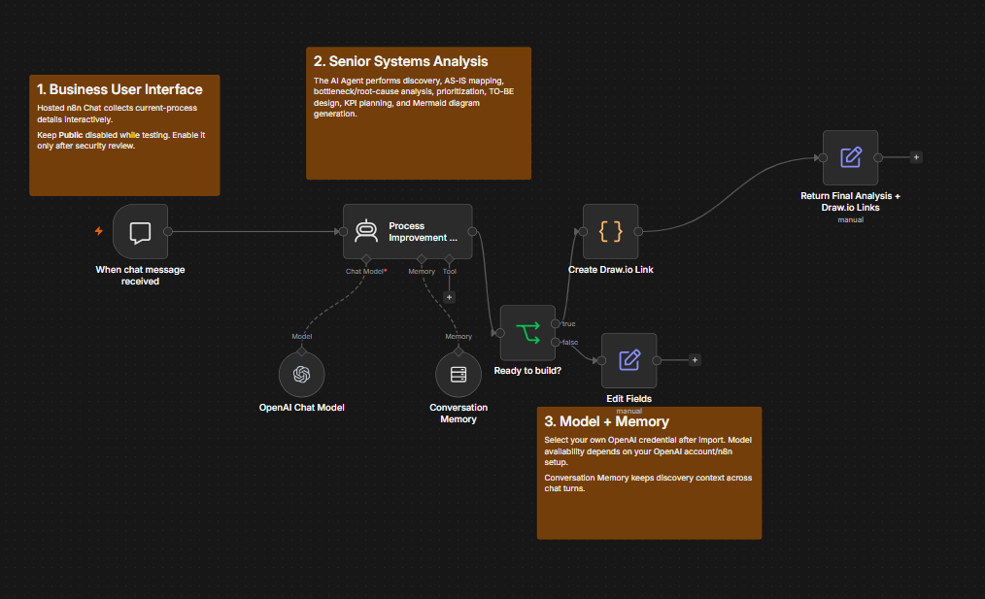
Figure 1. Final n8n Process Improvement AI Agent workflow.

3. How to Use the Agent
- Import the workflow JSON into n8n.
- Select your OpenAI credential/model in the OpenAI Chat Model node.
- Publish/activate the workflow and open the hosted n8n Chat URL.
- Describe the business process, including steps, actors, systems, known pain points, metrics, and controls where available.
- If important details are missing, answer the agent’s discovery questions.
- When the process is sufficiently understood, review the full analysis in chat.
- Use the AS-IS draw.io link to open the current-state process flow with bottlenecks highlighted in red.
- Use the TO-BE draw.io link to open the improved process flow with new/materially improved steps highlighted in green.
- Refine the draw.io diagrams as needed and use the analysis to support stakeholder discussions, requirements, backlog refinement, or process-improvement planning.

4. Short Test Case - Employee Software Access Request
Item | Details
Process Name | Employee Software Access Request
Business Objective | Provide employees access to approved software quickly while maintaining manager approval and security controls.
Trigger | An employee submits a software access request.
End | Access is granted or the request is rejected and documented.
Process Steps
1. Employee submits a software access request in the service portal.
2. Manager reviews and approves or rejects the request.
3. Approved requests enter the IT Service Desk queue.
4. Service Desk manually checks whether the employee already has a license and whether the requested software is approved.
5. If information is missing, the Service Desk sends the request back to the employee for clarification.
6. Service Desk manually emails the Security team for approval when the software requires elevated access.
7. Security reviews the request and responds by email.
8. Service Desk updates the ticket manually with the Security decision.
9. If approved, Service Desk assigns the request to the Application Support team.
10. Application Support provisions the software.
11. Service Desk confirms access with the employee and closes the ticket.
Known Bottlenecks
- Bottleneck 1 - Step 4: Manual license and software-approval checks take time and are repeated for many requests.
- Bottleneck 2 - Steps 6-8: Security approval is handled through email, creating waiting time and manual ticket updates.
Current Metrics
- About 60 requests per day.
- Average completion time: 2 business days.
- About 15% of requests are returned because required information is missing.
- Security-related requests can wait 4-6 hours for approval.
Controls That Must Remain
- Manager approval.
- Security approval for elevated-access software.
- Audit trail of approvals.
- Final access confirmation.
Test Prompt: Analyze this process, identify the bottlenecks, create the AS-IS and TO-BE process flows, and recommend improvements while preserving the required controls.

5. Sample Agent Results
The following sample results were generated from the test case above. Mermaid source is intentionally omitted from this document and replaced with rendered process-flow diagrams.

1. EXECUTIVE SUMMARY
The process analyzed is the Employee Software Access Request process. Its business objective is to provide employees with access to approved software quickly while preserving required manager approval, security approval for elevated-access software, an audit trail of approvals, and final access confirmation.
The current process is generally clear and controlled, but two significant inefficiencies are evident:
- Step 4 is a confirmed bottleneck because license and software-approval checks are performed manually and repeatedly.
- Steps 6–8 form a confirmed bottleneck area because security approval is handled by email, introducing waiting time and requiring manual ticket updates.
A further confirmed issue is that 15% of requests are returned for missing information, which creates rework and delay.
The overall improvement approach is to preserve the required controls while reducing avoidable manual effort, wait time, and rework through better intake validation, structured workflow routing, system-based approval capture, and reduced manual ticket handling.
Expected benefits include faster turnaround, lower manual effort for Service Desk staff, better auditability, reduced rework, and improved consistency in handling access requests.

2. CURRENT PROCESS OVERVIEW
Item | Details
Process Name | Employee Software Access Request
Business Objective | Provide employees access to approved software quickly while maintaining manager approval and security controls
Process Trigger | An employee submits a software access request
Process End | Access is granted or the request is rejected and documented
Current Volume | About 60 requests per day
SLA / Service Target | Not provided
Primary Actors | Employee, Manager, IT Service Desk, Security Team, Application Support Team
Primary Systems | Service portal, email, ticketing/service management system
Key Controls | Manager approval, Security approval for elevated-access software, audit trail of approvals, final access confirmation
Major Dependencies | Manager responsiveness, Service Desk processing capacity, Security review turnaround, Application Support provisioning, completeness of submitted request information

3. AS-IS PROCESS STEPS
Step Number | Process Step | Detailed Description | Process Owner | System/Application | Input | Output | Bottleneck Status | Control/Dependency
1 | Submit Software Access Request | Employee submits a software access request through the service portal. | Employee | Service portal | Access need/request details | Submitted request ticket | Normal | Depends on employee entering complete information
2 | Manager Reviews Request | Manager reviews the request and either approves or rejects it. | Manager | Service portal / ticketing system | Submitted request | Approved or rejected request | Normal | Required manager approval control
3 | Route Approved Request to Service Desk Queue | Approved requests are placed into the IT Service Desk queue for fulfillment processing. | System / IT Service Desk | Ticketing system | Manager-approved request | Request in Service Desk queue | Normal | Depends on queue routing
4 | Check License and Software Approval | Service Desk manually verifies whether the employee already has a license and whether the requested software is approved. | IT Service Desk | Ticketing system and related reference sources | Queued approved request | Validation result or identified issue | Confirmed Issue / Likely Bottleneck | Manual verification dependency; repeated activity
5 | Request Clarification if Information Missing | If required information is missing, Service Desk sends the request back to the employee for clarification. | IT Service Desk | Ticketing system / service portal | Incomplete request | Clarification request sent | Confirmed Issue | Rework loop caused by incomplete intake information
6 | Send Security Approval Email | For software requiring elevated access, Service Desk manually emails the Security team for approval. | IT Service Desk | Email | Request requiring security review | Security approval request sent | Confirmed Issue / Likely Bottleneck | Required security approval must remain
7 | Review Elevated Access Request | Security reviews the request and responds by email with approval or rejection. | Security Team | Email | Security approval request | Security decision | Confirmed Issue / Likely Bottleneck | Required security approval control
8 | Update Ticket with Security Decision | Service Desk manually records the Security decision in the ticket. | IT Service Desk | Ticketing system | Security email decision | Updated ticket with decision | Confirmed Issue / Likely Bottleneck | Audit trail dependency; manual update activity
9 | Assign Request to Application Support | If approved, Service Desk assigns the request to the Application Support team for provisioning. | IT Service Desk | Ticketing system | Approved request | Provisioning assignment | Normal | Depends on accurate routing
10 | Provision Software Access | Application Support provisions the requested software access. | Application Support Team | Provisioning tools / application platform | Assigned approved request | Software access provisioned | Normal | Dependent on application support capability and entitlements
11 | Confirm Access and Close Ticket | Service Desk confirms access with the employee and closes the ticket. | IT Service Desk | Ticketing system / email | Provisioned access | Closed ticket and confirmation | Normal | Required final access confirmation control

4. AS-IS PROCESS FLOW
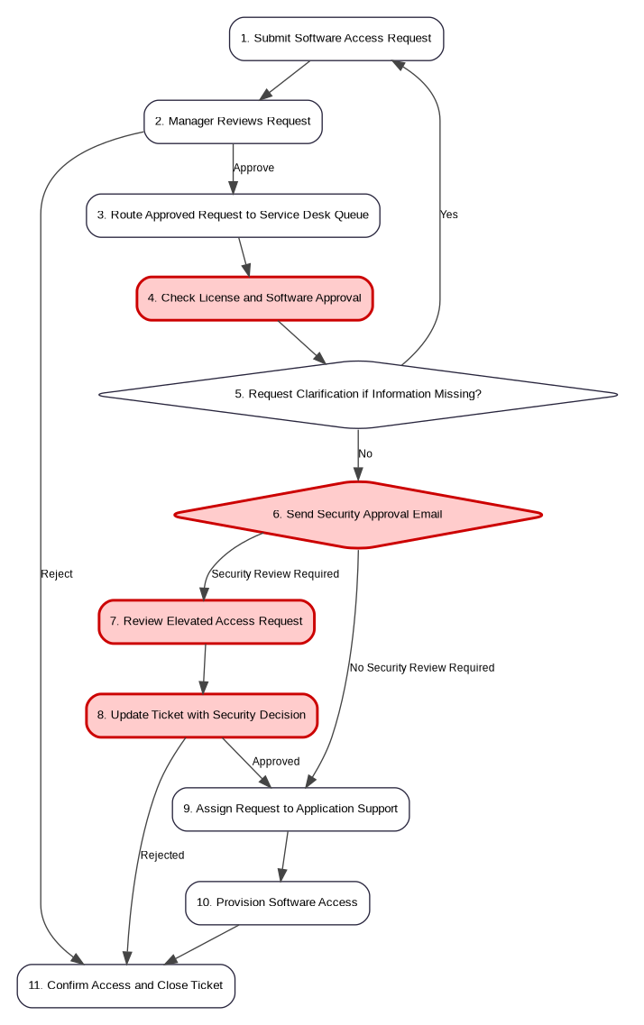
Figure 2. AS-IS process flow. Red steps identify confirmed/likely bottleneck areas.

5. BOTTLENECK AND ROOT-CAUSE ANALYSIS
Related AS-IS Step Number | Bottleneck / Issue | Evidence | Classification | Business / Operational / Security Impact | Priority | Root-Cause Hypothesis, if applicable | Recommended Action
4 | Manual license and software-approval checks are time-consuming and repetitive | User identified this as Bottleneck 1; checks are manual and repeated across many requests; volume is about 60 requests/day | Confirmed Issue | Slower request handling, higher manual effort, increased queue time, risk of inconsistent validation | High | Validation data may not be centrally available in the workflow, forcing repeated manual lookup | Add structured validation support, approved software reference integration, and license visibility at fulfillment stage
5 | Requests are returned for missing information | 15% of requests are returned for clarification | Confirmed Issue | Rework, increased cycle time, user frustration, extra Service Desk effort | High | Intake form may not enforce all required fields or business rules before submission | Improve request form design and pre-submission validation
6 | Security approval initiation is manual via email | User identified Steps 6–8 as Bottleneck 2; manual email handling introduces delay | Confirmed Issue | Wait time, manual handling, reduced transparency, dependency on inbox monitoring | High | Workflow does not route security-review cases through a structured approval mechanism | Replace email-based routing with ticket-based approval workflow while preserving security control
7 | Security response time creates waiting time | Security-related requests can wait 4–6 hours for approval | Confirmed Issue | Delays cycle time for elevated-access requests; potential queue buildup | High | Security approvals may not be prioritized or workflow-managed in a queue with SLA visibility | Introduce queue-based approval handling, notifications, and turnaround monitoring
8 | Service Desk manually updates ticket with Security decision | User identified manual ticket updates as part of Bottleneck 2 | Confirmed Issue | Additional manual work, risk of transcription error, weaker process efficiency | Medium | Security decisions are not captured directly in the ticketing workflow | Capture approval decisions directly within the workflow for automatic audit logging
6–8 | Fragmented security approval trail across email and ticket | Approval handled by email, then re-entered manually into ticket | Likely Bottleneck | Auditability risk, inconsistent records, extra handling, potential missed updates | Medium | Separate systems and lack of integrated approval capture | Use ticket-native approval records or integrated approval workflow
2, 6–8 | Approval controls may be operationally sound but administratively inefficient | Required approvals must remain; delays arise from how approvals are routed and recorded, not from the need for approval itself | Root-Cause Hypothesis | Important for improvement design because controls cannot be removed | Medium | The issue is workflow design rather than the control requirement | Streamline routing and evidence capture without removing approvals

6. RECOMMENDATIONS
Process Improvement | System Improvement | Data Improvement | Integration Improvement | Automation Opportunity | Workflow Improvement | Ownership Improvement | Governance Improvement | Control Consideration | Expected Benefit
Redesign intake to require complete request details before submission | Update service portal form to include mandatory fields and conditional questions | Standardize required request data for each software type | Integrate approved software catalog/reference into request workflow if available | Pre-submit validation to reduce incomplete tickets | Automatically route complete requests forward and incomplete ones back before Service Desk review | Clarify employee responsibility for complete submissions | Maintain a governed list of approved software and elevated-access software | Preserve manager approval and audit trail | Reduced rework and lower clarification volume
Standardize license and software-approval validation | Present Service Desk with a guided validation view | Make software approval status and license availability visible in process | Integrate ticket workflow with license/reference data sources where feasible | Auto-check known approval and license conditions when data is available | Reduce repeated manual lookups | Define ownership for software approval reference data | Establish stewardship for software catalog quality | Preserve review where automated confidence is insufficient | Faster processing and more consistent decisions
Replace email-based security approval with ticket-based approval workflow | Use ticketing system approvals rather than standalone email | Capture structured security decision data | Integrate Security approval step directly into the service workflow | Auto-route elevated-access requests to Security | Trigger approval tasks automatically and notify Security | Clarify Security queue ownership and response responsibility | Add approval SLA monitoring and exception management | Preserve required Security approval and audit trail | Reduced waiting time and stronger traceability
Automatically write Security decisions back to the ticket | Eliminate duplicate manual updates | Store decision, approver, timestamp, and comments in structured fields | Native integration within service management platform preferred | Auto-update status based on approval outcome | Remove unnecessary Service Desk administrative steps | Service Desk focuses on exceptions rather than transcription | Standardize approval recording rules | Preserve audit evidence | Lower manual effort and better audit quality
Add queue monitoring for aging requests | Surface pending approvals and fulfillment delays | Track delay reasons | Integrate dashboards across Service Desk and Security queues if possible | Automated reminders/escalations for overdue approvals | Better exception handling | Assign queue monitoring responsibility | Introduce operational review cadence | Preserve approval controls | Improved SLA management and visibility
Maintain final confirmation step but standardize closure evidence | Use closure templates/checklists | Capture confirmation method and timestamp | Not required if available natively | Auto-send confirmation request/notification | Ensure closure consistency | Clarify Service Desk closure ownership | Closure quality review if needed | Preserve final access confirmation control | Better customer communication and closure quality

7. TO-BE PROCESS STEPS
Step Number | Process Step | Detailed Description | Process Owner | System/Application | Input | Output | Improvement | Automation/Integration | Control/Dependency | Expected Benefit | KPI/Measurement
1 | Submit Software Access Request | Employee submits the request through an improved service portal form with required fields and conditional questions. | Employee | Service portal | Access need/request details | Structured request submission | Modified | Form validation and guided data capture | Depends on employee input | Fewer incomplete requests | Clarification rate
2 | Validate Request Completeness | The portal or workflow checks whether all required information is present before routing the request. | System | Service portal / workflow engine | Submitted request | Complete request or prompt to correct | New | Automated validation | Preserves intake quality control | Reduced rework before fulfillment | First-pass completeness rate
3 | Manager Reviews Request | Manager reviews and approves or rejects the request. | Manager | Ticketing/workflow system | Complete request | Approved or rejected request | Unchanged | Existing approval workflow | Required manager approval control | Preserved governance with improved intake quality | Manager approval turnaround
4 | Route Approved Request to Service Desk Queue | Approved requests are routed to the Service Desk queue. | System | Ticketing system | Approved request | Queued request | Unchanged | Existing routing | Queue dependency remains | Consistent handoff | Queue entry time
5 | Perform Guided License and Software Validation | Service Desk reviews request using visible software approval and license information supported by workflow data and references. | IT Service Desk | Ticketing system with validation support | Queued approved request | Validation result | Modified | Assisted validation; potential data lookup integration | Human review retained where needed | Reduced manual lookup time and more consistency | Validation handling time
6 | Determine Whether Security Review Is Required | Workflow identifies whether requested software requires Security approval for elevated access. | System / IT Service Desk | Ticketing/workflow system | Validated request | Routing decision | New | Rules-based routing | Required security control preserved | Faster and more consistent routing | Correct routing rate
7 | Route Security Approval Task | For elevated-access software, the system creates and routes a Security approval task within the ticketing workflow. | System | Ticketing/workflow system | Request requiring security review | Security approval task | New | Automated workflow routing | Required Security approval control | Eliminates email initiation delay | Security routing time
8 | Review Elevated Access Request | Security reviews the request within the workflow and approves or rejects it. | Security Team | Ticketing/workflow system | Security approval task | Security decision | Modified | System-based approval capture | Required security approval and audit trail | Better visibility and auditability | Security approval turnaround
9 | Record Security Decision Automatically | The workflow automatically records Security’s decision, approver, and timestamp in the ticket. | System | Ticketing/workflow system | Security decision | Updated ticket | New | Automated ticket update | Audit trail preserved | Removes manual ticket administration | Manual update reduction
10 | Assign Request to Application Support | Approved requests are assigned to Application Support for provisioning. | IT Service Desk / System | Ticketing system | Fully approved request | Provisioning assignment | Modified | Possible automatic routing | Depends on correct assignment rules | Faster handoff | Assignment turnaround
11 | Provision Software Access | Application Support provisions the requested software. | Application Support Team | Provisioning tools / application platform | Assigned approved request | Software access provisioned | Unchanged | Existing provisioning tools | Provisioning dependency remains | Controlled fulfillment | Provisioning cycle time
12 | Confirm Access and Close Ticket | Service Desk confirms access with the employee and closes the ticket with closure evidence recorded. | IT Service Desk | Ticketing system / notification tool | Provisioned access | Closed ticket and confirmation | Modified | Standardized closure workflow and notification | Required final access confirmation control | Better closure consistency and customer communication | Closure confirmation rate

8. TO-BE PROCESS FLOW
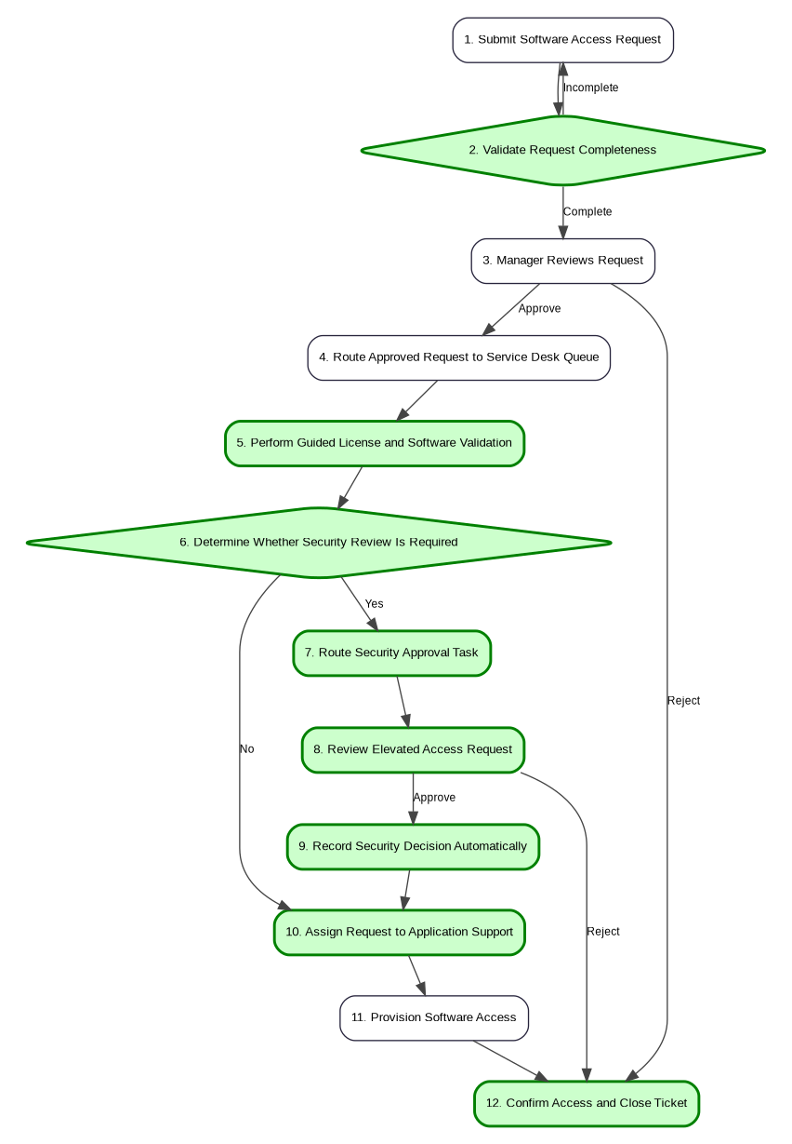
Figure 3. TO-BE process flow. Green steps identify new or materially improved activities.

9. KPI AND MEASUREMENT PLAN
KPI | Business Purpose | Current Baseline | Target | Measurement Method | Measurement Frequency | Owner
End-to-end completion time | Measure overall request speed | Average completion time: 2 business days | Proposed target to be defined after workflow redesign | Ticket submission-to-closure elapsed time | Weekly / Monthly | Service Desk Manager
Clarification / return rate | Measure intake quality and rework | About 15% | Proposed target to reduce from current baseline | Count of requests returned for missing information / total requests | Weekly / Monthly | Service Desk Manager
Security approval turnaround time | Measure delay in elevated-access approvals | 4–6 hours for security-related requests | Proposed target to be defined after workflow implementation | Time from Security task creation to decision | Weekly | Security Team Lead
Manual ticket update rate for security approvals | Measure administrative waste reduction | Baseline to be established | Target: near-zero manual updates if workflow automation is implemented | Count of manually updated security approval tickets | Monthly | Service Desk Manager
First-pass completeness rate | Measure percentage of requests complete at initial submission | Baseline to be established | Proposed target to be defined after intake validation goes live | Percentage of requests not returned for missing information | Weekly / Monthly | Service Portal Owner
Queue aging for Service Desk review | Measure backlog and processing delay | Baseline to be established | Proposed target to be defined | Age of tickets waiting at Step 5 | Daily / Weekly | Service Desk Manager
Security workflow SLA compliance | Measure performance against internal approval expectations | Baseline to be established | Proposed target to be defined | Percentage of Security approval tasks completed within agreed turnaround | Weekly / Monthly | Security Team Lead
Final confirmation completion rate | Measure adherence to required closure control | Baseline to be established | 100% recommended because this is a required control | Audit of ticket closure records | Monthly | Service Desk Manager

10. RISKS, CONTROLS, DEPENDENCIES, AND ASSUMPTIONS

Risks
Type | Description
Implementation Risk | Workflow changes may require ticketing-system configuration effort and stakeholder alignment across Service Desk, Security, and Application Support
Implementation Risk | Data needed for automated or guided license/software validation may not currently be centralized or reliable
Operational Risk | If routing rules for security-review software are incomplete, requests may be misrouted
Operational Risk | Over-reliance on automation without proper exception handling could delay non-standard requests

Security/Compliance Considerations
Item | Description
Required Control | Manager approval must remain
Required Control | Security approval for elevated-access software must remain
Required Control | Audit trail of approvals must remain
Required Control | Final access confirmation must remain
Control Consideration | Improvements should change routing and recording mechanisms, not eliminate required human approvals

Dependencies
Type | Description
System Dependency | Service portal and ticketing/workflow capabilities
Data Dependency | Reliable approved software list and elevated-access classification data
Data Dependency | License availability or entitlement reference information, if used for assisted validation
Organizational Dependency | Security team participation in workflow-based approval model
Organizational Dependency | Application Support provisioning responsiveness
Organizational Dependency | Service Desk adoption of revised workflow
External Dependency | Not provided

Assumptions Requiring Validation
Assumption | Reason
Service portal and ticketing system can support structured validation and approval workflow changes | Specific platform capabilities were not provided
Approved software and elevated-access categories can be maintained in a usable reference source | Source system for this data was not provided
Security approvals can be performed in the ticketing workflow rather than only by email | Current policy constraints beyond stated controls were not provided
Rejected requests can be documented and closed through the same closure step used for fulfilled requests | End-state wording indicates both granted and rejected requests are documented, but closure handling detail was not separately specified

11. IMPLEMENTATION ROADMAP

0–30 DAYS
Recommendation | Related problem/bottleneck | Expected outcome | Primary owner/stakeholder | Key dependency | Suggested timeframe
Document current required intake fields and missing-information reasons | Step 5 rework / 15% clarification rate | Better understanding of why requests are incomplete | Service Desk Manager | Historical ticket review | 0–30 days
Clarify ownership for approved software list and elevated-access classification | Step 4 and Steps 6–8 delays | Foundation for better routing and validation | IT Service Owner / Security Lead | Agreement across IT and Security | 0–30 days
Standardize closure checklist including final access confirmation evidence | Control preservation at Step 11 | More consistent closure and audit readiness | Service Desk Manager | Ticketing template update | 0–30 days
Establish operational monitoring for security-related request aging | Steps 6–8 delay | Better visibility into waiting requests | Security Team Lead / Service Desk Manager | Reporting access | 0–30 days

30–90 DAYS
Recommendation | Related problem/bottleneck | Expected outcome | Primary owner/stakeholder | Key dependency | Suggested timeframe
Enhance portal form with mandatory fields and conditional questions | Step 5 rework | Reduced incomplete submissions | Service Portal Owner | Form configuration capability | 30–90 days
Configure workflow to identify software requiring Security approval | Steps 6–8 delay | More consistent routing and fewer manual decisions | Service Management Platform Owner | Maintained software classification data | 30–90 days
Replace email-based Security approval with ticket-based approval tasks | Steps 6–8 bottleneck | Reduced wait and stronger audit trail | Service Management Platform Owner / Security Lead | Security buy-in and workflow capability | 30–90 days
Configure automatic recording of Security decisions in ticket | Step 8 manual update | Reduced administrative effort and better traceability | Service Management Platform Owner | Workflow approval configuration | 30–90 days

90+ DAYS
Recommendation | Related problem/bottleneck | Expected outcome | Primary owner/stakeholder | Key dependency | Suggested timeframe
Integrate software approval and license reference data into fulfillment workflow | Step 4 bottleneck | Faster and more consistent validation | IT Systems Owner | Data quality and integration feasibility | 90+ days
Introduce guided or partially automated validation for common software requests | Step 4 bottleneck | Reduced manual effort at scale | Service Management Platform Owner | Reliable software/license data | 90+ days
Implement dashboarding and KPI governance across Service Desk and Security | Overall cycle time and approval delay | Sustained performance management | IT Service Owner / Security Lead | KPI definitions and reporting capability | 90+ days

6. Practical Use as a Business Systems Analyst
- Use the agent to accelerate discovery and documentation, not to replace stakeholder validation.
- Validate bottlenecks with process owners and operational data before committing to automation or system changes.
- Convert recommendations into requirements, user stories, acceptance criteria, process decisions, integration requirements, and measurable KPIs.
- Use the AS-IS diagram to align stakeholders on the current process and the TO-BE diagram to support solution design, implementation planning, and UAT scope.
- Treat security, compliance, financial, and regulatory controls as design constraints that must be preserved unless formally changed by the authorized owner.

