Assignment 4 report

1. We follow the recommended steps described in the readme. We also get some ideas from the document A Practical Guide to Support Vector Classification
2. The parameters we have explored

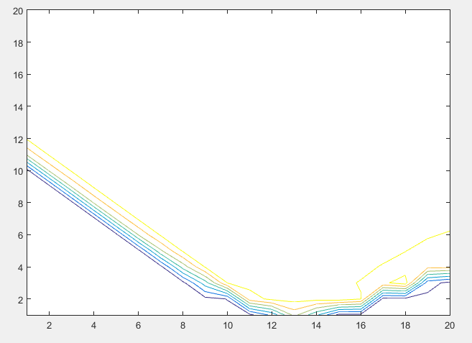

The code controlling the parameters are

for C_index in range(-10, 10):

for gamma_index in range(-10, 10):

After searching for this range, we know the range of C and gamma values that tend to have better result. Then this value space is searched with smaller granularity.

In order to speed up the process, the first round searching is performed on datatest1.csv, and the second round is performed on all the data provided.

1. We are using RBF kernel
   1. We have tried other kernels, they don’t work well.
2. The process of finding the final parameters

This is the main function

-1 -1

converted

-t 2 -v 10 -c 0.500000 -g 0.500000

Cross Validation Accuracy = 98.9105%

-1 0

converted

-t 2 -v 10 -c 0.500000 -g 1.000000

Cross Validation Accuracy = 98.9348%

-1 1

converted

-t 2 -v 10 -c 0.500000 -g 2.000000

Cross Validation Accuracy = 98.93%

-1 2

converted

-t 2 -v 10 -c 0.500000 -g 4.000000

Cross Validation Accuracy = 98.93%

-1 3

converted

-t 2 -v 10 -c 0.500000 -g 8.000000

Cross Validation Accuracy = 98.9251%

0 -1

converted

-t 2 -v 10 -c 1.000000 -g 0.500000

Cross Validation Accuracy = 98.9154%

0 0

converted

-t 2 -v 10 -c 1.000000 -g 1.000000

Cross Validation Accuracy = 98.93%

0 1

converted

-t 2 -v 10 -c 1.000000 -g 2.000000

Cross Validation Accuracy = 98.9251%

0 2

converted

-t 2 -v 10 -c 1.000000 -g 4.000000

Cross Validation Accuracy = 98.9251%

0 3

converted

-t 2 -v 10 -c 1.000000 -g 8.000000

Cross Validation Accuracy = 98.9251%

1 -1

converted

-t 2 -v 10 -c 2.000000 -g 0.500000

Cross Validation Accuracy = 98.9202%

1 0

converted

-t 2 -v 10 -c 2.000000 -g 1.000000

Cross Validation Accuracy = 98.9348%

1 1

converted

-t 2 -v 10 -c 2.000000 -g 2.000000

Cross Validation Accuracy = 98.9251%

1 2

converted

-t 2 -v 10 -c 2.000000 -g 4.000000

Cross Validation Accuracy = 98.9154%

1 3

converted

-t 2 -v 10 -c 2.000000 -g 8.000000

Cross Validation Accuracy = 98.9348%

2 -1

converted

-t 2 -v 10 -c 4.000000 -g 0.500000

Cross Validation Accuracy = 98.9348%

2 0

converted

-t 2 -v 10 -c 4.000000 -g 1.000000

Cross Validation Accuracy = 98.9348%

2 1

converted

-t 2 -v 10 -c 4.000000 -g 2.000000

Cross Validation Accuracy = 98.9105%

2 2

converted

-t 2 -v 10 -c 4.000000 -g 4.000000

Cross Validation Accuracy = 98.9202%

2 3

converted

-t 2 -v 10 -c 4.000000 -g 8.000000

Cross Validation Accuracy = 98.9494%

3 -1

converted

-t 2 -v 10 -c 8.000000 -g 0.500000

Cross Validation Accuracy = 98.9397%

3 0

converted

-t 2 -v 10 -c 8.000000 -g 1.000000

Cross Validation Accuracy = 98.9348%

3 1

converted

-t 2 -v 10 -c 8.000000 -g 2.000000

Cross Validation Accuracy = 98.9202%

3 2

converted

-t 2 -v 10 -c 8.000000 -g 4.000000

Cross Validation Accuracy = 98.93%

3 3

converted

-t 2 -v 10 -c 8.000000 -g 8.000000

Cross Validation Accuracy = 98.964%