**SOP for Setting**

**Moultrie M-550 Digital Trail Camera**

**for Stream Flow Picture Documentation**

The Digital Trail Camera setup is used to capture low or dry flow in rivers and streams.

# What You Will Need

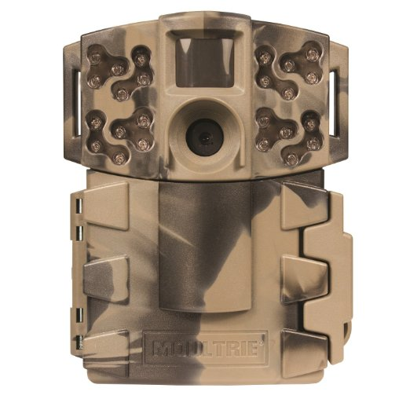 Moultrie M550 trail camera

Digital camera

8 AA batteries

Multimeter

16 MB or greater SD card

Lock and key

Galvanized aircraft or

similar cable

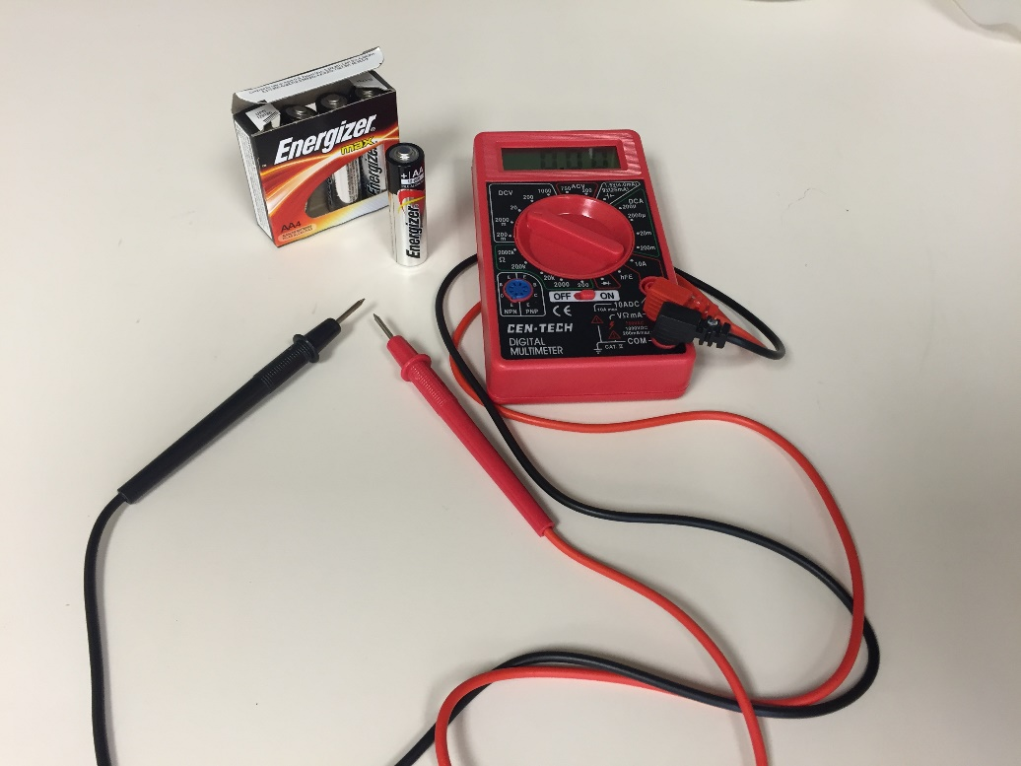**Step 1:** The trail camera takes 8 AA batteries. Use only high quality alkaline batteries. Test batteries for polarity and voltage with battery tester or multimeter prior to deployment. Simultaneously touch the red probe to the “+” end of the battery and the black probe to the “-“ end of the battery.

*Use a multimeter to test polarity of AA batteries. Sometimes, “new” batteries come from the factory with wrong polarity and should not be used. This is also an important step when checking batteries of unknown age.*

**Negative = black**

**Positive = red**

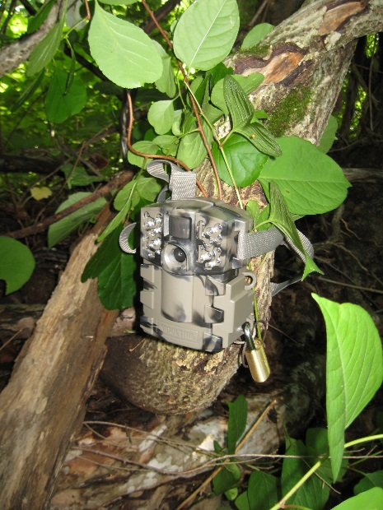Polarity is correct and battery is fresh if tester reads ~1.6 volts. Any battery less than 1.4 volts should not be used. Once 8 batteries test “ok”, open camera cover, press the “EJECT” button to eject tray and insert batteries taking care to note correct polarity.

**Step 2:** Insert SD card when camera is off. **Camera will not operate without SD card**.

*Button Guide: The OK button selects the item to be changed. The UP/DOWN and LEFT/RIGHT buttons are used to step through and modify the menu options.*

**Step 3:** Determine the best location for the trail camera. The image that the camera will produce should be a clear photo of the stream, and it should be hidden as well as possible, without covering the lens. Secure the trail camera to the tree with strap. In addition, take photos upstream and downstream from the center of the stream channel with a digital camera.

**Step 4 (Settings):**

1. Turn camera on to “CUSTOM START”. Use the up/down arrows to navigate to “INFOSTRIP OPTIONS”. Use the left/right arrows to navigate. Navigate to “DATE & TIME” and set the correct date and time. Press OK to begin, and OK to finish. Navigate to “INFOSTRIP ACTIVE” and select “YES”. Navigate to “TEMPERATURE” and select “CELSIUS”. Return to the “INFOSTRIP OPTIONS” page.
2. Use the up/down arrows to navigate to “PHOTO/VIDEO OPTIONS”. Use the left/right arrows to navigate to “PHOTO QUALITY” and then use the up/down arrows to select “ENHANCED”. Return to the “PHOTO/VIDEO OPTIONS” page.
3. Use the up/down arrows to navigate to “MEMORY OPTIONS”. Use the left/right arrows to navigate “ERASE ALL IMAGES” and select “YES”. Return to the “MEMORY OPTIONS” page.
4. Use the up/down arrows to navigate to “TIMELAPSE”. Use the **left** arrow to navigate to “TIMELAPSE INTERVAL” and select “1 HR”. Use the **left** arrow to navigate to “T.L. PROGRAM #1”. For “START”, select “9am”. Use the **left** arrow to navigate to “STOP” and select “10am”. Use the **left** arrow to navigate to “T.L. PROGRAM #2”. For “START”, select “3pm”. Use the **left** arrow to navigate to “STOP” and select “4pm”. Return to the “TIMELAPSE” page.
5. Use the up/down arrows to navigate to “MOTION DETECT”. Use the **left** arrow to navigate to “DETECTION DELAY” and select “5 MINUTES”. Return to the “MOTION DETECT” page.
6. Use the up/down arrows to navigate to “MOTION+T.L.” and use the right arrow to select “START”. *If you start the program in just the “TIMELAPSE” or just the “MOTION DETECT”, you will only trigger one of the functions and not both!*

|  |  |  |  |  |  |
| --- | --- | --- | --- | --- | --- |
|  | Program (TI) | Time | Time Frame | Example | What does the setting mean? |
| **Motion Detect** | N/A | 5 Min | N/A | N/A | This setting will trigger a picture to be taken every 5 minutes if motion is detected. |
| **Time Lapse** | Set to two program intervals per day  (TL#1 and TL#2) | 1 Hour | 1 Hour | TL#1 9-10 AM TL#2 3-4 PM | This setting will take 1 picture at 9 AM and 1 picture at 3 PM. This will produce 2 photos a day. |

**Step 5:** Use locks supplied by DEEP with BAZ key. All locks work with the same key. Make sure lock is through the hole than controls the door (bottom hole). Tether a looped wire cable around a solid object like a tree, then through the lock.

**Step 6:** Using a digital camera, take photos of the camera install location (somebody should be in the picture, pointing to the trail camera), and the stream from the cameras point of view.

**Step 7:** Fill out the trail camera field data sheet.

**Step 8:** Leave trail camera for appropriate amount of time. When retrieving the camera, **REMEMBER THE KEY TO THE LOCK!** Upload pictures to the shared drive under:

Streamflow\Dry Stream Documentations\Flow Impairment Photo Project\Pictures

Label a new folder as: Stream Name Trail Camera Deployment Dates *(example: Burton Brook Trail Camera Aug 3 to Aug 24 2016)*

Once all pictures are uploaded, determine the best time (best quality photo) that the picture was taken. Create another folder and copy & paste all of the pictures at that specific time into the new folder. For example, if the best quality picture was taken at 4PM every day, create a new folder called “@4PM” and copy & paste every single picture that was taken at 4PM into that folder.

**Step 9:** Remove AA batteries from Moultrie Trail Camera. Do not store cameras long term with batteries inside as they may corrode the battery terminals. If redeploying the camera, check the batteries to make sure the voltage meter reads > 1.4 V before setting in the field and clean the lens with a Kimwipe or other non-abrasive tissue.