**SOP for Setting RECONYX HyperFire 2**

**Digital Trail Camera**

**For Streamflow Photo Documentation**

The digital trail camera setup is used to monitor streamflow.

# What You Will Need

RECONYX HyperFire 2 Trail Camera

Handheld Digital Camera

12 AA Energizer Lithium Batteries

Multimeter

16 MB or Greater SD Card

SD Card Reader

Lock and Key

Lockbox

Wireless Drill and Screws

**Step 1:** Prior to deployment, ensure that the firmware is up-to-date. To do this, go to [http://www.reconyx.com/page/firmware](http://www.reconyx.com/page/firmware%20) and follow the instructions online.

**Step 2:** The trail camera takes 12 AA batteries. Use only lithium batteries. Test batteries for polarity and voltage with battery tester or multimeter prior to deployment. Sometimes, “new” batteries come from the factory with wrong polarity and should not be used. This is also an important step when checking batteries of unknown age. Simultaneously touch the red probe to the “+” end of the battery and the black probe to the “-” end of the battery. Polarity is correct and battery is fresh if tester reads ~1.6 volts. Any battery less than 1.4 volts should not be used. Record average voltage in field notebook. Once 12 batteries test “OK”, open the camera latch by grasping behind the latch and flipping it toward the front. Opening the camera cover will allow access to the battery chamber. Insert the batteries taking care to note the correct polarity.

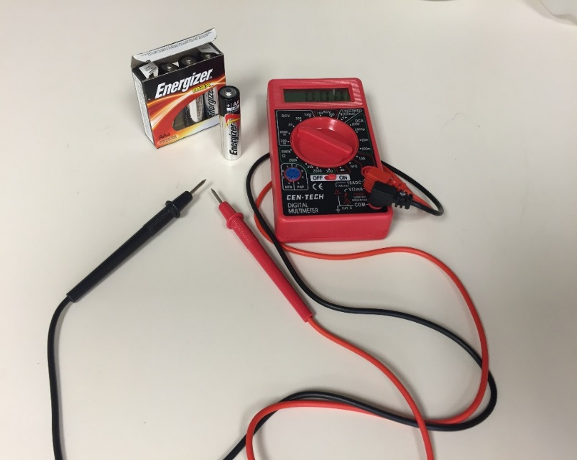

**Positive = red**

**Negative = black**

**Step 3:** Insert SD card when camera is off.

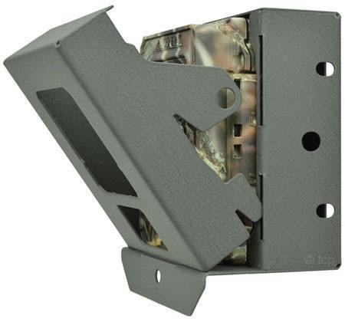**Step 4:** Determine the best location for the trail camera. The image that the camera will produce should be a clear photo of the stream, and it should be hidden as well as possible, without covering the lens. If possible, position the trail camera so it is facing the center of the stream channel (for example, on the bank of a meander). If possible, the image should show both banks, and should capture a riffle-pool sequence in the stream. Screw the lock box into the tree where the camera will be placed. **Make sure to remove any overhanging branches in the picture frame.**

**Step 5 (Settings):**

*Button Guide: The UP/DOWN and LEFT/RIGHT buttons are used to step through and modify the menu options. The OK button accepts the setting and steps through to the next option.*

1. Turn camera on. The camera will display the date and time before displaying setting choices. Ensure that this information is correct. Use the **left/right** arrows to navigate to “CHANGE SETUP” and press OK/down arrow. The left/right arrows are used to navigate within the options of this main setting.
2. Navigate to “MOTION” and press OK. Use the **down** arrow to navigate through the motion settings. Use the **left/right** arrows to change a setting and then press OK. Set the following parameters:
   1. MOTION PICTURES: ON **\*NOTE: If the trail camera is pointing towards a road, do not use the motion detect setting.**
   2. NUMBER OF PICS: 1
   3. MOTION VIDEO: OFF (if ON is selected, then the next setting to display is video length)
   4. QUIET PERIOD: 5 SEC
   5. SENSITIVITY: VERY HIGH

The screen will display “FINISHED OK”. Use the **down** arrow to return to CHANGE SETUP.

1. Use the **right** arrow to navigate to “TIME LAPSE”. Set the following parameters:
   1. LAPSE PICTURES: ON
   2. LAPSE VIDEO: OFF
   3. INTERVAL: 1 HOUR
   4. LAPSE SCHEDULES: 24 HOUR

The screen will display “FINISHED OK”. Use the **down** arrow to return to CHANGE SETUP.

1. Use the **right** arrow to move to “DAY/NIGHT”. Use the **down** arrow to navigate through the setting. Set the Following Parameters:
   1. TAKE PICURES: DAY/NIGHT
   2. TAKE VIDEOS: DAY/NIGHT *NOTE: this option will still display even if motion detect and timelapse video is turned off.
   3. FLASH OUTPUT: HIGH
   4. NIGHT MODE : OPTIMIZED

The screen will display “FINISHED OK”. Use the **down** arrow to return to “CHANGE SETUP”

1. Use the **right** arrow to navigate to “USER LABEL” and press OK. Confirm that the correct camera number is displayed, and press the down arrow until “FINISHED OK” is displayed. Use the **down** arrow to return to “CHANGE SETUP”.
2. Do not change settings under “CODELOC”.
3. Use the **right** arrow to navigate to “DATA BANDS” and press OK/down arrow. Set the following parameters:
   1. TIME FORMAT: 12 HOUR
   2. TEMPERATURE: CELSIUS
4. Use the **right** arrow to navigate to “DATE/TIME”. If the date and time were displayed correctly when first turning the camera on, press the **right** arrow to continue on to the next setting. If the date and time were incorrect, press the down arrow to navigate to “SET DATE”. Use the left/right arrows to navigate between the values and the up/down arrows to change the date. This setting is displayed as year/month/day. When finished, press OK to navigate to “SET TIME” and follow the same procedure. Press OK when finished, and “FINISHED OK” will display. Press the down arrow to return to “CHANGE SETUP”.
5. Use the **right** arrow to navigate to “LOCATION”. Press the down arrow to set appropriate location settings.
6. Use the **right** arrow to navigate to “RESOLUTION”. Press OK/down arrow and select “16:9 WIDE”. Press OK/down arrow and “FINISHED OK” will display. Press the **down** arrow to continue to the “CHANGE SETUP” main menu and then press the **up** arrow to return to the main menu.
7. Use the **left/right** arrows to navigate to “ERASE CARD” and press OK. Select “YES”. Use the **up** arrow to return to the main menu.
8. To start the camera, use the left/right arrows to navigate to “ARM CAMERA” and press OK. There will be a ten second countdown with the option to cancel by pressing OK. Close the camera door.

**Step 6:** Use locks supplied by DEEP with BAZ key. All locks work with the same key. Place the camera into the lock box and lock it with the BAZ lock in the hole at the bottom of the lock box.

**Step 7:** Using a handheld digital camera, take photos of the camera install location (somebody should be in the picture, pointing to the trail camera). In addition, take upstream and downstream photos at the trail camera location.

**Step 8:** In a field notebook, note the date/time of deployment, stream name, AWQ Station ID, trail camera number, average battery voltage, detailed description of trail camera location, and any settings that are different than the ones provided in Step 5.

**Step 9:** Check on the trail camera on a monthly basis. Replace SD card and check batteries. When retrieving the camera, **REMEMBER THE KEY TO THE LOCK!** If it’s winter, bring rubbing alcohol to unfreeze locks. Upload pictures to PSShare:\Streamflow\Dry Stream Documentations under the appropriate monitoring year.

Label a new folder as: StationID_StreamName_StartDeploymentDate_EndDeploymentDate_CameraNumber *(example: 15244_CobbleBrook_082118_091918_14)*

**Step 10:** Remove AA batteries from Reconynx Trail Camera. Do not store cameras long term with batteries inside as they may corrode the battery terminals. If redeploying the camera, check the batteries to make sure the voltage meter reads > 1.4 V before setting in the field and clean the lens with a Kimwipe or other non-abrasive tissue.