CIS 483 Progress Report 2 Phase 2 Interactive Frontend
MNSU-CampusEco | October 26, 2026

1 Report header
Item | Details
Group name / number | MNSU-CampusEco
Members (full names) | Yonatan Alemayehu; Misgana Kebede; Clement Mbuyi; Emran Abatemam
Course | CIS 483
Progress Report # | 2
Phase | Phase 2 Interactive Frontend
Report date | October 26, 2026
GitHub repository link | github.com/mnsu-campuseco/mnsu-campuseco
Checkpoint commit or tag | Phase 2 working tree; latest committed baseline 0ff51d5. Phase 2 commit/tag pending.

The Phase 1 static portals now support a complete browser-based delivery workflow. A hub operator checks in a package, a crew member claims and delivers it, and the recipient tracks the package and confirms receipt. JavaScript and jQuery update the interface without a full-page form reload. Browser storage retains records after refresh and synchronizes other portal tabs on the same origin.
Phase 2 covers JavaScript objects and events, jQuery integration, and mobile-first responsive design. The application remains a frontend demonstration; authentication, database storage, and server endpoints are planned for Phase 3.

2 Work completed this phase

Phase 2 Interactive Frontend
Item | What we implemented and source files | Status
JavaScript objects and rules | js/models.js defines Package, Vehicle, and EcoCourier. Validation covers cargo, IDs, battery limits, claim ownership, ordered milestones, and a single receipt after delivery. | Done
Functions and DOM events | js/app.js handles check-in, crew shifts, claims, milestones, tracking, preferences, registration, and receipt forms. Submit handlers preserve native validation and update the DOM without navigation. | Done
Browser persistence | Versioned localStorage saves the shared dataset; sessionStorage retains the current tab shift. Hydration restores model methods. Storage events refresh other same-origin tabs. | Done
jQuery integration | Local js/vendor/jquery-3.7.1.min.js loads before the models/controller. Selectors, .on(), delegated clicks, dynamic rows, sliding panels, and an animated route marker drive the interface. | Done
Responsive design | css/phase2.css starts with one column and adds layouts at 420, 600, and 900 px. Navigation wraps; the mobile courier queue uses cards; wide logs and history scroll inside containers. | Done
Validation and interaction checks | tests/models.test.cjs and tests/browser/phase2.spec.cjs cover business rules, portal workflow, persistence, storage recovery, input safety, keyboard behavior, and responsive layouts. | Passed

Verification on October 26, 2026 passed 4 model tests and 11 Chrome browser tests using npm test and npm run test:browser. Responsive tests cover the landing page and all portals at 320, 390, 768, and 1440 pixels. The browser suite also checks presentation navigation and slide geometry.
Presentation materials are available in docs/presentation.html and docs/presentation-notes.md. README.md documents setup, demo steps, the requirement map, and the frontend boundaries.

3 Screenshots

Landing page and Hub Operator portal
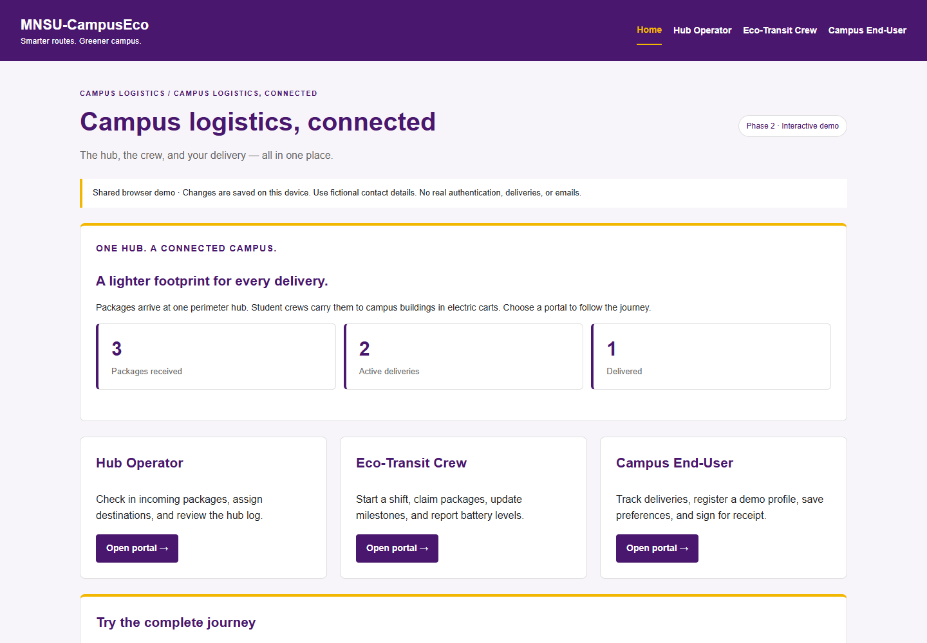
Figure 1: Landing page with portal navigation, browser totals, and demonstration guidance.
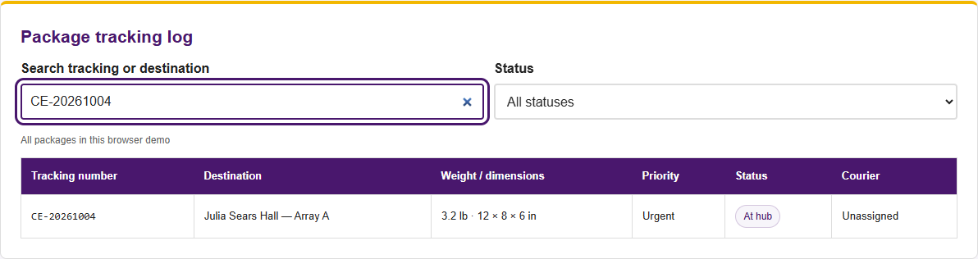
Figure 2: Hub tracking log showing the newly checked-in package CE-20261004.
The operator enters a tracking number, weight, dimensions, campus destination, and optional urgent priority. Duplicate tracking numbers are rejected. Search and status filters narrow the shared tracking log.

Eco Transit Crew portal
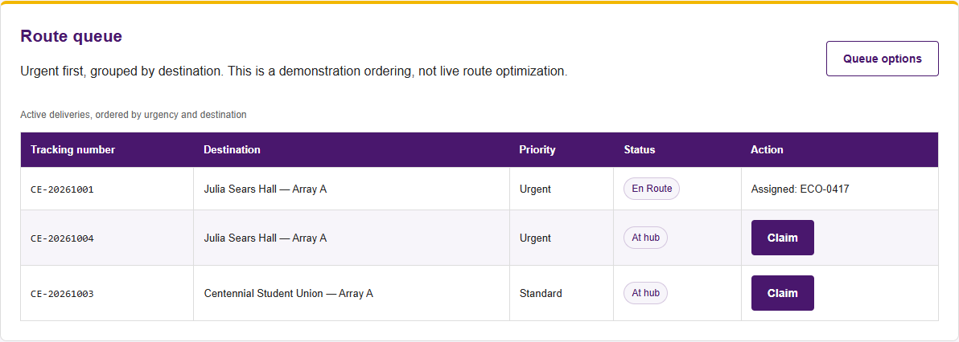
Figure 3: Delivery queue with claim controls, priority, destination, and assigned driver.
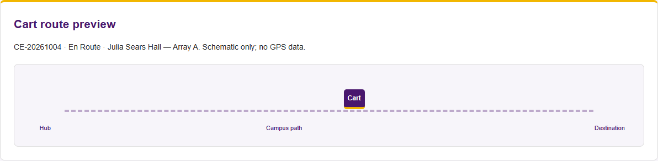
Figure 4: Route preview uses a schematic cart marker to show the selected transit stage.
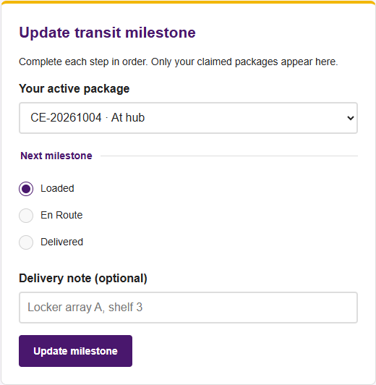
Figure 5: Milestone reporting follows Loaded, En Route, then Delivered.
Crew members start a demo shift with a driver ID and cart. Carts require at least 20% battery to claim new work. Only the assigned courier can advance a package; active deliveries must be completed before changing carts or ending a shift.

Campus End User portal
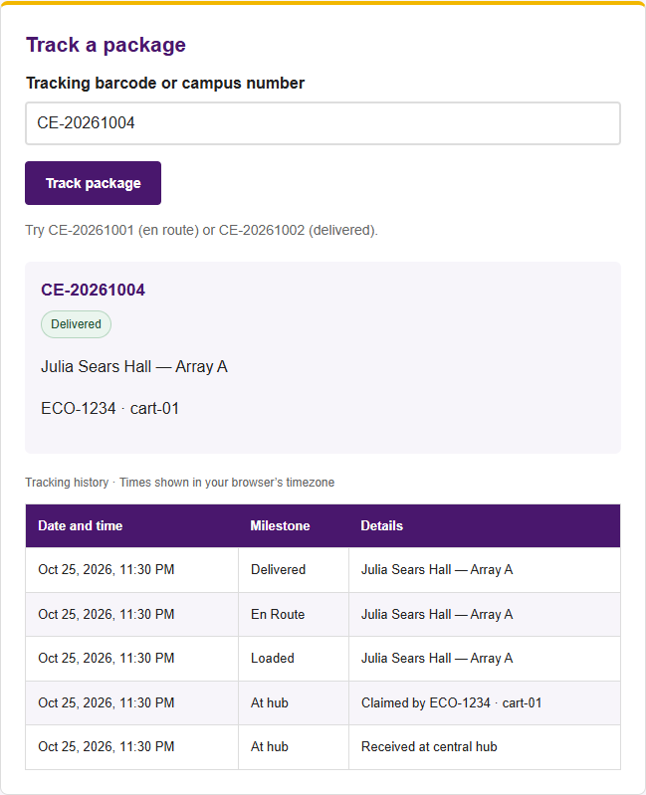
Figure 6: Tracking lookup displays the package status and timestamped delivery history.
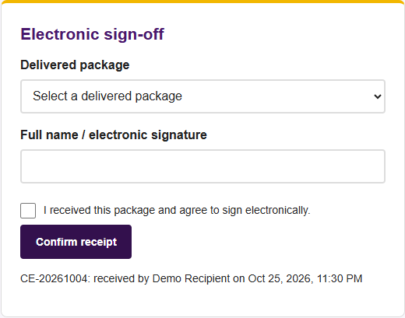
Figure 7: A recipient can confirm receipt after delivery.
The portal also saves delivery preferences and a demo profile, filters in-app notifications, and calculates illustrative carbon savings. Each completed delivery contributes 2 km multiplied by 0.20 kg of avoided CO2 per km. No email or real authentication is provided.

4 Problems and next steps
Problem or limitation | Solution or next step
Shared state across separate portals | Use a versioned dataset, reread state before mutations, and refresh other tabs through storage events. Simultaneous writes are not transactional; Phase 3 needs server coordination.
Blocked or unreadable browser storage | Display a warning and use page memory when storage is unavailable. Corrupt saved data blocks writes until an explicit scoped demo reset.
Invalid or out-of-order delivery actions | Enforce duplicate prevention, driver ownership, a 20% claim battery threshold, sequential status changes, and one receipt per delivered package.
Small-screen queues and wide tables | Use mobile delivery cards, wrapped navigation, responsive columns, and internal scrolling for logs/history. Controls have at least 44 px height.
Demo identities and local data only | Phase 3 should add authenticated endpoints, server validation, a durable relational database, and asynchronous UI updates. Route and carbon results remain illustrative.

Planned work for Phase 3
Planned for the next phase | Proposed review owner
Connect package check-in and tracking logs to authenticated server endpoints. | Misgana Kebede
Connect recipient tracking, preferences, notifications, and receipt records to durable storage. | Emran Abatemam
Connect crew assignment, fleet data, and delivery transitions to server-side business rules. | Clement Mbuyi
Coordinate shared API/database integration, repository checkpoint, and documentation. | Yonatan Alemayehu

5 Team contributions
Phase 1 assigned the portal ownership shown below. These areas provide the Phase 2 review roster; the team should confirm individual Phase 2 implementation and commit attribution before submission.
Member | Assigned area and Phase 2 review scope
Yonatan Alemayehu | Shared frontend and integration: index.html, css/main.css, css/phase2.css, README.md, shared models/controller, tests, report, and presentation integration.
Misgana Kebede | Hub Operator: pages/operator.html and css/operator.css; review package check-in, validation, duplicate prevention, shared tracking log, totals, and filters.
Clement Mbuyi | Eco-Transit Crew: pages/courier.html and css/courier.css; review shifts, cart/battery selection, claiming, ownership, milestone order, queue filters, and route preview.
Emran Abatemam | Campus End-User: pages/enduser.html and css/enduser.css; review tracking/history, preferences, demo registration, notification filters, receipt confirmation, and carbon metrics.

The shared model/controller supports all portals. The current Phase 2 implementation is present in the working tree, while the latest committed baseline is the Phase 1 commit 0ff51d5. Record the final Phase 2 commit or tag after the team reviews and commits the deliverables.

Team review and submission
Review the end-to-end demonstration, confirm individual contributions, and rehearse Technical Presentation 1. The Phase 2 due date is October 26, 2026. One member should submit the compiled report, presentation materials, and repository link through D2L.

