NLU

A Watson Explorer Content Analytics UIMA analysis engine for Watson Natural Language Understanding.



**Revision History**

|  |  |  |  |  |
| --- | --- | --- | --- | --- |
| **Date** | **Version** | **Status** | **Description** | **Author** |
| 06/04/2017 | 1.0 | Release | Initial | Martin Saunders |
| 19/10/2017 | 1.1.x | Controlled Release | Added support for custom models | Martin Saunders |
| 23/10/2017 | 1.2.0 | Release | Added support for custom models | Martin Saunders |
|  | 1.2.x |  | Bug fixes |  |
| 11/12/2017 | 1.3.0 | Release | Port to Watson Java SDK 4.1.0 | Martin Saunders |

**Contents**

1. Introduction 3

1.1 Languages Supported 3

2. Installation 4

2.1 Pre-Requisites 4

2.2 Content Analytics Studio 4

# Introduction

The Watson Natural Language Understanding service uses natural language processing to analyze semantic features of any text. This NLU annotator allows those identified semantic features to be annotated and utilised in any UIMA compliant pipeline such as Watson Explorer Content Analytics server and Content Analytics Studio.

It supports the the following features of the Watson NLU service

* Entities  
  Identify people, cities, organisations and many other entity types in the text using the default model
  + Sentiment analysis on identified entities
  + Emotion analysis on identified entities
* Custom Entities  
  Identifies entities defined in a custom model deployed into NLU.
* Sentiment  
  Analyse the general sentiment of the entire document
* Emotion  
  Detect emotion conveyed by the entire document.

For example the screen shot below shows an Entity annotation with targeted sentiment and emotion enabled.

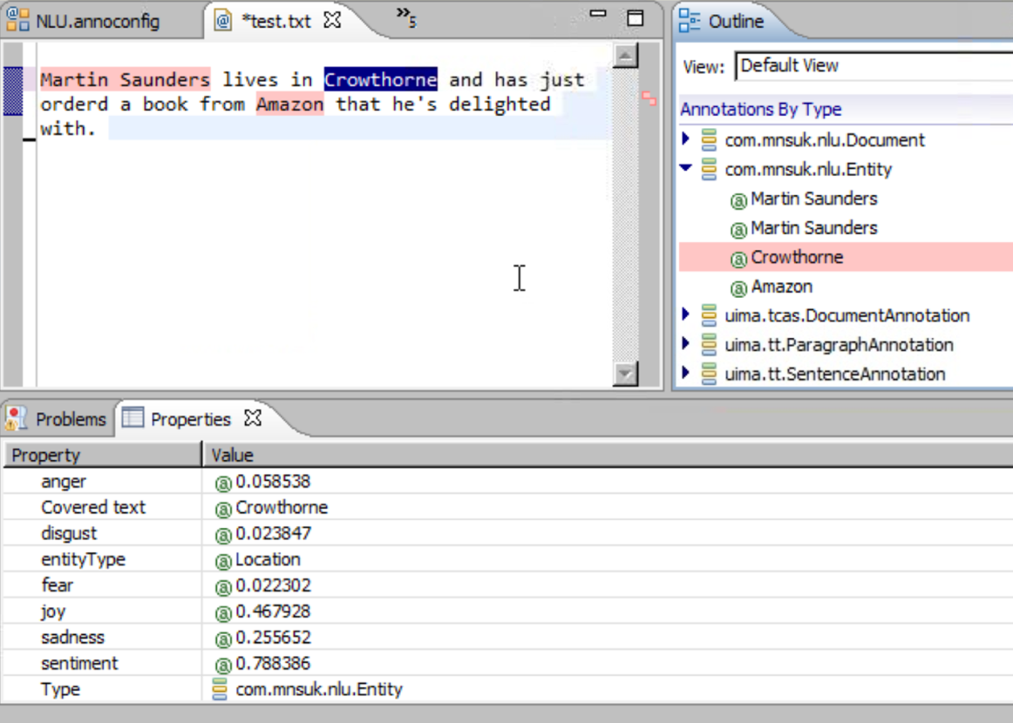

## Languages Supported

The annotator supports the same languages as the Watson NLU service. At the time of writing these are:

Entities: Arabic, English, French, German, Italian, Portuguese, Russian, Spanish and Swedish.

Emotion: English only

Sentiment: Arabic, English, French, German, Italian, Portuguese, Russian and Spanish.

# Installation

## Pre-Requisites

* Installation of Content Analytics Studio version 11 or above
* NLU files:
  + Core files (included in distribution):
    - NLU-ae.xml
    - NLU-n-n-n.jar
    - ICAUIMAUtils-n-n-n.jar
  + Watson Java JDK
    - java-sdk-4.x.x-jar-with-dependencies.jar
* Credentials for an instance of the Watson NLU service deployed in Bluemix.

## Content Analytics Studio

### Create a project.

### In this project create a folder to hold the NLU resources. This can be anywhere in the workspace but something like **Resources/Custom/NLU** would be a good choice.

### Copy the annotation engine configuration file (**NLU-ae.xml**) and all the jar files that make up NLU into this new folder.

### In the relevant UIMA pipeline configuration file in your project add a custom stage as the penultimate stage of the pipeline. To do this:

* Double click on the relevant pipeline configuration file under your ***Configuration/Annotators*** folder to open and edit it.  
  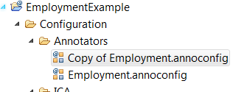
* select the Lexical Analysis stage  
  click the “Add” button  
  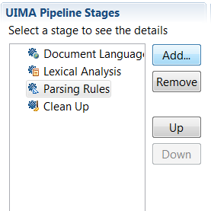
* select “Custom” in the popup window  
  click “OK”  
  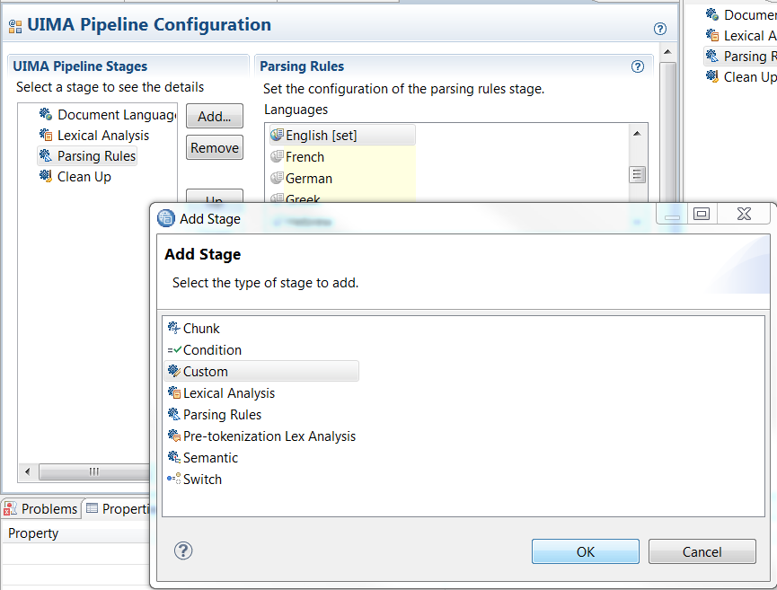
* Click in the text box of the Custom panel under where it says ***Analysis Engine File Path:*** and click the ***Select*** button. Navigate to the folder created in step 2.2.2 and select the ***NLU-ae.xml*** annotation engine configuration file.  
    
  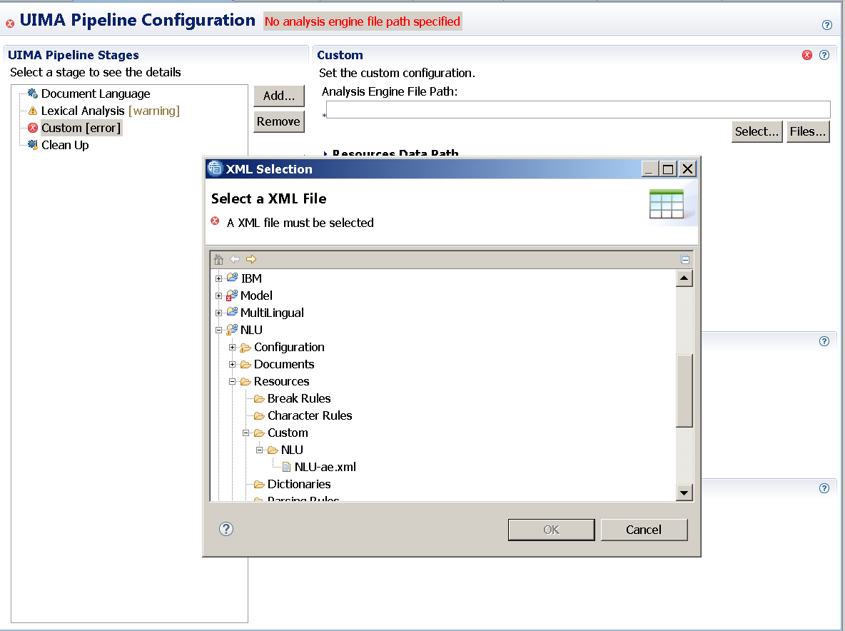
* Back in the ***Custom*** panel click the small right arrow to open the ***Class Path*** panel and click ***Select***. Again navigate to the new folder and this time click the check boxes to select all the jar files.  
  Click ***OK***  
  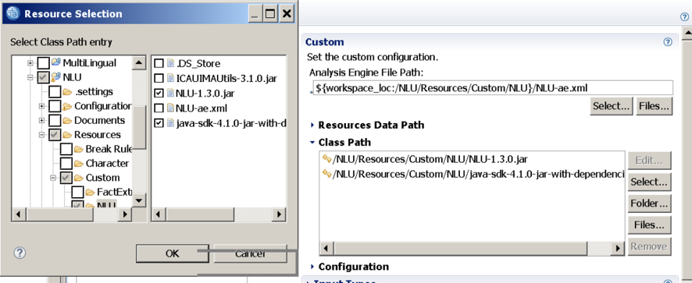
* Back in the ***Custom*** panel click the small right arrow to open the ***Configuration*** panel, then click the small right arrow to open the ***No group*** Configuration group. 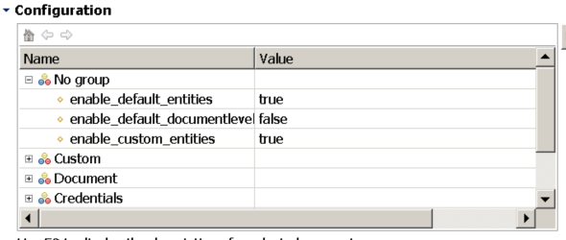

Set the parameters according to the guidance in the table below.

|  |  |  |
| --- | --- | --- |
| **Parameter** | **Default** | **Note** |
| **enable_default_entities** | true | true | false  Enable entity level analysis with the default NLU model. |
| **enable_default_documentlevel** | true | true | false  Enable document level analysis with the default NLU model. |
| **enable_custom_entities** | false | true | false  Enable entity level analysis with a custom NLU model. |

* Close the ***Nogroup***  group and click the right arrow to open the ***Credentials*** Configuration group.   
  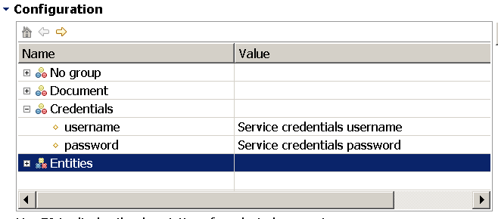   
    
  Set the username and password with the credentials from your Watson NLU service deployed in Bluemix. 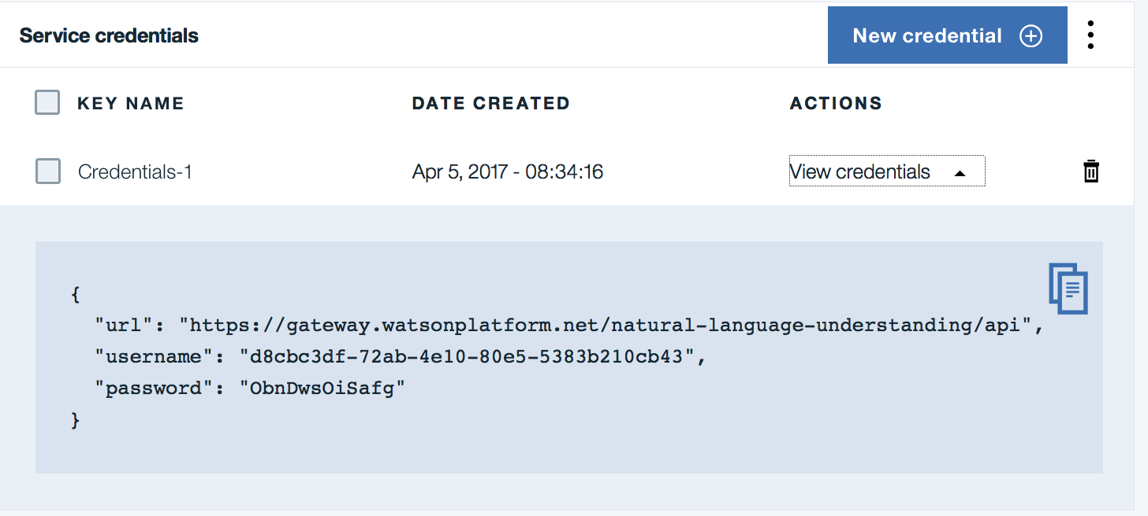
* Close the ***Credentials*** group and then click to open the ***Document*** group,

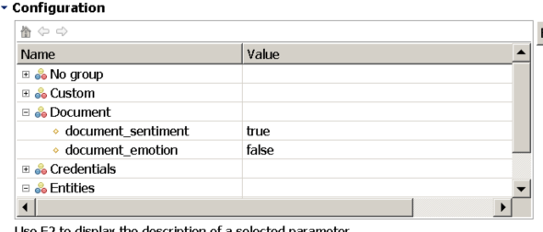

Set the parameters according to the guidance in the table below.

|  |  |  |
| --- | --- | --- |
| **Parameter** | **Default** | **Note** |
| **document_sentiment** | true | true | false  Set this to true to enable document level sentiment analysis. |
| **document_emotion** | true | true | false  Set this to true to enable document level emotion analysis. |

Note: if **enable_default_documentlevel** is set to “true” then at least one of the other these parameters must also be set to true.

* Close the ***Document*** group and click the right arrow to open the ***Entities*** group,

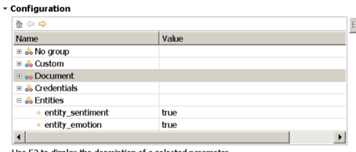  
  
Set the parameters according to the guidance in the table below.

|  |  |  |
| --- | --- | --- |
| **Parameter** | **Default** | **Note** |
| **entity_sentiment** | true | true | false  Set this to true to enable targetted sentiment analysis for detected entities. |
| **entity_emotion** | true | true | false  Set this to true to enable targetted emotion analysis for detected entities. |

* Close the ***Entities*** group and click the right arrow to open the ***Custom*** group,

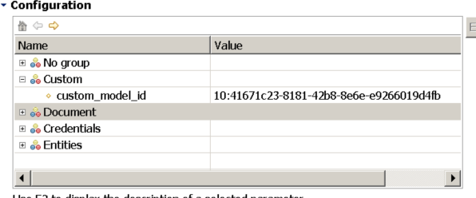  
  
Set the parameters according to the guidance in the table below.

|  |  |  |
| --- | --- | --- |
| **Parameter** | **Default** | **Note** |
| **custom_model_id** | none | none | model ID  Enter a valid identifier if **enable_custom_entities** was set to true. Set to 'none' if custom model processing is disabled. |

* Save the UIMA pipeline configuration file
* You’re ready to go!