

Ga-Pila Disaster Risk Reduction

and

Resilience Implementation Plan

2025–2030

Strengthening resilience today to secure Ga-Pila’s development and wellbeing tomorrow

GA-PILA COMMUNITY DEVELOPMENT TRUST (GCDT)
Ga-Pila Village
Ward 16
Mogalakwena Local Municipality
Waterberg District
Limpopo Province
Republic of South Africa

Date of Issue: 19 December 2025

Document Control Page

Control

Item | Description
Document Title | Ga-Pila Disaster Risk Reduction and Resilience Implementation Plan (2025–2030)
Document Status | Official Community Adoption Version
Version Number | Version 1.0
Plan Custodian | Ga-Pila Community Development Trust (GCDT)
Official Adoption Date
Review Cycle | Annual review and update
Next Scheduled Review
Plan Coverage Area | Ga-Pila (Ga-Pila), Ward 6, Mogalakwena Local Municipality
District | Waterberg District, Limpopo Province

Document History

Version | Date | Description | Prepared/Authorised by
1.0 |  | Initial community adoption version | GCDT

Distribution List

Recipient/Organisation | Purpose | Copy Number
Ga-Pila Community Development Trust | Plan Custodianship
Ga-Pila Traditional Council | Governance Endorsement
Ward 6 Office | Local Governance Interface
DMVF | Operational Implementation
Mogalakwena Local Municipality (Disaster Management Unit) | Alignment + Record
Waterberg District Disaster Management Centre | Record + Support Ready Reference
Community Copy (Public Record) | Transparency | ___

Declaration of Adoption

This Disaster Risk Reduction and Resilience Implementation Plan for Ga-Pila (Sterkwater) (2025–2030) has been developed in accordance with the Disaster Management Act 57 of 2002, the National Disaster Management Framework (2005), and the principles of cooperative governance. The Plan reflects the specific risk conditions, vulnerabilities, capacities and development priorities of the Ga-Pila community and is informed by participatory risk assessment, structured community consultation, and sound disaster risk management logic.

This Plan is authentic and community-specific to Ga-Pila (Sterkwater). It articulates local disaster risk priorities grounded in lived experience, vulnerability analysis, land-use realities and existing community resilience mechanisms. All information contained herein has been validated through community engagement processes, local institutional inputs, and field-based hazard and risk assessments.

The Plan is designed as a practical, working implementation framework rather than a static policy document. It will be reviewed annually to ensure continued relevance to changing risk conditions, settlement dynamics, development patterns and community priorities. The Ga-Pila Community Development Trust is designated as the official custodian and coordination authority of this Plan on behalf of the community, with responsibility for oversight, alignment and facilitation of implementation.

We, the undersigned, hereby adopt the Ga-Pila Disaster Risk Reduction and Resilience Implementation Plan (2025–2030) as the official disaster risk management framework for Ga-Pila (Sterkwater). We endorse this Plan as a community-led, development-centred approach that reduces disaster risk, safeguards lives, livelihoods and community assets, and strengthens long-term resilience. We commit to its implementation, regular review and continuous improvement in the collective interest of present and future generations.

Signed on behalf of the Ga-Pila Community

Name (in full):
Position: | Chairperson: Ga-Pila Community Development Trust (GCDT)
Signature: |  | Date:
Name (in full):
Position: | Representative: Ga-Pila Traditional Council
Signature: |  | Date:
Name (in full):
Position: | Ward Committee Representative – Ward 6
Signature: |  | Date:

Acknowledgements

The preparation of the Ga-Pila (Sterkwater) Disaster Risk Reduction and Resilience Implementation Plan (2025–2030) was made possible through the collective effort, engagement and resolve of the Ga-Pila community. The Plan draws its strength from local knowledge, everyday experience of risk, and a shared commitment to building safety, resilience and sustainable development.

The community extends its appreciation to the institutions and individuals whose contributions were central to the development of this Plan. Traditional leadership, through the Ga-Pila Traditional Council, provided guidance, legitimacy and community mobilisation that ensured the process was rooted in local governance and custom. The Ga-Pila Community Development Trust (GCDT) provided coordination, leadership and stewardship throughout the planning process, ensuring alignment with broader community development priorities. The Disaster Management Volunteer Force (DMVF) contributed practical insights drawn from on-the-ground experience, including hazard observation, risk identification and response considerations.

Special recognition is given to community members across all age groups - women and men, elders and youth - who shared their experiences, concerns and proposals during consultations. Their voices shaped the priorities and direction of this Plan. Appreciation is also extended to school representatives, clinic personnel and water committee members, whose sector-specific perspectives strengthened the understanding of service-related risks and vulnerabilities. Technical partners and advisors are acknowledged for their guidance, validation and support in translating community realities into a structured and implementable framework.

Dedication

This Disaster Risk Management Plan is dedicated to the people of Ga-Pila (Sterkwater), a community shaped by land, history and shared responsibility, and sustained by resilience in the face of hardship and change.

It honours the elders who carry memory and wisdom, the families who hold communities together in times of uncertainty, and the youth whose future depends on the choices made today. It recognises the quiet strength of households that prepare, adapt and respond long before assistance arrives, and the volunteers who step forward when others are at risk.

This Plan is also dedicated to those who protect the community through service and leadership, namely traditional leaders, community trustees, volunteers and local institutions, who work to ensure that safety, dignity and development remain inseparable. Their commitment reflects the understanding that resilience is not built-in moments of crisis, but through daily care for people, land and shared assets.

May this Plan serve as both a guide and a reminder: that preparedness is an act of responsibility, that protection is a collective duty, and that a community that plans together stands stronger against the risks of tomorrow.

Ga-Pila Community Development Trust (GCDT)
October 2025

Acronyms and Abbreviations

Acronym |  | Meaning
ACDCF |  | Ga-Pila Community Disaster Coordination Forum
GCDT |  | Ga-Pila Community Development Trust
DMVF |  | Disaster Management Volunteer Force
DRM |  | Disaster Risk Management
DRMP |  | Disaster Risk Management Plan
DRR |  | Disaster Risk Reduction
EMS |  | Emergency Medical Services
FBO |  | Faith-Based Organisation
IFRC |  | International Federation of Red Cross and Red Crescent Societies
KPA |  | Key Performance Area
LM |  | Local Municipality
MEL |  | Monitoring, Evaluation and Learning
MoU |  | Memorandum of Understanding
NDMF |  | National Disaster Management Framework
NGO |  | Non-Governmental Organisation
SAPS |  | South African Police Service
UNDRR |  | United Nations Office for Disaster Risk Reduction
WDM DMC |  | Waterberg District Disaster Management Centre

Foreword

Disaster risk in Ga-Pila (Sterkwater) is neither abstract nor occasional. It is experienced in the disruption of daily life, in damage to homes and infrastructure, in threats to water security, in fire incidents, in road accidents, and in the gradual pressures created by poverty, land constraints and environmental change. These risks affect not only safety but also dignity, livelihoods and the long-term development of the community. Climate variability and changing settlement patterns are increasing both the frequency and intensity of these challenges, placing additional strain on households and local systems.

This Disaster Risk Management Plan is a response to that reality. It has been developed to provide Ga-Pila with a clear, practical and community driven framework for reducing risk, strengthening preparedness and improving coordinated response. The Plan recognises that while external assistance is important, the first line of protection lies within the community itself. Households, local institutions, traditional leadership and volunteers play a decisive role in anticipating hazards, reducing exposure and responding effectively when incidents occur.

The Plan positions disaster risk management as an integral part of development rather than a separate emergency function. It emphasises prevention, preparedness and resilience building, alongside response and recovery. It also introduces clear coordination arrangements, defines roles and responsibilities, and strengthens linkages between the community, ward structures and municipal and district disaster management systems. In doing so, it seeks to move Ga-Pila away from reactive crisis management towards organised, predictable and accountable risk management.

Central to this approach is local leadership. The Ga-Pila Community Development Trust serves as the custodian and coordination authority of this Plan, working in collaboration with the Ga-Pila Traditional Council, the Disaster Management Volunteer Force, ward structures and key service institutions. This leadership model ensures that disaster risk management is locally anchored, transparent and aligned with broader community development priorities. Support from government and partners is welcomed, but it must reinforce, rather than bypass, community systems and decision-making processes.

This Plan is not intended to remain static. It is a living framework that will be reviewed and refined as risk conditions, settlement patterns and development priorities evolve. Its effectiveness will depend on consistent implementation, shared responsibility and sustained commitment from all role players. Through this Plan, Ga-Pila affirms its determination to protect life, safeguard livelihoods and strengthen resilience for present and future generations.

Together, we will build a resilient Ga-Pila.

____________________________________
Lilly Maja

Chairperson: Board of Trustees
Ga-Pila Community Development Trust (GCDT)
Date: ________________ 2025

Table of Contents

Document Control Page 2
Acknowledgements 3
Dedication 4
Acronyms and Abbreviations 5
Foreword 6
1. Introduction 10
1.1 Background 10
1.2 Purpose of the Plan 10
1.2.1 Purpose 10
1.2.2 Objectives 10
1.3 Legal and Policy Mandate 10
1.3.1 Legislative Framework 10
1.3.2 DRM Planning Levels in South Africa 11
1.3.3 Positioning of this Plan 11
1.4 Scope and Application 12
1.5 Institutional Endorsement and Authority 12
1.6 Alignment with Government DRM Structures 12
1.7 Methodology Used 12
2. Community Profile 13
2.1 Geographic Location and Administrative Context 13
2.2 Historical Background of Ga-Pila (Ga-Pila) 14
2.3 Physical and Environmental Context 16
2.4 Settlement Pattern and Land Use 17
2.5 Demographic and Socio-Economic Profile 20
2.5.1 Population and Household Characteristics 20
2.5.2 Education and Human Development Context 20
2.5.3 Economic Conditions and Income Sources 21
2.5.4 Livelihoods and Social Vulnerability 21
2.5.5 Community Resilience and Social Strengths 21
2.6 Infrastructure and Basic Services Profile 22
2.6.1 Water Supply 22
2.6.2 Sanitation 23
2.6.3 Electricity 23
2.6.4 Roads and Stormwater 24
2.6.5 Waste Management 26
2.6.6 Housing and Settlement Services 27
2.6.7 Community Facilities and Social Services 28
2.7 Governance, Community Structures and Institutional Systems 30
2.7.1 Traditional Leadership 30
2.7.2 Ward Representation and Municipal Governance 31
2.7.3 Community Organisations and Development Structures 31
2.7.4 Coordination, Participation and Institutional Gaps 31
2.8 Local Economy and Livelihood Systems 32
2.9 Social Dynamics, Cultural Norms and Community Values 33
2.10 Development Challenges and Opportunities 34
2.10.1 Key Development Challenges 35
2.10.2 Development Opportunities 35
3. Hazard, Risk and Vulnerability Profile 37
3.1 Introduction 37
3.2 Risk Analysis Methodology 37
3.3 Hazard Identification 39
3.4 Hazard Analysis 41
3.5 Exposure Analysis 43
3.6 Vulnerability Analysis 45
3.7 Capacity and Coping Mechanisms 47
3.8 Risk Prioritisation 49
3.9 Implications for Disaster Risk Reduction 52
4. Disaster Risk Reduction Strategy 53
4.1 Introduction and Purpose 53
4.2 Strategic Framework 53
4.2.1 Strategic Posture 53
4.2.2 Strategic Objectives 54
4.2.3 Strategic Pillars 54
4.2.4 Priority Risk Focus Areas 54
4.2.5 Strategic Principles 54
4.2.6 Risk Reduction Enablers 54
4.3 Strategic Alignment 55
4.4 Strategic Approach 56
4.5 Strategic Direction Summary 57
5. Disaster Risk Management Plan 58
5.1 Introduction and Purpose 58
5.2 Operational Plan Context 58
5.2.1 Link to Strategic Objectives 58
5.2.2 Hazard Coverage Scope 58
5.2.3 Planning Assumptions 59
5.2.4 Dependencies and Conditions for Success 59
5.3 Prevention and Mitigation Plan 59
5.4 Preparedness and Early Warning Plan 67
5.5 Emergency Response Plan 70
5.6 Recovery and Continuity Plan 73
5.7 Hazard-Specific Contingency Planning 76
5.8 Implementation Responsibilities Summary 80
6. Institutional and Community Coordination Arrangements 83
6.1 Purpose 83
6.2 Community Leadership and Local Disaster Structure 83
6.3 Operational Coordination System 84
6.4 Volunteer and Community-Based Disaster Management 84
6.5 Partnerships and Support Institutions 85
6.6 Monitoring, Evaluation and Learning (MEL) 85
6.7 Sustainability Framework 86
6.8 Conclusion 86

Introduction

Background
Bellevue Farm, although spatially separate from the village and located approximately 20 kilometres from the Ga-Pila residential settlement, is a community-owned productive asset comprising Portion 2 and Portion 5 of Farm Bellevue, with a combined extent of approximately 656 hectares. The Farm is held and operated under the custodianship of the Ga-Pila Community Development Trust for the benefit of the community.

As a landholding of this scale, Bellevue Farm plays a significant role in livelihoods, employment creation, food security, environmental stewardship and long-term community development. Disaster risks affecting the Farm include drought, fire, flooding, land degradation, infrastructure failure, occupational safety incidents, theft and damage to productive assets. While these risks may not always present as immediate residential emergencies, their impacts extend directly to the Ga-Pila community through loss of income, disruption of livelihoods, asset erosion and reduced development capacity.

The physical separation between the village and a 656-hectare operational farm introduces additional disaster risk considerations, including delayed response times, communication challenges and coordination complexity during emergencies. At the same time, shared ownership and Trust custodianship mean that risk management on Bellevue Farm cannot be separated from community disaster risk management. Effective resilience for Ga-Pila therefore depends on protecting both households and this extensive land-based asset under a unified disaster risk management framework.

Purpose of the Plan

Purpose
The purpose of the Ga-Pila (Sterkwater) Disaster Risk Management Plan is to establish a structured and coordinated approach to disaster risk reduction, preparedness, response and recovery across the Ga-Pila residential community and Bellevue Farm, comprising Portion 2 and Portion 5 of Farm Bellevue, a 656-hectare community-owned landholding located approximately 20 kilometres from the village and operated under the custodianship of the Ga-Pila Community Development Trust.

The Plan formalises disaster risk management arrangements at community level and ensures that risks affecting households, social infrastructure, productive land and community-owned assets are addressed within a single, coherent framework. It provides practical guidance for managing hazards in both proximate residential settings and remote operational environments, while strengthening coordination, accountability and alignment with broader community development and asset management priorities.

Objectives
The objectives of the Ga-Pila (Sterkwater) Disaster Risk Management Plan are to:
- reduce disaster risk to people, livelihoods, infrastructure, land and community-owned assets across both the Ga-Pila residential settlement and Bellevue Farm;
- identify, assess and prioritise hazards, vulnerabilities and exposure affecting households, social facilities, productive land and operational activities;
- strengthen prevention and mitigation measures that reduce the likelihood and impact of disasters in residential and land-based contexts;
- establish preparedness and early warning arrangements that take into account the physical separation between the village and Bellevue Farm;
- define clear coordination, communication and response procedures for incidents occurring within the settlement and on remote landholdings;
- support effective recovery, rehabilitation and continuity of livelihoods and operations following disaster events;
- strengthen alignment between community governance structures, Trust custodianship arrangements and municipal and district disaster management systems; and
- promote shared responsibility for disaster risk management as a foundation for long-term resilience and sustainable development.

These objectives ensure that DRM becomes a community-owned, structured and sustainable system rather than a reactive activity.

Legal and Policy Mandate

Legislative Framework
Disaster Risk Management in South Africa is guided by a clear legal and policy framework. The key instruments that provide the mandate for this Plan are summarised in Table 1.1 below.
Before the table is presented, it is important to emphasise that Section 52 of the Disaster Management Act obligates municipalities to develop and implement disaster management plans that include community participation. Similarly, Enabler 1 of the National Disaster Management Framework (2005) specifically promotes community-based disaster risk management as a cornerstone of local risk reduction.

Table 1.1: DRM Legal and Policy Framework Applicable to this Plan
Legal/Policy Instrument | Relevance to the Ga-Pila DRM Plan
Disaster Management Act, 57 of 2002 (as amended) | Provides the legal mandate for disaster risk reduction, preparedness, response and recovery; Section 52 mandates local planning.
National Disaster Management Framework (2005) | KPA 1–4 and Enabler 1 guide DRM planning, institutional arrangements and community participation.
Constitution of the Republic of South Africa, 1996 | Section 41 promotes cooperative governance; Section 152 promotes community involvement in local governance.
Municipal Systems Act, 32 of 2000 | Integrates DRM with local development planning and community participation.
Municipal Structures Act, 117 of 1998 | Defines ward and local governance roles in disaster response.
Traditional Leadership and Governance Framework Act, 41 of 2003 | Protects the role of traditional leadership in communal governance, including DRM.
Sendai Framework for Disaster Risk Reduction (2015–2030) | Aligns local DRM planning to global best practice; emphasises reducing risk and building resilience.

The instruments above establish DRM as a legal requirement and not a voluntary activity. They formalise planning obligations and enable Ga-Pila to cooperate with local and district authorities during disaster events.

DRM Planning Levels in South Africa
In South Africa, DRM planning is structured into four maturity levels to ensure progressive development of local DRM systems. These levels are outlined in Table 1.2 below.

Table 1.2: DRM Planning Levels in South Africa
DRM Plan Level | Description | Scope
Level 1 DRM Plan | Establishes basic risk profile, institutional arrangements and preparedness procedures | Community, Ward, Local Municipality
Level 2 DRM Plan | Introduces risk reduction projects, contingency planning and early warning integration | Local and District Government
Level 3 DRM Plan | Aligns DRM with development planning, includes budgeting and SOPs | District and Provincial structures
Level 4 DRM Plan | Full multi-hazard DRM system with data, GIS, scenarios and monitoring | Advanced municipalities and national systems

These levels demonstrate that DRM capacity is built progressively. Plans evolve from basic emergency readiness (Level 1) to full-scale DRM systems (Level 4).

Positioning of this Plan
The Ga-Pila (Ga-Pila) Plan is a Level 1 Community-Based DRM Plan. It establishes:
- Community DRM structures and responsibilities.
- Basic risk identification and priority hazards.
- Community preparedness and activation procedures.
- Linkages with Ward 6, Municipality and District DRM structures.

This Plan provides the foundation for future upgrades to Level 2 and Level 3 plans, which will include formalised risk reduction projects, standard operating procedures, and disaster financing mechanisms.

Scope and Application
This Disaster Risk Management Plan applies to all residents, households, institutions, facilities and economic activities within the Ga-Pila community (Sterkwater), as well as to Bellevue Farm, comprising Portion 2 and Portion 5 of Farm Bellevue, a 656-hectare community-owned landholding located approximately 20 kilometres from the village and operated under the custodianship of the Ga-Pila Community Development Trust.

The Plan governs all phases of disaster risk management, including prevention, mitigation, preparedness, response, recovery and rehabilitation. It applies to both natural and human-induced hazards that may affect people, infrastructure, land, production systems and community-owned assets, irrespective of their physical location.

The provisions of this Plan are binding on all designated disaster risk management role players within the Ga-Pila community and on all persons or entities operating on or utilising Bellevue Farm. The Plan further serves as the primary guiding framework for disaster risk management activities undertaken in collaboration with ward structures, the local municipality and the District Disaster Management Centre.

Institutional Endorsement and Authority
The development and implementation of this Plan are endorsed by the recognised leadership and development governance structures of Ga-Pila, as shown in Table 1.3.

Table 1.3: Institutional Endorsement of the Ga-Pila DRM Plan
Authority | Role
Ga-Pila Traditional Council | Provides traditional governance authority and emergency mobilisation power
Ga-Pila Community Development Trust (GCDT) | Development coordination and DRM accountability
Disaster Management Volunteer Force (DMVF) | Operational lead for DRM implementation

This endorsement establishes formal legitimacy, enabling collaboration with government, private sector, and funding partners to implement the DRM system.

Alignment with Government DRM Structures
The Plan is aligned with South Africa’s DRM governance architecture and follows cooperative governance principles. It links with:
- Ward Councillor and Ward Committee
- Mogalakwena Local Municipality DRM Unit
- Waterberg District Disaster Management Centre (DDMC)
- Limpopo Provincial Disaster Management Centre
- National Disaster Management Centre (as needed)

This alignment ensures access to support, escalation pathways and resources during major incidents.

Methodology Used
This Plan was developed through a participatory and evidence-based approach, combining local knowledge and technical guidance, as summarised in Table 1.4.

Table 1.4: Methodological Approach
Method | Application
Community workshops | Validation of hazards and risks
Household risk profiling | Identification of vulnerable households
Field assessments | Mapping of risk zones
Stakeholder consultations | Structured engagement with local leadership
Document review | Compliance with legal and policy frameworks

This approach ensures both community ownership and technical credibility of the Plan. It grounds disaster risk management priorities in lived experience, local knowledge and practical realities, while ensuring alignment with established disaster risk management principles and statutory requirements. As a result, the Plan is both locally legitimate and institutionally defensible, enabling effective implementation, coordination and review over time.

Community Profile

Introduction
This chapter provides a detailed profile of the physical, social, economic and institutional contexts within which disaster risk manifests in Ga-Pila. It establishes an evidence-based understanding of exposure, vulnerability and capacity, which is essential for informed hazard analysis and the design of appropriate disaster risk reduction, preparedness and response measures.

The chapter is deliberately structured around the two distinct but interrelated geographic and functional spaces covered by this Disaster Risk Management Plan. Part A focuses on the Ga-Pila residential community (Sterkwater) as a settlement and social environment, where disaster risks directly affect households, services and everyday life. Part B, which follows, profiles Bellevue Farm, comprising Portion 2 and Portion 5 of Farm Bellevue, as a community-owned land and productive asset under the custodianship of the Ga-Pila Community Development Trust.

This dual structure recognises that disaster risk in Ga-Pila does not arise only within the residential settlement, nor only within land-based operations, but across both spaces through different mechanisms and with different consequences. Profiling these contexts separately, yet within a single chapter, ensures that subsequent risk analysis and planning respond to the full spatial, social and economic footprint of the community.

Part A: Ga-Pila Community (Sterkwater)

Overview of Ga-Pila
Ga-Pila, also known as Sterkwater, is a rural settlement located within Mogalakwena Local Municipality in the Waterberg District Municipality of Limpopo Province. The community functions as the primary residential and social space for its residents, accommodating households, public facilities, informal and formal economic activity, and key governance and coordination structures.

Data informing this profile was collected through a structured household survey process undertaken during the development of the Ga-Pila Integrated Community Development Plan. Local enumerators collected data using electronic tools, covering approximately 400 households per week, which provides a credible statistical basis for analysing vulnerability, exposure and coping capacity at community level.

From a disaster risk management perspective, Ga-Pila is characterised by recurring, low- to medium-intensity risks rather than infrequent catastrophic events. These risks accumulate over time through service disruptions, environmental exposure and socio-economic stress, steadily eroding household resilience.

Geographic Location and Administrative Context
Ga-Pila is situated within a predominantly rural landscape under traditional authority. The settlement pattern is largely low-density and horizontally spread, reflecting incremental growth over time. Residential stands are organised into distinct sections of the village, with varying access to services and infrastructure.

Figure 2.1: Location of Ga-Pila (Sterkwater) within Mogalakwena Local Municipality
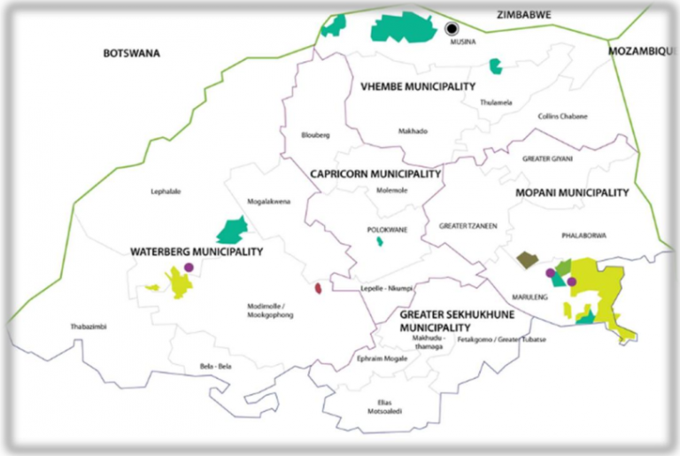

Figure 2.2: Settlement layout and residential sections of Ga-Pila (Sterkwater)

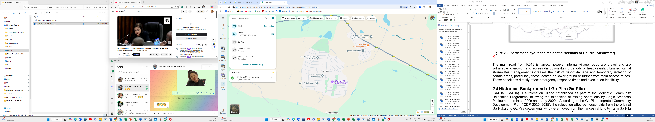

The main road from R518 is tarred, however internal village roads are gravel and are vulnerable to erosion and access disruption during periods of heavy rainfall. Limited formal stormwater management increases the risk of runoff damage and temporary isolation of certain areas, particularly those located on lower ground or further from main access routes. These conditions directly affect emergency response times and evacuation feasibility.

Population Profile and Social Characteristics
Women constitute 52 percent of the Ga-Pila population. Household composition analysis shows that 64 percent of households consist of one to four persons, while 14 percent consist of five persons. Single-person households account for 19 percent of all households and are predominantly elderly and female-headed.

Table 2.1: Household Composition and Disaster Risk Implications
Indicator | Proportion | Disaster Risk Meaning
Female population | 52% | Higher care and support burden during emergencies
Households with 1–4 persons | 64% | Limited internal response capacity
Single-person households | 19% | High vulnerability during evacuation and service disruption
Households with 5 persons | 14% | Increased overcrowding and exposure

Age distribution data indicates that adults aged 36 - 65 years constitute 59 percent of the population, while persons aged over 65 constitute 27 percent. This profile elevates health-related disaster risk and increases dependency during prolonged service interruptions.

Housing, Infrastructure and Basic Services
Housing in Ga-Pila is predominantly formal, reflecting the gradual consolidation of the settlement over time. While most dwellings are permanent structures, assessments referenced in the Integrated Community Development Plan identify variability in construction quality, including cracked slabs, foundation erosion and settlement-related structural stress. These conditions increase vulnerability to damage during periods of heavy or prolonged rainfall.

Settlement density has increased in certain sections of the village due to the addition of backyard rooms and informal extensions. Although the ICDP does not quantify backyard structures as a discrete indicator, field observations confirm uneven densification. Reduced spacing between dwellings affects fire spread dynamics, limits the safe placement and operation of on-site sanitation facilities and constrains access for emergency vehicles.

Electricity access is widespread within Ga-Pila; however, supply reliability is affected by feeder capacity constraints and load shedding. During electricity interruptions, households rely on alternative energy sources such as firewood, candles and gas. This practice increases the likelihood of household fires, particularly in denser sections of the settlement and where informal electrical connections are present.

Sanitation access represents a significant structural vulnerability. ICDP data indicates that 55% of households use pit latrines, 22% use ventilated improved pit latrines, 11% use dry toilets, and 11% of households have no access to sanitation facilities.

Table 2.5: Housing and Basic Services Profile (Ga-Pila Community)
Indicator | Proportion (%) | Disaster Risk Implication
Formal housing structures | Predominant | Reduced collapse risk; variable structural quality
Pit latrine use | 55% | Flooding and groundwater contamination risk
VIP toilet use | 22% | Overflow and maintenance risk during rainfall
Dry toilets | 11% | Hygiene and waste management challenges
No sanitation access | 11% | Elevated public health and disease risk
Electricity access | Widespread | Increased fire risk during outages

Overall, 88% of households rely on on-site sanitation systems, which are sensitive to rainfall intensity, soil conditions and groundwater levels. During heavy rainfall events, pit latrines and VIP systems are vulnerable to flooding and structural failure, increasing the likelihood of faecal contamination of surrounding soil and nearby water sources. This risk is amplified in areas with poor drainage and higher settlement density.

Housing conditions, sanitation coverage and energy reliability interact to produce recurrent, low- to medium-intensity incidents that accumulate over time and erode household assets, health and coping capacity.

Water Access and Public Health Risk
Water access in Ga-Pila is uneven and constitutes a key determinant of household vulnerability. Data from the Integrated Community Development Plan indicates that 11% of households have no access to water infrastructure, relying on communal sources, neighbouring households or informal arrangements. This condition represents a persistent vulnerability under normal circumstances and escalates into a critical risk during periods of drought, infrastructure failure or emergency conditions.

Distance-to-water analysis shows that 15% of households travel distances between 500 metres and 1 kilometre to access water, while 3% of households travel distances exceeding 1 kilometre. These access patterns reduce household flexibility, increase physical strain and affect the ability to respond to concurrent risks, particularly for households with elderly members, children or limited mobility.

Table 2.6: Water Access Profile and Disaster Risk Implications
Water Access Condition | Proportion of Households | Disaster Risk Implication
No access to water infrastructure | 11% | High vulnerability during service disruption
Distance to water between 500 m and 1 km | 15% | Delayed access and reduced response capacity
Distance to water exceeding 1 km | 3% | Elevated health and safety risk
Distance to water less than 500 m | 71% | Lower daily exposure, subject to reliability

Water access constraints intersect directly with the sanitation profile described in Section 2.5. Limited water availability undermines hygiene practices and increases the likelihood of contamination, particularly during heavy rainfall events when runoff and rising groundwater levels occur.

Public health data referenced in the ICDP records recurring diarrhoeal disease incidents within the municipality associated with water quality and sanitation conditions. In the Ga-Pila context, these patterns confirm that water access challenges contribute primarily to recurrent health-related emergencies rather than isolated catastrophic events.

Water availability also influences preparedness and response capacity beyond health considerations. Limited access to water constrains household-level and community-level fire suppression capacity, particularly during electricity outages when reliance on open flames increases.

Roads, Stormwater and Access Risk
Road and stormwater infrastructure conditions in Ga-Pila play a critical role in shaping access, mobility and emergency response capacity. Municipal infrastructure data referenced in the Integrated Community Development Plan indicates that only 14.5% of roads within the municipality are surfaced, with the remainder comprising gravel or earth roads. Ga-Pila’s internal road network reflects this broader pattern, with most access routes remaining unsurfaced.
Gravel roads within the settlement are vulnerable to erosion, surface degradation and loss of passability during periods of heavy rainfall. Poorly defined road shoulders and limited drainage infrastructure result in runoff concentrating along road alignments, accelerating surface damage and forming ruts and gullies. These conditions reduce vehicle accessibility and increase travel times under normal conditions, with more severe impacts during adverse weather events.

Stormwater management within the village is largely informal. The absence of engineered drainage systems means that stormwater is channelled through natural flow paths and improvised roadside trenches. These channels are prone to blockage by sediment and debris, resulting in overtopping and the diversion of water into residential yards and access routes.

Table 2.7: Roads and Stormwater Profile and Disaster Risk Implications – Ga-Pila Community
Infrastructure Indicator | Proportion / Condition | Disaster Risk Implication
Surfaced roads (municipal level) | 14.5% (Estimate) | Limited all-weather access
Unsurfaced internal roads | Predominant | Erosion and access failure during rainfall
Formal stormwater infrastructure | Minimal | Increased flooding and runoff damage
Informal drainage channels | Widespread | High blockage and overflow risk

Limited road surfacing and inadequate stormwater control increase the likelihood of temporary isolation of certain sections of the village during rainfall events. Access disruption affects not only emergency services, but also routine access to health facilities, schools and economic activities. Households with elderly members, persons with disabilities or chronic health conditions are particularly affected when access routes become impassable.

Road and stormwater conditions also influence post-incident recovery. Damage to access routes delays repairs to water, electricity and sanitation infrastructure and prolongs the impacts of otherwise moderate hazard events. As a result, access-related disruptions contribute to the cumulative effect of recurrent, low-intensity incidents that erode household resilience over time.

Figure 2.4: Typical condition of internal gravel roads and informal stormwater channels in Ga-Pila
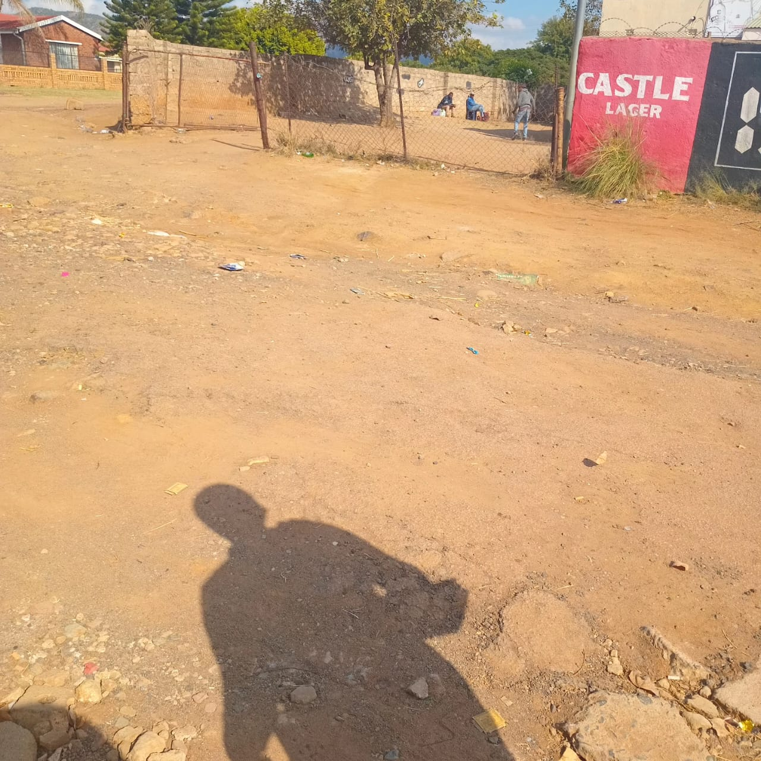

Figure 2.5: Areas of recurring runoff concentration and access disruption
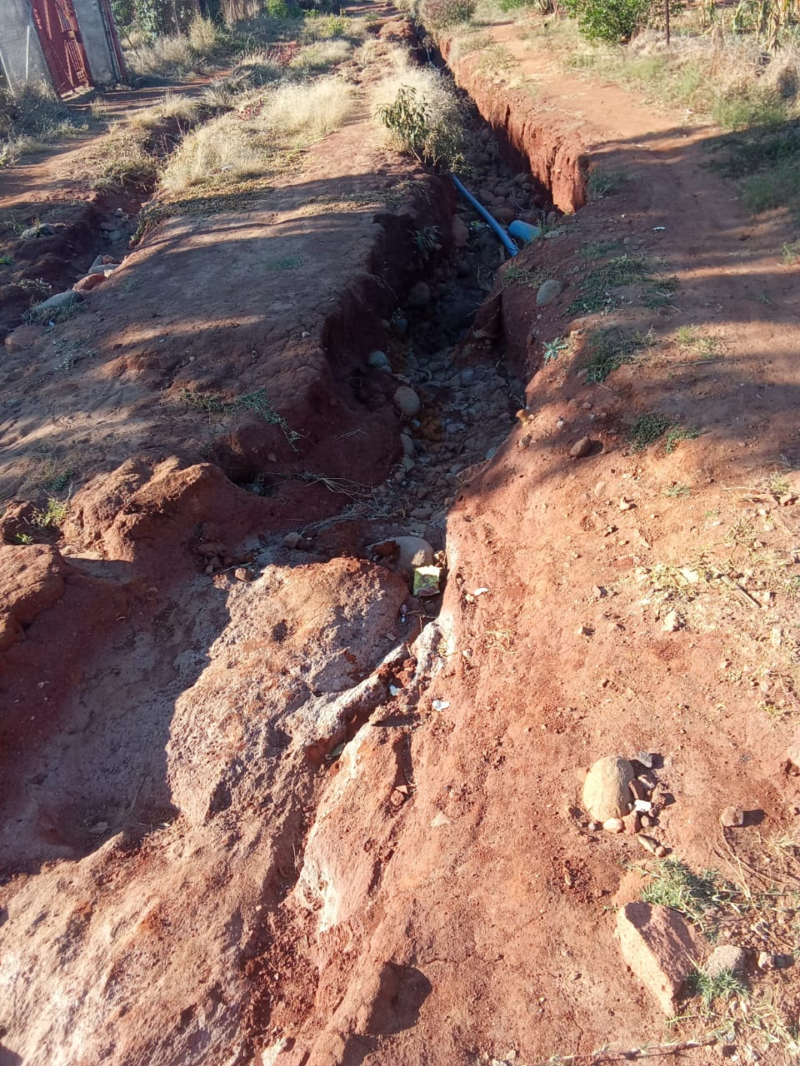

The current road and stormwater profile of Ga-Pila represents a measurable and persistent access risk. Limited surfaced roads, combined with informal stormwater management, constrain emergency response, disrupt livelihoods and extend recovery periods following rainfall events. These conditions provide a clear factual basis for prioritising access protection and stormwater management measures within the disaster risk management framework.

Community Facilities and Social Assets
Ga-Pila is served by a range of community facilities and social assets that support everyday social functioning and play an important role during emergencies. These include educational facilities, places of worship, community meeting spaces and administrative offices. The distribution and condition of these facilities influence both preparedness and response capacity within the community.

A central facility within the village is the Ga-Pila Community Hall complex, which has been repaired and refurbished and is currently fully functional. The complex comprises a main community hall, a designated study area and surrounding grounds suitable for gatherings and organised activities. Two offices within the facility are currently occupied, supporting community administration and coordination functions.

The kitchen component of the community hall is leased and used for other purposes and is presently congested with furniture and stored documents. While this does not affect the day-to-day use of the hall and study facilities, it limits the functionality of the complex during emergencies, particularly its potential use for catering, relief coordination or temporary shelter support that requires food preparation and storage capacity.

Educational facilities within Ga-Pila, including schools and early childhood development centres, constitute important social infrastructure. During emergencies, these facilities may be used informally as information points or temporary support spaces, although they are not formally designated or equipped as disaster shelters. Their structural condition, accessibility and proximity to vulnerable households are therefore relevant considerations in disaster preparedness planning.

Social assets in Ga-Pila extend beyond physical infrastructure. Faith-based organisations, burial societies, community volunteer groups and informal mutual-aid networks form a strong social fabric that supports households during times of stress. These structures provide assistance with caregiving, information dissemination and mobilisation of community support during incidents such as illness, bereavement or service disruptions.

While these social assets contribute significantly to coping capacity, their role in disaster response remains largely informal. There are limited formal linkages between these groups and municipal disaster management structures, and their potential contribution to organised preparedness, early warning dissemination and coordinated response is not yet fully institutionalised.

Figure 2.6: Location of key community facilities and social infrastructure in Ga-Pila

Figure 2.7: Community Hall complex and associated facilities

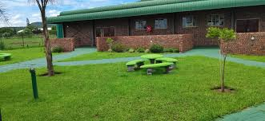
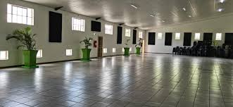
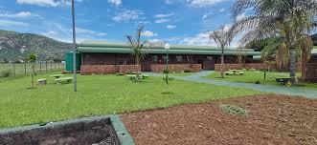

It is clear that Ga-Pila possesses a combination of functional community infrastructure and strong social networks that enhance resilience at household and community levels. However, functional limitations within key facilities and the largely informal nature of social asset mobilisation affect the extent to which these resources can be fully leveraged during disaster situations. These conditions inform the assessment of response capacity and coordination needs in subsequent sections of this Plan.

Physical and Environmental Context of Ga-Pila (Sterkwater)
Ga-Pila (Sterkwater) is situated within the Savanna biome of Limpopo Province, characterised by semi-arid climatic conditions, variable rainfall patterns and vegetation dominated by bushveld species. The community lies within the broader Mogalakwena landscape, where natural drainage systems, soil characteristics and climate variability play a decisive role in shaping environmental exposure and disaster risk.

The local climate is defined by summer rainfall occurring primarily between November and March, often delivered through short-duration, high-intensity thunderstorms. Rainfall variability is pronounced, with extended dry periods punctuated by sudden storm events. These patterns influence surface runoff, soil stability and water availability, particularly in areas where natural drainage paths have been altered over time. Prolonged dry seasons, coupled with rising average temperatures, contribute to heat stress, dust exposure and increasing pressure on limited water resources.

Soils in and around Ga-Pila are predominantly sandy to sandy-clay in composition, with shallow depth in certain areas. These soil conditions are highly susceptible to erosion when exposed to concentrated runoff and are less capable of supporting stable foundations where drainage is poorly managed. During heavy rainfall events, surface water moves rapidly across compacted ground, forming informal flow paths that contribute to yard flooding, road degradation and sediment accumulation around homesteads.

Vegetation cover within the village and its immediate surroundings is uneven and, in places, degraded. Limited grass cover reduces the land’s capacity to absorb rainfall, increasing the speed and volume of runoff during storms. During dry periods, exposed surfaces generate dust, affecting air quality and compounding respiratory stress, particularly among children and older persons.

Ga-Pila is located within a high lightning frequency zone, consistent with broader patterns observed across the Waterberg and Mogalakwena regions. Thunderstorm activity is frequently accompanied by lightning strikes, posing risks to people, livestock and structures, particularly where grounding, lightning protection and safe shelter practices are limited.

The environmental context of Ga-Pila is further influenced by surrounding mining activity within the Mogalakwena area. Heavy vehicle movement, altered landforms and compacted surfaces associated with mining operations affect natural drainage behaviour beyond the immediate footprint of the village. During dry seasons, dust emissions contribute to reduced air quality, while ground vibration and soil disturbance have been reported to exacerbate cracking and settlement stress in nearby residential structures.

Table 2.8: Key Environmental Conditions Influencing Disaster Risk in Ga-Pila
Environmental Factor | Local Environmental Expression | Disaster Risk Implication
Climate and rainfall | Erratic summer rainfall; intense storms | Flash runoff, erosion and localised flooding
Temperature patterns | Hot summers; prolonged dry periods | Heat stress; increased water demand
Soil characteristics | Sandy and sandy-clay, shallow soils | Erosion; reduced foundation stability
Vegetation cover | Patchy and degraded | Increased runoff and dust exposure
Lightning exposure | High lightning frequency zone | Injury, livestock loss and fire risk
Mining-related environmental effects | Dust, soil compaction, altered drainage | Respiratory stress; accelerated runoff

The environmental conditions described above function as primary risk drivers rather than background factors. Seasonal rainfall variability, soil erosion, heat stress, lightning exposure and mining-related environmental change interact to influence how hazards manifest and how frequently households experience disruption. These conditions contribute mainly to recurrent, low- to medium-intensity environmental hazards that accumulate impacts over time, affecting health, livelihoods and service reliability.

Understanding the natural environment of Ga-Pila is therefore essential to effective disaster risk management planning. Environmental exposure shapes vulnerability patterns throughout the year and must be factored into preparedness, early warning, land-use management and infrastructure protection measures addressed in subsequent chapters of this Plan.

Governance, Community Structures and Institutional Systems
Governance in Ga-Pila operates through a layered system comprising traditional authority, elected local government representation and community-based development structures. These institutions collectively shape decision making, development coordination, accountability and conflict resolution within the village. While governance structures are present and active, coordination between them is uneven, and institutional effectiveness is strongly dependent on community initiative rather than sustained external support. Decision making in the village is therefore characterised by active participation but fragmented authority. Leadership structures respond to issues as they arise, but there is no single, integrated governance platform that routinely aligns development priorities, service delivery concerns and disaster risk management planning.

Traditional Leadership
Ga-Pila falls under the jurisdiction of the Mapela Traditional Authority, with village-level governance exercised through the Ga-Pila Traditional Council under the authority of the Senior Traditional Leader. Traditional leadership plays a central role in land allocation, settlement administration, cultural affairs and dispute resolution. It remains the most consistent and visible governance structure in the village.

The Traditional Council oversees allocation of residential sites, confirmation of residency and issuance of local settlement records, including the document commonly referred to as the green file. It also convenes community meetings and serves as the primary point of engagement with external stakeholders, including government departments, mining companies and development partners.

While traditional leadership enjoys broad legitimacy, governance challenges exist. These include disputes related to land allocation, community concerns regarding the affordability of administrative documentation and delays when matters require escalation beyond village level. Despite these constraints, traditional leadership remains the backbone of governance in Ga-Pila and plays a stabilising role during periods of uncertainty or conflict.

Ward Representation and Municipal Governance
Ga-Pila is located within Ward 6 of Mogalakwena Local Municipality. Municipal representation is primarily exercised through the Ward Councillor and the Ward Committee, which function as intermediaries between the community and the municipality. The Ward Committee is responsible for conveying community concerns, service delivery issues and development priorities to municipal structures. In practice, this interface is weak. Feedback from municipal offices is often delayed, and follow-up on service delivery issues is inconsistent. Municipal officials seldom attend village meetings, and residents report limited visibility of the municipality within Ga-Pila. The Waterberg District Municipality, which holds disaster management oversight responsibilities, has minimal routine engagement in the village outside of specific incidents or formal reporting processes.

Sector departments such as Health, Education and Social Development engage sporadically, usually in response to specific cases or invitations. The absence of regular departmental outreach contributes to gaps in accountability and reinforces a perception of institutional distance between the community and government.

Community Organisations and Development Structures
Ga-Pila has a distinctive community-led development structure in the form of the Ga-Pila Community Development Trust (GCDT). The Trust plays a significant role in coordinating development initiatives, managing agreements linked to relocation commitments and engaging external stakeholders on behalf of the community. It is recognised by both traditional leadership and development partners as a legitimate community representative structure.

In addition to the GCDT, various project-specific committees emerge around issues such as housing, land disputes and service delivery. However, these structures are generally informal, lack legal standing and are not integrated into municipal planning forums. Youth groups, women’s organisations, sports committees and faith-based initiatives operate independently, without a shared planning or coordination framework.

While the GCDT provides leadership and continuity, it also carries high expectations from the community. In the absence of sustained government support, it is often expected to fill institutional gaps beyond its mandate and resources. This places strain on its capacity and highlights the need for stronger institutional backing and clearer role delineation.

Coordination, Participation and Institutional Gaps
There is no standing village-wide coordination platform that brings together traditional leadership, ward structures and development organisations on a regular basis. Coordination occurs on an issue-by-issue basis and depends on which structure initiates engagement. This results in parallel decision-making spaces rather than integrated planning.

Community participation levels are high, and meetings are generally well attended. However, decisions taken in meetings are not always implemented due to unclear responsibility allocation and lack of follow-up mechanisms. Municipal and sector department participation is irregular, shifting the burden of coordination to community structures without enforcement authority.

Despite these gaps, Ga-Pila has strong potential for improved coordination. Active leadership, high participation and existing organisational spaces provide a foundation for establishing a structured community development and disaster risk coordination forum in future.

Local Economy and Livelihood Systems
The local economy of Ga-Pila is characterised by limited formal employment, a narrow local business base and heavy reliance on informal and survivalist livelihood strategies. Economic conditions reflect both the legacy of relocation, which disrupted land-based livelihoods, and the village’s partial integration into the mining-driven economy of the Mapela region.

Household income is derived mainly from wage labour linked to mining and secondary services, informal trading within the village and transfer income through social grants and remittances. Employment opportunities are largely insecure and contract-based, limiting income stability. Most economic activity occurs outside the village, and limited local circulation of income constrains economic growth.

Limited informal economy plays a critical role in household survival. Activities include spaza shops, cooked food vending, construction teams, transport services, informal mechanics, welding, backyard rentals and small livestock keeping. While unstructured, these activities demonstrate adaptability and economic initiative, but operate without access to infrastructure, finance or formal support.
Rental accommodation has become an increasingly important livelihood strategy, contributing to household income while increasing settlement density. The absence of a formal business area, marketplace or enterprise support infrastructure limits economic expansion and keeps the local economy shallow.

Economic vulnerability directly influences disaster risk. Limited income reduces households’ ability to improve housing safety, maintain electrical connections, invest in water storage or recover after hazard events. Strengthening local livelihoods is therefore integral to reducing disaster vulnerability.

Social Dynamics, Cultural Norms and Community Values
Social life in Ga-Pila is shaped by shared history, cultural identity and collective memory of relocation. Community cohesion remains strong, supported by extended family structures, cultural practices and widespread participation in community activities. Sepedi is the dominant language, reinforcing social cohesion and shared identity. Extended families play a central role in caregiving, resource sharing and crisis response. Burial societies and savings groups provide informal financial protection, while churches offer counselling, welfare support and moral guidance. These networks constitute a critical layer of social resilience.

However, social cohesion is under pressure. Youth unemployment, limited recreation opportunities and perceptions of exclusion from decision making contribute to frustration and rising social tension. Substance abuse and petty crime are emerging concerns. While traditional norms continue to promote respect and collective responsibility, informal social control mechanisms are weakening. Despite these challenges, social resilience remains one of Ga-Pila’s strongest assets. Community members mobilise quickly during crises, but sustained social stability will require stronger youth inclusion, structured social programmes and accessible conflict resolution mechanisms.

Community-Level Disaster Risk Profile and Planning Implications
Disaster risk in Ga-Pila is primarily generated by everyday settlement conditions, service access constraints and environmental exposure rather than rare, extreme events. Risk accumulates through recurrent, low- to medium-intensity incidents that disrupt health, mobility, livelihoods and household stability. Population characteristics, infrastructure quality and environmental conditions interact continuously, shaping exposure and vulnerability over time. These dynamics mean that disaster risk manifests as repeated stress rather than sudden collapse, steadily eroding coping capacity. Understanding this cumulative risk pattern is essential for designing disaster risk management measures that prioritise prevention, preparedness and sustained risk reduction rather than reactive response.

The consolidated risk profile draws together evidence on sanitation, water access, energy reliability, access infrastructure, environmental conditions and livelihoods. These factors do not operate in isolation but reinforce one another. Heavy reliance on on-site sanitation interacts with uneven water access and informal stormwater management to elevate public health risk. Electricity interruptions combine with settlement densification to increase household fire risk. Environmental conditions such as heat, erosion and lightning exposure further intensify vulnerability. Table 2.9 summarises the principal hazards affecting Ga-Pila, identifies their key causes and outlines the practical implications for disaster risk management planning.

Table 2.9: Community-Level Disaster Risk Profile and Planning Implications for Ga-Pila
Hazard | Causes and Contributing Factors | Implications
Public health outbreaks | 88% reliance on on-site sanitation; 11% without sanitation; uneven water access; runoff intrusion | Recurrent diarrhoeal disease; contamination during rainfall; sustained health pressure
Household and structural fires | Electricity outages; candles and firewood use; backyard densification; informal wiring | Rapid fire spread; loss of shelter and assets; constrained emergency access
Flooding and stormwater damage | Intense summer rainfall; informal drainage; sandy soils; altered runoff paths | Yard flooding; sanitation failure; erosion of foundations and roads
Access disruption | Predominantly unsurfaced roads; erosion-prone gravel surfaces; stormwater concentration | Delayed emergency response; temporary isolation; extended recovery periods
Heat and drought stress | Semi-arid climate; rising temperatures; prolonged dry seasons | Heat-related illness; reduced hygiene and fire suppression capacity
Lightning-related incidents | High lightning frequency; limited grounding and protection | Injury risk; livestock loss; ignition of household fires
Environmental health stress | Degraded vegetation; exposed soils; dust and mining-related emissions | Respiratory stress; aggravated chronic illness
Livelihood disruption | Informal income dependence; loss of agricultural land; shallow local economy | Reduced recovery capacity; delayed repairs and mitigation
Social strain during emergencies | High elderly and single-person household proportion; informal care systems | Increased dependency; pressure on social support networks

The risk profile demonstrates that hazards in Ga-Pila are systemic and reinforcing. Infrastructure weaknesses prolong recovery, environmental exposure increases frequency of disruption and limited livelihoods reduce the ability of households to invest in safety and repair. As a result, even moderate events generate outsized impacts. Risk reduction therefore depends on strengthening everyday systems such as water, sanitation, access routes and energy safety, alongside targeted support for vulnerable households. Disaster risk management interventions must be embedded in routine development and maintenance processes rather than treated as standalone emergency actions.

Overall, the evidence confirms that effective disaster risk management in Ga-Pila requires an integrated, preventative approach. Reducing vulnerability depends on improving service reliability, protecting access infrastructure, managing environmental exposure and strengthening household and community coping capacity. Planning must recognise that resilience is built incrementally through sustained improvements rather than episodic intervention. This consolidated community-level risk profile provides a robust factual foundation for hazard prioritisation, vulnerability analysis and the identification of targeted, context-specific risk reduction measures in the chapters that follow.

Part B: Bellevue Farm

Overview of Bellevue Farm
Bellevue Bellevue Farm, comprising Portion 2 and Portion 5 of Farm Bellevue, is a community-owned agricultural asset held in custodianship by the Ga-Pila Community Development Trust (GCDT). The farm was purchased by Anglo American and transferred to the Trust in 2023 as part of the company’s long-standing commitment arising from the relocation of the Ga-Pila community from Old Ga-Pila nearly two decades ago. The transfer was framed as an act of restorative justice, intended to compensate for historical displacement and the loss of land-based livelihoods.

From a disaster risk management perspective, Bellevue Farm represents a complex risk environment shaped as much by institutional history and governance conditions as by physical and environmental factors. While the transfer of land addressed a compliance obligation associated with restitution, restorative justice remains substantively incomplete. The community received a commercial farming asset without accompanying operational equipment, start-up capital, skills transfer, or structured capacity building. After nearly twenty years without active farming, the Trust inherited responsibility for a functioning commercial property without the institutional readiness required to operate it safely, productively or sustainably.

Bellevue Farm is not a high-potential commercial agricultural property by conventional standards. Its viability depends less on the inherent land quality and more on infrastructure integrity, asset protection, operational management capacity and access to capital. The very genesis of the restorative justice process therefore constitutes the farm’s most significant underlying hazard: a complex commercial asset placed under community custodianship without the systems, tools or experience needed to manage operational, environmental and security risks. This foundational condition shapes all subsequent risk drivers examined in Part B of this Chapter.

Geographic Context and Location of Bellevue Farm
Bellevue Farm is located within Mogalakwena Local Municipality in the Waterberg District of Limpopo Province, approximately 20 kilometres from the Ga-Pila residential settlement and about 50 kilometres from Mokopane town, the nearest major commercial and service centre. Regional access is provided via the R518 provincial road, a key transport corridor linking rural settlements, mining areas and agricultural zones within the district. Access from the R518 to the farm is via an unsurfaced secondary road of approximately 4 kilometres, connecting the property to Ga-Pila and adjacent rural areas.

The farm lies within a range of 20 kilometres, within a landscape shaped by both agricultural and mining activity, which directly influences environmental and operational conditions. Heavy vehicle movement along the R518 and surrounding routes contributes to dust, road degradation and heightened security exposure, particularly for slow-moving or lightly protected farm assets. Distance from Mokopane constrains rapid access to repair services, spare parts, law enforcement and emergency response, extending recovery times following incidents. Telecommunications coverage across the area is uneven, limiting coordination and real-time oversight of farm operations.

The broader setting is semi-arid, with dispersed land uses, low infrastructure density and long distances between service nodes. Although proximity to the R518 provides strategic connectivity in principle, the final access segment represents a persistent vulnerability. During periods of heavy rainfall, inadequate maintenance or security disruption, access reliability is compromised, affecting routine operations, emergency response and asset protection. These locational characteristics significantly influence the feasibility of effective farm management and the speed at which risks can be identified and addressed.

Figure 2.9: Locality Map – Bellevue Farm in relation to Ga-Pila, Mokopane and the R518 corridor
Placeholder: Map illustrating regional context, distances and primary access routes.

Figure 2.10: Bellevue Farm Close-Range Layout Map – Portion 2 and Portion 5 of Farm Bellevue
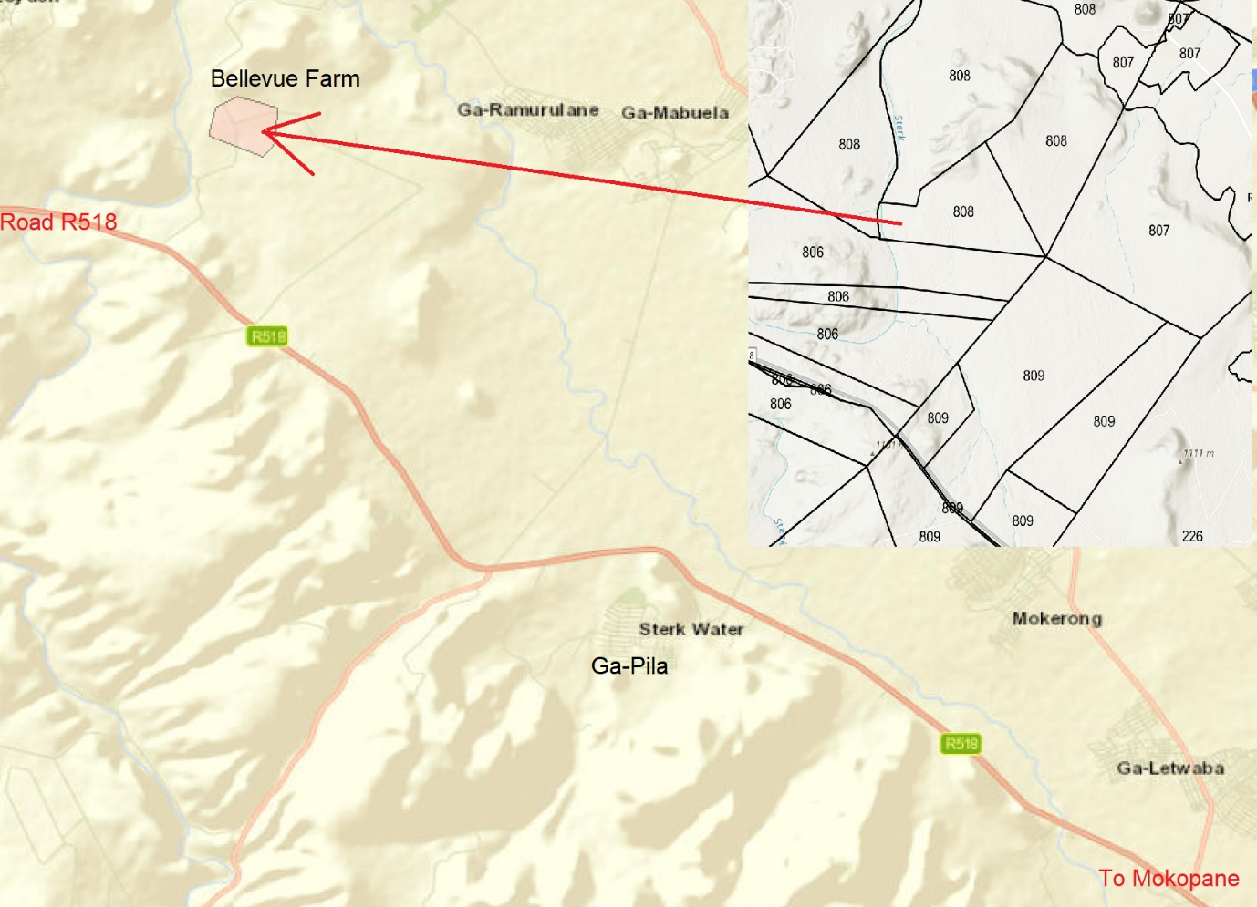

At farm scale, Bellevue operates as a single spatial unit across Portion 2 and Portion 5, with extended internal distances between work areas, infrastructure nodes and natural features. This spatial configuration increases dependence on mobile assets and passable internal routes for supervision, production activities and security patrols. In the absence of adequate vehicles and consistently maintained access tracks, routine management and emergency response capacity are significantly constrained. The geographic context of Bellevue Farm therefore functions as a structural risk multiplier, shaping operational exposure, security vulnerability and management feasibility across all functional domains addressed in the sections that follow.

Land Use, Infrastructure and Built Assets
Land use and infrastructure condition on Bellevue Farm are central determinants of operational viability and disaster risk. As outlined in the preceding sections, the farm was transferred as a functioning commercial property in form, but without the systems, assets and institutional capacity normally required to sustain such an operation. This section therefore examines how land is currently utilised, the state of built infrastructure and fixed assets, and how their condition shapes exposure to operational disruption, safety incidents and asset loss. Table 2.10, presented below, summarises the main categories of land use and built assets before their implications are discussed.

Bellevue Farm comprises Portion 2 and Portion 5 of Farm Bellevue and functions as a single operational unit under the custodianship of the Ga-Pila Community Development Trust. Land use is primarily agricultural, with cropping activities concentrated in cleared and previously cultivated areas. There is no livestock production on the farm. Supporting land uses include worker accommodation, storage areas, drying spaces, access tracks, borehole sites, dam infrastructure and security-related installations such as fencing and gates. Large portions of land remain undeveloped or underutilised due to limited capital, equipment shortages and constrained management capacity.

Built infrastructure on the farm reflects long-term use under previous ownership and has not been systematically refurbished since transfer. Fixed assets include residential housing for workers and supervisors, farm buildings used for storage and operational purposes, drying areas for crops, borehole infrastructure with associated tanks, an earth dam, fencing and access control points. Much of this infrastructure is ageing and shows signs of deferred maintenance. In several instances, infrastructure has been damaged through theft, vandalism or environmental exposure, including the loss of electrical components such as transformers and repeated breaches of fencing.

Table 2.10: Land Use and Built Assets Profile – Bellevue Farm
Land Use / Asset Category | Current Condition | Risk Implications
Cultivated land | Limited active cropping; large areas underutilised due to equipment and capacity constraints | Reduced agricultural output; increased exposure to soil erosion, weed infestation and land degradation
Worker housing | Functional but ageing structures with deferred maintenance | Occupational health and safety risks; declining habitability; potential long-term asset deterioration
Storerooms and sheds | Existing but limited in number; generally unsecured and poorly protected | High vulnerability to theft and vandalism; loss of inputs, tools and harvested produce
Drying areas | Informal and largely exposed to weather conditions | Crop losses during rainfall; reduced quality and marketability of produce
Boreholes and water storage tanks | Operational but dependent on unstable electrical infrastructure | Water supply interruption during power outages or theft of electrical components
Dam infrastructure | Dam wall breached and currently non-functional | Loss of strategic water storage; heightened exposure to drought and fire risk

The condition of built assets directly influences disaster and operational risk on the farm. Breached fencing and unsecured structures increase vulnerability to crime, while ageing housing and storage facilities pose safety and health risks to workers. The failure of the dam, following a breach of its wall, has removed a critical buffer against drought and fire risk, forcing reliance on boreholes that are themselves dependent on unstable electrical infrastructure. Limited storage and drying capacity increase exposure to weather-related losses during cropping cycles.

Land use and infrastructure conditions on Bellevue Farm reflect a mismatch between asset scale and institutional readiness. The absence of systematic asset management, combined with ageing infrastructure and ongoing security threats, transforms everyday operational challenges into persistent risk drivers. Addressing these conditions requires prioritised rehabilitation of critical built assets, improved protection of infrastructure and alignment of land use practices with realistic operational capacity. These issues form the baseline for subsequent sections on water, roads, security, assets and labour safety.

Water Resources, Environmental Exposure and Operational Risk
Water security on Bellevue Farm constitutes a primary operational and disaster risk driver, influencing agricultural viability, worker welfare, fire safety and asset protection. The farm relies entirely on groundwater abstraction supported by distributed storage infrastructure, with no functional surface water buffering following the breach of the earth dam on Portion 5. Water risk is therefore systemic rather than episodic, arising from uneven borehole productivity, water quality constraints, ageing infrastructure, power dependence and exposure to theft and vandalism. Table 2.11, presented below, consolidates the configuration, condition and risk implications of the farm’s water assets across Portion 2 and Portion 5.

The borehole network comprises three distinct installations with markedly different performance profiles. Borehole 3 on Portion 2 is the most productive source and supplies both the workers’ compound and the grass-thatched lodge. Despite its strategic importance, it is unsecured, power dependent and vulnerable to theft or sabotage. Borehole 1 on Portion 5, drilled after transfer of the farm to the Trust, supplies cropped fields and associated storage infrastructure, but its water quality is deemed unsuitable for human consumption and of uncertain suitability for irrigation. Borehole 2, located beneath a decommissioned windmill near the main farmhouse, is shallow, yields very limited volumes and is close to functional failure.

Table 2.11: Water Infrastructure Configuration and Risk Implications – Bellevue Farm
Water Asset | Location | Current Condition | Risk Implications
Borehole 3 (most productive) | Portion 2 | High yield; unsecured; power dependent | Critical supply vulnerable to theft and outages
Borehole 1 (post-handover) | Portion 5 | Operational; water unfit for human use | Limits domestic use; uncertain crop suitability
Borehole 2 (windmill borehole) | Portion 5 | Shallow; almost dry | Minimal contribution; near failure
Overhead plastic tanks | Portion 5 (fields) | ±20,000 litres (2 × 10,000 ℓ) | Irrigation dependent on Borehole 1 quality
Lightly raised plastic tank | Portion 5 (near main house) | ±5,000 litres | Limited buffering; quality constraints
Concrete/brick reservoir 1 | Portion 5 (near main house) | Repaired and functional; capacity unknown | Key buffering asset; single-source dependency
Concrete/brick reservoir 2 | Portion 2 (near container store and tractor shade) | Structurally sound; underutilised | Risk of deterioration if left unused
Workers’ compound tank | Portion 2 | ±5,000 litres; disconnected | High pressure damage risk; no buffering
Lodge overhead tank | Portion 2 | ±5,000 litres | Elevated fire risk due to thatch
Earth dam | Portion 5 (river edge) | Breached; non-functional | Total loss of surface storage

Beyond supply adequacy, the configuration of water infrastructure introduces secondary and compounding risks. The workers’ compound currently receives water directly from Borehole 3 following the disconnection of its storage tank, exposing the system to excessive pressure, pipe failure and immediate service interruption if pumping is disrupted. Borehole 3 also supplies the grass-thatched lodge on Portion 2, where no firefighting equipment is present and no records exist confirming recent fire-retardant treatment of the thatch. A 5,000-litre overhead tank located within approximately 100 metres provides limited buffering and does not materially mitigate fire risk.

The two concrete and brick reservoirs represent latent resilience assets, yet their effectiveness is uneven. Reservoir 1 on Portion 5 has been rehabilitated and is functional, providing valuable buffering for operations near the main house. Reservoir 2 on Portion 2, located adjacent to the container storeroom and tractor shade, remains structurally sound but underutilised and vulnerable to deterioration through disuse. The breached earth dam, constructed by impounding the Mogalakwena River along the upper boundary of Portion 5, represents a permanent loss of surface water resilience, intensifying drought exposure and reliance on electrically powered groundwater systems.

Water-related risk on Bellevue Farm arises from interlinked vulnerabilities spanning quality, quantity, infrastructure condition, security and fire safety. These conditions constrain agricultural planning, elevate human and asset safety risks and amplify the consequences of even minor system failures. Effective risk reduction will therefore require integrated intervention addressing water quality management, infrastructure rehabilitation, storage optimisation, asset protection and emergency preparedness rather than isolated technical fixes.

Access, Roads and Internal Mobility Risk
Access and internal mobility constitute one of the most critical operational and disaster risk drivers affecting Bellevue Farm. The farm lies within the Mogalakwena River catchment and is therefore exposed to predictable access disruption during periods of sustained rainfall. When the Mogalakwena River is in full flow, Bellevue Farm is periodically cut off from external access for three to five days at a time. These disruptions directly affect worker safety, emergency response, asset protection and continuity of operations. The condition of key access routes and internal mobility constraints is summarised in Table 2.12, while physical illustrations of the most critical constraints are provided in Figures 2.11 to 2.13.
Regional connectivity is anchored on the R518 provincial road, which provides reliable linkage to Mokopane and the wider district. Beyond this corridor, access resilience deteriorates sharply. The primary gravel access route from the R518 includes a low-lying concrete crossing designed for water to flow over, rather than beneath, the structure. During periods of heavy rainfall this crossing becomes impassable, isolating the farm entirely. A secondary raised access route via Sepharane village, which historically served as an alternative disaster access option, was washed away during the December 2024 / January 2025 rainfall events, eliminating critical redundancy. These conditions are illustrated in Figures 2.11 and 2.12 below.

Figure 2.11: Collapsed Alternative Access Route from Sepharane Village (I don’t have)
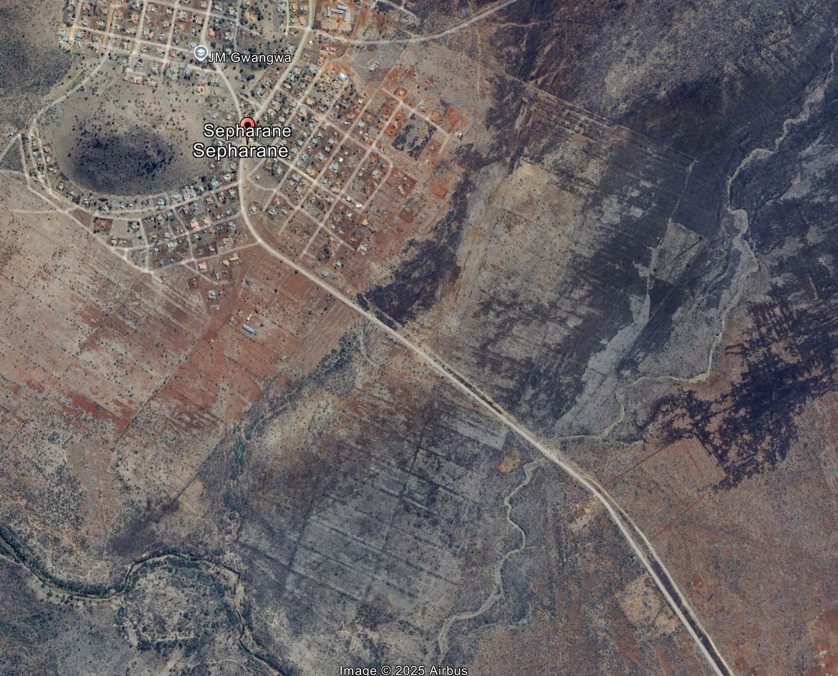.
Figure 2.12: Low-Lying Concrete Crossing on Primary Access Route
Placeholder: (Cant get)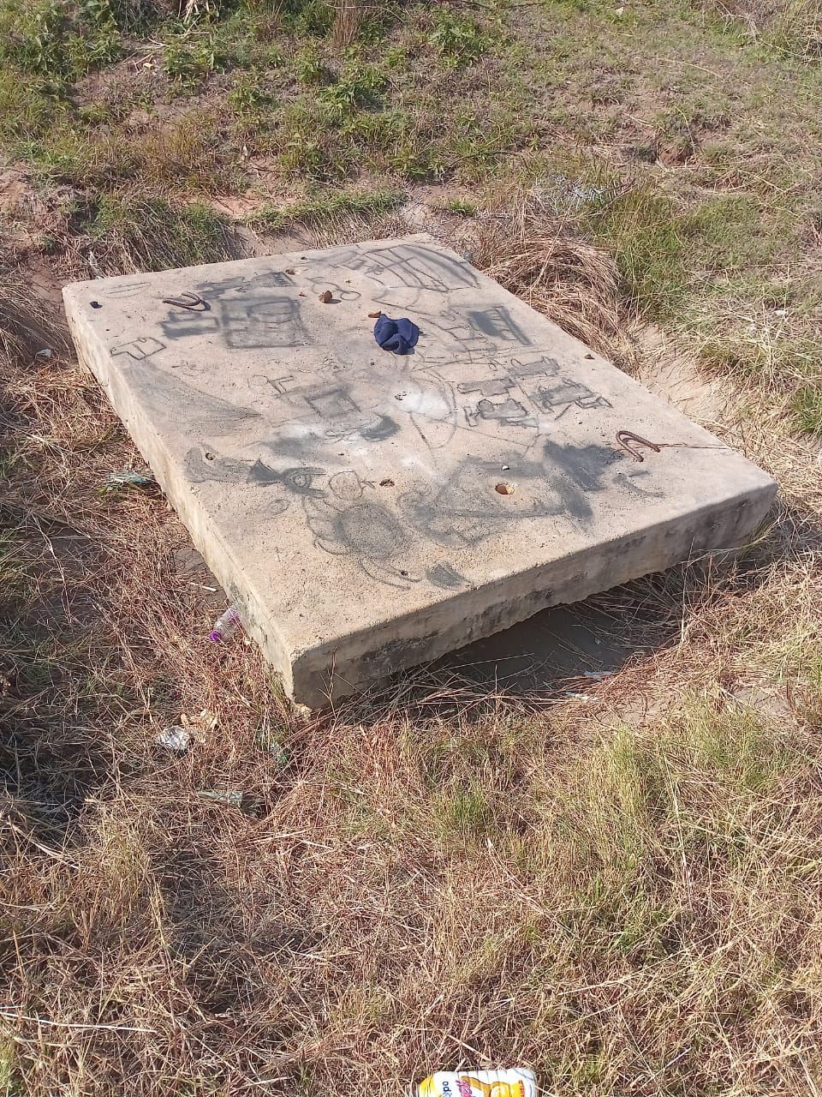

Table 2.12: Access and Internal Mobility Profile and Risk Implications – Bellevue Farm
Access Element | Location | Current Condition | Risk Implications
R518 provincial road | Regional corridor | Tarred; generally reliable | Primary connectivity to Mokopane and services
Primary gravel access road | R518 to farm | Moderately maintained | Vulnerable during heavy rainfall
Low-lying concrete crossing | Main access route | Overtopped when river is full | Farm cut off for 3–5 days
Sepharane alternative access | Neighbouring farm route | Collapsed (Dec 2024/Jan 2025) | Loss of emergency access redundancy
Internal farm roads | Portions 2 and 5 | Generally passable | Narrowing and seasonal deterioration
Grass encroachment | Internal tracks | Progressive | Reduced width and visibility
Mud-prone transition zone | Fields to main house | Seasonally impassable | Operational delays and vehicle risk
Vehicle availability | Entire farm | No dedicated vehicles | Severe emergency evacuation risk
Vehicle suitability | Entire farm | Requires high-clearance 4x4 | Ordinary vehicles cannot transit safely

At farm level, internal mobility is further constrained by narrowing gravel tracks due to grass encroachment and a persistent muddy section between the cultivated fields and the main house complex. This transition zone becomes difficult to traverse after rainfall, delaying supervision, harvesting activities and internal response. These internal constraints are illustrated in Figure 2.13, which shows typical conditions affecting routine movement across the property.

Figure 2.13: Mud-Prone Internal Road Section and Grass Encroachment
Placeholder (Still not quite)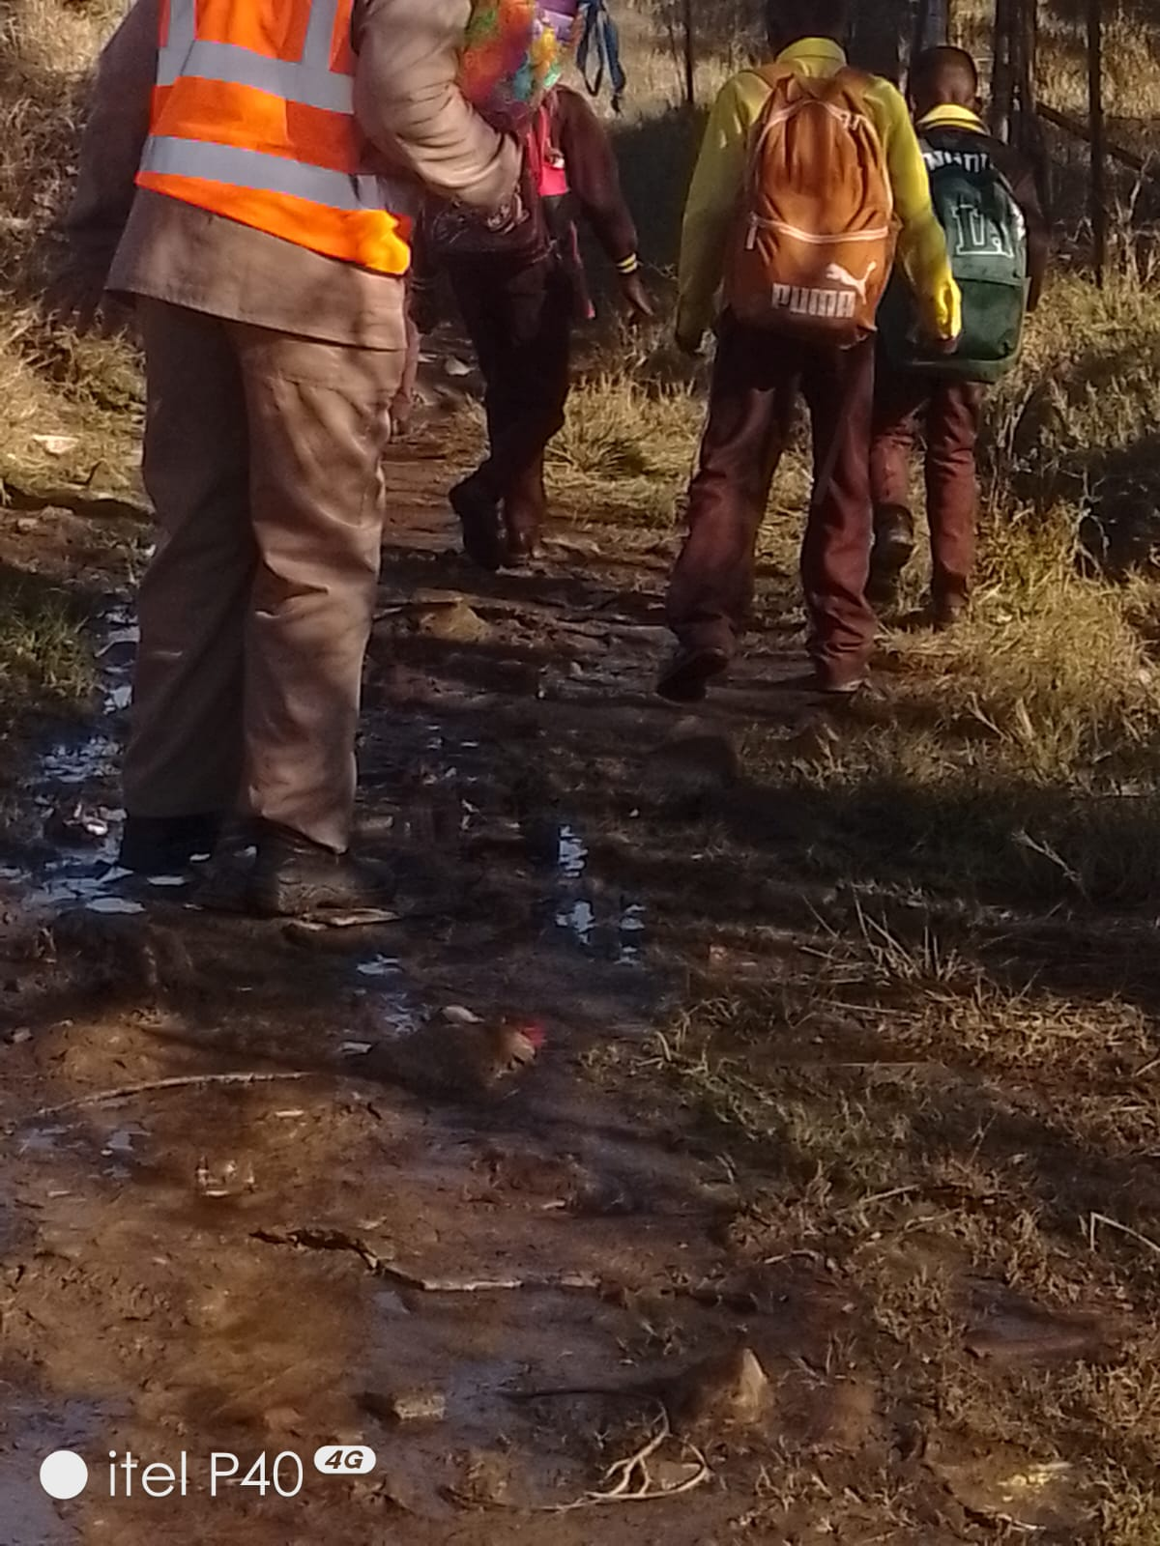

The combined loss of the Sepharane alternative route and the predictable overtopping of the primary access crossing means that Bellevue Farm currently lacks any reliable secondary access during flood conditions. When the river is flowing strongly, only vehicles with advanced four/all-wheel-drive capability can attempt access, and even these are constrained by safety considerations. Ordinary vehicles cannot transit the farm safely under such conditions.

Critically, the workforce has no means of rapid emergency transport. In the event of a medical emergency such as a snakebite, heat collapse, machinery injury or fire-related trauma, evacuation delays could be fatal. Extended internal distances, isolation during rainfall and the absence of on-site vehicles convert otherwise manageable incidents into life-threatening events. Access and mobility constraints therefore represent not only an operational limitation, but a direct human safety hazard that materially amplifies disaster risk on Bellevue Farm.

Security, Asset Protection and Human Safety Risk Assessment
From rom a security risk assessment perspective, Bellevue Farm presents a high-exposure, low-control risk environment that aligns precisely with what the Security-in-Depth (Defence in Depth) model defines as a structural security failure. This model, widely applied in intelligence, critical infrastructure protection and fiduciary risk oversight, is premised on a single core principle: effective security is achieved through multiple, mutually reinforcing layers, such that the failure of one layer is compensated for by others. At Bellevue Farm, this principle is not merely weakly applied; it is fundamentally absent.

When assessed against the standard layers of the Security-in-Depth (Defence in Depth) model, Bellevue Farm fails comprehensively across all five core elements:
- deterrence,
- detection,
- delay,
- response, and
- recovery.
Each layer is either weak, fragmented or entirely absent, and critically, none of the layers compensate for the failure of another.

Deterrence, the first and most visible layer, is weak. Vast areas of the property remain unfenced, human presence is predictable and frequently absent, there is no visible patrol dominance and no coherent perimeter or high-beam lighting strategy. These conditions do not discourage intrusion; they silently invite it. The size of the property, combined with prolonged periods of non-occupation across large sections, creates an open and permissive environment rather than a controlled one.

Detection capability exists only in fragments. CCTV coverage is present but intentionally undisclosed in number and uneven in distribution, resulting in extensive blind zones. While the cameras themselves are technically sophisticated, with night vision, motion detection, facial recognition, alarm triggers, automatic lighting activation and cloud-based recording, they are not integrated into any real-time response mechanism. There is no aerial surveillance, no intrusion analytics linked to intervention and no capacity to detect slow, incremental threats such as creeping land invasion or systematic asset stripping. Detection without response merely documents loss; it does not prevent it.

The delay layer, which should slow intruders long enough for intervention, is almost non-existent. Perimeter fencing has been breached repeatedly, including at least five times in the last 12 to 15 months on the Sepharane side of the Mogalakwena River. Large sections of the river boundary remain effectively unfenced and economically impractical to secure using conventional methods. There are no controlled access points, no buffer firebreaks functioning as physical barriers and no hardened zones protecting high-value assets. In risk terms, once intrusion occurs, there is nothing to stop progression.

Response capacity is functionally absent. The farm has no dedicated vehicle for emergencies or security intervention. Foot patrols remain the dominant mode of so-called security on a property of this scale, rendering them operationally irrelevant. Nine workers, including two supervisors and no farm manager, are dispersed across five housing points, creating security dilution rather than coverage. Distances between Portion 5 and Portion 2, and even between the workers’ compound and the lodge, are significant for a foot-dependent workforce supported by a single quad bike and two bicycles. In an emergency scenario, including snake bite, fire or violent intrusion, delayed response would almost certainly translate into loss of life.

Recovery, the final layer, is narrowly dependent on insurance. While the farm is insured, insurance is a financial instrument, not a life-saving mechanism. There is no redundancy planning for prolonged access cut-off, no continuity strategy for critical operations and no contingency for compound failures such as simultaneous security breach and extreme weather. Reliance on insurance in the absence of prevention reflects a compliance mindset rather than a risk management one.

The conclusion is unavoidable. Bellevue Farm does not possess layered security. It has isolated security artefacts, which in formal risk management doctrine is a recognised failure condition. This alone is sufficient to classify the farm as critically exposed. Security risk at Bellevue is not episodic or reactive; it is continuous, latent and compounding. The absence of visible crisis should not be mistaken for stability. In intelligence terms, this is a low-noise, high-consequence environment where threats incubate undetected until they manifest suddenly and irreversibly. Boards that fail in such contexts do so not through ignorance, but through dangerous comfort. Bellevue Farm is on a trajectory that demands urgent intervention, not reassurance.

Scale, Geography and the Illusion of Oversight
The most fundamental risk driver is scale. Bellevue Farm spans a large, 656-hectare footprint across Portions 2 and 5, with significant internal distances between housing, infrastructure, fields and boundaries. From a security doctrine standpoint, any asset that cannot be patrolled, monitored or responded to within minutes is already partially lost. Bellevue Farm fails this test comprehensively.

Foot patrols are functionally irrelevant on a property of this size. Yet, in practice, this remains the dominant mode of “security”. Nine workers, including two supervisors and no farm manager, are distributed across five housing points. This distribution creates security dilution rather than coverage. Each housing point becomes isolated instead of mutually reinforcing, while large sections of the farm experience extended periods of total human absence. The area beyond the Mogalakwena River on the Sepharane Village side is virtually non-patrolled, rendering it operationally ungoverned for significant stretches of time. Peripheral boundaries elsewhere on the farm are similarly exposed, with long intervals during which no human presence, observation or deterrence exists. In security risk terms, these conditions create predictable opportunity zones for theft, poaching, vandalism and gradual encroachment, with minimal likelihood of early detection or timely intervention.

Mobility Collapse and Emergency Fatality Risk
Mobility is the backbone of security. On Bellevue Farm, mobility is critically deficient. One quad bike and two bicycles serve an asset measured in hundreds of hectares. This is not a resource gap; it is a structural failure.

From an emergency response perspective, this alone places human life at unacceptable risk. There is no dedicated emergency vehicle. In practical terms, this means that a snake bite, severe burn, machinery injury or violent assault could easily result in death, not because treatment is unavailable, but because time to treatment exceeds survivability thresholds. This consititutes a foreseeable fatality condition. It does not require extraordinary circumstances. Ordinary incidents become lethal simply due to response incapacity. Trustees should understand clearly: continued operation under these conditions transfers moral and fiduciary liability directly to the custodial authority.

Surveillance Without Response: A Good Start but Still a Dangerous Half-Measure
CCTV surveillance exists and, at the time of reconnaissance, was reported to be operational and technically sophisticated. The system includes night vision, long-range capability, fixed and rotating cameras, motion and facial recognition, automatic alarm triggers, integrated lighting activation and cloud-based storage. These are strong features and should be acknowledged.

However, surveillance without response capability is an illusion of control. Detection that cannot be acted upon in real time does not prevent loss; it merely records it. The dotted nature of coverage leaves predictable blind spots, especially along some long sections of boundaries, remote infrastructure points and areas beyond the river.

The number and placement of cameras are intentionally undisclosed, which is good practice. What is not good practice is relying on cameras as a substitute for mobility, patrol capability and rapid escalation mechanisms. Cameras observe; they do not intervene. In high-exposure rural assets, surveillance must be paired with rapid response, layered deterrence and redundancy. Bellevue Farm has none of these in sufficient measure.

Perimeter Failure and the Imminent Risk of Land Loss
Repeated fence breaches, particularly on the Sepharane side, represent one of the most serious long-term threats to the Trust’s custodianship. Reports that fencing has been down for the fifth time within 12 to 15 months indicate chronic perimeter failure, not bad luck.

In security intelligence, persistent breaches are interpreted as probing behaviour. They test response, tolerance and enforcement thresholds. When breaches are repeatedly tolerated or slowly addressed, hostile actors escalate from opportunistic theft to de facto occupation.

The portion of land beyond the Mogalakwena River is especially vulnerable. It is difficult to access, expensive to secure and rarely monitored. This is precisely the type of terrain where slow, invisible land invasion occurs. Such encroachment does not begin with houses; it begins with grazing, temporary shelters, dumping and informal cultivation. By the time it is noticed, reversal becomes legally complex and politically volatile.

Without continuous monitoring, preferably through drone surveillance, the Trust is effectively blind to early-stage encroachment. Once occupation hardens, no amount of insurance, litigation or moral argument will restore the land easily.

Fire Risk: A Catastrophe Waiting on the Wings
Fire risk on Bellevue Farm is unmanaged to a degree that would be unacceptable in any commercial agricultural operation. Fireguards are poorly executed or absent. Firefighting equipment is absent. There are no structured fire response protocols.

The presence of a grass-thatched lodge dramatically amplifies this risk. While the lodge is powered by a reportedly efficient 3 kVA solar system, this creates a false sense of safety. Extreme weather events such as storms, prolonged cloud cover, lightning can disable solar systems for days. During such outages, the lodge becomes a highly flammable, poorly protected structure in an isolated environment.

The absence of fire suppression equipment near the lodge, combined with limited water access control and zero rapid evacuation capability, creates a scenario where loss of life is not hypothetical. It is only a matter of timing and conditions.

Alarms, Lighting and the Irresponsible Exposure of Critical Assets
None of the houses, storage facilities, sheds or meat processing and freezing areas are alarmed. There are no external high-beam security lights on buildings. This includes the container storeroom and shed complex, which contain movable, high-value assets and inputs. From a professional security standpoint, this configuration is indefensible. Cameras without alarms and lighting do not deter; they document. Containers and sheds without layered security are the first targets in rural asset stripping operations. The fact that a camera is nearby does not materially reduce risk if response capability is absent.

Human Factors: Awareness with Limited Capabilities
Two-way radios are present, which is a positive baseline measure. However, communication without mobility, escalation protocols or external linkages is functionally constrained and creates a false sense of control. Farm supervisors are not integrated into neighbouring farmer networks, rapid response structures or local mutual-aid arrangements, eliminating any prospect of timely reinforcement during incidents. There is no evidence of routine security briefings, drills, incident rehearsals or after-action reviews. As a result, communication exists in isolation, disconnected from response capability, authority or consequence.

Although the Implementing Agent has introduced certain systems, as reflected in available documentation, situational awareness among workers and effective security oversight by farm supervisors is effectively absent. Security awareness appears individual and experiential rather than institutionalised. This is inherently dangerous. Individuals compensate temporarily through habit and improvisation, but systems are what sustain control under stress. When individuals are fatigued, absent, intimidated or overwhelmed, awareness collapses abruptly, leaving assets and lives exposed.

Of particular concern is the high likelihood of internal collusive criminality, whether deliberate or through gross negligence. Unrecorded visitors have been observed on the property, tools and equipment are routinely left unsecured in open areas, and keys have reportedly been left on the quad bike. These behaviours are not benign. They indicate weak discipline, poor accountability and potential facilitation of later theft or sabotage. In security risk assessment, such patterns are classic precursors to insider-enabled crime, where external actors exploit internal lapses or tacit cooperation.

From a security risk assessment perspective, the most critical indicator of emerging threat on Bellevue Farm is system testing behaviour rather than any single offence. Adversaries rarely begin with high-value or high-visibility acts. They first probe for weakness: testing access points, observing response times, noting patterns of human absence, assessing lighting, mobility and communication gaps, and evaluating whether incursions trigger consequences. Where these probes encounter little resistance, escalation becomes rational rather than reckless.

In this context, the confirmed presence of poaching snares must be read as an early-stage diagnostic signal, not the core problem itself. Poaching is merely one low-risk manifestation of system testing. It indicates repeated unauthorised entry, growing familiarity with terrain and confidence that detection is unlikely. This reflects successful reconnaissance. Where such probing is neither detected nor disrupted, it typically graduates into theft, infrastructure sabotage, organised trespass and, ultimately, land encroachment. The danger lies not in the act observed, but in what it reveals: a permissive environment in which threat actors can learn, adapt and advance without interruption.

The Aggregate Picture: A System Under resourced and Left to Fail
Taken individually, each of these weaknesses is serious. Taken together, they form a coherent failure architecture. Table 2.13 summarises this architecture and its implications.

Table 2.13: Security, Asset Protection and Human Safety Profile – Bellevue Farm
Security Element | Current Condition | Risk Implications
Property scale | Large, dispersed landholding | Foot patrols ineffective
CCTV coverage | Dotted; incomplete | Persistent blind spots
Workforce distribution | Nine workers across five housing points | Thin security coverage
Mobility assets | One quad bike; two bicycles | Inadequate patrol and evacuation
Communication | Two-way radios | Ineffective without mobility
Perimeter fencing | Repeated breaches | Uncontrolled access
Fireguards | Poor or absent | High wildfire risk
Firefighting equipment | Absent | Severe life and asset risk
Alarm systems | None | Delayed response
Emergency transport | None | High fatality risk

Final Professional Assessment
Bellevue Farm is not secure. It is critically exposed. The current operating environment reflects a condition in which risk is not being managed, mitigated or controlled, but rather absorbed by chance. The Trust is relying on luck, goodwill and the absence of catastrophe as substitutes for structured security governance. This is not risk management; it is risk deferral.

Insurance coverage, while necessary, is profoundly inadequate as a primary safeguard. Insurance compensates for some financial loss after an event. It does not prevent death, does not reverse land invasion, does not restore institutional credibility and does not shield Trustees from moral, fiduciary or reputational accountability. In environments where human life, community-owned land and long-term restitution assets are at stake, insurance is the last layer of defence, not the first.

From a senior security risk assessment perspective, the most alarming feature is not any single deficiency documented in this section, but the normalisation of systemic exposure. This is the point at which governance failure typically begins. When decision-makers become comfortable operating inside a high-risk envelope, warning signs are reinterpreted as inconveniences, and absence of incident is mistaken for safety. In intelligence doctrine, this condition precedes sudden, irreversible loss.

Bellevue Farm exhibits all the indicators of a low-noise, high-consequence risk environment. Threats are incubating quietly rather than manifesting explosively. System testing is already occurring. Perimeter probing has been confirmed. Poaching, fence breaches, internal discipline lapses and prolonged unmonitored zones are not isolated problems; they are signals. They indicate that hostile actors are learning the terrain, understanding response limitations and gaining confidence that escalation will not be met with timely resistance.

Critically, the Trust currently holds custodianship of an asset that is geographically expansive, operationally complex and symbolically significant, yet is defended by a security posture that would be inadequate even for a fraction of its scale. The absence of layered deterrence, rapid mobility, integrated response and institutionalised security discipline creates a foreseeable pathway to outcomes that will be framed retrospectively as “unexpected”, but which are, in fact, predictable.

This section is not a commentary or criticism. It is a formal warning. The question before the Board of Trustees is no longer whether Bellevue Farm faces serious security and human safety risk. That question has been answered unequivocally by the evidence. The only remaining question is how long inaction can be sustained before the Trust is confronted with consequences that cannot be undone.

2.20 Consolidated Farm-Level Risk Profile and Strategic Implications
The cumulative evidence presented in Part B confirms that disaster and operational risk on Bellevue Farm is systemic, reinforcing and structurally embedded. Risk does not arise from isolated failures, but from the interaction between geography, infrastructure condition, water insecurity, access fragility, security collapse and institutional unpreparedness. These factors combine to produce a low-visibility, high-impact risk environment in which ordinary incidents have disproportionate consequences. Crucially, the farm’s exposure is magnified by its scale and symbolic significance as a restitution asset held in custodianship by the Ga-Pila Community Development Trust.

Table 2.14 consolidates the principal farm-level hazards identified across Sections 2.14 to 2.19, links them to their underlying drivers and highlights the strategic implications for disaster risk management, governance and asset protection. The table should be read as an integrated risk portrait rather than a checklist of discrete issues.

Table 2.14: Consolidated Farm-Level Risk Profile and Strategic Implications (Bellevue Farm)
Risk Domain | Key Drivers and Conditions | Strategic Implications
Governance and institutional readiness | Transfer of a commercial farm without equipment, capital, skills transfer or operational systems | Structural inability to manage risk; persistent dependence on crisis response rather than prevention
Geographic scale and spatial dispersion | 656-hectare footprint; long internal distances; fragmented housing and infrastructure nodes | Oversight illusion; delayed detection and response; large unmonitored zones
Access and isolation risk | Low-lying river crossing; collapse of alternative Sepharane access; rainfall-related cut-offs | Periodic total isolation; fatal delays in emergencies; loss of response redundancy
Water security and fire exposure | Uneven borehole productivity; water quality constraints; breached dam; power dependence | Constrained agricultural planning; elevated fire and human safety risk
Infrastructure condition | Ageing housing; unsecured storage; deferred maintenance; breached fencing | Accelerated asset degradation; theft, vandalism and safety incidents
Internal mobility | No dedicated vehicles; reliance on one quad bike and bicycles | Inability to patrol, evacuate or respond within survivability thresholds
Security architecture | Absence of layered deterrence, delay and response; dotted surveillance | High probability of asset loss, land encroachment and violent incidents
Human safety | No alarms, firefighting equipment or emergency transport | Foreseeable loss of life from routine incidents
Environmental and land encroachment risk | Unfenced river boundary; minimal monitoring beyond Mogalakwena River | Slow, invisible land invasion with high legal and political cost
Risk management posture | Reliance on insurance; absence of contingency and continuity planning | Financial compensation after loss; no protection against irreversible outcomes

The consolidated profile demonstrates that Bellevue Farm is operating within a risk envelope that exceeds what can reasonably be managed through informal controls, goodwill or incremental fixes. The interaction between access fragility, water insecurity, security collapse and human safety exposure means that failure in one domain rapidly cascades into others. In such environments, absence of incident should not be interpreted as stability, but as delayed consequence.

The Trust holds custodianship of an asset whose failure would endanger lives, livelihoods and the credibility of the restorative justice rationale underpinning its transfer. What was inherited is not a viable restorative asset, but a complex, under-resourced and high-risk burden, transferred without the means to secure, operate or protect it. By any credible standard, this does not constitute restorative justice, but rather the displacement of historical obligation into a present and potentially catastrophic liability. From a disaster risk management perspective, the core issue is no longer hazard identification but risk tolerance. Effective risk reduction therefore demands decisive, preventative intervention to restore control, redundancy and accountability at farm scale. Without such a shift, Bellevue Farm remains exposed to sudden and irreversible outcomes that will later be described as unforeseen, despite being plainly predictable from the evidence presented in this Chapter.

Hazard, Risk and Vulnerability Profile

Introduction
Disaster risk in Ga-Pila is shaped by persistent, localised hazards that affect households and community systems on a recurring basis rather than through rare, large-scale disaster events. The dominant risks are seasonal and every day in nature, arising from predictable conditions such as flooding linked to inadequate stormwater management, wind damage to housing, household fires associated with unsafe energy use, public health outbreaks linked to sanitation and waste management constraints, and access disruptions caused by deteriorating internal roads. These risks do not occur in isolation; they recur annually and accumulate over time, steadily eroding household assets, livelihoods and social resilience.

This risk profile is consistent with the Disaster Management Act (57 of 2002), the National Disaster Management Framework and the Sendai Framework for Disaster Risk Reduction (2015–2030), all of which emphasise the importance of understanding risk as a product of hazard exposure, vulnerability and underlying development conditions. The analysis presented in this section integrates community perspectives, observed settlement conditions and technical assessment to identify both current and emerging disaster risks affecting Ga-Pila. It recognises that vulnerability is shaped as much by service reliability, infrastructure quality and environmental exposure as by the hazards themselves.

During community engagements conducted in July 2024, one resident captured the lived reality of this cumulative risk with stark clarity:

“When the rains come or a fire breaks out, we already count what we will lose. Not because we are careless, but because nothing ever changes. We prepare ourselves for damage, not for help.”

This statement reflects a pattern of normalised exposure rather than episodic crisis. In Ga-Pila, disaster risk is not experienced as an exceptional interruption, but as a constant background condition that households anticipate and absorb. Such conditions reveal the interaction between environmental hazards and long-standing development constraints, including uneven service provision, ageing infrastructure and limited household coping capacity. Without addressing these root causes, risk reduction efforts will remain reactive and insufficient, allowing avoidable losses to continue accumulating quietly at community level.

Risk Analysis Methodology
South Africa’s National Disaster Management Framework (NDMF, 2005), in alignment with international best practice including the Sendai Framework for Disaster Risk Reduction (2015–2030) and guidance from UNDRR, IFRC and the World Bank’s Global Facility for Disaster Reduction and Recovery, adopts a risk-based and prevention-oriented approach to disaster management. This framework prioritises systematic risk understanding, vulnerability reduction, resilience building, and the strengthening of preparedness and response capabilities.

At its core, disaster risk is conceptualised as the interaction between hazards, underlying vulnerability and existing capacity, shaped by the level of exposure:

Disaster Risk = Hazard × Vulnerability × Exposure ÷ Capacity

Where:

Hazard | : | Potential damaging physical event (e.g., floods, drought, disease outbreaks, hazardous materials)
Vulnerability | : | Conditions that increase susceptibility to harm (e.g. poverty, weak infrastructure, poor planning)
Exposure | : | People, assets, services or systems located in hazard-prone areas
Capacity | : | Capabilities and resources to prevent, withstand, and recover (e.g. early warning, emergency services, governance)

This logical sequence drives both the NDMF and global DRR practice:
- Know Your Risk: Hazard, exposure, and vulnerability profiling
- Prevent and Mitigate: Reduce risk drivers, build resilience, apply land use control, enforce standards
- Prepare: Plans, systems, early warning, simulations, readiness
- Respond: Coordinated, rapid interventions to save lives and protect livelihoods
- Recover and Build Back Better: Restore and improve systems to reduce future risk

This approach reflects the broader risk management cycle and is designed to support development continuity rather than reactive crisis management. The disaster risk logic underpinning the NDMF and international best practice is deliberately proactive, risk-informed, development-oriented and resilience-focused. It rejects the notion of disasters as unavoidable acts of fate and instead treats them as governance and planning challenges that can be anticipated, mitigated and systematically managed. Against this backdrop, the assessment methodology integrated field-based evidence, community perceptions of risk, spatial observation and institutional review. Identified risks were prioritised through a structured likelihood-and-impact scoring process, as presented in Table 3.1.

Table 3.1: Risk Rating Framework
Likelihood Score | Description | Impact Score | Description
1 | Rare event | 1 | Negligible
2 | Possible but infrequent | 2 | Minor household-level impact
3 | Occurs annually | 3 | Moderate community disruption
4 | Seasonally recurrent | 4 | Significant local impact
5 | Very frequent or ongoing | 5 | Serious and widespread impact

Figure 3.1 illustrates the disaster risk logic applied to structure and guide the assessment.

Figure 3.1: Disaster Risk Logic Model
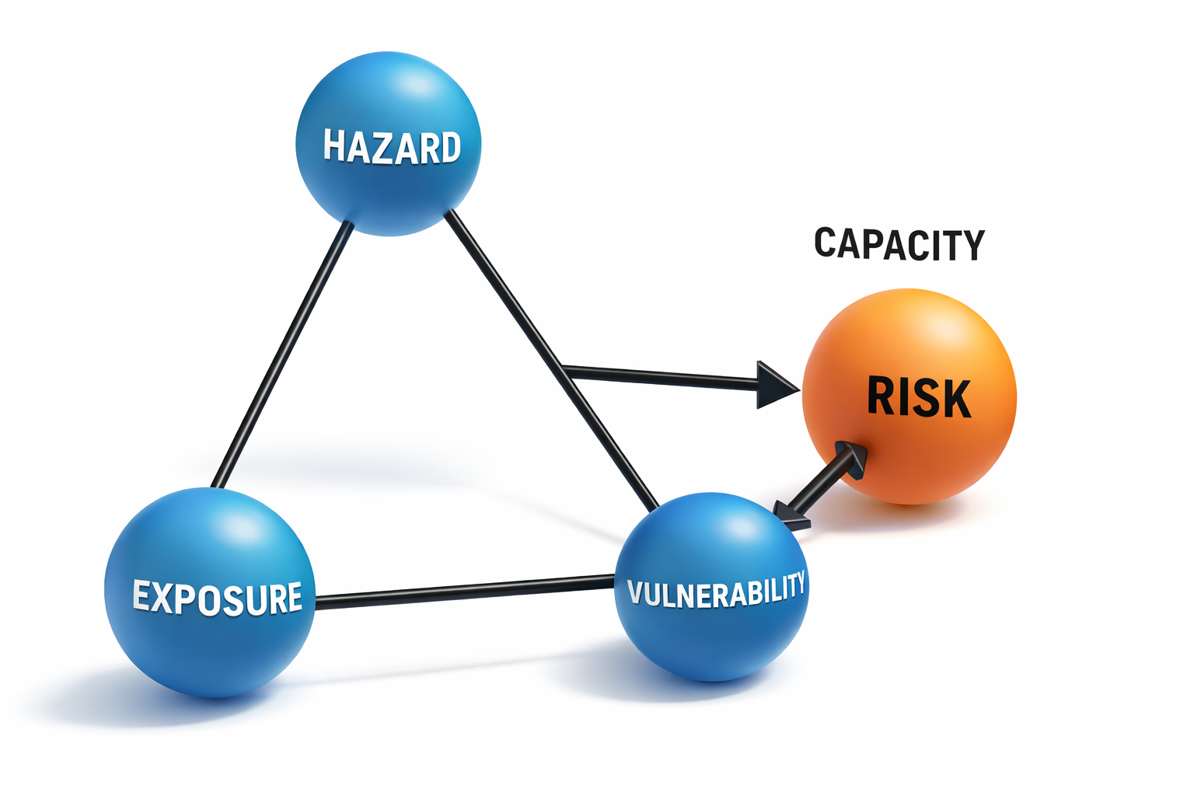

This approach ensures that disaster risk is not interpreted as a consequence of hazard occurrence alone. Instead, it reveals the underlying development, service delivery and governance deficiencies that generate and sustain vulnerability. In the case of Ga-Pila, risk is shaped far more by structural vulnerability than by the severity of hazards themselves. This confirms that resilience cannot be secured through emergency response measures in isolation, but must be systematically constructed through targeted, preventative and corrective development planning that addresses root causes rather than symptoms.

Hazard Identification
Disaster risk within the Ga-Pila area is generated through the interaction between recurring hazards and entrenched vulnerability conditions. However, this risk is not uniform across space or function. Two distinct risk environments exist and must be analysed separately: the Ga-Pila village settlement, characterised by dense residential occupation and service dependency, and Bellevue Farm, a large landholding and economic asset exposed to environmental, security and governance-related hazards.

Hazard identification therefore serves as a foundational analytical step, enabling systematic recognition of the forces shaping risk in each context and informing prioritised disaster risk reduction planning. This approach is aligned with the National Disaster Management Framework Key Performance Area 2 and Sendai Framework Priority 1, both of which emphasise that disasters arise from predictable hazard–vulnerability interactions rather than isolated or unforeseen events. For analytical clarity and internal consistency, hazard identification is presented in two subsections.

Ga-Pila Village Settlement
In the Ga-Pila village, disaster risk is driven primarily by high-frequency, low- to medium-intensity hazards that recur seasonally and cumulatively erode household security, livelihoods and basic infrastructure. These hazards seldom present as singular catastrophic events, yet their repetition steadily undermines development gains and deepens vulnerability over time.

Hazards affecting the village were identified through field engagements, participatory community risk mapping, seasonal recall of past impacts, direct observation of hazard-prone locations and technical inputs from local development and service delivery profiles. Particular emphasis was placed on lived experience, as many of these events do not trigger formal disaster declarations despite causing substantial household-level loss.

For consistency with recognised disaster risk taxonomies, village-level hazards were grouped into hydro-meteorological, climatological, environmental degradation, technological and infrastructure-related, public health, social and socio-economic, and governance-related categories. These classifications were validated through spatial observation, historical event recall and verification of recurring impact patterns. Table 3.2 presents the consolidated hazard inventory for the Ga-Pila village settlement.

The hazards identified for the village operate as an interconnected system rather than as isolated events. Flooding accelerates soil erosion and road failure, which restricts access to services and emergency response. Electricity instability increases reliance on open flames and informal energy sources, heightening household fire risk. Water interruptions intensify sanitation-related disease exposure. Disaster risk in Ga-Pila village is therefore cumulative, predictable and development-driven, not accidental.

Table 3.2: Summary of Hazards Identified in Ga-Pila (Sterkwater)
Hazard Category | Specific Hazards Identified | Local Triggers and Drivers | Recurrence Pattern | Primary Source of Evidence
Hydro-meteorological | Localised flooding and yard inundation | Intense summer rainfall; informal stormwater channels; sandy soils; altered runoff paths | Seasonal, recurring (rainy season) | Field observation; ICDP data; settlement layout analysis
Hydro-meteorological | Stormwater damage to roads and access routes | Gravel roads; lack of engineered drainage; runoff concentration along road alignments | Seasonal, recurrent | Municipal infrastructure data; field inspection
Hydro-meteorological | Temporary isolation of settlement sections | Erosion of internal roads; overtopped drainage channels; low-lying areas | Seasonal, event-driven | Community accounts; access assessment
Climatological | Heat stress and dehydration | Hot summers; prolonged dry periods; limited water access | Seasonal with increasing trend | Environmental context analysis; ICDP
Climatological | Drought and water scarcity stress | Semi-arid climate; borehole dependency; uneven water access | Multi-year cyclical | Household survey data; water access analysis
Environmental | Soil erosion around homesteads and roads | Sandy soils; degraded vegetation; stormwater scouring | Seasonal, cumulative | Field observation; environmental profile
Environmental | Dust exposure and poor air quality | Exposed soils; dry periods; mining-related vehicle movement | Seasonal and continuous | Environmental context section; field observation
Environmental | Lightning-related injury and fire ignition | High lightning frequency zone; limited grounding and protection | Seasonal (summer storms) | Regional lightning exposure analysis
Infrastructure / Technological | Road access failure | Predominantly unsurfaced roads; erosion during rainfall | Seasonal, recurring | Municipal data; community transport experience
Infrastructure / Technological | Electricity supply interruptions | Feeder capacity constraints; load shedding | Frequent, irregular | Community accounts; service profile
Infrastructure / Technological | Household and structural fires | Candle, gas and firewood use during outages; informal wiring; settlement densification | Frequent, recurring | Household interviews; ICDP references
Infrastructure / Technological | Sanitation system failure | Pit latrines and VIP toilets vulnerable to flooding and groundwater rise | Seasonal, recurrent | ICDP sanitation data; field observation
Public Health | Waterborne disease outbreaks | Contaminated runoff; sanitation flooding; limited water for hygiene | Seasonal with recurrence | ICDP public health references
Public Health | Sanitation-related illness | 88% reliance on on-site sanitation; poor drainage | Continuous with seasonal spikes | Sanitation profile; health data
Public Health | Reduced fire suppression capacity | Limited water access; distance to water sources | Continuous | Water access analysis
Social / Demographic | Evacuation vulnerability | High proportion of elderly and single-person households | Continuous | Household composition analysis
Social / Demographic | Care and dependency strain during emergencies | High female-headed and elderly households | Continuous | Population profile
Socio-economic | Livelihood disruption following incidents | Informal income dependence; limited local economy | Continuous, cumulative | Livelihood systems analysis
Socio-economic | Delayed recovery after hazard events | Low household income; limited savings | Continuous | Economic profile; risk synthesis
Governance / Institutional | Weak coordinated emergency response | Fragmented governance; limited municipal presence | Continuous | Governance and institutional assessment
Governance / Institutional | Informal disaster response structures | Reliance on social networks rather than formal systems | Continuous | Community structures analysis

Bellevue Farm
Bellevue Farm represents a fundamentally different hazard environment from the village settlement. While geographically linked to Ga-Pila, the farm functions as a large, dispersed land and asset system with extensive exposure, limited physical control and weak risk governance. Hazard identification for Bellevue Farm therefore extends beyond environmental threats to include security, asset protection and institutional hazards that exploit scale, isolation and absence of layered controls.

Hazards affecting Bellevue Farm were identified through site inspection, asset mapping, incident review, land-use observation and analysis of operational and governance arrangements. The consolidated hazard inventory for Bellevue Farm is presented in Table 3.3. Unlike the village, where vulnerability is the dominant risk driver, risk at Bellevue Farm is amplified by exposure at scale, predictability of absence, and insufficient deterrence, detection and response capacity.

Environmental hazards such as veld fires and land degradation are intensified by uncontrolled access, inadequate firebreak maintenance and delayed detection. Human-induced hazards, including theft, poaching, vandalism, infrastructure sabotage and unauthorised occupation, occur within a broader pattern of system testing and progressive exploitation. These hazards are not random; they reflect repeated probing of weak controls followed by escalating confidence that intrusion will go undetected or unchallenged.

Governance and institutional hazards further compound exposure. The absence of an integrated security strategy, limited on-site supervision capacity, and lack of external response linkages convert manageable threats into persistent risk trajectories.

Table 3.3: Summary of Hazards Identified at Bellevue Farm
Hazard Category | Specific Hazards Identified | Local Triggers and Drivers | Recurrence Pattern | Primary Source of Evidence
Environmental | Veld and bush fires | Poorly maintained firebreaks; dry biomass; delayed detection | Seasonal, recurring | Site inspection; fire history
Environmental | Land degradation | Uncontrolled access; overgrazing; illegal resource use | Continuous, cumulative | Land condition observation
Environmental | Flooding and erosion along river boundary | Unfenced river edge; storm runoff | Seasonal | Spatial inspection
Security / Human-Induced | Poaching and illegal hunting | Uncontrolled access; absence of patrol dominance | Recurrent | Snare observation; site evidence
Security / Human-Induced | Theft and asset stripping | Predictable human absence; weak deterrence | Recurrent | Incident patterns; asset loss
Security / Human-Induced | Infrastructure sabotage | Limited surveillance; delayed response | Episodic with escalation risk | Asset condition review
Security / Human-Induced | Unauthorised occupation and land encroachment | Large unfenced areas; low monitoring | Latent, slow-onset | Boundary inspection
Technological / Infrastructure | Power disruption at lodge | Dependence on single 3kVA solar system; extreme weather | Low frequency, high impact | System assessment
Technological / Infrastructure | Fire risk at storage and processing facilities | No alarms; no high-beam lighting; isolated containers | Continuous | Facility inspection
Governance / Institutional | Weak coordinated response | No integrated security strategy; no mutual-aid linkages | Continuous | Governance review

The hazard environments of the Ga-Pila village and Bellevue Farm are structurally different and must not be treated interchangeably. In the village, disaster risk is driven by vulnerability and service fragility. At Bellevue Farm, risk is driven by exposure at scale, weak control systems and absence of layered security and governance mechanisms.

A hazard only becomes disaster risk when it intersects with exposed and vulnerable people, livelihoods or assets. Section 3.4 therefore builds on this dual hazard inventory by analysing how hazards manifest differently across the village and the farm, the vulnerability conditions that magnify their impacts, and the systems most at risk in each context. This ensures that exposure profiling (Section 3.5), vulnerability analysis (Section 3.6) and capacity assessment (Section 3.7) are grounded in a coherent, spatially differentiated and evidence-based understanding of risk.

Exposure Analysis
Hazards Exposure refers to the presence of people, assets, livelihoods and systems in locations that could be adversely affected by hazards. Exposure does not in itself create disaster risk; rather, it determines who and what is placed in harm’s way when hazards interact with vulnerability conditions. Building on the hazard identification in Section 3.3, this section analyses exposure patterns separately for the Ga-Pila village settlement and Bellevue Farm, recognising their fundamentally different spatial forms, functions and risk dynamics.

This approach is consistent with the disaster risk logic embedded in the National Disaster Management Framework and Sendai Framework Priority 1, which require that risk analysis distinguish between hazard presence and exposure characteristics in order to inform targeted risk reduction.

Exposure Analysis: Ga-Pila Village Settlement
In the Ga-Pila village, exposure is primarily population-centred and infrastructure-dependent. Households, schools, clinics, internal roads, sanitation facilities and informal livelihood activities are densely clustered within a settlement pattern that has limited protective infrastructure. As a result, a large proportion of the population is repeatedly exposed to hazards that occur seasonally or intermittently but with high frequency.

Exposure in the village is intensified by settlement design and service delivery constraints. Many households are located in low-lying areas or along informal drainage paths, increasing exposure to flooding and stormwater runoff. Reliance on on-site sanitation and shared water points expands exposure to waterborne disease during periods of heavy rainfall or water supply disruption. Predominantly unsurfaced roads expose emergency routes, learners and pedestrians to access failure and transport-related hazards.

Hazard severity in the village is amplified less by extreme hazard intensity than by the concentration of people and fragile systems in hazard-prone spaces. Recurrent rainfall events expose sanitation systems, homes and roads simultaneously, while electricity disruptions expose households to secondary risks through unsafe energy substitution. These interacting exposures create cascading effects that extend well beyond the initial hazard trigger. Table 3.4 presents a consolidated exposure analysis for the Ga-Pila village settlement.

Table 3.4: Exposure Analysis Summary for Ga-Pila
Hazard Category | No. | Hazard | Local Causes / Drivers | Exposure Profile | Vulnerability Factors | Consequences and Risk Tier
Hydro-Meteorological Hazards
1 | Flooding and stormwater runoff | Intense summer rainfall; informal drainage; compacted soils; blocked channels | Low-lying households; internal roads; sanitation facilities | Weak foundations; erosion-prone soils; lack of diversion infrastructure | Yard flooding; road washaways; sanitation failure; access disruption | Tier 1 – Life-threatening priority risk
2 | Lightning | High lightning frequency zone; exposed structures | Homes, schools, open yards, grazing areas | No lightning protection; limited awareness | Injury, fatalities, fire ignition, appliance damage | Tier 2 – Serious recurring risk
3 | Strong winds | Seasonal thunderstorms; inadequate roof anchoring | Houses with lightweight roofing; schools | Nail-only roof fixing; informal extensions | Roof damage, injuries, loss of shelter | Tier 1 – Life-threatening priority risk
Climatological Hazards
4 | Heat stress | Rising temperatures; prolonged dry periods | Elderly persons; outdoor workers; learners | Limited water access; lack of shade | Dehydration; heat exhaustion | Tier 2 – Serious recurring risk
5 | Drought and water scarcity | Borehole dependency; rainfall variability | Entire community | No alternative water sources | Reduced hygiene; water conflict; fire risk | Tier 1 – Life-threatening priority risk
Environmental Degradation Hazards
6 | Soil erosion | Concentrated runoff; degraded vegetation | Footpaths; yards; roads | Sandy soils; no erosion control | Land loss; road damage | Tier 2 – Serious recurring risk
7 | Veld and grass fires | Dry vegetation; uncontrolled burning | Settlement edges; grazing land | No firebreaks; limited suppression | Property loss; grazing damage | Tier 2 – Serious recurring risk
8 | Land degradation | Overuse; settlement expansion | Communal land | Weak land-use control | Declining land productivity | Tier 3 – Emerging manageable risk
Technological / Infrastructure Hazards
9 | Electricity disruptions | Network constraints; lightning; load shedding | Entire settlement | No backup systems | Fire risk; food loss; insecurity | Tier 2 – Serious recurring risk
10 | Unsafe electrical wiring | Informal connections; overloaded circuits | Backyard rooms; dense yards | Poor safety compliance | Fires; electrocution | Tier 1 – Life-threatening priority risk
11 | Water supply interruptions | Borehole failure; vandalism | Entire settlement | Single-source dependency | Hygiene collapse; school disruption | Tier 1 – Life-threatening priority risk
12 | Road access failure | Gravel roads; rainfall erosion | Emergency routes; schools | Weak road base | Delayed response; isolation | Tier 2 – Serious recurring risk
Public Health Hazards
13 | Waterborne disease | Runoff contamination; storage practices | Children; households | Poor sanitation coverage | Diarrhoeal illness; dehydration | Tier 1 – Life-threatening priority risk
14 | Sanitation-related disease | Flooded pit latrines; greywater stagnation | Dense settlement areas | On-site sanitation reliance | Illness outbreaks | Tier 2 – Serious recurring risk
15 | Tuberculosis | Overcrowding; indoor smoke | Multi-person households | Poor ventilation | Chronic illness | Tier 2 – Serious recurring risk
Human-Induced / Socio-Economic Hazards
16 | Household and structural fires | Candles; firewood; gas; unsafe wiring | Informal and dense housing | Flammable materials | Fatalities; asset loss | Tier 1 – Life-threatening priority risk
17 | Road transport accidents | Poor visibility; informal road design | Pedestrians; learners | No sidewalks; speeding | Injury; death | Tier 2 – Serious recurring risk
Mining-Related Hazards
18 | Dust and air pollution | Haulage traffic; exposed surfaces | Roadside households | Chronic exposure | Respiratory stress | Tier 2 – Serious recurring risk
19 | Blasting vibration | Nearby mining activity | Older housing stock | Structural fragility | Cracking; instability | Tier 2 – Serious recurring risk

Based on frequency, severity, population exposure and vulnerability conditions, the highest-priority hazards for Ga-Pila are:
- Water supply interruptions
- Flooding and stormwater runoff
- Household and structural fires
- Unsafe electrical wiring
- Drought and water scarcity

The exposure profile confirms that disaster risk in Ga-Pila village manifests as persistent stress rather than episodic collapse. While individual households may withstand single events, the cumulative exposure of the settlement to repeated hazards steadily erodes resilience, damages infrastructure and prolongs recovery time.

Exposure Analysis: Bellevue Farm
Exposure at Bellevue Farm is fundamentally asset- and land-centred, rather than population-dense. The farm comprises a large, dispersed landholding with extensive boundaries, isolated infrastructure nodes, limited human presence and significant internal distances. This spatial configuration creates a distinct exposure profile characterised by scale, isolation and delayed response. Table 3.5 summarises the exposure profile for Bellevue Farm.

Table 3.5: Exposure Analysis Summary – Bellevue Farm
Hazard Category | No. | Hazard | Exposure Profile | Key Exposure Drivers | Consequences
Environmental | 1 | Veld and bush fires | Grazing land, lodge, boundary zones | Large unmanaged tracts; limited firebreaks | Loss of land productivity; infrastructure damage
Environmental | 2 | Flooding and erosion | River boundaries; access routes | Unfenced river edge; storm runoff | Boundary loss; access disruption
Security / Human-Induced | 3 | Theft and asset stripping | Sheds, containers, equipment | Predictable absence; no alarms or lighting | Financial loss; operational disruption
Security / Human-Induced | 4 | Poaching and illegal access | Remote land sections | Weak deterrence; blind zones | Wildlife loss; system testing escalation
Security / Human-Induced | 5 | Unauthorised occupation | Peripheral and riverine land | Low monitoring; slow detection | Long-term land loss risk
Infrastructure | 6 | Fire at lodge and facilities | Lodge, storage areas | No suppression equipment; isolation | Life safety risk; total asset loss
Governance / Institutional | 7 | Delayed emergency response | Entire property | Limited mobility; no emergency vehicle | Escalation from incident to catastrophe

Environmental hazards such as veld fires, flooding along riverine sections and land degradation expose grazing land, boundary infrastructure, storage facilities and the lodge to damage. However, the most critical exposure at Bellevue Farm arises from human-induced and security-related hazards, including theft, poaching, vandalism, infrastructure sabotage and unauthorised occupation. These hazards exploit predictable periods of absence, weak perimeter control and limited mobility across the property. Unlike the village, where exposure is driven by density, exposure at Bellevue Farm is driven by extent and invisibility. Large sections of the property remain unobserved for extended periods, allowing hazards to develop undetected. Infrastructure assets such as sheds, containers, processing facilities and the lodge are exposed due to the absence of alarms, limited lighting and delayed response capacity. River boundaries and unfenced areas further expose the land to slow-onset encroachment and cumulative loss.

Exposure is also compounded by governance and operational arrangements. Limited on-site supervision, reliance on foot patrols and lack of integration with external response systems mean that once a hazard materialises, the farm’s ability to intervene rapidly is severely constrained. In this context, exposure translates directly into elevated consequence. The exposure analysis shows that while Bellevue Farm has fewer people permanently on site, the consequences of exposure are disproportionately severe. Hazards that might be containable in a controlled environment escalate rapidly due to delayed detection, distance and weak response capacity. Exposure at Bellevue Farm is therefore high-impact, low-reversibility in nature.

The dual exposure profiles of the Ga-Pila village and Bellevue Farm confirm that disaster risk in the study area is spatially differentiated and functionally distinct. Village risk is driven by population density and service fragility, while farm risk is driven by scale, asset exposure and governance gaps. Section 3.6 (Vulnerability Analysis) follows by examining the social, economic, institutional and infrastructural conditions that explain why these exposed people and assets experience harm when hazards occur. This ensures that risk reduction and response planning are grounded not only in where hazards strike, but in why their impacts become severe and persistent.

Vulnerability Analysis
Vulnerability refers to the conditions that increase the susceptibility of people, livelihoods, infrastructure and systems to harm when hazards occur. While exposure identifies who or what is at risk, vulnerability explains why loss, disruption and delayed recovery occur, and why the same hazards repeatedly produce disproportionate consequences for certain groups or assets. Vulnerability is shaped by physical fragility, economic insecurity, social inequality, environmental degradation and institutional limitations, all of which influence the ability to anticipate, absorb, respond to and recover from hazard impacts.

The National Disaster Management Framework emphasises that disaster risk in South Africa is fundamentally a development challenge rather than a natural one. Disasters are rarely the result of hazards alone; they emerge where hazards intersect with long-standing vulnerability conditions created by poverty, inadequate planning, weak infrastructure and limited access to services. This logic applies to both the Ga-Pila village settlement and Bellevue Farm, although the nature and expression of vulnerability differ significantly between the two contexts. Accordingly, vulnerability analysis is presented separately for the Ga-Pila village and Bellevue Farm.

Vulnerability Analysis: Ga-Pila Village
In the Ga-Pila village, vulnerability is primarily human-centred and socially embedded. It arises from a combination of household poverty, fragile housing conditions, limited livelihood security, constrained access to services and weak institutional support. These conditions mean that even low- to medium-intensity hazards produce significant hardship and long recovery periods. The key vulnerability conditions affecting the Ga-Pila village are summarised in Table 3.5A.

Vulnerability within the village is unevenly distributed. Groups that consistently experience heightened vulnerability include children, elderly residents, people with disabilities, female-headed households and households without stable income. These groups often lack durable housing, savings, private transport, secure sanitation and rapid access to assistance. As a result, they are less able to prepare for hazard events, protect assets or recover quickly after loss.

Table 3.5A: Vulnerability Analysis Summary – Ga-Pila Village
Vulnerability Category | Underlying Causes | Who or What is Most Affected | Evidence from Ga-Pila | Risk Implication
Social vulnerability | Poverty, household dependency, weak safety networks | Children, elderly residents, people with disabilities, female-headed households | Reliance on neighbours and informal support | Higher human impact and slow recovery
Economic vulnerability | High unemployment, grant dependence, fragile informal economy | Low-income households, informal traders, elderly on fixed incomes | Income loss during disruptions | Prolonged livelihood stress
Physical vulnerability | Weak construction, informal extensions, ageing housing | Informal rooms, older dwellings | Recurrent storm and wind damage | Elevated housing failure risk
Environmental vulnerability | Soil exposure, erosion, poor drainage | Settlement edges, low-lying yards | Visible erosion and runoff channels | Increased flooding and access disruption
Institutional vulnerability | Limited local disaster resources, slow response | Vulnerable households, community committees | Absence of emergency equipment | Delayed coordination and assistance
Health vulnerability | Poor sanitation, dust exposure, indoor smoke | Elderly, children, chronically ill residents | Clinic-reported illness patterns | Compounded health impacts
Livelihood vulnerability | Climate-sensitive activities, limited diversification | Informal workers, livestock keepers | Livestock loss and income interruption | Reduced coping capacity

Within the elderly population, particular attention must be paid to surviving residents who personally experienced relocation from Old Ga-Pila. While they are not the sole vulnerable group, they carry compounded risk due to age-related frailty, fixed or limited incomes and the long-term social and economic effects of displacement. Unlike younger generations, they often have reduced capacity to rebuild after loss or adapt to repeated shocks. Their situation illustrates how historical processes continue to shape present-day vulnerability without defining vulnerability for the community as a whole.

A major driver of vulnerability in the village is weak physical resilience at household level. Many dwellings lack reinforced roofing, proper foundations or safe electrical installations, increasing susceptibility to wind damage, flooding and fire. Informal backyard rooms and ageing structures are particularly exposed. When damage occurs, households with limited income or physical capacity struggle to carry out repairs, resulting in repeated exposure to subsequent events.

Systemic vulnerability is further intensified by fragile essential services. Dependence on a single borehole and constrained electricity infrastructure means that service failures affect large portions of the settlement simultaneously. While all households are impacted, consequences are more severe for those with limited mobility, poor health or no alternative coping mechanisms. Limited access to emergency transport and slow response times exacerbates these conditions during medical emergencies or fires.

Vulnerability Analysis: Bellevue Farm
Vulnerability at Bellevue Farm is structural, spatial and governance-related, rather than population-dense. It arises from scale, isolation, limited human presence, weak security systems and inadequate protective infrastructure. Unlike the village, where vulnerability is driven by poverty and density, vulnerability at the farm is driven by exposure without control. The principal vulnerability conditions affecting Bellevue Farm are summarised in Table 3.5B.

The farm’s large size, dispersed infrastructure and long, poorly monitored boundaries create inherent vulnerability to environmental hazards, security threats and slow-onset losses. Limited mobility, absence of rapid response capacity and reliance on foot patrols mean that hazards are often detected late and addressed slowly. Once an incident occurs, the capacity to contain escalation is minimal.

Table 3.5B: Vulnerability Analysis Summary – Bellevue Farm
Vulnerability Category | Underlying Causes | Assets or Systems Affected | Evidence from Bellevue Farm | Risk Implication
Spatial vulnerability | Large scale, dispersed assets, long boundaries | Land, infrastructure, grazing areas | Extended unmonitored areas | Delayed detection and response
Security vulnerability | Weak perimeter control, limited deterrence | Equipment, livestock, land | Repeated breaches and incursions | Escalation to asset and land loss
Infrastructure vulnerability | No alarms, limited lighting, poor fire protection | Lodge, sheds, storage facilities | Absence of layered protection | High loss severity
Mobility vulnerability | Limited vehicles, foot-dependent patrols | Emergency response systems | One quad bike for entire farm | Fatal delay risk
Environmental vulnerability | Poor firebreaks, unmanaged vegetation | Grazing land, lodge | Seasonal fire exposure | Large-scale asset loss
Governance vulnerability | Fragmented oversight, limited supervision | All farm operations | Predictable absence patterns | Systemic control failure

Critical infrastructure on the farm, including the lodge, storage facilities, sheds and processing areas, is vulnerable due to the absence of alarms, limited lighting, inadequate fire protection and weak redundancy. While some assets are insured, insurance does not reduce vulnerability to life-threatening incidents, irreversible land loss or reputational damage.

Environmental vulnerability is evident in unmanaged veld fire risk, poorly maintained firebreaks and limited water availability for fire suppression. Governance vulnerability is reflected in fragmented oversight, limited on-site supervision and insufficient integration with external emergency or security networks. These conditions mean that Bellevue Farm is highly sensitive to relatively common hazards and security breaches, with consequences that escalate rapidly due to delayed intervention.

The vulnerability analysis confirms that disaster risk across the Ga-Pila area is context-specific but structurally embedded. In the village, vulnerability is driven by social and economic deprivation interacting with fragile infrastructure. At Bellevue Farm, vulnerability arises from scale, isolation and weak control mechanisms that magnify the consequences of otherwise manageable hazards.

In both contexts, vulnerability cannot be addressed through emergency response alone. It requires corrective development planning, infrastructure strengthening, governance reform and targeted protection of high-risk groups and assets. Failure to address these root conditions ensures that hazards will continue to translate into loss, disruption and long-term erosion of resilience.

Section 3.7 follows by examining existing capacity and coping mechanisms, identifying the strengths, resources and social systems that can be mobilised to offset vulnerability and support more effective, equitable and sustainable disaster risk reduction across both the village and Bellevue Farm.

Capacity and Coping Mechanisms
While Section 3.5 examined the vulnerability conditions that intensify disaster risk in Ga-Pila, this section focuses on the capacities, coping mechanisms and resilience assets that enable households, institutions and operational systems to withstand, respond to and recover from hazard impacts. In disaster risk management terms, capacity refers to the knowledge, skills, resources, organisational arrangements and social networks that reduce risk and moderate the consequences of hazard events.

Capacity across the Ga-Pila area is uneven and context-specific. In the village, capacity is primarily social and adaptive, rooted in community cohesion and informal systems. At Bellevue Farm, capacity is operational and asset-based, but fragmented and insufficient relative to the scale and exposure of the asset. These two capacity environments are therefore assessed separately.

Capacity and Coping Mechanisms (Ga-Pila Village)
Capacity in the Ga-Pila village exists largely at household and community level and is predominantly informal, socially embedded and experience-driven rather than institutionally resourced. While these capacities do not eliminate risk or compensate for structural development deficits, they play a critical buffering role, particularly in the absence of rapid external emergency response.

Community capacity in Ga-Pila is anchored in strong social cohesion and shared responsibility. Residents routinely assist one another during hazard events such as flooding, household fires, illness and access disruption. Common coping actions include diverting stormwater away from homesteads, reinforcing roofs against wind damage, pooling labour to clear access paths after storms, sharing food during service interruptions and assisting vulnerable neighbours during crises. These responses are not formally organised, but they are deeply embedded in everyday social practice.

Long-standing social institutions are central to sustaining resilience. Churches, burial societies, stokvels and informal savings groups provide financial, emotional and logistical support during periods of loss and stress. Although not designed as disaster response mechanisms, these structures significantly reduce social fragmentation and hardship following hazard events. Their contribution is particularly important for low-income households, elderly residents and those with limited physical capacity.

Local and indigenous knowledge also contributes meaningfully to preparedness. Community members, especially older residents, possess detailed understanding of seasonal patterns, flood-prone zones, safe movement routes and environmental signals associated with drought or heavy rainfall. While this knowledge is not systematically documented or formally integrated into planning processes, it informs household-level decisions such as relocating livestock, securing property and adjusting daily activities during high-risk periods.

A notable strengthening of organised local capacity occurred in 2025 with the establishment of the Ga-Pila Disaster Management Volunteer Force (DMVF). The DMVF consists of twenty community members who completed a twelve-week Basic Disaster Risk Management First Responder Programme. Volunteers provide immediate response to household fires, storm incidents, missing-person searches and community safety alerts, and support public awareness activities. This represents a significant step towards institutionalising local disaster response capacity, even though the team currently operates without dedicated equipment, transport or formal integration into municipal disaster management structures.

Institutional capacity within the village remains limited but provides important entry points for strengthening resilience. Traditional leadership structures retain legitimacy and play a stabilising role during crises by mobilising community participation and mediating disputes. Ward committee structures, school governance bodies and water committees contribute to coordination and information flow, particularly in managing borehole access and resolving water-related conflict during shortages. However, these structures have limited authority over infrastructure protection and service delivery and lack access to dedicated disaster resources.
The main capacity dimensions evident in the Ga-Pila village are summarised in Table 3.6A.

Table 3.6: Capacity and Coping Mechanisms in Ga-Pila
Capacity Category | Existing Capacities | Evidence from Ga-Pila | Limitations | Resilience Contribution
Community-based capacity | Mutual aid, neighbour support, collective response | Households assist during fires, storms and illness | Informal and uneven across sections | Enables immediate response and social recovery
Social support systems | Burial societies, churches, savings groups | Support during bereavement, illness and financial stress | Not structured for disaster response | Reduces social strain after hazard events
Indigenous and local knowledge | Seasonal awareness, hazard anticipation | Elders identify flood-prone areas and drought patterns | Not formally documented or integrated | Supports early preparedness behaviour
Local leadership structures | Traditional leadership and ward-level coordination | Community meetings convened to address risks | Limited authority over infrastructure and services | Facilitates mobilisation and communication
Institutional community structures | Water committees, school governance bodies | Management of borehole access and local disputes | Limited resources and technical support | Provides basic coordination capacity
Communication and information sharing | Word-of-mouth alerts, WhatsApp groups | Rapid sharing of incident information | No formal early warning linkage | Enables quick informal alerts
Emergency response at community level | Immediate household and neighbour intervention | Residents respond before services arrive | No equipment or protective gear | Reduces initial impact severity
Organised disaster response capacity | Disaster Management Volunteer Force (DMVF) | Twenty trained volunteers (2025) | Limited equipment and formal recognition | Strengthens organised local response
Livelihood adaptation | Food gardens, livestock sharing, income flexibility | Households adjust activities during stress periods | Climate variability limits effectiveness | Supports survival and short-term coping
..

Despite these strengths, village capacity remains compensatory rather than transformative. There is no community disaster store, no firefighting equipment, no designated evacuation points, no emergency transport and no dedicated budget for disaster risk reduction. Social cohesion absorbs shocks, but it cannot substitute for investment in basic resilience infrastructure or institutional support.

Capacity and Coping Mechanisms (Bellevue Farm)
Capacity at Bellevue Farm differs fundamentally from that of the village. It is asset-centric, operational and spatially distributed, but critically misaligned with the scale, exposure and risk profile of the farm. While some capacity elements exist, they are fragmented, under-resourced and insufficient to manage foreseeable hazards or emergencies. The principal capacity elements and limitations at Bellevue Farm are summarised in Table 3.6B.

The farm benefits from limited operational assets, including basic on-site housing, two-way radios for communication, a quad bike and bicycles for movement, and a dotted CCTV system with advanced technical features. These elements provide a baseline level of operational awareness and communication. However, they do not constitute a coherent or integrated capacity system. Human capacity on the farm is thinly spread. Nine workers, including two supervisors and no farm manager, are distributed across multiple residential points on a property exceeding 600 hectares. This limits the ability to concentrate response, sustain patrols or mount coordinated interventions. Capacity is therefore highly vulnerable to absence, fatigue and concurrent incidents.

Emergency response capacity on the farm is particularly weak. There is no dedicated emergency vehicle, no on-site firefighting equipment, no alarm systems on buildings, no external high-beam lighting and no designated evacuation or assembly points. While two-way radios enable communication, communication without mobility, escalation protocols or external linkages has limited practical value in emergencies. Institutional and network capacity is also constrained. Farm supervisors are not formally linked to neighbouring farmers, rapid response groups or mutual-aid arrangements, limiting the possibility of reinforcement during incidents. There is no documented emergency response plan, no routine drills and no redundancy planning for compound failures such as extreme weather combined with security breaches. In effect, Bellevue Farm possesses isolated capacity artefacts rather than an integrated capacity system. These artefacts can delay loss marginally, but they cannot prevent escalation or protect life under adverse conditions.

Table 3.6B: Capacity and Coping Mechanisms – Bellevue Farm
Capacity Category | Existing Capacities | Evidence from Bellevue Farm | Limitations | Resilience Contribution
Communication | Two-way radios | Used by supervisors and workers | No escalation or external linkage | Basic coordination only
Mobility | One quad bike, two bicycles | On-site transport | Inadequate for scale | Limited patrol reach
Surveillance | CCTV with night vision and analytics | Operational at reconnaissance | No response integration | Observation without intervention
Human resources | On-site workforce | Continuous presence | Thinly distributed | Minimal deterrence
Energy systems | Solar at lodge | Reliable under normal conditions | Weather dependent | Localised resilience
Informal coping | Improvisation by staff | Ad hoc responses | No system continuity | Short-term mitigation

Capacity across the Ga-Pila area exists, but it is uneven, fragile and insufficiently institutionalised. In the village, capacity is socially strong but materially weak. At Bellevue Farm, capacity is technically present but structurally misaligned with risk. In both contexts, capacity absorbs stress rather than reducing it at source. This confirms that disaster risk reduction cannot rely on existing coping mechanisms alone. Capacity must be strengthened, integrated and scaled to match exposure and vulnerability. Without this shift, both the village and Bellevue Farm will continue to operate at the margins of resilience. Section 3.8 follows by integrating hazard, vulnerability and capacity findings to prioritise disaster risks, providing the basis for targeted risk reduction measures and strategic interventions proposed in Chapter 4.

Risk Prioritisation
Risk prioritisation integrates the findings of the hazard analysis (Section 3.4), vulnerability analysis (Section 3.5) and capacity and coping assessment (Section 3.6) to determine which disaster risks require immediate and sustained intervention. Not all hazards pose the same level of threat. Some occur frequently and generate cumulative losses, while others occur less often but carry the potential for severe consequences, including loss of life, irreversible asset damage or systemic failure.
This section applies a structured and evidence-based approach to distinguish between priority risks and lower-order risks, thereby providing a defensible basis for sequencing disaster risk reduction actions and allocating limited resources where preventative impact will be greatest.
Risk prioritisation follows the disaster risk logic applied in South Africa’s National Disaster Management Framework and the Sendai Framework for Disaster Risk Reduction, which define disaster risk as a function of hazard likelihood, exposure, vulnerability and capacity. In this assessment, risk was calculated using the following relationship:

Risk = Hazard × Vulnerability × Exposure ÷ Capacity

Each identified hazard was scored on a scale of one to five for likelihood, impact, vulnerability and exposure. Capacity was scored inversely, recognising that stronger capacity reduces overall risk. The resulting risk scores were grouped into four tiers using the classification framework set out in Table 3.7.

Table 3.7: Risk Rating Classification Framework
Risk Score Range | Risk Tier | Priority Level
80 to 125 | Tier 1 | Priority risk requiring urgent action
50 to 79 | Tier 2 | Serious recurring risk
25 to 49 | Tier 3 | Manageable emerging risk
5 to 24 | Tier 4 | Low escalation risk

Risk scoring combined technical evidence with community experience, including recurrence patterns, observed impacts, population exposure and the effectiveness of existing coping mechanisms. The outcome is a comparative risk profile that distinguishes between immediate life-threatening risks, chronic recurring pressures and lower-probability escalation risks. Given the fundamentally different exposure patterns, vulnerability drivers and capacity conditions between the Ga-Pila Village and Bellevue Farm, risk prioritisation is presented separately for each context.

Risk Prioritisation (Ga-Pila Village
The risk profile for Ga-Pila Village confirms that disaster risk is driven primarily by systemic service vulnerabilities and high-frequency settlement-level hazards, rather than rare catastrophic events. Risk manifests as persistent stress on households, infrastructure and social systems, with cumulative impacts that steadily erode resilience.

Tier 1 risks represent conditions that pose immediate and serious threats to life, health and community stability. These include water supply interruption, flooding and stormwater runoff, household and structural fires, unsafe electrical wiring and drought-related water stress. These hazards affect large portions of the population simultaneously and have the potential to escalate rapidly into humanitarian crises if unmanaged.

Tier 2 risks consist of serious recurring hazards that compound vulnerability over time. These include electricity disruptions, strong winds, road access failure, veld and grass fires, waterborne disease and animal disease outbreaks. While not always immediately fatal, they undermine livelihoods, disrupt essential services and weaken household recovery capacity.

Tier 3 risks are emerging or moderate risks linked to environmental degradation, climate stress, health pressures and socio-economic strain. Individually manageable, their cumulative effect contributes to long-term vulnerability.
Tier 4 risks, such as lightning and tailings dam failure, have lower likelihood but potentially severe consequences and therefore require monitoring, preparedness and early warning integration rather than routine mitigation investment.

Risk Prioritisation – Bellevue Farm
The risk profile for Bellevue Farm differs fundamentally from that of the village. While population exposure is lower, the consequences of failure are significantly higher, and capacity to respond independently is weaker. Disaster risk on the farm is therefore characterised by low-frequency but high-consequence events that threaten operational continuity, asset integrity and human safety.

Tier 1 risks on the farm are dominated by existential and systemic threats, including water supply failure, fire incidents, access failure during emergencies, security breaches, land encroachment and severe drought. In several cases, limited on-site response capacity and distance from emergency services amplify risk despite lower exposure.

Tier 2 risks include electricity system failure, veld fires, occupational injuries and extreme weather exposure. These hazards disrupt operations, increase liability and escalate rapidly if not contained.
Tier 3 and Tier 4 risks are largely environmental or technical in nature and require monitoring, maintenance and preparedness rather than intensive mitigation investment.

Table 3.8A: Risk Prioritisation Matrix – Ga-Pila Village

No | Hazard | Likelihood | Impact | Vulnerability | Exposure | Capacity (reverse) | Risk Score | Risk Tier
1 | Water supply interruption | 5 | 5 | 5 | 5 | 2 | 125 | Tier 1
2 | Flooding and stormwater runoff | 4 | 5 | 5 | 5 | 2 | 100 | Tier 1
3 | Household and structural fires | 5 | 4 | 5 | 4 | 3 | 93 | Tier 1
4 | Unsafe electrical wiring | 5 | 4 | 5 | 4 | 3 | 93 | Tier 1
5 | Drought and water scarcity | 4 | 4 | 5 | 5 | 3 | 87 | Tier 1
6 | Electricity disruptions | 4 | 4 | 4 | 4 | 3 | 75 | Tier 2
7 | Strong winds | 4 | 4 | 4 | 4 | 3 | 75 | Tier 2
8 | Road access failure | 4 | 4 | 4 | 4 | 3 | 75 | Tier 2
9 | Waterborne disease | 4 | 4 | 5 | 4 | 4 | 72 | Tier 2
10 | Veld and grass fires | 4 | 4 | 4 | 4 | 3 | 75 | Tier 2
11 | Animal disease outbreaks | 3 | 4 | 4 | 4 | 3 | 64 | Tier 2
12 | Heat stress | 3 | 3 | 3 | 4 | 3 | 45 | Tier 3
13 | Sanitation-related disease | 3 | 3 | 4 | 3 | 3 | 39 | Tier 3
14 | Soil erosion | 3 | 3 | 3 | 3 | 4 | 33 | Tier 3
15 | Dust and air pollution | 4 | 3 | 3 | 4 | 4 | 45 | Tier 3
16 | Road transport accidents | 3 | 3 | 4 | 4 | 4 | 45 | Tier 3
17 | Blasting vibration effects | 3 | 3 | 3 | 3 | 3 | 33 | Tier 3
18 | Hazardous material spills | 2 | 4 | 3 | 3 | 3 | 28 | Tier 3
19 | Land degradation | 3 | 2 | 3 | 3 | 3 | 26 | Tier 3
20 | Lightning | 3 | 2 | 3 | 2 | 3 | 20 | Tier 4
21 | Tailings dam failure | 1 | 5 | 4 | 4 | 2 | 20 | Tier 4
22 | Public health disease outbreaks | 3 | 3 | 4 | 3 | 4 | 36 | Tier 3
23 | Social instability and crime | 3 | 3 | 4 | 4 | 4 | 45 | Tier 3

Table 3.8B: Risk Prioritisation Matrix – Bellevue Farm
No | Hazard | Likelihood | Impact | Vulnerability | Exposure | Capacity (reverse) | Risk Score | Risk Tier
1 | Water supply interruption | 4 | 5 | 4 | 3 | 1 | 240 | Tier 1
2 | Fire (structural / veld) | 4 | 5 | 4 | 3 | 1 | 240 | Tier 1
3 | Emergency access failure | 4 | 5 | 4 | 3 | 1 | 240 | Tier 1
4 | Security breach and violent intrusion | 4 | 5 | 4 | 3 | 1 | 240 | Tier 1
5 | Drought and water scarcity | 4 | 4 | 4 | 3 | 2 | 96 | Tier 1
6 | Electricity system failure | 4 | 4 | 3 | 3 | 2 | 72 | Tier 2
7 | Veld and grass fires | 4 | 4 | 3 | 3 | 2 | 72 | Tier 2
8 | Occupational injury | 3 | 4 | 3 | 2 | 2 | 72 | Tier 2
9 | Wildlife or snakebite incidents | 3 | 4 | 3 | 2 | 1 | 144 | Tier 1
10 | Asset theft and vandalism | 4 | 3 | 4 | 3 | 1 | 144 | Tier 1
11 | Land encroachment | 3 | 5 | 4 | 3 | 1 | 180 | Tier 1
12 | Lightning strike | 3 | 3 | 3 | 2 | 2 | 54 | Tier 2
13 | Environmental degradation | 3 | 4 | 3 | 3 | 3 | 36 | Tier 3
14 | Soil erosion | 3 | 3 | 3 | 3 | 3 | 27 | Tier 3
15 | Extreme heat stress (workers) | 3 | 3 | 3 | 2 | 2 | 27 | Tier 3
16 | Machinery failure | 3 | 3 | 3 | 2 | 3 | 18 | Tier 4
17 | Fuel or chemical spills | 2 | 4 | 3 | 2 | 2 | 24 | Tier 4

Strategic Implications
The separated risk profiles demonstrate that Ga-Pila Village and Bellevue Farm require distinct disaster risk reduction pathways.
In the village, priority interventions must focus on service resilience, settlement protection, public safety and community-level response capacity.
On the farm, priority interventions must address existential operational risks, security, access reliability, fire protection and water system redundancy.

This differentiated prioritisation provides a clear, evidence-based foundation for the targeted risk reduction strategies and implementation measures proposed in Chapter 4, ensuring that interventions respond directly to the most pressing risks in each context rather than applying a uniform or diluted approach.

Integrated Disaster Risk Management Plan; Ga-Pila (Sterkwater) Village

Strategic Posture and Operational Context
Disaster risk in Ga-Pila Village is not episodic, exceptional or confined to extreme events. It is a persistent and cumulative condition produced by everyday development realities, fragile service systems, settlement patterns, environmental stress and limited institutional reach. The risk profile established in Chapters 1 to 3 confirms that the dominant threats to life, livelihoods and community stability arise from recurrent and interacting hazards such as water supply interruptions, flooding and stormwater runoff, unsafe energy use, household fires, health risks and access failure, rather than from rare catastrophic events alone.

This Integrated Disaster Risk Management Framework adopts a proactive, prevention-led and community-centred strategic posture. It deliberately shifts Ga-Pila away from a reactive disaster response model towards a structured system that reduces risk at source, strengthens preparedness, enables disciplined response and supports recovery in a manner that stabilises development gains. Disaster risk management is therefore treated as a core development function, not an auxiliary emergency activity.

Operationally, the framework recognises the realities that shape Ga-Pila’s risk environment. Emergency services are distant, response times are constrained, and first response will almost always be local. Community capacity exists, but it is uneven, largely informal and under-resourced. Essential services such as water, electricity and access routes are single-point dependent and prone to cascading failure. Vulnerability is socially differentiated, with children, elderly residents, people with disabilities and low-income households experiencing disproportionate impact during hazard events.

Within this context, the framework establishes a locally anchored, institutionally aligned and operationally disciplined system for managing disaster risk. It integrates prevention, preparedness, response and recovery into a single coherent logic, anchored in community leadership and progressively linked to municipal and district disaster management structures. The framework provides the strategic foundation upon which the Operational Framework in Section 4.3 is built.

Strategic Framework
The Strategic Framework defines the intent, direction and organising logic of disaster risk management in Ga-Pila Village. It articulates the outcomes the community seeks to achieve, the principles that guide decision-making, and the enabling conditions required to translate intent into sustained action. The framework is informed by the risk analysis presented in Chapter 3 and aligned with the Disaster Management Act (Act 57 of 2002), the National Disaster Management Framework and the Sendai Framework for Disaster Risk Reduction.

Vision
A safe, prepared and resilient Ga-Pila Village where lives, livelihoods, services and community assets are protected from disaster risk, and where development progress is not repeatedly undermined by avoidable hazards.

Mission
To reduce disaster risk in Ga-Pila Village through proactive prevention, targeted risk mitigation, strengthened local capacity and coordinated risk governance, ensuring that disaster risk management supports sustainable development and community wellbeing.

Strategic Objectives
This Integrated Disaster Risk Management Framework is guided by the following strategic objectives:
- To reduce priority disaster risks that threaten human life, health, livelihoods and community stability in Ga-Pila Village.
- To protect critical services, including water supply, energy provision, road access and public health systems, from recurrent disruption and cascading failure.
- To promote safer settlement practices, infrastructure resilience and environmental protection as a means of addressing structural vulnerability.
- To strengthen community-based and institutional capacity for disaster risk management, preparedness, response and recovery.
- To enable coordinated governance, partnerships and resource mobilisation for sustained disaster risk reduction.

Strategic Pillars
The framework is structured around five mutually reinforcing strategic pillars:
- Risk Reduction and Safer Settlements: Preventing the creation of new risk and reducing existing exposure through safer land use, infrastructure protection and environmental management.
- Protection of Essential Services: Safeguarding water, energy, access routes and health systems against disruption that rapidly escalates into disaster conditions.
- Community Preparedness and Resilience: Strengthening local readiness, first response capability and collective action before external support arrives.
- Risk Governance and Accountability: Establishing clear leadership, coordination, decision-making and reporting arrangements for disaster risk management.
- Sustainability and Partnerships: Ensuring continuity, learning and support through institutional alignment and strategic partnerships.

Priority Risk Focus Areas
Based on the risk prioritisation results presented in Chapter 3, the framework prioritises focused action on the following high-risk areas:
- Water supply interruption and water insecurity
- Flooding and stormwater runoff within the settlement
- Household and structural fires linked to unsafe energy use
- Unsafe electrical connections and energy practices
- Drought and prolonged water scarcity

These risks represent the highest leverage points for reducing loss, disruption and repeated hardship in Ga-Pila Village.

Strategic Principles
Implementation of this framework is governed by the following principles:
- Risk reduction before response: Preventing and reducing risk takes precedence over managing consequences.
- Community-centred resilience: Local capacity is the foundation of effective disaster risk management.
- Prevention through development: Disaster risk reduction must be integrated into everyday planning and service delivery.
- Shared responsibility: Disaster risk management is a collective function across households, community structures and institutions.
- Local capability strengthening: External support must reinforce, not replace, local systems.
- Transparency and accountability: Clear authority, communication and documentation underpin trust and effectiveness.
- Sustainability and continuity: Actions must be maintainable beyond individual events or funding cycles.

Risk Reduction Enablers
Effective implementation of this framework is enabled by the following conditions:
- Strengthening and formal utilisation of community-based disaster management capacity, including the Disaster Management Volunteer Force.
- Leveraging the coordinating role of the Ga-Pila Community Development Trust in development and risk governance.
- Improving local risk information, hazard monitoring and early warning mechanisms.
- Building structured working relationships with Mogalakwena Local Municipality and the Waterberg District Disaster Management Centre.
- Embedding disaster risk considerations into local development planning, service management and investment decisions.

Strategic Approach
The strategic approach defines how disaster risk reduction will be achieved in Ga-Pila. It provides the practical logic for shifting from fragmented and reactive crisis response towards coordinated risk reduction and resilience building. This approach recognises that disaster risk is not caused by natural events alone but is produced by vulnerability and development conditions which can be reduced through deliberate and sustained action. The strategic logic guiding this approach is illustrated in Figure 4.1, which shows how community resilience, service protection, governance strengthening and prevention measures combine to reduce disaster risk over time.

Figure 4.1: Ga-Pila Disaster Risk Reduction Strategic Approach Model
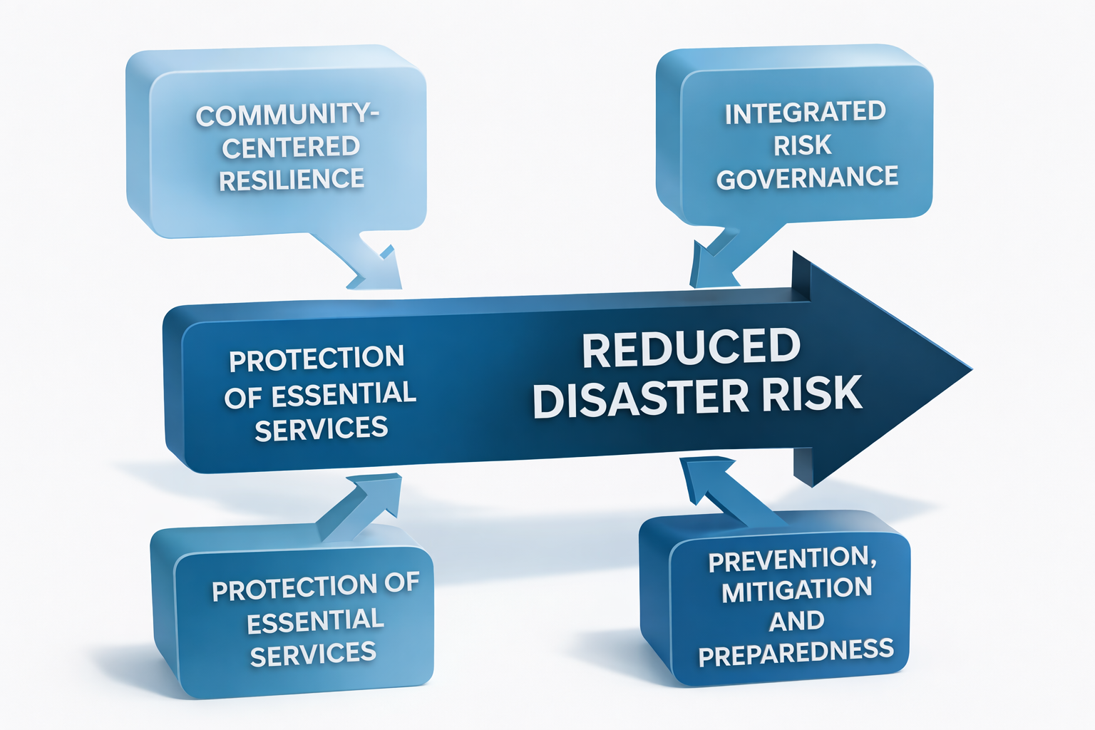

Community Centred Resilience
The foundation of this strategy is community resilience. Risk reduction will only be effective when local capability is strengthened, because emergency services are distant and external support is delayed during hazard impact. This approach builds local agency by supporting collective action, risk awareness, first responder capability and local preparedness planning. Community structures such as the Disaster Management Volunteer Force and civil society partners play a central role in risk detection, early warning, preparedness and local response. Risk reduction measures will be designed to be appropriate for local conditions, locally owned and sustained over time.

Integrated Risk Governance
Disaster risk is a governance challenge. To reduce systemic risk, local coordination must improve, decision making must be risk informed and risk reduction must be integrated into service delivery and planning. The strategic approach therefore promotes shared responsibility and coordinated implementation between the community, Mogalakwena Local Municipality and the Waterberg District Disaster Management Centre. Risk governance will be strengthened through structured communication, reporting, accountability and monitoring arrangements. This approach ensures that disaster risk reduction is institutionalised rather than treated as a once off project.

Protection of Essential Services
Service fragility is a major driver of disaster risk in Ga-Pila. Interruptions to water supply, electricity and road access quickly escalate into disaster conditions and threaten lives and local livelihoods. The strategic approach therefore prioritises the protection of essential services and critical infrastructure. This includes strengthening water security, improving electrical safety, maintaining safe access routes and reducing flood risk through drainage interventions. Service protection is central to preserving community stability, supporting economic activity and protecting vulnerable households.

Prevention, Mitigation and Preparedness
This strategy is built on the prevention first principle. It intentionally shifts Ga-Pila from a reactive disaster response posture to a proactive risk reduction system. Prevention will be achieved through risk aware planning and development control. Mitigation will reduce hazard and exposure conditions through targeted measures such as drainage improvements, fire safety upgrades and infrastructure strengthening. Preparedness will ensure readiness through training, early warning systems and contingency planning.

This strategic approach strengthens the conditions for resilience by reducing risk drivers, increasing capacity and improving local coordination. It provides the logic for operationalising disaster risk reduction in practice. The next section concludes the strategic direction before it is translated into action through the Disaster Risk Management Plan in Chapter 5.

Strategic Direction Summary
This Disaster Risk Reduction Strategy establishes a clear direction for reducing disaster risk in Ga-Pila and safeguarding the wellbeing of the community. It responds directly to the local risk conditions identified in Chapter 3 and provides a strategic framework to guide coordinated and sustained action. The strategy recognises that disaster risk in Ga-Pila is primarily a development challenge driven by service fragility, unsafe settlement patterns and limited risk governance. Addressing these root causes requires a shift from reactive disaster response towards proactive and resilience driven development.

The strategy provides long term guidance anchored in risk reduction, community capability, service protection and institutional alignment. It positions disaster risk reduction as a shared responsibility between the community, local government, district disaster management structures and development partners. The strategic approach is transformational in nature. It commits to preventing risk creation, reducing existing risks and building the resilience required to withstand future shocks. The next step is to translate this strategy into practical implementation. Chapter 5 presents the Disaster Risk Management Plan for Ga-Pila, which converts this strategy into priority risk reduction measures, implementation responsibilities and timelines.

Disaster Risk Management Plan

Introduction and Purpose
This Bellevue Farm represents a disaster risk environment that is fundamentally distinct from that of Ga-Pila Village. Whereas village risk is dominated by household vulnerability, settlement density and service fragility, disaster risk on Bellevue Farm is shaped by exposure of productive assets, dependence on natural systems, spatial dispersion, and the need for uninterrupted agricultural operations.

The Farm functions simultaneously as:
- A productive economic enterprise;
- A workplace with occupational health and safety obligations;
- A land-based ecological system;
- A repository of high-value fixed and mobile assets; and
- A livelihood platform linked to broader community benefit.

Disaster risk in this context is therefore not episodic. It is embedded within production cycles, environmental conditions and operational systems. Even moderate hazard events can generate disproportionate economic loss, asset degradation and long-term productivity decline if not actively managed.

The purpose of this chapter is to establish a farm-specific, integrated disaster risk management framework and operational plan that:
- Protects human life, livestock and agricultural assets;
- Reduces vulnerability of land, water and production systems;
- Ensures continuity of operations during and after hazard events;
- Limits cascading and secondary losses; and
- Embeds disaster risk management into routine farm governance and decision-making.

This chapter translates the risk analysis presented in Chapter 3 into operationally enforceable measures, aligned with agricultural best practice, the National Disaster Management Framework and the Sendai Framework for Disaster Risk Reduction.

Strategic Risk Posture for Bellevue Farm

Distinctive Farm Risk Characteristics
The disaster risk posture of Bellevue Farm is characterised by:
- Concentration of productive assets, including boreholes, irrigation infrastructure, fencing, buildings, equipment and livestock;
- Direct dependence on climatic and environmental conditions, with limited buffering capacity during droughts, floods and extreme weather;
- Seasonal labour and activity cycles, which influence supervision, safety and response capacity;
- Biosecurity exposure, particularly relating to animal disease and contamination risks;
- Spatial dispersion of infrastructure, increasing detection and response times; and
- Cascading risk dynamics, where failure in one subsystem rapidly triggers secondary losses across production, access and security.

As a result, disaster risk on the Farm is systemic, cumulative and operationally consequential. Risk management failure does not only threaten safety; it undermines economic viability and long-term sustainability.

Strategic Framework

Strategic Posture
The strategic posture for Bellevue Farm is one of risk containment, production continuity and asset preservation. Disaster risk management is treated as a core operational discipline, not an emergency add-on or compliance exercise.

The framework adopts a preventive, anticipatory and continuity-oriented posture, recognising that:
- Prevention is significantly more cost-effective than recovery;
- Delayed response amplifies losses exponentially in agricultural systems; and
- Farm resilience is achieved through disciplined systems rather than reactive intervention.

Vision
A resilient, productive and secure Bellevue Farm where agricultural operations, livelihoods and assets are protected from disaster risk.

Mission
To reduce disaster risk on Bellevue Farm through proactive prevention, operational preparedness, disciplined response and structured recovery that safeguard production continuity and long-term sustainability.

Strategic Objectives
The disaster risk management framework for Bellevue Farm is guided by the following objectives:
- Protect farm workers, residents and contractors from hazard exposure.
- Safeguard critical agricultural infrastructure and production assets.
- Reduce vulnerability of land, livestock and water resources.
- Ensure continuity of farming operations during hazard events.
- Enable rapid stabilisation and recovery following disruptions.
- Embed disaster risk reduction into everyday farm management practice.

Strategic Principles
Implementation of this framework is governed by the following principles:
- Asset protection before loss compensation;
- Prevention embedded in routine operations;
- Production continuity as a risk reduction objective;
- Clear operational accountability and authority;
- Environmental stewardship as a resilience measure; and
- Build-back-better as a recovery standard.

Operational Framework

Farm Disaster Risk Management
This section constitutes the operational core of the Bellevue Farm Disaster Risk Management Plan. It integrates prevention, preparedness, response, recovery and contingency planning into a single, coherent operational system aligned with agricultural management cycles.

Table 5.1: Priority Prevention and Mitigation Measures for Bellevue Farm
Ref | Action | Risk Addressed | Output | Responsibility | Timeframe | Verification
F-P1 | Secure and protect boreholes and pumping systems | Water supply failure | Reliable water access | Farm Management | Immediate | Inspection records
F-P2 | Maintain perimeter and internal fencing | Livestock loss, theft | Controlled animal movement | Farm Management | Continuous | Maintenance log
F-P3 | Implement erosion control on slopes and access routes | Land degradation | Stabilised land and roads | Farm Management | Seasonal | Site inspections
F-P4 | Establish and maintain firebreaks | Veld and grass fires | Reduced fire spread | Farm Management | Seasonal | Firebreak map
F-P5 | Conduct electrical safety inspections | Fire ignition | Reduced electrical risk | Farm Management | Annual | Compliance report
F-P6 | Secure chemical and fuel storage | Hazardous spills | Controlled storage | Farm Management | Immediate | Storage audit

Table 5.2: Preparedness and Early Warning Measures
Ref | Action | Hazard | Output | Responsibility | Review Cycle
F-PR1 | Monitor seasonal climate forecasts | Drought, floods | Early operational decisions | Farm Manager | Monthly
F-PR2 | Establish emergency communication protocol | All hazards | Rapid internal alerts | Farm Manager | Quarterly
F-PR3 | Train workers in basic emergency response | Fires, injuries | First response capability | Farm Management | Annual
F-PR4 | Pre-position fire suppression equipment | Fires | Rapid containment | Farm Management | Seasonal
F-PR5 | Implement livestock disease surveillance | Animal disease | Early detection | Farm Management | Continuous

Table 5.3: Emergency Response Actions – Farm Context
Ref | Action | Incident Type | Output | Lead | Escalation Trigger
F-ER1 | Prioritise human safety | All incidents | Injury prevention | Farm Manager | Immediate
F-ER2 | Isolate affected production zones | Disease, contamination | Risk containment | Farm Manager | Capacity exceeded
F-ER3 | Activate fire suppression | Veld fires | Fire controlled | Farm Management | Immediate
F-ER4 | Relocate or confine livestock | Floods, fires | Reduced livestock loss | Farm Management | Immediate
F-ER5 | Escalate to external services | All hazards | Additional capacity | Farm Manager | Threshold breach

Table 5.4: Recovery and Continuity Measures
Ref | Action | Recovery Focus | Output | Timeframe
F-R1 | Conduct post-incident damage assessment | Assets | Verified loss profile | 48–72 hours
F-R2 | Restore water and power to production | Services | Operational stabilisation | Immediate
F-R3 | Repair fencing and access routes | Infrastructure | Production restored | Short term
F-R4 | Rehabilitate or restock livestock | Production | Livelihood recovery | Medium term
F-R5 | Integrate mitigation into repairs | Resilience | Reduced future risk | Ongoing

Table 5.5: Hazard-Specific Contingency Focus Areas
Hazard | Primary Contingency Focus
Drought | Water rationing, stocking adjustment
Flooding | Livestock relocation, access protection
Veld fires | Firebreak activation, suppression readiness
Animal disease | Quarantine and veterinary escalation
Infrastructure failure | Redundancy and rapid repair
Hazardous spills | Containment and isolation

Implementation Discipline and Accountability
Disaster risk management on Bellevue Farm is a direct operational responsibility of farm management. Accountability is non-delegable and integral to production governance.
Implementation is enforced through:
- Routine operational monitoring;
- Seasonal preparedness reviews;
- Incident-based after-action assessments; and
- Annual framework updating.

Failure to implement prevention and preparedness measures constitutes avoidable operational risk exposure, as the majority of farm-level disaster losses arise from foreseeable and manageable hazards.

Conclusion
Bellevue Farm operates within a high-exposure, high-dependency risk environment where disasters translate rapidly into production losses, asset degradation and livelihood disruption. This chapter establishes a robust, farm-specific disaster risk management framework that prioritises prevention, continuity and disciplined response.

By embedding disaster risk management into everyday operations, Bellevue Farm is positioned not only to withstand shocks, but to recover efficiently, preserve productive capacity and sustain long-term economic viability, while continuing to serve broader community development objectives.

Disaster Risk Management Framework and Operational Plan (Ga-Pila (Sterkwater) Village)

Introduction and Purpose
Disaster risk in Ga-Pila Village is not defined by rare extreme events but by persistent, everyday conditions that repeatedly translate hazards into loss. The risk profile established in Chapter 3 demonstrates that disaster risk in the village is driven primarily by settlement density, fragile basic services, unsafe housing conditions, environmental degradation and socio-economic vulnerability. These factors interact with recurrent hazards such as flooding, fires, drought and service interruptions, producing cumulative impacts on health, safety, livelihoods and wellbeing.

Ga-Pila Village is a human settlement system, not an industrial or agricultural enterprise. Disaster risk management in this context is therefore fundamentally about protecting people, stabilising basic services, reducing exposure at household and neighbourhood level, and strengthening community-based response and recovery capacity. When water supply fails, roads wash away or fires spread between closely spaced dwellings, the consequences escalate rapidly into humanitarian distress rather than isolated asset loss.

The purpose of this chapter is to establish a village-specific, integrated disaster risk management framework and operational plan that:
- Reduces the creation of disaster risk through safer settlement conditions;
- Protects life, health and household livelihoods;
- Strengthens continuity of essential services;
- Enhances community preparedness and first-response capability; and
- Embeds disaster risk reduction into everyday local governance and development practice.

This chapter translates the hazard, vulnerability, capacity and risk prioritisation analysis presented in Chapter 3 into operationally actionable measures, aligned with the National Disaster Management Framework, the Disaster Management Act (Act 57 of 2002) and the Sendai Framework for Disaster Risk Reduction.

Strategic Framework

Strategic Posture
The disaster risk management posture for Ga-Pila Village is preventive, people-centred and development-oriented. Risk is addressed upstream, before hazards materialise into emergencies, through deliberate reduction of vulnerability and exposure at household and settlement scale.

The framework recognises that:
- Most disaster losses in the village are foreseeable and recurrent;
- Emergency response alone cannot reverse entrenched vulnerability; and
- Sustainable risk reduction requires integration with service delivery, land use and community systems.

Disaster risk management is therefore treated as a core local governance function, not an episodic emergency intervention.

Vision
A safe, prepared and resilient Ga-Pila Village where lives, livelihoods and essential services are protected from disaster risk.

Mission
To reduce disaster risk in Ga-Pila Village through proactive prevention, strengthened community preparedness, effective local response and resilient recovery that supports sustainable human settlement development.

Strategic Objectives
The framework is guided by the following objectives:
- Reduce priority disaster risks that threaten life, health and household stability.
- Protect critical services, particularly water supply, electricity, roads and sanitation.
- Promote safer housing, settlement layout and environmental management.
- Strengthen community-based preparedness, early warning and first response capacity.
- Enable rapid recovery and continuity of daily life following hazard events.
- Institutionalise disaster risk reduction within local governance and development processes.

Strategic Principles
Implementation of this framework is governed by the following principles:
- Risk reduction before emergency response
- Protection of life as the primary objective
- Prevention through development and service planning
- Community ownership and participation
- Differential vulnerability recognition
- Shared responsibility across actors
- Sustainability and continuity

Risk Reduction Enablers
Delivery of this framework is enabled by:
- Active community structures and social cohesion;
- The Ga-Pila Disaster Management Volunteer Force (DMVF);
- Local leadership and governance platforms;
- Existing informal early warning and communication networks; and
- Strategic linkages with municipal and district disaster management systems.

Operational Framework Integrated Disaster Risk Management Framework (Village Context)

This section constitutes the operational core of the Ga-Pila Village Disaster Risk Management Plan. It integrates prevention, preparedness, response, recovery and contingency planning into a single, coherent operational system, grounded in settlement-level realities.

Prevention and Mitigation Measures

Table 6.1: Priority Prevention and Mitigation Measures – Ga-Pila Village
Ref | Action | Risk Addressed | Output | Responsibility | Timeframe | Verification
V-P1 | Improve stormwater diversion at household and road level | Flooding | Reduced runoff impact | Community & Municipality | Medium term | Site inspection
V-P2 | Promote fire-safe spacing and removal of combustible waste | Household fires | Reduced fire spread | Community structures | Continuous | Visual audits
V-P3 | Upgrade unsafe household electrical connections | Electrical fires | Safer household wiring | Municipality | Phased | Compliance records
V-P4 | Stabilise eroded access routes | Access failure | Improved mobility | Municipality | Seasonal | Road condition logs
V-P5 | Protect communal water infrastructure | Water interruption | Service reliability | Water Committee | Continuous | Maintenance records

Preparedness and Early Warning

Table 6.2: Preparedness and Early Warning Measures – Ga-Pila Village
Ref | Action | Hazard | Output | Responsibility | Review Cycle
V-PR1 | Monitor rainfall and seasonal forecasts | Floods, drought | Anticipatory action | DMVF | Monthly
V-PR2 | Community alert dissemination via WhatsApp and word-of-mouth | All hazards | Rapid warning | DMVF | Continuous
V-PR3 | Household fire safety awareness | Fires | Risk awareness | DMVF | Annual
V-PR4 | Identify vulnerable households | All hazards | Targeted support | Community leadership | Annual

Emergency Response

Table 6.3: Emergency Response Actions – Village Context
Ref | Action | Incident Type | Output | Lead | Escalation Trigger
V-ER1 | Prioritise evacuation of vulnerable persons | Floods, fires | Reduced casualties | DMVF | Immediate
V-ER2 | First response before external services | All incidents | Impact reduction | DMVF | Capacity exceeded
V-ER3 | Activate emergency communication | All hazards | Coordinated response | DMVF | Incident severity

Recovery and Continuity

Table 6.4: Recovery and Continuity Measures – Ga-Pila Village
Ref | Action | Recovery Focus | Output | Timeframe
V-R1 | Rapid damage assessment | Housing, services | Verified impact | 48–72 hours
V-R2 | Restore water and access | Essential services | Stability restored | Immediate
V-R3 | Support household repairs | Shelter | Reduced repeat risk | Short term
V-R4 | Integrate mitigation into repairs | Resilience | Build-back-better | Ongoing

Hazard-Specific Contingency Focus

Table 4.5: Hazard-Specific Contingency Focus – Ga-Pila Village
Hazard | Primary Contingency Focus
Flooding | Household protection and access
Fires | Rapid containment and evacuation
Drought | Water rationing and prioritisation
Disease outbreaks | Early detection and isolation
Service failure | Temporary coping arrangements

Implementation Discipline and Accountability
Implementation of disaster risk management in Ga-Pila Village relies on clear role definition and shared accountability. While many measures are community-driven, sustained effectiveness depends on coordination with municipal and district structures. Implementation discipline is maintained through:
- Routine monitoring by community structures;
- Seasonal preparedness reviews;
- Incident-based after-action assessments; and
- Periodic updating of this plan.

Failure to implement preventive measures constitutes avoidable risk creation, given the predictable nature of the dominant hazards affecting the village.

Conclusion
Ga-Pila Village operates within a high-frequency, vulnerability-driven disaster risk environment where hazards repeatedly translate into human hardship rather than isolated losses. This chapter establishes a robust, settlement-specific disaster risk management framework that prioritises prevention, preparedness and community-based response.

By embedding disaster risk management into everyday settlement governance and development practice, Ga-Pila Village is positioned to progressively reduce loss, strengthen resilience and safeguard the dignity and wellbeing of its residents.

Institutional and Community Coordination Arrangements

Purpose and Scope
This chapter establishes the institutional, governance, coordination, and accountability arrangements that underpin disaster risk management for Ga-Pila (Sterkwater) Village and Bellevue Farm. While both spatial areas fall under a single Disaster Risk Management Plan, they represent fundamentally different risk environments and therefore require distinct institutional configurations, command arrangements, and coordination systems.

The purpose of this chapter is to ensure that disaster risk management is authoritative, coordinated, and enforceable, with no ambiguity regarding leadership, operational responsibility, or escalation pathways. The chapter applies across the full disaster management continuum, namely, prevention, preparedness, response, recovery, and continuity, and provides the institutional backbone that enables the effective implementation of Chapters 4 and 5.

This chapter is applicable to:
- Community-based disaster risk management within Ga-Pila Village;
- Asset, production, and environmental risk management on Bellevue Farm; and
- All internal and external stakeholders involved in disaster risk reduction and disaster response within these two spatial systems.

Governance Logic and Authority Separation
Disaster risk governance within this Plan is guided by the principle that authority must follow risk context. Although Ga-Pila Village and Bellevue Farm are geographically linked and share certain support structures, they differ significantly in:
- Population density and vulnerability profiles;
- Asset concentration and economic exposure;
- Nature of hazards and escalation dynamics; and
- Operational response requirements.

For this reason, a single, unified institutional arrangement would weaken accountability and compromise response effectiveness. Instead, this Plan adopts a dual-system governance logic, whereby:
- Ga-Pila Village operates under a community-centred disaster governance model, prioritising life safety, public health, household protection, and social stability; and
- Bellevue Farm operates under an asset- and production-centred disaster governance model, prioritising occupational safety, fire control, environmental protection, and business continuity.

Despite this separation, both systems are anchored within a common legal, policy, and oversight framework, ensuring coherence, coordination, and escalation compatibility when required.

Institutional Arrangements

Village Disaster Risk Governance Structure
Disaster risk management in Ga-Pila Village is led through a community-based governance model, recognising that hazards in the village environment affect households, public services, and vulnerable populations simultaneously. Authority is therefore structured to ensure rapid decision-making, trusted communication, and coordinated mobilisation.
The Ga-Pila Community Development Trust (GCDT) serves as the primary disaster risk governance authority for the Village. It provides strategic leadership, authorises activations, coordinates partners, and ensures alignment with municipal and district disaster management structures. The Disaster Management Volunteer Force (DMVF) functions as the operational arm, executing prevention, preparedness, response, and recovery actions under Trust authorisation.

Traditional leadership structures and the Ward Committee provide governance legitimacy, community mobilisation, and linkage to local government systems, while essential service institutions such as the clinic and schools support continuity and protection of critical social functions.

Table 7.1: Institutional Roles and Responsibilities (Ga-Pila Village)
Institution / Structure | Primary Role | Decision Authority | Operational Responsibility | Activation Triggers | Escalation Pathway
Ga-Pila Community Development Trust (GCDT) | Lead disaster risk governance authority | Full authority to activate, coordinate and communicate | Strategic direction, partner mobilisation, authorisation | Any Tier 1 or Tier 2 hazard | Mogalakwena LM → Waterberg DMC
Disaster Management Volunteer Force (DMVF) | Operational execution | Acts under Trust authorisation | Prevention, early warning, response, assessments, recovery support | Incident confirmation | GCDT
Traditional Council | Governance legitimacy and mobilisation | Community authority | Community order, mobilisation, land-use support | Community disruption | GCDT
Ward Committee | Government liaison | Advisory | Municipal reporting and coordination | Infrastructure or service failure | Mogalakwena LM
Local Clinic | Health protection | Functional authority | Disease surveillance, first aid, alerts | Health incidents | Department of Health
Schools and ECD Centres | Child safety and continuity | Functional authority | Learner protection, messaging | Severe weather or service failure | GCDT

Farm Disaster Risk Governance Structure
Disaster risk management on Bellevue Farm is structured around a production-environment-safety governance model. The Farm represents a controlled operational environment with defined authority lines, specialised hazards, and high-value productive assets. Governance arrangements therefore prioritise clear command, rapid decision-making, and protection of workers, infrastructure, and production systems.

The Farm Authority (as designated by ownership and management arrangements) serves as the primary incident authority on the Farm. The Trust retains an oversight and escalation role, ensuring that Farm disaster risk management aligns with broader community and regulatory frameworks without interfering in day-to-day operational command. The DMVF provides operational support to the Farm when requested but does not exercise command authority unless formally delegated.

Table 7.2: Institutional Roles and Responsibilities (Bellevue Farm)
Institution / Role | Primary Responsibility | Asset / Risk Domain | Decision Authority | Incident Triggers | Escalation Threshold
Farm Authority / Management | Lead disaster authority | Production assets, workers, infrastructure | Full authority on Farm | Fire, injury, environmental incident | GCDT / Municipality
Farm Supervisors | Operational control | Field operations and labour | Limited operational authority | On-site incident | Farm Authority
Disaster Management Volunteer Force (DMVF) | Support response | Fire, search and rescue, first aid | Support only | Upon request | Farm Authority
Ga-Pila Community Development Trust | Oversight and coordination | Governance and escalation | Advisory and escalation authority | Multi-system impact | Mogalakwena LM
Fire Services / EMS | Specialised response | Fire, injury | Statutory authority | Uncontrolled incident | District / Provincial

Operational Coordination System (Sterkwater Village)
Village coordination prioritises rapid information flow, community mobilisation, and service continuity. Coordination mechanisms are designed to function under conditions of power loss, network failure, and high social stress.

Table 7.3: Village Operational Coordination Matrix
Function | Lead | Support | Coordination Mechanism
Early warning | GCDT | DMVF | WhatsApp alerts, loudhailers
Evacuation | DMVF | Traditional Council | Pre-identified safe points
Health response | Clinic | DMVF | Referral and first aid
Infrastructure access | Ward Committee | Municipality | Emergency reporting

Operational Coordination System (Bellevue Farm)
Farm coordination prioritises command clarity, safety compliance, and asset protection.

Table 7.4: Farm Operational Coordination Matrix
Function | Lead | Support | Coordination Mechanism
Fire response | Farm Authority | DMVF / Fire Services | Incident command
Worker safety | Supervisors | EMS | Safety protocols
Environmental protection | Farm Authority | Environmental Officers | Incident reporting

Volunteer and Community-Based Disaster Management
The DMVF operates across both spatial contexts but under different authority regimes.

Table 7.5: DMVF Deployment and Authority Limits; Village vs Farm
Aspect | Village | Farm
Command authority | GCDT | Farm Authority
Primary role | First response and mobilisation | Support and specialist response
Decision-making | Community-based | Operational and asset-based

Partnerships and Support Institutions

Table 7.6: Partner Engagement Matrix by Spatial Context
Partner Category | Village Focus | Farm Focus
Health | Clinic, DoH | Occupational health
Environment | Waste, sanitation | Soil, fire, pollution
Emergency services | EMS, Fire | Fire, HazMat
Private sector | Relief support | Production continuity

Monitoring, Evaluation and Learning (MEL)
Monitoring and learning systems track different outcomes across the two contexts.

Table 7.7: MEL Indicators — Village and Farm
Indicator Type | Village | Farm
Human safety | Injuries, evacuations | Occupational incidents
Service continuity | Water, access | Power, irrigation
Recovery time | Household stabilisation | Production resumption

Sustainability and Continuity Framework

Table 7.8: Sustainability Measures by Context
Measure | Village | Farm
Training | Annual DMVF refreshers | Safety drills
Resources | Community equipment | Fire and safety tools
Reviews | Annual DRM review | Seasonal risk review

Monitoring and Evaluation (M&E)
The M&E matrices, one for Ga-Pila (Sterkwater) Village and one for Bellevue Farm are designed to be operational, auditable, and decision-useful, not descriptive. Each matrix is aligned to Chapters 4 and 5, supports annual and incident-based review.

The purpose of the Matrix is to help the Board and other stakeholders to track the effectiveness of disaster risk reduction, preparedness, response, recovery, and governance measures affecting households, services, and vulnerable populations in Ga-Pila Village.

Table 7.9: Monitoring and Evaluation Matrix (Sterkwater) Village
DRM Dimension | Indicator | What is Measured | Data Source | Frequency | Responsibility | Use of Findings
Risk Reduction | Number of flood-prone sites mitigated | Physical reduction of flood exposure points | DMVF mitigation logs; site inspections | Bi-annual | DMVF (reports to GCDT) | Prioritise further drainage and settlement upgrades
Risk Reduction | % of high-risk households with basic fire safety measures | Uptake of prevention actions at household level | Household surveys; DMVF inspections | Annual | DMVF | Target fire prevention campaigns
Preparedness | Functionality of early warning channels | Ability to disseminate alerts within 15 minutes | WhatsApp logs; loudhailer tests | Quarterly | GCDT | Strengthen communication redundancy
Preparedness | DMVF readiness score | Availability of trained volunteers and equipment | Training records; equipment inventory | Bi-annual | GCDT | Identify training and resourcing gaps
Emergency Response | Average response time to incidents | Time from alert to on-site response | Incident logs | Per incident | DMVF | Improve mobilisation efficiency
Emergency Response | % of incidents managed without external escalation | Local response effectiveness | Incident reports | Quarterly | GCDT | Assess local capacity sufficiency
Recovery | Time to restore water and access after incidents | Service continuity resilience | Municipal and Trust reports | Per incident | GCDT | Advocate for infrastructure investment
Recovery | % of affected households stabilised within 14 days | Household recovery effectiveness | Recovery assessments | Per incident | GCDT | Improve recovery support mechanisms
Vulnerability Reduction | Incidents affecting elderly or disabled households | Differential impact on vulnerable groups | Incident and clinic data | Quarterly | GCDT + Clinic | Adjust targeting of mitigation actions
Public Health | Reported waterborne disease cases post-events | Health impact of hazards | Clinic records | Quarterly | Local Clinic | Strengthen sanitation interventions
Governance & Coordination | Frequency of DRM coordination meetings held | Institutional functioning | Meeting minutes | Quarterly | GCDT | Improve coordination discipline
Learning & Improvement | DRM actions revised based on lessons learned | Adaptive management | After-action reviews | After major incidents | GCDT | Update plans and protocols

Table 7.10: Monitoring and Evaluation Matrix (Bellevue Farm)

DRM Dimension | Indicator | What is Measured | Data Source | Frequency | Responsibility | Use of Findings
Risk Reduction | Number of firebreaks and fuel-load controls maintained | Prevention of veld and structural fires | Farm inspection records | Seasonal | Farm Authority | Reduce fire ignition and spread risk
Risk Reduction | Compliance with safety and electrical standards | Reduction of ignition and injury risks | Safety audits | Bi-annual | Farm Authority | Enforce corrective actions
Preparedness | % of workers trained in emergency procedures | Workforce readiness | Training attendance registers | Annual | Farm Authority | Plan refresher training
Preparedness | Availability of firefighting and first-aid equipment | Operational readiness | Equipment inventories | Quarterly | Farm Authority | Address equipment gaps
Emergency Response | Response time to on-site incidents | Speed of containment and rescue | Incident logs | Per incident | Farm Supervisors | Improve on-site command
Emergency Response | Number of incidents escalating beyond farm capacity | Threshold of local capacity | Incident reports | Annual | Farm Authority | Adjust resource allocation
Occupational Safety | Number of injuries or near-misses | Worker safety performance | Safety incident reports | Monthly | Farm Authority | Strengthen safety controls
Environmental Protection | Environmental incidents recorded | Soil, water, or pollution damage | Environmental logs | Per incident | Farm Authority | Mitigation and compliance actions
Business Continuity | Downtime of critical operations | Impact on production continuity | Production records | Per incident | Farm Authority | Improve continuity planning
Recovery | Time to resume normal farm operations | Recovery effectiveness | Farm management reports | Per incident | Farm Authority | Strengthen recovery protocols
Coordination | Joint drills or engagements with DMVF | Inter-system coordination | Exercise reports | Annual | Farm Authority + GCDT | Improve joint response readiness
Learning & Improvement | Implementation of corrective actions after incidents | Organisational learning | After-action reviews | After incidents | Farm Authority | Update farm DRM procedures

These matrices are not reporting for reporting’s sake. They are intended to:
  - Support annual DRM reviews,
  - Inform budgeting and prioritisation,
  - Provide evidence during municipal, district, or donor engagements, and
  - Drive continuous improvement, not compliance theatre.

Each matrix should be reviewed:
- Quarterly at management level, and
- Annually at governance level, with findings explicitly linked to revisions of Chapters 4 and 5.

Conclusion
This chapter establishes an operationally effective institutional framework for disaster risk management across Ga-Pila Village and Bellevue Farm. By deliberately separating authority structures while maintaining coordinated oversight, the Plan avoids ambiguity, strengthens accountability, and ensures that disaster risk governance is aligned with the realities of each spatial system.

This institutional architecture enables Chapters 4 and 5 to be implemented with clarity, authority, and resilience, ensuring that disaster risk management is not only planned, but governable, executable, and sustainable over time.

Bibliography

Ga-Pila Community Development Trust (2019) Ga-Pila Integrated Community Development Plan (ICDP). Mogalakwena: GCDT.

African Union Commission (2017) Programme of Action for the Implementation of the Sendai Framework for Disaster Risk Reduction 2015–2030 in Africa. Addis Ababa: African Union Commission.

Anglo American Platinum (2009) Anglo Platinum Update on Mogalakwena Resettlement – General Update on Community Issues. Johannesburg: Anglo American Platinum Limited.

Anglo American Platinum (2023) Draft Mogalakwena Mine Land Use and Spatial Application Framework (MLUS AA). Johannesburg: Anglo American Platinum Limited.

Blaikie, P., Cannon, T., Davis, I. and Wisner, B. (2004) At Risk: Natural Hazards, People’s Vulnerability and Disasters. 2nd edn. London: Routledge.

Carter, W.N. (2008) Disaster Management: A Disaster Manager’s Handbook. Manila: Asian Development Bank.

Centre for Applied Legal Studies (2008) Anglo Platinum – Chapters 4 to 5: Relocation and Community Impacts. Johannesburg: University of the Witwatersrand.

Coetzee, C. and van Niekerk, D. (2012) ‘Tracking the evolution of the disaster management cycle: A general system theory approach’, Jàmbá: Journal of Disaster Risk Studies, 4(1), Art. #54, pp. 1–9.

Council for Scientific and Industrial Research (CSIR) (2019) Green Book: Adapting South African Settlements to Climate Change – Summary for Policymakers. Pretoria: CSIR.

Department of Basic Education (DBE) (2012) National School Safety Framework. Pretoria: Department of Basic Education.

Department of Cooperative Governance (2015) Disaster Management Amendment Act No. 16 of 2015. Pretoria: Government Printer.

Department of Cooperative Governance and Traditional Affairs (COGTA) (2005) National Disaster Management Framework. Pretoria: COGTA.

Dube, E. (2015) ‘Improving disaster risk reduction capacity in rural communities’, Jàmbá: Journal of Disaster Risk Studies, 7(1), pp. 1–8.

Initiative for Responsible Mining Assurance (IRMA) (2025) Mogalakwena Audit Packet: IRMA Third-Party Audit Report. Canada: Initiative for Responsible Mining Assurance.

Intergovernmental Panel on Climate Change (IPCC) (2022) Climate Change 2022: Impacts, Adaptation and Vulnerability. Cambridge: Cambridge University Press.

International Federation of Red Cross and Red Crescent Societies (IFRC) (2007) Vulnerability and Capacity Assessment (VCA) Guidelines. Geneva: IFRC.

International Federation of Red Cross and Red Crescent Societies (IFRC) (2016) Road Map to Community Resilience. Geneva: IFRC.

Mnwana, S., Mtero, F. and Hay, M. (2016) Dispossessing the Dispossessed? Mining and Rural Struggles in Mokopane, Limpopo. Johannesburg: SWOP Institute, University of the Witwatersrand.

Mogalakwena Local Municipality (2023) Integrated Development Plan (IDP) 2023–2024. Mokopane: Mogalakwena Local Municipality.

Mogalakwena Local Municipality (2023) Mogalakwena Land Use Scheme – Draft Scheme. Mokopane: Mogalakwena Local Municipality.

Mogalakwena Local Municipality (2025) Integrated Development Plan (IDP) 2025–2026. Mokopane: Mogalakwena Local Municipality.

National Disaster Management Centre (NDMC) (2017) Guidelines for the Development of Disaster Management Plans. Pretoria: NDMC.

National Planning Commission (NPC) (2012) National Development Plan 2030: Our Future – Make it Work. Pretoria: The Presidency.

Office of the Premier – Limpopo Province (2024) Limpopo Spatial Development Framework (LSDF). Polokwane: Office of the Premier.

Pelling, M. (2003) The Vulnerability of Cities: Natural Disasters and Social Resilience. London: Earthscan.

Republic of South Africa (1996) Constitution of the Republic of South Africa (Act 108 of 1996). Pretoria: Government Printer.

Republic of South Africa (2000) Local Government: Municipal Systems Act (No. 32 of 2000). Pretoria: Government Printer.

Republic of South Africa (2002) Disaster Management Act (No. 57 of 2002). Pretoria: Government Printer.

Republic of South Africa (2013) Spatial Planning and Land Use Management Act (No. 16 of 2013). Pretoria: Government Printer.

SADC (2023) Regional Disaster Risk Management Strategy and Action Plan 2022–2030. Gaborone: SADC Secretariat.

South African Human Rights Commission (2009) Report on Limpopo Community Discussion Forums, 2–4 December 2008. Johannesburg: South African Human Rights Commission.

Sphere Association (2018) The Sphere Handbook: Humanitarian Charter and Minimum Standards in Humanitarian Response. Geneva: Sphere Association.

SRK Consulting (2019) Draft Environmental Impact Assessment (EIA) and Environmental Management Programme (EMPr) for Mogalakwena Mine Expansion. Johannesburg: SRK Consulting.

UNDRR (2015) Sendai Framework for Disaster Risk Reduction 2015–2030. Geneva: United Nations Office for Disaster Risk Reduction.

Waterberg District Municipality (2022) District Disaster Management Plan Review. Modimolle: Waterberg District Municipality.

World Bank (2013) Building Resilience: Integrating Climate and Disaster Risk into Development. Washington, DC: World Bank.

Zutari (2023) Final Part 2 Amendment Report: 120MW Mogalakwena Mine Solar Photovoltaic Energy Facility. Pretoria: Zutari.

Annexure 1: Community Hazard and Risk Register
Referenced in Section 3.4 – Hazard Analysis and Section 3.8 – Risk Ranking

No. | Hazard Category | Hazard | Associated Vulnerability | Location / Area Affected | Potential Impact / Risk Description | Proposed Mitigation / Action
1 | Hydro-Meteorological | Flooding and stormwater runoff | Infrastructure, property, health | Low-lying areas, road crossings | Flooding of homes, road washaways, water contamination, and isolation of households | Construct and maintain drainage channels and culverts; clear blockages; install diversion systems
2 | Hydro-Meteorological | Strong winds | Housing, infrastructure | Informal and RDP dwellings | Roof uplift, falling debris, injuries, and property loss | Reinforce roofing structures; secure lightweight materials; community awareness on wind hazards
3 | Hydro-Meteorological | Lightning | Human, livestock, property | Schools, churches, sports fields, open yards | Injury, death, damage to appliances and structures | Install lightning rods; provide awareness on lightning safety
4 | Hydro-Meteorological | Water supply interruption | Health, livelihoods, sanitation | Entire community (single borehole reliance) | Water shortages, hygiene decline, livestock loss, social conflict | Drill additional boreholes; install water storage tanks; promote conservation practices
5 | Climatological | Drought and water scarcity | Agriculture, food security | Entire community and grazing lands | Crop failure, livestock deaths, household water rationing | Water harvesting; drought-tolerant crops; efficient irrigation and borehole maintenance
6 | Climatological | Heat stress and extreme temperatures | Human health, productivity | Outdoor workers, learners, elderly | Dehydration, fatigue, school absenteeism | Provide shaded areas; hydration programmes; awareness campaigns
7 | Environmental / Ecosystem Degradation | Soil erosion | Environment, infrastructure | Slopes, unpaved roads, homesteads | Loss of fertile soil, road damage, structural instability | Re-vegetation, contouring, erosion barriers
8 | Environmental / Ecosystem Degradation | Land degradation | Livelihoods, environment | Communal grazing and farmlands | Reduced agricultural productivity, dust generation | Controlled grazing; soil rehabilitation projects
9 | Environmental / Ecosystem Degradation | Veld and grass fires | Livelihoods, property | Peri-urban areas, grazing fields, farm boundaries | Destruction of grazing land, property loss, smoke inhalation | Establish firebreaks; train community volunteers; provide firefighting tools
10 | Technological / Infrastructure | Unsafe electrical wiring | Human, property, infrastructure | Informal settlements, small businesses | Electrical fires, electrocution, loss of property | Safety inspections; community rewiring support in partnership with Eskom
11 | Technological / Infrastructure | Electricity disruptions | Economic, social, and safety | Village-wide | Increased fire risk from candles and paraffin; disruption of livelihoods | Maintenance collaboration with Eskom; backup power (solar); community alert protocols
12 | Technological / Infrastructure | Road access failure | Emergency response, mobility | Internal and connecting routes | Delayed response to medical emergencies; access barriers | Routine road maintenance; culvert installation; drainage improvement
13 | Technological / Infrastructure | Hazardous material spills | Environment, human safety | Fuel transport routes | Soil and water contamination; health risk | Develop spill response plan; emergency coordination with transporters
14 | Technological / Infrastructure | Household and structural fires | Human safety, property | Residential clusters, high-density zones | Injury, loss of life, destruction of homes | Firefighting kits; community training; safer energy alternatives
15 | Technological / Infrastructure | Road transport accidents | Human safety | Main access roads, intersections | Injuries and fatalities from speeding or poor visibility | Road signage, speed control, pedestrian safety programmes
16 | Socio-Economic / Human-Induced | Food insecurity and loss of income | Livelihoods, social stability | Vulnerable households | Malnutrition, poverty, theft | Community gardens; skills and microenterprise development
17 | Socio-Economic / Human-Induced | Alcohol-related violence | Social stability, health | Taverns, community gatherings | Domestic violence, crime, injury | Behavioural campaigns; social support and counselling
18 | Socio-Economic / Human-Induced | Animal disease outbreaks | Livelihoods, food security | Livestock zones | Loss of income, reduced nutrition, health risks | Veterinary outreach, regular vaccination campaigns
19 | Socio-Economic / Human-Induced | Dust and air pollution (mining-related) | Human health | Areas near haul roads and mining routes | Respiratory and eye ailments, reduced air quality | Dust suppression by mines; tree barriers; environmental monitoring
20 | Socio-Economic / Human-Induced | Tailings dam failure (external risk) | Human, environment | Downstream areas near Mogalakwena Mine | Large-scale flooding, toxic contamination | Emergency coordination with mining company; early warning system

Annexure 2: Community Hazard Maps
Referenced in Section 3.4 (Hazard Analysis) and Section 5.3 (Prevention and Mitigation Plan)

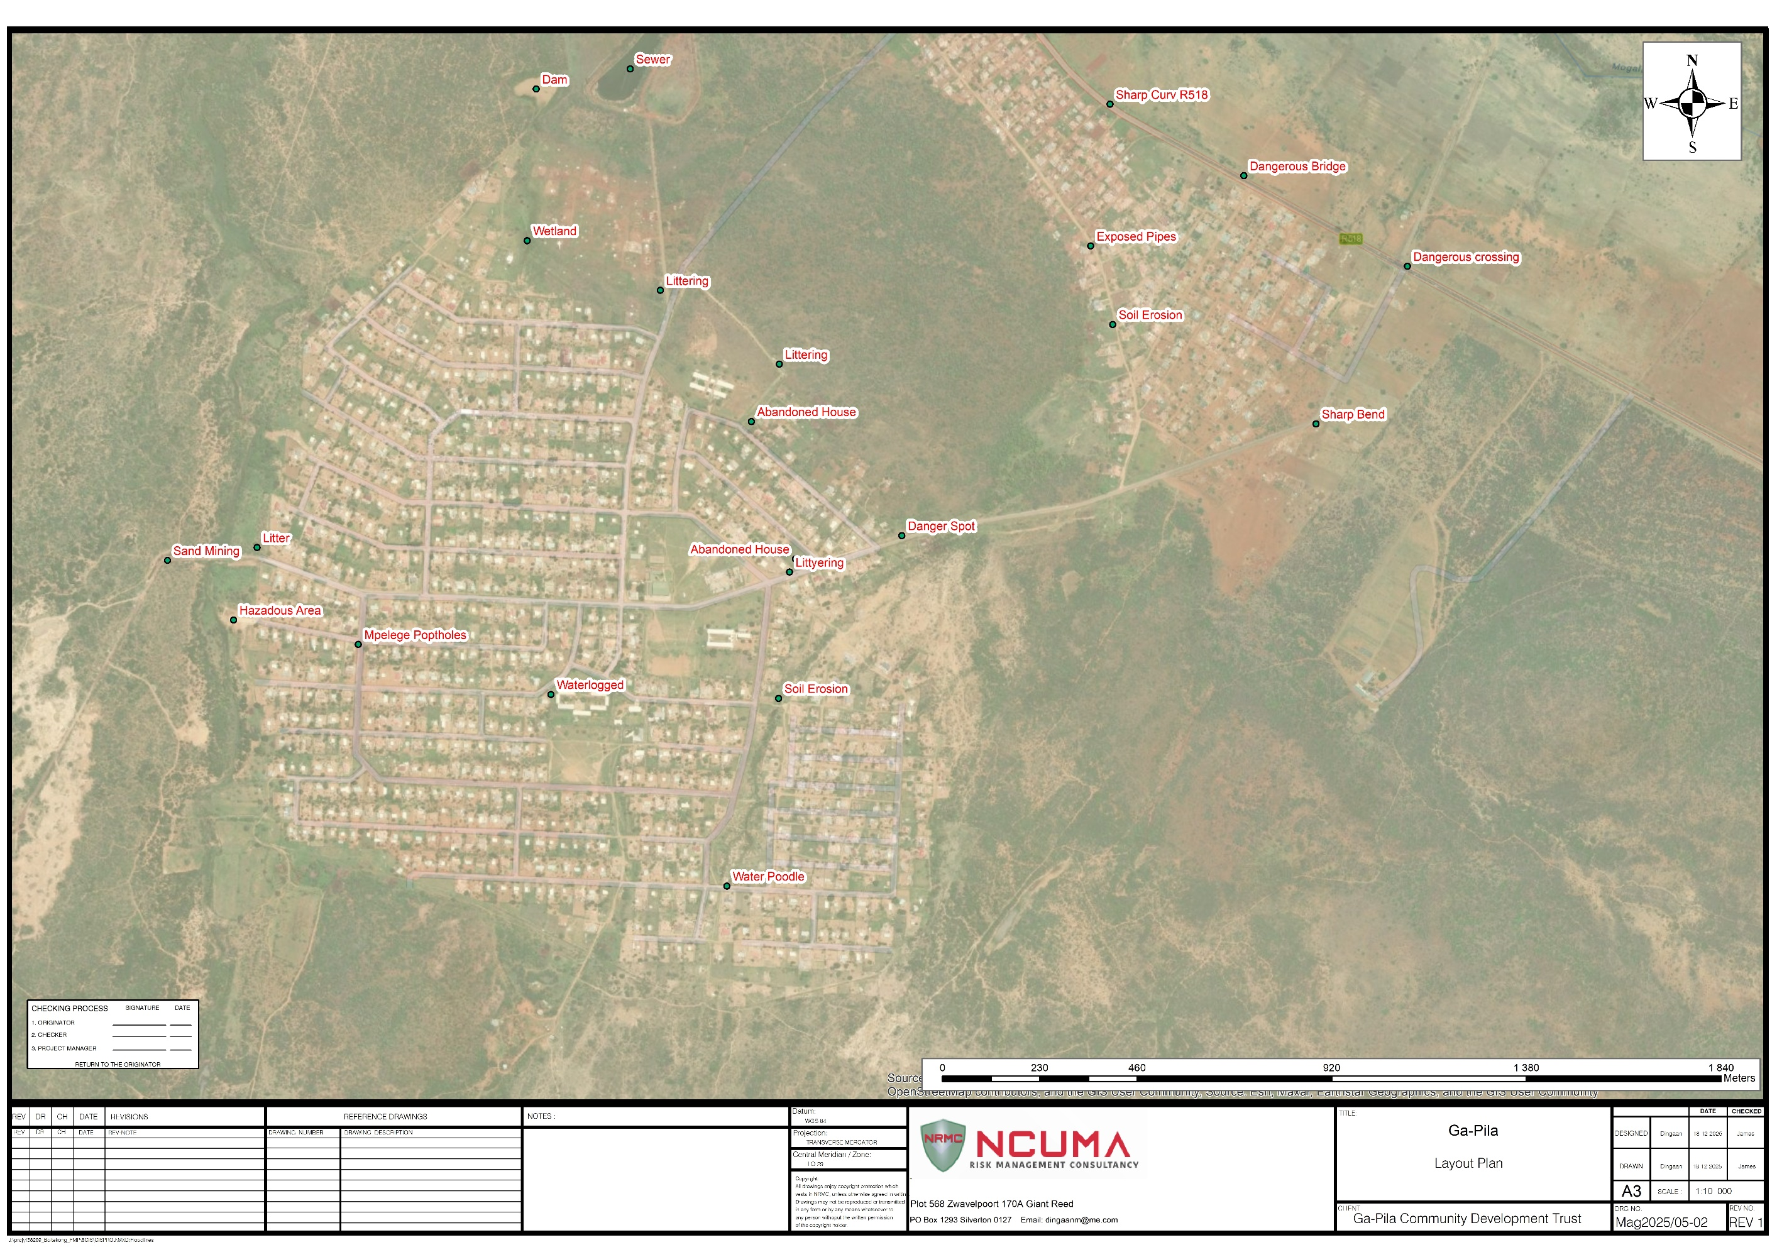

Annexure 3: Seasonal Hazard and Preparedness Calendar
Referenced in Section 5.4 (Preparedness and Early Warning)

Purpose
This annexure presents the seasonal timing of hazards affecting Ga-Pila Village, linking each to early-warning triggers and preparedness measures. It supports coordinated readiness across the Ga-Pila Community Development Trust (GCDT), Disaster Management Volunteer Force (DMVF), and partner institutions.

Table A3.1: Seasonal Hazard and Preparedness Calendar
Season (Period) | Hazard | Hazard Category | Indicative Triggers / Early Warning Signals | Preparedness and Mitigation Actions | Lead Responsibility | Supporting Partners
Summer (Dec – Feb) | Flooding and stormwater runoff | Hydro-Meteorological | Heavy rainfall; blocked drains; rising stream levels | Clear culverts; inspect bridges; activate evacuation routes | DMVF Early Warning Unit | GCDT, Municipality, Kgoro
Summer (Dec – Feb) | Lightning | Hydro-Meteorological | SAWS thunderstorm alerts; electrical activity | Maintain lightning rods; suspend outdoor events; safety education | DMVF Safety Desk | Schools, Churches, SAWS
Summer (Dec – Feb) | Strong winds / hailstorms | Hydro-Meteorological | Gusty conditions; storm warnings | Reinforce roofs; secure structures; prune trees | DMVF Response Team | Public Works, GCDT
Summer (Dec – Feb) | Heat stress / extreme temperatures | Climatological | Temperatures > 35 °C; heatwave alerts | Provide shaded areas; hydration campaigns | DMVF Health Desk | Clinics, Schools
Summer (Dec – Feb) | Road transport accidents | Technological / Infrastructure | Wet roads; festive traffic peaks | Maintain signage; patrols; first-aid readiness | DMVF Response Team | SAPS, Traffic Dept
Autumn (Mar – May) | Drought onset / water scarcity | Climatological | Declining rainfall; falling borehole yield | Promote water saving; service boreholes | GCDT Technical Team | DMVF, Farmers
Autumn (Mar – May) | Water supply interruptions | Hydro-Meteorological | Equipment failure; low pressure | Preventive maintenance; standby power | GCDT Infrastructure Desk | Municipality
Autumn (Mar – May) | Veld and grass fires (build-up phase) | Environmental / Ecosystem | Dry vegetation; open burning | Maintain firebreaks; awareness campaigns | DMVF Fire Sub-Unit | Fire Services, Farmers
Autumn (Mar – May) | Soil erosion / land degradation | Environmental / Ecosystem | Early runoff; bare slopes | Vegetate bare soil; repair drains | GCDT Environmental Desk | Public Works
Winter (Jun – Aug) | Drought peak | Climatological | Extended dryness; low water tables | Enforce water-use controls; promote rainwater harvesting | GCDT Technical Team | Municipality, DMVF
Winter (Jun – Aug) | Veld and structural fires | Environmental / Ecosystem | Low humidity; windy conditions | Strengthen fire patrols; maintain equipment | DMVF Fire Sub-Unit | Fire Services, Kgoro
Winter (Jun – Aug) | Electricity disruptions | Technological / Infrastructure | Load-shedding; transformer faults | Maintain equipment; promote solar lighting | GCDT Technical Desk | Eskom
Winter (Jun – Aug) | Unsafe electrical wiring | Technological / Infrastructure | Illegal connections; exposed lines | Household inspections; rewiring campaigns | DMVF Safety Desk | Eskom, Kgoro
Winter (Jun – Aug) | Air pollution / respiratory illnesses | Environmental / Ecosystem | Smoke; dust; indoor fires | Health education; medical outreach | DMVF Health Desk | Clinics, Schools
Spring (Sep – Nov) | Early storms / flash floods | Hydro-Meteorological | First rains; storm alerts | Inspect culverts; reinforce embankments | DMVF Early Warning Unit | GCDT, Municipality
Spring (Sep – Nov) | Soil erosion (re-emergence) | Environmental / Ecosystem | Heavy rains on bare ground | Restore vegetation; clean stormwater channels | GCDT Environmental Desk | Public Works
Spring (Sep – Nov) | Animal disease outbreaks | Socio-Economic / Human-Induced | Veterinary alerts; livestock deaths | Vaccination drives; isolate herds | DMVF Livelihoods Desk | Veterinary Services
Spring (Sep – Nov) | Dust and air pollution (mining-related) | Socio-Economic / Human-Induced | Windy conditions; mine operations | Engage mines; monitor air quality; plant trees | GCDT Environmental Desk | Mining Company
Spring (Sep – Nov) | Food insecurity / income loss | Socio-Economic / Human-Induced | Poor yields; low employment | Promote gardens; skills training; cash-for-work | GCDT Livelihoods Desk | DMVF, NGOs
Spring (Sep – Nov) | Alcohol-related violence | Socio-Economic / Human-Induced | Festive gatherings; tavern activity | Community dialogues; patrols; referral systems | DMVF Safety Desk | SAPS, Churches, Social Workers
Spring (Sep – Nov) | Tailings dam failure (external risk) | Socio-Economic / Human-Induced | Heavy rains near mine; seepage signs | Conduct drills; maintain mine early-warning link | GCDT Disaster Desk | Mine Management, DMVF
Year-Round (Continuous) | Electricity disruptions | Technological / Infrastructure | Load-shedding; theft; faults | Maintain transformers; adopt renewable lighting | GCDT Technical Desk | Eskom, Community Safety Forum
Year-Round (Continuous) | Unsafe electrical wiring | Technological / Infrastructure | Informal connections; degraded lines | Rewiring campaigns; awareness sessions | DMVF Safety Desk | Eskom, Kgoro
Year-Round (Continuous) | Food insecurity (low-income households) | Socio-Economic / Human-Induced | High unemployment; limited land | Livelihood support; youth skills training | GCDT Livelihoods Desk | NGOs, Farmers
Year-Round (Continuous) | Alcohol-related violence and social conflict | Socio-Economic / Human-Induced | Substance abuse; household tensions | Counselling; peer-support; education | DMVF Safety Desk | SAPS, Churches
Year-Round (Continuous) | Hazardous material spills / transport accidents | Technological / Infrastructure | Frequent road transport; fuel movement | Emergency spill-response readiness; coordination | DMVF Response Team | SAPS, Traffic Dept
Year-Round (Continuous) | Abandoned structures / illegal dumping | Environmental / Ecosystem | Crime; waste accumulation | Secure structures; provide waste skips | GCDT Environmental Desk | Municipality, Kgoro

Summary

- Seasonal profile: Summer and Spring are dominated by hydro-meteorological hazards, while Winter heightens technological and environmental risks.

- Year-round vigilance: Chronic hazards such as unsafe wiring, social instability, and waste management require continuous attention.

- Operational integration: Quarterly reviews (Feb, May, Aug, Nov) ensure coordination across GCDT and DMVF portfolios.

Annexure 4: Ga-Pila Disaster Management Volunteer Force (DMVF) Structure and Training Record
Referenced in Section 3.7 (Capacity and Preparedness) and Section 6.4 (Institutional Structure)

Purpose
This annexure provides a consolidated view of the organisational structure, composition, and training status of the Ga-Pila DMVF. It records existing capacity, training achievements, and linkages within the Ga-Pila Community Disaster Management System to support operational readiness, accountability, and continuous skills enhancement.

Overview of the DMVF
The Disaster Management Volunteer Force (DMVF) serves as the operational arm of the Ga-Pila Community Development Trust (GCDT).
It consists of twenty trained local volunteers who completed a twelve-week Basic Disaster Risk Management First Responder Programme.

The DMVF executes community safety, early-warning, and first-response activities including:
- Clearing blocked stormwater drains and erosion control
- Supporting household evacuation and fire suppression
- Assisting vulnerable households during crises
- Conducting rapid damage and needs assessments
- Supporting relief distribution and post-incident recovery

All activations are authorised through the GCDT, ensuring safe, disciplined, and coordinated deployment.

Figure A4.1: Simplified DMVF Organisational Structure

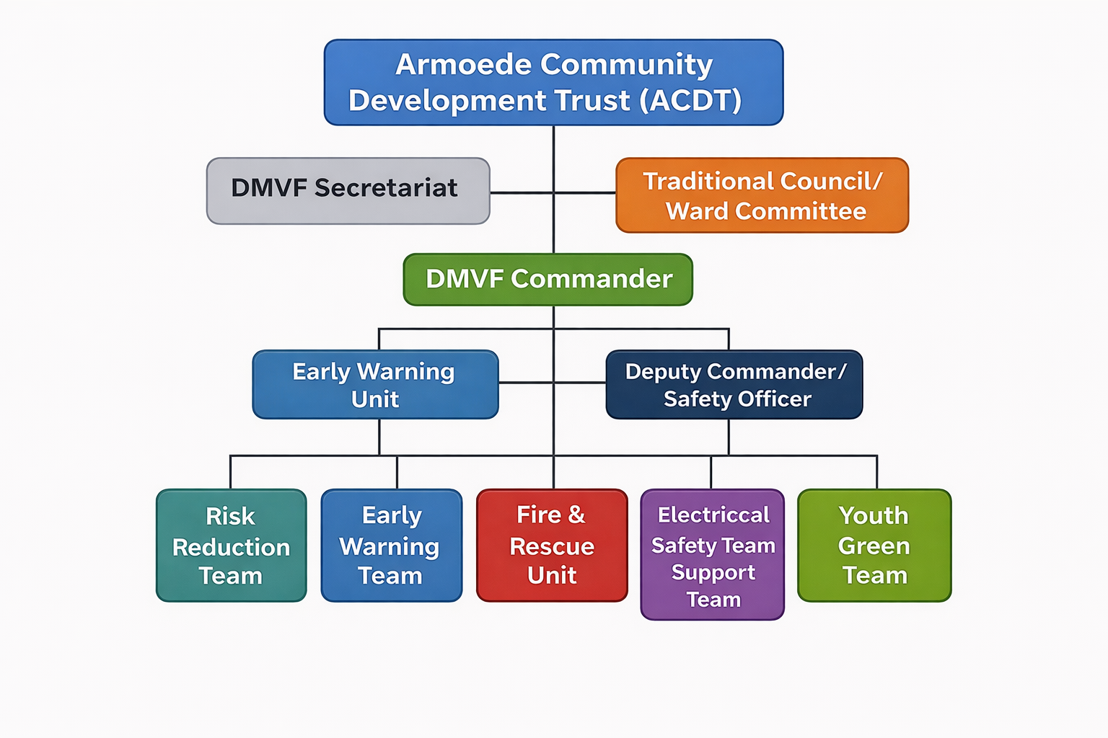
DMVF Institutional Structure
Level / Unit | Designation / Function | Reporting Line | Key Responsibilities
GCDT Board of Trustees | Oversight Authority | Reports to Community & Regulators | Custodian of the DRM Plan; approves activations; liaises with municipal and district structures.
GCDT IOC/ DMVF Secretariat | Coordination and Administration | Reports to GCDT Board | Maintains incident registers, training records, and external communications.
DMVF Commander | Field Command & Control | Reports to GCDT Disaster Desk | Leads volunteer deployments; ensures safety and discipline.
Deputy Commander / Safety Officer | Safety and Incident Oversight | Reports to DMVF Commander | Oversees PPE use, first-aid readiness, and incident logs.
Risk Reduction Team | Drainage & Infrastructure Support | Reports to DMVF Commander | Drainage maintenance, erosion control, debris removal.
Early Warning & Communication Unit | Alerts & Information Flow | Reports to DMVF Secretariat | Disseminates warnings; maintains liaison with SAWS and schools.
Fire & Rescue Support Unit | Response & Rescue | Reports to DMVF Commander | Fire containment, household evacuation, light search and rescue.
Electrical Safety & Hazard Team | Infrastructure Safety | Reports to Deputy Commander | Detects faulty wiring; supports Eskom coordination.
Livelihoods & Health Support Team | Social and Health Relief | Reports to DMVF Secretariat | Assists vulnerable families, supports clinic referrals, manages relief distribution.
Youth Green Team | Environmental Rehabilitation | Reports to DMVF Commander | Implements gully stabilisation and revegetation activities.

This structure ensures:
- Clear Authority: GCDT leadership avoids fragmented responses.
- Operational Capacity: DMVF executes front-line DRM actions.
- Governance Legitimacy: Traditional Council and Ward Committee endorse and support the mandate.
- Institutional Linkage: Municipal and District DMCs provide technical support and escalation channels

D. Training and Capacity Development Record

Training Programme / Course | Duration | Provider / Facilitator | Participants (No.) | Core Competencies Covered | Status / Remarks
Basic Disaster Risk Management First Responder Programme | 12 weeks | Waterberg DMC & Mogalakwena LM DRM Unit | 20 | First aid, fire response, evacuation techniques, incident reporting protocols | Completed (2025)
Early Warning and Simulation Exercise | 2 days | GCDT + Schools + Clinic | 20 + Community | Message relay, alert timing, communication chain testing | Annual drills completed
Electrical Safety Inspection Training | 3 days | Mogalakwena LM Electrical Dept / DMVF Safety Unit | 10 | Household inspection procedures, risk identification and remediation | Ongoing rotational refreshers
Fire Prevention and Basic Firefighting | 5 days | Waterberg Fire Services & DMVF Fire Sub-Unit | 15 | Use of extinguishers, safe evacuation, firebreak maintenance | Completed
Community Relief and Logistics Training | 2 days | NGO Partner / GCDT Relief Desk | 12 | Needs assessment, distribution protocols, vulnerable group support | Completed
Digital DRM Monitoring Register Training | 1 day | GCDT Secretariat + Ward Committee | 8 | Data capture and reporting for monitoring framework | Initiated; follow-up scheduled
Environmental Risk Mitigation and Gully Rehabilitation | 1 week | GCDT & Farmers Forum | 10 | Brush-packing, grass planting, soil stabilisation | Completed with support from Youth Green Team

E. Sustainability and Next Steps
- Maintain a bi-annual training (or refresher) calendar and annual simulation schedule.
- Formalise recognition of the DMVF within municipal disaster systems for equipment and insurance support.
- Establish a Community Disaster Equipment Fund managed by the GCDT for PPE and response tools.
- Strengthen linkages with the Waterberg DMC for continuous skills development and joint exercises.

Annexure 5: Early Warning and Emergency Communication Protocol

Referenced in Section 5.4 - Preparedness and Early Warning and Section 6.4 - Coordination

Purpose
To provide a systematic and community-integrated protocol for detecting, validating, communicating, and acting on early warning information in Ga-Pila. The protocol ensures that risk information translates into timely, inclusive, and actionable communication that saves lives, safeguards livelihoods, and protects local development gains.

This annexure operationalises the Sendai Framework Priority 4, Enhancing Disaster Preparedness for Effective Response and to “Build Back Better” in Recovery, Rehabilitation and Reconstruction, and aligns with Key Performance Area 4 of South Africa’s National Disaster Management Framework (NDMF, 2005).

5.1 Conceptual Basis
Early warning is not an event but a systemic capability built upon science, communication, trust, and social mobilisation. Its effectiveness depends on four interdependent pillars:
- Risk Knowledge: Understanding who and what is at risk;
- Monitoring and Forecasting: Continuous detection and interpretation of hazard data;
- Dissemination and Communication: Reliable, accessible, and trusted message delivery;
- Response Capability: The ability and willingness of people to act when warned.

In the Ga-Pila context, this framework integrates scientific observation (meteorological and hydrological), indigenous knowledge, and community reporting through a decentralised system led by the Ga-Pila Community Development Trust (GCDT) and implemented by the Disaster Management Volunteer Force (DMVF).

5.2 Principles Guiding the Protocol
The protocol is anchored in the following principles, distilled from decades of field learning and global best practice:
- Speed and Accuracy: The first message must be the right message — timely, verified, and actionable.
- Trust and Credibility: Communities act when they trust the source; hence, all warnings are authenticated through established structures.
- Inclusivity and Reach: No household or vulnerable group should be left uninformed or unable to respond.
- Two-Way Communication: Early warning is as much about receiving local signals as it is about sending official alerts.
- Redundancy and Resilience: Multiple communication pathways ensure continuity during power or network failures.

5.3 Structure of the Early Warning System
Figure A5.1 (below) presents the Ga-Pila Early Warning and Emergency Communication Flow, linking detection, validation, and dissemination.

Figure A5.1: Flow of Early Warning and Communication in Ga-Pila

This model reinforces local agency within a structured command chain, ensuring that early action is triggered at the lowest competent level.

5.4 Warning Levels and Triggers
Early warnings are graded into four levels of escalating seriousness, harmonised with district and national protocols.

Level | Trigger / Condition | Examples of Hazard Indicators | Lead Activator | Expected Community Action
Level 1 – Advisory | Early signs of potential hazard | Continuous rainfall, rising water levels, reports of veld burning | DMVF Early Warning Unit | Observe, monitor, and alert leadership; prepare for update
Level 2 – Watch | Probability of hazard within 48–72 hours | Forecasted heavy rainfall, strong winds, power instability | GCDT Early Warning Lead | Ready equipment, check communication tools, brief households
Level 3 – Warning | Confirmed threat or hazard likely within 24 hours | Local flooding, veldfire moving toward settlement | GCDT + DMVF | Issue public alerts; activate partial standby and community mobilisation
Level 4 – Emergency | Hazard event confirmed or unfolding | Flash floods, uncontrolled fire, disease outbreak | Incident Commander (GCDT) | Execute emergency response; evacuate and protect lives

Each level corresponds with pre-defined action cards held by DMVF team leaders, ensuring discipline and uniformity across responses.

5.5 Communication Channels and Protocols
The Ga-Pila system adopts a multi-channel, multi-institutional approach, drawing from field-tested communication redundancy principles:

Primary Channels:
- GCDT-verified WhatsApp broadcast lists (community-wide, bilingual).
- Loudhailer notifications through trained volunteers and vehicle-mounted systems.
- Direct liaison with Traditional Council, Ward Committee, School Principals, and Clinic Head.
- SMS or voice alerts for off-grid or remote households.

Backup Channels:
- Local faith-based and cultural institutions.
- Door-to-door messengers for elderly or disabled persons.
- Local radio (where possible) for wide-area alerts.

Each channel is tested quarterly, and activation roles are clearly mapped in the GCDT Emergency Communication Directory (updated annually).

5.6 Verification and Escalation Mechanism
All alerts follow a four-step verification process before dissemination to prevent false alarms or panic.

Step | Verification Action | Responsible Entity
1 | Receive forecast, observation, or local report | DMVF Early Warning Unit
2 | Validate data with the municipal or district DRM Centre | GCDT Early Warning Lead
3 | Classify and authorise the warning level | GCDT Chairperson or delegated Incident Commander
4 | Disseminate through designated communication channels | DMVF Communication Team
5 | Notify the District DMC and maintain event log | GCDT Secretariat

This procedure ensures scientific accuracy, chain of command integrity, and accountability consistent with NDMF Enabler 2: Information Management and Communication Systems.

5.7 Warning Message Format
Messages must be action-oriented and avoid technical jargon. All warnings follow a unified format for clarity and consistency.

Component | Example
Header | “⚠️ COMMUNITY FLOOD WARNING: ZONE 3 AT RISK”
Hazard Description | “Persistent rainfall and overflowing channels detected in lower Ga-Pila.”
Impact Summary | “Low-lying households and bridges may be affected within 6–12 hours.”
Immediate Action Required | “Move valuables, avoid stormwater channels, and stand by for evacuation notice.”
Issued by/Contact | “GCDT Early Warning Unit (Tel: 015 XXX XXXX). Valid until 18:00, 21 October.”

This structure ensures the message is both technically sound and socially understandable, bridging science and community comprehension.

5.8 Inclusivity and Accessibility
The protocol recognises that warnings are only effective when accessible to all. Measures include:
- Bilingual messaging in English and Sepedi.
- Visual symbols (e.g., coloured flags, icons) for semi-literate recipients.
- Community focal points for elderly and persons with disabilities.
- School-based awareness so children act as secondary communicators within households.

The approach mirrors lessons from UNDRR’s Global Platform (2023) on people-centred early warning systems, ensuring no one is left behind.

5.9 Review, Testing, and Continuous Improvement
The GCDT and DMVF conduct:
- Quarterly communication drills simulating real scenarios (fire, flood, drought).
- Annual multi-stakeholder review workshops involving Traditional Council, Ward Committee, schools, and local service departments.
- Post-event evaluations to assess timeliness, message clarity, and behavioural response.

Findings are documented in the M&E and Learning Framework (Annexure 8) to inform protocol refinement.

5.10 Institutional Roles
Function | Primary Responsibility | Supporting Role
System Oversight | GCDT (Early Warning Subcommittee) | Mogalakwena Local Municipality DRM Section
Monitoring & Observation | DMVF Early Warning Team | Community Watch Points
Communication Activation | DMVF Communication Officers | Ward Committee, School Heads
Escalation & Reporting | GCDT Secretariat | Waterberg District DMC
Feedback & Learning | GCDT + DMVF | Traditional Council, NGOs

5.11 Concluding Reflection
The Ga-Pila Early Warning and Emergency Communication Protocol is more than a procedural tool. It is a manifestation of institutional maturity and social trust. It converts early warning into early action, embodying the highest principles of risk governance and community resilience.

As affirmed in over three decades of practice and research:

“A warning not understood is a warning not issued.”

This annexure ensures that in Ga-Pila, every signal becomes an instruction, and every message saves a life.

Annexure 6: Incident Response and Activation Flowchart

Referenced in Section 5.5 - Response Strategy and Section 5.7- Contingency Planning

Purpose
To present a clear and standardised process for activation, coordination, and escalation of incident response within the Ga-Pila community. The flowchart and supporting framework ensure disciplined decision-making, unity of command, and timely deployment of available resources during any emergency. The system empowers the community to act swiftly while maintaining accountability and alignment with the Mogalakwena Local Municipality and Waterberg District Disaster Management Centres.

6.1 Conceptual Foundation
Incident response requires a balance between structure and flexibility. Drawing from more than three decades of operational experience in Africa, it is evident that community-based response functions best when:
- Roles and lines of authority are clearly defined and widely understood.
- Decisions are taken as close as possible to the point of impact.
- Communication flows are short, direct, and verifiable.

The Ga-Pila framework therefore follows a three-tier activation structure:
- Level 1 (Local Containment): Incidents manageable within the community using local resources.
- Level 2 (Supported Response): Incidents that exceed community capacity and require municipal or sectoral assistance.
- Level 3 (Escalated Disaster): Incidents beyond local and municipal capacity that require district or provincial coordination.

This model is consistent with the National Disaster Management Framework’s emphasis on decentralised but coordinated response capability.

6.2 Activation Triggers
Incident response may be initiated through different types of triggers. The table below outlines how each trigger type originates and the corresponding verification process.

Table A6.1: Activation Triggers and Verification Pathways
Trigger Type | Source Example | Verification Pathway
Observation-Based Trigger | Household reports smoke, flooding, or structural collapse | DMVF verifies and informs GCDT Response Lead
Forecast-Based Trigger | Early warning from meteorological or health authority | GCDT validates and prepares response teams
Instruction-Based Trigger | Directive from Mogalakwena LM or District DMC | Immediate activation of coordination centre and DMVF

All triggers must be logged in the Incident Register, which is maintained by the GCDT Secretariat and linked to the Early Warning and Communication Protocol (Annexure 5).

6.3 Command Structure
The Ga-Pila Incident Command System (ICS) adapts the national model to the local context. It ensures unity of command, operational clarity, and coordinated reporting.

Table A6.2: Local Incident Command Structure
Role | Designation / Responsibility
Incident Commander | GCDT Chairperson or delegated officer
Operations Lead | DMVF Team Leader for Response
Logistics Lead | Ward Committee representative supported by Traditional Council liaison
Planning and Intelligence Lead | DMVF Risk Information Officer
Communication and Liaison Lead | GCDT Secretariat

All functions report to the GCDT Board for overall oversight and compliance.

6.4 Incident Response and Activation Flow
The process below illustrates how an incident moves from detection to stabilisation and closure. It demonstrates the logical flow of decision-making and action.

Figure A6.1: Incident Response and Activation Flow

6.5 Command Communication Matrix
Effective communication throughout the response cycle is crucial for maintaining operational control. The matrix below outlines the communication pathway, responsible parties, mediums, and expected outputs for each stage.

Table A6.3: Command Communication Matrix
Stage | Primary Communicator | Recipient(s) | Medium | Expected Output
Detection | Reporter (DMVF or Household) | GCDT Response Lead | Call or Message | Verified alert
Activation | GCDT Incident Commander | DMVF, Traditional Council, Ward Committee | Broadcast, Loudhailer | Mobilisation order
Coordination | GCDT Secretariat | LM DRM, Clinic, SAPS | Official Notification | Resource deployment
Situation Report | DMVF Operations Lead | GCDT Board, District DMC | Report Template | Situation Report
Closure | GCDT Chairperson | All Stakeholders | Meeting and Circular | Incident Closure Record

6.6 Operational Thresholds for Escalation
To ensure that incidents are managed proportionally and without confusion of authority, the thresholds below define when and how escalation occurs.

Table A6.4: Operational Thresholds for Escalation
Response Level | Indicative Criteria | Authority to Activate | External Notification
Level 1 – Local Containment | Limited to a single zone or fewer than five households | DMVF Response Lead | None
Level 2 – Supported Response | Multi-zone impact or infrastructure affected | GCDT Incident Commander | Mogalakwena LM
Level 3 – Declared Disaster | Widespread damage, fatalities, or displacement | GCDT Chairperson (through LM) | District and Provincial DMC

These thresholds preserve coordination discipline and align with disaster classification standards in the South African Disaster Management Framework.

6.7 Institutional Roles and Responsibilities
The following table clarifies the respective responsibilities of the main entities involved in incident response and coordination.

Table A6.5: Institutional Roles and Responsibilities
Entity | Core Responsibilities
Ga-Pila Community Development Trust (GCDT) | Lead coordination, incident command, liaison, and reporting
DMVF | Field response, first aid, safety, and search operations
Traditional Council | Community mobilisation, access facilitation, and oversight of safety
Ward Committee | Communication support, logistics, and local reporting
Local Clinic | Emergency medical support and health reporting
Mogalakwena LM and Waterberg DMC | Technical reinforcement, transport, and specialist support

6.8 Post-Incident Learning and Reporting
Each incident, regardless of scale, must generate learning to strengthen preparedness and institutional maturity. This process consists of:
- Operational Debrief: Held within 24 hours of event stabilisation.
- After-Action Report (AAR): Compiled within 7 days by DMVF and validated by GCDT.
- Integration into Monitoring and Learning Systems: Findings incorporated into the M&E Framework (Annexure 8).

6.9 Concluding Reflection
The Ga-Pila Incident Response and Activation Framework is not a theoretical construct but a practical and proven system rooted in community participation and institutional discipline. It transforms local capacity into a coordinated force that can prevent loss, reduce suffering, and accelerate recovery.

As years of DRM practice have shown:

“Communities that plan, communicate, and act together recover faster and stronger than those that wait for help to arrive.”

Annexure 7: Recovery and Continuity Action Framework

Section 5.6 (Recovery and Continuity Plan) and Section 6.6 (Monitoring, Evaluation and Learning)

Purpose
To provide a structured approach for restoring normalcy after an incident while embedding resilience-building measures that reduce future disaster risk. The framework ensures that post-disaster recovery in Ga-Pila is coordinated, equitable, and development-oriented rather than reactive. It defines recovery phases, institutional roles, financing options, and monitoring parameters aligned with the principles of “Build Back Better” and “Leave No One Behind.”

7.1 Conceptual Foundation
Recovery is both a process and an opportunity. It aims not merely to return to pre-disaster conditions but to transform vulnerabilities into strengths. The Ga-Pila approach to recovery is guided by four interrelated principles:
- Restoration with Improvement: Every reconstruction activity should enhance resilience and reduce hazard exposure.
- Community Ownership: Recovery must be locally led, supported by technical and financial partners.
- Integrated Planning: Recovery must align with broader development and land-use planning instruments.
- Equity and Inclusion: Vulnerable households must receive targeted support to ensure no one is left behind.

The recovery process in Ga-Pila follows three interdependent phases (that is the Early Recovery, Intermediate Recovery, and Long-Term Rehabilitation) all supported by continuous learning and accountability mechanisms.

7.2 Recovery Phases and Objectives
The three phases of recovery are outlined in Table A7.1. Each phase builds on the previous one, ensuring smooth transition from emergency relief to sustainable development.

Table A7.1: Recovery Phases and Core Objectives
Recovery Phase | Timeframe | Primary Objective | Key Activities
Early Recovery | 0–3 months | Stabilise affected households and re-establish essential services | Rapid needs assessment, emergency shelter, water and sanitation restoration, temporary livelihood support
Intermediate Recovery | 3–12 months | Repair damaged infrastructure and restore community services | Rehabilitation of roads, schools, clinics, small-scale irrigation, livelihood diversification
Long-Term Rehabilitation | 12–36 months | Achieve sustainable restoration and integrate risk reduction into development | Reconstruction of resilient housing, land rehabilitation, governance strengthening, institutional learning

7.3 Governance and Coordination for Recovery
Recovery governance is anchored in the Ga-Pila Community Development Trust (GCDT) as the principal coordinating entity. Its oversight ensures that recovery activities remain transparent, inclusive, and well-aligned with local and district frameworks.

The table below outlines institutional roles for effective coordination and accountability.
Table A7.2: Institutional Roles in Recovery Governance
Entity | Core Responsibilities
Ga-Pila Community Development Trust (GCDT) | Lead coordination, oversight of funding, and alignment with strategic recovery priorities
DMVF Recovery Unit | Field coordination, household recovery support, and damage verification
Traditional Council | Community mobilisation, access facilitation, and dispute resolution
Ward Committee | Local reporting, liaison with municipal services, and monitoring community needs
Mogalakwena Local Municipality | Technical assessment, infrastructure rehabilitation, and integration into municipal plans
Waterberg District DMC | Oversight, logistics, and access to district-level support mechanisms
Non-Governmental and Faith-Based Organisations | Support provision of relief materials, psychosocial care, and technical aid

7.4 Recovery Financing and Resource Mobilisation
Effective recovery depends on timely mobilisation of resources. The financing strategy combines community contributions, Trust resources, government allocations, and external donor support.

The resource mobilisation mechanism operates through the following pathways:
- Internal Financing: Utilisation of GCDT emergency and contingency funds.
- Public Sector Support: Requests to Mogalakwena LM and Waterberg DMC for infrastructure repair and technical services.
- Private Sector Partnerships: Engagement with local mines, businesses, and insurers for funding or materials.
- Community Contributions: Labour, local materials, and volunteerism for small-scale works.
- External Assistance: Formal requests to national or international humanitarian partners if recovery needs exceed local capacity.

Table A7.3: Recovery Resource Mobilisation Framework
Source | Instrument / Mechanism | Purpose of Funds | Accountability Channel
GCDT Contingency Reserve | Direct fund allocation | Immediate community-level recovery | GCDT Finance Committee
Municipal and District Budgets | Disaster relief and rehabilitation grants | Repair of public infrastructure | LM and DMC reporting
Corporate Social Investment | Partner agreements with local mines and companies | Livelihood recovery, training, and materials | Joint Recovery MoUs
NGOs and Donor Agencies | Project grants or in-kind support | Shelter, food security, psychosocial support | Donor reporting templates
Community Contributions | Voluntary labour and materials | Minor repairs and public clean-ups | DMVF documentation and oversight

7.5 Monitoring, Learning, and Accountability
Monitoring ensures transparency and helps track progress across recovery phases. GCDT, in collaboration with DMVF, uses a structured approach that integrates both qualitative and quantitative indicators. Learning and reflection are embedded into every stage of recovery.

The monitoring framework below presents performance indicators to be tracked through periodic progress reviews.

Table A7.4: Recovery Monitoring and Learning Framework
Objective | Key Indicators | Data Source | Reporting Frequency
Restoration of critical infrastructure | Number of facilities restored to operational level | Site inspection reports, LM records | Quarterly
Livelihood recovery | Number of households resuming productive activities | Household surveys, DMVF logs | Biannual
Social inclusion | Proportion of women and vulnerable households benefiting from recovery aid | Community verification and beneficiary lists | Quarterly
Institutional learning | Number of post-incident reviews and knowledge products produced | GCDT and DMVF reports | Annual
Community satisfaction | Community perception of fairness and transparency in recovery | Feedback sessions and focus groups | Annual

7.6 Post-Disaster Recovery Workflow
The following process flow ensures that recovery actions are systematic, inclusive, and progressively developmental.

Figure A7.1: Post-Disaster Recovery Workflow

7.7 Transition to Development
Recovery in Ga-Pila is not a temporary process but a bridge to sustainable development. The transition from relief to rehabilitation and development is achieved through three reinforcing pathways:
- Institutional Integration: Recovery plans are absorbed into GCDT’s annual workplan and Mogalakwena LM’s Integrated Development Plan (IDP).
- Economic Revitalisation: Livelihoods are diversified through community enterprises and agricultural revitalisation.
- Resilient Infrastructure Development: Reconstruction integrates climate adaptation, local materials, and hazard-proof design.
These pathways transform recovery into a development opportunity rather than a return to vulnerability.

7.8 Concluding Reflection
The Recovery and Rehabilitation Framework affirms that the success of post-disaster action lies not in the speed of rebuilding but in the quality of renewal. True recovery strengthens governance, rebuilds trust, and restores dignity.

As experience from decades of disaster management practice teaches us:

“Recovery is not the end of a disaster; it is the beginning of resilience.”

Annexure 8: Monitoring, Evaluation and Learning (MEL) Framework

Sections 6.6 (Monitoring, Evaluation and Learning) and 7.5 (Recovery Monitoring and Learning Framework)

Purpose
To provide a consolidated framework that guides systematic monitoring, periodic evaluation, and continuous learning in the implementation of the Ga-Pila Disaster Risk Management (DRM) Plan. This annexure builds upon the operational tables in Chapters 5 and 6 and introduces an overarching mechanism for performance tracking, knowledge generation, and adaptive improvement aligned with the Sendai Framework Priority 4, NDMF KPA 4, and the Mogalakwena Local Municipality’s performance management system.

8.1 Conceptual Basis
Monitoring and Evaluation (M&E) are not mere compliance tools but essential processes for accountability, institutional learning, and adaptive resilience. In the Ga-Pila context, M&E ensures that:
- Activities under each DRM function are implemented as planned.
- Evidence informs decision-making, resource allocation, and partnership engagement.
- Lessons from implementation feed back into policy and practice improvement.

The Monitoring, Evaluation and Learning (MEL) system therefore integrates three complementary streams:
- Performance Monitoring: Tracking implementation progress, resource use, and outputs against targets.
- Evaluation: Periodic assessment of outcomes, effectiveness, and impact on resilience.
- Learning: Capturing knowledge, best practices, and lessons to enhance future planning and response.

The overall process is illustrated in Figure A8.1, which depicts the continuous cycle of planning, implementation, monitoring, evaluation, reflection, and adaptation.

Figure A8.1: MEL System Flow
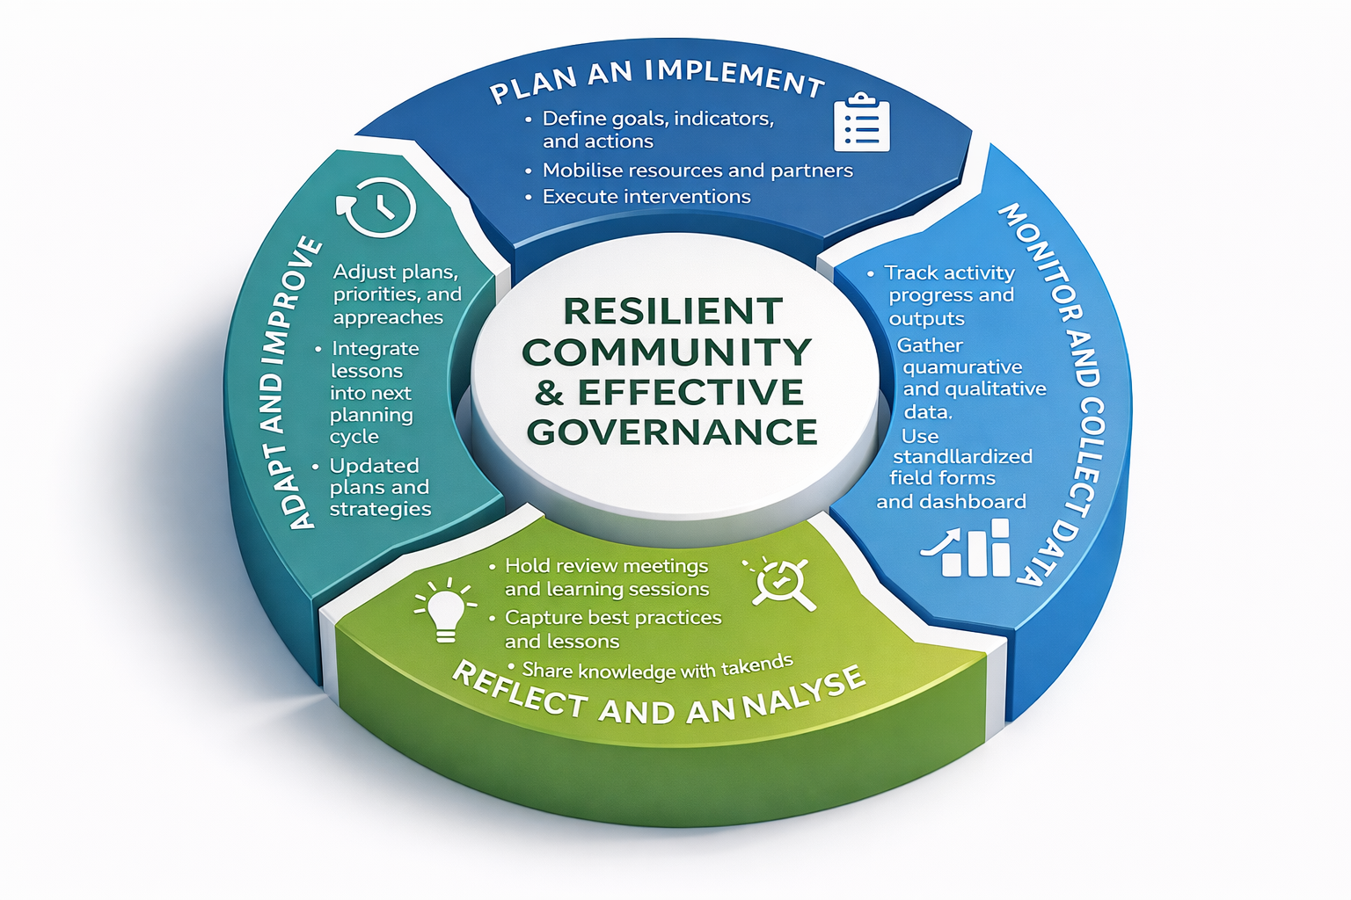

8.2 Institutional Responsibilities
Monitoring is coordinated through the Ga-Pila Community Development Trust (GCDT) as the accountable institution, supported by the Disaster Management Volunteer Force (DMVF), Traditional Council, and Ward Committee. Oversight and technical guidance are provided by the Waterberg District Disaster Management Centre (DMC) and Mogalakwena Local Municipality.

Table A8.1: Institutional Roles for Monitoring and Learning
Entity | Key Responsibilities
GCDT | Overall coordination, data validation, consolidation of reports, and feedback to community and partners
DMVF | Field-level monitoring, data collection, documentation of incidents, and lesson sharing
Traditional Council | Oversight of compliance, community mobilisation for surveys, and inclusion assurance
Ward Committee | Verification of outputs and liaison with municipal structures
Waterberg DMC | External verification, evaluation support, and reporting alignment
Partner Organisations | Joint monitoring, technical input, and dissemination of findings

8.3 Performance Framework
The MEL framework uses a hierarchy of results indicators (inputs, outputs, outcomes, and impacts) consistent with both development evaluation and disaster risk management logic. The matrix below defines what is monitored, how it is measured, and how often reviews occur.

Table A8.2: Results-Based Monitoring Framework
Results Level | Focus of Measurement | Example Indicators | Data Sources | Reporting Frequency
Input | Resources allocated and used | - Budget utilisation  - Staff time  - Volunteer mobilisation | Financial records, activity logs | Quarterly
Output | Delivery of planned activities | - Number of trainings held  - Length of firebreaks cleared  - Infrastructure repaired | Project reports, DMVF logs | Quarterly
Outcome | Behavioural or system change achieved | - % of households with early warning access  - Reduction in fire outbreaks | Household surveys, evaluation studies | Annual
Impact | Long-term resilience improvements | - Reduction in losses  - Increased water security  - Reduced response times | Disaster loss database, municipal reports | Biennial

8.4 Data Management and Quality Assurance
Monitoring quality depends on reliable data. Data management in Ga-Pila will follow a Community–Trust–District data pathway ensuring consistency and integrity.

Table A8.3: Data Management Protocol
Process Step | Lead Actor | Tools / Mechanisms | Verification Approach
Data Collection | DMVF teams | Field forms, mobile data capture | Supervisor checks
Data Consolidation | GCDT Secretariat | Excel dashboard, community registers | Cross-verification with partner data
Data Validation | GCDT M&E Officer | Review meetings, sample audits | Triangulation with municipal data
Reporting | GCDT Board | Quarterly reports and presentations | Approval minutes
Archiving and Learning | GCDT & Ward Committee | Shared digital and physical repository | Annual review and update

8.5 Evaluation Approach
Evaluation assesses not only whether planned activities were implemented but also whether they were effective and relevant in reducing risk.

Evaluations will be guided by five key principles:
- Relevance: Alignment of activities with local priorities and hazards.
- Efficiency: Optimal use of resources and time.
- Effectiveness: Achievement of intended outcomes.
- Sustainability: Ability to maintain results beyond project cycles.
- Learning and Adaptation: Use of evidence for continual improvement.

Table A8.4: Evaluation Plan
Evaluation Type | Purpose | Frequency | Lead Responsibility | Output
Process Evaluation | Assess implementation efficiency | Annually | GCDT | Annual performance report
Outcome Evaluation | Measure results and behavioural change | Every 2 years | GCDT with Waterberg DMC | Evaluation report
Impact Evaluation | Assess long-term resilience outcomes | Every 5 years | GCDT and partners | Impact report
After-Action Review | Capture lessons after major incidents | As needed | DMVF & GCDT | After-action summary

8.6 Learning, Reflection, and Knowledge Uptake
Learning is an intentional process embedded across all DRM functions. It turns data into wisdom by enabling reflection, innovation, and corrective action.

Learning will occur through structured quarterly learning circles, annual review workshops, and documentation of case studies on community response, recovery, and prevention.

Table A8.5: Learning and Knowledge Uptake Activities
Learning Mechanism | Frequency | Responsible Unit | Expected Output
Quarterly Reflection Sessions | Quarterly | GCDT Secretariat, DMVF | Learning briefs and practice notes
Annual Review Workshop | Annually | GCDT, Ward Committee, Traditional Council | Consolidated annual report and plan adjustments
Case Study Development | Annually | GCDT Research and Documentation Team | Knowledge products and shared best practices
Peer Exchange Visits | Every 2 years | GCDT with Waterberg DMC | Exchange reports and replication plans
Community Feedback Dialogues | Biannual | DMVF and Traditional Council | Community satisfaction reports

8.7 Reporting and Feedback Mechanisms
The reporting chain ensures accountability while maintaining two-way communication between the community and oversight bodies.

Table A8.6: Reporting and Feedback Framework
Level | Reporting To | Primary Output | Feedback Mechanism
Community / DMVF | GCDT | Activity updates, incident logs | Community meetings
GCDT | Ward Committee & LM DRM | Quarterly and annual reports | Review meetings
LM DRM | District DMC | Consolidated municipal report | Joint coordination sessions
District DMC | Provincial DRM | District-level summary report | Policy briefs and feedback loop

8.8 Indicator Alignment with Sendai Framework
To ensure international coherence, the community-level indicators are mapped against Sendai Framework Targets A–E. This ensures that local reporting contributes to national and global DRR tracking.

Table A8.7: Alignment of Local Indicators to Sendai Targets
Sendai Target | Global Focus | Local Indicator for Ga-Pila
Target A | Reduce mortality | Number of lives saved through early warning
Target B | Reduce affected population | % of households with restored basic services within 7 days
Target C | Reduce economic loss | Value of community infrastructure restored
Target D | Reduce damage to critical infrastructure | % of functional facilities within 1 month post-event
Target E | Increase DRR strategies | Existence and annual review of the Ga-Pila DRM Plan

8.9 Concluding Reflection
The Monitoring, Evaluation and Learning Framework transforms the DRM Plan from a static document into a living system that evolves through feedback, participation, and evidence. It ensures that accountability is upward (to authorities), horizontal (to partners), and downward (to the community).

“Measurement without learning is bureaucracy; learning without measurement is guesswork. Together, measurement and learning, they create wisdom.”
Annexure 9: Stakeholder Coordination and Support Matrix

Referenced in Section 6.4 (Institutional Coordination)

Purpose
To clarify the relationships, mandates, and coordination pathways among all stakeholders engaged in disaster risk management within Ga-Pila. The matrix ensures that operational and support actors understand their roles, avoid duplication, and adhere to the Trust-centred command, coordination, and communication system.

Coordination Architecture
The Ga-Pila Disaster Risk Management architecture is designed around the principle that local ownership drives effective coordination. The Ga-Pila Community Development Trust (GCDT) serves as the entry point and overall coordination authority, ensuring alignment with the Disaster Management Act (2002) and the district-provincial-national DRM system. The DMVF functions as the operational arm, while the Traditional Council safeguards customary governance, local legitimacy, and social cohesion. Support services, such as municipal, district, sectoral, and private partners, provide technical, logistical, and financial assistance in accordance with established protocols. The matrix below consolidates these linkages across the five functional pillars of disaster management.

Figure A9.1: Coordination Hierarchy Overview

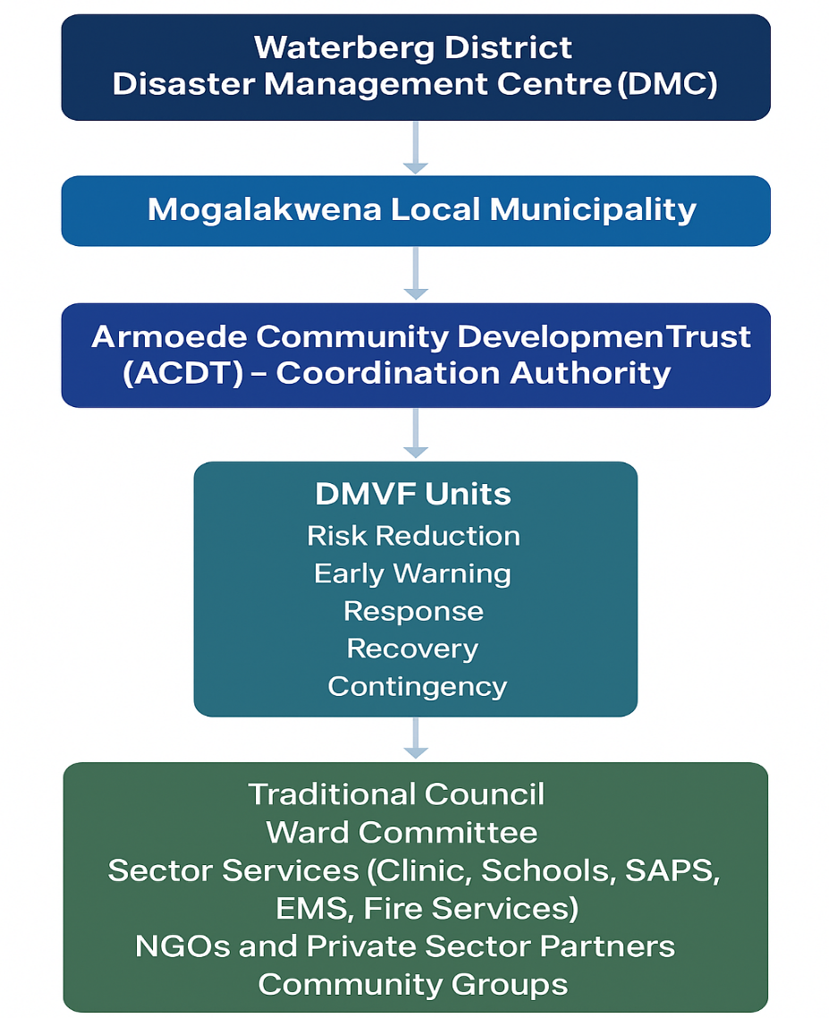

Table A9.1: Stakeholder Coordination and Support Matrix
Disaster Management Function | Lead Responsibility | Operational Execution | Support Structures | Primary Interface / Escalation Pathway | Key Deliverables
Prevention & Mitigation | GCDT | DMVF – Risk Reduction Team | Traditional Council, Farmers Group, Ward Committee | Waterberg DMC → District Municipality | Annual risk-reduction programme implemented; erosion and flood hotspots mitigated
Preparedness & Early Warning | GCDT | DMVF – Early Warning Unit | Schools, Local Clinic, Ward Committee | Mogalakwena LM → Waterberg DMC | Functioning community early-warning and communication system; seasonal readiness campaigns completed
Emergency Response | GCDT (Incident Commander) | DMVF – Response Unit | SAPS, EMS, Fire Services, Traditional Council | Waterberg Disaster Operations Centre | Effective command and control; coordinated evacuation, rescue, and fire suppression
Recovery & Continuity | GCDT | DMVF – Recovery Team | NGOs, Farmers Group, Social Services, Ward Committee | Mogalakwena LM → Provincial Humanitarian Desk | Damage and needs assessment reports; restored access, services, and livelihoods
Hazard-Specific Contingency | GCDT | DMVF – Contingency Team | Clinic, Fire Services, Traditional Council | Waterberg DMC → Provincial Disaster Management Centre | Hazard-specific standby plans operationalised; triggers monitored and acted upon
Training & Awareness Support | GCDT | DMVF – Training Unit | Schools, NGOs, Faith Groups | Mogalakwena LM → District Training Forum | 4 annual community training and awareness sessions delivered
Monitoring, Evaluation & Learning (MEL) | GCDT | Executive Administrator & DMVF Secretariat | Traditional Council Chair, Ward Committee | Waterberg DMC → SADC Learning Exchange Network | Quarterly MEL reports; lessons integrated into updated plans
Finance & Resource Mobilisation | GCDT (Trust Board) | Executive Administrator & Finance Desk | Private Sector Partners, NGOs, District Finance Unit | Waterberg DMC → Provincial Treasury | Secured funding and donor coordination; accountability for resource flows
Community Mobilisation & Social Cohesion | GCDT | Traditional Council & Ward Committee | Senior Citizens Forum, Youth Groups, Faith Organisations | Mogalakwena LM → Social Development Unit | Inclusive participation, verified community attendance, and equitable recovery assistance

The coordination hierarchy underpinning disaster risk management in Ga-Pila is summarised in Figure A9.1 and elaborated through the matrix below. It delineates the vertical and horizontal linkages that connect community structures with municipal, district, and provincial systems, ensuring both accountability and coherence in the implementation of the Ga-Pila Disaster Risk Management Plan.

Key coordination principles include:

- Hierarchy of Coordination: The GCDT retains overall authority and convening power; DMVF acts as the technical and operational executor; Traditional Council ensures legitimacy and customary oversight.

- Escalation Protocol: All disaster-related matters escalate upward through GCDT → District DMC → Provincial Centre → NDMC, ensuring vertical coherence.

- Horizontal Linkages: Coordination with schools, clinics, SAPS, and municipal services ensures integrated multi-sectoral response.

- Information Flow: All field reports and incident logs flow through the DMVF Secretariat to the GCDT for validation and onward submission.

- Review Cycle: The matrix shall be reviewed annually or after any major incident to update roles and contact details.

Annexure 10: Implementation Tracking Template

Referenced: Section 6.6 (Monitoring, Evaluation and Learning)
Purpose
This annexure provides a structured tool for tracking the implementation of disaster risk management interventions across all thematic areas and timeframes. It enables the Ga-Pila Community Development Trust (GCDT), Disaster Management Volunteer Forum (DMVF), and partners to monitor progress, identify delays or bottlenecks, assess impact, and ensure that corrective measures are promptly taken. The template supports evidence-based reporting and alignment with district and national monitoring systems.

Implementation Tracking Framework
The template below provides a standard format for monitoring the progress of activities across the prevention, preparedness, response, recovery, and contingency domains. It aligns with the logical framework approach, focusing on inputs, outputs, outcomes, and impacts, while ensuring that monitoring indicators are both quantitative and qualitative.

Figure A10.1: Implementation Tracking Cycle

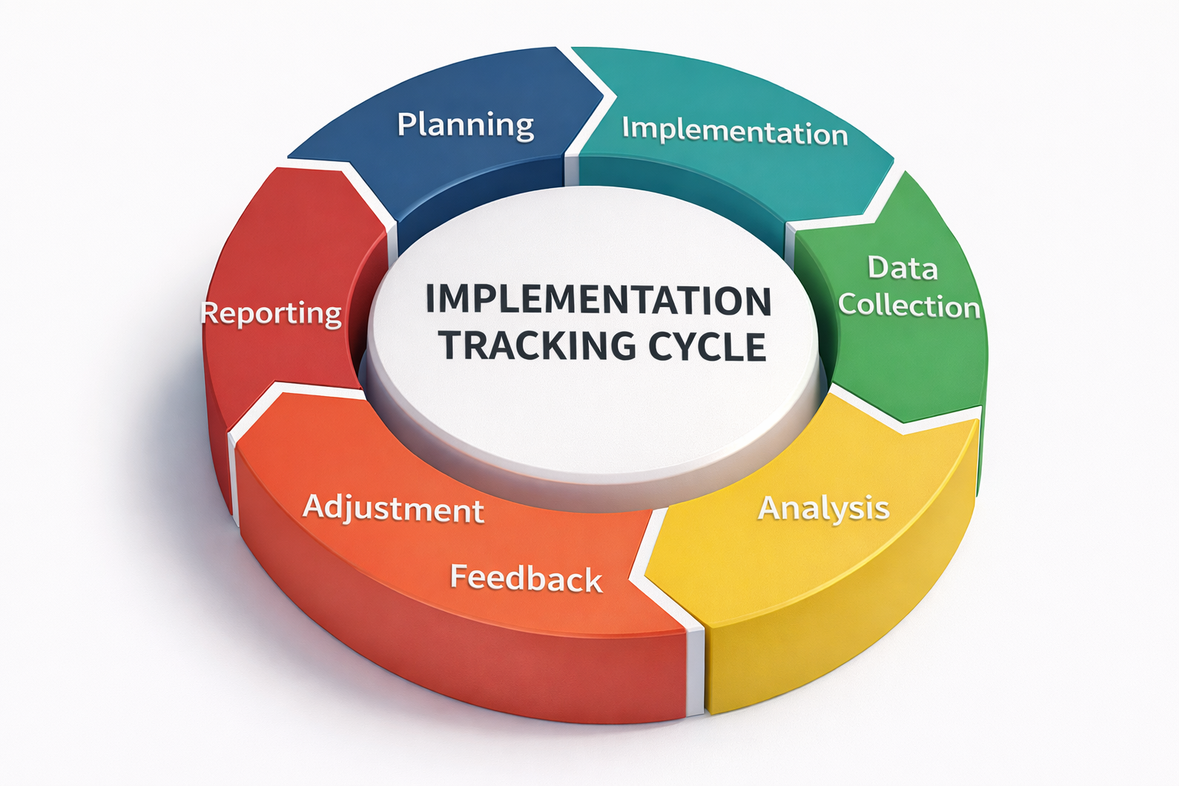
Below is the completed Implementation Tracking Template (Table A10.1) with realistic, context-specific examples for the Ga-Pila Community Disaster Risk Management Plan. It demonstrates professional-level tracking aligned with community, municipal, and district roles.

Table A10.1: Implementation Tracking Template (Illustrative Example)

No. | Objective / Expected Result | Activity / Action | Lead Responsibility | Support Required | Timeframe | Progress Status | Verification / Evidence | Challenges / Risks | Corrective Actions / Follow-up | Remarks / Next Steps
1 | Reduced flood and stormwater risk in high-risk zones | Clear and reopen blocked stormwater channels before rainy season | DMVF Risk Reduction Team | Mogalakwena LM – Technical Services | 0–6 months | In Progress (70%) | Photos, progress report, community feedback | Limited tools and manpower | Mobilise additional volunteers and request equipment support from LM | Finalise before next rainfall season
2 | Improved community water security and reduced drought impact | Install five 10,000L water tanks linked to borehole | GCDT | Waterberg DMC, local NGOs | 6–12 months | Completed | Installation certificate, photos | Transport delays for tanks | Schedule early procurement in future | Plan for solar pumping integration
3 | Lower incidence of household fires and electrical hazards | Conduct safety inspections and replace damaged wiring | DMVF Electrical Safety Unit | Mogalakwena LM – Electrical Department | 0–6 months | In Progress (40%) | Inspection checklist, incident reports | Inconsistent household access | Awareness campaign to improve access compliance | Include follow-up inspection next quarter
4 | Strengthened early warning and preparedness capacity | Conduct emergency simulation and early warning test | GCDT and DMVF Early Warning Unit | Schools, Clinic, Ward Committee | Annual | Completed | Attendance register, evaluation forms | Poor turnout in initial drill | Schedule drills on weekends | Maintain quarterly readiness drills
5 | Improved public health through sanitation and hygiene | Construct simple ventilation channels at pit toilets | Households supported by DMVF | Mogalakwena LM – Sanitation Unit | 6–24 months | In Progress (55%) | Site inspection records, photos | Shortage of materials | Liaise with LM for supply support | Next round of construction to focus on clinic zone
6 | Reduced erosion and land degradation | Stabilise erosion gullies using brush packing and grass planting | Youth Green Team | GCDT, Farmers Group | 6–24 months | Completed | Site inspection, photos | Initial drought slowed grass growth | Supplemented with irrigation support | Extend method to other risk zones
7 | Enhanced data-driven monitoring and reporting | Operationalise digital DRM monitoring register | GCDT Secretariat | DMVF, Ward Committee | 0–6 months | Initiated | Register template, digital copy | Limited digital literacy | Training planned for DMVF members | Link system with Waterberg DMC reporting tool

The table is to be updated quarterly and consolidated annually by the DMVF Secretariat, with inputs from all implementing partners and reporting to the GCDT.

Guidance Notes for Use

- Objective / Expected Result: Clearly indicate the strategic or operational goal that the action contributes to (e.g., reduced flood risk, strengthened early warning, improved coordination).

- Activity / Action: Specify the exact intervention being tracked (e.g., construction of diversion channels, community training, emergency drills).

- Lead Responsibility: Identify the accountable structure (e.g., GCDT, DMVF unit, Traditional Council).

- Support Required: Note supporting partners such as Mogalakwena LM, Waterberg DMC, clinics, schools, or NGOs.

- Progress Status: Use qualitative or percentage measures such as “Not Started,” “In Progress (40%),” “Completed,” or “Ongoing.”

- Verification / Evidence: Provide means of verification—e.g., photos, reports, minutes, site inspections, attendance registers.

- Challenges / Risks: Record issues affecting implementation such as resource constraints, coordination delays, or environmental conditions.

- Corrective Actions / Follow-up: Outline remedial actions and identify who will implement them and by when.

- Remarks / Next Steps: Capture additional insights, lessons, or priorities for the next review cycle.

Effective tracking ensures that the Ga-Pila Disaster Risk Management Plan remains a living instrument, that is facilitates continually learning, adapting, and responding to changing risks and realities. It strengthens institutional memory, enhances accountability, and builds the community’s long-term resilience through evidence-based governance and informed decision-making.

Annexure 11: Minimum Equipment List
Referenced in Section 5.4 (Preparedness and Early Warning), and Section 6.4 (Institutional Structure)

Purpose
This annexure outlines the minimum equipment standards required for the effective operation of the Disaster Risk Reduction and Response Task Team (DRRRTT) in Ga-Pila. It ensures that the community has the tools necessary for preparedness, early response, and recovery, while integrating mechanisms for long-term sustainability through community-based management and limited commercial use of assets.
The standards are informed by Sphere (2018), NDMC (2017), and Sendai Framework (2015–2030) guidelines, contextualised for a rural community of 2,028 residents (487 households).

Guiding Principles
- Adequacy: Equipment levels match risk exposure and population size.
- Safety: All tools must comply with minimum safety and quality standards.
- Simplicity: Equipment must be locally operable and serviceable.
- Durability: Assets must be built for rugged, field conditions.
- Sustainability: Equipment management must allow for self-financing and continuity through practical use and community stewardship.

Table A11.1: Minimum Equipment and Justification
Equipment Item | Minimum Standard (per households/people) | Quantity Required (Ga-Pila: 487 households) | Operational Function / Justification
Fire Beaters | 1 per 25 households | 20 units | Rapid suppression of veld and grass fires before escalation.
First Aid Kits | 1 per 50 households | 10 kits | First-response care for injuries and medical emergencies.
Stretchers | 1 per 120 households | 4 units | Safe evacuation of injured or immobile individuals.
Handheld Radios | 1 per 40 households | 12 units | Maintains communication when networks fail; enables coordination.
Megaphones | 1 per 100 households | 5 units | Broadcasts emergency messages and evacuation instructions.
Reflective Vests | 1 per DMVF volunteer | 30 units | Improves visibility and establishes responder authority.
Emergency Lamps | 1 per 50 households | 10 units | Ensures visibility during night operations and power outages.
Rescue Ropes & Harnesses | 1 per 150 households | 4 sets | For flood rescue and stabilising hazardous structures.
Community Siren / Bell System | 1 per sector | 2 units | Provides wide-area early warnings for floods, fires, and severe weather.
Water Storage (10,000 L JoJo Tanks) | 1 per 100 households | 5 tanks | Backup water supply for firefighting, hygiene, and drought relief.
Pressurised Towable Water Bowsers | 1 per 250 households | 2 units | 1 500–2 000 L pressurised trailers towed by bakkies for firefighting, drought relief, and water distribution. Dual-use model enables revenue generation through event hire to fund maintenance and replacement.
Basic Tool Kits (Spades, Pickaxes, Rakes) | 1 per DMVF unit | 6 sets | For drain clearing, debris removal, and minor repair work.
Protective Gloves & Masks | 1 per volunteer | 30 pairs | Ensures personal safety during clean-up and biohazard exposure.
Rain Gear (Ponchos and Gumboots) | 1 per volunteer | 30 sets | Allows safe operation in wet or stormy conditions.
Hand Extinguishers | 1 per facility | 6 units | Initial suppression of small fires in public facilities.
Whistles and Flashlights | 1 per field responder | 30 each | Low-cost signalling and night navigation tools.

Water Bowser Stationing and Rationale
To ensure equitable access, two pressurised towable water bowsers will be strategically stationed as tabulated below.

Stationing Point | Unit Assigned | Rationale
Community Hall | 1 x Pressurised Water Bowser | Centrally located and accessible for rapid deployment to the lower and western sections of Ga-Pila. Proximity to key community gathering points makes it ideal for firefighting, drought relief, and event hire. The Hall also hosts most major functions, enabling oversight by the GCDT and trained DMVF volunteers.
Study Centre | 1 x Pressurised Water Bowser | Located towards the eastern and upper settlement zones, enabling swift deployment to outlying areas. The Study Centre already serves as a DRM coordination hub, making it suitable for water supply management and emergency dispatch.

Operational and Security Rationale:
To ensure safe custody, security personnel stationed at the Community Hall and Study Centre must be drawn from individuals who have completed the GCDT’s Disaster Risk Management (DRM) First Responder training.
This ensures that:
- Security staff can respond immediately to fire or flooding incidents.
- Assets remain safeguarded by individuals who understand the operational and safety requirements of the equipment.
- Bowser operation and dispatch are always managed by trained and accountable personnel, ensuring readiness, traceability, and responsible use.
- The same personnel can assist the DMVF in water supply, hose connection, or pump activation when needed.

Procurement Standards and Technical Specifications
Equipment Item | Technical Specification | Minimum Quality Standard / Certification
Fire Beaters | Rubber paddle ≥ 250 mm; handle 1.2 m | SABS approved
First Aid Kits | Standard multi-compartment kit with antiseptic, CPR mask, and dressings | SANS 10287
Stretchers | Foldable aluminium; ≥ 120 kg load | ISO 13485
Handheld Radios | UHF 400–470 MHz; ≥ 5 km range | ICASA / IP54
Megaphones | ≥ 20 W output; ≥ 500 m range | CE / SABS
Reflective Vests | High-visibility polyester with reflective strips | EN ISO 20471
Emergency Lamps | Rechargeable LED ≥ 800 lumens; ≥ 10 h runtime | SABS IEC 60598
Rescue Ropes & Harnesses | 10 mm static rope; ≥ 22 kN strength | EN 1891 / EN 358
Community Siren / Bell | Solar or manual, ≥ 800 m audible range | IP65
Water Storage Tanks | 10 000 L polyethylene; lockable tap | SANS 1731
Pressurised Water Bowsers | 1 500–2 000 L pressurised steel tank; dual-wheel trailer; 12 V pump (≥ 2 bar); hose reel (≥ 20 m); spray nozzle; pressure gauge; rear lights; tow hitch; high-visibility colour; GCDT/DMVF markings. | SABS / NRCS certified; roadworthy; compliant with National Road Traffic Act
Basic Tool Kit | Spade, pickaxe, shovel, rake, sledgehammer | Industrial-grade
Protective Gloves & Masks | Nitrile gloves, N95 masks | SANS / EN 149
Rain Gear | PVC poncho and gumboots; ≥ 5 000 mm waterproof | SABS
Hand Extinguishers | 4.5 kg ABC dry chemical | SABS 1475
Whistles & Flashlights | Metal whistle; LED torch ≥ 6 h runtime | CE / SABS

Management, Maintenance, and Deployment
- Custodianship: Managed by the GCDT Disaster Desk, with DMVF oversight.
- Storage: Under cover at the Community Hall and Study Centre; secured and kept filled at 70–80% capacity to maintain pump integrity.
- Maintenance: Monthly pressure checks, hose inspections, and trailer servicing recorded in the DMVF Equipment Register.
- Revenue Use: Hire income from bowsers to fund maintenance, tyre replacement, pump servicing, and repainting.
- Training: Refresher courses every six months for all DMVF and security staff handling the bowsers.

Compliance and Record-Keeping
- Procurement follows GCDT Procurement Policy and relevant safety standards.
- DMVF Safety Officer maintains a Procurement and Maintenance Register (serials, warranties, inspections).
- Annual joint audit by the GCDT, DMVF Secretariat, and Municipal DMC.
- Financial tracking of bowser income and expenditure ensures transparency and accountability.

