Milestone 2: Draft Disaster Risk Reduction Standard Operating Procedures
Prepared for
Armoede Community Development Trust

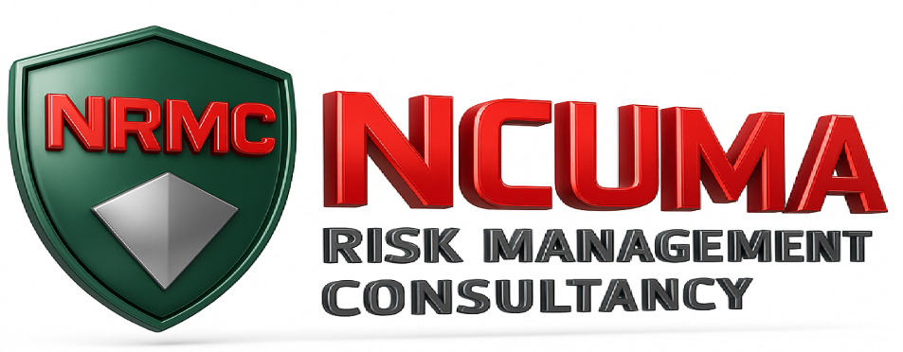
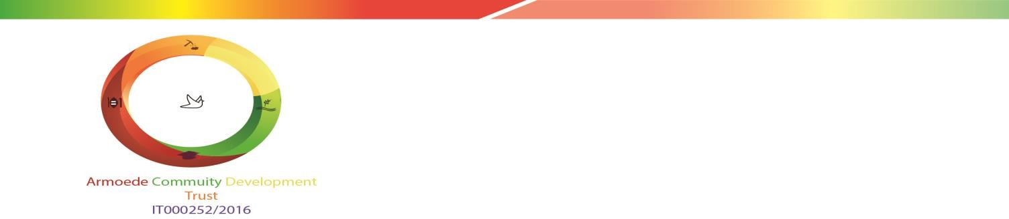

Milestone 2: Draft Disaster Risk Reduction Standard Operating Procedures

Armoede Community Development Trust

NCUMA Risk Management Consultancy

September 2026

Compiled by: |  | :

Dingaan Mahlangu

Director

Email: dingaanm@me.com

Authors:

Dingaan Mahlangu

Executive Summary
This document translates the project architecture approved in the Inception Report (NCUMA Risk Management Consultancy, 2026a) into a practical, community-level disaster risk management operating system for Ga-Sekhaolelo. It gives operational effect to the approved Disaster Risk Reduction and Resilience Implementation Plan (Armoede Community Development Trust, n.d.) through four linked procedures covering governance and interagency coordination; prevention, preparedness and early warning; emergency activation and response; and relief, recovery and Build Back Better. The 21 consolidated instruments that support these procedures are issued separately in the companion Toolkit (NCUMA Risk Management Consultancy, 2026c).
The system follows one common sequence: Trigger, Assess, Decide, Act and Escalate, Record, Close and Improve. It assigns community-level actions to ACDT structures and designated disaster wardens, and reserves command, rescue, firefighting, clinical care, law enforcement, hazardous-material response and statutory disaster-management functions for the competent authorities established under the Disaster Management Act and related legislation (South Africa, 2002; South Africa, 2005b; South Africa, 2015). Where the responsible external service is unknown or unavailable, the procedures require escalation through municipal emergency and disaster-management channels rather than unauthorised substitution by volunteers.
This is a technically reviewed draft prepared for socialisation and institutional consideration. Operational contact names, telephone numbers, route maps, assembly-point capacities, vulnerable-person support arrangements and resource quantities must be verified during socialisation before final approval (Annex B). These are controlled local configuration records, not omissions from the procedures. Until final approval, the package may be used for review and exercises but must not be represented as an approved statutory emergency plan.
This revision adds Harvard-style referencing to the legal and normative sources on which the procedures rest, removes content that was repeated between and within the two Milestone 2 documents, moves supporting records into annexes, and inserts PlantUML placeholders for six process diagrams. Every web address in the reference list was tested and found live on 19 September 2026.

Acronyms and Abbreviations
Acronym | Meaning
ACDT | Armoede Community Development Trust
DRM | Disaster Risk Management
EMS | Emergency Medical Services
NCUMA | NCUMA Risk Management Consultancy
SOP | Standard Operating Procedure

Introduction and Basis of the Procedures

Milestone 2 Deliverable Statement
Required output | Included in this package | Verification
Four technically reviewed draft SOPs | D2.1 to D2.4 | Cross-references, role boundaries, triggers, actions, escalation and close-out defined
Twenty-one consolidated toolkit instruments | D2.1.1 to D2.4.5, including six cards within D2.3.6, issued in the companion Toolkit | Toolkit Master Index and complete operational templates (NCUMA Risk Management Consultancy, 2026c)
Ready for stakeholder socialisation | Role-based fields and local verification schedule included | Local configuration and verification schedule (Annex B) and test scenarios (Annex C)
Ready for institutional consideration | Approval points and reserved decisions identified | Common control provisions (Section 1.5) and submission declaration (Annex D)

Legal and Normative Basis
Disaster management is a functional area of concurrent national and provincial legislative competence, and the Constitution requires all spheres of government and organs of state to co-operate with one another (South Africa, 1996a, s. 41 and Schedule 4, Part A). The Disaster Management Act places primary responsibility for the coordination and management of local disasters on the municipality, reserves the classification of disasters to the National Disaster Management Centre and the declaration of a local state of disaster to the municipal council, and provides for disaster management volunteers (South Africa, 2002, ss. 23, 54, 55 and 58). The 2015 amendment strengthened the duties of organs of state and municipalities for risk assessment, planning and reporting (South Africa, 2015). The National Disaster Management Framework organises these duties into four key performance areas: institutional capacity, risk assessment, risk reduction, and response and recovery (South Africa, 2005b). A reviewed framework was gazetted for comment in June 2023 (South Africa, 2023); these procedures must be rechecked against the final instrument once it is promulgated.
These procedures therefore do not create statutory powers. They organise lawful community action and its interface with the institutions that hold those powers, in keeping with the all-of-society approach of the Sendai Framework, which recognises the role of community-based organisations and volunteers and sets Build Back Better as its fourth priority (United Nations Office for Disaster Risk Reduction, 2015, paras 19(d), 32 and 36(a)). Good practice confirms that community structures reduce risk most reliably when their mandate, limits and links to formal services are explicit (International Federation of Red Cross and Red Crescent Societies, 2012; Twigg, 2015). Table 1 lists the instruments that govern each procedure.
Table 1: Legal and normative instruments applied in the procedures
Instrument | Relevance to the procedures | Applied in
Disaster Management Act, amendment and framework (South Africa, 2002; South Africa, 2005b; South Africa, 2015) | Statutory roles of municipal, district, provincial and national disaster management centres; classification and declaration; planning duties. | All procedures
Disaster Management Volunteer Regulations (South Africa, 2010) | A municipality may establish a unit of volunteers. Disaster wardens who wish to act as statutory disaster management volunteers must enrol through the municipal unit; appointment by ACDT does not confer that status. | D2.1, D2.2, D2.3
Intergovernmental Relations Framework Act and Municipal Systems Act (South Africa, 2000; South Africa, 2005a) | Co-operative government and community participation. Community structures liaise with, and do not direct, organs of state. | D2.1
Protection of Personal Information Act (South Africa, 2013) | Minimality, purpose limitation, security safeguards and special protection of health information and information about children. | All procedures; registers of people needing assistance
South African Weather Service Act (South Africa, 2001) | The Weather Service is the authoritative national source of severe weather warnings. | D2.2 early warning
Fire Brigade Services Act and National Veld and Forest Fire Act (South Africa, 1987; South Africa, 1998b) | Firefighting is a function of the designated fire service; landowner duties and fire danger ratings for veldfire. | D2.2, D2.3 (Card B)
National Health Act (South Africa, 2003) | Emergency medical services and public-health response are functions of the health authorities. | D2.3 (Cards C and D)
South African Police Service Act (South Africa, 1995) | Law enforcement, public order and missing-person investigation rest with the police. | D2.3 (Card E)
Mine Health and Safety Act and National Environmental Management Act (South Africa, 1996b; South Africa, 1998a, s. 30) | Mine emergencies are the responsibility of the mine employer and the mining inspectorate; emergency incidents affecting the environment must be reported and contained by the responsible person. | D2.3 (Card F), D2.4
Water Services Act (South Africa, 1997) | The water services authority is responsible for supply, interruption notices and emergency provision. | D2.3 (Card C)
Social Assistance Act (South Africa, 2004) | Social relief of distress is administered by the State; households are referred, not assessed for eligibility, by community structures. | D2.4
Sphere Handbook and Core Humanitarian Standard (CHS Alliance, Groupe URD and Sphere Association, 2024; Sphere Association, 2018) | Assistance on the basis of need alone; protection principles; accessible complaints and feedback; minimum standards for water, shelter and relief items. | D2.4
ISO 31000 and ISO 22320 (International Organization for Standardization, 2018a; International Organization for Standardization, 2018b) | Risk assessment, treatment, monitoring and recording; incident-management structure, roles and working together. | D2.2 and D2.3
Early-warning guidance (International Federation of Red Cross and Red Crescent Societies, 2012; United Nations General Assembly, 2016; World Meteorological Organization, 2018) | Four elements of an effective warning system: risk knowledge; monitoring and warning; dissemination and communication; and response capability. | D2.2
Build Back Better and after-action review guidance (Hallegatte, Rentschler and Walsh, 2018; United Nations Office for Disaster Risk Reduction, 2017; World Health Organization, 2019) | Recovery that reduces future risk; structured learning after incidents and exercises. | D2.4

Common Operating Sequence
Every procedure and every tool follows the same six steps (NCUMA Risk Management Consultancy, 2026a, s. 4). Figure 1 shows the sequence.
1. Trigger. Identify the trigger and open the tool named in the relevant SOP.
2. Assess. Assess immediate danger without entering an unsafe area or delaying emergency notification.
3. Decide. Refer the required decision to the authorised role.
4. Act and escalate. Take only the actions permitted for the user’s role and training; escalate specialist needs.
5. Record. Record times, sources, decisions, notifications and outstanding actions contemporaneously.
6. Close and improve. Close the record only after stand-down, handover or completion is authorised; capture lessons and corrective action.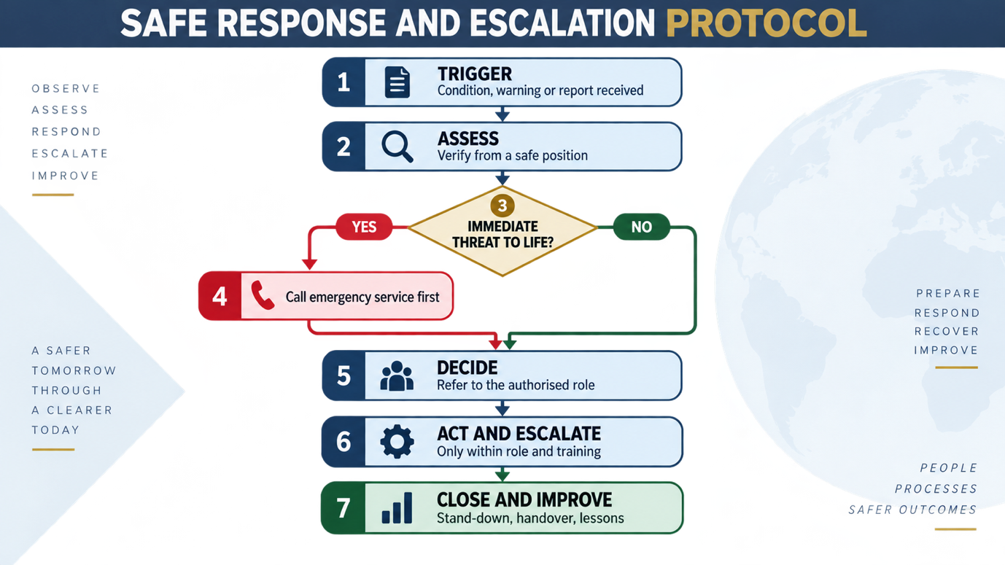
Figure 1: Common operating sequence

Non-Negotiable Safety and Authority Rules
The following rules apply to every procedure in this document and every tool in the Toolkit. They are stated once, here, and are not repeated elsewhere.
- Call the appropriate emergency service immediately where life safety is threatened; documentation must not delay notification.
- Disaster wardens do not perform technical rescue, structural firefighting, clinical treatment, law enforcement, hazardous-material handling, mine rescue, electrical isolation or traffic control beyond their lawful training and authority (South Africa, 1987; South Africa, 1995; South Africa, 1996b; South Africa, 2003).
- A community activation coordinates community support; it does not declare a disaster, commandeer resources, direct statutory responders or create legal powers (South Africa, 2002, ss. 23 and 55).
- Warnings must be traceable to an authorised or credible source. Unverified social-media content must not be rebroadcast as an official warning (South Africa, 2001; World Meteorological Organization, 2018).
- Personal information must be limited to what is necessary, kept secure, and disclosed only for a lawful operational purpose (South Africa, 2013).
- Assistance must be based on need and vulnerability and delivered impartially, safely and transparently (CHS Alliance, Groupe URD and Sphere Association, 2024; Sphere Association, 2018).

Common Control Provisions
The provisions in Table 2 apply to all four procedures. Each procedure states only its own purpose, coordinator and related tools. The document-control fields required by the Inception Report (NCUMA Risk Management Consultancy, 2026a, s. 11) are included.
Table 2: Control provisions common to D2.1 to D2.4
Control item | Requirement
Document owner | ACDT, coordinated operationally through its authorised structure
Applies to | ACDT governance structures, Monte View within its Implementing Agent mandate, designated disaster wardens and participating community structures
Authority boundary | Supports community organisation and lawful liaison. Does not replace or direct statutory disaster-management or emergency services.
Status | Draft for stakeholder socialisation and institutional consideration
Version | Draft 0.2, September 2026 (referenced and consolidated revision of Draft 0.1)
Effective date | On recorded approval by the Board of Trustees or its delegated structure
Review | Annually; after any Level 2 or Level 3 activation; after each exercise; and on any material change in law, mandate or local risk
Amendment history | Draft 0.1: technical draft. Draft 0.2: Harvard referencing added and verified; repeated content consolidated; annexes and diagram placeholders added. Later amendments are recorded through tool D2.1.4.

SOP D2.1: DRM Governance, Institutional Coordination and Interagency Liaison
Control item | Requirement
Purpose | To establish accountable DRM ownership, delegated decision rights, meeting and reporting arrangements, interagency liaison, referral, escalation and controlled recordkeeping.
Procedure coordinator | ACDT-authorised DRM focal role, supported by Monte View during the assignment
Related tools | D2.1.1–D2.1.4
Normative basis | (International Organization for Standardization, 2018b; South Africa, 2000; South Africa, 2002; South Africa, 2005a); governance arrangements in the Inception Report (NCUMA Risk Management Consultancy, 2026a, s. 6)
Common provisions | Section 1.4 (safety and authority rules) and Section 1.5 (control provisions) apply.

Purpose and Outcomes
This SOP ensures that every material DRM matter has an accountable owner, a documented decision route and a lawful external interface. Its outcome is a traceable governance system in which operational matters are resolved at the lowest competent level and reserved, high-risk or externally dependent matters are escalated promptly. This reflects the principle of action at the lowest competent level with timely escalation adopted in the Inception Report (NCUMA Risk Management Consultancy, 2026a, s. 3.2) and the requirement of ISO 22320 that roles, responsibilities and working relationships be defined before an incident (International Organization for Standardization, 2018b).

Roles and Authority
The roles below preserve the statutory position that the municipality coordinates and manages a local disaster (South Africa, 2002, s. 54). Figure 2 shows the reporting and escalation pathways.
Role | Permitted or required functions | Reserved limits
ACDT Board of Trustees | Strategic oversight; approve or direct policy, material commitments and matters reserved by ACDT governance. | Does not assume municipal or statutory emergency command.
Implementation Oversight Committee | Monitor alignment, progress, risks and implementation issues within its mandate; recommend action. | May not exceed delegated authority or instruct external statutory bodies.
Monte View as Implementing Agent | Coordinate engagements, consolidated comments, reporting and implementation interfaces for and on behalf of ACDT within mandate. | Refer reserved matters to ACDT; does not exercise emergency-service powers.
ACDT DRM focal role | Maintain controlled documents, directory, registers, readiness cycle and internal escalation; initiate routine coordination. | Material expenditure, public statements and reserved policy decisions require appropriate approval.
Lead disaster warden | Coordinate wardens, verify field information, allocate safe community support tasks and maintain logs. | No specialist response command; hand over to competent responders.
Disaster wardens | Observe, notify, warn when authorised, support accountability and community safety within training. | No rescue, firefighting, clinical, security, hazardous-material or mine-response functions.
Statutory and technical institutions | Exercise their legal mandates and provide warnings, technical direction or response. | Community structures do not direct their operations.

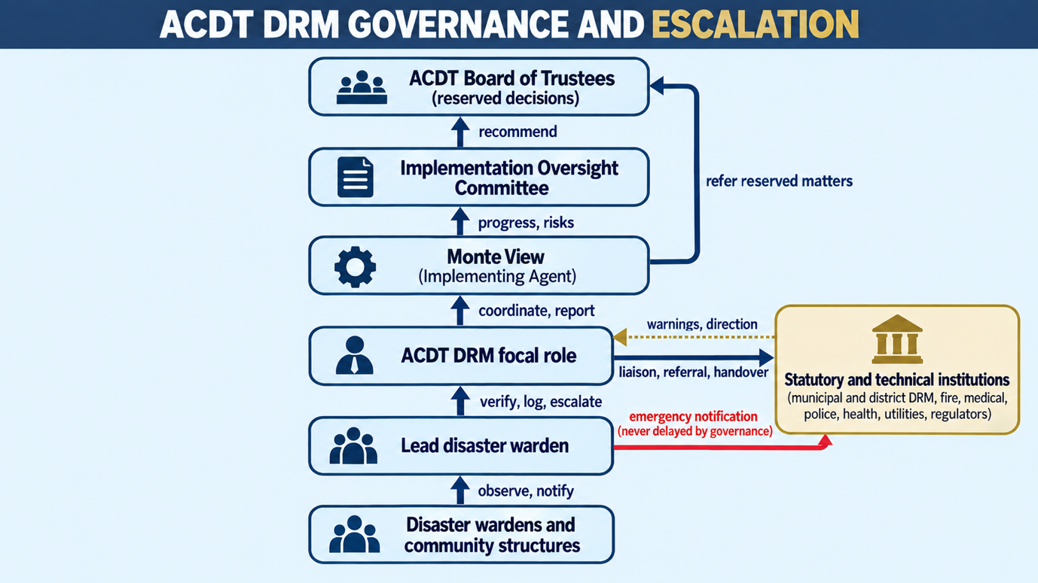
Figure 2: Governance, coordination and escalation pathways

Procedure
Step | Trigger and required action | Decision or escalation | Record
1 Receive and classify | Receive a governance, risk, incident, resource, complaint or external-interface matter. Record source, date, urgency and affected people. | Life-safety matters bypass routine governance and go directly to emergency notification under D2.3. | D2.1.3
2 Confirm ownership | Identify the accountable role using D2.1.1. Acknowledge receipt and state the next action. | If ownership is disputed or outside mandate, refer to Monte View and the authorised ACDT structure. | D2.1.3
3 Assess authority | Determine whether the action is operational, delegated, reserved, statutory or specialist. | Reserved decisions go to Board of Trustees or delegated structure; statutory matters go to the competent authority. | D2.1.1 and D2.1.3
4 Coordinate | Contact relevant internal and external role-players using verified channels. State facts, requested action, urgency and callback details. | Use alternate channel and higher-level focal point if no acknowledgement within the urgency deadline. | D2.1.2
5 Decide and act | Record decision, decision-maker, basis, conditions, responsible person and deadline. Implement within authority. | Escalate delay, refusal, dependency, resource shortfall or safety concern. | D2.1.3
6 Report and review | Provide status reporting at the agreed interval. Review open decisions and overdue actions. | Material risks or overdue high-priority actions enter governance meeting agenda. | D2.1.4
7 Close and control | Confirm action completion, notify affected parties, archive records and update controlled documents. | Unresolved systemic issues transfer to D2.4.5 corrective-action tracking. | D2.1.3 and D2.1.4

Escalation Standards
The time standards below are community service standards set by this procedure. They do not bind external institutions, whose response is governed by their own mandates.
Priority | Example | Initial escalation | Follow-up standard
Immediate | Threat to life, active fire, violence, medical emergency, hazardous release | Emergency services immediately; then lead warden and ACDT focal role. | Continue attempts and log every contact until acknowledged or handed over.
Urgent | Warning requiring community action; serious infrastructure or water disruption | Relevant authority and ACDT focal role as soon as verified. | Escalate alternate channel if no acknowledgement within 30 minutes, or sooner if conditions worsen.
High | Material risk, repeated non-compliance, significant resource gap | ACDT focal role and Monte View on the same working day. | Governance referral within 24 hours or earlier if deadline-sensitive.
Routine | Administrative update, low-risk maintenance or scheduled review | Responsible role through normal reporting. | Track to agreed due date.

Monitoring Indicators
- Verified governance and emergency directory reviewed monthly.
- All decisions and referrals have an owner, due date and closure status.
- High-priority overdue actions are reported to the appropriate governance forum.
- Controlled SOP copies and amendment histories remain current.

SOP D2.2: Risk Prevention, Mitigation, Preparedness and Early Warning
Control item | Requirement
Purpose | To identify and prioritise community risks, track mitigation, maintain seasonal readiness, verify warnings, notify the community safely, and prepare evacuation and vulnerable-person support arrangements.
Procedure coordinator | ACDT DRM focal role and lead disaster warden
Related tools | D2.2.1–D2.2.6
Normative basis | (International Federation of Red Cross and Red Crescent Societies, 2012; International Organization for Standardization, 2018a; South Africa, 2001; South Africa, 2005b; South Africa, 2013; United Nations Office for Disaster Risk Reduction, 2020; World Meteorological Organization, 2018)
Common provisions | Section 1.4 (safety and authority rules) and Section 1.5 (control provisions) apply.

Risk and Readiness Cycle
The cycle applies the risk-management process of ISO 31000, in which risks are identified, analysed, evaluated, treated, monitored and recorded (International Organization for Standardization, 2018a), to the community scale described in the second and third key performance areas of the National Disaster Management Framework (South Africa, 2005b).
Phase | Minimum action | Output
Observe | Record hazards, exposure, vulnerability, existing controls and evidence without entering unsafe locations. | D2.2.1 observation and risk record
Prioritise | Rate likelihood and consequence; identify urgent life-safety issues and responsible institutions. | D2.2.2 prioritised action
Treat | Select elimination, prevention, mitigation, preparedness, transfer or escalation action. | Assigned action, budget/dependency and due date
Prepare | Verify wardens, contacts, equipment, routes, assembly points and accessible warning methods. | D2.2.3, D2.2.4 and D2.2.6
Warn | Verify official warning, approve community message, disseminate through multiple channels and confirm reach. | D2.2.5
Review | Reassess after incidents, exercises, seasons and material changes. | Updated risk register and corrective actions

Risk Prioritisation Method
Likelihood and consequence are each rated from 1 to 5. Risk score equals likelihood × consequence. Scores guide attention but do not override professional or statutory advice. Any credible imminent threat to life is treated as immediate regardless of score.
Score | Band | Required response
1–4 | Low | Manage routinely and review at least annually.
5–9 | Moderate | Assign mitigation and monitor quarterly or before the relevant season.
10–16 | High | Prioritise action, monthly monitoring and governance reporting.
17–25 | Extreme | Immediate escalation; restrict exposure where lawful; seek competent technical or statutory intervention.

Early-Warning Procedure
A warning system is effective only when risk knowledge, monitoring and warning, dissemination and communication, and response capability all function together (United Nations General Assembly, 2016; World Meteorological Organization, 2018). At community level the decisive elements are verification of the source and reach to the last household (International Federation of Red Cross and Red Crescent Societies, 2012). Severe weather warnings are taken from the South African Weather Service or from the municipal disaster management function relaying them (South Africa, 2001). Figure 3 shows the flow.
1. Receive the warning from an identified source and preserve the original message and time received.
2. Verify the issuing authority, affected area, validity period, expected impact and recommended protective action. Cross-check with a second credible source when time permits; do not delay urgent official warnings.
3. Classify the required community action: awareness, preparedness, immediate protective action or evacuation support.
4. Obtain approval from the designated authorised role. Where delay would create danger, call emergency services and follow the pre-authorised message protocol.
5. Rewrite only for clarity and local relevance without changing technical meaning. Include source, location, hazard, timeframe, action, assistance channel and update time.
6. Disseminate through at least two suitable channels, including direct provision for people who may not receive standard digital messages.
7. Record delivery, acknowledgements, gaps, rumours and corrections. Escalate unreachable high-risk areas or persons.
8. Issue update, correction or all-clear only from an authorised source; archive the full warning trail.

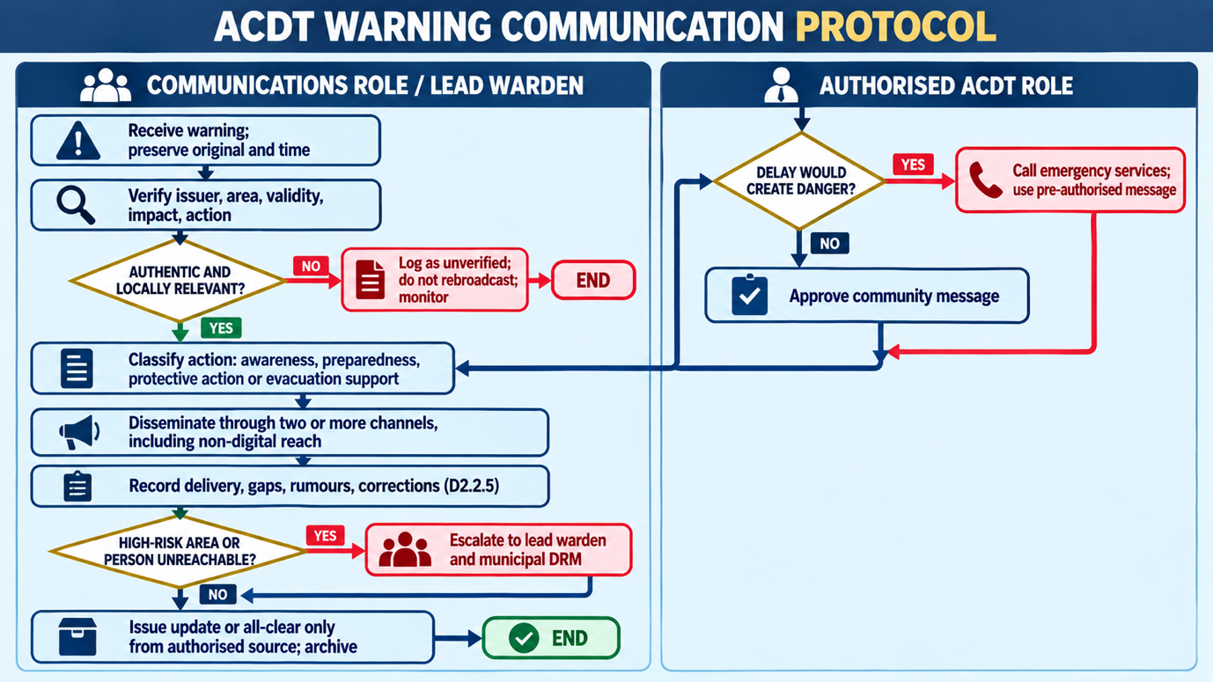
Figure 3: Early-warning verification and notification flow

Warning Quality Check
Question | Pass condition
Is it authentic? | Issuing authority or credible technical source confirmed.
Is it relevant? | Ga-Sekhaolelo or an identified local exposure is within the affected area/time.
Is it actionable? | Message states what recipients should do and avoid.
Is it accessible? | Language, channel and format account for local and higher-risk groups.
Is it traceable? | Source, approver, version, issue time and next update are recorded.
Is reach confirmed? | Channel results, acknowledgements and gaps are logged.

Preparedness Standards
The standards below follow preparedness guidance that plans, resources and procedures are reliable only when physically verified and exercised (United Nations Office for Disaster Risk Reduction, 2020).
- Routes and assembly points must be physically checked before each relevant season and after construction, flooding or access changes.
- No assembly point is approved solely by map review; safety, capacity, accessibility, lighting, sanitation, shelter, ownership and onward transport must be assessed.
- Lists of people requiring additional assistance must be voluntary, necessary, protected and reviewed sensitively (South Africa, 2013).
- Equipment is recorded as available only after physical verification, condition check, custodian confirmation and access confirmation.
- Exercises must test warning receipt, escalation, warden mobilisation, assembly-point accountability and responder handover.

SOP D2.3: Emergency Activation, Incident Coordination and Priority Hazard Response
Control item | Requirement
Purpose | To provide a safe and traceable community procedure for incident notification, verification, activation, coordination, warning, evacuation support, situation reporting, responder handover and stand-down.
Procedure coordinator | Lead disaster warden under the authorised ACDT coordination arrangement
Related tools | D2.3.1–D2.3.6
Normative basis | (International Organization for Standardization, 2018b; South Africa, 1987; South Africa, 1995; South Africa, 1996b; South Africa, 1998a; South Africa, 2002; South Africa, 2003)
Common provisions | Section 1.4 (safety and authority rules) and Section 1.5 (control provisions) apply.

Activation Levels
Activation levels describe the posture of the community team only. They are distinct from the classification of a disaster and the declaration of a state of disaster, which remain statutory decisions (South Africa, 2002, ss. 23 and 55). Figure 4 shows the permitted transitions.
Level | Condition | Community posture | Authority
Level 0 Routine | No active incident; normal monitoring. | Maintain readiness and record low-level observations. | Routine responsible roles.
Level 1 Alert | Credible concern or warning; impact uncertain or limited. | Verify, notify lead warden, increase monitoring and prepare resources. | Lead warden/ACDT focal role within approved protocol.
Level 2 Community Activation | Actual or imminent impact requiring coordinated community support. | Open incident log; allocate wardens; notify authorities; warn and support safe movement/accountability. | Authorised ACDT role; emergency notification must not wait for internal approval.
Level 3 Major Incident Support | Serious, expanding or multi-site incident; statutory coordination required. | Prioritise life safety; support official instructions; establish liaison and handover; maintain situation reports. | Competent statutory authority commands response; community team supports within capability.
Stand-down | Threat controlled, handed over or no longer requires activation. | Account for team, close tasks, preserve records, assess needs and initiate review. | Incident authority or authorised community lead after external confirmation where relevant.
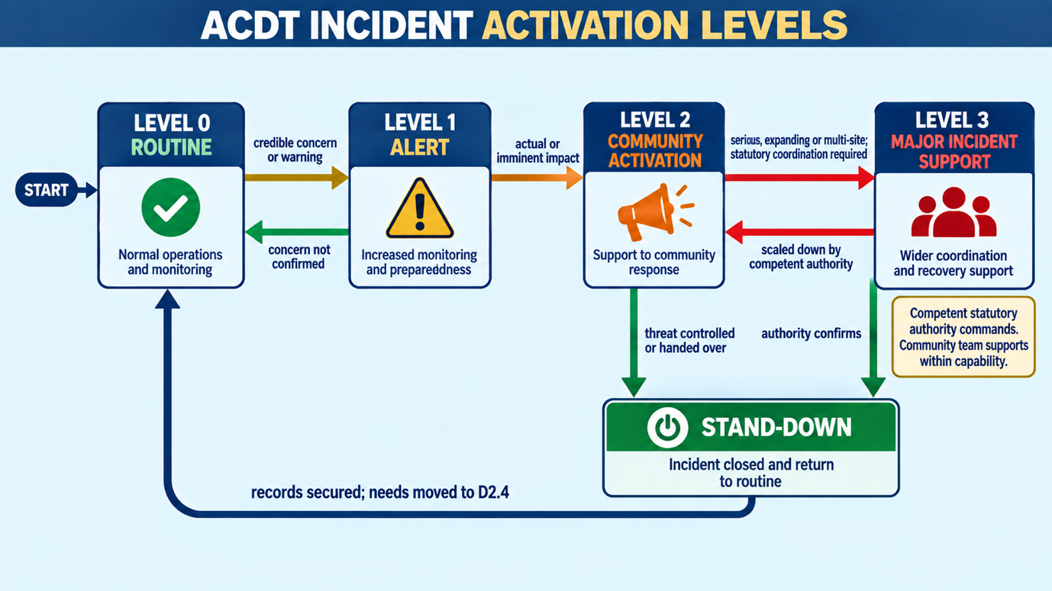
Figure 4: Community activation levels

Immediate Sequence
Time priority | Action
First actions | Move away from danger; call the competent emergency service; give exact location, hazard, people at risk and callback number.
Within minutes | Notify lead warden; verify from a safe position; open D2.3.1 and record all times.
On activation | Establish a safe coordination point; appoint logkeeper and communications liaison; allocate only safe tasks.
During operations | Maintain communications and accountability; issue verified community messages; provide situation updates; preserve access for responders.
On responder arrival | Identify yourself; provide concise handover; disclose known hazards, casualties, missing persons, actions and outstanding needs; follow official direction.
At stand-down | Confirm team safety; communicate all-clear only when authorised; secure records; initiate needs assessment and after-action review.
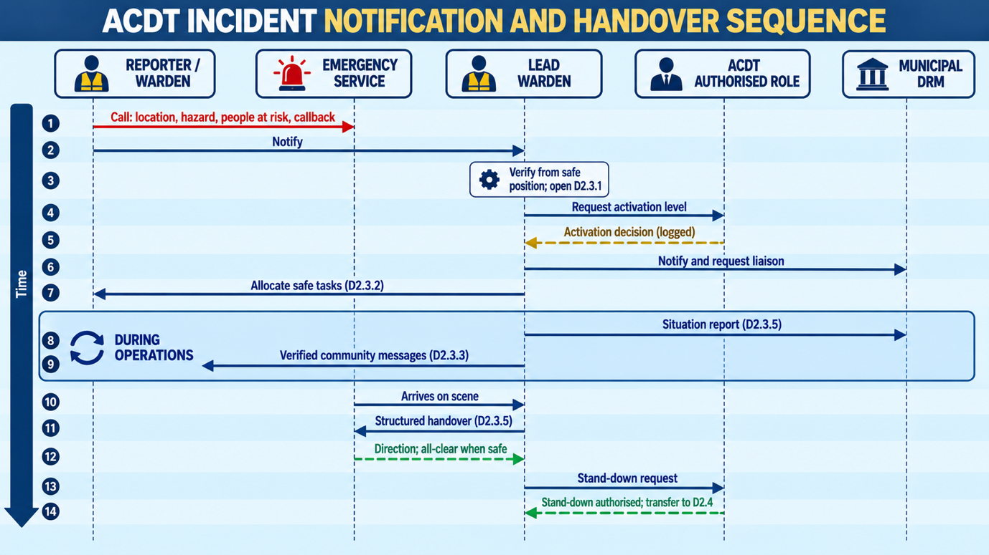
Figure 5: Immediate incident sequence and responder handover

Community Coordination Functions
The functions below adapt the incident-management components of ISO 22320 (coordination, information, communication, safety and resources) to a volunteer community team that supports, and hands over to, the competent authority (International Organization for Standardization, 2018b).
- Information: receive, verify, map and report facts, distinguishing confirmed information from reports awaiting verification.
- Liaison: maintain one recognised contact point with municipal DRM and emergency services.
- Communication: circulate approved warnings and corrections; monitor misinformation.
- Safety: keep wardens and the public outside exclusion zones; use buddy working and check-in intervals.
- Evacuation support: communicate routes, assist orderly movement within capability, support people needing assistance and account at assembly points.
- Logistics support: identify available community resources but obtain owner consent and required authorisation before use.
- Welfare: identify immediate shelter, water, sanitation, medication continuity, protection and psychosocial referral needs.

Situation Report Minimum Content
The reporting form is tool D2.3.5 in the Toolkit (NCUMA Risk Management Consultancy, 2026c). The table sets the minimum content that each report must carry.
Field | Minimum information
Incident | Reference, hazard, date/time, location and reporting period.
Current situation | What happened, verified extent, trend and access constraints.
Human impact | Deaths/injuries only if officially confirmed; missing/unaccounted; displaced; higher-risk needs.
Infrastructure and environment | Roads, electricity, water, structures, environmental or mine-related concerns.
Actions | Emergency services notified; community actions completed/in progress; warnings and evacuation status.
Needs and constraints | Immediate resource or specialist support requested; unmet needs and safety restrictions.
Outlook | Likely change, next decision point and next report time.
Approval | Prepared by, verified by and dissemination list.

Prohibited Actions
- Entering floodwater, unstable structures, fire areas, electrical hazards, violent scenes, mine workings or contaminated areas.
- Transporting seriously ill or injured persons where EMS is available unless necessary to escape immediate danger and safe to do so.
- Publishing names, images or unconfirmed casualty information.
- Collecting donations or distributing relief outside the approved accountability process.
- Declaring an evacuation, all-clear or disaster unless authorised by the competent authority or an approved local protocol.

SOP D2.4: Relief, Recovery and Build Back Better
Control item | Requirement
Purpose | To assess needs and losses, request and account for relief, plan equitable recovery, apply Build Back Better, close incidents and convert lessons into completed corrective action.
Procedure coordinator | ACDT-authorised relief and recovery focal role
Related tools | D2.4.1–D2.4.5
Normative basis | (CHS Alliance, Groupe URD and Sphere Association, 2024; Hallegatte, Rentschler and Walsh, 2018; South Africa, 2004; Sphere Association, 2018; United Nations General Assembly, 2016; United Nations Office for Disaster Risk Reduction, 2015; United Nations Office for Disaster Risk Reduction, 2017; World Health Organization, 2019)
Common provisions | Section 1.4 (safety and authority rules) and Section 1.5 (control provisions) apply.

Relief and Recovery Principles
Build Back Better means using recovery, rehabilitation and reconstruction to increase resilience by integrating risk reduction into the restoration of infrastructure, livelihoods and societal systems (United Nations General Assembly, 2016). Evidence indicates that recovery which is stronger, faster and more inclusive substantially reduces the welfare losses of future events (Hallegatte, Rentschler and Walsh, 2018). Relief is given on the basis of need alone, with accessible complaints handling (CHS Alliance, Groupe URD and Sphere Association, 2024; Sphere Association, 2018). Households that may qualify for State social relief of distress are referred to the responsible authority (South Africa, 2004).
- Life-saving and protection needs take priority.
- Eligibility and prioritisation are based on verified need and vulnerability, not affiliation or influence.
- One household or beneficiary identifier is used to reduce duplication while limiting personal data.
- All stock movements are supported by request, receipt, issue and balance records.
- Recovery decisions reduce future risk and do not restore unsafe conditions without mitigation.
- Affected people receive accessible information on available support, criteria, complaints and unresolved needs.

Procedure
Figure 6 shows the flow from stand-down to corrective action.
Step | Action | Control
1 Initiate assessment | Confirm area is safe to enter and assessment is authorised. Use D2.4.1; separate verified facts from estimates. | Do not enter unsafe structures or restricted areas.
2 Prioritise needs | Classify life-safety, protection, shelter, water, sanitation, food, health, livelihoods and service-continuity needs. | Record vulnerability and urgency; collect minimum personal information.
3 Request assistance | Aggregate verified requirements, available resources, gap, delivery point, timing and responsible contact. | Approval and external referral recorded.
4 Receive and store | Inspect quantity and condition; record donor/source, restrictions, batch or expiry where relevant, custodian and storage location. | Segregate damaged, expired or unsuitable items.
5 Distribute | Publish criteria; verify entitlement; record quantity issued; provide complaints channel; reconcile remaining stock. | No preferential or undocumented issue.
6 Plan recovery | Set recovery outcome, responsible owner, cost/dependency, risk-reduction measure and completion evidence. | Apply Build Back Better screening in D2.4.3.
7 Review and close | Complete incident review, identify lessons, assign corrective actions and report outstanding needs. | Close only with accountable approval and retained evidence.
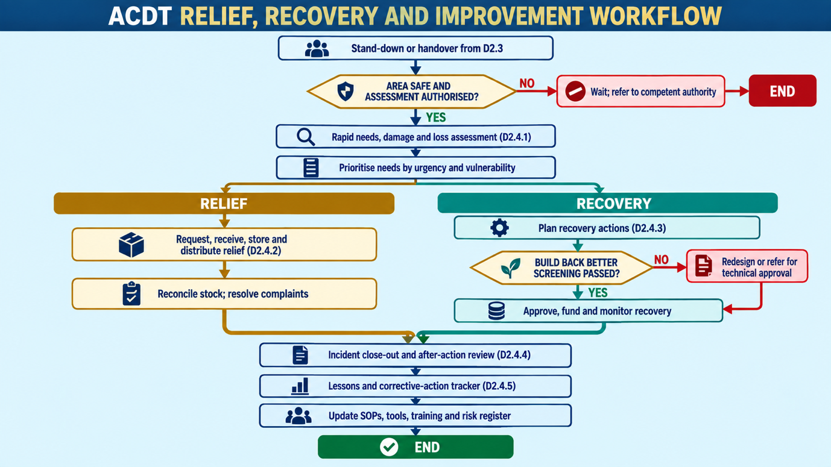
Figure 6: Relief, recovery and Build Back Better flow

Build Back Better Screening
The screening questions apply the Build Back Better guidance of the United Nations Office for Disaster Risk Reduction (United Nations Office for Disaster Risk Reduction, 2017). The completed record is kept on tool D2.4.3.
Criterion | Required question
Location | Will recovery avoid or reduce exposure to known flood, fire, environmental, geotechnical, infrastructure or mining-related hazards?
Design | Does the proposed repair or reconstruction improve safety, durability, accessibility and maintainability?
Services | Are water, sanitation, energy, access, communications and emergency access more resilient?
Livelihoods | Does recovery restore income without recreating unsafe or environmentally harmful practices?
Inclusion | Can women, children, older persons, persons with disabilities and other higher-risk groups access and use the restored service safely?
Environment | Are erosion, waste, pollution, water use and ecosystem impacts controlled?
Governance | Are approvals, ownership, maintenance responsibility, budget and monitoring clear?

Relief Accountability Standards
- Two-person verification for receipt, stock count and reconciliation where practicable.
- Daily stock balance during active distribution and written variance explanation.
- Separation, where practicable, between approval, custody and issue functions.
- Complaints may be made without losing eligibility or facing retaliation.
- Beneficiary lists and vulnerability details are not displayed publicly.
- Unmet needs remain visible until referred, resolved or formally closed with reasons.

Close-Out and Learning
Every activation at Level 2 or above, and every exercise, closes with an after-action review that compares what was expected with what happened and converts findings into owned corrective actions (World Health Organization, 2019). Tools D2.4.4 and D2.4.5 hold the record.

Reference List
Harvard style. All web addresses were tested and returned the cited source on 19 September 2026. Acts are cited as originally enacted; users must consult the current consolidated text.
Armoede Community Development Trust (n.d.) Disaster Risk Reduction and Resilience Implementation Plan. Approved plan. Unpublished; controlled copy held by NCUMA Risk Management Consultancy.
CHS Alliance, Groupe URD and Sphere Association (2024) Core Humanitarian Standard on Quality and Accountability. 2024 edn. Geneva: CHS Alliance. Available at: https://www.corehumanitarianstandard.org/the-standard (Accessed: 19 September 2026).
Hallegatte, S., Rentschler, J. and Walsh, B. (2018) Building Back Better: Achieving Resilience through Stronger, Faster, and More Inclusive Post-Disaster Reconstruction. Washington, DC: World Bank. Available at: https://openknowledge.worldbank.org/handle/10986/29867 (Accessed: 19 September 2026).
International Federation of Red Cross and Red Crescent Societies (2012) Community Early Warning Systems: Guiding Principles. Geneva: International Federation of Red Cross and Red Crescent Societies. Available at: https://www.preventionweb.net/publication/community-early-warning-systems-guiding-principles (Accessed: 19 September 2026).
International Organization for Standardization (2018a) ISO 31000:2018 Risk management: Guidelines. 2nd edn. Geneva: International Organization for Standardization. Available at: https://www.iso.org/standard/65694.html (Accessed: 19 September 2026).
International Organization for Standardization (2018b) ISO 22320:2018 Security and resilience: Emergency management: Guidelines for incident management. 2nd edn. Geneva: International Organization for Standardization. Available at: https://www.iso.org/standard/67851.html (Accessed: 19 September 2026).
NCUMA Risk Management Consultancy (2026a) Inception Report: Development and Socialisation of Disaster Risk Reduction Standard Operating Procedures. Deliverable D1, prepared for Armoede Community Development Trust. Unpublished.
NCUMA Risk Management Consultancy (2026c) Milestone 2: Disaster Risk Reduction Operational Toolkit. Draft deliverable D2, prepared for Armoede Community Development Trust. Unpublished.
South Africa (1987) Fire Brigade Services Act 99 of 1987. Pretoria: Government Printer. Available at: https://www.gov.za/node/735013 (Accessed: 19 September 2026).
South Africa (1995) South African Police Service Act 68 of 1995. Pretoria: Government Printer. Available at: https://www.gov.za/documents/south-african-police-service-act (Accessed: 19 September 2026).
South Africa (1996a) Constitution of the Republic of South Africa, 1996. Pretoria: Government Printer. Available at: https://www.gov.za/documents/constitution/constitution-republic-south-africa-1996-04-feb-1997 (Accessed: 19 September 2026).
South Africa (1996b) Mine Health and Safety Act 29 of 1996. Pretoria: Government Printer. Available at: https://www.gov.za/documents/mine-health-and-safety-act (Accessed: 19 September 2026).
South Africa (1997) Water Services Act 108 of 1997. Pretoria: Government Printer. Available at: https://www.gov.za/documents/water-services-act (Accessed: 19 September 2026).
South Africa (1998a) National Environmental Management Act 107 of 1998. Pretoria: Government Printer. Available at: https://www.gov.za/documents/national-environmental-management-act (Accessed: 19 September 2026).
South Africa (1998b) National Veld and Forest Fire Act 101 of 1998. Pretoria: Government Printer. Available at: https://www.gov.za/documents/national-veld-and-forest-act (Accessed: 19 September 2026).
South Africa (2000) Local Government: Municipal Systems Act 32 of 2000. Pretoria: Government Printer. Available at: https://www.gov.za/documents/local-government-municipal-systems-act (Accessed: 19 September 2026).
South Africa (2001) South African Weather Service Act 8 of 2001. Pretoria: Government Printer. Available at: https://www.gov.za/documents/south-african-weather-service-act (Accessed: 19 September 2026).
South Africa (2002) Disaster Management Act 57 of 2002. Pretoria: Government Printer. Available at: https://www.gov.za/documents/disaster-management-act (Accessed: 19 September 2026).
South Africa (2003) National Health Act 61 of 2003. Pretoria: Government Printer. Available at: https://www.gov.za/documents/acts/national-health-act-61-2003-23-jul-2004 (Accessed: 19 September 2026).
South Africa (2004) Social Assistance Act 13 of 2004. Pretoria: Government Printer. Available at: https://www.gov.za/documents/social-assistance-act (Accessed: 19 September 2026).
South Africa (2005a) Intergovernmental Relations Framework Act 13 of 2005. Pretoria: Government Printer. Available at: https://www.gov.za/documents/intergovernmental-relations-framework-act (Accessed: 19 September 2026).
South Africa (2005b) National Disaster Management Framework. Government Notice 654, Government Gazette 27534, 29 April. Pretoria: Government Printer. Available at: https://www.preventionweb.net/publication/south-africa-national-disaster-management-framework-2005 (Accessed: 19 September 2026).
South Africa (2010) Disaster Management Act, 2002: Disaster Management Volunteer Regulations. Government Notice R.1215, Government Gazette 33882, 17 December. Pretoria: Government Printer. Available at: https://www.gov.za/documents/notices/disaster-management-act-regulations-volunteers-17-dec-2010 (Accessed: 19 September 2026).
South Africa (2013) Protection of Personal Information Act 4 of 2013. Pretoria: Government Printer. Available at: https://www.gov.za/documents/protection-personal-information-act (Accessed: 19 September 2026).
South Africa (2015) Disaster Management Amendment Act 16 of 2015. Pretoria: Government Printer. Available at: https://www.gov.za/documents/disaster-management-amendment-act-16-2015-15-dec-2015-0000 (Accessed: 19 September 2026).
South Africa (2023) National Disaster Management Framework 2023: Reviewed Copy 1. Government Notice 3635, Government Gazette 48874, 30 June. Pretoria: Government Printer. Available at: https://www.gov.za/sites/default/files/gcis_document/202307/48874gon3635.pdf (Accessed: 19 September 2026).
Sphere Association (2018) The Sphere Handbook: Humanitarian Charter and Minimum Standards in Humanitarian Response. 4th edn. Geneva: Sphere Association. Available at: https://spherestandards.org/handbook (Accessed: 19 September 2026).
Twigg, J. (2015) Disaster Risk Reduction. Good Practice Review 9. New edn. London: Humanitarian Practice Network, Overseas Development Institute. Available at: https://odihpn.org/en/publication/disaster-risk-reduction/ (Accessed: 19 September 2026).
United Nations General Assembly (2016) Report of the Open-ended Intergovernmental Expert Working Group on Indicators and Terminology Relating to Disaster Risk Reduction. A/71/644. New York: United Nations. Available at: https://www.undrr.org/publication/report-open-ended-intergovernmental-expert-working-group-indicators-and-terminology (Accessed: 19 September 2026).
United Nations Office for Disaster Risk Reduction (2015) Sendai Framework for Disaster Risk Reduction 2015-2030. Geneva: United Nations Office for Disaster Risk Reduction. Available at: https://www.undrr.org/publication/sendai-framework-disaster-risk-reduction-2015-2030 (Accessed: 19 September 2026).
United Nations Office for Disaster Risk Reduction (2017) Words into Action Guidelines: Build Back Better in Recovery, Rehabilitation and Reconstruction. Consultative version. Geneva: United Nations Office for Disaster Risk Reduction. Available at: https://www.undrr.org/publication/words-action-guidelines-build-back-better-recovery-rehabilitation-and-reconstruction (Accessed: 19 September 2026).
United Nations Office for Disaster Risk Reduction (2020) Words into Action Guidelines: Enhancing Disaster Preparedness for Effective Response. Geneva: United Nations Office for Disaster Risk Reduction. Available at: https://www.undrr.org/enhancing-disaster-preparedness-effective-response (Accessed: 19 September 2026).
World Health Organization (2019) Guidance for After Action Review (AAR). WHO/WHE/CPI/2019.4. Geneva: World Health Organization. Available at: https://www.who.int/publications/i/item/WHO-WHE-CPI-2019.4 (Accessed: 19 September 2026).
World Meteorological Organization (2018) Multi-hazard Early Warning Systems: A Checklist. Geneva: World Meteorological Organization. Available at: https://library.wmo.int/records/item/55893-multi-hazard-early-warning-systems-a-checklist (Accessed: 19 September 2026).

Annex A: Technical Quality Assurance Record
This annex records the internal completeness review required by the Inception Report (NCUMA Risk Management Consultancy, 2026a, s. 5.1, Gate 2). It applies to both Milestone 2 documents and is held here only.
Quality criterion | Result | Evidence in package
Four integrated SOPs completed | Pass | D2.1–D2.4
Twenty-one consolidated tools completed | Pass | D2.1.1 to D2.4.5 in the Toolkit; six hazard cards contained within D2.3.6
Common operating sequence applied | Pass | Trigger, assessment, decision, action/escalation, record and close-out across all SOPs
Role and authority limits explicit | Pass | Roles table (Section 2.2), control tables and Section 1.4
Safety and safeguarding integrated | Pass | Prohibited actions, privacy, inclusion, volunteer safety and relief controls
Cross-references and handoffs defined | Pass | Tool index, SOP steps and D2.3-to-D2.4 transition
Document control included | Pass | Section 1.5 and tool D2.1.4
Sources referenced and verified | Pass | Harvard reference lists in both documents; every web address tested live on 19 September 2026
Repeated content removed | Pass | Shared material held once; records moved to Annexes A to D; cross-references used in the Toolkit
Diagrams | Placeholder | Six PlantUML placeholders in this document and four in the Toolkit; all source compiled without error
Local operational configuration verified | Pending stakeholder verification | Contacts, named delegates, route maps, assembly points, resources and local support arrangements

Annex B: Local Configuration and Verification Schedule
The items below are controlled local records that must be confirmed before final issue.
Item requiring confirmation | Why required | Verification owner/forum | Finalisation evidence
Named ACDT decision-makers and delegations | Enables timely approval without exceeding mandate. | ACDT/Monte View governance review | Signed D2.1.1 delegation record.
Municipal, district and emergency contacts | Enables reliable notification and escalation. | Stakeholder socialisation with relevant institutions | Tested D2.1.2 directory.
Disaster warden roster and coverage areas | Enables mobilisation and accountability. | Community/warden verification | Completed D2.2.4 register.
Priority local risks and mapped hotspots | Aligns procedures with actual exposure. | Community and technical stakeholder review | Updated D2.2.1 risk register/map reference.
Routes and assembly points | Prevents directing people into unsafe or inaccessible locations. | Community walk-through and competent stakeholder input | Signed D2.2.6 verification.
Higher-risk support arrangements | Supports inclusive warnings and evacuation. | Voluntary, protected community verification | Restricted assistance register and consent review.
Resources, custodians and access | Avoids reliance on unavailable or unusable items. | Physical inspection | D2.2.4 resource register.
Relief criteria, storage and complaints channel | Supports accountable and impartial assistance. | ACDT governance and stakeholder review | Approved D2.4.2 configuration.
Document owner, effective date and review date | Establishes controlled issue. | Board/delegated approval | Final approval record and controlled version.

Annex C: Recommended Socialisation Test Scenarios
The scenarios reflect the priority hazards identified for Ga-Sekhaolelo in the Inception Report (NCUMA Risk Management Consultancy, 2026a, s. 1).
Scenario | Interfaces to test | Primary records
Flash flooding following intense rainfall | Warning verification, route safety, evacuation support, accountability and municipal handover. | D2.2.5, D2.3.1, D2.3.4, D2.3.5
Veld fire threatening homes and electricity infrastructure | Fire-service notification, exclusion, public message, warden safety and responder access. | D2.3.1–D2.3.3 and D2.3.6B
Extended water interruption during extreme heat | Service-provider verification, higher-risk outreach, relief request and accountable water distribution. | D2.2.5, D2.2.6, D2.4.1, D2.4.2
Mine-related environmental concern affecting community water | Safe observation, operator/regulator referral, public-health interface and recovery monitoring. | D2.1.2, D2.2.1, D2.3.6F, D2.4.3

Annex D: Milestone 2 Submission Declaration
NCUMA Risk Management Consultancy submits this document and the companion Toolkit (NCUMA Risk Management Consultancy, 2026c) as Milestone 2 under the accepted Inception Report architecture (NCUMA Risk Management Consultancy, 2026a, s. 10.2). Together they contain four technically reviewed draft SOPs and 21 consolidated toolkit instruments for stakeholder socialisation and institutional consideration. Final controlled issue will follow disposition of material stakeholder comments, Board or delegated governance direction, completion of local configuration verification and the final technical quality check.
Role | Name | Signature | Date and time
Prepared by
Reviewed or authorised by

