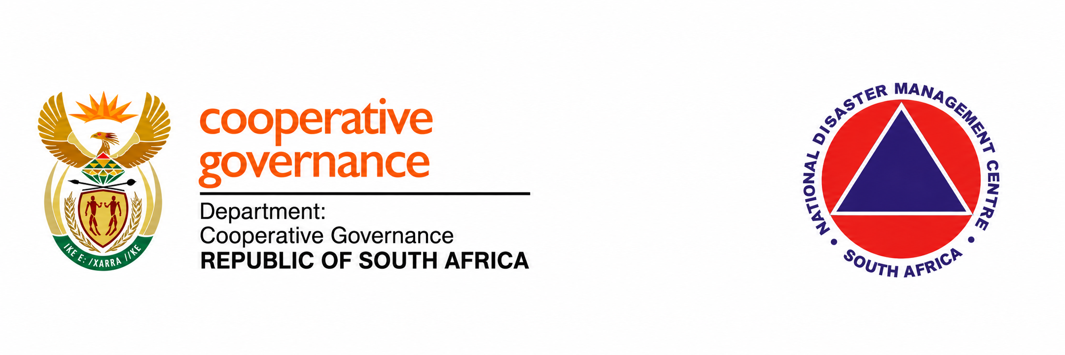
NATIONAL DISASTER MANAGEMENT CENTRE
Department of Cooperative Governance
MONTHLY WORKPLAN
Sub-stream: Build Back Better (BBB)
Workplan Period: 13 October 2026 to 31 October 2026
Prepared by: Eng. Dingaan Mahlangu
Disaster Management Results Management Office Stream

1. Executive Summary
Refine BBB standards, municipal tools, environmental protections and community readiness inputs during 13–31 October. These outputs are anticipated, subject to data, stakeholder participation and approvals.

2. Objectives for the Period
Convert technical and strategic inputs into reviewed municipal and community tools.

3. Summary of Performance Targets
KRA 1: standards and preliminary site sheets. KRA 2: environmental and public health inputs. KRAs 3–4: readiness, coordination and evidence reporting.
Actual: 0 hours; Estimated: 0 hours; Scheduled: 0 hours; Anticipated: 72 hours. Actual hours exclude estimates, scheduled durations and anticipated work.
October: 24 estimated retrospective hours plus 72 anticipated hours. The 96-hour ceiling is provisional. September scheduled hours are separate. The source report includes 24 hours for strategic report consolidation without a verified basis; this example classifies them as Estimated pending verification.
Previous contract ended 3 September; renewal took effect 5 October. Gap: 4 September to 4 October. September contributions are included for continuity and do not establish approved billable hours.

4. Summary of Expected Outputs
1. Standards and compliance pack — Planned. Evidence reference not entered.
2. Environmental protection inputs — Planned. Evidence reference not entered.
3. Readiness and integration tools — Planned. Evidence reference not entered.
4. Reviewed package and monthly report — Planned. Evidence reference not entered.

5. Detailed Planned Activities

5.1 Infrastructure Standards and Pilot Preparation
Dates: 2026-10-13 to 2026-10-20 | KRA: KRA 1
Hours: 20 (anticipated) | Status: Planned
Owner: Eng. Dingaan Mahlangu
Output: Standards and compliance pack
Purpose: Refine hazard-resistant design and checks.
Strategy and APP alignment: KRA 1: resilient infrastructure and settlement access.
Dependencies: Data, stakeholder availability and required approvals.
Activity detail: Anticipated: refine infrastructure standards and compliance checks, consult relevant technical bodies and prepare three preliminary site design sheets and pilot briefs. Ethekwini Metro is the next pilot area to be visited pending approval.

5.2 Environmental and Public Health Inputs
Dates: 2026-10-15 to 2026-10-16 | KRA: KRA 2
Hours: 12 (anticipated) | Status: Planned
Owner: Eng. Dingaan Mahlangu
Output: Environmental protection inputs
Purpose: Prepare wastewater, waste and monitoring tools.
Strategy and APP alignment: KRA 2: environmental/public health risk reduction.
Dependencies: Data, stakeholder availability and required approvals.
Activity detail: Anticipated: prepare wastewater, solid-waste, drainage and air/water monitoring requirements, including O&M and scorecard inputs for marginalized areas. The pilot area has not been identified but we would use the Setswetla as a pilot already visited that has a lot of sewer issues and waste management difficulties.

5.3 Community Readiness and Inter-stream Integration
Dates: 2026-10-21 to 2026-10-26 | KRA: KRAs 3–4
Hours: 24 (anticipated) | Status: Planned
Owner: Eng. Dingaan Mahlangu
Output: Readiness and integration tools
Purpose: Prepare community guidance and SEMS/CSIR inputs.
Strategy and APP alignment: KRAs 3–4: evacuation, warnings and technical coordination.
Dependencies: Data, stakeholder availability and required approvals.
Activity detail: Anticipated: develop household securing guidance and evacuation tools, obtain community feedback, consolidate CSIR requirements and coordinate engineering, planning and health inputs with SEMS/ICS, Fire Services, Logistics/BCM and NGO streams. A meeting with Ms. D Kunene and Dr. Duze is anticipated once dates have been confirmed to discuss the approach to tackle this item.

5.4 Package Review and Month-end Reporting
Dates: 2026-10-27 to 2026-10-31 | KRA: KRAs 1–4
Hours: 16 (anticipated) | Status: Planned
Owner: Eng. Dingaan Mahlangu
Output: Reviewed package and monthly report
Purpose: Consolidate evidence and November priorities.
Strategy and APP alignment: KRAs 1–4: performance review and follow-up.
Dependencies: Data, stakeholder availability and required approvals.
Activity detail: Anticipated: consolidate technical feedback, update the BBB indicator/evidence pack, report progress and actual task hours, and prepare November priorities. Working-day close-out is planned for 29–30 October; the reporting position extends to 31 October.

6. Cross Stream Integration
The Limpopo findings connect BBB recovery planning with SEMS command and reporting arrangements, Fire Services capability, logistics, continuity and civil-society participation. Musina/Beitbridge requires corridor and cross-border coordination; Fetakgomo-Tubatse/Sekhukhune requires adaptation to rural, mining and industrial risks.
The CSIR PSA brief provides a proposed technical interface for damage assessment, GIS and recovery prioritisation alongside climate, logistics/command and wildfire intelligence. NDMC retains operational decisions and acceptance authority.

7. Dependencies and Delivery Risks
Site and data selection, stakeholder availability, technical review, pilot approval and CSIR cost requirements remain to be confirmed.

8. Deliverables Against the Workplan
Output | Purpose | Contribution to DM RMO Strategy and Matrix and NDMC APP Targets | Relevant PoE and status
Standards and compliance pack | Refine hazard-resistant design and checks. | KRA 1  KRA 1: resilient infrastructure and settlement access. | Planned  Evidence not entered  20 hours (anticipated)
Environmental protection inputs | Prepare wastewater, waste and monitoring tools. | KRA 2  KRA 2: environmental/public health risk reduction. | Planned  Evidence not entered  12 hours (anticipated)
Readiness and integration tools | Prepare community guidance and SEMS/CSIR inputs. | KRAs 3–4  KRAs 3–4: evacuation, warnings and technical coordination. | Planned  Evidence not entered  24 hours (anticipated)
Reviewed package and monthly report | Consolidate evidence and November priorities. | KRAs 1–4  KRAs 1–4: performance review and follow-up. | Planned  Evidence not entered  16 hours (anticipated)

9. Conclusion
Complete reviewed outputs and compile evidence for month-end reporting and November planning.

10. Workplan Review and Sign Off
This workplan records intended activities for the Build Back Better (BBB) sub-stream for 13 October 2026 to 31 October 2026. Hours are planning allocations subject to review and approval.
Signature __________________
Name: Eng. Dingaan Mahlangu
Date: 2026-10-13

ANNEXURES
A1. Limpopo Strategic Visit Report prepared jointly by Mr. Dingaan Mahlangu and Mr Thinus Pretorius (field period 15–18 September 2026).
A2. NDMC CSIR PSA Enhancement Brief, Mahlangu, Abdoola and Mkhonza, dated 23 September 2026.
A3. Build Back Better Monthly Workplan October 2026, dated 9 October 2026.
A4. BBB September October Progress and Workplan presentation, prepared 12 October 2026.
A5. September PoE workbook containing accepted invitations dated 21, 22 and 23 September.
A6. Timesheet RMO September 2026 Dingaan and September PoE supplied on 13 October. The timesheet covers 21 August–20 September and records 68 hours.

