REGIONAL DISASTER RISK MANAGEMENT INNOVATION PROGRAMME
Final Programme Document
Ten innovations for the Southern African Development Community: why they were chosen, what they cost, what they return, and how they will be delivered over five years
Field | Detail
Prepared for | Southern African Development Community Secretariat, Disaster Risk Reduction Unit, and the International Federation of Red Cross and Red Crescent Societies
Contract | Service contract CLMX055740, Deliverable 5 (Final Programme and Summary Brief). The approved Inception Report of 5 May 2026 refers to this document as D6; the contract numbering governs payment and is used throughout
Prepared by | Academy of Resilience and Continuity
Built on | The Innovation Landscape Assessment (Deliverable 2), the Draft Programme and Annexes (Deliverable 3), the cost estimation matrix (Annex R.1), and the programme data pack
Horizon | Five years from endorsement, in three phases
Status | Final, subject to verification by the Secretariat and the International Federation

Short forms used in this document. To keep the text readable, three names are shortened after first use: the Southern African Development Community becomes "the Community"; its Humanitarian and Emergency Operations Centre becomes "the Operations Centre"; the International Federation of Red Cross and Red Crescent Societies becomes "the International Federation". No other abbreviations are used.

Contents
1. Summary 4
2. Why this Programme is worth funding 4
2.1 What the Innovation Landscape Assessment found 4
2.2 What the Draft Programme diagnosed 5
2.3 Why this makes the Programme fundable 5
3. Objectives, streams and structure 5
3.1 Objectives and result areas 5
3.2 The six innovation streams and the five pillars 6
3.3 The five pillars 6
3.4 Governance 6
4. How the ten were chosen 7
4.1 What the ten cover 7
5. The ten innovations 8
6. Theory of change 9
6.1 The four pathways 9
6.2 The assumptions that carry the most weight 9
7. Cost-benefit analysis 10
7.1 Cost 10
7.2 Benefit 11
8. Feasibility 11
8.1 The mandate test 12
9. Gender equality and social inclusion across the ten 12
9.1 The cross-cutting method 13
9.2 What the Programme will do about the absences 13
10. Comparative implementation plan across the five pillars 13
11. Programme implementation matrix 15
12. What the Programme will produce 17
12.1 How the outputs will be measured 17
13. Monitoring and evaluation 17
13.1 The principle every indicator satisfies 17
13.2 What is monitored, by whom, and how often 18
13.3 The reporting line 18
13.4 Evaluation 18
13.5 The learning loop 18
14. Risk analysis 18
14.1 The scale 19
14.2 The register 19
15. What the Programme means for the region and the Operations Centre 20
15.1 For the Community 20
15.2 How the Programme enables the Operations Centre to deliver its mandate 20
16.1 What the platform holds 21
16.2 How it is used after this contract 21
17. Enabling strategies 22
17.1 Governance and institutional framework 22
17.2 Funding and sustainability 22
17.3 Capacity building and training 22
17.4 Innovation sourcing and partnerships 23
17.5 Legal and ethical considerations 23
18. Verification against the contract and the Inception Report 24
18.1 The ten components the contract requires of a programme document 25
19. What remains to be settled 25

1. Summary
The Southern African Development Community does not lack disaster risk management innovation. Thirty-four distinct innovations are operating or piloted across the region. What the region lacks is the set of arrangements that lets those innovations work together: the authority to issue a warning, the money that moves before a disaster rather than after it, the channel that carries a warning to a household in its own language, and the record that lets one country copy what works in another.
This Programme selects ten of the thirty-four and builds a five-year delivery plan around them. The ten were not chosen as the ten highest scorers. They were chosen as the smallest set that closes every break in the regional system. Together they cover all five pillars of the Programme, all five links in the chain from warning to action, and all five points at which the regional architecture currently fails. They close eleven of the sixteen missing functions the assessment identified; the Programme’s own instruments close three more.
Half of the ten are arrangements between organisations rather than purchases of equipment. That is deliberate and it is the Programme’s central finding. Arrangements are the cheapest instruments in the portfolio to establish and to run, and they reach the most households, yet they go unfinanced because there is nothing to buy. Establishing all ten in one Member State costs an indicative USD 2.8 to 7.2 million, with running costs of USD 0.7 to 1.7 million a year thereafter — roughly a quarter of the set-up cost, every year, indefinitely.
The Programme is an enabler of the Operations Centre rather than a transfer of anything to it. Ownership stays with the Disaster Risk Reduction Unit; what the Operations Centre gains is the means to deliver a mandate it already holds. None of the ten is a rebuilding instrument, so none falls outside what the Operations Centre may lead. What it gains is the means to hold the region’s record of what works: holding the activation and delivery data of all ten, supplying protocols to Member States that adopt them, and coordinating the two that cross borders.
The Programme is built on a data pack of forty-eight structured tables and nine document templates, with code that populates each template from the data. That platform continues to produce funding proposals after this contract ends: every new innovation added to the record can be profiled, costed and drafted into a concept note for a named financing window without starting from blank paper.

2. Why this Programme is worth funding
The case rests on two bodies of work completed under this contract, each built on evidence rather than assertion.

2.1 What the Innovation Landscape Assessment found
Evidence stream | What it produced
Desk review | The regional and international literature on thirty-four innovations across the five pillars
Key informant interviews | Twenty-one interviews across eight Member States and the regional level, coded into 401 segments
Country survey | Eight responses across seven Member States, recording lead institutions, beneficiaries, barriers and financing
Triangulation | Each finding tested across the three streams and graded by how many independently support it
Reach | Twelve of the sixteen Member States represented in at least one stream

Three findings from the assessment shape everything in this Programme. Innovation inside each pillar is comparatively healthy; the failures sit between the pillars. Twelve of the thirty-four innovations are technology, thirteen are arrangements between organisations, and nine are part of each, so a financing instrument designed around buying things reaches fewer than a third of the portfolio. And inclusion is uneven: of thirty innovations for which an inclusion determination could be extracted from the interview coding, not one records any provision for migrants and displaced people.

2.2 What the Draft Programme diagnosed
The Draft Programme turned the landscape into a diagnosis. Sixteen functions exist that no institution in the region reliably performs. Ten of the sixteen are about authority, agreement and accountability; three concern money and two concern reach. None is solved by acquiring a technology the region does not have.
Those sixteen gaps arise from eight root causes. Three are structural and respond only to a change in law, mandate or budget: authority that exists in principle with no instrument to exercise it, running costs that nobody owns, and the asymmetry between sovereign Member States and a regional body. Two are coordination failures: nothing obliges anyone to document what works, and innovations are designed without deciding who they are for. The remaining three sit in the wider financing ecosystem and in where capability is concentrated.
The gaps cluster at five points where the regional system breaks — where risk information must become authority to act, where authority must release money, where money must reach a household, where delivery must become learning, and where anyone checks that a warning produced an action. The Draft Programme mapped forty-eight links between gaps and the innovations that could close them, and set an eight-criterion instrument for choosing among them.

2.3 Why this makes the Programme fundable
A financier asks three questions: is the problem real, does the proposed answer address its cause, and will it last. The assessment answers the first with triangulated evidence from three streams. The diagnosis answers the second, because each of the ten is placed against a named gap and a named root cause rather than against a general need. The third is answered by the cost matrix, which shows for the first time what each innovation costs to keep running, and by the requirement that no proposition goes to a financier without a named person accountable for that running cost.

3. Objectives, streams and structure
The Programme has three layers. The first is the portfolio: the ten innovations and the five pillars they are delivered through. The second is governance: who owns the Programme, who operates it, and who decides. The third is the platform that holds the evidence and produces the documents.

3.1 Objectives and result areas
The Programme pursues five objectives. Each is traced to a function the assessment found missing, not to a policy aspiration: an objective that closes no stated gap does not appear.
 | Objective | What it closes
1 | Close the institutional joints | The arrangements on which four of the five breaks depend: who may warn, who governs a register, who turns a payout into a delivery instruction, who may share data across a border
2 | Make working innovations fundable | The inability to convert an operating instrument into a proposition a financier can act on, which the evidence identifies as the binding constraint on raising money
3 | Reach the two-thirds the market does not | The systematic under-financing of arrangements and hybrids, which no capital-expenditure instrument reaches
4 | Make warnings produce action | The distance between a technically correct warning and an observed protective action, which is a failure of language, trust and channel
5 | Record what works | The absence of any documentation obligation, without which operating instruments stay unrepeatable and invisible to the region

The result areas are the four outcomes the Programme measures itself against: risk information that is authoritative and acted upon; communities that receive and act on warnings in a language and channel they trust; financing that is pre-arranged and reaches households through a named delivery partner; and what operates being documented, replicated and institutionalised. Section 13 sets out how each is measured.

3.2 The six innovation streams and the five pillars
The Programme delivers through six innovation streams and appraises through five analytical pillars. Both are retained and they answer different questions. The streams are the delivery architecture: what the Programme does. The pillars are the analytical architecture through which the evidence was gathered and the portfolio scored. The crosswalk below lets a reader move between them without re-deriving either.
Stream | What it covers | Analytical pillar
1 | Early warning, anticipatory action and climate information services | Pillar 1, with financing elements in Pillar 4
2 | Digital transformation, data systems and geospatial intelligence | Pillar 1
3 | Community-centred and social innovations | Pillar 2
4 | Resilient infrastructure, nature-based solutions and climate-smart technologies | Pillars 1 and 2
5 | Institutional, governance and policy innovations | Pillar 3
6 | Disaster risk financing, insurance and sustainable funding mechanisms | Pillar 4

Pillar 5, knowledge management and replication, is cross-cutting: it carries the documentation obligation that every stream reports into rather than holding instruments of its own beyond the reporting protocol.

3.3 The five pillars
Pillar | What it covers | Innovations from the ten
1. Risk data, early warning and anticipatory action | Forecasting, warning dissemination and the triggers for early action | Cell broadcasting with local-language voice; impact-based forecasting; drone-based rapid mapping
2. Community-centred and inclusive disaster risk management | Community structures, indigenous knowledge and reach to excluded groups | Community-based evacuation centres; community early warning with indigenous knowledge; the Red Rose cash and voucher platform
3. Governance, coordination and institutional innovation | Authority, mandate and the arrangements between institutions | Traditional-authority engagement in warning dissemination
4. Innovation financing, partnerships and scaling | Money that moves before a disaster, and partnerships to sustain it | Community early action protocols; the World Food Programme anticipatory action portfolio
5. Knowledge management, learning and regional replication | Documentation, learning and replication across Member States | The weekly community early warning reporting protocol, Democratic Republic of the Congo

3.4 Governance
The Programme is owned by the Disaster Risk Reduction Unit of the Community’s Secretariat. The Unit is its custodian and its accountable owner: it holds the portfolio, chairs the Programme Board, approves what enters and leaves, and answers for the Programme to the Council and the Ministerial Committee. It works with the Climate Services Centre and other relevant units of the Secretariat. The Humanitarian and Emergency Operations Centre does not own the Programme and is not asked to. It is the Community’s operational arm for activation, regional coordination, partner mobilisation and support to Member States, and the Programme exists in part to equip it to deliver that mandate. The distinction is deliberate: ownership carries the portfolio and the accountability, and the Operations Centre carries the operations. A Programme Board takes portfolio decisions and keeps the custody of running costs as a standing item. Member State disaster management authorities operate the innovations and hold the two facts no regional body can supply: the national law under which each operates, and the post accountable for its running cost.
Figure 1 — Programme structure
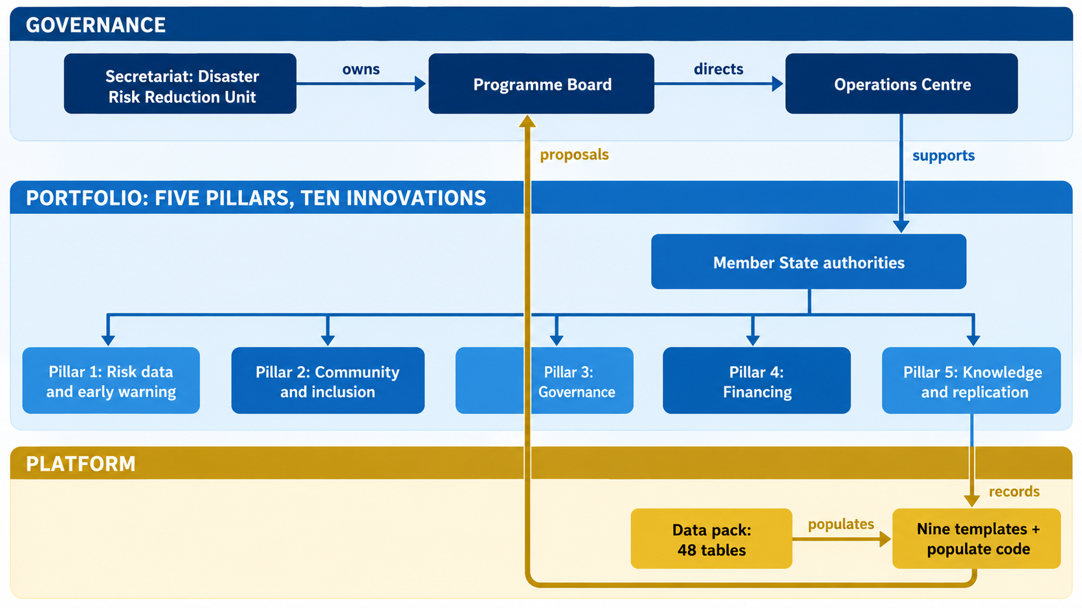

4. How the ten were chosen
The Draft Programme’s prioritisation instrument ranks innovations one at a time on eight criteria. A ranking alone produces a poor portfolio, because it cannot see what two innovations do to each other. The top of the ranking is crowded with warning and early-action instruments, and a set drawn straight from it would fund three versions of the same function while leaving governance and learning empty. The ten were therefore chosen by applying four tests to the ranked list.
Test | How it shaped the ten
Remove duplicates of the same function | Cell broadcasting, short message alerts and ring-back tone warnings all carry a warning to a handset. Cell broadcasting with local-language voice was kept as the strongest of the group; the other two are delivered through it rather than alongside it
Exclude what the Programme does not implement | The United Nations Central Emergency Response Fund anticipatory window is externally capitalised and governed. It is a financing source for the ten, not one of them
Treat umbrellas as frames, not items | Early Warnings for All is the global initiative into which impact-based forecasting and cell broadcasting both feed. It is the frame the Programme works within, not a separate innovation
Cover every pillar and every break | Traditional-authority engagement and the weekly reporting protocol rank lower on the index but are the only strong instruments in Pillars 3 and 5. Drone-based rapid mapping is included as the region’s one sovereign-scale technology comparator

4.1 What the ten cover
Dimension | Coverage by the ten
Five pillars | All five
Five links from warning to action | All five: producing the trigger (forecasting, mapping), authorising the decision (cell broadcasting, traditional authority), releasing funds (the two early-action instruments), delivery to the household (evacuation centres, community early warning, cash and voucher), and learning (weekly reporting)
Five breaks in the regional system | All five
Sixteen missing functions | Eleven closed directly. The Programme’s own instruments close three more: its platform converts innovations into fundable proposals; its adoption plans domesticate regional instruments; its funding rule assigns running-cost custody. The two not closed are domestic financing of innovation, addressed in the final phase, and the link to human, animal and plant health surveillance, for which the assessment found no respondent and which is outside this Programme’s scope
Type | Five arrangements, three hybrids, two technologies — weighted toward the arrangements the assessment shows are under-financed
Figure 2 — The ten innovations on the chain from warning to action
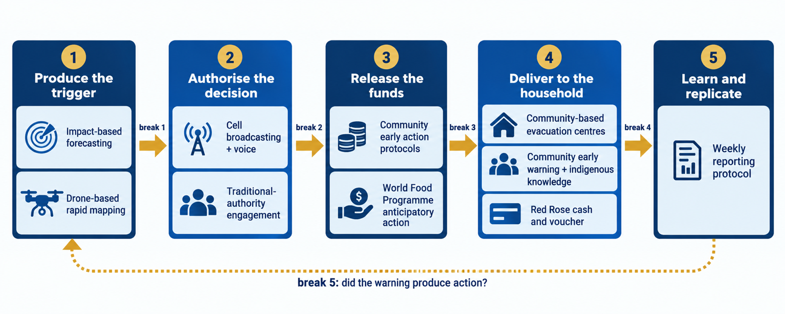

5. The ten innovations
Each innovation below is described from the data pack. Lead institutions, geography and operating evidence are drawn from the landscape assessment; pillar placement and gap closure from the Draft Programme.
 | Innovation | Lead institution | Where it operates | Missing functions it closes
1 | Community-based evacuation centres | Department of Disaster Management Affairs, Malawi | Malawi; recurrent-hazard Member States | Verifying that a warning produced action; reaching excluded groups
2 | Cell broadcasting with local-language voice translation | Mobile network operators with national disaster management authorities | Mozambique; regional replication | Authorising who may warn; communicating risk; operating across languages
3 | Community early action protocols | The International Federation with national Red Cross and Red Crescent Societies | Mozambique; continental | Converting a payout into a delivery instruction
4 | Impact-based forecasting | National Disaster Management Office, Botswana | Botswana, Eswatini, Malawi, Mozambique | Authorising the warning; verifying action
5 | Community multi-hazard early warning with indigenous knowledge | Community structures with traditional authorities | South Africa, Namibia | Verifying action; reaching excluded groups; working across languages
6 | World Food Programme anticipatory action portfolio | World Food Programme with national authorities | Regional, including Zimbabwe | Converting a payout into delivery; moving premiums to domestic budgets
7 | Red Rose cash and voucher platform | The International Federation and the Red Cross Red Crescent Movement | Mozambique; regional | Governing beneficiary registries; converting payout to delivery
8 | Drone-based rapid mapping for early action | Disaster Management and Mitigation Unit, Zambia | Zambia; flood and drought-prone Member States | Cross-border data sharing; routing delivery data into learning
9 | Traditional-authority engagement in warning dissemination | Traditional authorities with the National Disaster Management Office, Botswana | Botswana; Member States with active chieftaincy | Authorising the warning at community level; communicating risk
10 | Weekly community early warning reporting protocol | Directorate-General of Civil Protection, Democratic Republic of the Congo | Four provinces, Democratic Republic of the Congo | Routing delivery data into learning; documenting what operates
The numbering above is used throughout the rest of this document.

6. Theory of change
The theory of change follows the contribution-analysis method set in the Inception Report: it states how the Programme contributes to outcomes it does not control alone, and names the assumptions that must hold. The Programme’s causal chain runs from risk information that produces a trigger, through governance that authorises a decision and financing that releases funds, to community systems that deliver the action and give the trigger its legitimacy, and finally to learning that recalibrates the trigger.

6.1 The four pathways
Pathway | What changes | Innovations | Sendai Framework target
1. Strengthened early warning and anticipatory action | Warnings are impact-based and trigger pre-arranged action | 4, 8, 3, 6 | Target G, then B and C
2. Improved coordination and governance | Authority to warn and to act is designated and exercised | 9, 2 | Target E
3. Adoption of context-appropriate innovations | What works in one Member State is documented and copied | 10, 7 | Targets D and E
4. Enhanced risk communication and community engagement | Warnings reach households in their own language through trusted channels, and communities confirm action was taken | 1, 5, 2, 9 | Target G, at the access dimension
Pathway 4 carries the largest share of the ten and is the one most often missing from regional programmes. Most Member States do not lack warnings. What they lack is the distance between a warning being available and a household being able to act on it — which is why the contribution is to the access dimension of Target G rather than to availability.

6.2 The assumptions that carry the most weight
Assumption | What happens if it fails | Programme response
Delivery becomes a record: operating institutions will document what happened | Innovations work where they are and stay unreplicable everywhere else. The Draft Programme marks this as only partly holding | Documentation is a condition of completion for every innovation, carried by innovation 10
Member States will designate who may issue a warning | Warning channels are built that nobody may lawfully use | Mandate is tested before any innovation proceeds
Someone will carry the running cost when donor funding ends | The innovation stops after its first year | No proposal is submitted without a named post accountable for running cost
Figure 3 — Theory of change
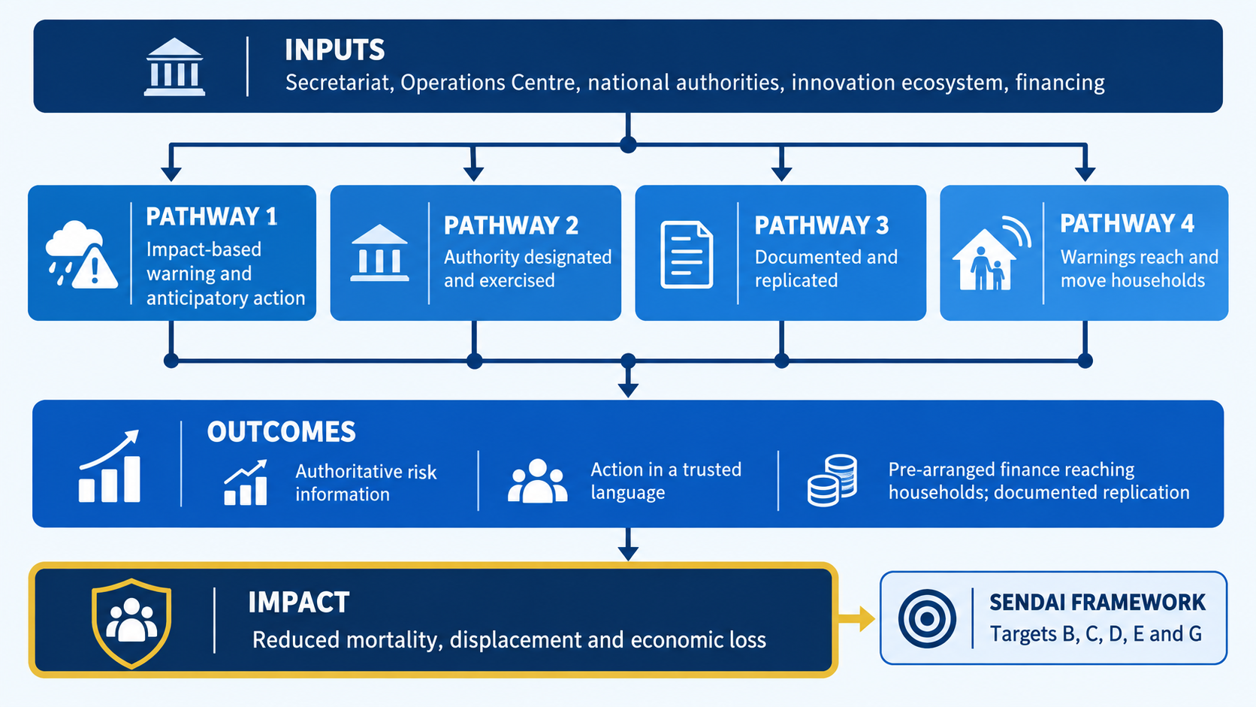

7. Cost-benefit analysis
No cost figure was recorded for any innovation in any evidence source used by the assessment. The cost estimation matrix at Annex R.1 was built to close that gap. It groups innovations into cost archetypes — instruments bought the same way, not instruments that do the same thing — and sets each band from a named, published comparator. The figures below are indicative bands, not quotations. They are sound for comparison and planning; any proposal to a financier replaces them with a costed proposal at national prices.

7.1 Cost
 | Innovation | Cost archetype | Set-up, one Member State | Running cost per year | Confidence
1 | Evacuation centres | Community arrangement | USD 150,000 – 400,000 | USD 40,000 – 90,000 | Moderate
2 | Cell broadcasting + voice | Dissemination | USD 600,000 – 1,800,000 | USD 150,000 – 400,000 | Moderate
3 | Community early action protocols | Anticipatory protocol | USD 120,000 – 300,000 | USD 60,000 – 150,000 | Moderate
4 | Impact-based forecasting | Forecasting | USD 400,000 – 900,000 | USD 120,000 – 300,000 | Moderate
5 | Community early warning + indigenous knowledge | Community early warning | USD 200,000 – 550,000 | USD 70,000 – 180,000 | Moderate
6 | World Food Programme anticipatory action | Anticipatory protocol | USD 150,000 – 400,000 | USD 11 per person reached | High
7 | Red Rose cash and voucher | Cash and registry | USD 400,000 – 1,100,000 | 17 cents per dollar transferred | High
8 | Drone-based rapid mapping | Aerial systems | USD 700,000 – 1,500,000 | USD 200,000 – 450,000 | High
9 | Traditional-authority engagement | Community arrangement | USD 60,000 – 180,000 | USD 30,000 – 80,000 | Moderate
10 | Weekly reporting protocol | Documentation | USD 30,000 – 90,000 | USD 15,000 – 45,000 | Moderate
 | All ten, one Member State |  | USD 2.8 – 7.2 million | USD 0.7 – 1.7 million, plus transfer costs
Two findings follow from the table. Running cost is roughly a quarter of set-up cost for the set as a whole, every year, indefinitely; a financing instrument that pays for set-up and not for running cost pays for the first year of something that then stops. And the five arrangements — innovations 1, 3, 6, 9 and 10 — together cost less to establish than the single most expensive technology, while reaching the most households.

7.2 Benefit
A computed benefit-cost ratio needs national loss data that the assessment did not collect, and none is stated here. What the published evidence does support is an indicative position for each class of innovation, set out below with its basis.
Class | Published evidence of return | Innovations | Position
Early warning | The United Nations Office for Disaster Risk Reduction reports that USD 800 million invested in early warning in developing countries avoids USD 3 to 16 billion of loss a year — a return of roughly four to twenty times | 2, 4, 5, 9 | Strongly favourable
Anticipatory action | Independent reviews find a return 1.5 to 2 times that of response after the event. A World Food Programme study in Nepal found up to 34 dollars saved for each dollar spent before a disaster. The first Southern African activation, in Zimbabwe, reached 32,500 people at about USD 11 each | 3, 6 | Strongly favourable
Community arrangement | A Malawian evacuation centre serving about 8,000 people was costed at USD 37,785, about USD 4.70 per person covered, with the community contributing a fifth. The benefit is lives saved rather than loss avoided and is not monetised here | 1 | Favourable; unquantified
Cash and voucher | The World Food Programme delivers cash at a cost of 17 cents per dollar transferred. The benefit is speed and dignity of assistance rather than avoided loss | 7 | Favourable
Aerial systems | A sovereign-scale project in Mozambique, financed at USD 967,000, established a training centre and monitoring across five flood zones. The benefit is time: assessment that took weeks takes days | 8 | Favourable
Documentation | Running cost of USD 15,000 to 45,000 a year. Its benefit is the replication of every other innovation, so its return rises with the size of the portfolio it documents | 10 | Strongly favourable by construction
The position column is an indicative judgement from published comparators, not a calculation. It is sufficient to show that no innovation in the ten has a doubtful case, and that the cheapest instruments carry some of the strongest.

8. Feasibility
Feasibility is tested in three ways: whether the innovation is already operating, whether the Draft Programme scored it feasible technically and institutionally, and whether the institutions named can lawfully do what is asked of them.
 | Innovation | Stage | Feasibility score | What most constrains it
1 | Evacuation centres | Operating | Technical 10, institutional 10 | The legal basis for designating a structure, per Member State
2 | Cell broadcasting + voice | Operating | Determination outstanding | Who is legally permitted to issue a public warning, and operator agreements
3 | Community early action protocols | Operating | Technical 10, institutional 10 | Pre-agreed triggers per hazard and district
4 | Impact-based forecasting | Operating | Determination outstanding | Funding, policy, institutional capacity and data, as named by the Botswana lead
5 | Community early warning + indigenous knowledge | Operating | Technical 10, institutional 10 | Written permission from knowledge holders, which is a legal requirement in several Member States
6 | World Food Programme anticipatory action | Operating | Determination outstanding | National government co-ownership of triggers
7 | Red Rose cash and voucher | Operating | Determination outstanding | Data protection law for beneficiary information
8 | Drone-based rapid mapping | Piloted | Determination outstanding | Civil aviation rules on altitude, distance and flight beyond line of sight
9 | Traditional-authority engagement | Operating | Technical 10, institutional 10 | A defined role in issuing warnings, not only relaying them
10 | Weekly reporting protocol | Operating | Technical 10, institutional 10 | None material; it runs as a by-product of work already funded

8.1 The mandate test
Every innovation passes the test of whether the Operations Centre may take part. Its mandate does not extend to rebuilding after a disaster, and none of the ten is a rebuilding instrument: eight are preparedness, and two — cash and voucher delivery and drone mapping — are response. All ten are therefore within bounds.
At national level, each innovation needs a stated legal provision under which its national institution operates it. That is a fact only each Member State can supply, and it is requested rather than assumed. Four innovations also engage laws outside disaster management, each now identified: civil aviation for drone mapping, telecommunications and alerting authority for cell broadcasting, data protection for cash and voucher delivery, and the protection of traditional knowledge for the indigenous knowledge component. The last is the most demanding: under the regional protocol on traditional knowledge, permission not given in writing has no effect, and knowledge belonging to a community may not be transferred at all.
Nine of the ten are already operating. The one pilot, drone mapping, has the strongest regional cost comparator in the portfolio. Feasibility is not the constraint on this Programme; custody of running costs and national legal provision are.

9. Gender equality and social inclusion across the ten
Inclusion is treated as a determination rather than a commitment. Each innovation is assessed against seven groups, and each group is scored as designed into the innovation, named as a beneficiary without a design feature, or not provided for. The determination is extracted from the interview coding; it is not a fresh judgement. Absence is recorded, because a programme that lists only what it does for inclusion cannot be judged on what it does not do.
Innovation | Women | Youth | Disability | Older | Minority | Remote | Displaced
1 Evacuation centres | Named | Named | Named | Named | Named | Named | None
2 Cell broadcasting + voice | Designed | Designed | Designed | None | None | Designed | None
3 Early action protocols | Named | Named | Named | Named | Named | Named | None
4 Impact-based forecasting | Named | Named | Named | None | None | Named | None
5 Community early warning | Named | Named | Named | None | Named | Named | None
6 Anticipatory action | Named | Named | Named | Named | Named | Named | None
7 Cash and voucher | Named | Named | Designed | Named | Named | None | None
8 Drone mapping | Named | Named | Named | Named | Named | Named | None
9 Traditional authority | Not determined
10 Weekly reporting | Not determined
The pattern is stark. Not one of the eight determined innovations records provision for migrants and displaced people. Older people and minority groups are unprovided for in three each. Only cell broadcasting has design features — voice translation in local languages — that reach several groups at once, which is why it carries the highest inclusion score of the ten.

9.1 The cross-cutting method
Inclusion runs through all three phases rather than sitting in one pillar. In the first phase, determinations are completed for innovations 9 and 10 and confirmed for the other eight. In the second, every innovation that records no provision for displaced people designs one in before it is scaled — the single most important inclusion action in the Programme, because displacement is precisely what the disasters it addresses produce. In the third, inclusion is measured through the Programme’s own framework, which counts determinations completed including the groups recorded as unprovided for.

9.2 What the Programme will do about the absences
Recording an absence is not a strategy. The Programme acts on the determinations in three ways, and each is carried in the implementation matrix rather than left as an intention.
Action | Commitment
Design provision before scaling | No innovation is scaled to a second Member State until it carries a designed provision for migrants and displaced people, the one group for which no innovation in the portfolio records any provision. This is a condition of the scale-up phase, not an aspiration
Complete the determinations | The two innovations without a determination are completed before the validation workshop. An innovation carried without one cannot be appraised for what it does not do
Measure the absences, not only the provision | The measurement framework counts determinations completed including recorded zeros, so a rising count cannot be achieved by omitting the groups that are hardest to reach

The strategy follows from the diagnosis: inclusion failures in this portfolio come from design without an inclusion determination, which is a coordination failure rather than a resource constraint. It is therefore closed by a rule applied at the right moment, not by a budget line.

10. Comparative implementation plan across the five pillars
The plan follows the three phases of the approved Inception Report. The short term is the first year: quick wins and pilots. The medium term is years two and three: scaling and replication across Member States. The long term is years four and five: institutionalisation in national policy and budgets, and long-term financing. Pillar 3 anchors institutionalisation and Pillar 4 anchors resource mobilisation, which runs continuously.
Pillar | Short term: year 1 | Medium term: years 2–3 | Long term: years 4–5
1. Risk data and early warning | Impact-based forecasting and cell broadcasting piloted in three to five Member States; drone mapping pilot extended beyond Zambia | Regional alerting architecture in place; the Operations Centre’s link to national situation rooms operational | Impact-based warnings standard practice; alerting authority designated in national law
2. Community and inclusion | Evacuation centres and community early warning designated in pilot districts; inclusion determinations completed | Provision for displaced people designed into every innovation before scaling; replication to eight to ten Member States | Community structures carried on national budget lines; indigenous knowledge held under community ownership
3. Governance | Traditional-authority roles agreed in pilot Member States; mandate tests completed for all ten | Legal provisions confirmed in each adopting Member State | Innovations named in the successor to the Community’s disaster risk management strategy from 2031; Operations Centre procedures updated
4. Financing | First concept notes submitted to named windows; early action protocols and triggers agreed | Costed proposals at national prices replace the indicative bands; private and blended co-financing secured | Running-cost posts named and funded in each Member State; domestic financing of innovation established
5. Knowledge and replication | Documentation standard issued; weekly reporting protocol adopted as the regional template | Every activation of the ten recorded in the regional record | A self-sustaining pipeline: what is documented is proposed, funded and copied
Figure 4 — Five-year implementation
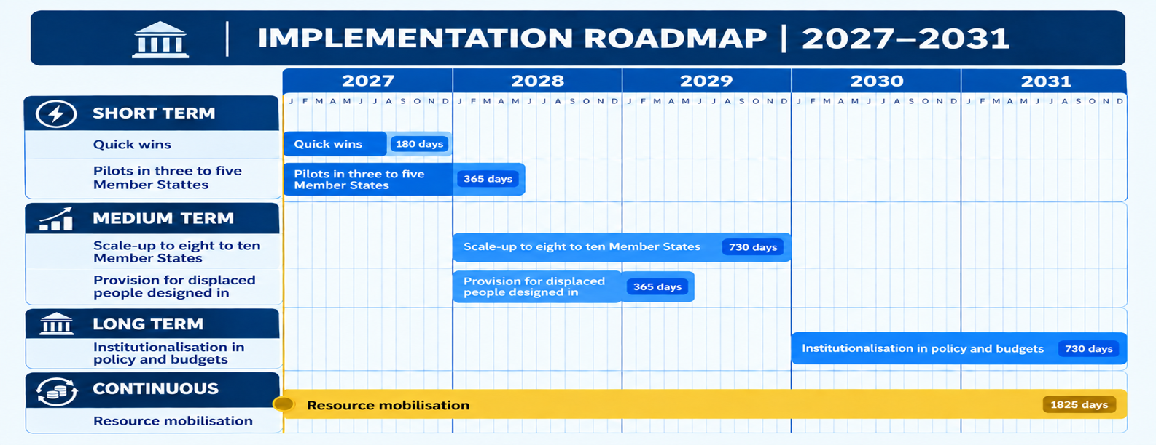

11. Programme implementation matrix
One row per innovation. The matrix brings together the lead, the pillar, the three horizons, the Operations Centre’s role, the indicative cost, the indicator it reports into, and the inclusion action it carries. It is the reference for work planning; the narrative sections above explain the reasoning behind each column.
 | Innovation and lead | Pillar | Short term: year 1 | Medium term: years 2–3 | Long term: years 4–5 | Operations Centre role | Indicative cost: set-up / per year | Reports into | Inclusion action
1 | Evacuation centres — Disaster Management Affairs, Malawi | 2 | Designate and inspect centres in pilot districts; agree activation conditions | Link designation to the warning channel; replicate the protocol to other Member States | Named in national policy; running cost on a budget line | Holds the record; supplies the protocol to adopting States | USD 150–400k / 40–90k | Outcome 2: action in a trusted language | Design provision for displaced people
2 | Cell broadcasting + voice — operators with national authorities | 1 | Pilot in three to five States; secure operator agreements | Regional alerting architecture; voice translation in the working languages | Alerting authority designated in law | Coordinates cross-border activation | USD 600k–1.8m / 150–400k | Outcome 1: authoritative, interoperable warning | Extend design to older and minority groups
3 | Community early action protocols — the International Federation with national societies | 4 | Agree triggers per hazard and district | Scale protocols with pre-arranged funding | Carried by national societies and domestic contingency funds | Mobilises partners | USD 120–300k / 60–150k | Outcome 3: finance reaching households | Design provision for displaced people
4 | Impact-based forecasting — National Disaster Management Office, Botswana | 1 | Pilot impact products with meteorological services | Standard product across adopting States | Standard national practice | Holds regional forecast record; supports Member States | USD 400–900k / 120–300k | Outcome 1 | Add older, minority and displaced groups
5 | Community early warning + indigenous knowledge — community structures | 2 | Obtain written permission from knowledge holders; agree benefit sharing | Validate indigenous indicators on their predictive record | Held under community ownership; integrated in national warning | Supplies the consent protocol | USD 200–550k / 70–180k | Outcome 2 | Design provision for displaced and older people
6 | Anticipatory action — World Food Programme with national authorities | 4 | Agree government co-owned triggers | Extend activations beyond Zimbabwe | Triggers owned by national authorities | Mobilises partners; coordinates regional pre-positioning | USD 150–400k / USD 11 per person reached | Outcome 3 | Design provision for displaced people
7 | Red Rose cash and voucher — the International Federation | 2 | Clear data protection for beneficiary records | Link to national social protection registers | Registry governance in national law | Coordinates regional delivery standards | USD 400k–1.1m / 17 cents per dollar | Outcome 3 | Extend to remote and displaced groups
8 | Drone-based rapid mapping — Disaster Management and Mitigation Unit, Zambia | 1 | Extend the Zambian pilot; clear civil aviation rules | Regional training and certification centre; shared aircraft pool | Imagery routed into structured needs assessment | Coordinates cross-border deployment | USD 700k–1.5m / 200–450k | Outcome 1; Outcome 4 | Design provision for displaced people
9 | Traditional-authority engagement — traditional authorities with Botswana’s national office | 3 | Agree the role of traditional authority in issuing warnings | Replicate to Member States with active chieftaincy | Role recognised in national disaster law | Supplies the engagement protocol | USD 60–180k / 30–80k | Output A: institutional instruments | Complete the inclusion determination
10 | Weekly reporting protocol — Civil Protection, Democratic Republic of the Congo | 5 | Issue as the regional documentation template | Every activation of the ten recorded to it | The standard by which the region learns | Holds the regional record for all ten | USD 30–90k / 15–45k | Outcome 4: documented and replicated | Complete the inclusion determination
Pillar numbers: 1 risk data and early warning; 2 community and inclusion; 3 governance; 4 financing; 5 knowledge and replication. Costs are indicative bands per adopting Member State, from Annex R.1.

12. What the Programme will produce
Horizon | Outputs
Short term: year 1 | Ten innovations profiled, costed and mandate-tested. Inclusion determinations complete for all ten. The documentation standard issued. Pilots operating in three to five Member States for the warning and early-action instruments. The first concept notes submitted to named financing windows. The validation workshop held and its decisions recorded
Medium term: years 2–3 | The ten replicated to eight to ten Member States. A regional alerting architecture and the Operations Centre’s link to national situation rooms operating. Provision for displaced people designed into every innovation. Costed proposals at national prices in place of indicative bands. Private and blended co-financing secured. Every activation of the ten recorded in the regional record
Long term: years 4–5 | The ten named in national policy and carried on national budget lines, with a named post accountable for each running cost. The innovations written into the successor to the Community’s disaster risk management strategy from 2031. The Operations Centre’s procedures updated to reflect its role as the regional record. A proposal pipeline that sustains itself from the platform

12.1 How the outputs will be measured
Every indicator is readable from records that already exist or that the innovations themselves produce. An indicator that needs a new survey does not get collected, and a framework of uncollected indicators gives the appearance of measurement without the fact of it.
Level | What changes | How it is measured
Impact | Reduced disaster mortality, displacement and economic loss | Sendai Framework targets, from Member State returns
Outcome 1 | Risk information is authoritative, interoperable and acted upon | Member States issuing standard warnings through an authorised channel
Outcome 2 | Communities receive and act on warnings in a language and through a channel they trust | Share of the at-risk population reached in a language of use; lead time to protective action
Outcome 3 | Financing is pre-arranged and reaches households through a named delivery partner | Financed instruments with a named delivery partner and running-cost post
Outcome 4 | What operates is documented, replicated and institutionalised | Innovations named in national policy or carried on a budget line
Output C | Inclusion determinations completed | Determinations across all seven groups, including recorded absences
Output D | Arrangements and hybrids carried | Share of the financed portfolio that is not a purchase of equipment
Evaluation — whether the Programme caused the change observed — runs on the Programme’s own cycle, at mid-term and at close, and is not attempted for individual innovations.

13. Monitoring and evaluation
Monitoring and evaluation is owned by the Disaster Risk Reduction Unit and answers two different questions. Monitoring asks whether the Programme is doing what it said it would do, and is continuous. Evaluation asks whether the change observed can be attributed in part to the Programme, and happens three times in five years. They are kept apart because conflating them produces reporting that measures activity and calls it result.

13.1 The principle every indicator satisfies
Each indicator is readable from records that already exist or that the innovations themselves produce: activation records, district inspection records, national policy texts, budget documents and the regional record. No indicator requires a new survey instrument. An indicator that needs one does not get collected, and a framework of uncollected indicators gives the appearance of measurement without the fact of it. Any proposed indicator that fails this test is removed rather than carried.

13.2 What is monitored, by whom, and how often
Level | What is monitored | Who reports it | How often
Impact | Disaster mortality, displacement and economic loss in the participating Member States | National disaster management authorities, through existing Sendai Framework returns | Annually
Outcome | Authoritative risk information acted upon; households reached and acting in a language they trust; pre-arranged financing reaching households; what operates documented and replicated | The institution operating each innovation, to its national authority | Per activation, aggregated annually
Output | Institutional arrangements established; propositions produced and submitted; inclusion determinations completed; arrangements and hybrids carried | Programme record | Quarterly
Process | Evidence integrity: sources cited, derivations confirmed, requests distinguished from gaps | Programme record | Continuous, reported quarterly

13.3 The reporting line
The operating institution reports to its national disaster management authority. The national authority reports to the Operations Centre, which holds the regional record. The Operations Centre reports to the Disaster Risk Reduction Unit, which owns the Programme and reports to the Programme Board. Nothing in this line asks the Operations Centre to judge a Member State; it holds and transmits the record, and the judgement sits with the Unit and the Board.

13.4 Evaluation
Point | When | What it establishes
Baseline | Within the first six months | The starting position for each indicator in each participating Member State, without which no later claim can be made
Mid-term evaluation | End of year three | Whether the pathways are producing the outcomes expected, and whether the assumptions still hold. The decision point for re-shaping the portfolio
Final evaluation | Year five | Contribution to the outcomes, and what should carry forward into the successor programme

Evaluation uses contribution analysis, as committed at inception. The Programme is one actor among many in every pathway, and its claim is that it made a difference the pathway would not otherwise show, not that it caused the outcome alone. Each evaluation therefore tests the assumptions in section 6.2 explicitly and reports which of them failed.

13.5 The learning loop
Monitoring data is not filed and forgotten. Activation records enter the regional record; the record feeds the replication offer made to other Member States; what a Member State adopts changes the portfolio; and the evaluation points recalibrate the indicators. That loop is the reason the documentation obligation is a condition of completion for every innovation rather than a reporting courtesy.

14. Risk analysis
Risk is managed on a five-level scale. A risk is scored on the combination of how likely it is and what it would cost the Programme if it occurred, and is reviewed at every Programme Board meeting. The register below is the position at issue; it is a live document and the ratings move.

14.1 The scale
Rating | Meaning | What it requires
Closed | The risk has been retired because the thing that caused it has been resolved | Recorded so that the register shows what has been dealt with, not only what is outstanding
Low | Unlikely, or consequences absorbed within normal delivery | Monitored; no separate action
Medium | Possible, with consequences that would delay delivery | A named owner and a stated mitigation
High | Likely, or consequences that would stop a workstream | A named owner, a mitigation and a date; reported to the Board at every meeting
Extreme | Would stop the Programme, or expose the Community or a Member State to legal or reputational harm | Escalated immediately; delivery of the affected instrument halts until the risk is reduced

14.2 The register
 | Risk | Rating | Owner | Mitigation
1 | An innovation is scaled before the arrangement that gates it exists, producing capability nobody may lawfully use | Extreme | Programme Board | Sequencing rule: institutional arrangements precede the technology that depends on them. No instrument enters the scale-up phase until its gating arrangement is in place
2 | Indigenous knowledge is used without written authorisation from the holding community | Extreme | Disaster Risk Reduction Unit | Written consent, attribution and benefit sharing are conditions precedent. Delivery halts where authorisation is absent
3 | No Member State names a post accountable for recurrent cost, so instruments stop when founding financing ends | High | Member States | No proposition is submitted to a financier without a named post. The matter is a standing item of the Programme Board
4 | Financing covers set-up but not running costs | High | Disaster Risk Reduction Unit | Running cost is stated separately in every proposition, at about a quarter of set-up each year, and the transition to domestic budgets is sequenced across the three phases
5 | The national legal provision cannot be confirmed for an instrument | High | Member States | The instrument is referred to the governance workstream rather than dropped. A missing mandate is itself a finding the Programme exists to address
6 | No provision is designed for displaced people before instruments are scaled | High | Disaster Risk Reduction Unit | Designed provision is a condition of entry to the scale-up phase, carried in the implementation matrix
7 | Indicative cost bands are used as budget figures in a submission | High | Disaster Risk Reduction Unit | Bands are marked for scoring and planning only. A submission requires a costed proposal at national prices
8 | The documentation obligation lapses once founding financing ends | High | Operations Centre | Documentation is a condition of completion for every instrument, and the weekly reporting protocol is the regional template
9 | The validation workshop is delayed, holding the Final Programme Document as a draft | Medium | Disaster Risk Reduction Unit | Member State engagement proceeds in parallel on the two facts the Programme needs, so the workshop confirms rather than originates them
10 | The Operations Centre cannot absorb the regional record for ten instruments across ten Member States | Medium | Operations Centre | The scale-up phase is paced to absorptive capacity, which is tested by return before an instrument is replicated
11 | The prioritisation index remains provisional, weakening the portfolio case | Medium | Academy of Resilience and Continuity | Outstanding determinations are extraction against documents already held, not new research. Scheduled before submission
12 | Media organisations do not engage, leaving public awareness material unwritten | Medium | Disaster Risk Reduction Unit | Engagement through the continental network of disaster risk reduction journalists; material is specified until it returns
13 | Member States adopt instruments without joining the regional reporting arrangement | Medium | Operations Centre | Joining the arrangement is step six of the adoption plan and a condition of replication support
14 | Partner priorities redirect the portfolio away from the arrangements that reach households | Medium | Programme Board | The measurement framework counts the share of the financed portfolio that is not a purchase of equipment
15 | No cost basis existed for any innovation, preventing appraisal | Closed | Academy of Resilience and Continuity | Closed by the cost estimation matrix at Annex R.1, which bands every instrument against named published comparators
16 | Inclusion could not be determined, leaving the portfolio unappraisable for who it reaches | Closed | Academy of Resilience and Continuity | Closed by extraction from the interview coding for thirty of thirty-four instruments, with absences recorded

Two risks are rated extreme and both are avoidable by sequencing rather than by spending. Six are high and five of those are held by Member States, which is why the three requests at the end of this document are the Programme’s principal risk control. Two risks are closed, and they are shown because a register that records only what is outstanding gives no credit for what has been resolved and no evidence that it is being worked.

15. What the Programme means for the region and the Operations Centre

15.1 For the Community
For the region the Programme changes three things. It moves disaster risk management innovation from isolated projects to a structured pipeline in which what works in one Member State is documented, costed and offered to the others. It aims regional money at the five points where the system breaks rather than inside the pillars that already work. And it brings into financing the two-thirds of the region’s innovations that are arrangements rather than equipment, which are the cheapest to run and reach the most people.
The Programme is also the delivery of a commitment the region has already made. It is a named action in the Community’s Disaster Risk Management Strategy and Action Plan 2022–2030, and it contributes to Sendai Framework targets B and C on mortality and economic loss, D on resilient infrastructure and systems, E on national strategies, and G on access to early warning — the four priorities the Inception Report committed to.

15.2 How the Programme enables the Operations Centre to deliver its mandate
The Operations Centre is the operational arm of the Community in disaster risk management: activation, regional coordination, partner mobilisation and support to Member States. Its mandate does not extend to rebuilding after a disaster. The Programme was tested against that boundary innovation by innovation, and all ten sit inside it.
Function | What the Programme changes
Activation | The Operations Centre coordinates activation for the two innovations that cross borders — cell broadcasting and drone mapping. It does not activate national instruments such as evacuation centres, and the Programme does not ask it to
Regional coordination | It becomes the holder of the regional record: every activation of the ten is documented to a single standard and held where every Member State can see it
Partner mobilisation | It mobilises partners for the two anticipatory action instruments and for the pre-positioning they depend on
Member State support | It supplies the protocols, conditions and standards to each Member State that adopts an innovation, rather than the national arrangement itself
Interoperability | It owns the gate through which national data reaches the regional layer, and its link to national situation rooms becomes operational in the medium term
The effect is to give the Operations Centre a role no other body in the region can play — the memory of what works — without asking it to do anything its mandate forbids. The constraint to watch is capacity: holding the record for ten innovations across up to ten Member States is a real workload, and the medium-term phase should be paced to it.

Figure 5 — Governance and the Operations Centre’s role
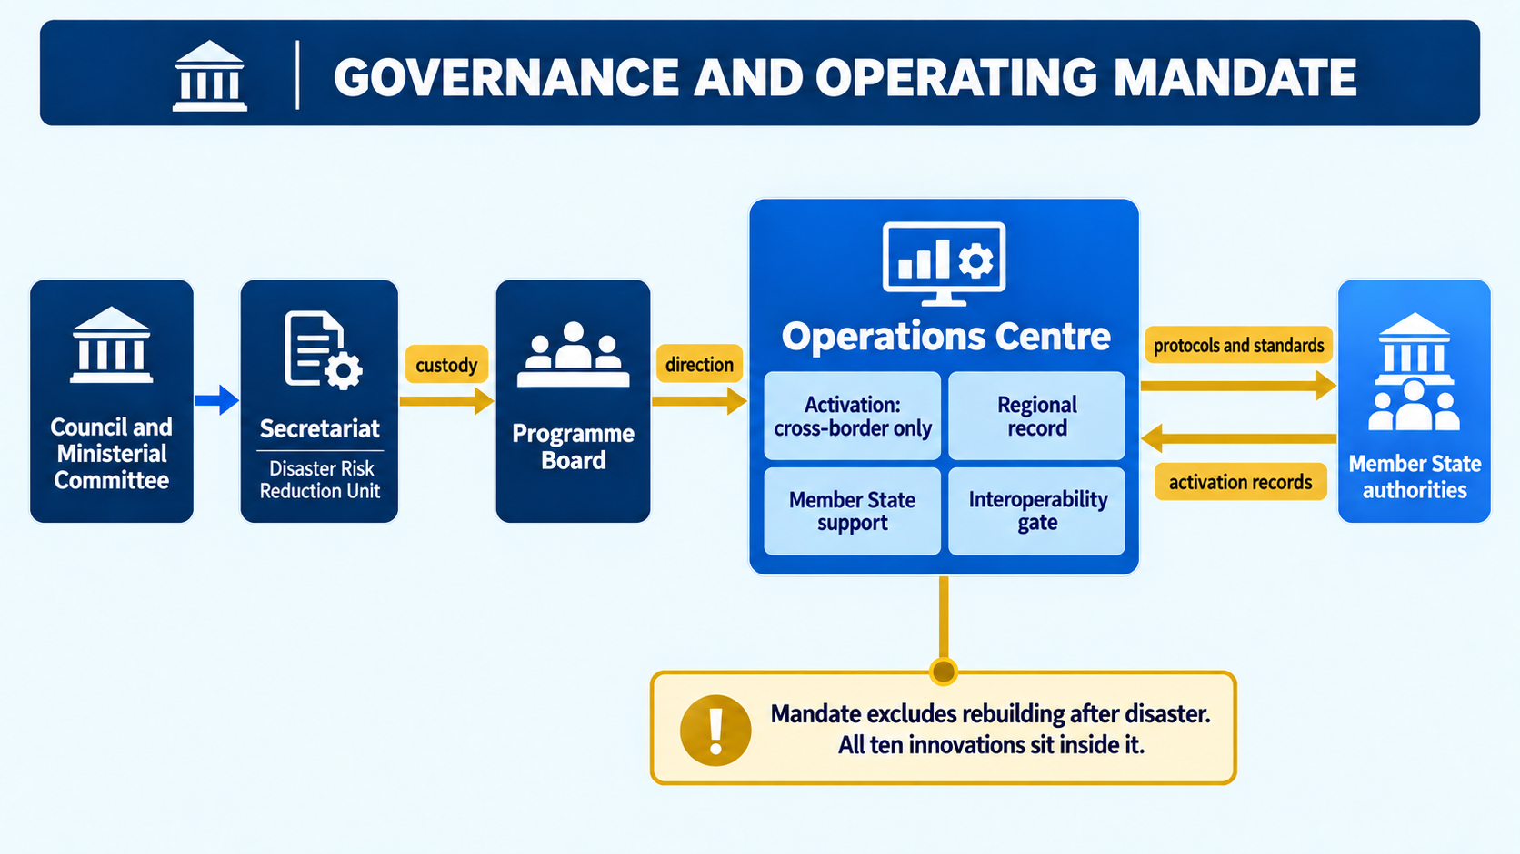
16. The platform: rich data and continued use for funding proposals
The Programme does not end with this document. It is built on a platform that continues to turn evidence into funding proposals after the contract closes.

16.1 What the platform holds
Component | Content
The data pack | Forty-eight structured tables in one workbook: the thirty-four innovation records with their lead institutions, geography and operating evidence; the sixteen gaps and eight root causes; the forty-eight gap-to-innovation links; the inclusion determinations extracted from the 401 coded interview segments; the legal and mandate registers; the measurement framework; and the cost matrix
Nine templates | On the Community’s letterhead: the programme document, the concept note, the implementation plan, the validation workshop pack, the summary brief, the Member State adoption plan, the public warning and communication plan, the terms of reference, and the completeness annex
Populate code | One script per template that reads the data pack and fills the template. Tested across all thirty-four innovations with no failures
Readiness board | Tracks, for each product, whether the Programme has finished its own part and which facts it is waiting on from others

16.2 How it is used after this contract
Each funding round follows the same path. A new or updated innovation is added to the data pack. It passes the admission tests: it must be evidenced, lawful, practicable and linked to a gap. Its inclusion determination and cost band are read from the record. The populate code then produces a concept note, an implementation plan and an adoption plan, each on letterhead and each carrying an annex stating which statements rest on evidence and which are requested from others.
Concept notes can be drafted for any of the windows the Programme was designed around: the European Union’s disaster risk management support to the Community, the Green Climate Fund, the Adaptation Fund, bilateral partners, and blended or commercial finance where a return can be identified. The same record produces all of them, so a Member State does not start each proposal from blank paper.
Two rules keep the platform honest. Nothing is generated: a field the data pack does not hold is either omitted or written as a request naming who is being asked. And the indicative cost bands may be used to score and plan but never in a submission, which must carry a costed proposal at national prices.
Figure 6 — The platform: from record to funding proposal
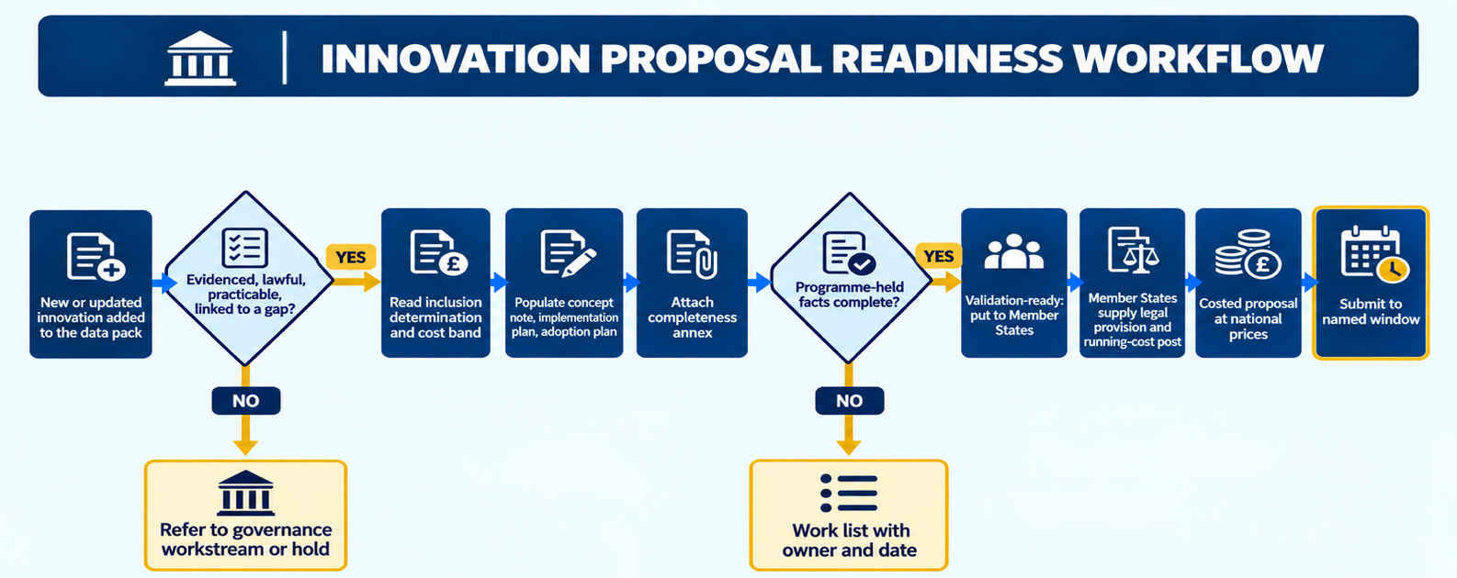

17. Enabling strategies
Five enabling strategies carry the Programme. They were developed and accepted at the Draft Programme and are summarised here so that this document is complete in itself; the full text remains at sections 16.1 to 16.5 of the Draft.

17.1 Governance and institutional framework
The Secretariat is the political custodian through its Disaster Risk Reduction Unit, working with the Climate Services Centre and relevant sector units. The Operations Centre is the operational arm. A Programme Board takes portfolio decisions, holds the risk register, and keeps custody of recurrent cost as a standing item. Each Member State names a focal point in its national disaster management authority. Decision rights are explicit: the Board admits and removes instruments from the portfolio; the Secretariat approves anything that binds the Community; a Member State decides anything that binds itself.

17.2 Funding and sustainability
Financing is sought through four donor windows together with commercial and blended routes, chosen per instrument rather than per programme. Four conditions must be satisfied before any proposition is packaged: a named delivery counterpart, treatment of basis risk where a trigger is parametric, a premium transition pathway where cost is subsidised, and a named recurrent-cost custodian.
Sustainability is the transition from partner subsidy to domestic budget, and the Programme treats it as a sequence rather than a hope. In the first phase running costs sit with the financing instrument; in the second a budget line is created alongside it; in the third the line carries the full cost and the post accountable for it is named. An instrument that has not started the sequence by the end of the second phase is reported to the Board as at risk.

17.3 Capacity building and training
Capability is concentrated in a few institutions, which the assessment identifies as a root cause rather than an inconvenience. The Programme responds with a proposal and bankability capability stream delivered through the regional centres of excellence, training in business continuity management for the institutions that must keep instruments running through disruption, and a short absorptive-capacity return completed by every institution that would operate an innovation. Where capacity is not yet present, a capacity-building pathway is recorded against the instrument and it is sequenced behind that work rather than carried as ready.

17.4 Innovation sourcing and partnerships
Innovation is sourced through structures that already exist rather than through a new platform: national disaster management authorities, academia and research institutions, innovation hubs, civil society, the private sector and regional bodies. Partnership archetypes from the assessment govern what each partner is asked for, so that a university is not asked to deliver and an operator is not asked to research.
Media organisations are partners in this stream rather than an audience for it. The assessment records that risk communication through media and participatory channels is a function no institution reliably performs, and that no media practitioner responded during the evidence gathering. The Programme therefore engages regional media through the continental network of disaster risk reduction journalists to establish three things it does not currently know: how a warning is received, edited and retransmitted; what would allow media organisations to act as accountable partners in the warning chain rather than as terminal conduits; and how local-language risk communication is sustained between events rather than mobilised only during them. Public awareness material follows that engagement rather than preceding it, because material designed by those who issue warnings rather than those who carry them is the error the engagement exists to correct.

17.5 Legal and ethical considerations
No instrument enters the portfolio until its mandate, legality and practicability have been tested, and the governing legal regime has been identified for each class of instrument: civil aviation for aerial systems, telecommunications and alerting authority for warning dissemination, data protection for beneficiary information, public finance law for contingent liabilities, water allocation law for water capture, and the protection of traditional knowledge for indigenous knowledge.
Two ethical obligations go beyond what the law requires. The first concerns indigenous knowledge: consent must be in writing, attribution belongs to the holding community, benefit sharing is agreed before access, and ownership does not transfer to the Programme or to any Member State. Under the regional protocol on traditional knowledge, authorisation not granted in writing has no effect and community-held knowledge may not be assigned at all, so this is a condition precedent rather than an implementation detail. The second concerns the inclusion absences recorded in section 9: knowing that no instrument in the portfolio reaches displaced people creates a duty to act on that finding, which is why it is written into the scale-up condition rather than left in an annex.
Figure 7 — Enabling strategies around the delivery architecture
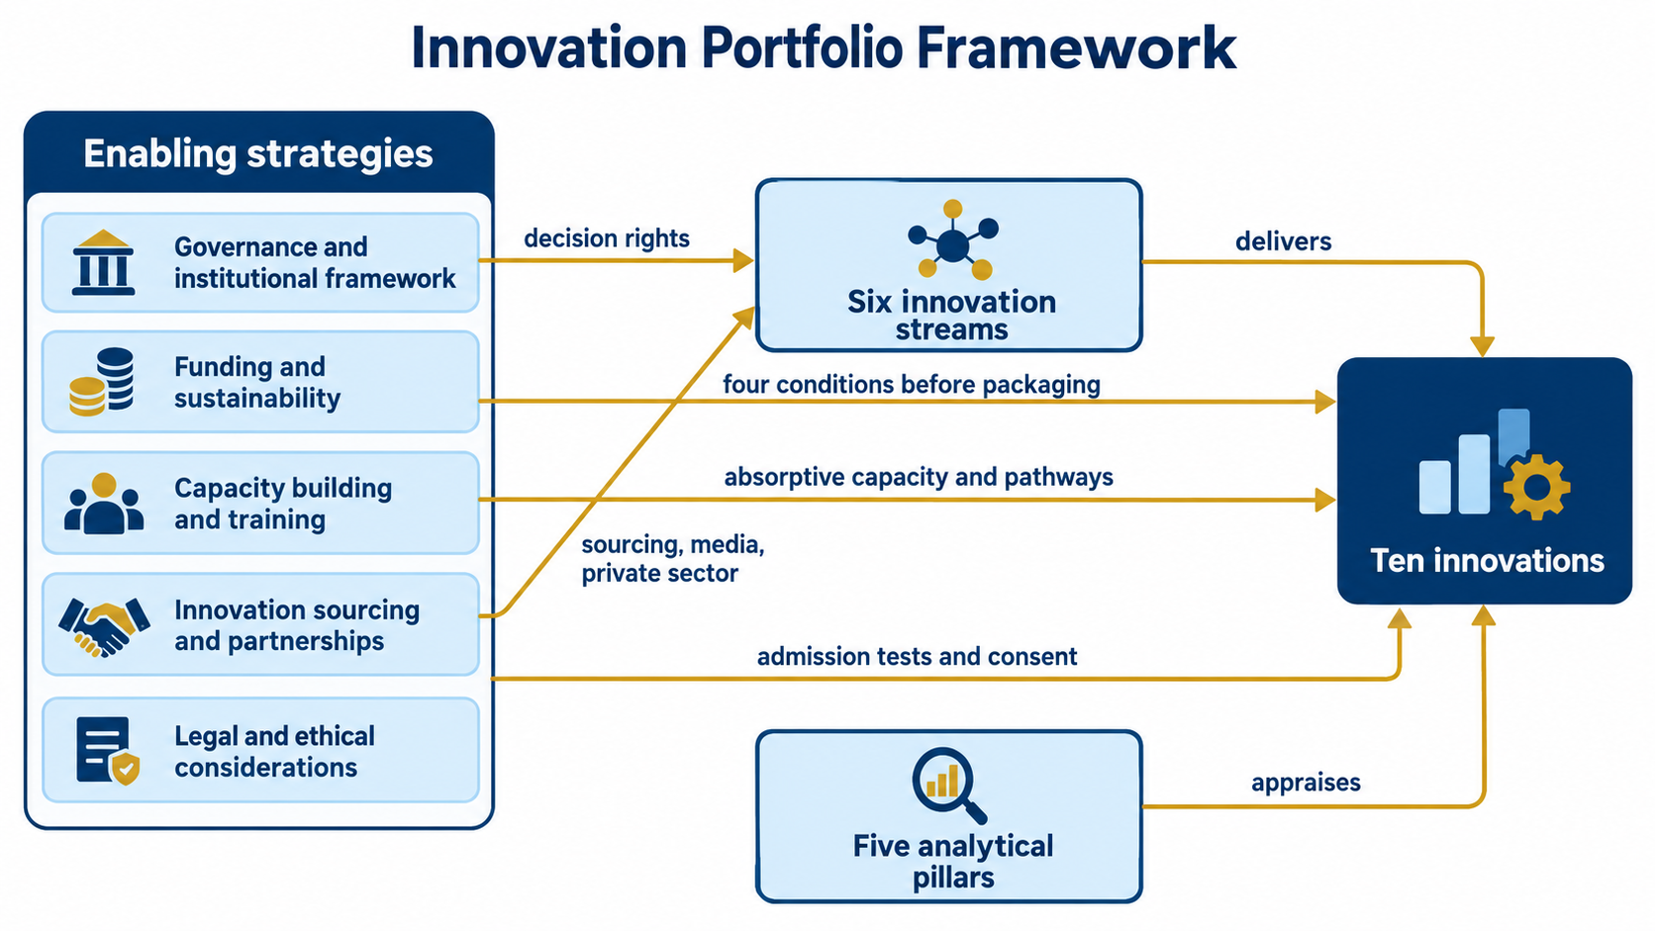

18. Verification against the contract and the Inception Report
The table traces each requirement of the signed contract and the approved Inception Report to where this document, or the deliverables it rests on, meets it.
Requirement | Where it is met | Status
Identify, assess and institutionalise technological and non-technological innovations | Sections 2, 4 and 5; Deliverables 2 and 3 | Met
A regional innovation framework aligned with the Community’s priorities | Section 3; Deliverable 3 | Met
Embed gender equality and social inclusion | Section 9 and the matrix at Section 11 | Met; two determinations to complete
A programme for developing, testing and deploying innovations | Sections 10 and 11 | Met for deployment; testing through pilots
Regional capacity for learning and replication | Innovation 10; Sections 10 and 14 | Met
Early warning, risk data and interoperability | Pillar 1 innovations; Section 13.2 | Met
Support Member States to adopt and institutionalise | Adoption plans; long-term horizon | Met; legal provision requested
Risk communication with media | Public warning and communication plan | Designed; media engagement pending
Coordination arrangements across the Community | Section 3.2 and Section 13 | Met
Partnerships with the private sector and others | Section 14.2; financing pillar | Met
A prioritisation matrix | Section 4; Deliverable 3 | Met; index provisional
A theory of change, objectives and result areas | Section 6 | Met
An implementation roadmap with institutional arrangements and resources | Sections 10 and 11; Section 7 | Met
Three to five year horizon in three phases | Sections 10, 11 and 12 | Met
Contract Deliverable 5: Final Programme and Summary Brief | This document; the Summary Brief is issued with it | Met on issue of the brief

18.1 The ten components the contract requires of a programme document
The contract defines this document as the Draft Programme revised. The Draft is specified as ten named components, and the table below tests this document against that list directly.
Required component | Status | Where
Programme rationale | Present | Sections 1 and 2
Objectives | Present | Section 3.1
Innovation streams | Present | Section 3.2, with the crosswalk to the five pillars
Gender and inclusion strategy | Present | Sections 9, 9.1 and 9.2
Implementation roadmap | Present | Sections 11 and 12
Governance and institutional framework | Present | Section 15.1, with the regional role at section 14
Funding and sustainability strategy | Present | Section 15.2, with cost and benefit at section 8
Capacity building and training strategy | Present | Section 15.3
Innovation sourcing and partnerships strategy | Present | Section 15.4, including media and public awareness
Legal and ethical considerations | Present | Section 15.5, with the mandate test at section 10.1

One contractual condition remains outside this document. The Final is defined as the programme revised on stakeholder inputs, and those come from the validation workshop. Until that workshop is held this document stands as the pre-validation final draft, and it is reissued as the contractual Final once the workshop record is incorporated.

19. What remains to be settled
Four matters are open, and each has an owner. None changes the analysis above or the shape of the Programme.
Matter | Who settles it | Effect when settled
The national legal provision under which each innovation operates | Each adopting Member State | Completes the mandate test at national level
The post accountable for each running cost | Each adopting Member State | Clears the condition for submitting to a financier
The remaining scores in the prioritisation index | The Programme, from Deliverables 2 and 3 | The ranking becomes final rather than provisional
Language and channel arrangements with regional media | Regional media organisations | Communication material is drafted rather than specified
The first two are the facts the Programme is designed to ask for. They are held by Member States and no regional body can supply them. They are therefore requests made through the products of this Programme, not gaps in it.
End of the Final Programme Document

