POLICY BRIEF · REGIONAL DISASTER RISK MANAGEMENT INNOVATION PROGRAMME · SEPTEMBER 2026
The region does not need more innovation. It needs the arrangements that let its innovation work.
Thirty-four disaster management innovations are operating across Southern Africa today. Sixteen things exist that none of them reliably does, and ten of those sixteen are about authority, agreement and accountability rather than equipment. Not one is solved by buying a technology the region does not have.
What the evidence shows
The evidence comes from three independent streams: a review of the regional and international literature, twenty-one interviews across eight Member States and the regional level, and a country survey returned by seven Member States. Twelve of the sixteen Member States are represented.
Innovation inside each part of the disaster management system is comparatively healthy. The system breaks between the parts — where risk information must become authority to act, where authority must release money, where money must reach a household, where delivery must become learning, and where anyone checks that a warning produced an action. Five such breaks were identified, and all five stay open because the arrangements that would close them reach no household directly and are therefore never prioritised.
Two-thirds of what the region has built is not equipment. Thirteen of the thirty-four innovations are arrangements between organisations and nine are part arrangement, part technology. A financing instrument built around buying things reaches fewer than a third of the portfolio — and misses most of what actually reaches households.
What the Programme will do
The Programme selects ten of the thirty-four: not the ten highest scorers, but the smallest set that closes every break. Together they cover all five pillars, all five links from warning to action, and all five breaks. They close eleven of the sixteen missing functions directly; the Programme’s own instruments close three more.
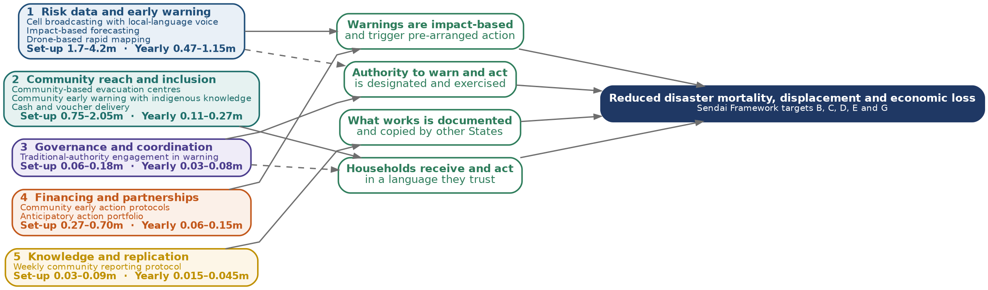
The five pillars with their indicative cost per Member State, the four pathways they drive, and the result. All ten in one Member State: set-up 2.8 to 7.2 million United States dollars, then 0.7 to 1.7 million every year.
What it costs, and the number that matters
Every innovation now carries an indicative cost band drawn from published comparators, several from inside the region. The figure that should shape financing decisions is not the set-up cost but the one beneath it: running cost is about a quarter of set-up, every year, indefinitely. A financing instrument that pays for establishment and not for running costs pays for the first year of something that then stops.
The cheapest instruments carry some of the strongest cases. A community evacuation centre serving eight thousand people was costed in Malawi at about five United States dollars per person covered, with the community contributing a fifth. The weekly reporting protocol that lets one Member State copy another costs less than fifty thousand dollars a year to run. Early warning investment is independently reported to return between four and twenty times its cost, and acting before a disaster between one and a half and two times more than responding after it.

Who owns it, who runs it, and who it enables
The Programme is owned by the Disaster Risk Reduction Unit of the Southern African Development Community Secretariat. The Unit holds the portfolio, chairs the Programme Board and answers for the Programme. Member State disaster management authorities operate the innovations in their own territories.
The Humanitarian and Emergency Operations Centre does not own the Programme. The Programme exists in part to equip it to deliver the mandate it already holds: coordinating regionally, holding the record of what works, and supplying protocols to any Member State that adopts an innovation. None of the ten innovations is a rebuilding instrument, so all ten sit inside that mandate rather than testing its edges.
How progress is measured
Every indicator is readable from records that already exist or that the innovations themselves produce: activation records, district inspections, national policy texts and budget documents. Nothing requires a new survey, because an indicator that needs one does not get collected. Progress is monitored continuously and evaluated three times in five years, with a baseline taken in the first six months.
What could stop it
Two risks are rated extreme and both are avoidable by sequencing rather than by spending: scaling an innovation before the arrangement that gates it exists, which produces capability nobody may lawfully use; and using indigenous knowledge without written authorisation from the holding community, which is a legal requirement and not a courtesy. Of the six risks rated high, five are held by Member States, which is why the three requests below are the Programme’s principal means of controlling risk.
What is being asked
Three things are asked of Member States, and none of them requires funding.
 | Request | Why it matters
1 | Name the institution that will lead each core arrangement | Without a named lead, nothing can be put to a financier as a regional proposition
2 | State the law under which your country may operate each instrument | It is what allows the Programme to confirm that what it proposes is lawful where it will happen
3 | Name the post accountable for running costs | It decides whether an innovation survives the end of donor funding
These three answers unblock the Programme. Without them, no proposition in it can be submitted to any financing partner.
This Programme is a named action in the Southern African Development Community Disaster Risk Management Strategy and Action Plan 2022–2030. It is the delivery of a commitment the region has already made.
Prepared under service contract CLMX055740 with the International Federation of Red Cross and Red Crescent Societies. Cost figures are indicative bands for planning, not quotations; costed proposals at national prices follow.

