DELIVERABLE D4 · INNOVATION PROGRAMME
A Disaster Risk Management Innovations Programme for Regional Preparedness and Response
How the Southern African Development Community can put the region’s innovations to work through its SHOC
Field | Entry
Implementation period | 2027 to 2031, five years
Geographic scope | Regional framework across all sixteen Member States, with priority investment windows in innovations for disaster preparedness and response, regional readiness and coordination
Indicative programme envelope | United States dollars 5.6 billion, subject to baseline validation, feasibility, design and financing appraisal. Section 9 sets out what is costed from evidence today and how it sits inside that envelope
Lead institutions | Secretariat of the Southern African Development Community; SHOC; SADC Member States; regional development partners; private sector; academia; civil society organisations
Strategic anchors | Strategy and Implementation Plan of SHOC; Vision 2050; Regional Indicative Strategic Development Plan 2020 to 2030; Disaster Risk Management Strategy and Action Plan 2022 to 2030
Evidence base | the Landscape Assessment; the Innovation Gap Analysis and its annexes; scored assessment of twenty-six candidate operational tools; cost estimation matrix (Annex R.1). References are issued separately

Executive summary
The exposure of the Southern African Development Community to natural and human-induced hazards makes disaster risk management (DRM) essential for strengthening the resilience of institutions, and national economies across the region. To address this challenge, the integration of innovations in disaster risk reduction, preparedness, response and coordination has become a priority. The study has revealed that the SADC region has no shortage of disaster risk management innovations as about thirty-four are operating or piloted across Southern Africa. What is missing is therefore not invention or innovations but integration of innovations: the hand-offs between risk information, the authority to act on it, the finance that moves before impact, the delivery that reaches a household, and the record that lets one Member State use what another has proved.
The SADC Humanitarian and Emergency Operations Centre (SHOC) is already using innovations more than it is generally recognised. Its Multi-Hazard Situation Room is operating and already issues impact-based advisories. Three situation rooms now exist in the region. The subnational risk model for the whole region has been assessed for hosting at SHOC. An emergency response team mechanism is trained and interoperable with United Nations coordination systems. What is incomplete is not the ambition but the operating architecture around it: several key standard operating procedures are still under development, and the instruments that would carry a warning the last mile are not yet switched on.
Twenty-six candidate tools were scored against eight criteria for use by SHOC, and the result is counter-intuitive in a useful way. The instruments best able to reach a household directly are the ones least able to be switched on, because cellular alerting requires a regulatory authorisation that does not yet exist in most Member States. The binding constraint on SHOC is institutional, not technical. That single finding should shape the investment sequence more than any ranking of tools.
The Programme is delivered as a working platform, not only as documents. The evidence base is held as structured data and generates ten document types for any of the thirty-four innovations in any Member State on demand. It is live, it can be demonstrated, and it is the asset that lets the Programme continue producing propositions after this consultancy ends. Section 8 gives the access link and sets out why it matters.
The proposition of this innovation programme is integration rather than acquisition. Ten innovations are presented as worked examples inside a larger scheme, not as a shopping list. Their value to SHOC comes from being operated as one chain under one set of procedures, and the business case rests on a simple proposition that the evidence supports: readiness bought before an event is materially cheaper than response bought after it.
For 2027 to 2031, the SADC Community and SHOC should mobilise investment in these integrated functions through phased, appraised funding packages. The first window of fifty-five to sixty-five million United States dollars is indicative; the SHOC integration layer is costed at section 9.3; and the regional envelope of 5.6 billion United States dollars is a planning aspiration subject to validation, not an approved budget or a secured financing commitment.

Where each question is answered
The study focused on five (5) questions to guide this document. They are answered in the order below, and nothing else in the document is there for any other reason.
Question | Where | The short answer
Where innovation stands in the region, and how SHOC already uses it | Sections 1 and 3 | Thirty-four innovations exist; SHOC already uses them in five areas, three of them established
How SHOC can absorb and use innovation to strengthen its mandate | Sections 3.2 and 4 | It can absorb what feeds a situation room; the constraint is procedure and authority, not technology
What difference innovation will make to SHOC operations | Sections 5, 6 and 10.1 | A shorter interval between hazard signal and protective action, measured on records SHOC already keeps
The value proposition and business case for investing | Section 10 | Four propositions, each checkable; readiness bought before an event is cheaper than response after it
The investment required, and how funding is mobilised | Sections 9.1 to 9.4 | Fifty-five to sixty-five million for the first window, ten to twenty-one million for what SHOC itself must build, and the rules for applying it
Table of Contents
Executive summary 1
Where each question is answered 1
1. Landscape Assessment and the Innovation Gap Analysis findings 3
1.1 The Landscape Assessment: what exists 3
1.2 The Innovation Gap Analysis: what is missing 4
1.3 What the two together establish, and what they do not 4
2. The regional mandate, and what it permits 5
2.1 How the mandate is assembled 5
2.2 What the Community may and may not do 6
2.3 Why this complements the hypothesis rather than constraining it 6
3. SHOC: position and what it uses today 6
3.1 What SHOC is already using 7
3.2 How well positioned SHOC is to absorb more 7
4. Which innovations fit the mandate, and what they add 7
4.1 Three findings that should shape the investment 8
4.2 What fits each part of the mandate 8
5. Theory of change and the core hypothesis 9
5.1 The core hypothesis 9
5.2 The four pathways 10
5.3 The assumptions that carry the most weight 10
6. Logic model 10
7. Implementation metrics and the readiness scorecard 11
7.1 Implementation matrix 11
7.2 The readiness scorecard 11
8. The delivery platform and its significance. 12
8.1 Why it matters to SHOC rather than to the consultancy 12
9. What full deployment requires 13
9.1 Software, hardware and the part that is neither 13
9.2 What the evidence supports costing today 13
9.3 What SHOC itself must build, and what it costs 14
9.4 How the funding would be applied 14
10. The business case for investing in innovation at SHOC 15
10.1 What SHOC gains, stated as outcomes 15
10.2 The cost of not investing 16
11. What is asked 16

1. Landscape Assessment and the Innovation Gap Analysis findings
The design of this programme rests on two completed deliverables, and their findings are set out here before any proposition is put, so that a reader can judge the proposition against the evidence rather than after it. The Landscape Assessment established what exists while the Innovation Gap Analysis established what is missing. The hypothesis at section 5 is an answer to what the two together show, and it should be read as such.

1.1 The Landscape Assessment: what exists
The Landscape Assessment answered one question: what disaster risk management innovation already exists across the sixteen Member States, where it is located, how far it has developed, and which institutions lead or operate it. It recommended nothing, which is why it can be relied on as a baseline.
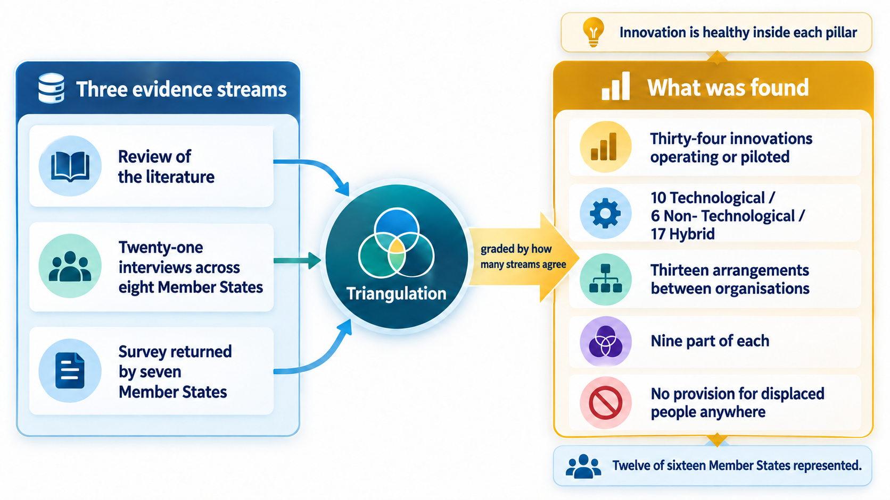
Figure 1 · The Landscape Assessment: how the evidence was built, and what it found
Landscape Assessment finding | What it means for SHOC
Thirty-four innovations operating or piloted across the region | SHOC does not need to commission invention. It needs to select, integrate and operate what already exists
Twelve are technological, thirteen are arrangements between institutions, nine are part of each | Two-thirds of what the region has built cannot be acquired through a procurement. They are agreements, protocols and standing arrangements, which is what a coordination centre is equipped to create
Twelve of the sixteen Member States are represented in at least one evidence stream | The picture is regional rather than anecdotal. Four Member States are not represented and that limit is stated rather than smoothed over
Innovation inside each pillar is comparatively healthy; the system fails between the pillars | SHOC sits exactly at those joints. Its mandate is the hand-off, which is where the failure is
Of thirty innovations where an inclusion determination could be made, none records provision for migrants and displaced people | The group most directly produced by the hazards SHOC responds to is the group no instrument currently reaches

1.2 The Innovation Gap Analysis: what is missing
The Innovation Gap Analysis turned that stock of innovation into a diagnosis. It examined the functions no institution in the region reliably performs, why those absences persist, and where in the chain from warning to action the system fails. This is the analysis every instrument in this Programme was selected against.
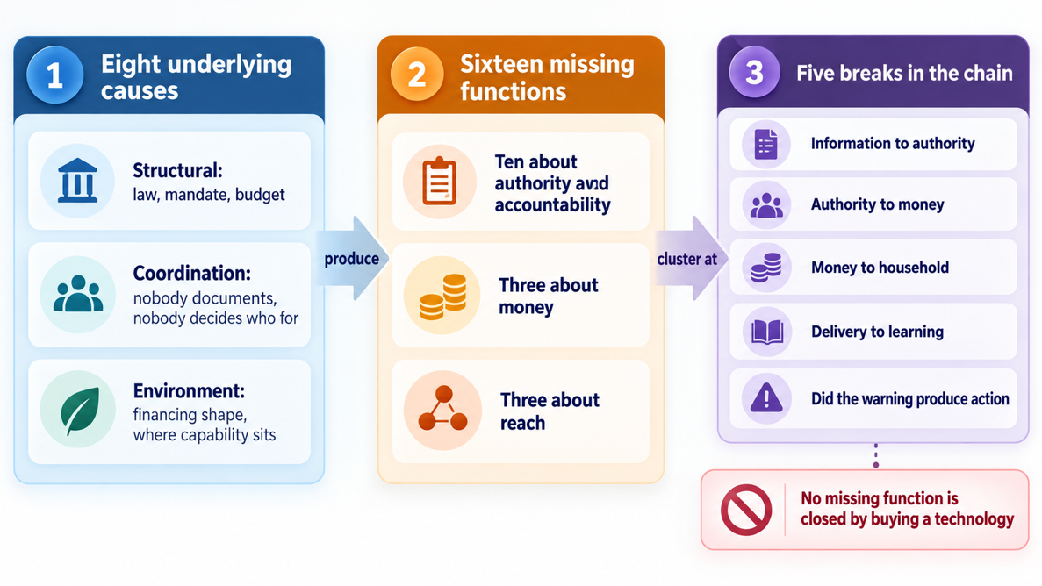
Figure 2 · The Innovation Gap Analysis: eight underlying causes, sixteen missing functions, five breaks in the chain
Innovation Gap Analysis finding | Composition | What follows from it
Sixteen functions exist that no institution in the region reliably performs | Ten concern authority, agreement and accountability; three concern money; three concern reach | No missing function is closed by acquiring a technology the region does not have. This single finding is why the Programme places arrangements ahead of equipment
Eight underlying causes | Structural, needing a change in law, mandate or budget; coordination failures, where nothing obliges anyone to document or to decide who an instrument is for; and features of the wider environment, being how financing is shaped and where technical capability sits | Most of the causes are institutional, which means they are correctable by agreement rather than by expenditure — and correctable at a fraction of the cost of the technology they currently block
Five breaks in the chain from warning to action | Risk information becoming a decision; a decision releasing finance; finance reaching a household; delivery becoming learning; and the verification that a warning produced an action | All five are open, and all five stay open for the same reason: the arrangements that would close them reach no household directly and are therefore never prioritised in any ranking

1.3 What the two together establish, and what they do not
Established by the two deliverables | Not established, and therefore open
The region has no shortage of innovations. Thirty-four are operating or piloted | Whether integrating them under common procedure changes regional performance. That is the hypothesis at section 5, and it is a claim rather than a finding
The failures are institutional, at the hand-offs, not technical and not inside the pillars | Whether SHOC can absorb integration at the pace proposed. Section 3 assesses its position; the scorecard at section 7.2 measures it
No instrument reaches migrants and displaced people | What provision for that group would cost or require. It is a design task, scheduled before scale-up
Nothing in the evidence records a cost for any innovation | What the regional programme costs in full. Section 9 states what can be costed today and what cannot
The distinction between the two columns is the discipline of this document. What the Landscape Assessment and the Innovation Gap Analysis established is reported as finding. What follows from it is argued as proposition and tested by the logic model at section 6. The Programme does not present the second as though it were the first.

2. The regional mandate, and what it permits
This section highlights what the Community is actually authorised to do, so the mandate is set out before the proposition rather than after it. It is not a formality. The hypothesis in section 5 indicates that integration under common procedure will change how the region performs, and the strength of that claim depends entirely on whether the Community may lawfully integrate it. It may — but not by command, and the distinction shapes the whole Programme.
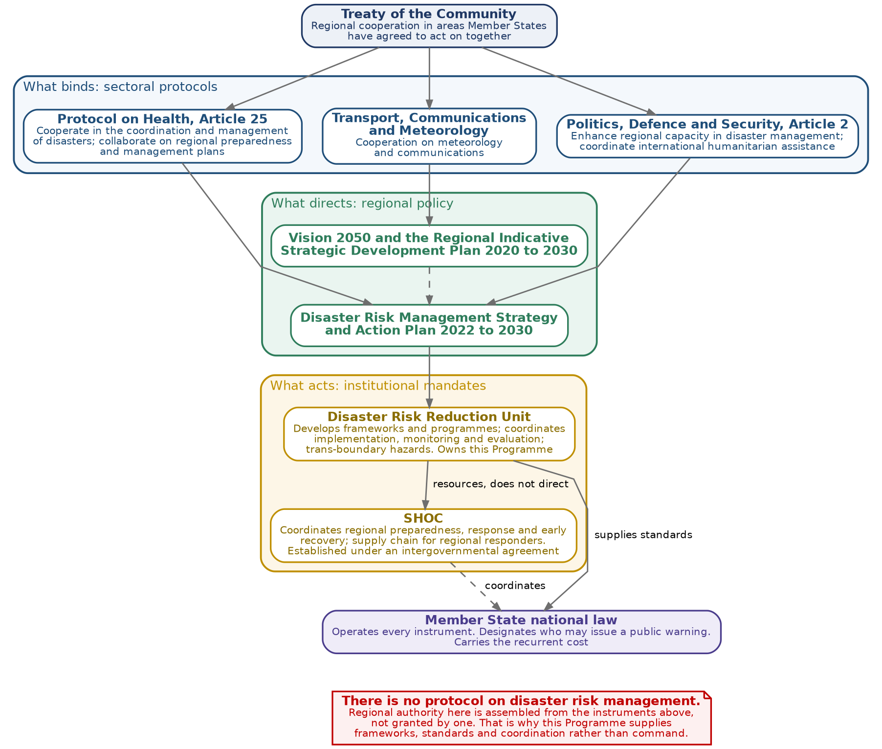
Figure 3 · The regional mandate: what binds, what directs, what acts, and where it stops

2.1 How the mandate is assembled
There is no protocol on disaster risk management. The Community states this itself, and it is the single most important fact about the authority this Programme operates under. Regional authority in this field is assembled from several instruments rather than granted by one, and a programme that implies otherwise is describing an authority that does not exist.
Layer | What it provides | What it means here
What binds: sectoral protocols | The Protocol on Health, at Article 25, obliges Parties to cooperate in the coordination and management of disasters and to collaborate on regional awareness, risk reduction, preparedness and management plans. The Protocol on Politics, Defence and Security Cooperation, at Article 2, makes regional capacity in disaster management and the coordination of humanitarian assistance an objective of the Organ. The Protocol on Transport, Communications and Meteorology supports cooperation in the two sectors most of these instruments run on | This is the treaty-level obligation. Every preparedness instrument proposed here rests on the Health Protocol, and the alerting instruments rest on the communications and meteorology cooperation the third protocol supports
What directs: regional policy | Vision 2050, the Regional Indicative Strategic Development Plan 2020 to 2030, and the Disaster Risk Management Strategy and Action Plan 2022 to 2030 | Policy authority, not legal authority. It directs what the region will do; it does not by itself empower action inside a Member State
What acts: institutional mandates | The Disaster Risk Reduction Unit is mandated to develop effective frameworks and programmes that facilitate coordination, implementation, and monitoring and evaluation, and to coordinate regional preparedness for hazards that cross borders. SHOC is mandated to coordinate regional preparedness, response and early recovery, and to facilitate the supply chain for regional responders | This is the closest fit of all. The mandate of the Unit describes this Programme almost word for word, and the mandate of SHOC describes the operations the Programme is designed to resource
Where it stops: Member State law | Every instrument is operated by a national institution under national law. Designating who may lawfully issue a public warning is a national act. So is carrying the recurrent cost | The Community supplies; the Member State adopts. No regional instrument can substitute for either decision

2.2 What the Community may and may not do
The Community may | The Community may not
Develop frameworks, standards, protocols and programmes for disaster risk management | Operate a disaster instrument inside a Member State
Coordinate regional preparedness and response, particularly for hazards that cross borders | Direct a national disaster management authority
Monitor and evaluate practice against regional, continental and global targets | Compel a Member State to report
Coordinate international humanitarian assistance | Bind a Member State in the absence of a ratified instrument

2.3 Why this complements the hypothesis rather than constraining it
The mandate permits exactly the thing the hypothesis proposes, and withholds exactly the thing it does not need. The hypothesis at section 5 is that integrating instruments under one set of procedures will shorten the interval between hazard signal and protective action. Integration of that kind is framework, standard and coordination work, which is what the Unit is mandated to do and what SHOC exists to carry out. It requires no authority to operate anything inside a Member State, and it asks for none.
That is also why the hypothesis is testable. A proposition that depended on the Community directing national authorities could never be tested, because the Community cannot do it and the test would never run. A proposition that depends on supplying a standard and coordinating its adoption can be tested as soon as the standard is issued and a Member State adopts it. The mandate is therefore not a limitation on the argument of this Programme; it is the reason the argument can be put to the evidence at all.
One boundary carries directly into the investment sequence. The instruments that reach a household are blocked by a national regulatory decision on who may issue a public warning. No regional instrument can take that decision, and no amount of investment at SHOC can substitute for it. That is why the request at section 11 puts the designation of alerting authority ahead of the technology it would authorise.
Programme accountability remains with the Secretariat’s Disaster Risk Reduction Unit, supported by a Programme Steering Committee under delegated authority. SHOC defines operational requirements and tests whether outputs strengthen its mandate. National authorities approve and operate national instruments. The Steering Committee reviews delivery, risks and recurrent-cost commitments quarterly; national authorities provide implementation returns, while SHOC supplies the activation evidence needed to assess operational results.

3. SHOC: position and what it uses today
SHOC is established as an autonomous, self-accounting institution of the Community, located in Nacala, Nampula Province, Mozambique, under an intergovernmental memorandum of agreement that requires two-thirds of the sixteen Member States to sign for it to come into force. Within the mandate set out in section 2, it coordinates; it does not operate instruments inside a Member State, and its mandate does not extend to rehabilitation and reconstruction. Every innovation proposed here was tested against that boundary.

3.1 What SHOC is already using
The answer to whether SHOC uses innovations today is yes, in five areas, at different stages of maturity. The table states the extent rather than the intention.
Area | What is in use | Extent | What limits it
Situation awareness | Multi-Hazard Situation Room, operating as the regional nerve centre for monitoring, early warning and decision support. Three situation rooms now exist in the region: at SHOC, in Mozambique and in the United Republic of Tanzania | Established | Interoperability with national situation rooms is being built rather than complete
Impact-based advisory | SHOC already issues impact-based advisories on hazards affecting the region, with work under way to extend them to earthquakes, lightning and wildfire | Established and extending | Coverage is hazard by hazard; the advisory does not yet carry to the household
Regional risk information | The subnational risk model developed for the entire region, assessed at SHOC in February 2026 for hosting as a sustainable regional platform for risk information management and multi-hazard early warning | Emerging | Hosting decision, recurrent cost and staffing
Response coordination | Emergency response team mechanism, trained with international partners and interoperable with United Nations coordination systems; regional simulation exercise conducted at Nacala in July 2026 to test readiness | Established | Deployment depends on standing arrangements that are still being documented
Emergency telecommunications | Very high frequency and ultra high frequency systems and emergency alert systems for operational coordination | Emerging | Standard operating procedures for emergency telecommunications are under development

What is not yet in place is the operating architecture rather than the technology. Several key standard operating procedures remain under development, including early warning and monitoring, emergency telecommunications, emergency response teams, information and communications technology security and access, and supply chain. Until those are issued, each innovation SHOC adopts has to be operated by arrangement rather than by procedure, which is the single largest constraint on absorbing anything new.
Before adoption, SHOC and the relevant national institution should confirm an operational owner, staff and training needs, interoperability and data-sharing arrangements, service continuity, and the budget required to maintain the capability. An exercise should test the complete chain before routine use. Where these conditions are incomplete, the implementation plan should identify the responsible institution and the corrective action, and pace deployment to demonstrated absorptive capacity.

3.2 How well positioned SHOC is to absorb more
Dimension | Position | Consequence for this Programme
Institutional home | An operating situation room, a director, a trained response team mechanism and an established partner network | SHOC can absorb instruments that feed a situation room. It is less able to absorb instruments that require field operations it does not staff
Legal standing | Established under an intergovernmental agreement requiring two-thirds of Member States | Investment that depends on the instrument being fully in force should be sequenced behind investment that does not
Procedures | Several core standard operating procedures under development | Procedure should be financed alongside technology, not after it. An instrument without a procedure is not an operating capability
Recurrent cost | Sustainability planning under way, including a business continuity model | Every instrument proposed here carries a stated annual running cost and a named accountable post before it is accepted
Partnerships | Active relationships with continental, United Nations and movement partners, and a record of co-delivered equipping | Much of the capability can be reached through partnership rather than purchase

4. Which innovations fit the mandate, and what they add
Twenty-six candidate tools were assessed on one instrument against eight weighted criteria: measurable impact on disaster risk reduction, strategic alignment, inclusion responsiveness, technical feasibility, institutional feasibility, cost-effectiveness, scalability and sustainability. Each weight was then perturbed in turn and the full set recomputed sixteen times. The membership of the leading group did not change under any perturbation, so a disagreement about the weights should be resolved by asking which tools belong in the leading group, not by arguing about their order within it.

4.1 Three findings that should shape the investment
Finding | What follows from it
The ranking measures reach, not capability | Five of the six highest-ranked tools reach the household with no institutional transfer in between, and all five are alerting or public-information instruments. Field capabilities that need an institution to convert their output into action — aerial survey, logistics, platforms, surveillance — cluster lower irrespective of technical merit. The ranking should not be read as a statement of operational value to SHOC
Institutional feasibility is the binding constraint at the top | The two highest-scoring alerting instruments carry the two lowest institutional feasibility scores in the leading group, both because cellular alerting requires a regulatory authorisation that does not exist. The tools most able to reach households are the ones least able to be switched on
Inclusion is the weakest criterion across the set | Eleven of the twenty-six score three or below on inclusion responsiveness and seven score one. In every case this reflects an absent inclusion design rather than absent evidence, which means it is correctable at design stage rather than inherent

4.2 What fits each part of the mandate
The SHOC’s mandate focuses on readiness, coordination, preparedness and response, and logistics of the SADC region. Grouping the assessed tools against those functions is more useful than ranking them against each other, because SHOC adopts by function.
Mandate function | Instruments that fit | What they add | Position
Regional readiness and risk information | Subnational risk model; regional hazard watch platform; flood forecasting and soil-moisture products; fire information systems and satellite burn-scar products | A single regional risk picture, refreshed continuously, that the situation room can act on without assembling it by hand each time | Partly in use; the risk model is the anchor investment
Early warning and advisory | Impact-based forecasting; common alerting protocol with last-mile integration; localised action guidance | Converts a hazard forecast into an impact statement and a protective instruction, in a form every channel can carry without re-keying | Impact-based advisory established; alerting protocol not yet adopted
Reaching the household | Cell broadcasting with local-language voice; short message alerting; ring-back tone warnings | The last mile. These are the only instruments in the set that reach a household with no institutional transfer in between | Not in use. Blocked by alerting authority rather than by cost or technology
Coordination and situational awareness | Situation room integration with national rooms; expert pooling and surge roster; loss and damage dashboards | Turns a regional picture into an allocation of people and resources, and records what was done | Situation room established; roster and dashboards not yet
Response and regional logistics | Humanitarian logistics platform; drone-based rapid mapping; aerial systems competence centre; cargo drones for last-mile delivery | Compresses the time between an event and an informed deployment, and moves relief where roads do not | Partner capability exists regionally; not yet integrated into SHOC’s operating procedure
Learning and replication | Weekly community reporting protocol; documentation standard | Makes each activation an entry in a regional record, so that what one Member State proves another can adopt | Not in use. The cheapest instrument in the set and the one that makes all the others transferable
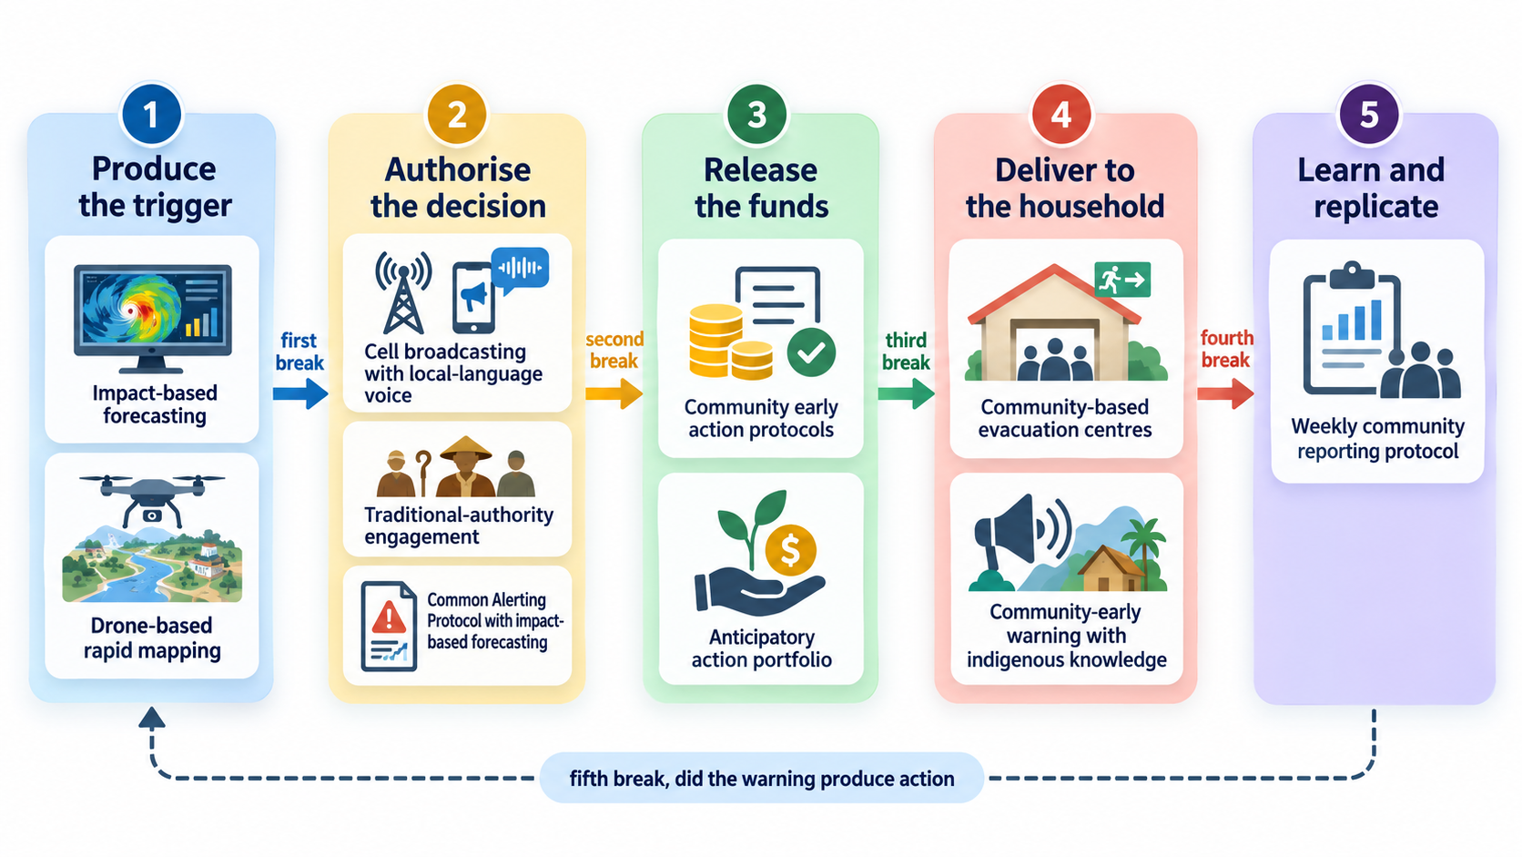
Figure 4 · Ten worked examples placed on the chain from hazard signal to protective action
The ten listed are examples and they are not the programme. They are presented because each closes a hand-off that no other instrument closes, and because together they demonstrate the integration this Programme argues for. The larger scheme is the chain itself: any instrument that occupies one of these five positions and can be operated under SHOC’s procedures belongs in the Programme, whether or not it appears in this document.
The examples remain open to replacement or extension as evidence improves. Admission requires a documented gap within SHOC’s functions, demonstrated operating evidence, national legal clearance where needed, a delivery counterpart, inclusive design and a costed sustainability plan. Partnerships with national authorities, research institutions, civil society and private operators provide the delivery routes; regional standards and documented adoption pathways provide the means to scale.

5. Theory of change and the core hypothesis

5.1 The core hypothesis
The mandate at section 2 establishes that the Community may develop frameworks, standards and programmes and may coordinate their adoption, but may not operate anything inside a Member State. The hypothesis is framed to sit inside that, which is what makes it testable.
If SHOC operates risk information, authorised alerting, pre-arranged financing triggers and a documented delivery record as a single chain under one set of procedures, rather than as separate tools under separate arrangements, then regional coordination shifts from reactive to anticipatory and the interval between hazard signal and protective action falls materially — because the binding constraint on that interval is the institutional hand-off between instruments, not the technical performance of any one of them.
What would falsify it. If instruments were integrated under common procedure and the interval between signal and action did not fall, the hypothesis would be wrong and the constraint would lie elsewhere — most plausibly in national absorption rather than regional coordination. The logic model at section 6 is built to detect that, because a theory of change that cannot be disproved is not a theory.
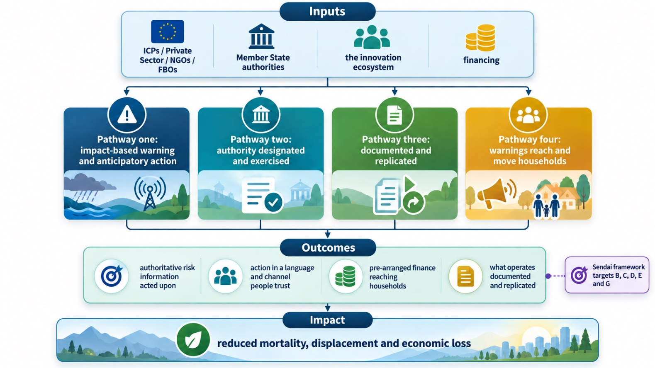
Figure 5 · Theory of change: inputs, four pathways, outcomes and impact

5.2 The four pathways
Pathway | What changes | What SHOC contributes
Impact-based warning and anticipatory action | Warnings state the expected impact and trigger pre-arranged action | The regional advisory and the trigger standard that Member States adopt
Authority designated and exercised | Someone is lawfully able to issue a public warning, and does | Convening the regulators and operators; supplying the alerting standard
Documented and replicated | What works in one Member State is recorded and offered to the others | The regional record, which only SHOC is positioned to hold
Warnings reach and move households | A warning arrives in a language and channel people trust, and produces an action | The message standard and the verification that action followed

5.3 The assumptions that carry the most weight
Assumption | If it fails | How it is managed
Member States designate who may lawfully issue a public warning | The last-mile instruments cannot be switched on and the chain stops one step short of the household | Sequenced first. Regulatory convening precedes investment in alerting technology
Operating institutions document what happened to a common standard | Instruments work where they are and remain unreplicable everywhere else | Documentation is a condition of completion for every instrument, not a reporting courtesy
Recurrent cost is carried after the investment period | Instruments stop in their second or third year | A named accountable post and a budget line are required before an instrument is accepted as complete

6. Logic model
The theory of change states the direction of travel. The logic model states what will be built, what will be measured, and what each measurement rests on. Every indicator below is readable from records that already exist or that the instruments themselves produce; an indicator requiring a new collection instrument has been removed rather than carried, because an unmeasured indicator is worse than none.
Level | Result | Indicator | Means of verification | Assumption
Impact | Reduced disaster mortality, displacement and economic loss in participating Member States | Sendai Framework Targets A, B and C | Member State returns to the Sendai monitoring system | Hazard exposure stays within the range observed
Outcome 1 | The interval between hazard signal and protective action falls | Median hours from regional signal to first recorded protective action, per activation | SHOC activation records | Alerting authority is designated in the participating States
Outcome 2 | Regional coordination becomes anticipatory rather than reactive | Share of activations in which action is triggered before impact rather than after assessment | SHOC activation records | Triggers are agreed and finance is pre-arranged
Outcome 3 | What one Member State proves, another adopts | Number of instruments adopted by a second or later Member State | The regional record held by SHOC | The documentation standard is issued and used
Output 1 | A single regional risk picture, refreshed continuously | Risk model hosted and refreshed to an agreed cycle | Hosting record and refresh log | Hosting decision taken; recurrent cost carried
Output 2 | An alerting standard issued and adopted | Member States that have adopted the standard | National policy or regulatory instrument | Regulators convene and decide
Output 3 | Operating procedures issued | Procedures issued, of those identified as outstanding | SHOC | Procedure development is financed alongside technology
Output 4 | Every activation documented to one standard | Share of activations documented to the standard | The regional record | Documentation is a condition of completion, not a courtesy
Output 5 | Inclusion provision designed in, not assumed | Determinations completed across seven groups, including recorded absences | Programme record | Data can be disaggregated at source
Output 6 | Recurrent cost assigned before completion | Instruments with a named accountable post and a budget line | Member State budget documentation | Budget cycles allow a new line inside the period
Two indicators carry the hypothesis and should be read together. Outcome 1 measures whether the interval falls; Outcome 2 measures whether action moves ahead of impact. If the outputs are delivered and neither outcome moves, the hypothesis is wrong and the constraint lies in national absorption rather than regional coordination. Both baselines are set in the first six months, because without them neither claim can be made later.
SHOC and participating national authorities agree indicator definitions, baseline values and phase targets within the first six months. The activation record captures signal, decision, finance release, protective action and relief-dispatch times, so that regional logistics performance can be tested alongside warning lead time. Records capture reach by sex, age and disability, with safe provision for migrants and displaced people; inclusion determinations alone do not demonstrate that people were reached. The Disaster Risk Reduction Unit coordinates a contribution-based mid-term review at the end of year three and a final review in 2031.

7. Implementation metrics and the readiness scorecard

7.1 Implementation matrix
Delivery is phased against the mandate functions rather than against the instruments, because SHOC adopts by function. Each phase carries a metric that can be reported without a new survey.
Mandate function | Phase one, 2027 to 2028 | Phase two, 2029 to 2030 | Phase three, 2031 | Metric
Readiness and risk information | Host the regional risk model; agree the refresh cycle | Integrate national situation rooms to a common interface | Named in regional and national policy | Refresh cycle met; national rooms integrated
Early warning and advisory | Issue the alerting standard; extend impact-based advisory to the remaining hazards | Member States adopt the standard | Standard carried in national instruments | Hazards covered; States adopting
Reaching the household | Convene regulators on alerting authority | Deploy alerting in States that have designated authority | Alerting authority designated region-wide | States with designated authority
Coordination and surge | Issue the outstanding operating procedures; stand up the surge roster | Exercise the chain end to end at the regional simulation | Procedures institutionalised and reviewed annually | Procedures issued; exercise completed
Response and logistics | Integrate partner field capability into procedure | Deploy under procedure in a live activation | Capability held under standing arrangement | Activations run under procedure
Learning and replication | Issue the documentation standard | Document every activation; publish the regional record | Replication offered as routine | Activations documented; instruments replicated

7.2 The readiness scorecard
The scorecard is one of the instruments which the SHOC can apply to see its own position and track it. Ten dimensions, each scored from zero to four, assessed against the evidence available at the time of writing. The current column is a determination from the record rather than a self-assessment, and it should be reviewed by SHOC and corrected where the record is incomplete. The target is the position the Programme is designed to reach by 2031.
Dimension | What a score of four looks like | Now | 2031 | Movement required
Situation awareness | A regional risk picture refreshed continuously and shared with every national situation room | 3 | 4 | Integration with national rooms
Impact-based advisory | Impact-based advisories across all principal regional hazards | 3 | 4 | Extension to the remaining hazards
Reaching the household | Warnings reach households directly in a language and channel they trust | 0 | 3 | Alerting authority, then technology
Anticipatory triggers | Pre-agreed triggers release finance and mobilise response before impact | 1 | 3 | Trigger standards and pre-arranged finance
Coordination and surge | A trained, rostered capability deployable under written procedure | 3 | 4 | Surge roster and procedures issued
Response and logistics | Field capability integrated into procedure and exercised | 2 | 3 | Integration rather than acquisition
Documentation and learning | Every activation recorded to one standard and available regionally | 1 | 4 | The documentation standard, which is the cheapest instrument in the set
Operating procedures | The procedures identified as outstanding issued and under annual review | 1 | 4 | Financing procedure alongside technology
Inclusion provision | Designed provision for all seven groups, including displaced people | 1 | 3 | Design at instrument level, before scale-up
Recurrent cost custody | Every instrument carries a named accountable post and a budget line | 1 | 3 | Member State decisions, not investment
The scorecard totals sixteen of forty today and is designed to reach thirty-five. Two features of that movement matter more than the total. The largest single gain available is in documentation and learning, which is the cheapest instrument assessed and the one that makes every other instrument transferable. And the lowest score in the set, reaching the household, cannot be raised by investment at all until a national regulatory decision is taken — which is the finding at section 4.1, appearing here as a number.

8. The delivery platform and its significance.
The Programme is not delivered as a set of documents. It is delivered as a working platform, and this is the part most easily overlooked because it does not look like a deliverable. The platform holds the evidence base as structured data, and generates the products the Programme needs from that one record. It is live and can be demonstrated.

Field | Detail
Access | https://arc-d4-programme-generator-c7qdwgesqvnwjafgvpxgat.streamlit.app/
What it holds | The consolidated data pack: thirty-four innovation records with lead institutions, geography, maturity, barriers, financing, inclusion determinations, gap and opportunity linkages, legal and mandate registers, the prioritisation instrument and the cost estimation matrix
What it produces | Ten document types from that one record: regional programme document, concept note, implementation plan, validation pack, policy brief, Member State adoption plan, public warning and communication plan, terms of reference, completeness annex and funding proposal
Scale | Any of the thirty-four innovations, in any Member State, against any of the ten document types, generated on demand rather than drafted from blank paper

8.1 Why it matters to SHOC rather than to the consultancy
 | Reason | What it means in operation
One | It is what makes replication practical rather than aspirational | Replication fails because the second Member State starts from nothing. Here the adoption plan, the concept note and the terms of reference for an instrument already proved elsewhere are generated from the record in minutes. The cost of offering an instrument to the fifteenth Member State is close to the cost of offering it to the second
Two | It enforces the Programme’s rules automatically, where a person would forget them | Nothing is invented: a field the record does not hold is either omitted or written as a request naming who is being asked. Cost bands never appear in a document a bidder sees. Inclusion absences are stated rather than quietly dropped. These are rules a drafter has to remember and the platform applies every time
Three | It is the asset that outlives the contract | When this consultancy ends, the record, the templates and the code remain with the Disaster Risk Reduction Unit and with SHOC. A new or updated innovation is added to the record and the full set of products regenerates. The Programme continues to produce propositions without the people who built it
Four | It turns the regional record from an obligation into a return | SHOC is the only institution positioned to hold what works across the region. Holding it is a cost until something converts it into propositions a financing partner can act on. The platform is that conversion
The practical test is the one to apply. Ask for a concept note, an implementation plan and a terms of reference for any one of the thirty-four innovations, in any Member State, and judge how long it takes and what it costs. That is the capability being transferred, and it is the reason the platform is reported here as a component of the Programme rather than as a tool of the consultancy that built it.
One operational note. The platform is hosted on a community service that suspends an application after a period without use, so a reviewer opening the link cold may need to restart it and wait briefly. Before the platform is relied on as an institutional asset it should be moved to hosting controlled by the Secretariat, and the cost of doing so is included in the integration layer at section 9.2.
Institutional handover covers the data pack, the templates, the code, user administration, maintenance responsibilities and staff training. SHOC and the Unit agree data-access permissions, backup and recovery arrangements, and a funded support owner before accepting the platform as an operational service.

9. What full deployment requires
No cost figure was recorded for any innovation in any evidence source used by the Landscape Assessment. The cost estimation matrix was built to close that gap: nine cost archetypes, each banded against named published comparators, several from inside the region. The figures below are bands for appraisal, replaced by nationally priced figures before financial close.

9.1 Software, hardware and the part that is neither
Component | What it covers | Share of a typical instrument | Why it is stated separately
Hardware | Sensors, aerial systems, telecommunications equipment, situation room infrastructure | Low in most instruments; dominant in aerial and telecommunications | It is the part a procurement can buy, and the part most programmes over-weight
Software and data | Platforms, licences, imagery and data acquisition, integration between systems | Moderate at establishment, high in recurrent cost | Data acquisition and refresh dominate running cost and are routinely under-budgeted
Institutional | Agreements, protocols, standard operating procedures, regulatory authorisation, training, documentation | Dominant in two-thirds of the portfolio | It cannot be procured as a product and is therefore the part that goes unfunded. It is also the binding constraint identified at section 3.1

9.2 What the evidence supports costing today
The ten worked examples have been costed bottom-up as a first investment window, on a method that charges first implementation in full and later adoption at a replication rate, and funds running cost only through the transition to national budgets rather than for the life of the Programme.
Window | Indicative range | Basis
First window: the ten worked examples, eight Member States, five years | United States dollars 55 to 65 million | Bottom-up from the cost estimation matrix. Management, oversight and indirect recovery are approximately eleven per cent of the total, within every ceiling the funding partners apply
SHOC integration layer | United States dollars 10 to 21 million | What SHOC itself must build to run the ten as one chain: risk model hosting, situation room integration, the alerting standard, the outstanding procedures, the documentation standard, the surge roster, exercising and the staffing to operate them. Costed at section 9.3, to be confirmed with SHOC
Regional scale-up to all sixteen Member States | Within the indicative envelope | The envelope of 5.6 billion United States dollars is a programme-level planning figure for the full regional agenda to 2031. It is not derived from the instrument costings in this document and should not be presented as though it were
The relationship between the two tables should be stated plainly rather than reconciled by arithmetic. What this document can cost from evidence is a first window of approximately sixty million United States dollars for Member State adoption, and a further ten to twenty-one million for the SHOC integration layer at section 9.3. The indicative envelope is a planning figure for the whole regional agenda across five years, including national-level investment that no regional programme controls. Baseline validation, feasibility and financing appraisal will establish what sits between the two, and this Programme should not claim to have done that work before it has been done.

9.3 What SHOC itself must build, and what it costs
The first window above finances adoption of the ten instruments by Member States. It does not finance what SHOC must build in order to run them as one chain, and that is a separate cost object which has until now been left open. It is costed below on the same method: unit rates, bands for appraisal, replaced by procured prices before financial close. These figures should be confirmed with SHOC, which holds facts about its own establishment that this Programme does not.
Component | Establishment | Each year | What it buys
Regional risk model hosting | 0.6 to 1.2m | 0.25 to 0.5m | Platform, licences, data acquisition and the agreed refresh cycle for the subnational risk model
Situation room integration | 0.9 to 1.8m | 0.2 to 0.4m | Interfaces and connectivity between SHOC and national situation rooms, to a common data standard
Alerting standard and regulatory convening | 0.4 to 0.8m | 0.1 to 0.2m | Developing the common alerting standard and convening regulators and operators in each Member State
Operating procedures | 0.3 to 0.6m | 0.08 to 0.15m | Drafting, consultation and issue of the outstanding procedures, and their annual review
Documentation standard and regional record | 0.25 to 0.5m | 0.15 to 0.3m | The standard itself and the record that holds what each activation produced
Surge roster and expert pooling | 0.35 to 0.7m | 0.2 to 0.4m | Establishing and maintaining a rostered, deployable capability under written procedure
Training and exercising | 0.4 to 0.8m | 0.3 to 0.6m | Annual simulation exercising of the complete chain rather than of separate tools
Platform migration and support | 0.12 to 0.25m | 0.06 to 0.12m | Moving the delivery platform to hosting the Secretariat controls, with a funded support owner
Integration staffing at SHOC | — | 0.45 to 0.9m | The posts that operate the above. Without them the components are assets rather than capability
Total, SHOC integration layer | 3.3 to 6.7m | 1.8 to 3.6m | Five-year total of ten to twenty-one million United States dollars, including four years of running cost
The whole ask, stated once. Fifty-five to sixty-five million United States dollars for Member State adoption of the ten instruments, and ten to twenty-one million for the SHOC integration layer: a programme of sixty-five to eighty-six million United States dollars over five years. The two must be presented together and funded together, because the first without the second buys ten instruments that do not connect, and the second without the first buys a chain with nothing on it.
One accounting rule prevents the obvious error. Regional costs sit in the integration layer and national costs sit in the first window, and no cost appears in both. Where a partner is already financing a component regionally, it is recorded as a contribution against that line rather than requested again.

9.4 How the funding would be applied
Funding is applied by function and released against conditions, not disbursed against a work plan. The rules below are what a financing partner would be asked to accept and what the Unit would be bound by.
Tranche | Released when | Share | What it may fund
One: institutional | On approval of the Programme | About 20 per cent | Procedures, the alerting standard, regulatory convening, the documentation standard, baseline and indicator definitions. No technology
Two: first adoption | When the gating arrangement for an instrument is in place and its four conditions are met | About 35 per cent | Establishment of instruments in the first adopting Member State, and the regional risk model hosting
Three: replication | When the first adoption is operating and documented to the standard | About 30 per cent | Adoption by later Member States at the replication rate, and situation room integration
Four: institutionalisation | When a named post and a budget line exist for each instrument | About 15 per cent | Transition support, final exercising, and handover of the platform
Four conditions apply to every instrument before any tranche touches it, and they are not waivable. A named delivery counterpart in the Member State. Nationally priced costs replacing the indicative band. A named post accountable for the recurrent cost from the first full budget year. And, where a trigger is parametric, a stated treatment of basis risk and a pathway from subsidised premium to domestic financing.
The funding may be applied to | The funding may not be applied to
Institutional work: agreements, procedures, standards, regulatory convening, training and documentation | Technology whose gating arrangement is not yet in place, or whose authority to operate has not been designated
Establishment of an instrument in a Member State that has met the four conditions | An instrument in a Member State that has not named the post accountable for its recurrent cost
Running cost during the transition: in full in year one, at half in years two and three | Running cost beyond the transition, which falls to the national or institutional budget
Regional components that serve all participating States from a single implementation | A regional component already financed by a partner, which is recorded as a contribution instead
Exercising, evaluation and the independent reviews at year three and 2031 | Rehabilitation and reconstruction, which fall outside the mandate of SHOC
Why the sequence is built this way. The first tranche buys no equipment at all. That is deliberate, and it follows directly from the finding at section 4.1: the instruments that reach households are blocked by a regulatory decision rather than by cost. Financing technology before that decision is taken produces capability nobody may lawfully use, which is the single most expensive mistake available to this Programme.

10. The business case for investing in innovation at SHOC
The case does not rest on the merits of any instrument. It rests on four propositions, each of which can be checked.
The published returns below are comparators, not calculated returns for this Programme. Appraisal should test local avoided losses, time saved, operating costs and uncertainty against a without-programme baseline. The decision to invest should rest on an affordable improvement in preparedness, coordination and logistics, with recurrent funding secured; a regional benefit-cost ratio should be reported only when the baseline and loss data support it.
 | Proposition | The evidence behind it
One | Readiness bought before an event is cheaper than response bought after it | Investment in early warning in developing countries is independently reported to avoid losses of between four and twenty times its cost. Acting ahead of a disaster returns between one and a half and two times what the same money returns spent afterwards, and a study in Nepal found up to thirty-four dollars saved for each dollar spent before the event
Two | SHOC is the only institution positioned to hold the regional record | A Member State can prove an instrument; only a regional body can make that proof available to the other fifteen. The cheapest instrument assessed is the reporting protocol, and its return rises with every instrument it documents
Three | The binding constraint is institutional, and institutional constraints are cheap to fix | The alerting instruments that reach households are blocked by regulatory authorisation, not by cost. Convening regulators and operators costs a fraction of the technology it unblocks, and without it the technology cannot be switched on at all
Four | Integration multiplies instruments that are already paid for | Several capabilities SHOC would use are already financed by partners regionally. The investment proposed is substantially in the connective arrangements that let existing assets work together, which is the cheapest capability per unit of effect available to SHOC

10.1 What SHOC gains, stated as outcomes
Gain | What it looks like in operation
A single regional risk picture | The situation room begins each day with a current, regionally consistent picture rather than assembling one from separate national sources
An advisory that carries | An impact-based advisory that reaches a household in a language it uses, through a channel it trusts, because the alerting standard and the authority exist
Anticipatory rather than reactive coordination | Pre-agreed triggers release finance and mobilise response before impact rather than after assessment
A record that compounds | Every activation documented to one standard, so the fifteenth Member State to adopt an instrument starts from the experience of the first fourteen
A platform that converts the record | The evidence base held as data and turned into concept notes, adoption plans, tenders and funding proposals on demand, as described at section 8
Demonstrable readiness | A regional simulation exercise that tests an operating chain rather than a set of separate tools

10.2 The cost of not investing
If the Programme is not taken forward, three things follow from the evidence rather than from supposition. The instruments that reach households stay switched off, because nothing else in the region is convening the regulators required to authorise them. What each Member State learns stays with that Member State, because no documentation standard obliges otherwise and none is otherwise being issued. And SHOC continues to coordinate response rather than anticipate it, because anticipation requires the pre-arranged triggers and the authorised channels that this Programme is designed to put in place.

11. What is asked
 | Request | Of whom
1 | Endorse the integrated approach: instruments adopted as one operating chain under common procedure, rather than as separate acquisitions | Committee of Ministers responsible for disaster risk management, through the Disaster Risk Reduction Unit
2 | Confirm SHOC integration layer and the decisions it depends on, so that it can be costed | SHOC Secretariat
3 | Designate who may lawfully issue a public warning, and on what channel | Member States, through their regulators and national disaster management authorities
4 | Name the post accountable for the recurrent cost of each instrument adopted | Member States
5 | Commission the baseline validation and feasibility appraisal that sits between the costed first window and the indicative envelope | Secretariat, with the funding partner
6 | Agree the resource mobilisation and recurrent-financing plan at section 9.3, and authorise preparation of appraised funding packages | Disaster Risk Reduction Unit, with SHOC, Member States and financing partners

The first three cost nothing and unblock most of the rest. The chain described in this document stops one step short of the household until the third is settled, and that step is a regulatory decision rather than an investment.
References are issued as a separate document accompanying this submission. Sources for every factual claim about SHOC’s current operations, for the published returns cited in the business case, and for the evidence base are listed and linked there.

