ENS 491-492 – Graduation Project
Final Report

Project Title: #440 Taxi Pooling App(shareCab)

Group Members: #23818 Emre Bener
#24014 Murat Nuhoğlu

Supervisor(s): Yücel Saygın

Date: 16.05.2021


- EXECUTIVE SUMMARY

The main purpose of the project is to provide service to people who want to reduce their spending on transportation. The project suggests a taxi pooling method based on an interactive smartphone application called shareCab, that can be used in large transportation terminals, more specifically for airports in Istanbul. It has started to implement in both IOS and Android platforms in order to reach maximum amount of user. With this mobile application, users will be able to meet with other users who will go to their destination from the airports and share a taxi ride. The mobile application will also have a social media aspect for its users’ safety issues. With this social media aspect, users will be able to choose who to share their taxi ride. They will be able to see other users’ profile which consists of their name, age, profile picture and comment and ratings given by their previous travel-buddies before they match. After the match they will be able to chat and meet at the specific location in the airport.
As the applications such as Uber and Lyft are illegal in Turkey, there exists no available application to reduce users’ transportation cost. The designed application will be accepted legal because transportation will be provided by yellow taxis. The aim of the project is to just connect people who wants to share a taxi ride and payment will not be in the scope of this project however users will be able to see estimated price for their trip.
The main motivation of the project is to reduce the transportation costs of the users and at the same time to ensure a safe journey to them. The application will be designed to provide service to the users however, it will also benefit environment. Since it decreases the number of taxis in the current traffic density, it decreases the air pollution caused by taxis.

- PROBLEM STATEMENT

Traffic density have always been an issue for the big cities like Istanbul. One of the contributors to this density is Taxis. In Istanbul, there are approximately 18 thousand taxis currently working which is a lot. Since they are always in traffic, they directly have an impact on traffic density. Moreover, they cause air pollution which effects the health of human beings and other living creatures (Chun-Ying, 2018, p.5). In addition, taxi fares are high compared to other countries and cheaper applications such as Uber and Lyft are not allowed in Turkey. Therefore, the aim of the project is to create an application that allows users to share taxi so that users can travel with taxis while spending almost half of the price compared to usual taxi ride. Moreover, the number of taxis in the instant traffic and therefore, air pollution caused by taxis decreases.
In the literature there exists applications to allow users to share a taxi ride, such as Lyft and Uber. However, those applications are not allowed to be used by the country law. As stated in the law, transportation with those applications (Uber, Lyft) are now prohibited, and people who want to travel can use public transportation or yellow taxis. So, in that sense, the motivation of the developers for this project was to find a new solution for the people who does not want to spend too much money for the transportation spending.

  - Objectives/Tasks

- Throughout the development process of the applications, both developers worked hard to define all possible problems and to find a working solution for those problems. The biggest objective of the developers was to create an application with user-friendly interface. We always worked to create an application which is easy to understand and fun to use. Therefore, while developing the project, both developers collected an idea about how other applications look and thought about how it can be improved for the users.
- The most important feature in the modern world technology can be seen as security. In that sense authentication of the users was one of the most important implementations should have done on the project. This objective is completed with the help of native expo libraries and Firebase. Firebase provides a secure database for the users and expo libraries allows them to sign in with their social accounts. Firebase sends a SMS message to the user while signing up, moreover it sends an email when the user changes the profile information and so on. Therefore, it makes the application more secure since it provides two factor authentication.
- The hardest problem that encountered through the project development is to match users in real time to share their taxi ride. It was an important task to complete main functionality. Because of the nature of the application, users were expected to match with each other. This feature is implemented with Socket io library of JavaScript. Although the socket io library is generally used to keep real time chat logs in the database, developers of the application used socket io to keep real time user array and their coordinates to match users.
- Another objective of the project was to create a functionality which allows users to choose a starting point and a destination point for their trip. Luckily, Google provides a map service for the developers. With the help of Google Cloud platform, implementation of functionalities has completed. Google Maps API provided users a map view which they can travel through and Google Places API allowed users to search any location on the map.
- As a sign in method, there exists variety of methodologies which can be used in modern applications. For the authentication purposes, developers use different sign in methods such as Google, Facebook, Apple, GitHub, Twitter and almost every social media application like those. To achieve authentication services in this project, native expo libraries are used in implementation. Developers of the application used Google, Facebook and Apple sign in for the authentication.
- Push notification is one of the most important feature in the applications. There are different ways to send notification to the users. Developers of the application chose Expo push notification library to push notification for the different purposes. However, this feature has not been implemented. Yet…
- Car Pooling application concept depends on trust of users to each other. However, we are living in a world which people can not trust to every human being. To overcome and reduce this trust issue, social media aspect is implemented. Every user has a profile page which consist of their name, age, and gender, also the number of previous trips and the average rating they got from their previous cab-mates. We believe that if the user can see those information, it might be easier to trust another user. Moreover, developers of the application work on comment and ratings system nowadays which will also be displayed in the users’ profile that might increase the feeling of trust with the comment of their previous cab-mates.
- Users should be able to update their information. In the edit profile section, all users are able to update their profile picture, and email easily. However, it is not possible to update their name, age, and gender to increase security of the application.
- Users need to upload a profile picture while signing up and later from their profile page. This feature is Implemented with the help of Google Firebase. To allow this feature, it was necessary to ask permission from the user since the application needs to access to the camera or photo library. After the user gives the permission and takes or chooses a photo to upload, Firebase automatically uploads photo to the database and provides a URL link for this photo which will also be stored in the MongoDB.
- Users should sign in, sign up and log out with the properly working application flow. This flow is accessed with Context Provider. There exists a library in the JavaScript which allows user to keep track of their logged state. Moreover, developers also used the functions from the Google Firebase which navigates application through the logged state of the user.
- Users should be able to delete their account whenever they want. There will be a section in the edit profile page which will allow user to delete their account. However, this feature is not implemented yet.
  - Realistic Constraints

Economic: Although it does not require any economical constraints during the mobile application development phase, if the application is to be published in the Google Play Store and App Store, there is a publishing fee of $ 25 for the Google Play Store and $ 99 for the App Store. In addition, if the application is published in stores, it is necessary to rent a server on a platform such as AWS (Amazon Web Service) in order for the backend code to be accessible.
Environmental: When examining the effect of the application on environmental factors, it can be said that taxi pooling significantly reduces the number of taxi in traffic and thus, the traffic density. This application can be described as a perfect fit for a city like Istanbul with a very serious traffic problem. In addition to reducing the traffic density, there is a reduction in fuel consumption at the same rate. Two people traveling from the same place to the same place in the same taxi will reduce fuel consumption by 50%. Considering the price of fuel in our country, it is clear that there is a serious financial savings. In addition to this fuel saving, other contributions it will bring will be the reduction of carbon emission and therefore the decrease of air pollution. Considering all these factors, it is seen that the application is environmentally friendly and its positive effects on the environment will increase as the usage rate increases.
Sustainability: It will not have any sustainability problems under any circumstances where the mobile application is internet and smart phone. However, considering the health issues caused by the pandemic process, it is quite possible for people to prefer the practice less than the normal situation.
Safety: Because the app is based on people sharing taxis with people they don't know, safety concerns are inevitable. However, in order for the users to feel more comfortable, they were able to learn more about the person they will travel with by reading their profile photos, ratings and comments from their previous trips before choosing the person they will travel with. In addition, having a taxi driver in the vehicle with the users will also make the users feel more comfortable in terms of safety.
Health: As mentioned before, considering that we are in the pandemic process, the number of people who can share a taxi at the same time has been reduced from 4 to 2. Even though 4 people sharing a taxi brings greater benefits both economically and environmentally, the health of our users is always at the forefront for us. In addition, for the pandemic process, users can be notified with a pop-up about what they can do to protect their health during the journey before starting their journey.

- METHODOLOGY
In the project, since the problem that intended to be solved requires an application to be developed, there were variety of ways for the environment choice. An application supported by both IOS and Android platforms planned to be developed in order to reach maximum number of people. The application could have implemented in Android Studio for only Android, or in Swift for only IOS but the developers of the application chose one of the cross-platform languages for the frontend development, React Native. There were plenty of reasons behind the choice of React Native. Since it provides a slick, smooth and responsive user interface, it is reasonable to use React Native for mobile application development. It is also much faster and cheaper to build apps in React Native as opposed to building native ones, without the need to compromise on quality and functionality.
Another reason behind the choice was the prior knowledge of developers on React.js. The developers of the application have used React.js for the different projects before. Since both React.js and React Native are software languages ​​created by Facebook, there are serious similarities in their usage, and this accelerates the learning process considerably. Therefore, it was a factor affecting the choice of developers in that way.
For the backend development, Node.js is chosen to implement server side. It is an asynchronous programming language so that it is much faster compared to others. Also, the previous experiences of the developers were again an important factor affecting the choice of server-side implementation environment. For the database part of the backend, MongoDB and Firebase are used collaboratively. Both are NoSQL database systems that stores the data in JSON format. Moreover, both of them can easily be managed for different purposes. MongoDB has a module called mongoose, which can be easily accessed from the Node.js. In the MongoDB, personal information of the users such as name, email, profile picture, phone number, age, and gender are stored. Also, there is one more database for the comment and ratings of the users stored there. In the firebase, profile pictures of the users and social accounts such as Google, Facebook and Apple accounts that linked with the user’s accounts are stored.
The application is implemented with user-friendly interface and fully logical navigation. As the application starts, it welcomes users with the landing page which consist of two button choices (Figure 1). The user either can choose to sign in with the phone number or sign in with their social accounts such as Google, Facebook, or Apple accounts. Implementation of social account sign in is accomplished with the features provided by expo social library. If the user chooses to sign in with those social accounts, application redirects to the corresponding login page and users can directly sign in with the preferred account of their choice (Figure 2). However, if the user wants to sign in with their phone number, application navigates to phone number screen (Figure 6).
In phone number screen, user is asked to provide a phone number to complete SMS verification. If the entered phone number already has an account created before, it sends a code via SMS and after the verification of that code, it navigates to home screen where user can start to use application. However, if the phone number entered is a new phone number, user must create a new account by following the pages and filling the input boxes. After user enters a phone number, application sends a 6-digit random number via SMS to authenticate the user, then navigates to the verification screen (Figure 7).
In verification screen, there is an input box which user can enter the 6-digit code that got via SMS. If the code entered by user is not correct, the application asks for the code again, or user can press the ‘send code again’ button to refresh the verification code. After the verification is completed, application navigates to the email screen (Figure 8).
In email screen, there exists an input box to get email of the user. If the email entered by user has an account already, or signed in with the social accounts before, it gives the appropriate errors to the user and asks for the email until a proper email is entered. After that, it navigates to the personal information screen (Figure 9).
In personal information screen, the user is asked to provide a name and last name to display in their profile screen. After the user enters that information, application navigates to the last page of sign-up screen, which is called profile page screen (Figure 10). In that screen, there are two available options for the users. The user can either take a photo from the camera or choose one from their library. The application asks for the necessary permissions before it reaches to any other application. After the user chooses the profile picture, application saves all the provided information of user, then navigates to home screen which user can start to use application.
The main navigation style of the application is bottom tab navigation. The application navigates to home screen when the user presses the button on the bottom left, and it navigates to my profile screen when the user presses the button on the bottom right. Whole home screen consists of a map which user can travel through (Figure 11). This page is designed to carry out main functionalities of the application. User should choose a starting point for the trip, which can be either SAW (Sabiha Gökçen Airport) or IST (Istanbul Airport). If user clicks any of the airports, screen automatically focuses to the location of that airport. After that, user is expected to provide a destination point. If the user presses to the pick the destination button, application redirects to a new page, which user can choose a destination by putting a marker on the map or searching a destination from a Google places input box. After the destination is approved by the user, ‘Search cab-mates!’ button becomes pressable, and if clicked, pop-up screen comes up to screen and shows the available matches for the user. Since it is hard to find any two user who wants to go to the exact same destination, application is designed to match users who wants to go to the destinations that are in the range of 2 kilometers. The application provides a list of available users that can travel together to all users. This feature is implemented with the socket io library of JavaScript.
Socket io library generally used for chat applications or real time applications. However, developers of the application used socket io library to create a real time array of users and their destinations to get instant information about the other available users. User can choose who to share their taxi ride regarding their profile page screen. In that screen, there are information about the user such as name, age, gender, number of previous trips and average rating point got from all previous trips. Developers of the application believes that providing an information about rating of the user and the comments that are given from their previous cab-mates will increase the security of the application. If the user wants to travel with any other available user, it sends a notification to other user, and if other user also wants to travel, they got a match. They can meet at the specific location in the airport then share a taxi ride together. And consequently, the application achieves its purpose.
In the my profile page of the users, there are personal information about the user (Figure 15). These information are name, age, gender, number of previous trips and ratings. Below that, there are four different buttons which user can use.
First one is See previous trips button. If the user clicks that button, it navigates to another screen which user can see the list of previous trips and a button which will let users to comment on their trip(Figure 16). Once the user comments on a trip, the button disables and comment that they give to other users with the star rating is displayed in the screen(Figure 17).
Second button is, invite your friend button. This button is not implemented because the application is not deployed to Google Play Store or IOS App Store. However, it was supposed to reach the contacts of the user and send an invitation via SMS to use application.
Third button is help button. If the user clicks that button, application navigates to page which users can get help about any problem they may encounter while using app and a frequently asked questions section (Figure 18). In the profile and account section, there are three different headers which may help user (Figure 19). First one is changing profile photo. In that page users can get an information about how they can change their profile picture(Figure 20). Second one is update phone number. Since updating phone number might cause a security problem, this page informs user that they can delete their account and create a new account with desired phone number (Figure 21). Third one is delete my account which gives a detailed description of how users can delete an account (Figure 22). In the getting started and FAQs screen, there are 3 different section which users can see (Figure 23). Those sections provides and information about why the users should use ShareCab and what is the purpose of this project.
Fourth button is account settings button. In that screen users can change their profile picture or email (Figure 27). If the user clicks to the photo, three buttons shows up on the screen and user can either choose a photo from their library or take a photo instantly. If the user wants to change email, they can fill up the email input box and can click to submit to update their email.
And lastly, sign out button which users can sign out from their account. After the user signs out, application directly navigates back to landing page to allow user to use application all over again with the desired user account (Figure 1)
- RESULTS & DISCUSSION

The main reason why the students who developed the project chose this project was to develop a professional mobile application which is ready to be deployed in App Store and Google Play Store and used by actual users with a modern, useful and user-friendly interface. Looking at the current state of the project, it is seen that it has an interface at the level of the leading and widely used mobile applications in the market. Since the project is developed in a JavaScript framework, students also became very fluent in CSS (Cascading Style Sheets) while designing the screens. Besides developing a quality and user-friendly interface, of course, the functionality of the application was one of the top priorities. In order to achieve the functional requirements of the application, very important services such as Google Cloud Platform and Firebase, which are among the services provided by Google to software developers, were learned and used effectively while developing the project. These services of Google made the application much more useful in both the authentication flow and the location selection and search on the map.
Other functionalities such as sending push notifications and signing in with social accounts (Google, Apple, and Facebook) are handled by native Expo libraries. The main functionality of the application is handled by Socket.io. Thanks to Socket.io we can display the available users to a specific user in real time. In conclusion, being able to use these technologies effectively is qualities that are seen as a huge plus in a professional software development career. Thanks to this project, students gained the necessary infrastructure to be ready for complex projects in professional business life.
In the current state of the project, it would be correct to say that front-end part of the application is completely finished. Even though some screens are static, design and implementation of each screen is completed. The reason why there are static screens is that the comment, rating, and previous trips features are not implemented yet. As a result, the project cannot be said to be completely finished for now. It requires a couple additional backend feature implementation in order to be a mobile application which can be deployed in App Store and Google Play Store.
There are several features in the initial objects that are not implemented. The first of these was that the application was planned to be used in the whole city in the first stage, and then it was changed to be used only from airports to city centers.
Another feature was the user-to-user messaging service. Although it is an absolutely necessary feature for the application to be more professional, this feature was suspended after the meetings with the supervisor due to the limited time and the small number of students working on the project.
In the initial plan moreover, the application was planned to allow up to 4 people to share a taxi, but later this number was changed to 2, taking into account the health issues of users due to the COVID-19 pandemic.
During the development phase of the project, the developers always worked in parallel with the initial objectives and the project was progressed in this direction. Looking at the initial objects and the current state of the project, it would not be wrong to say that the initial objects have become reality. Although it is not correct to say that the project contributed to the previous state-of-art, the application, developed by using the most up-to-date technologies and tools, offers users a service where they can reduce their spending and socialize.

- IMPACT
There are many applications that do car pooling on the market, the first ones that come to mind are of course Uber and Lyft. Although these applications are very common globally, their use is unfortunately not legal in our country. Most of the carpooling apps either offer freight with independent drivers like Uber, or drivers with their own vehicles like BlaBla Car look for other people to companion with them. However, shareCab does not do any of these, it just brings people together who want to reach the city center from the airports via taxi. No other mobile application of this concept was found in the patent search. Consequently, it can be concluded that there is no freedom-to-use issue. It can be said with certainty that the application has a commercialization aspect, especially by advertising or contracting with airlines, it is possible to reach a much wider audience of users. But in line with such a serious commercialization idea, much more comprehensive tests need to be done.

- ETHICAL ISSUES
Ethical judgements are prioritized during the development process of the project. The application will be tested through the students of the Sabancı University which will increase the reliability of the application. However, after the application will be deployed to Google Play Store or Apple App Store, it will be based on the trust of people to each other. In order to minimize this trust issue, the social media aspect for the project is implemented. We considered the risk factors that may occur and the whole project is based on ethically accepted values.

- PROJECT MANAGEMENT
Since the start of the project, 3 major changes have been made in the project planning. The first of these and the most important for the implementation of the project was to change the environment in which the project was developed. React Native CLI and Expo CLI. Expo CLI is a third-party service and React Native CLI is developed by the react native team and society. The development of the application was started in the React Native CLI environment, but due to technical problems experienced later, the application was moved to the Expo CLI. The main reason for this change is that while developing applications with the React Native CLI, it is necessary to have a computer with macOS operating system to test devices with iOS operating system. Since the operating system of both developers' computers was Windows, it was not possible to test the application on a device with iOS operating system. In addition, Android Studio, which provides emulators for testing Android devices, used a lot of computer resources, and consequently caused difficulties and wasted time during the testing phase. In Expo, when we download the Expo Go application to any phone with Android or iOS operating system and read the QR code on the console when the project is run, we can test the application through the Expo Go application. Expo has many simplified libraries to access device features and to take advantage of some services. As a result, the Expo development environment was preferred due to the convenience it provides.
The second major change was the change in the usage areas of the application. While it was planned to be used all over Istanbul in the first stage, it was decided to provide transportation from the airports to the city centers with the joint decision of the software developers and the supervisor. The main reason behind this change is that there are too many people at the airports to reach the city center by taxi and the taxi prices are quite high because the airports are far from the city centers. Considering these environmental factors, it was decided that the airports are very suitable for the usability of the application.
The last major change was made in the authentication flow of the application. In the first stage, authentication was provided with the username and password seen in classical web applications. As a result of researches on similar mobile applications in the market, it was decided that authentication should be made with a one-time password sent to the user's phone number. While the membership process was presented to the user as a form on a single screen in the first stage, a multi-screen and visually satisfying interface was created.

- CONCLUSION AND FUTURE WORK
Thanks to the application developed, every person who travels by taxi from airports in Istanbul is provided with a service where they can both reduce the travel cost and socialize. In addition, there is an inverse correlation between increased use of the application and traffic density and air pollution. The more people use the application, the lower the number of taxis in traffic, and as a result, there will be a drastic reduction in air pollution. Although the functionality of the project has reached the desired level, of course many different features can be implemented. As the number of students working on the project was less than planned, normally a four-person project, the main focus of the developers was functionality. If we are to continue working on the project, the first feature to be developed should be chatting. In this way, people can determine their meeting points in a healthier way.
Another development may be that the application can be used not only at airports but from all over the city. However, in order for this feature to be developed, the application may need to communicate with taxi stands, as there is not a taxi stand everywhere as in airports. As a solution to this, a separate application can be developed for taxi drivers, such as BiTaksi, so that the taxi drivers can see the users who approve to travel with each other and go to pick up the passengers. If this implementation is made, payment methods can be added to the scope of the application. Since the distance to be traveled is predetermined, the taxi fare can be divided into two and transferred from the users account to the taxi driver's account. In this way, in addition to the service offered to passengers, the service can also be provided to find passengers at the taxi stands contracted with the application, and the application can be made profitable for both passengers and taxi drivers.

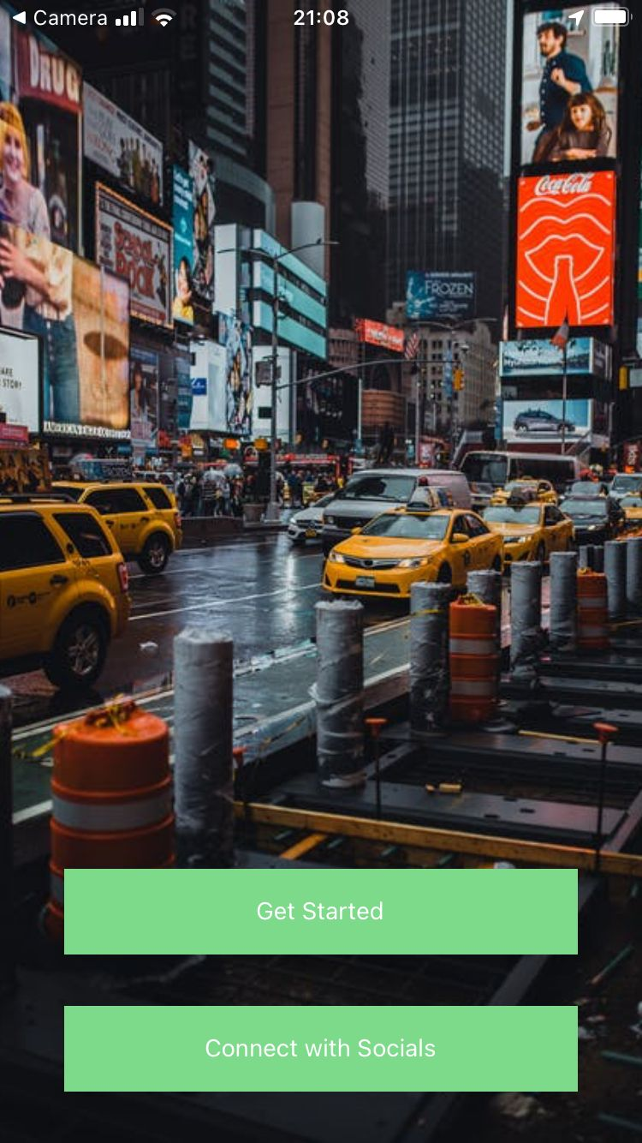
- APPENDIX
Figure 01
(Landing Page)
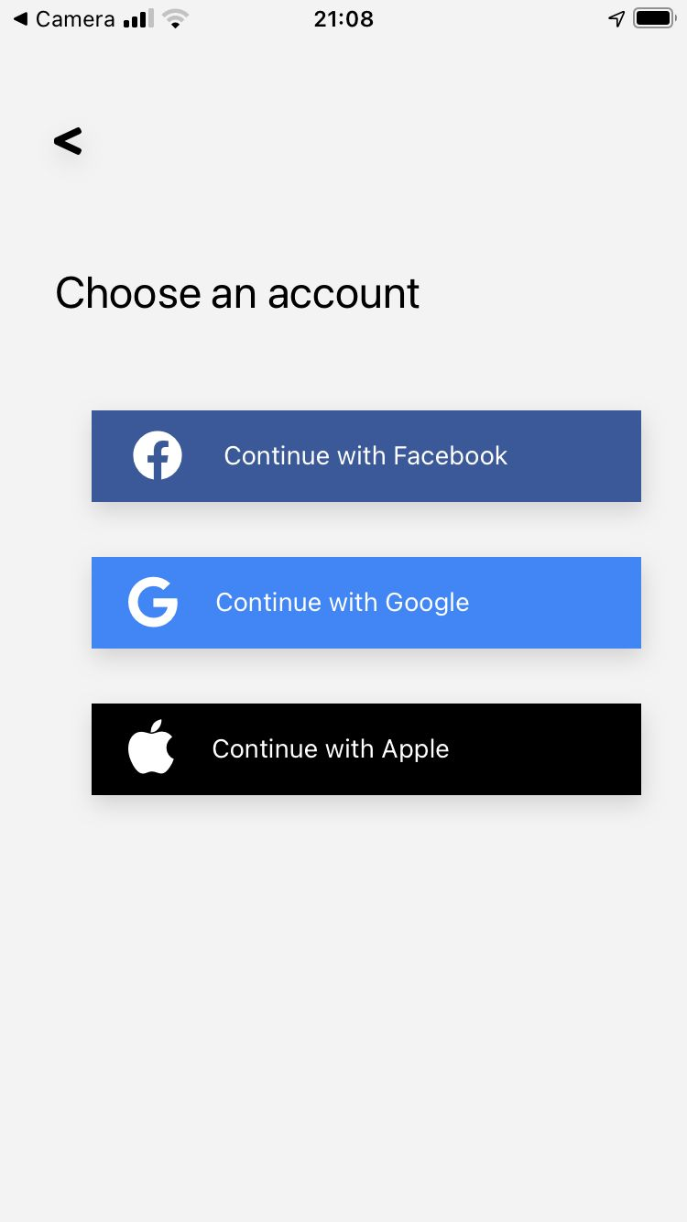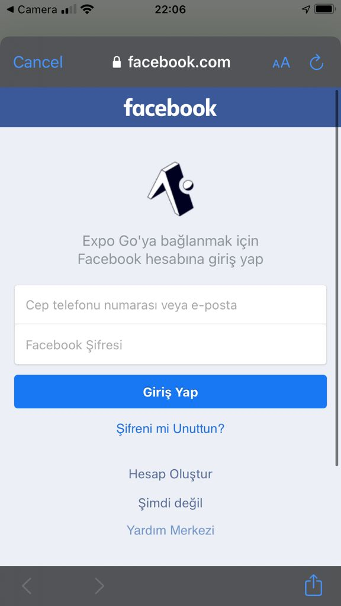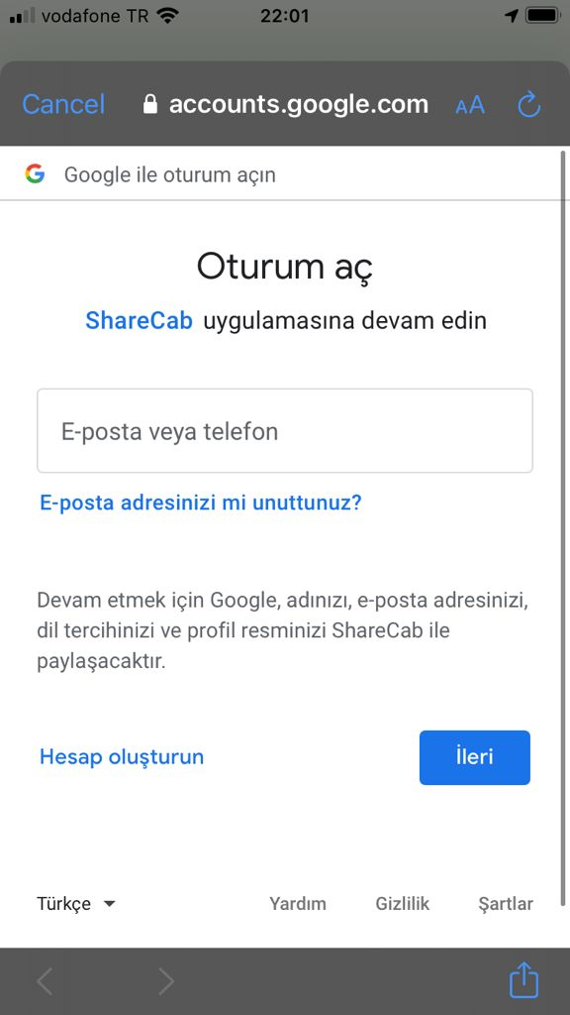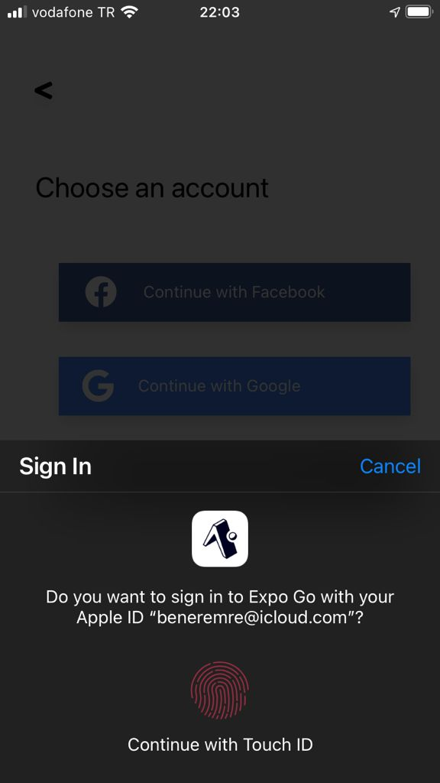
Figure 02
(Social Login Page)
Figure 03
(Facebook Login Page)
Figure 04
(Google Login Page)
Figure 05
(Apple Login Page)
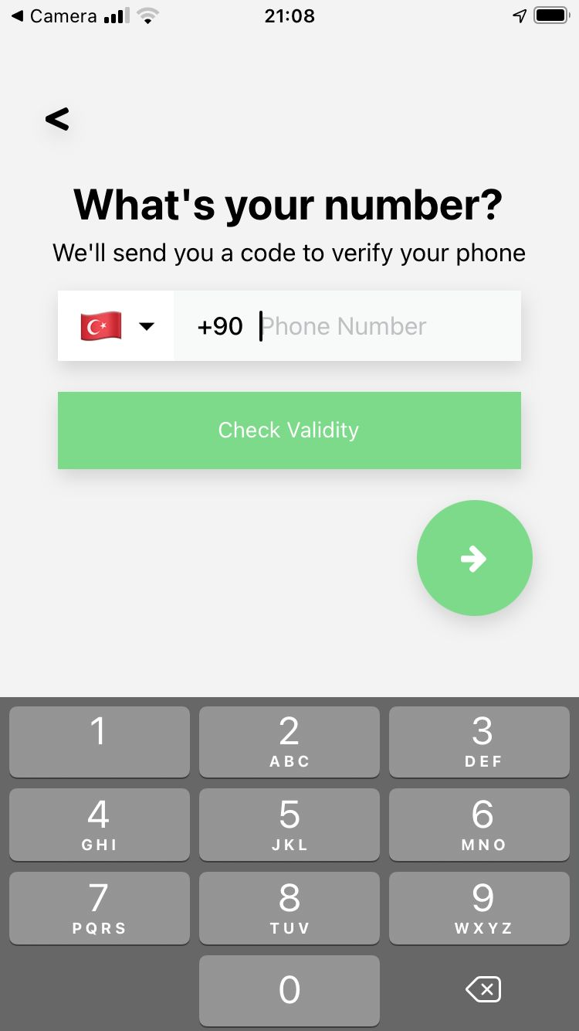
Figure 06
(Phone Number Screen)
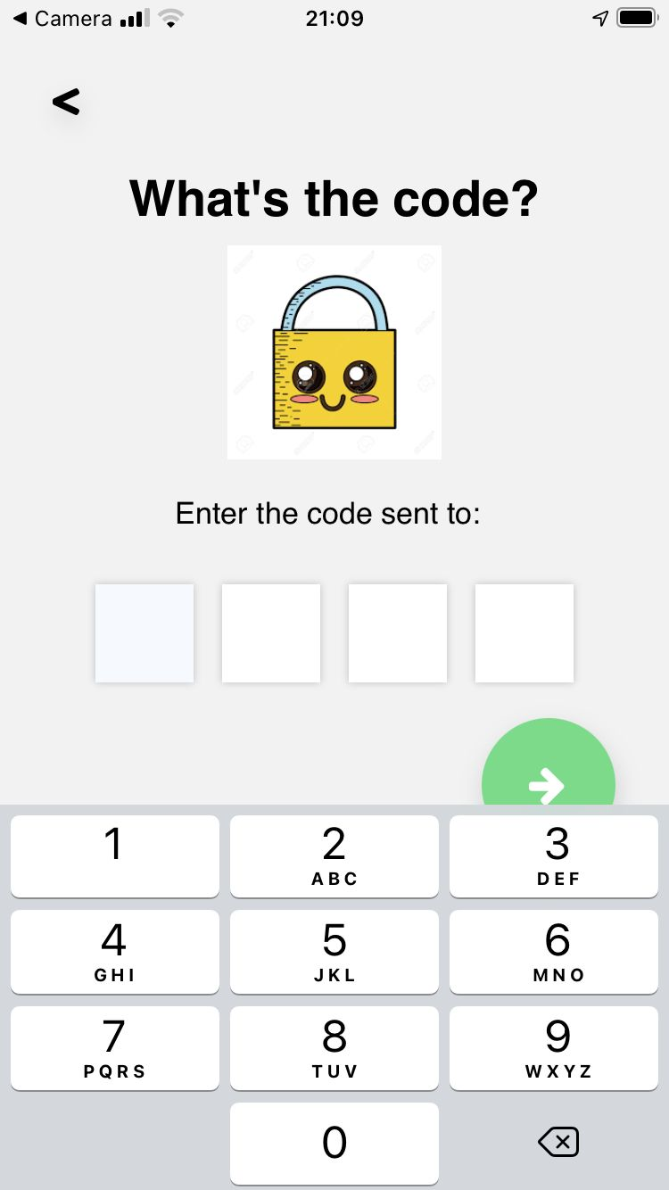
Figure 07
(Code Verification Screen)
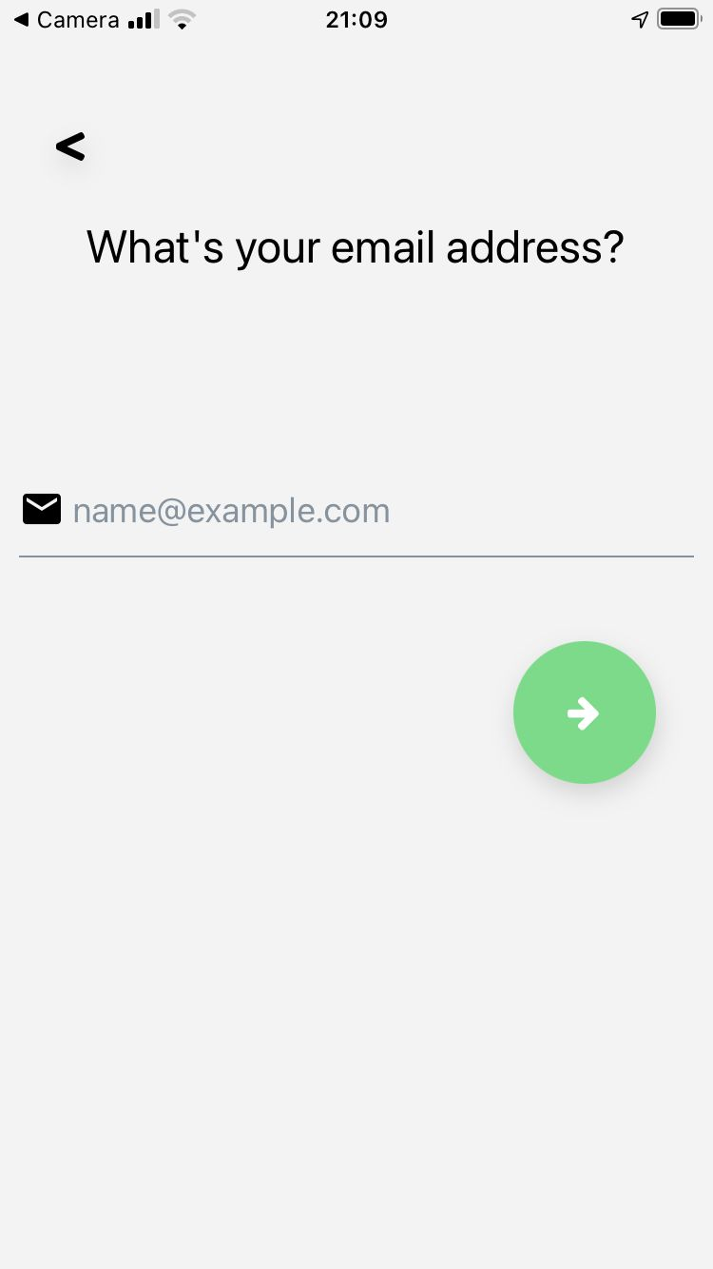
Figure 08
(Email Screen)
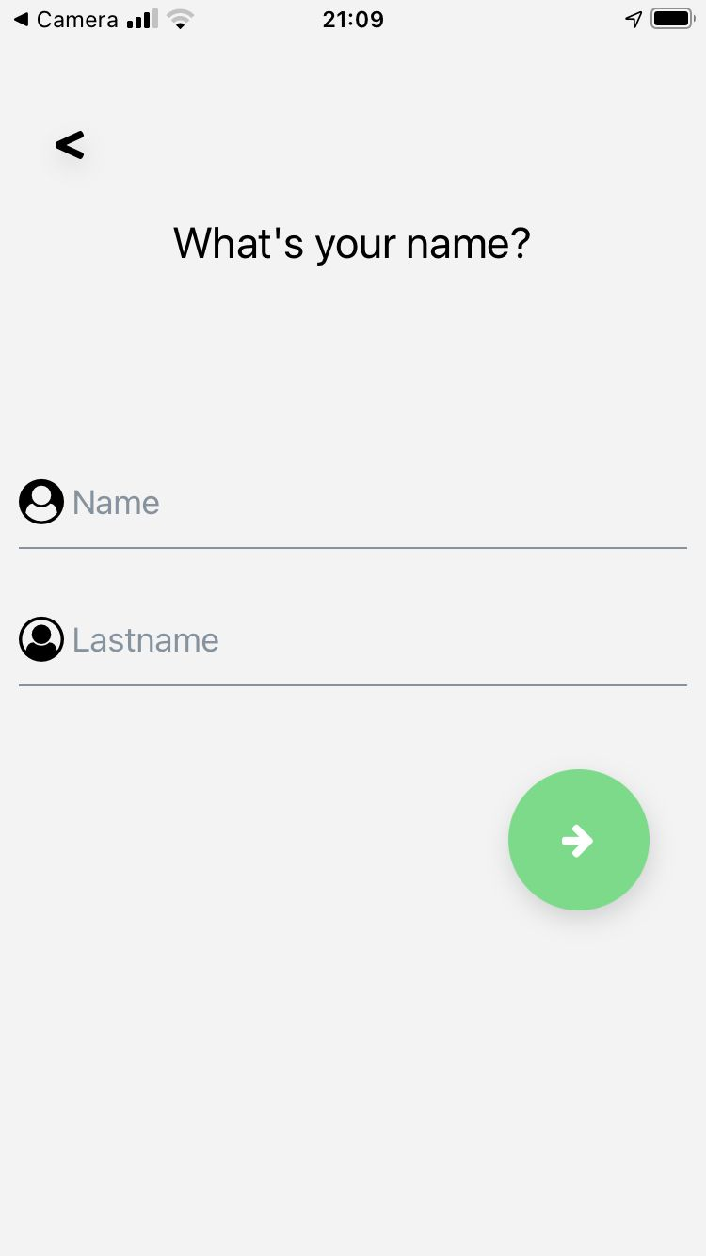
Figure 09
(Personal Info Screen)
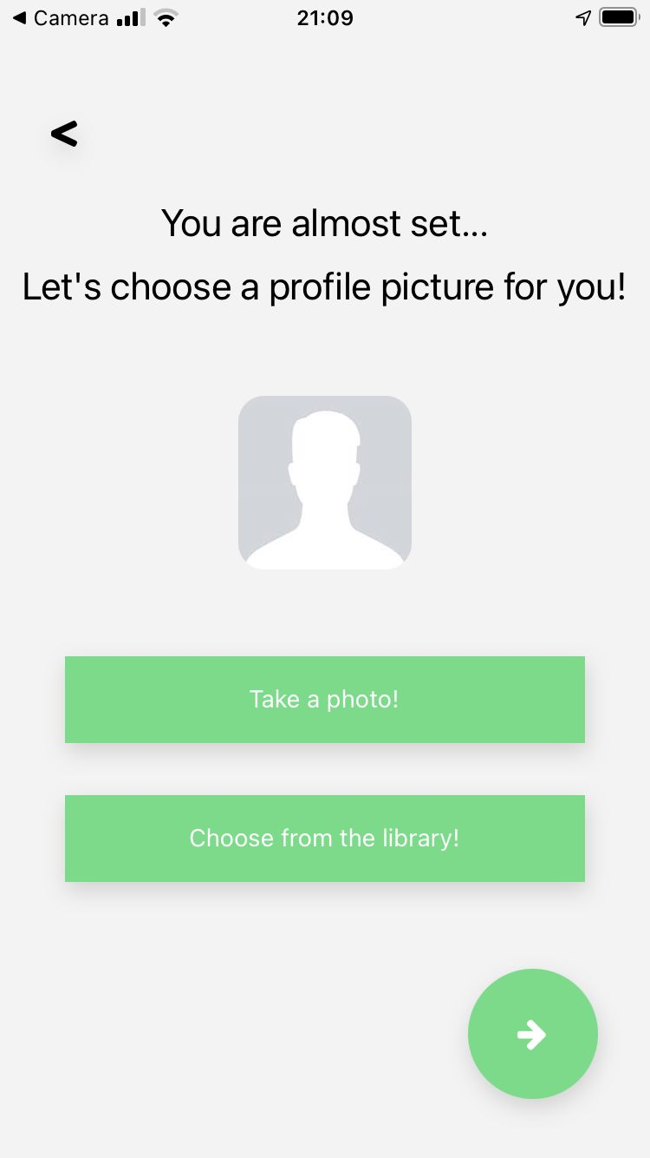
Figure 10
(Profile Picture Screen)
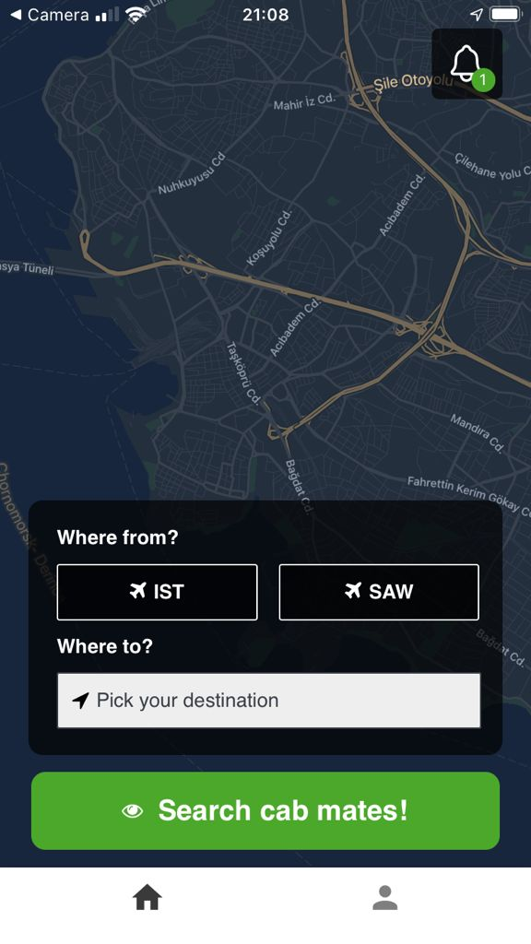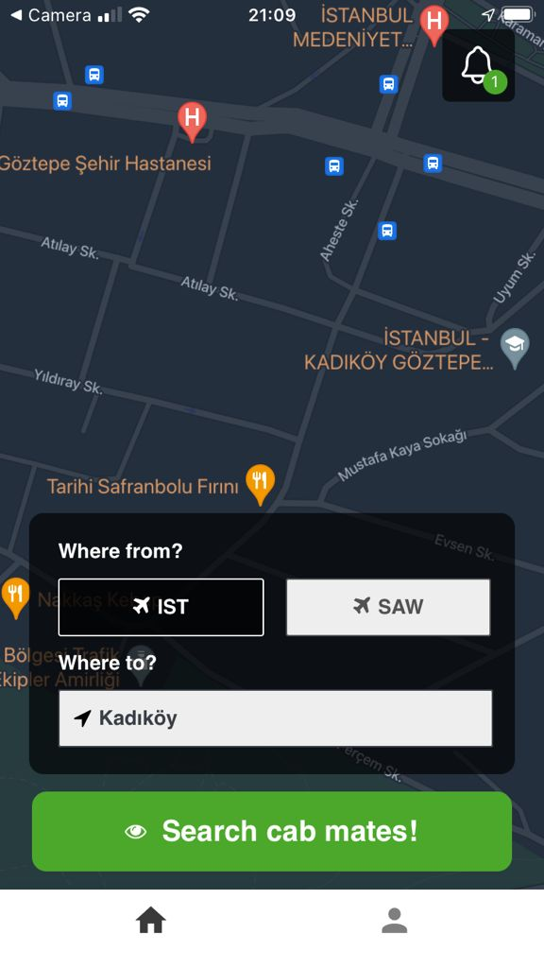
Figure 11
(Initial Home Screen)
Figure 12
(Home Screen when destination picked)
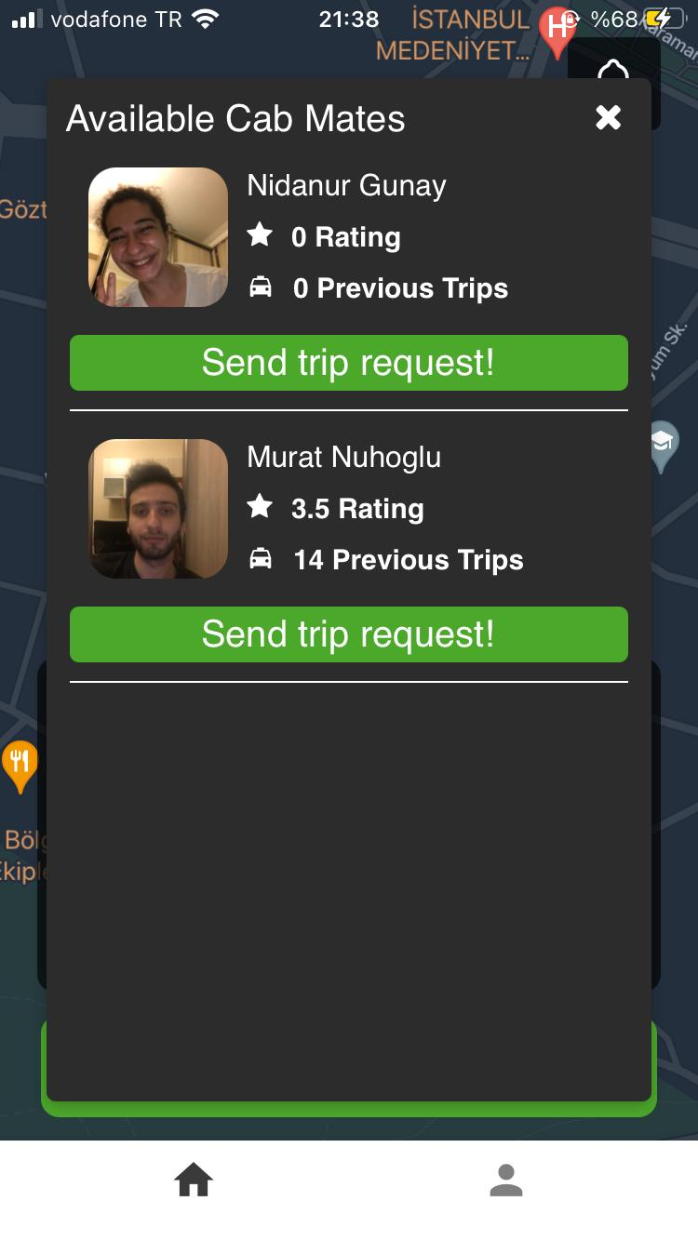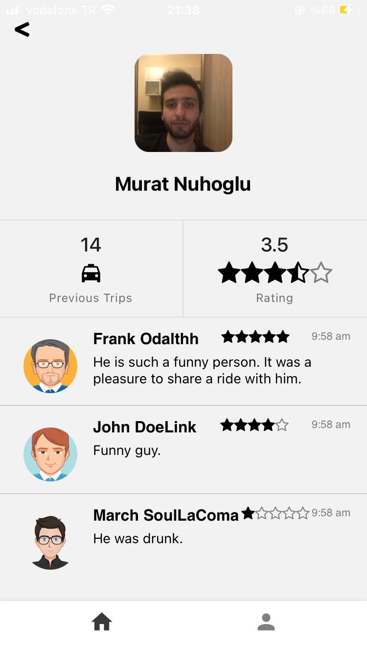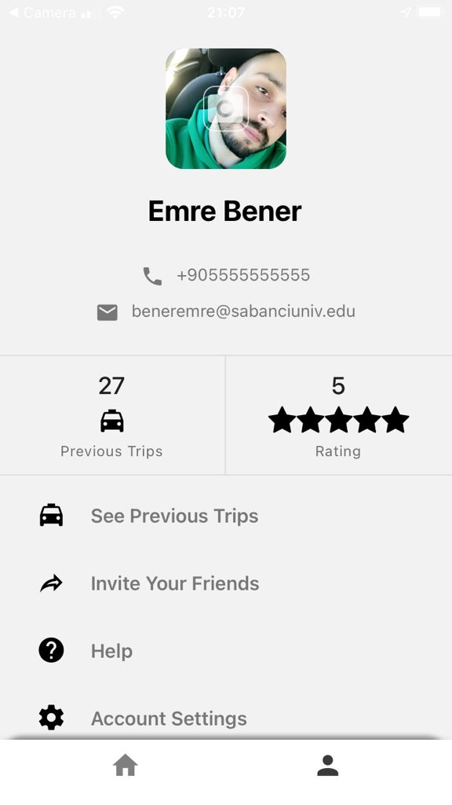
Figure 13
(Available Users Screen)
Figure 14
(View Profile Screen)
Figure 15
(My Profile Screen)
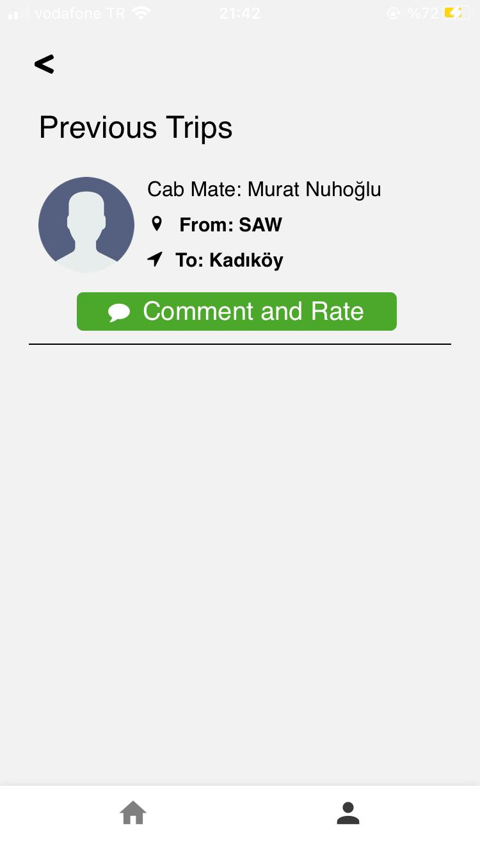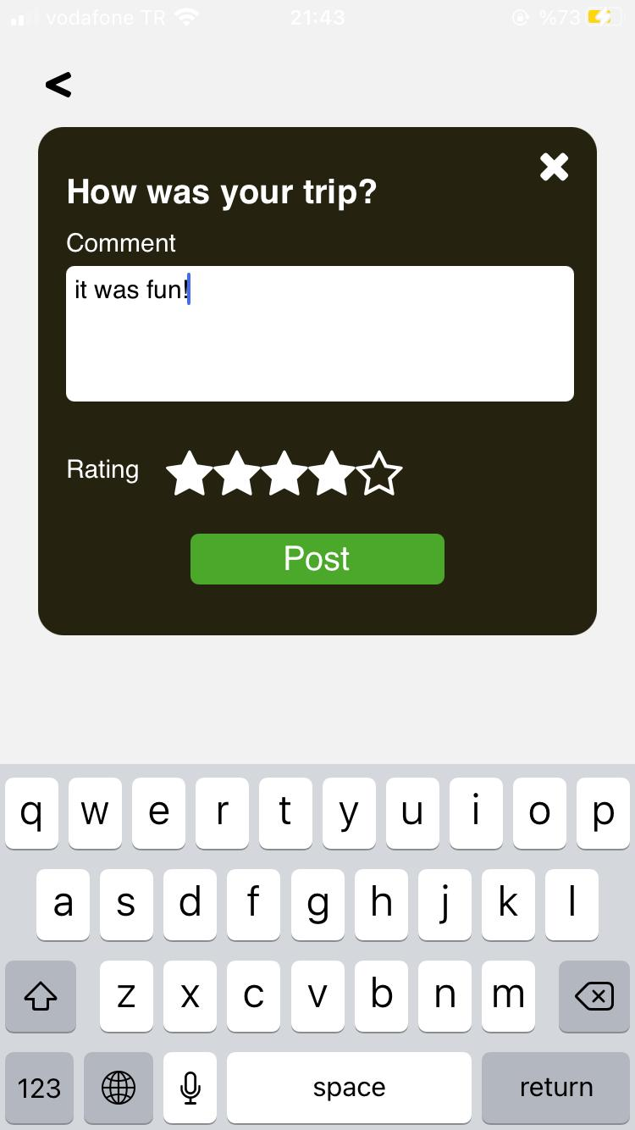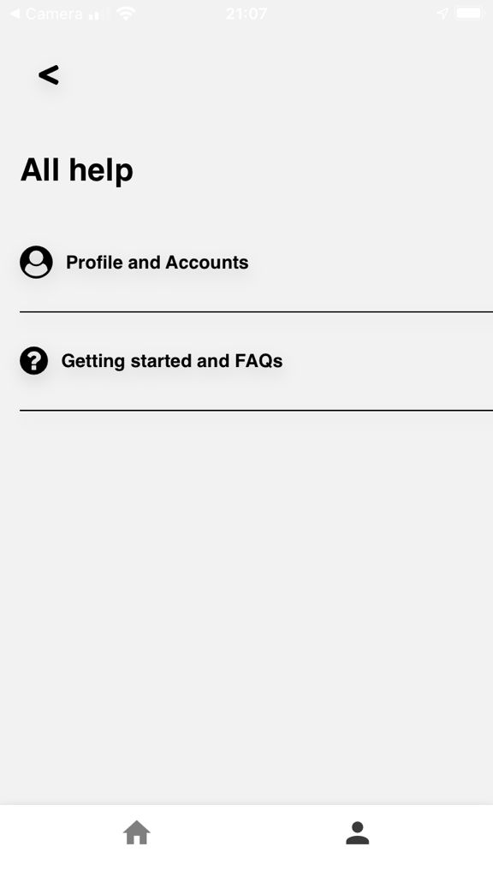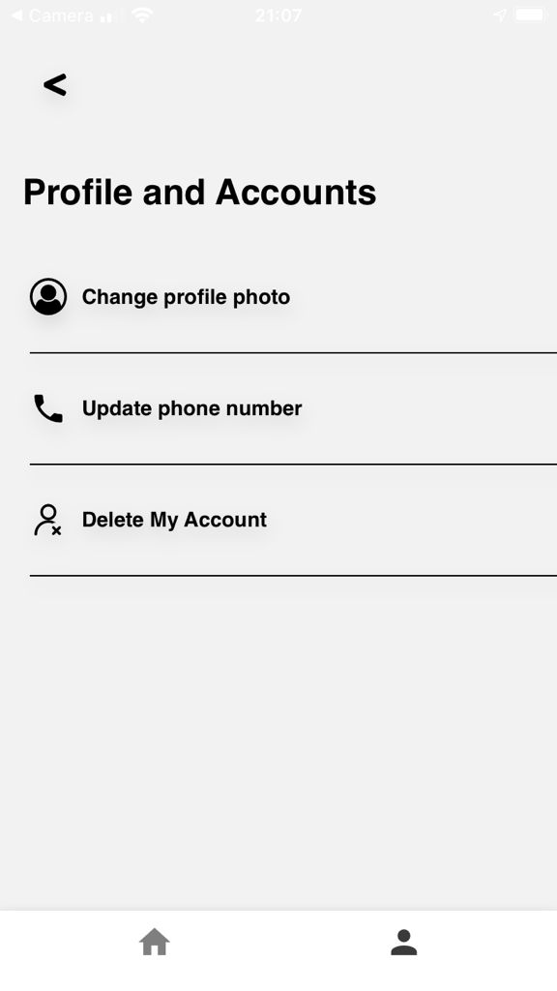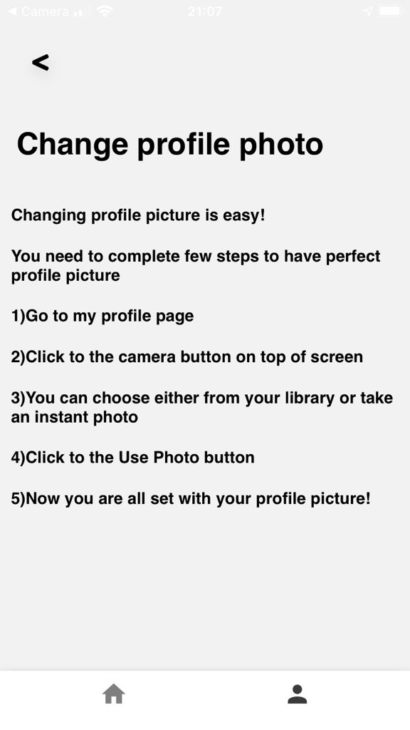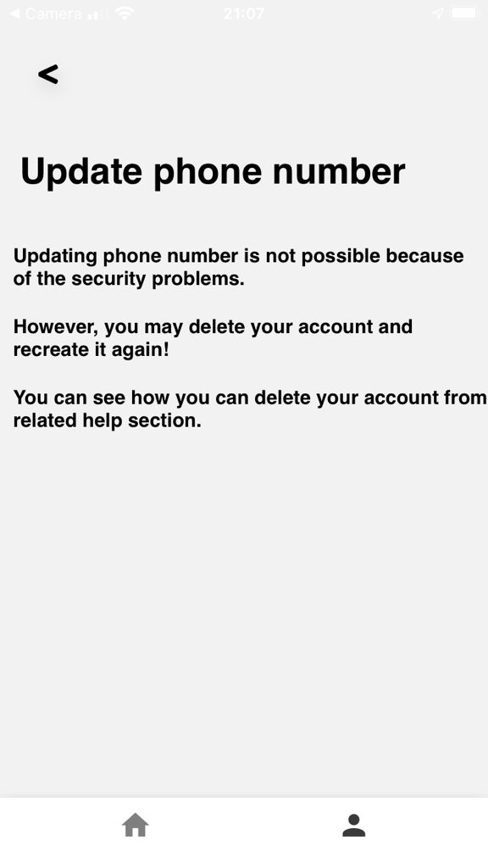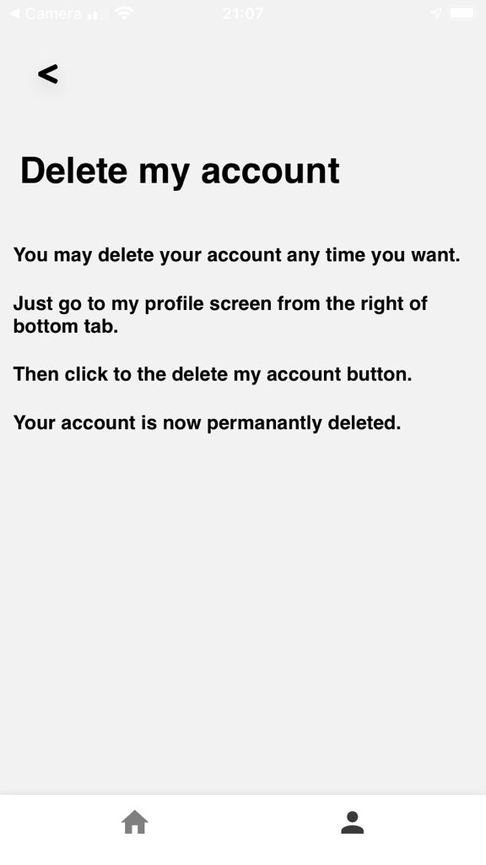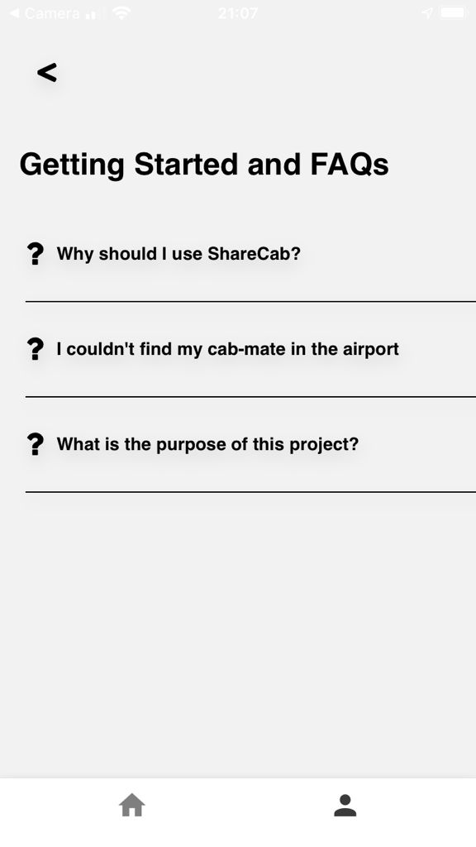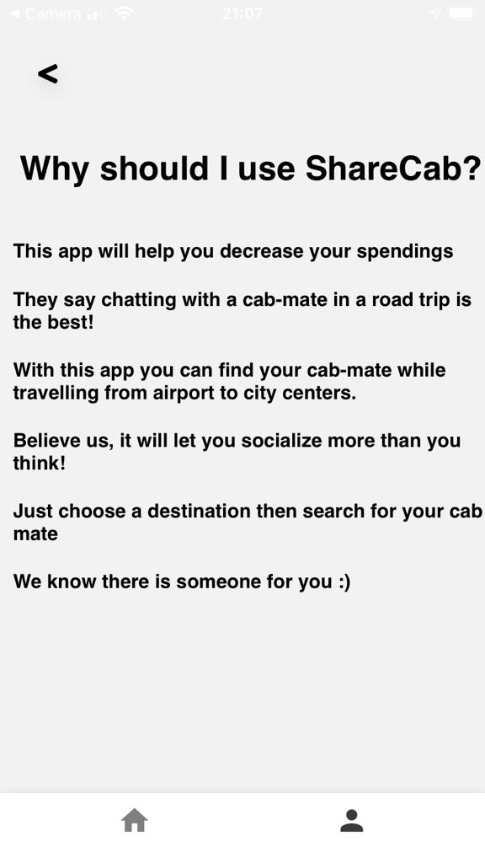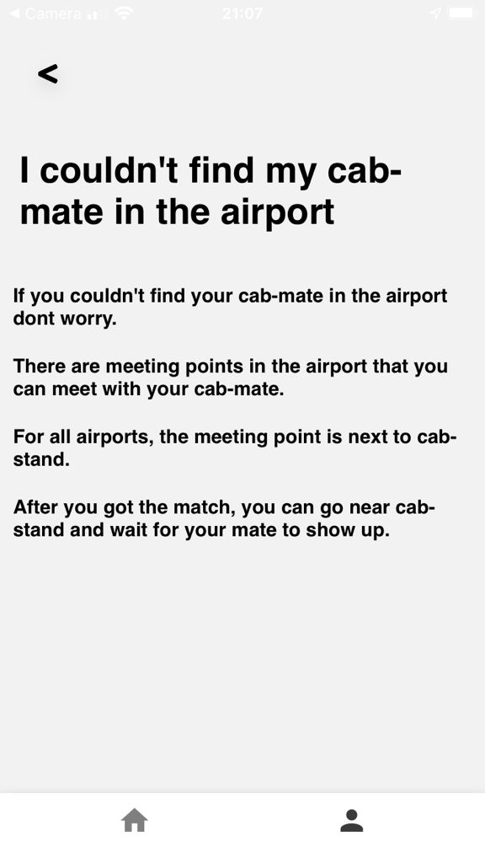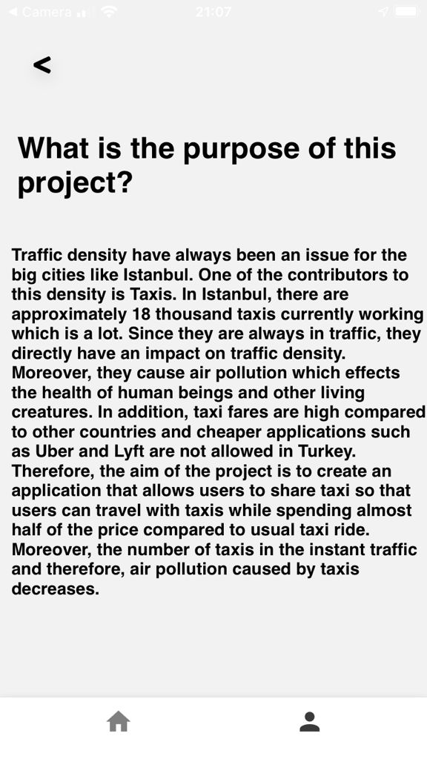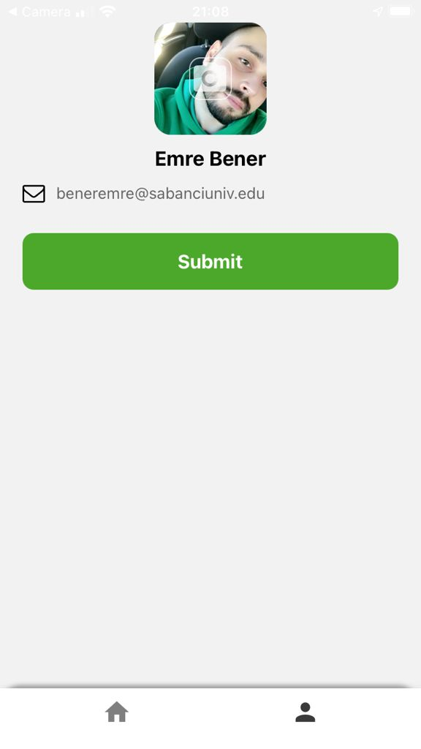
Figure 16
(See Previous Trips Screen)
Figure 17
(Comment and Rate Screen)
Figure 18
(Help Screen)
Figure 19
(Help Screen 1)
Figure 20
(Help Screen 2)
Figure 21
(Help Screen 3)
Figure 22
(Help Screen 4)
Figure 23
(Help Screen 5)
Figure 24
(Help Screen 6)
Figure 25
(Help Screen 7)
Figure 26
(Help Screen 8)
Figure 27
(Account Settings Screen)

- REFERENCES

- Gao, J., Bai, X., &amp; Tsai, W. (2014, January 06). Mobile Application Testing: A Tutorial. Retrieved January 14, 2021, from https://ieeexplore.ieee.org/abstract/document/6693676/citations#citations

- Eisenman, Bonnie. Learning React Native. Sebastopol, CA: O'Reilly Media, 2015. https://books.google.com.tr/books?hl=tr&amp;lr=&amp;id=274fCwAAQBAJ&amp;oi=fnd&amp;pg=PR2&amp;dq=react+native&amp;ots=tGpnbHh2p_&amp;sig=UAOXTDGjl_EJ2Ur4JwmKNymm8rc&amp;redir_esc=y#v=onepage&amp;q=react%20native&amp;f=false.

- Santi, Paolo, Giovanni Resta, Michael Szell, Stanislav Sobolevsky, Steven Strogatz, and Carlo Ratti. Taxi pooling in New York City: a network-based approach to social sharing problems, n.d. https://www.researchgate.net/profile/Stanislav_Sobolevsky/publication/257656945_Taxi_pooling_in_New_York_City_a_network-based_approach_to_social_sharing_problems/links/545f80de0cf295b56161c4fc/Taxi-pooling-in-New-York-City-a-network-based-approach-to-social-sharing-problems.pdf

- Hahn, E. (2016). Express in action: Writing, building, and testing Node.js applications. Shelter Island: Manning.

- Ahmad, I., & Dewan, K. K. (2007, February). Carpooling: A Step to Reduce Congestion (A Case Study of Delhi). ResearchGate. https://www.researchgate.net/publication/26623758_Carpooling_A_Step_to_Reduce_Congestion_A_Case_Study_of_Delhi

