Nama : Muhammad Nur Ichsan B.

Judul : Test Case Fullstack

Dokumen Teknis Test Case

* ERD

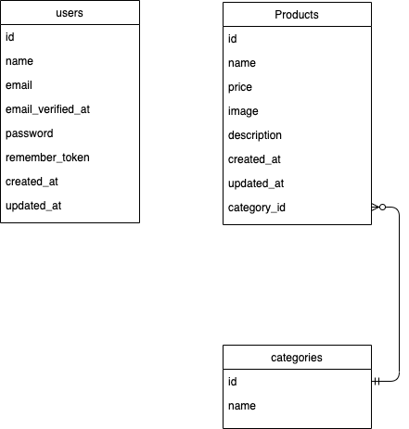

* DML

Category

- Insert : INSERT INTO categories (id,name,created_at,updated_at) values ('1', 'Pro', '','');

- Update : UPDATE categories name = 'Pro' where id='1';

- Delete : DELETE FROM categories WHERE id='1';

- Select : SELECT * FROM categories;

Product

- Insert : INSERT INTO products

(id,name,price,image,description,category_id,created_at,updated_at)

values ('1', '','' ,'','','','');

- Update : UPDATE products price = '100000' where id='1';

- Delete : DELETE FROM products WHERE id='1';

- Select : SELECT * FROM products;

* Activity Diagram

Login Activity

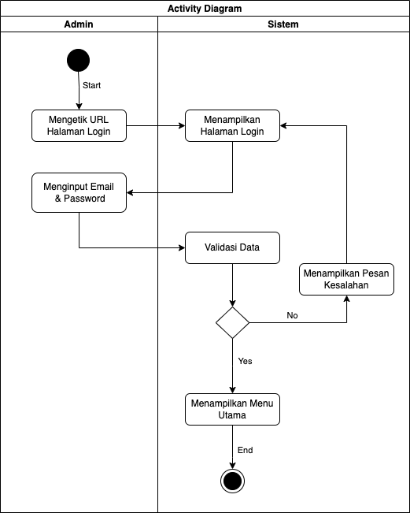

Category Activity

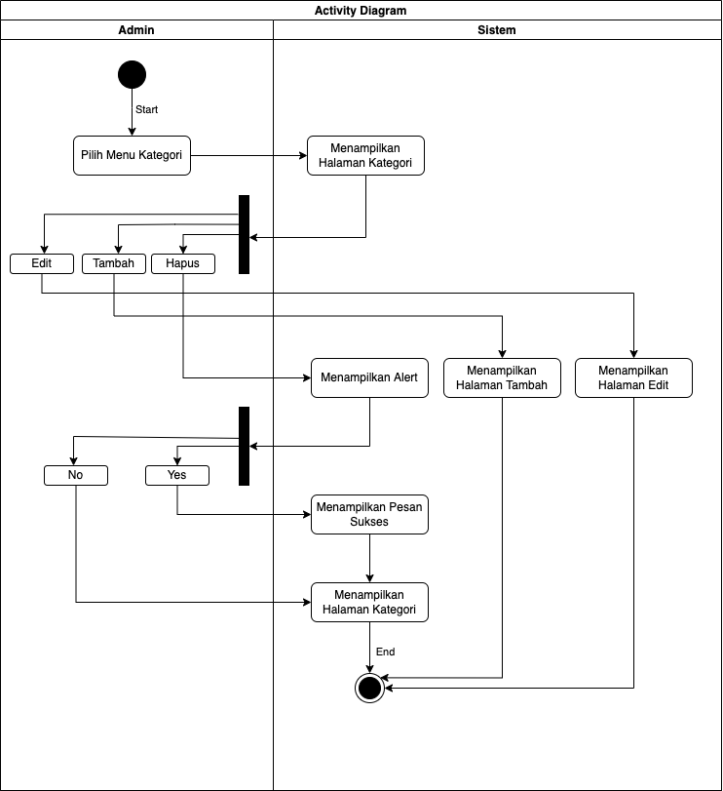

Product Activity

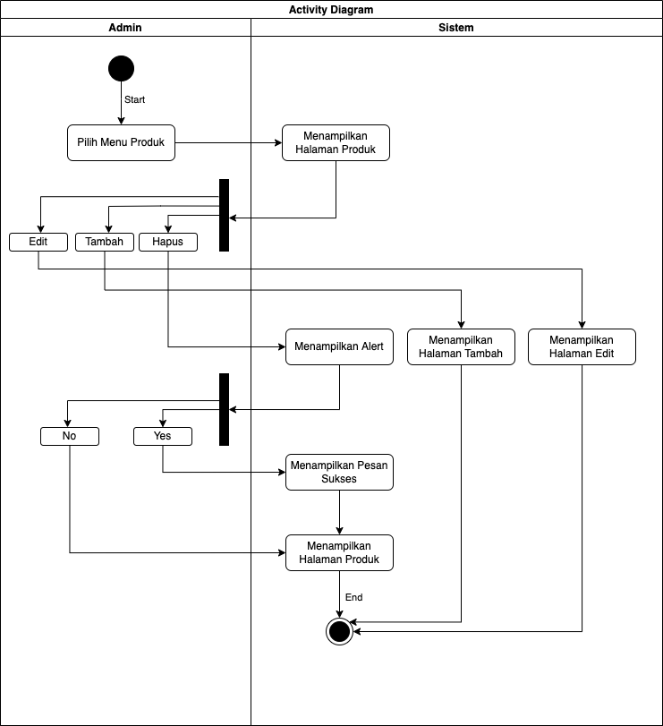

* Use Case

