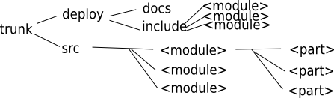
libqxt developer guide

License
with contributing code to libqxt you agree the LICENSE document served with every distribution of libqxt.
This is LGPL.

Project structure
The library is splitted into modules. Each module is a library on its own. A Module then is splitted into parts. A Part normaly is a single class and its related code.

About Interfaces
Every part has a part.h file that contains the interface. It should be constant over versions. The part.cpp file is for all the private code.
Parts may have subdirs if the one cpp file is insufficient.
QxtPimpl may help you hiding your internal interface. Remeber: Private class members in the interface are bad!
Every interface needs to be exported. Use QXT_DLLEXPORT in fornt of every declaration.

Stability flags
Every part has flags that can be set in the modules project file, that indicate the stability on several platforms. Every platform can be prefixed with + to indicate „stable“, and – to indicate „will not compile on that platform“. Platforms are described by qmakes mkspecs.
e.g. +linux-g++ means it is stable for linux gcc.

Documentation
We use doxygen to make our automated docs. Every interface has to be documented. Either look how other parts are documented or ask someone for help. Check the qt docs out to see some good written docs.

Coding conventions
- Make it readable for other people.
- Internal dev docs are good.
- Compiler warnings may not be ignored.

happy hacking
Arvid
Project Manager

