All for alpha = 1e-3:

Accuracy ( orange ) and stability ( blue ) vs weight (log scale)

3rd degree:

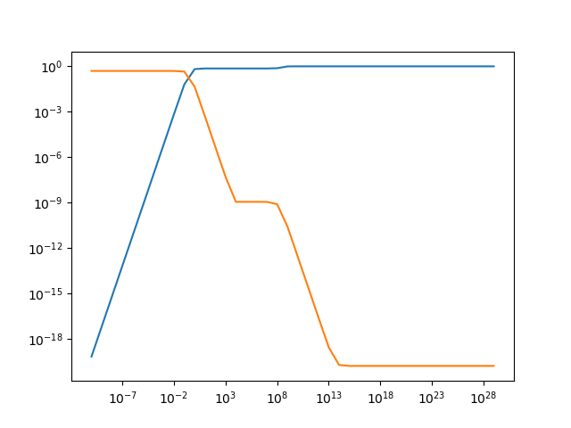

5th degree: Accuracy (blue) stability (orange)

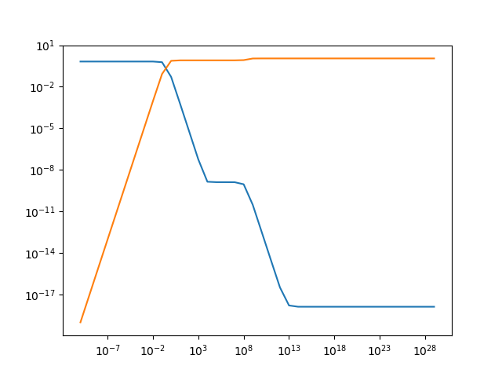

9th degree: (labelled, accuracy blue stability orange)

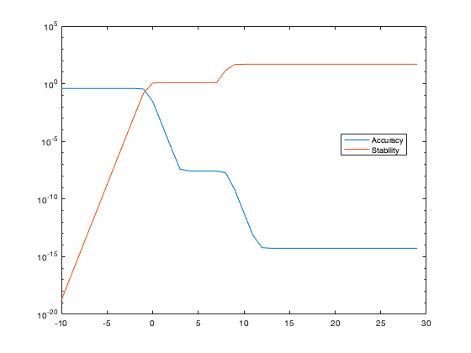

Abs(1 minus stability) comparison for al=1e-3, 3rd and 5th degree

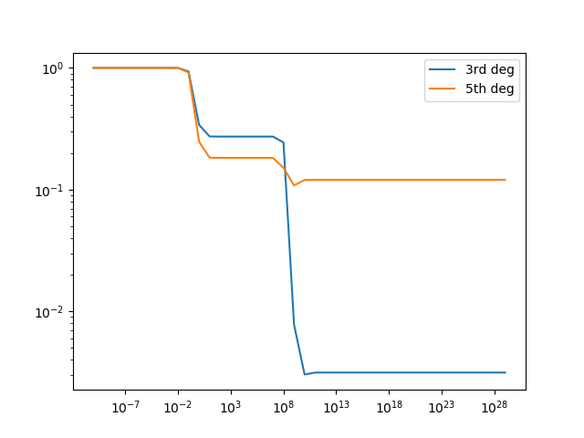

Abs(1 minus stability) for al = 1e-3 9th degree:

