Fashion Shop

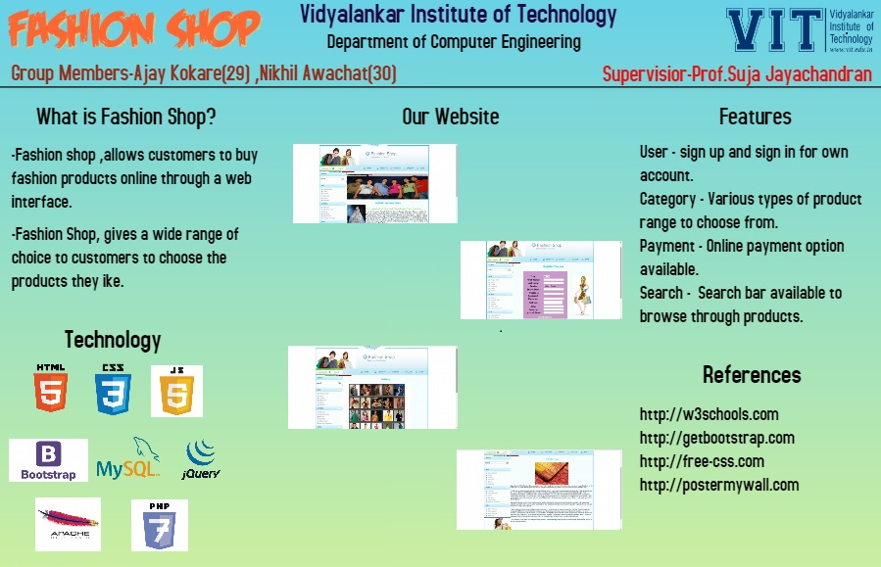



MINI PROJECT ON

Online Shopping

BY

Nikhil Awachat 14102A0030

Ajay Kokare 14102A0029

**Under the guidance of**

**Prof. Suja Jayachandran**



Department of Computer Engineering

2016 – 2017

Table of content

|  |  |  |
| --- | --- | --- |
| SR NO. | CONTENT | PG NO. |
| 1. | Acknowledgement | 03 |
| 2. | Abstract | 04 |
| 3. | Objectives | 05 |
| 4. | Plan of Work | 06 |
| 5. | Technologies used | 07 |
| 6. | Requirement Gathering | 08 |
| 7. | Designs of project | 09 |
| 8. | Feasibility Study | 14 |
| 9. | Future Enhancement | 16 |
| 10. | Screenshots | 17 |
| 11. | Bibliography | 20 |

Acknowledgement

We feel privileged to express our deepest sense of gratitude and sincere thanks to our guide **PROF. Suja Jayachandran** for her excellent guidance throughout the project work. Her prompt and kind help directed us to the completion of dissertation work.

Finally, we would like to acknowledge all our friends those who directly or indirectly helped us in the completion of our project.

ABSTRACT

The aim of this project is on the online shopping site, it is developed using HTML, JAVA script, CSS, PHP.

The site is very useful where the buyer can directly buy the products from home via internet on mobile or system.

The site reduces lot of work load for customer as well as owner. The transaction of money is completed in real time system.

By this online shopping the product is directly delivered to customer home.

Objectives

A Online Shop is an website where the User can purchase fashion accessories

The main Objective of this system is maintaining the Online Shopping and also provide online payment facility to customer.

Plan of Work

As to reached to the goal of our project we made some plan to be follow to get our project successfully implemented for this definitely we use one of the SDLC model called **Waterfall model.**

Waterfall model contains Requirement gathering, System designing, Implementation, System testing, System Deployment, System maintenance. So as per this we made plans, schedules etc.

Plan of work are as follows:

* Captured all the requirements, understands the requirements and do the feasibility test to ensure that the requirements are testable or not.
* As per the requirements create the design
* Captured the hardware/software requirements and documented the design.
* As per the design created the programs/code and integrated the codes for the next phase.
* Perform all the testing activities (Functional and Non-Functional) to make sure that the system meets the requirements.
* Deploy the application in the respective environments

Technologies used

This project will be a website to be developed in HTML, CSS, PHP and SQL server as backend.

**HTML**

➢ HTML is a markup language for describing web documents.

➢ HTML Stands for Hyper Text Markup Language.

➢ A markup language is a set of markup tags.

**CSS**

➢ CSS is Style sheet Language that describes the presentation of an HTML (or XML) document.

➢ CSS describes how elements must be rendered on screen, on paper, or in other media.

**PHP**

➢ PHP is a server scripting language, and a powerful tool for making dynamic and interactive Web pages.

➢ PHP is a widely-used, free, and efficient alternative to competitors such as Microsoft's ASP.

**JavaScript**

➢ JavaScript is the programming language of HTML and Web. Programming makes computers do what you want them to do.

➢ JavaScript is easy to learn.

**SQL**

➢ SQL is a standard language for accessing database.

➢ SQL lets you access and manipulate database.

➢ SQL is an ANSI (American National Standard Institute) standard.

REQUIREMENT GATHERING

**Requirements :**

A requirement issome quality or performance demanded of a person in accordance with certain fixed regulations: requirements for admission to

college. A requisite is not imposed from outside; it is a factor which is judged necessary.

**Functional Requirements** :

Functional requirements may be calculations, technical details, data manipulation and processing and other specific functionality that define what a system is supposed to accomplish.

**Non**- **Functional Requirements** :

In [systems engineering](https://en.wikipedia.org/wiki/Systems_engineering) and [requirements engineering](https://en.wikipedia.org/wiki/Requirements_engineering), a non-functional requirement is a [requirement](https://en.wikipedia.org/wiki/Requirement) that specifies criteria that can be used to judge the operation of a system, rather than specific behaviors.

**Project Requirements:**

|  |  |
| --- | --- |
| **Functional Requirements** | **Non**- **Functional Requirements** |
| * Login | * Performance |
| * View Items | * Security |
| * Place Order | * Reliability |
| * Make Payment | * Availability |
|  | * Safety |
|  | * Reusability |
|  | * Maintainability |

Designs of project

**Main System Use Case:**

**USE CASE DIAGRAM FOR ADMIN**

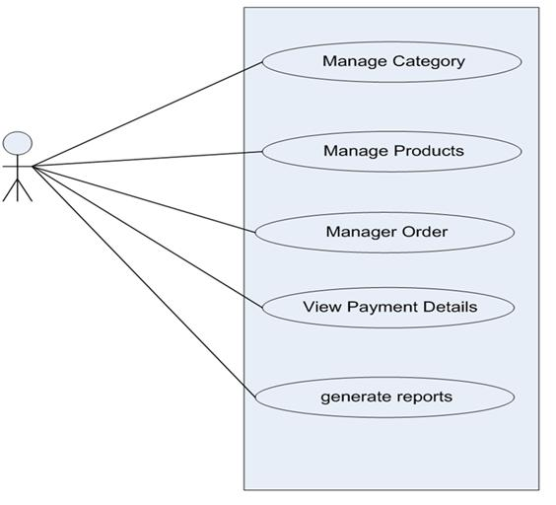

USE CASE DIAGRAM FOR USER

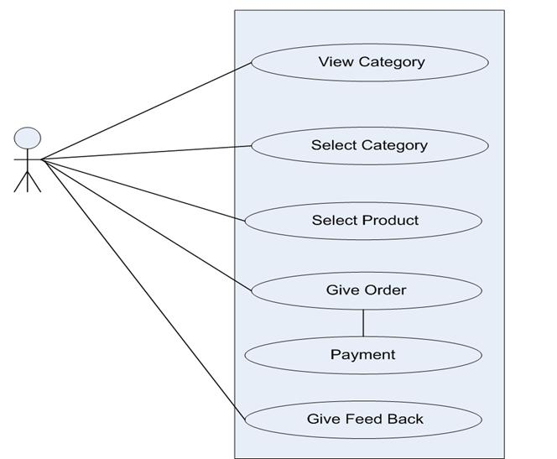

**ACTIVITY DIAGRAM FOR USER**

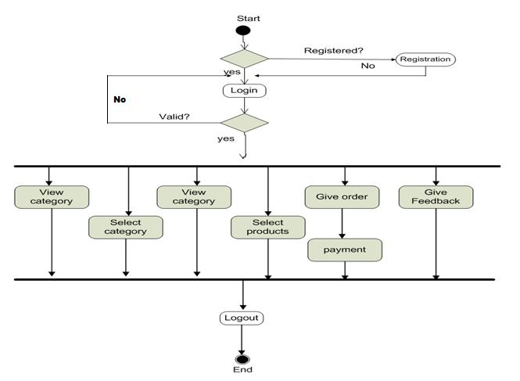

**Class Diagram**

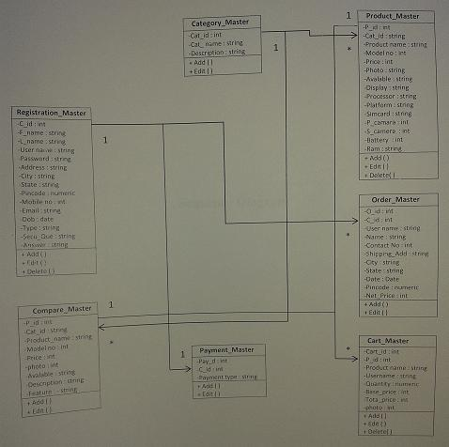

Feasibility Study

The feasibility study is the important step in any software development process. This is because it makes analysis different aspects like cost required for developing and executing the system, the time required for each phase of the system and so on. If these important factors are not analyzed then definitely it would have impact on the organization and the development of the system will totally b a failure. So for running the project and organization successfully this step is very important step in a software development life cycle process.

**PROJECT DEFINATION :**

This Software will be helpful in the smooth functioning of the organization due to integration of various functions.

The software maintains central database with following information stored in different tables:

1. Registration
2. Login
3. View Products
4. Select Product
5. Make Purchase
6. Make Payment
7. Logout

**EXISTINGN SYSTEM :**

The present system is totally depend on manual data management for different activities such as maintaining details of customer, supplier etc. They maintain Different registers for various activities such as storing and searching data which is tedious and time consuming task.

In present system all transactions are done manually with pen and paper so the frequent updating is not possible. Also generating reports, bills accurately is not possible with current system.

**Drawbacks of Existing System :**

1. It is manual and time consuming.
2. It utilizes a large amount of space for customer and supplier transaction information in paper files
3. No reminder for customer and Purchaser.
4. 6. Sometime the calculation has to be done manually so it requires a lot of work.
5. Updating is not performed that efficiently and may lead complications.
6. No security as data can be misplaced or damaged.
7. Lastly, it was not offers a user friendly work environment

**TECHNICAL FEASIBILITY:**

Time & Legal Feasibility: In this type of feasibility study, we examine whether our proposed project can be completed in the specified time frame or not and it does not break any laws. So it is legally feasible too. Technical feasibility our information system uses “HTML, CSS and PHP” on windows platform as a frontend and MS Access as backend to store the database related shop billing system.

**BEHAVIOUR FEASIBILITY :**

As the project is very easy to implement with ease and convenience, behavioral analysis methods in a measure of how well a proposed system solves a problem and take advantages of opportunities identified during scope definition and how it satisfies the requirement analysis phase of system development.

Financial & Economical Feasibility.

The cost of the hardware and software is feasible, as it requires investments at the start of the system like the computers printers etc. but a normal computer user will definitely poses the following configuration which is the requirement of the system we developed.

So with the use of this system, the shop staff doesn’t have to invest any extra amount for the working of the system.

FUTURE ENHANCEMENT

* In the future I want to enhance my project with the admin part of online shopping.
* Add more accessories in web-site.
* Add more features to the site.

Screenshots

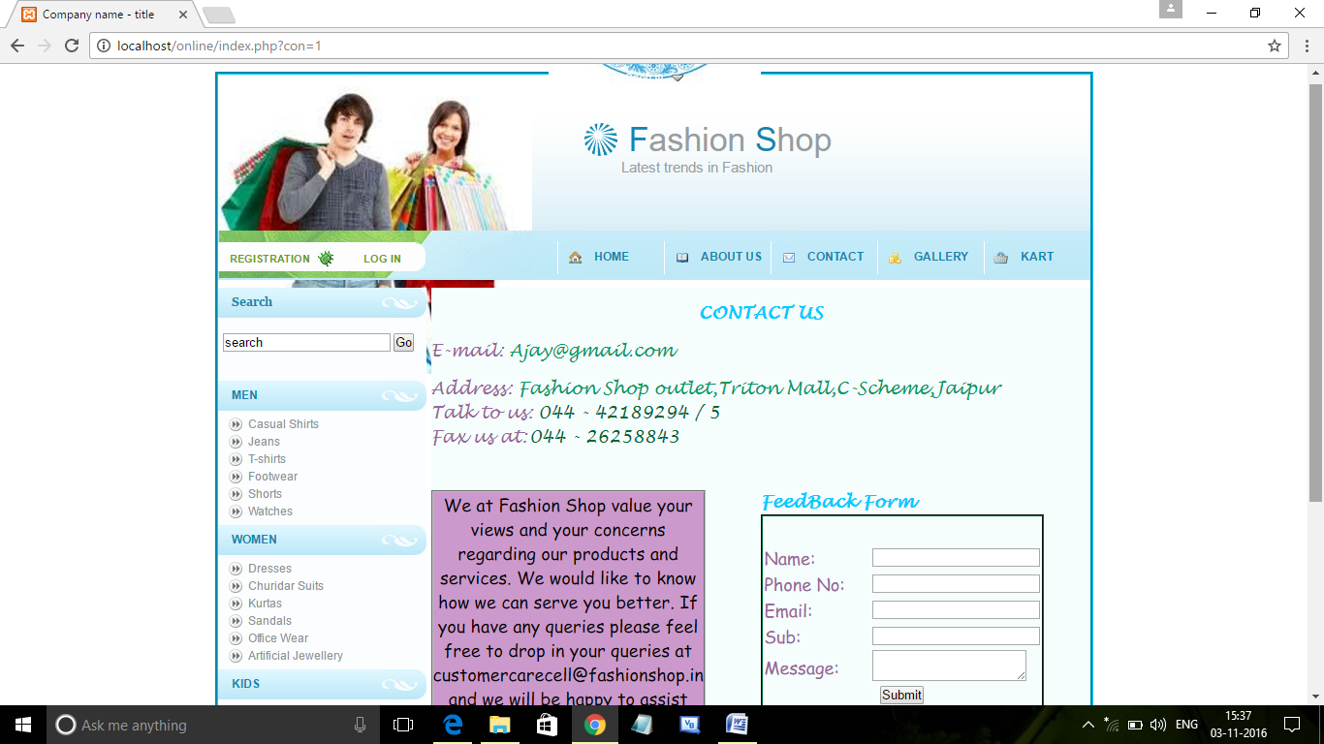



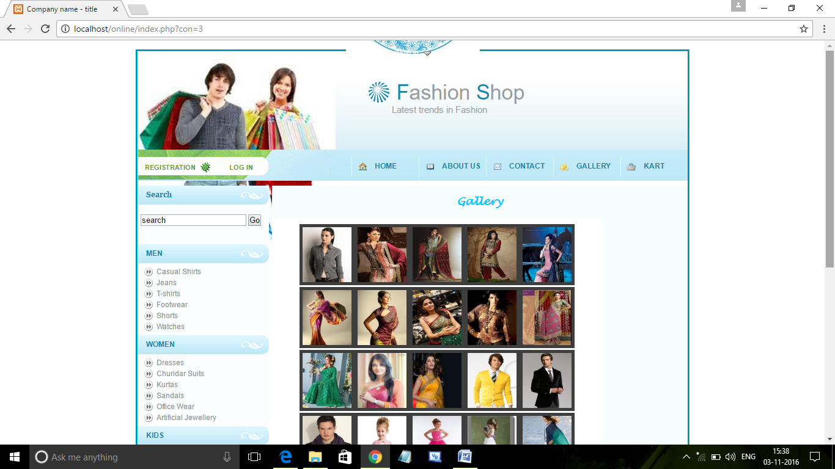

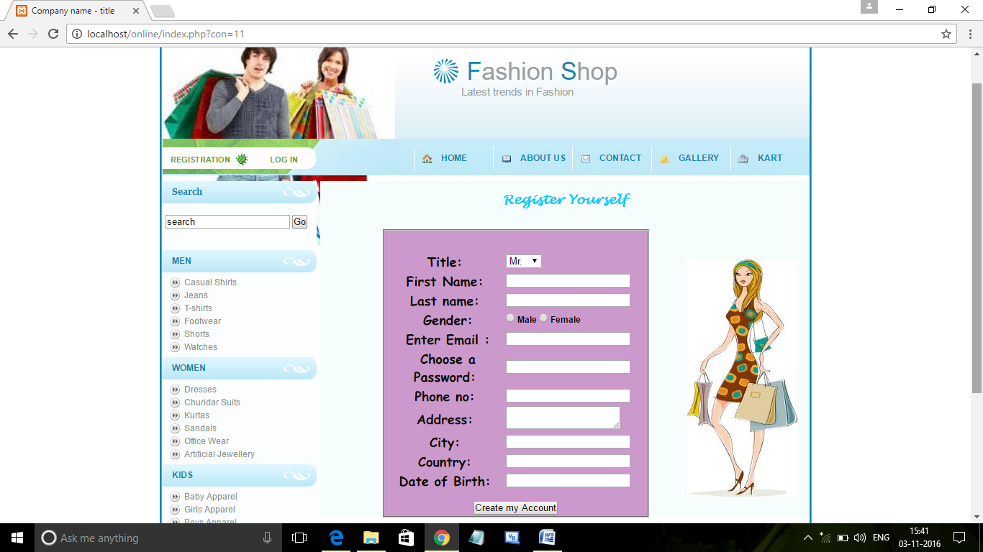

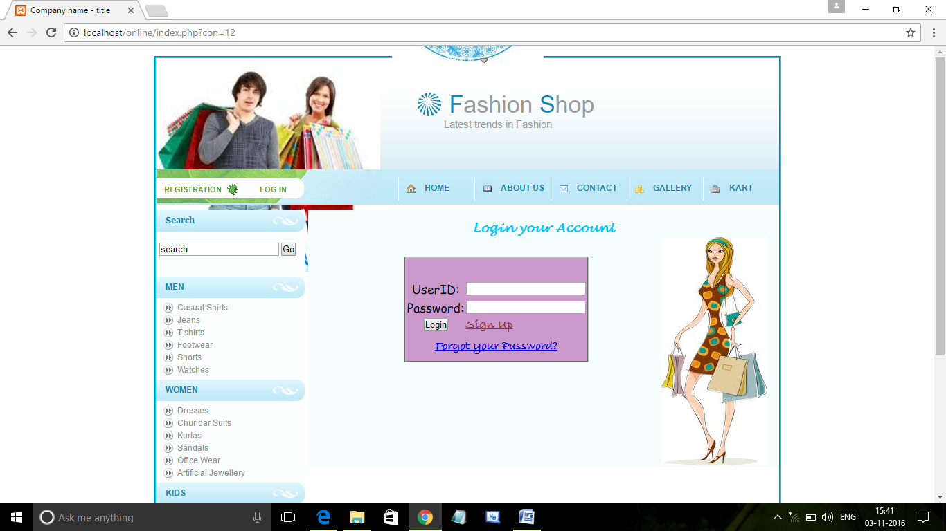

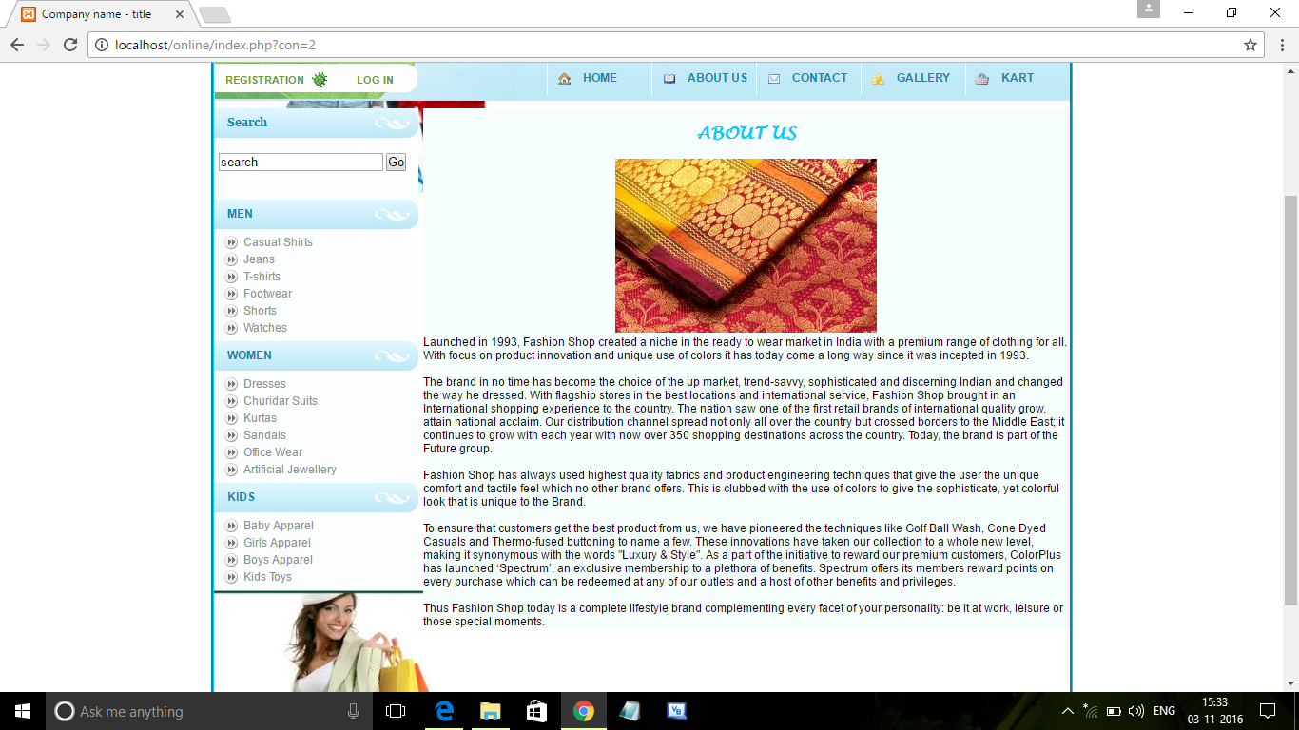

**Bibliography**

** Referred from websites**

* + http://www.w3schools.com
  + http://www.youtube.com
  + http://www.google.com