


Cairo University - Faculty of Engineering
Electronics & Electrical Communication Engineering
Digital Communications - Modulation

Part 3: OFDM System Simulation
BER Performance of BPSK and 16-QAM over Rayleigh Fading with and without Rate-1/5 Coding

Table of Contents
1. Objective and Scope 3
2. System Model and Simulation Method 3
2.1 OFDM Grid, Modulation, and FFT/IFFT 3
2.2 Coding and Interleaving 4
2.3 Cyclic Prefix 4
2.4 Channel Models 4
2.5 Receiver and Performance Metrics 5
3. Simulation Parameters 6
4. Results and Discussion 6
4.1 BER Results for BPSK 7
4.2 BER Results for 16-QAM 8
4.3 Coding and Channel-Model Comparison 9
4.4 EVM and Receiver Diagnostics 10
5. Assumptions and Limitations 11
6. Conclusions 12
7. References 12

1. Objective and Scope
This report documents the OFDM system simulation specified in Project Part 3 of the Digital Communications course. The goal is to evaluate the reliability of an orthogonal frequency-division multiplexing (OFDM) link when the transmitted information is mapped using BPSK or 16-QAM and passes through Rayleigh fading channels. The receiver reconstructs the information bits, and the bit error rate (BER) is measured as a function of the signal-to-noise ratio (SNR).
The supplied assignment defines a 256-point inverse fast Fourier transform (IFFT), two channel models, and two coding options. The required results are BER-versus-SNR curves for four combinations per modulation scheme: flat fading with and without coding, and frequency-selective fading with and without coding. This report follows those requirements. EVM and constellation plots are included as supplementary diagnostics, not as substitutes for the required BER results.
• Modulation schemes: BPSK and Gray-coded 16-QAM.
• Coding: uncoded transmission or rate-1/5 repetition coding with majority-vote decoding.
• Channels: flat Rayleigh fading and the assignment’s simplified frequency-selective model, with an independent Rayleigh coefficient on each subcarrier.
• Required performance measure: BER against SNR for all eight scenarios.
The official brief specifies BPSK and 16-QAM for the final BER plots. QPSK is not treated as a required data-modulation scenario in this report.

2. System Model and Simulation Method
The transmitter maps information bits to modulation symbols, distributes those symbols over the OFDM frequency grid, transforms each OFDM symbol to the time domain using an IFFT, and prepends a cyclic prefix. The channel applies fading and additive white Gaussian noise (AWGN). At the receiver, the cyclic prefix is removed, an FFT recovers the subcarrier values, the channel is compensated, and the symbols are demapped into bits. The deinterleaver and repetition decoder are used when coding is enabled.
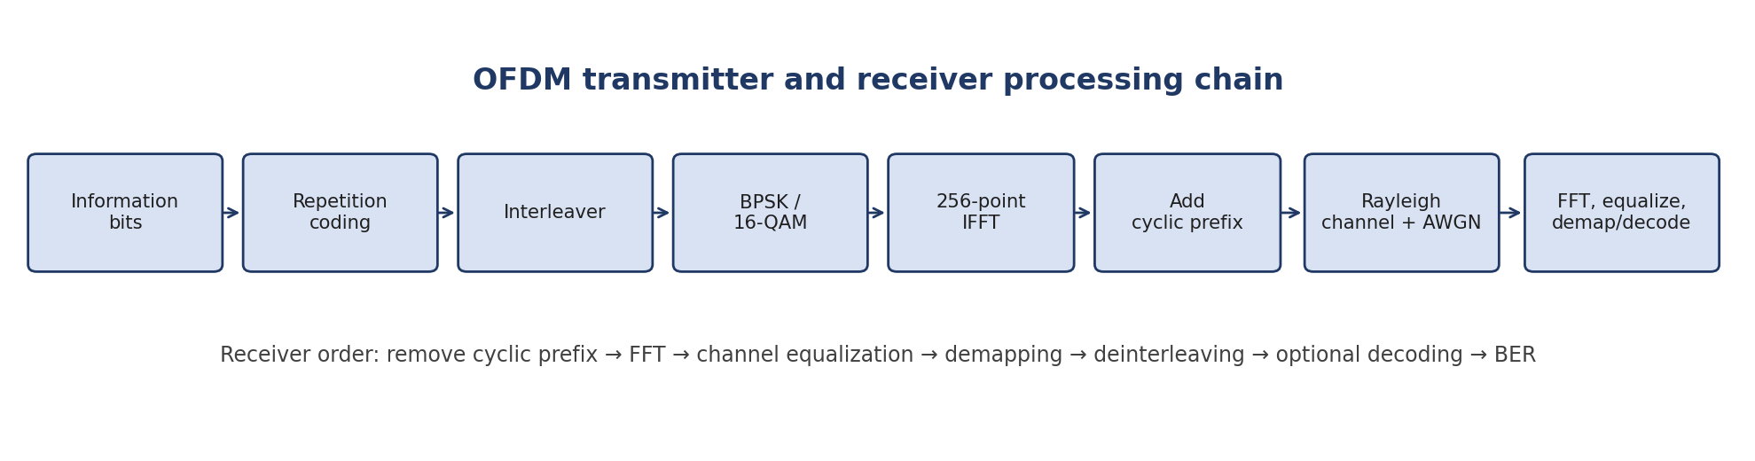
Figure 1. Processing chain implemented for the OFDM simulation.

2.1 OFDM Grid, Modulation, and FFT/IFFT
The OFDM grid is a two-dimensional time-frequency representation. Rows identify subcarriers and columns identify OFDM symbol intervals. Each active grid entry contains one complex modulation symbol. The main script uses N = 256 subcarriers, so each column is transformed by a 256-point IFFT. The frequency-bin ordering is centered in the grid for display; ifftshift places the bins in MATLAB IFFT order and fftshift restores the centered order at the receiver.
x[n] = (1/√N) Σₖ₌₀ᴺ⁻¹ X[k] exp(j 2πkn/N), N = 256
The implementation uses `ifft(ifftshift(X,1),N,1)*sqrt(N)` at the transmitter and `fftshift(fft(y,N,1),1)/sqrt(N)` at the receiver. The square-root scaling makes the transform pair unitary, preserving symbol energy under the transform. The fast Fourier transform (FFT) is the algorithm used to compute the discrete Fourier transform efficiently; the IFFT implements its inverse.
BPSK uses one bit per modulation symbol. In the submitted mapper, bit 0 maps to +1 and bit 1 maps to −1. The 16-QAM mapper groups four bits per symbol, with two bits selecting the in-phase level and two selecting the quadrature level. The Gray-coded 4-PAM level mapping on each axis is 00 → −3, 01 → −1, 11 → +1, and 10 → +3. The resulting complex point is divided by √10 to normalize the average symbol power to one.

2.2 Coding and Interleaving
The rate-1/5 repetition code repeats every information bit five times. At the receiver, five detected coded bits are grouped and the original bit is estimated by majority voting: the decoded bit is 1 if at least three of the five decisions are 1. Repetition adds redundancy, improves the chance of recovering a bit under noise and fading, and lowers the information throughput per transmitted modulation block.
The number of information bits is adjusted so that the repeated bit stream fits the mapper input size for one 256-subcarrier OFDM symbol. For BPSK, the mapper takes 256 bits; 51 information bits produce 255 repeated bits, and one zero is appended. For 16-QAM, the mapper takes 256 × 4 = 1024 coded bits; 204 information bits produce 1020 repeated bits, and four zeros are appended. The padding bits are not counted as information bits when BER is calculated.
Interleaving permutes the coded-bit order before modulation, and deinterleaving applies the inverse permutation before decoding. The assignment specifies a 32 × 32 interleaver for 16-QAM. It does not specify the BPSK interleaver dimensions, so the implementation uses 16 × 16 as an explicit assumption. Both dimensions match the number of mapper input bits per OFDM symbol in their respective cases.

2.3 Cyclic Prefix
A cyclic prefix (CP), also called a cyclic extension in the assignment, is made by copying the last CP samples of an OFDM symbol and placing them at the beginning. The receiver removes these samples before the FFT. If the CP is at least as long as the channel excess delay, delayed multipath components fall within the CP interval and the useful FFT window is protected from inter-symbol interference. This also supports a one-tap frequency-domain channel model for each subcarrier.
The assignment does not prescribe a CP length. The submitted code uses 16 samples, which is documented as an implementation assumption rather than a requirement from the brief.

2.4 Channel Models
Flat Rayleigh fading applies one complex random channel coefficient to all subcarriers in a given OFDM symbol. The coefficient is independently drawn for each symbol, so all subcarriers share the same amplitude and phase rotation during that symbol interval. The received time-domain model is:
y[n] = h x[n] + w[n]
Here h is a complex Rayleigh fading coefficient and w[n] is complex AWGN. The complex coefficient is generated as (u + jv)/√2, where u and v are independent standard normal random variables. This normalization gives E{|h|²} = 1.
For the frequency-selective model, the assignment explicitly asks that every subchannel be independently faded and that fading be applied in the frequency domain. Accordingly, each subcarrier k has its own coefficient H[k], and the model is:
Y[k] = H[k] X[k] + W[k]
The resulting channel magnitude and phase can vary from subcarrier to subcarrier. This is a simplified frequency-selective model: in a physical multipath environment, neighboring subcarriers usually have correlated channel responses. The implementation follows the assignment’s independent-per-subcarrier assumption.
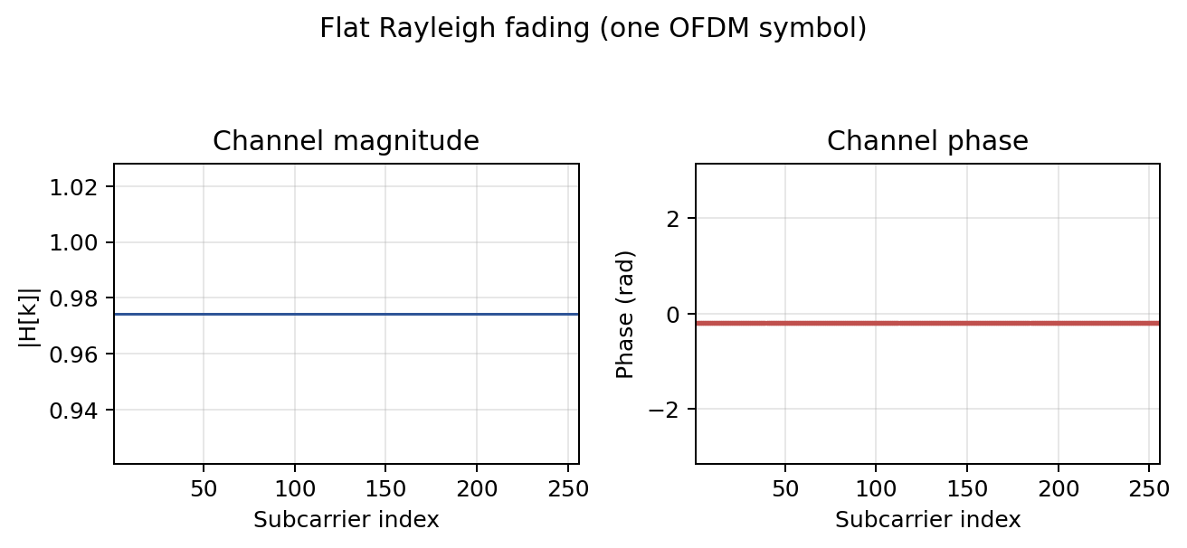
Figure 2. Example magnitude and phase response of a flat Rayleigh channel across the 256 subcarriers for one OFDM symbol.
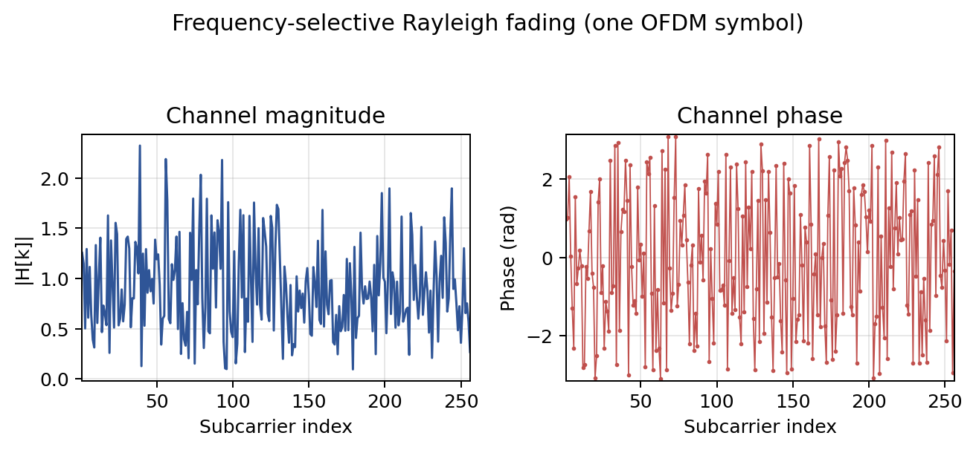
Figure 3. Example magnitude and phase response of the frequency-selective Rayleigh channel. Each subcarrier has its own random complex gain.

2.5 Receiver and Performance Metrics
The receiver reshapes the serial waveform into OFDM symbols, removes the CP, and performs the 256-point FFT. To isolate the channel-model behavior, the simulation assumes perfect channel state information (CSI): the actual channel coefficient used in the transmission is available to the equalizer. For flat fading, the same coefficient is used for every subcarrier in that symbol. For frequency-selective fading, the corresponding H[k] is used on each subcarrier.
X̂[k] = Y[k] H*[k] / (|H[k]|² + ε), ε = 10⁻¹⁰
This is a regularized zero-forcing equalizer. The conjugate form is equivalent to division by H when ε is negligible, while the small regularization prevents unstable division by a coefficient that is nearly zero. Deep fades can still amplify noise and therefore produce larger residual errors.
The required metric is the bit error rate, computed by comparing the recovered information bits with the transmitted information bits:
BER = number of incorrect information bits / total information bits
The code also reports root-mean-square error vector magnitude (RMS EVM) after equalization. EVM compares the measured/equalized complex symbols with the ideal transmitted symbols and is normalized to the reference-symbol power:
EVM_RMS (%) = 100 × √[Σ |rₖ − sₖ|² / Σ |sₖ|²]
BER is the assignment’s required result. EVM is supplementary: it quantifies constellation displacement even when a displaced symbol remains inside the correct demodulation decision region.

3. Simulation Parameters
The core parameters follow the attached MATLAB source. A fixed random seed is used to make each MATLAB run repeatable within the same MATLAB random-number implementation. Because the channel is stochastic, different random-number generators can produce different markers while preserving the same expected trends.
Parameter | Value / implementation choice
IFFT/FFT size | 256 points (specified by the assignment)
Cyclic-prefix length | 16 samples (assumption; not specified in the brief)
Subcarrier spacing used for diagnostic frequency axes | 15 kHz
Sampling rate implied by the code | 256 × 15 kHz = 3.84 MHz
OFDM symbols per frame | 8
Frames per SNR point | 100
SNR sweep | 0, 2, 4, …, 24 dB (13 points)
Modulation | BPSK and Gray-coded 16-QAM
Channel models | Flat Rayleigh; independent frequency-domain Rayleigh fading per subcarrier
Coding | Uncoded and rate-1/5 repetition code
Interleaver | BPSK: 16 × 16 assumed; 16-QAM: 32 × 32 as specified
Receiver channel knowledge | Perfect CSI; no pilot-based estimate used in the BER loop
Noise normalization | Complex AWGN variance = mean transmit waveform power / 10^(SNR/10)
Repetition-code decoder | Hard decisions followed by majority vote over groups of five

Table 1. Simulation settings used by the OFDM link.
Modulation | M | Bits per symbol | Uncoded bits / OFDM symbol | Info bits / OFDM symbol, coded | Coded mapper input
BPSK | 2 | 1 | 256 | 51 | 255 repeated bits + 1 zero pad
16-QAM | 16 | 4 | 1,024 | 204 | 1,020 repeated bits + 4 zero pads

Table 2. Mapper capacity and repetition-code padding per OFDM symbol.
Each SNR point uses 100 × 8 = 800 OFDM symbols per scenario. The uncoded information-bit counts are 204,800 for BPSK and 819,200 for 16-QAM. Under repetition coding, the corresponding information-bit counts are 40,800 for BPSK and 163,200 for 16-QAM. Thus, the BER resolution differs by scenario; zero observed errors do not establish a mathematically zero underlying BER.

4. Results and Discussion
The project requirement is to plot BER against SNR for four cases in each modulation scheme. The figures below show the four requested curves: flat fading with no coding, flat fading with rate-1/5 repetition, frequency-selective fading with no coding, and frequency-selective fading with rate-1/5 repetition. The EVM curves are included as an additional view of the receiver output.

4.1 BER Results for BPSK
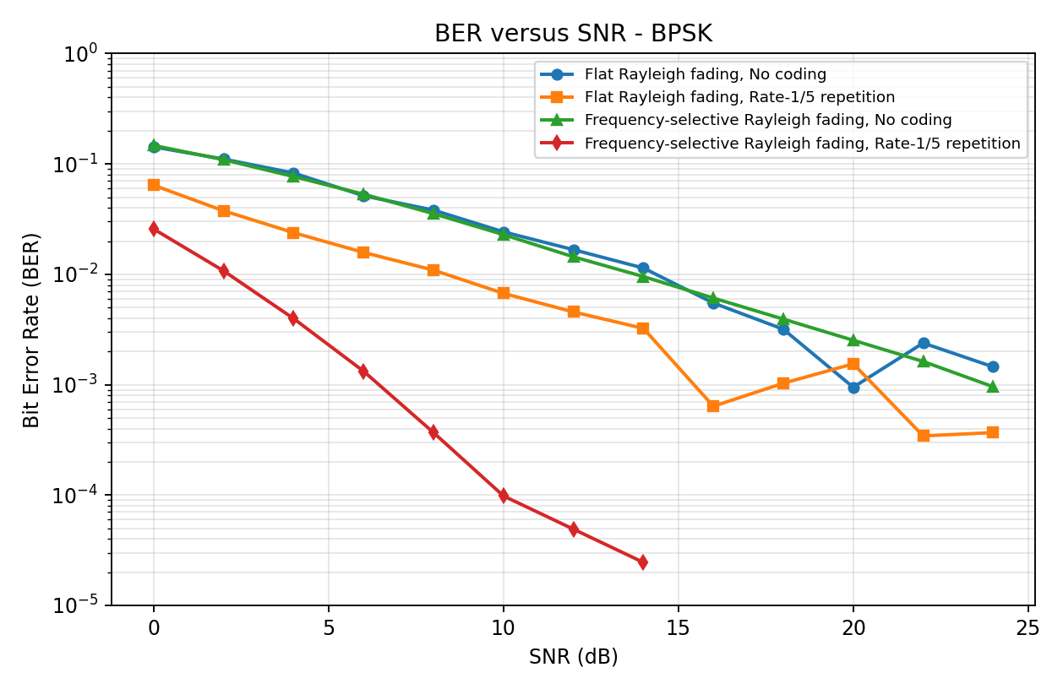
Figure 4. BER versus SNR for BPSK under both Rayleigh channels, with and without rate-1/5 repetition coding.
The uncoded BPSK BER begins near 0.14 at 0 dB for both channel models and generally decreases as SNR increases. At the upper end of the simulated range, the uncoded curves are on the order of 10⁻³. The two channel curves are broadly similar because both models draw unit-average-power Rayleigh coefficients; the main structural difference is whether one gain is shared across an OFDM symbol or an independent gain is applied to every subcarrier.
The repetition-coded curves are below the corresponding uncoded curves across most of the sweep. Each information bit is transmitted five times, and the receiver uses majority voting to reduce the impact of individual bit-decision errors. The frequency-selective coded curve records zero errors for some of the higher-SNR points in this finite run. Those points are limited by the finite number of information bits, not evidence that the true BER is exactly zero.

4.2 BER Results for 16-QAM
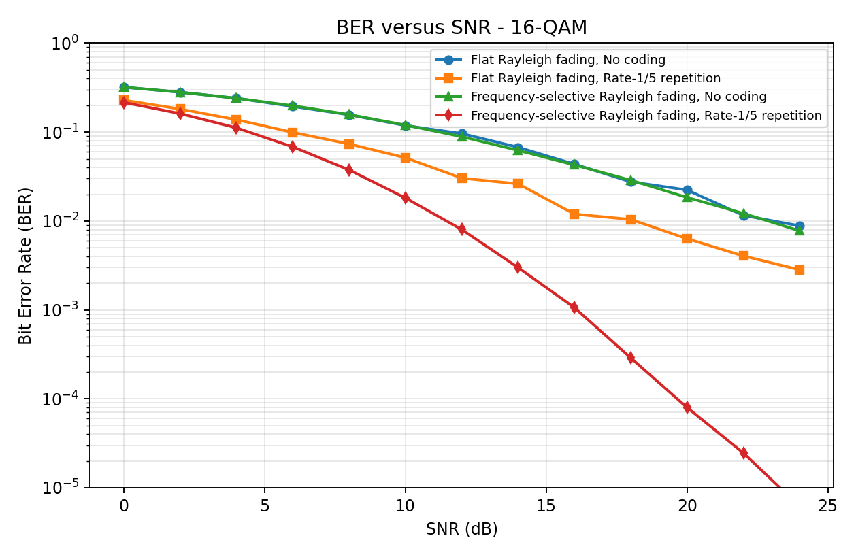
Figure 5. BER versus SNR for 16-QAM under both Rayleigh channels, with and without rate-1/5 repetition coding.
The uncoded 16-QAM curves start near 0.32 at 0 dB and fall with increasing SNR. They remain above the BPSK curves over the displayed range. With unit average symbol energy, 16-QAM must distinguish among 16 constellation points, so neighboring points are closer than the two BPSK states. A smaller decision margin makes the receiver more sensitive to noise and fading.
Rate-1/5 repetition coding improves the observed BER for 16-QAM as well. The frequency-selective coded case reaches approximately 6 × 10⁻⁶ at 24 dB in this run, while the flat coded case is approximately 2.8 × 10⁻³. These values reflect this finite Monte Carlo realization and the precise SNR normalization used in the supplied implementation; they should not be interpreted as universal theoretical limits.
Modulation | Channel | Coding | BER at 0 dB | BER at 24 dB
BPSK | Flat Rayleigh | No coding | 0.1426 | 1.45 × 10⁻³
BPSK | Flat Rayleigh | Rate-1/5 repetition | 0.0641 | 3.68 × 10⁻⁴
BPSK | Frequency-selective Rayleigh | No coding | 0.1471 | 9.57 × 10⁻⁴
BPSK | Frequency-selective Rayleigh | Rate-1/5 repetition | 0.0257 | 0 observed errors
16-QAM | Flat Rayleigh | No coding | 0.3201 | 8.81 × 10⁻³
16-QAM | Flat Rayleigh | Rate-1/5 repetition | 0.2285 | 2.82 × 10⁻³
16-QAM | Frequency-selective Rayleigh | No coding | 0.3206 | 7.73 × 10⁻³
16-QAM | Frequency-selective Rayleigh | Rate-1/5 repetition | 0.2158 | 6.00 × 10⁻⁶

Table 3. Selected BER values from the reference Monte Carlo realization.
For the BPSK coded frequency-selective scenario, no errors were recorded among 40,800 information bits at 24 dB. The single-run resolution is therefore about 1/40,800 ≈ 2.45 × 10⁻⁵; the recorded estimate is zero, but the underlying BER is not proven to be zero. Increasing the frame count is recommended for stable high-SNR estimates.

4.3 Coding and Channel-Model Comparison
Across both modulation schemes, repetition coding generally reduces BER. The cost is throughput: a rate-1/5 code spends five transmitted coded bits on one information bit. In the current code, SNR is defined using average transmit waveform power divided by complex noise variance, rather than energy per information bit. Consequently, coded and uncoded runs are not normalized to equal energy per information bit; repetition gives an information bit multiple transmitted opportunities and extra total transmitted energy. The curves demonstrate the implementation’s coded/uncoded behavior, but a strictly energy-fair coding comparison would normalize Eb/N0 explicitly.
The flat and frequency-selective curves are broadly comparable in the uncoded cases because the per-subcarrier fading coefficients have the same Rayleigh marginal distribution in both models. The frequency-selective model introduces a different gain on each subcarrier, while the flat model shares one gain across the symbol. With perfect CSI and one-tap equalization, no pilot-estimation error is included. Differences between finite-run curves arise from channel realizations, finite bit counts, and the way coding spreads repeated copies over the interleaved bit positions.
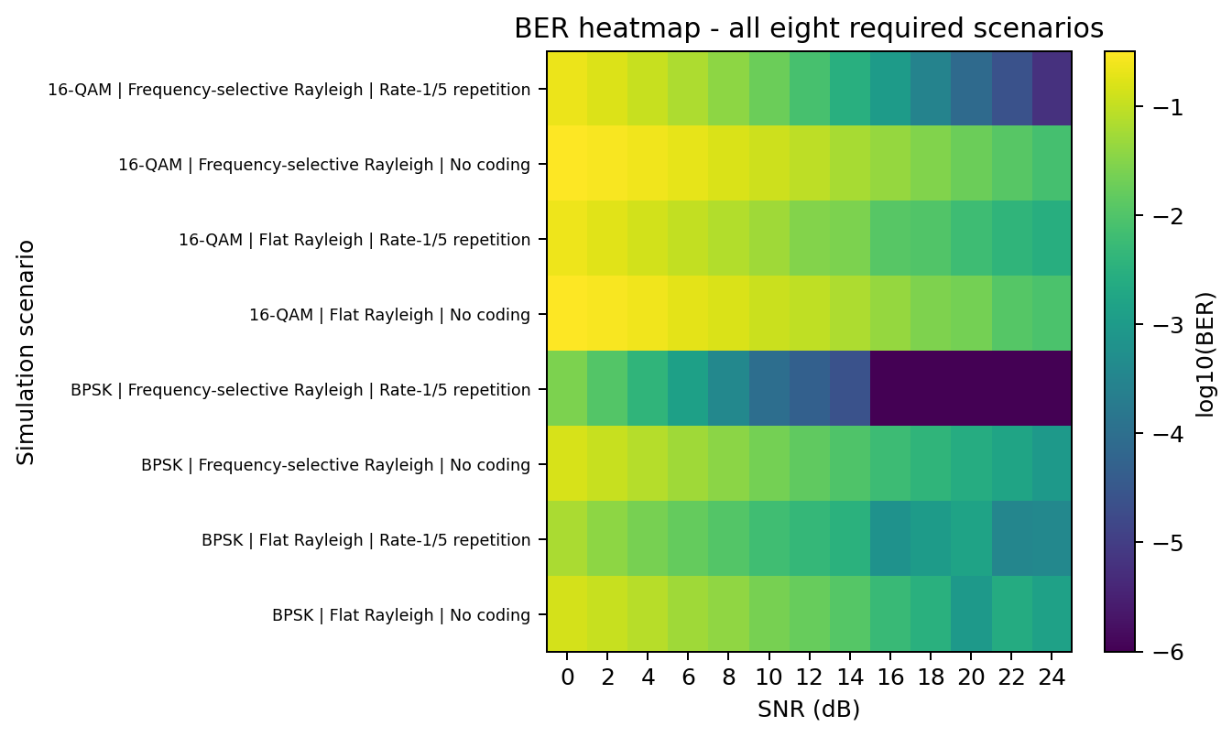
Figure 6. Logarithmic BER heatmap across all eight required channel, coding, and modulation scenarios.

4.4 EVM and Receiver Diagnostics
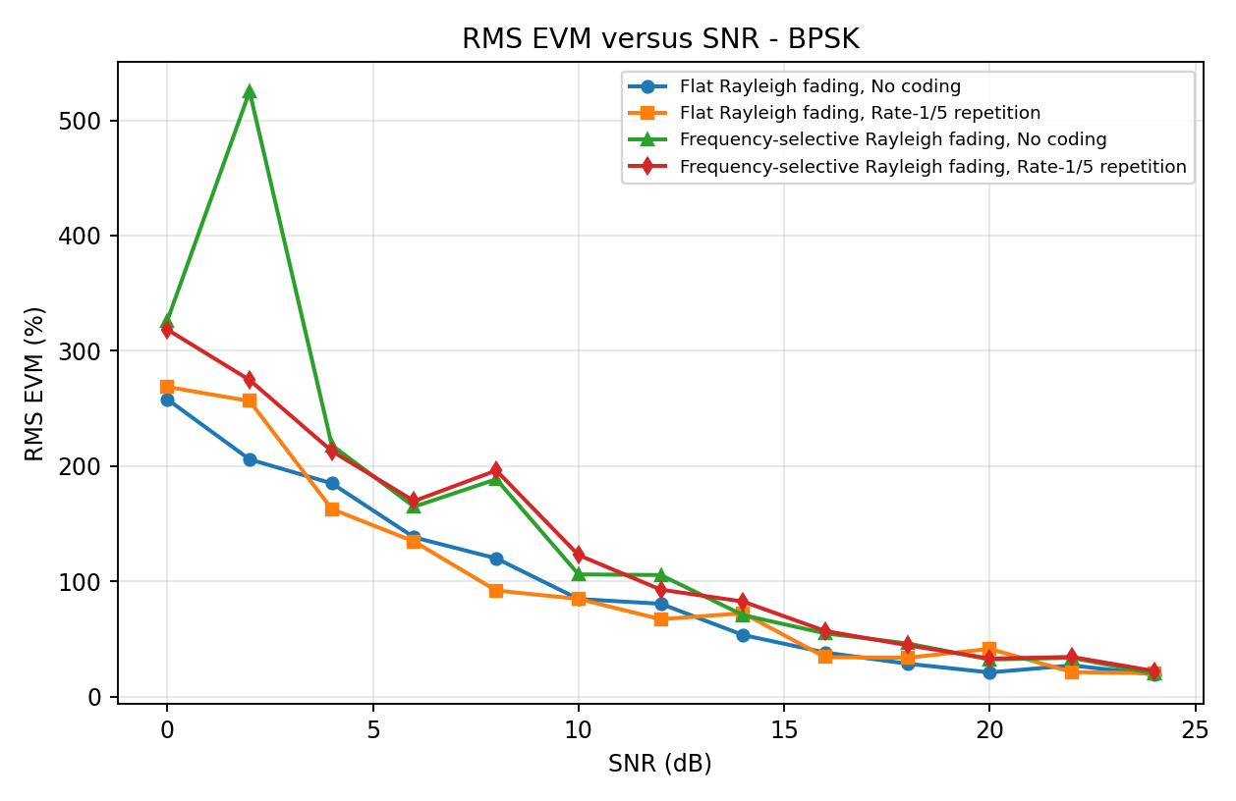
Figure 7. RMS EVM versus SNR for BPSK. EVM is measured after equalization against the transmitted constellation symbols.
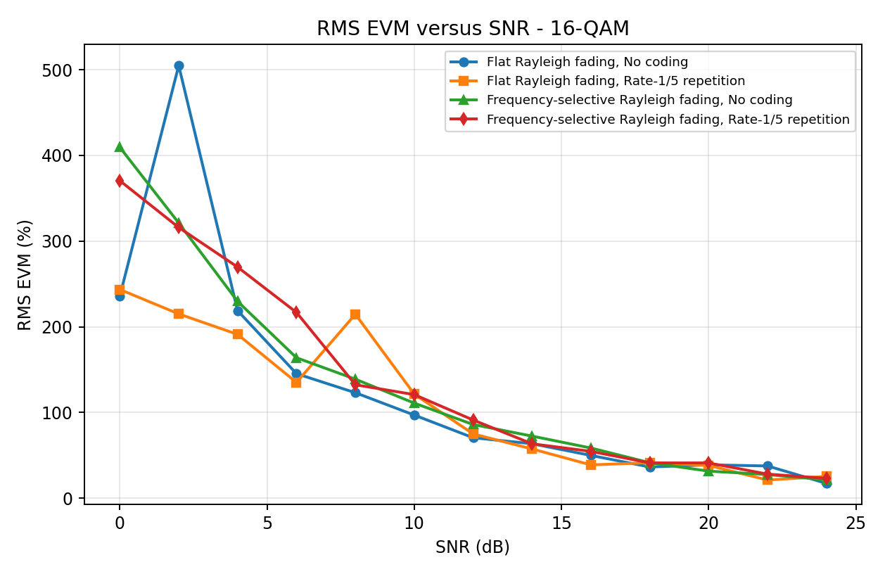
Figure 8. RMS EVM versus SNR for 16-QAM. Large values at low SNR and spikes at isolated points are associated with noise and deep fading.
EVM generally decreases as the target SNR increases, but it is not required to be strictly monotonic in a finite simulation. Zero-forcing equalization multiplies the received subcarrier by a factor proportional to 1/H[k]. When |H[k]| is small, this operation amplifies noise, so a few deeply faded subcarriers can dominate the RMS EVM. The regularization term prevents numerical division by zero but cannot remove the noise amplification inherent to deep fades.
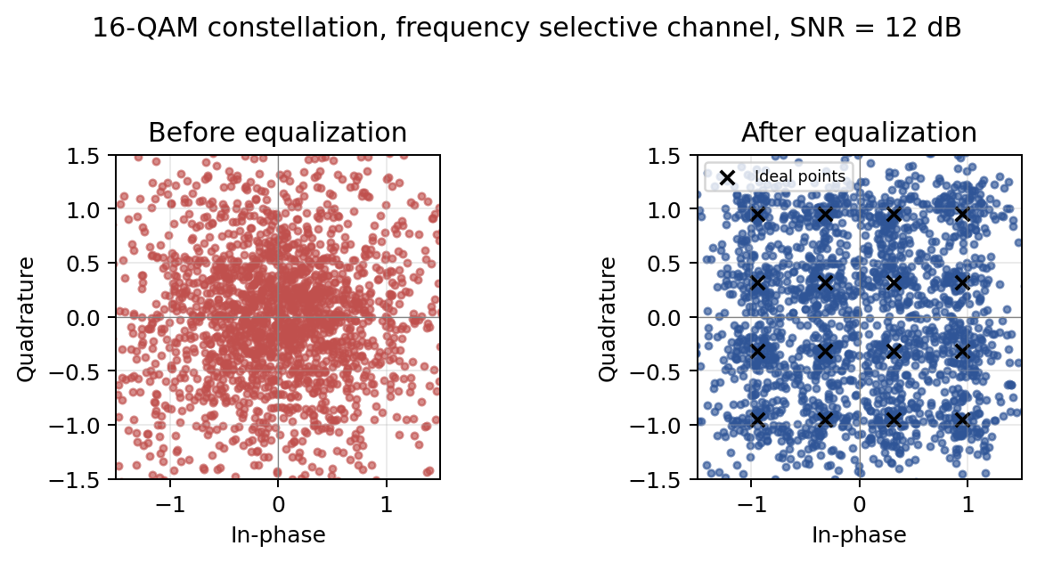
Figure 9. Illustrative 16-QAM constellation before and after one-tap equalization at 12 dB SNR; display axes are limited to show the main constellation cluster.
Before equalization, channel amplitude and phase changes spread the received points away from their ideal positions. After equalization, the point cloud clusters closer to the 16-QAM constellation. Some residual displacement remains because AWGN is still present and deep-fade equalization amplifies it. This view is diagnostic; the project’s acceptance measure remains BER versus SNR.

5. Assumptions and Limitations
• Cyclic prefix: a length of 16 samples is used because the assignment does not specify a length. For a physical multipath channel, the CP should be chosen to cover the channel excess delay.
• BPSK interleaver: the assignment specifies 32 × 32 for 16-QAM but does not state a BPSK size. The code uses 16 × 16, which matches 256 coded input bits per BPSK OFDM symbol.
• Perfect CSI: the BER loop uses the actual channel coefficient for equalization. It does not estimate the channel from pilot/reference symbols. The supplied tutorial screenshots discuss pilot-based estimation, but the assignment’s explicit BER tasks do not specify a pilot pattern or channel estimator.
• Frequency-selective model: each subcarrier is independently faded in the frequency domain, as requested. This is a simplified model and does not reproduce the frequency correlation of a multipath channel response.
• SNR definition: the code sets complex-noise variance using transmit waveform power / 10^(SNR/10). This is SNR, not a direct Eb/N0 sweep. A coded-versus-uncoded comparison at equal Eb/N0 would require an explicit energy-per-information-bit adjustment.
• Monte Carlo precision: 100 frames × 8 OFDM symbols are simulated per SNR point. At high SNR, a small number of bit errors leads to statistical scatter or zero-error points; the source comments recommend increasing the frame count to 500–1000 for final smooth curves.
Reproducibility note: the plots embedded here are generated from a numerical reproduction of the same block equations and parameters to document expected behavior. Exact Monte Carlo markers can differ from a MATLAB run because random-number generators and implementation details may differ. Before final submission, rerun the supplied MATLAB code and replace the embedded plots with its exported PNG files if exact code-to-figure matching is required.

6. Conclusions
The OFDM simulation implements the principal blocks described in the assignment: coding, interleaving, BPSK/16-QAM mapping, 256-point IFFT, cyclic-prefix insertion, Rayleigh fading, receiver FFT, equalization, demapping, and BER calculation. It evaluates the two specified channel models with both coding options, producing the eight BER scenarios required by the project.
The Monte Carlo curves show the expected main trends: BER generally falls as SNR rises; the rate-1/5 repetition code lowers the measured BER by using multiple coded copies; and BPSK is more robust than 16-QAM at the same stated waveform SNR. The flat and frequency-selective channels produce broadly comparable uncoded statistics under the assignment’s Rayleigh assumptions, while their individual realizations differ. EVM and constellation plots provide complementary evidence of channel distortion and receiver equalization.
The main qualifications are that the CP length and BPSK interleaver dimensions are implementation assumptions, the receiver uses perfect channel knowledge rather than pilots, and the noise normalization is expressed as waveform SNR rather than equal Eb/N0. Increasing the Monte Carlo run length and optionally adding an explicit pilot-estimation experiment would strengthen a final engineering evaluation.

7. References
• Cairo University, Faculty of Engineering, Digital Communications - Modulation, “Project Part 3: OFDM System Simulation,” supplied assignment PDF, 2027 filename, with deadline stated as 14 December 2026.
• “Part1_Report.docx,” supplied report template for the course’s preceding single-carrier simulation; used as the typography, heading-color, table, and figure-caption style reference.
• “ofdm_project_complete.m,” supplied MATLAB source snapshot, including the manual mapper/demapper, 256-point FFT/IFFT processing, Monte Carlo loops, BER/EVM analysis, and figure-export logic.

