


Cairo University - Faculty of Engineering
Electronics & Electrical Communication Engineering
Advanced Communication Systems - EECG331

Part 1: Single-Carrier System over an AWGN Channel
BER Performance of BPSK, QPSK, 8PSK, 16-QAM and BFSK, with BFSK Power Spectral Density

Table of Contents

1. Objective and Scope 3
2. System Model and Simulation Method 3
2.1 Mapper 3
2.2 AWGN Channel and Noise Scaling 3
2.3 Simulation Parameters 4
3. Theoretical BER Expressions 4
4. Results and Discussion: BER of BPSK, QPSK, 8PSK and 16-QAM (Task 1.4) 5
4.1 Individual BER Curves 5
4.2 Comparison of the Four Schemes 7
4.3 QPSK: Gray (Assignment Figure 2) versus Non-Gray (Assignment Figure 3) Mapping 8
5. Results and Discussion: BFSK (Task 1.5) 8
5.1 Basis Functions 8
5.2 Baseband-Equivalent Signals and Carrier Frequency 9
5.3 BER of BFSK 9
5.4 Power Spectral Density of the Baseband-Equivalent Signal 10
6. Conclusions 11

1. Objective and Scope
This part of the project introduces the simulation of single-carrier digital communication systems. A random bit stream is mapped to symbols, transmitted over an additive white Gaussian noise (AWGN) channel, demapped, and compared with the transmitted bits to estimate the bit-error rate (BER) as a function of E_{b}/N₀. All simulations use the baseband-equivalent system, with no carriers.
The report covers the two tasks of the assignment:
- Task 1.4: BER versus E_{b}/N₀ for BPSK, QPSK, 8PSK and 16-QAM, each with its theoretical BER (or a tight bound) on the same graph, and a comparison of the two QPSK bit mappings (Figure 2 and Figure 3 of the assignment).
- Task 1.5: BFSK: basis functions, baseband-equivalent signals and carrier frequency, simulated and theoretical BER, and the power spectral density (PSD) of the baseband-equivalent signal set.
The MATLAB code, figures and this report are in the project repository (part1-awgn folder).

2. System Model and Simulation Method
The chain is Data bits → Mapper → AWGN channel → Demapper → BER calculator. The same random bit stream is used for every modulation scheme, so differences between curves come from the scheme and not from the data.

2.1 Mapper
Each mapper produces unit-grid baseband symbols following the constellations of the assignment (Figure 2 of the assignment). The energy per symbol E_{s} and the energy per bit E_{b} = E_{s}/log₂M that result from these mappings are listed below.
Scheme | Mapping | E_{s} | E_{b} | Demapper (ML decision)
BPSK | 0 → −1, 1 → +1 | 1 | 1 | Sign of received sample
QPSK (Fig. 2, Gray) | b₀ → I, b₁ → Q, each ±1 | 2 | 1 | Independent sign decisions on I and Q
QPSK (Fig. 3, non-Gray) | I = b₀; Q set by b₀ ⊕ b₁ | 2 | 1 | Sign decisions, then b₁ = Î ⊕ Q̂
8PSK (Gray) | Unit circle, phases as in the assignment figure | 1 | 1/3 | Minimum Euclidean distance
16-QAM (Gray) | b₀b₁ → I and b₂b₃ → Q: 00→−3, 01→−1, 11→+1, 10→+3 | 10 | 2.5 | Per-axis thresholds at 0 and ±2
BFSK | 0 → [√E_{b}, 0], 1 → [0, √E_{b}] on orthonormal basis | 1 | 1 | Compare correlator outputs
Table 1. Mappers, symbol and bit energies, and demappers used in the simulation.

2.2 AWGN Channel and Noise Scaling
Noise is generated with randn. For a target signal-to-noise ratio γ_{b} = E_{b}/N₀, the noise power is set from the energy per bit of each scheme, so that all schemes are compared at the same E_{b}/N₀:
$$γ_{b} = \frac{E_{b}}{N_{0}}, N_{0} = \frac{E_{b}}{γ_{b}}, σ^{2} = \frac{N_{0}}{2}$$
The noise is added with variance σ² per real dimension (real noise for BPSK and BFSK-basis components; independent I and Q noise for the complex schemes).

2.3 Simulation Parameters
Parameter | Value
Bits per E_{b}/N₀ point | 1.2 × 10⁶ (a multiple of 12, so it divides evenly by 1, 2, 3 and 4 bits per symbol with no padding)
E_{b}/N₀ range | −2 to 14 dB in 1 dB steps
Random seed | rng('default'): results are reproducible
BFSK PSD | Welch method (pwelch), Hamming window of 2048 samples, 50 % overlap, 4096-point FFT; 20 000 bits at 64 samples per bit
Resolution limit | With 1.2 × 10⁶ bits the smallest measurable BER is about 8 × 10⁻⁷
Table 2. Simulation parameters.

3. Theoretical BER Expressions
With the Q-function Q(x) = ½ erfc(x/√2) and γ_{b} = E_{b}/N₀, the reference curves drawn with the simulated points are:
Scheme | Theoretical BER | Type
BPSK | $$P_{b} = Q\left(\sqrt{2γ_{b}}\right)$$ | Exact
QPSK (Gray) | $$P_{b} = Q\left(\sqrt{2γ_{b}}\right)$$ | Exact
QPSK (non-Gray) | $$P_{b} = \frac{3}{2}p - p^{2}, p = Q\left(\sqrt{2γ_{b}}\right)$$ | Exact
8PSK (Gray) | $$P_{b} ≈ \frac{2}{3}Q\left(\sqrt{6γ_{b}}\sin\left(\frac{π}{8}\right)\right)$$ | Tight approximation
16-QAM (Gray) | $$P_{b} ≈ \frac{3}{4}Q\left(\sqrt{\frac{4γ_{b}}{5}}\right)$$ | Tight approximation
BFSK (coherent, orthogonal) | $$P_{b} = Q\left(\sqrt{γ_{b}}\right)$$ | Exact
Table 3. Theoretical BER expressions used as references.
All the expressions have the form Q(√(d²/(2N₀))), where d is the minimum distance of the signal set. Writing d² in units of E_{b} explains the ordering of the results in Section 4: BPSK and QPSK have d² = 4E_{b}, BFSK has 2E_{b}, 8PSK has 12E_{b}·sin²(π/8) ≈ 1.76E_{b}, and 16-QAM has 1.6E_{b}.

4. Results and Discussion: BER of BPSK, QPSK, 8PSK and 16-QAM (Task 1.4)

4.1 Individual BER Curves
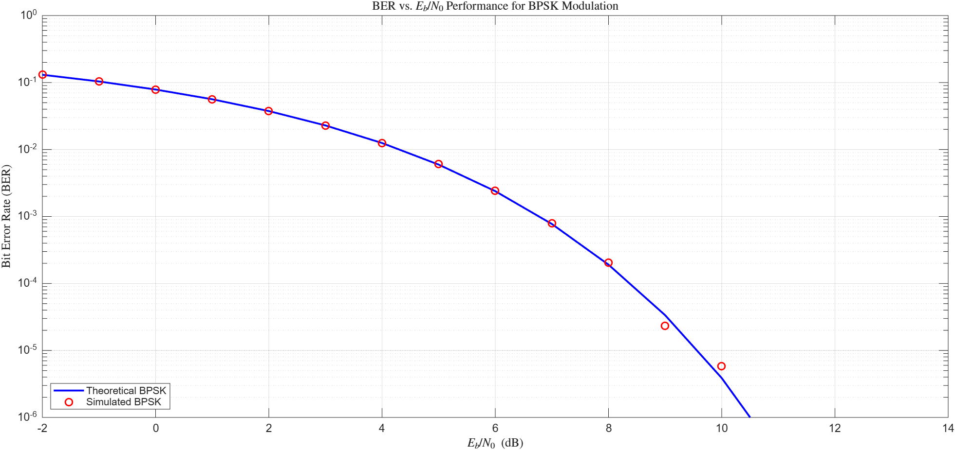
Figure 1. BER versus E_{b}/N₀ for BPSK: theory (line) and simulation (markers).
Comment. The simulated BER follows the theoretical curve across the whole range. It falls from about 0.13 at −2 dB to about 10⁻³ near 7 dB. At the highest SNRs (9–10 dB) the markers scatter slightly around the curve because only a few tens of errors are counted out of 1.2 × 10⁶ bits, and the relative uncertainty of a BER estimate is roughly 1/√(number of errors). Beyond about 10 dB the true BER is below the 8 × 10⁻⁷ resolution of this run, so zero errors are recorded and no points can be shown on the logarithmic axis.
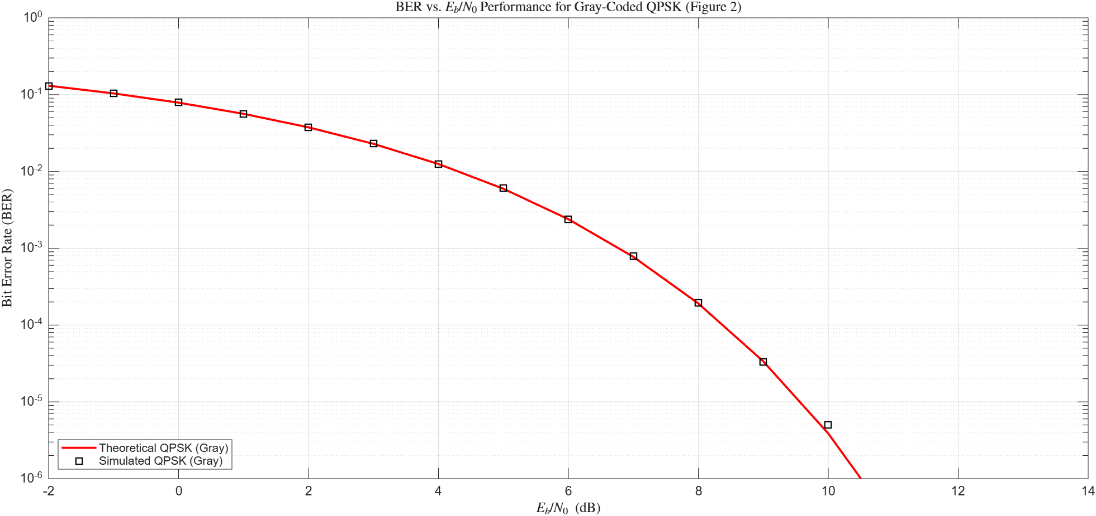
Figure 2. BER versus E_{b}/N₀ for Gray-coded QPSK (assignment Figure 2): theory and simulation.
Comment. The Gray-coded QPSK curve is identical to the BPSK curve. QPSK is two independent BPSK streams on the orthogonal I and Q axes; with Gray mapping each bit controls one axis, and each axis carries energy E_{b} per bit. A noise sample on one axis therefore corrupts only the bit on that axis. QPSK sends two bits per symbol, so it needs half the bandwidth of BPSK for the same bit rate with no BER penalty.
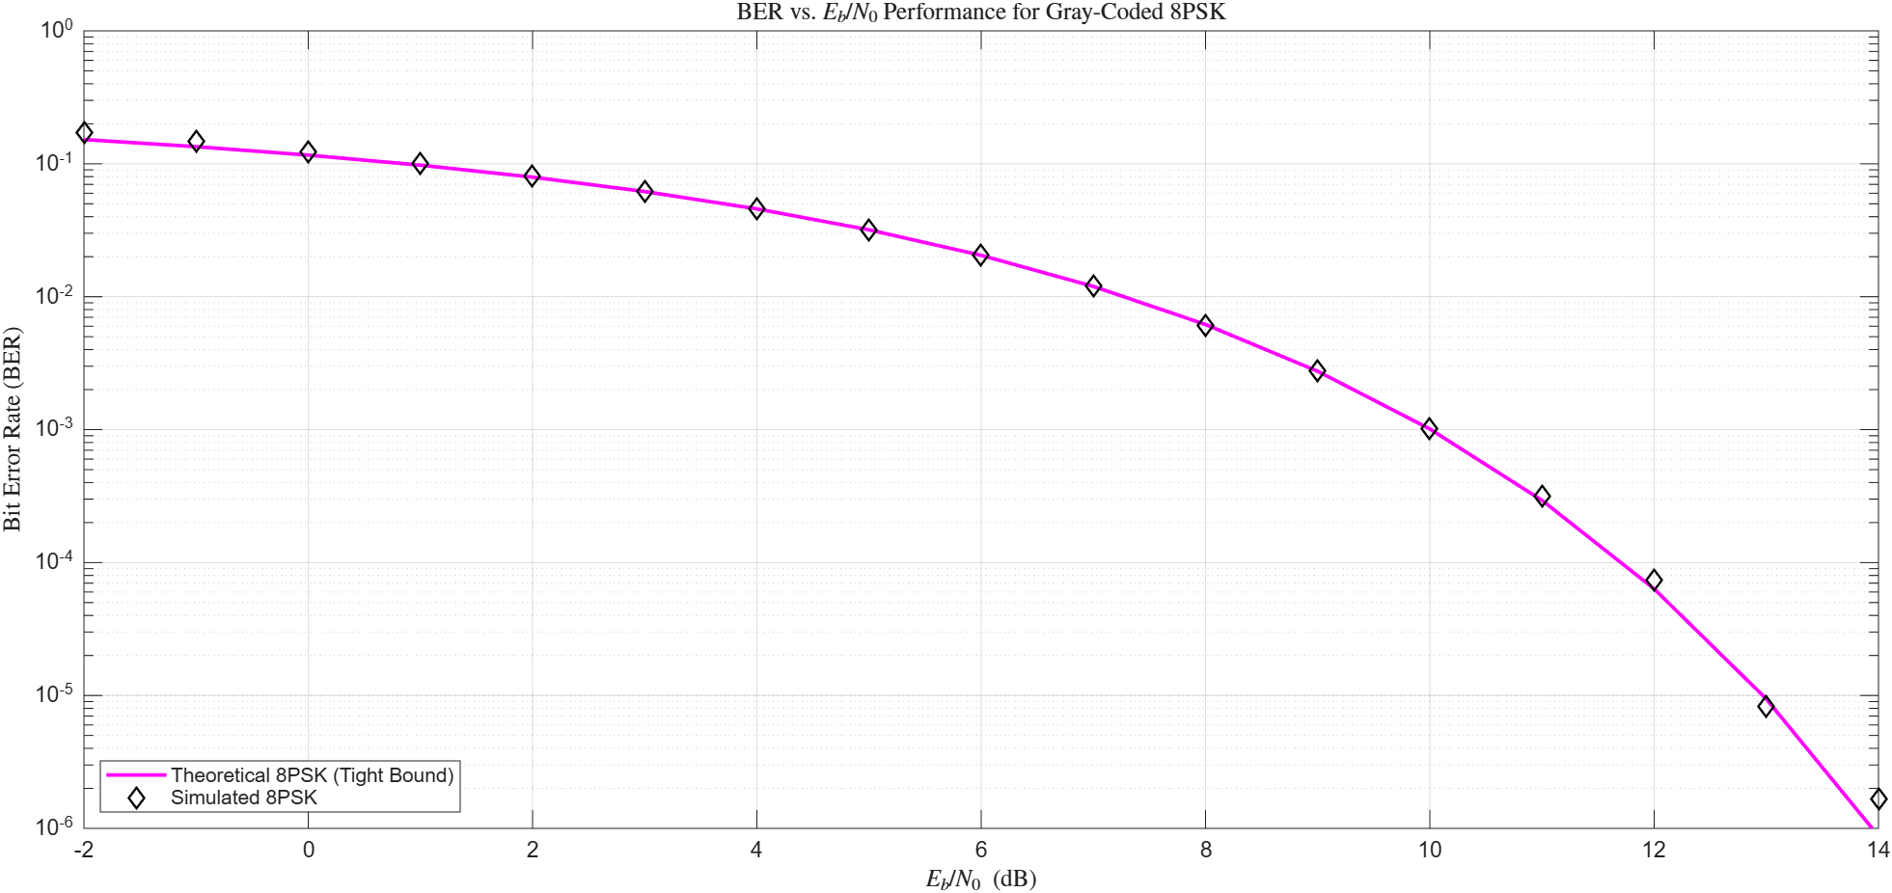
Figure 3. BER versus E_{b}/N₀ for Gray-coded 8PSK: tight approximation and simulation.
Comment. The 8PSK simulation agrees with the nearest-neighbour approximation from about 0 dB upward. At the lowest SNRs the simulated points lie slightly above the curve: the approximation counts only errors to adjacent symbols, and at low SNR errors to farther symbols add to the true BER. The approximation becomes tight as SNR grows, which is why it is used as the reference.
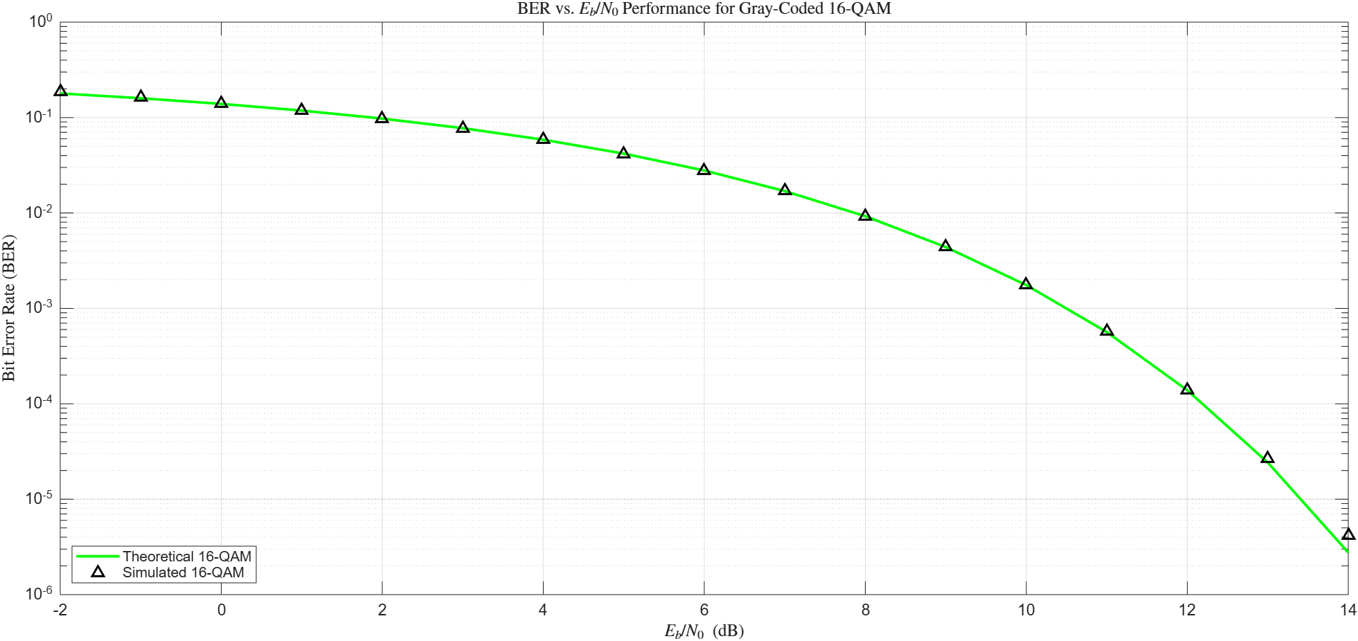
Figure 4. BER versus E_{b}/N₀ for Gray-coded 16-QAM: tight approximation and simulation.
Comment. The 16-QAM simulation also matches its approximation, with the same small deviation at the lowest SNRs. Each axis is a 4-level PAM signal, and the Gray labelling gives the two bits of an axis different protection: the first bit (the sign) changes only when the decision crosses 0, whereas the second bit changes when it crosses ±2, so the second bit is more error-prone. The theoretical expression is the average over all four bits.

4.2 Comparison of the Four Schemes
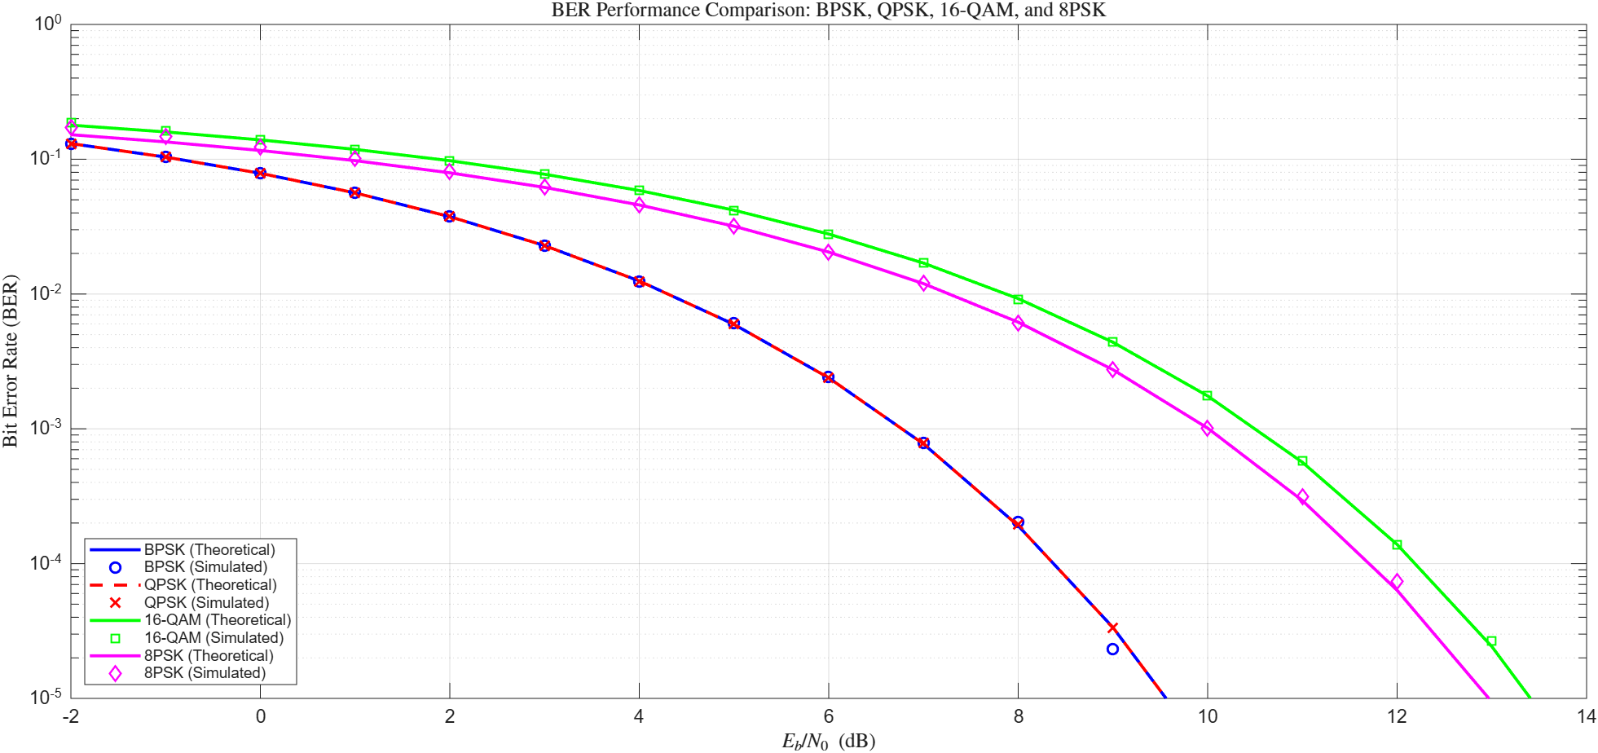
Figure 5. BER versus E_{b}/N₀ for BPSK, QPSK, 16-QAM and 8PSK on one graph (theory and simulation).
Comment. At equal E_{b}/N₀, BPSK and QPSK give the lowest BER (their curves coincide), 8PSK is next, and 16-QAM is the worst. The ordering follows the minimum distance per bit energy: as more bits are packed into each symbol with the same energy per bit, the points of the constellation get closer. This is the power–bandwidth trade-off of M-ary modulation: 16-QAM sends 4 bits per symbol and uses a quarter of the bandwidth of BPSK for the same bit rate, but needs more energy per bit for the same BER.
The horizontal (dB) gaps between the curves are small at low SNR, where all four BERs lie between 0.13 and 0.18, and grow with SNR toward the limit set by the minimum distance. Table 4 gives the E_{b}/N₀ required for BER = 10⁻³ and 10⁻⁵ from the closed-form expressions of Table 3.
Scheme | Req. E_{b}/N₀ at 10⁻³ (dB) | Req. E_{b}/N₀ at 10⁻⁵ (dB) | Loss vs. BPSK at 10⁻³ (dB) | Loss vs. BPSK at 10⁻⁵ (dB)
BPSK / QPSK (Gray) | 6.79 | 9.59 | 0 | 0
QPSK (non-Gray) | 7.12 | 9.77 | 0.33 | 0.18
BFSK (coherent) | 9.80 | 12.60 | 3.01 | 3.01
8PSK (Gray) | 10.01 | 12.97 | 3.22 | 3.38
16-QAM (Gray) | 10.52 | 13.43 | 3.73 | 3.84
Table 4. E_{b}/N₀ required for a given BER, from the theoretical expressions.
Two observations follow from the table. First, 16-QAM is only about 0.5 dB worse than 8PSK although it carries one more bit per symbol: placing points on a square grid in amplitude and phase uses the signal energy more efficiently than placing all of them on one circle. Second, the asymptotic loss predicted by the minimum distance, 10·log₁₀(4E_{b}/d²), is 3.57 dB for 8PSK and 3.98 dB for 16-QAM; the values at 10⁻⁵ (3.38 dB and 3.84 dB) approach these limits from below.

4.3 QPSK: Gray (Assignment Figure 2) versus Non-Gray (Assignment Figure 3) Mapping
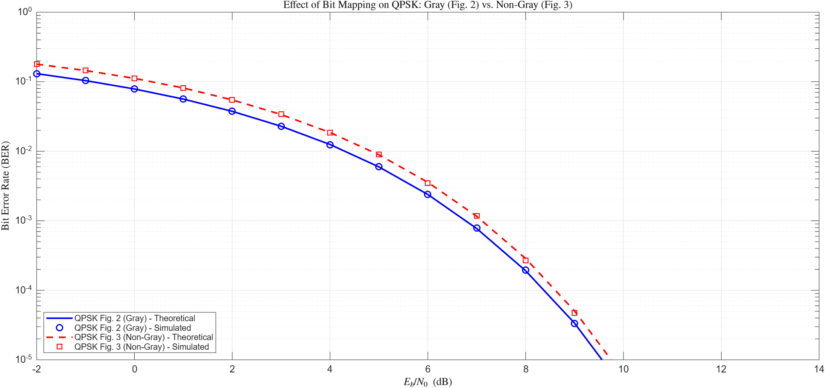
Figure 6. QPSK BER versus E_{b}/N₀: assignment Figure 2 (Gray) against assignment Figure 3 (non-Gray), theory and simulation.
Comment. The non-Gray mapping (assignment Figure 3) is worse than the Gray mapping (assignment Figure 2) at every SNR, and the simulation reproduces the theoretical curve for both. The two mappings use exactly the same constellation points and the same decision regions, so their symbol error probability is identical; only the assignment of bits to points differs.
In the labelling of assignment Figure 3, the horizontally adjacent pairs 01–10 and 00–11 differ in both bits, while the vertically adjacent pairs 01–00 and 10–11 and the diagonal pairs differ in one bit. An error on the I axis alone therefore flips two bits, an error on the Q axis alone flips one bit, and an error on both axes flips one bit. Averaging over the two bits of a symbol gives
$$P_{b} = \frac{2p(1-p) + p(1-p) + p^{2}}{2} = \frac{3}{2}p - p^{2}$$
with p = Q(√(2γ_{b})) the error probability of each axis. At high SNR this tends to 1.5 p, so the non-Gray BER is about 1.5 times the Gray BER. In terms of required SNR, the penalty is 0.33 dB at BER = 10⁻³ and shrinks to 0.18 dB at 10⁻⁵ (Table 4), because a fixed BER ratio corresponds to a smaller dB gap on the steeper part of the curve. With Gray mapping every nearest-neighbour symbol error costs exactly one bit error, which is the minimum possible, so Gray labelling is the preferred choice.

5. Results and Discussion: BFSK (Task 1.5)
The BFSK signal set is
$$s_{i}(t) = \sqrt{\frac{2E_{b}}{T_{b}}}\cos\left(2πf_{i}t\right), 0 ≤ t ≤ T_{b}$$
with tone frequencies f_{i} = (n_{c} + i)/T_{b}, i = 1, 2.

5.1 Basis Functions
The signal set has two orthonormal basis functions, one per tone:
$$φ_{i}(t) = \sqrt{\frac{2}{T_{b}}}\cos\left(2πf_{i}t\right), 0 ≤ t ≤ T_{b}, i = 1, 2$$
They are orthogonal because the product of the two cosines integrates to zero over a bit interval: the frequency difference f₂ − f₁ = 1/T_{b} and the sum f₁ + f₂ = (2n_{c} + 3)/T_{b} both complete a nonzero whole number of cycles in T_{b}. Their energy is normalised to one by the factor √(2/T_{b}). In signal space the two signals are s₁ = [√E_{b}, 0] and s₂ = [0, √E_{b}]. Their distance is d² = 2E_{b}, half that of BPSK.

5.2 Baseband-Equivalent Signals and Carrier Frequency
Writing the passband signal as the real part of the complex envelope times the carrier,
$$s_{i}(t) = Re\left\{s_{bb,i}(t) e^{j2πf_{c}t}\right\}$$
and letting A = √(2E_{b}/T_{b}), the baseband-equivalent signals are
$$s_{bb,i}(t) = A e^{j2π\left(f_{i} - f_{c}\right)t}$$
The result depends on the carrier frequency chosen as the reference. Two choices are considered:
Model | Carrier f_{c} | s_{bb,1}(t) | s_{bb,2}(t) | Tones at
A | f₁ = (n_{c} + 1)/T_{b} | $$A$$ | $$A e^{j2π\frac{t}{T_{b}}}$$ | 0 and 1/T_{b}
B | (f₁ + f₂)/2 = (n_{c} + 1.5)/T_{b} | $$A e^{-jπ\frac{t}{T_{b}}}$$ | $$A e^{+jπ\frac{t}{T_{b}}}$$ | ±1/(2T_{b})
Table 5. Baseband-equivalent signals for the two reference carriers, for 0 ≤ t ≤ T_{b}.
In Model A, f_{c}T_{b} is an integer, so the carrier phase is the same at the start of every bit and the expressions above apply unchanged to each bit. In Model B, f_{c}T_{b} = n_{c} + 1.5 is not an integer, so the carrier phase advances by an odd multiple of π from one bit to the next, and the baseband-equivalent waveform of the k-th bit must be multiplied by (−1)^{k} when the bits are concatenated. This factor keeps the waveform a continuous complex exponential in absolute time, which is what places the tones at ±1/(2T_{b}). Without it, each bit would restart the exponential at phase 0 and the spectrum would show spurious lines at multiples of 1/T_{b} instead.

5.3 BER of BFSK
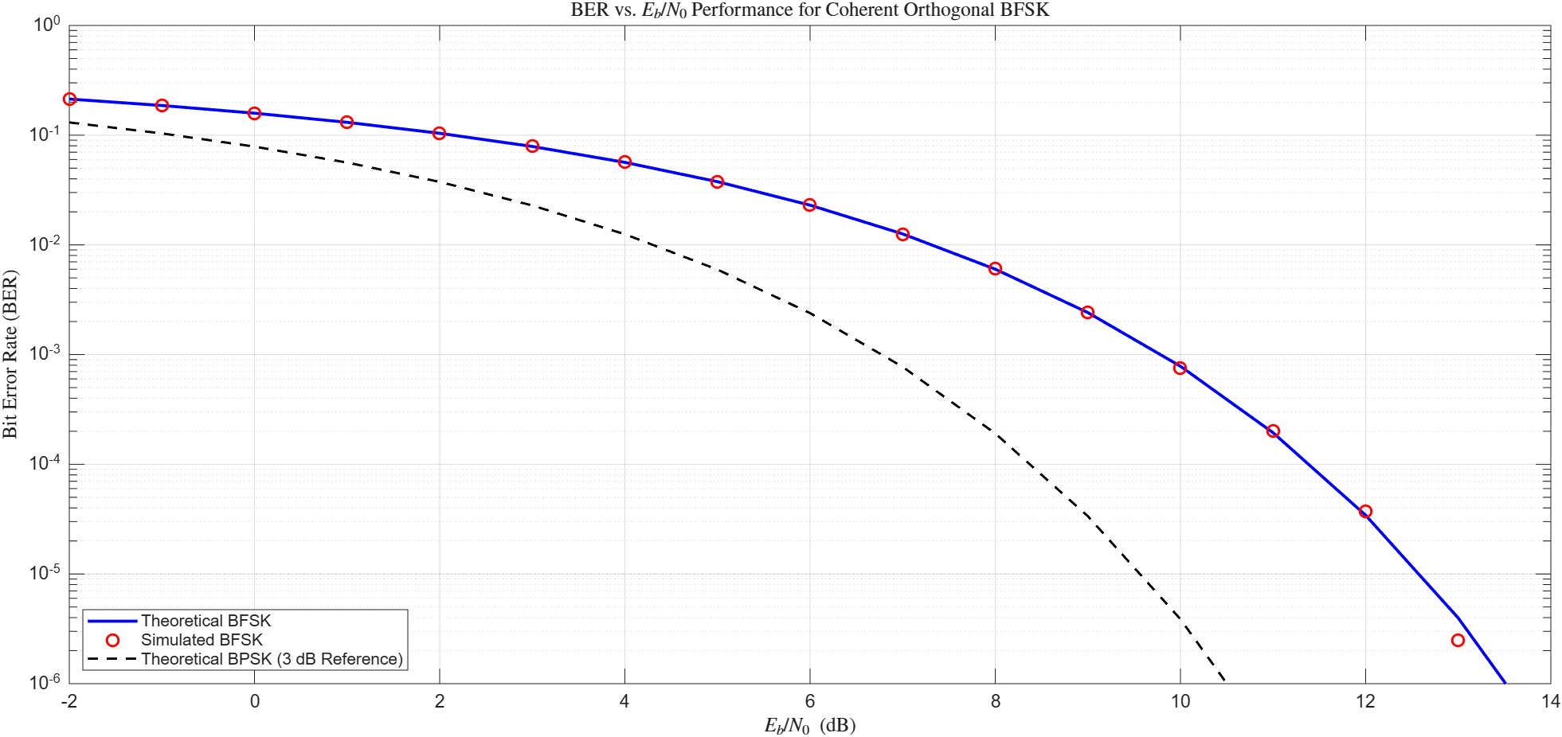
Figure 7. BER versus E_{b}/N₀ for coherent orthogonal BFSK: theory and simulation, with the BPSK curve as a reference.
Comment. The simulated BFSK BER matches the theoretical expression Q(√γ_{b}) over the whole range, including the last points near 10⁻⁵ to 10⁻⁶, where the few error counts explain the small scatter. The BFSK curve is displaced from the BPSK curve by 3 dB: BFSK needs 9.8 dB for a BER of 10⁻³, against 6.8 dB for BPSK (Table 4). The cause is the signal-space geometry. For the same E_{b}, the two BFSK signals are at distance d² = 2E_{b}, while the BPSK signals are at d² = 4E_{b}; the receiver sees a factor of two less distance, hence a factor of two (3 dB) less effective SNR. Orthogonal signalling in return allows non-coherent reception and gives a flat-envelope signal, but it is less power-efficient than antipodal signalling for the same bit rate.

5.4 Power Spectral Density of the Baseband-Equivalent Signal
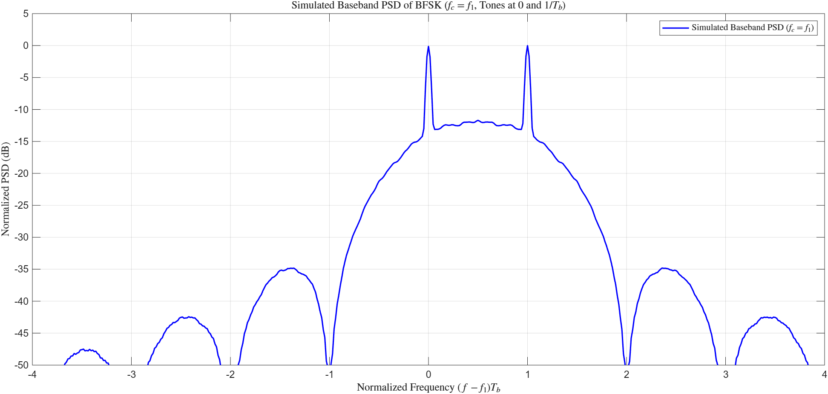
Figure 8. Simulated baseband PSD of BFSK with the reference carrier f_{c} = f₁ (Model A). Tones at 0 and 1/T_{b}.
Comment. The PSD consists of two discrete spectral lines at the two tone frequencies (0 and 1/T_{b}), shown at the 0 dB reference, on top of a continuous part about 12 dB lower between and around them. The main lobe extends from −1/T_{b} to +2/T_{b}, so the null-to-null bandwidth is 3/T_{b}, i.e. three times the bit rate; BFSK is therefore much less bandwidth-efficient than BPSK, whose main lobe is 2/T_{b} wide. The nulls fall at integer multiples of 1/T_{b} outside the main lobe. The side lobes are low (about −35 dB for the first, then −42 dB and −47 dB) and decay quickly, because with f₂ − f₁ = 1/T_{b} each tone completes a whole number of cycles per bit, so the phase is continuous at the bit boundaries and there are no abrupt phase jumps to spread energy.
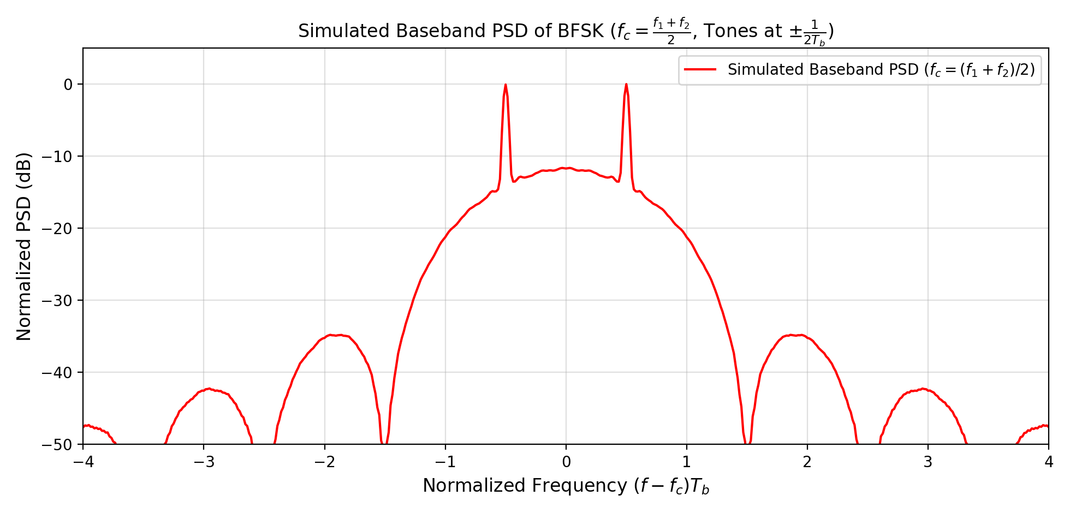
Figure 9. Simulated baseband PSD of BFSK with the symmetric carrier f_{c} = (f₁ + f₂)/2 (Model B). Tones at ±1/(2T_{b}).
Comment. Choosing the carrier at the centre of the two tones moves the spectrum so that it is symmetric about zero: the discrete lines sit at ±1/(2T_{b}) and the main lobe runs from −1.5/T_{b} to +1.5/T_{b}. The shape is exactly that of Figure 8 shifted by 1/(2T_{b}): the occupied bandwidth (3/T_{b} null-to-null), the line-to-continuum ratio and the side-lobe levels are unchanged. This confirms that the choice of reference carrier changes only where the baseband spectrum is centred, not the transmitted passband signal and not the BER. The symmetric form is the more convenient one for analysis, since the two baseband signals are complex conjugates of each other.

6. Conclusions
- The Monte Carlo simulation of every scheme agrees with its theoretical BER within the statistical scatter expected from the number of counted errors; the 8PSK and 16-QAM references are tight approximations that are slightly optimistic only at the lowest SNRs.
- BPSK and Gray-coded QPSK have identical BER versus E_{b}/N₀, and QPSK halves the bandwidth. Higher-order schemes (8PSK, 16-QAM) increase spectral efficiency at the price of about 3.2 dB and 3.7 dB more E_{b}/N₀ at BER = 10⁻³.
- Bit mapping matters: the non-Gray QPSK labelling has the same symbol error rate as Gray, but about 1.5 times the BER at high SNR (0.18–0.33 dB penalty at BER between 10⁻³ and 10⁻⁵).
- Coherent orthogonal BFSK needs 3 dB more E_{b}/N₀ than BPSK and occupies a null-to-null bandwidth of 3/T_{b}; its low side lobes follow from the continuous-phase tone spacing of 1/T_{b}. The reference carrier only shifts the baseband spectrum.
- The measurable BER is limited by the 1.2 × 10⁶ simulated bits (about 8 × 10⁻⁷); increasing the number of bits would extend the curves to higher SNR.

