


Cairo University - Faculty of Engineering
Electronics & Electrical Communication Engineering
Advanced Communication Systems - EECG331

Part 3: OFDM System Simulation
BER Performance of BPSK and 16-QAM over Flat and Frequency-Selective Rayleigh Fading, with and without Rate-1/5 Repetition Coding

Table of Contents

1. Objective and Scope 3
2. OFDM Principles 3
2.1 Orthogonal Subcarriers 3
2.2 OFDM Grid, IFFT and FFT 3
2.3 Cyclic Prefix 4
3. System Model and Simulation Method 4
3.1 Coding, Interleaver and Mapper 4
3.2 IFFT and Cyclic Prefix 5
3.3 Channel Models 5
3.4 Receiver 5
3.5 SNR Definition and Energy Convention 5
3.6 Simulation Parameters 6
4. Theoretical BER Expressions 6
5. Results and Discussion: BER versus SNR 8
5.1 BPSK 8
5.2 16-QAM 9
5.3 Comparison of the Eight Scenarios 9
5.4 MATLAB Console Output 10
6. Results and Discussion: EVM versus SNR 11
7. Results and Discussion: Link Diagnostics at SNR = 12 dB 11
7.1 Transmitter 12
7.2 Transmit Spectrum and Received Waveform 12
7.3 Channel Response 13
7.4 Receiver Constellations 14
8. Conclusions 16

1. Objective and Scope
This part of the project simulates an orthogonal frequency-division multiplexing (OFDM) link. A random bit stream is optionally encoded with a rate-1/5 repetition code, block-interleaved, mapped to BPSK or 16-QAM symbols, placed on 256 subcarriers with a 256-point IFFT, extended with a cyclic prefix and sent through a fading channel with additive white Gaussian noise (AWGN). The receiver removes the prefix, applies a 256-point FFT, equalises each subcarrier, de-maps, de-interleaves and decodes. The recovered bits are compared with the transmitted bits to estimate the bit-error rate (BER) as a function of the signal-to-noise ratio (SNR).
The report covers the requirement of the assignment and the supporting results used to explain it:
- Requirement: BER versus SNR for BPSK and 16-QAM, for the two channel models (Rayleigh flat fading, and frequency-selective fading in which every sub-channel is faded independently in the frequency domain), each with and without the rate-1/5 repetition code: four curves for each modulation scheme, eight in total.
- Supporting results: an analytical BER cross-check, RMS error-vector magnitude (EVM) versus SNR, a BER heat map of the eight scenarios, and transmitter, channel and receiver diagnostics at SNR = 12 dB.
The MATLAB script (ofdm_project_complete.m) generates every simulation result and saves each figure as a PNG file in the OFDM_figures folder. Only base MATLAB functions are used: the mapper, de-mapper and interleaver are implemented manually, and the OFDM transform uses fft and ifft.

2. OFDM Principles

2.1 Orthogonal Subcarriers
OFDM is a form of frequency-division multiplexing in which many closely spaced subcarriers are transmitted in parallel. Each subcarrier is a sinusoid that carries one modulation symbol (QAM or PSK) per OFDM symbol interval. With subcarrier spacing Δf = 1/T, where T is the useful symbol duration, every subcarrier completes a whole number of cycles in T. The subcarriers are therefore mutually orthogonal: their spectra overlap, but each one is exactly zero at the centre frequency of every other one, so the receiver FFT separates them without interference.
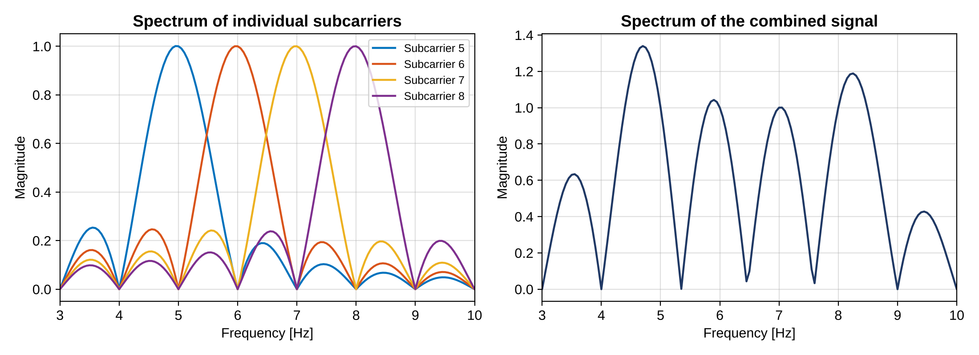
Figure 1. Spectra of four subcarriers (5 to 8 Hz, 1 s observation, zero-padded FFT) and of their sum. Each peak sits at its own frequency and has nulls at the other subcarrier frequencies.
Comment. Zero-padding the FFT only interpolates the plotted spectrum so the lobes look smooth; it does not make the subcarriers more orthogonal. Orthogonality comes from the subcarrier spacing 1/T and holds as long as the receiver uses the correct symbol timing and frequency. It is degraded by carrier-frequency offset, an incorrect FFT window, phase noise, and multipath that extends beyond the cyclic prefix; in those cases energy leaks between FFT bins as intercarrier interference.

2.2 OFDM Grid, IFFT and FFT
The transmitted data form an OFDM grid: rows are subcarriers (frequency), columns are OFDM symbols (time), and each cell holds one complex modulation symbol. One column is one OFDM symbol. The IFFT converts a column from the frequency domain to N = 256 time-domain samples, which is how the sum of 256 modulated subcarriers is produced in one step. The simulation uses the unitary scaling below, so that the mean power of the time samples equals the mean power of the symbols:
x[n] = (1/√N) · Σ_{k=0}^{N−1} X[k] · exp(j2πkn/N)
The receiver applies the inverse operation, Y[k] = (1/√N) Σ y[n] exp(−j2πkn/N). In MATLAB, ifftshift and fftshift move the zero-frequency subcarrier between the centre of the grid and the first FFT bin.

2.3 Cyclic Prefix
In a multipath channel a delayed copy of the signal arrives after the direct path. The copy changes the amplitude and phase of the direct symbol and spills into the next symbol (inter-symbol interference). The cyclic prefix (CP) copies the last samples of each OFDM symbol to its front. If the CP is longer than the delay spread, the channel acts as a circular convolution, so after the FFT each subcarrier is only multiplied by one complex gain H[k], which a single-tap equaliser removes. The CP is discarded at the receiver.

3. System Model and Simulation Method
The chain is Data bits → Coding → Interleaver → Mapper → 256-point IFFT → Add cyclic prefix → Channel → Receiver (Figure 2). The same chain is used for every scenario; only the modulation, the channel model and the coding switch change.
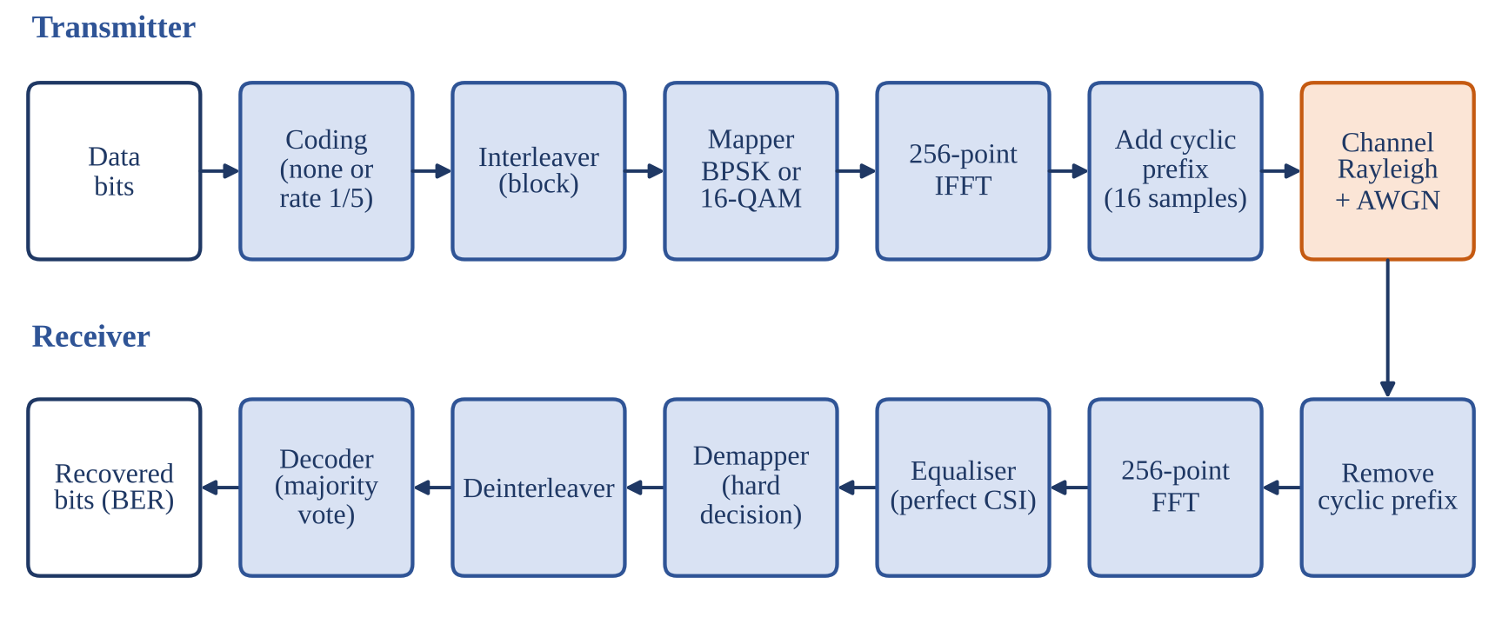
Figure 2. Block diagram of the simulated OFDM link.

3.1 Coding, Interleaver and Mapper
Each OFDM symbol carries 256 mapper symbols, i.e. 256 coded bits for BPSK and 1024 for 16-QAM. With the rate-1/5 repetition code every information bit is repeated five times, so fewer information bits fit in one OFDM symbol and the remainder is zero-padded to the full symbol capacity (Table 1). The coded bits then pass through a block interleaver (written column by column, read row by row). Because the five copies of a bit are adjacent before interleaving, the interleaver places them 16 positions apart for BPSK (16 subcarriers) and 32 positions apart for 16-QAM (8 subcarriers), so the copies never share a subcarrier.
Quantity | BPSK | 16-QAM
Bits per symbol, b = log₂M | 1 (M = 2) | 4 (M = 16)
Coded bits per OFDM symbol | 256 | 1024
Information bits per OFDM symbol, uncoded / coded | 256 / 51 | 1024 / 204
Zero bits added after repetition coding | 1 (5 × 51 = 255) | 4 (5 × 204 = 1020)
Interleaver (rows × columns) | 16 × 16 (assumed: not specified) | 32 × 32 (assignment)
Spacing of the five copies of a bit | 16 subcarriers | 8 subcarriers
Table 1. Bit budget, interleaver size and copy spacing for one OFDM symbol (256 subcarriers).
The mapper produces unit-average-power symbols (Table 2). Gray labelling is used for 16-QAM so that a nearest-neighbour symbol error flips one bit. The de-mapper takes hard decisions with thresholds at 0 for BPSK and at 0 and ±2 (before scaling) on each 16-QAM axis.
Scheme | Mapping | E_{s} | E_{b} | De-mapper
BPSK | 0 → +1, 1 → −1 | 1 | 1 | Sign of the real part
16-QAM (Gray) | Bits b₁b₂ → I and b₃b₄ → Q: 00 → −3, 01 → −1, 11 → +1, 10 → +3, all divided by √10 | 1 | 1/4 | Per-axis thresholds at 0 and ±2/√10
Table 2. Mappers (average symbol energy normalised to 1).

3.2 IFFT and Cyclic Prefix
The mapped symbols are arranged with the zero-frequency subcarrier at the centre of the grid and converted by a 256-point IFFT (ifft after ifftshift, multiplied by √N). A cyclic prefix of 16 samples is prepended, giving 272 samples per OFDM symbol. The assignment does not specify the CP length; 16 samples is assumed.

3.3 Channel Models
Both channels are normalised so that E[|H|²] = 1, and complex AWGN is added in the time domain after the channel.
- Rayleigh flat fading: one complex Gaussian gain h ~ CN(0, 1) multiplies all samples of an OFDM symbol; the gain is independent from one OFDM symbol to the next. All 256 subcarriers of a symbol therefore see the same gain.
- Frequency-selective fading: every sub-channel is faded independently by its own Rayleigh gain, modelled in the frequency domain as required by the assignment: Y[k] = H[k]·X[k] with independent H[k] ~ CN(0, 1) for every subcarrier and every OFDM symbol. The faded grid is then passed through the IFFT and the CP is added.
The model has no time dispersion, so the CP has no inter-symbol interference to remove here; it is included because the block diagram requires it and is discarded by the receiver. Independent per-subcarrier fading is a simplification of a physical multipath channel, whose gains are correlated across neighbouring subcarriers.

3.4 Receiver
The receiver removes the CP, applies the 256-point FFT (scaled by 1/√N) and equalises each subcarrier with a regularised zero-forcing equaliser that uses perfect channel knowledge. It then de-maps with hard decisions, de-interleaves, and, when coding is used, decodes each group of five bits by majority vote (at least three ones decode as 1). BER is counted on the information bits only.
X̂[k] = Y[k] · H*[k] / ( |H[k]|² + ε ), ε = 10⁻¹⁰
Pilot-based channel estimation is not used for the BER curves. Pilot symbols with 2-D interpolation can track a smoothly varying channel, but they cannot track sub-channels that are faded independently of each other, so perfect channel knowledge is used as the baseline and documented as an assumption.

3.5 SNR Definition and Energy Convention
The mean power of the transmitted samples is 1, and the noise variance is set to σ²_{w} = P_{s}/γ, where P_{s} is the measured transmit power and γ the target SNR. Since the FFT is unitary, γ equals the average energy per symbol over the noise density, γ = E_{s}/N₀, at every subcarrier. Coded and uncoded systems use the same SNR, i.e. the same transmit power and bandwidth. The rate-1/5 code therefore spends five times more energy on each information bit; Table 3 gives the conversion to the energy per information bit.
Scheme | E_{b}/N₀ (information bits) | Offset from the SNR
BPSK, uncoded | γ | 0 dB
BPSK, rate 1/5 | 5γ | +6.99 dB
16-QAM, uncoded | γ/4 | −6.02 dB
16-QAM, rate 1/5 | 5γ/4 | +0.97 dB
Table 3. Relation between the simulated SNR γ and E_{b}/N₀ per information bit.

3.6 Simulation Parameters
Parameter | Value
IFFT / FFT size | 256 (all subcarriers active, no guard band)
Cyclic prefix | 16 samples (assumed)
OFDM symbols per frame, frames per SNR point | 8 symbols, 100 frames
SNR range | 0 to 24 dB in 2 dB steps (13 points)
Information bits per SNR point | BPSK: 204 800 uncoded, 40 800 coded; 16-QAM: 819 200 uncoded, 163 200 coded
Independent fading realisations per SNR point | Flat: 800 (one per OFDM symbol); frequency-selective: 800 × 256
Subcarrier spacing (diagnostic spectra only) | 15 kHz, sampling rate 3.84 MHz
Random seed | rng(42, 'twister'): results are reproducible
Diagnostic snapshots | First uncoded frame at SNR = 12 dB
Resolution limit | Smallest non-zero BER = 1 / (information bits); a point with no errors is not drawn on the logarithmic axis
Table 4. Simulation parameters.

4. Theoretical BER Expressions
Because the equaliser has perfect channel knowledge, each equalised subcarrier is z = X + n/H, so a bit sees an AWGN channel whose SNR is γ|H|². With the Q-function Q(x) = ½ erfc(x/√2), the uncoded BER follows by averaging over the Rayleigh distribution of |H|². For BPSK the average is
P_b = E[ Q(√(2γ|H|²)) ] = ½ · ( 1 − √( γ / (1 + γ) ) )
For Gray-coded 16-QAM each axis is a 4-PAM signal whose two bits have different error probabilities (with a² = γ|H|²/5): the sign bit has p₁ = ½[Q(a) + Q(3a)] and the inner/outer bit has p₂ = Q(a) + ½Q(3a) − ½Q(5a), and the BER is their mean. In both cases flat and frequency-selective fading give the same uncoded BER, because each bit only sees one Rayleigh gain. With the repetition code, a bit is wrong when at least three of its five copies are wrong:
P_info = Σ_{j=3}⁵ C(5,j) · p^{j} · (1 − p)^{5−j}
In frequency-selective fading the five copies sit on different subcarriers with independent gains, so p is the Rayleigh-averaged uncoded error probability of each copy. In flat fading all copies share the same gain, so the expression above is evaluated at the instantaneous SNR and only then averaged over |H|². The bit position of every copy inside its 16-QAM symbol is taken from the real interleaver. Table 5 summarises the behaviour at high SNR.
Case | High-SNR BER | Diversity order | Notes
BPSK uncoded (flat or freq.-selective) | ≈ 0.25/γ | 1 | Exact expression above
BPSK rate 1/5, flat | ≈ 0.072/γ | 1 | Same slope, 3.5× lower
BPSK rate 1/5, freq.-selective | ≈ 0.156/γ³ | 3 | Majority of 5 independent copies
16-QAM uncoded | ≈ 1.99/γ | 1 | Exact expression above
16-QAM rate 1/5, flat | ≈ 0.54/γ | 1 | Same slope, 3.7× lower
16-QAM rate 1/5, freq.-selective | ≈ 97/γ³ | 3 | Copies share bit positions
Table 5. Asymptotic behaviour of the analytical BER expressions (γ is the linear SNR).
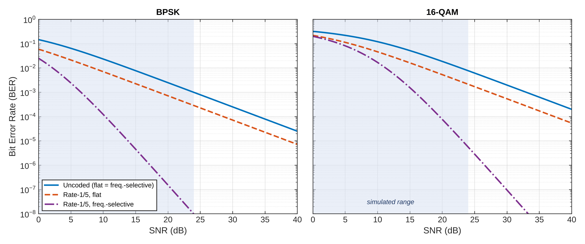
Figure 3. Analytical BER versus SNR for BPSK (left) and 16-QAM (right). The shaded band is the simulated range (0 to 24 dB).

5. Results and Discussion: BER versus SNR

5.1 BPSK
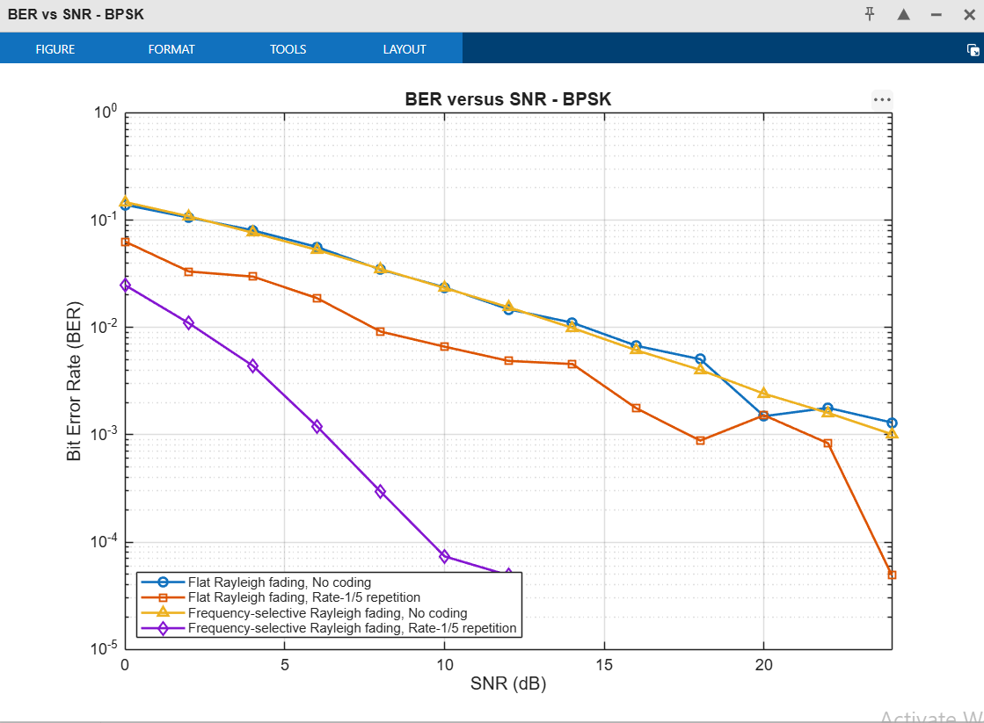
Figure 4. BER versus SNR for BPSK: four cases (two channels, with and without rate-1/5 repetition coding).
Comment. The two uncoded curves overlap and fall slowly, from about 0.14 at 0 dB to about 10⁻³ at 24 dB, a decade of BER for every 10 dB. This matches the analytical Rayleigh result ½(1 − √(γ/(1+γ))): 0.146 at 0 dB, 2.3 × 10⁻² at 10 dB and 9.9 × 10⁻⁴ at 24 dB. The channel model does not matter without coding, because every bit sees one Rayleigh gain either way, and a bit is lost whenever its gain is small (a deep fade).
With the repetition code the two channels behave very differently. In frequency-selective fading the five copies of each bit are spread over independent subcarriers, so a bit is lost only when at least three of five independent gains are poor. The curve is much steeper (a gain of about 17 dB over the uncoded system at BER = 10⁻³, Table 6) and reaches zero recorded errors from 14 dB onward (fewer than 1/40 800 = 2.5 × 10⁻⁵). In flat fading all five copies share one gain per OFDM symbol, so the code cannot combat a deep fade: the curve is only shifted down by a constant factor (about 3.5) and has the same slope as the uncoded one. It is also jagged, because only 800 independent fades are simulated per point and each deeply faded OFDM symbol contributes hundreds of errors at once.

5.2 16-QAM
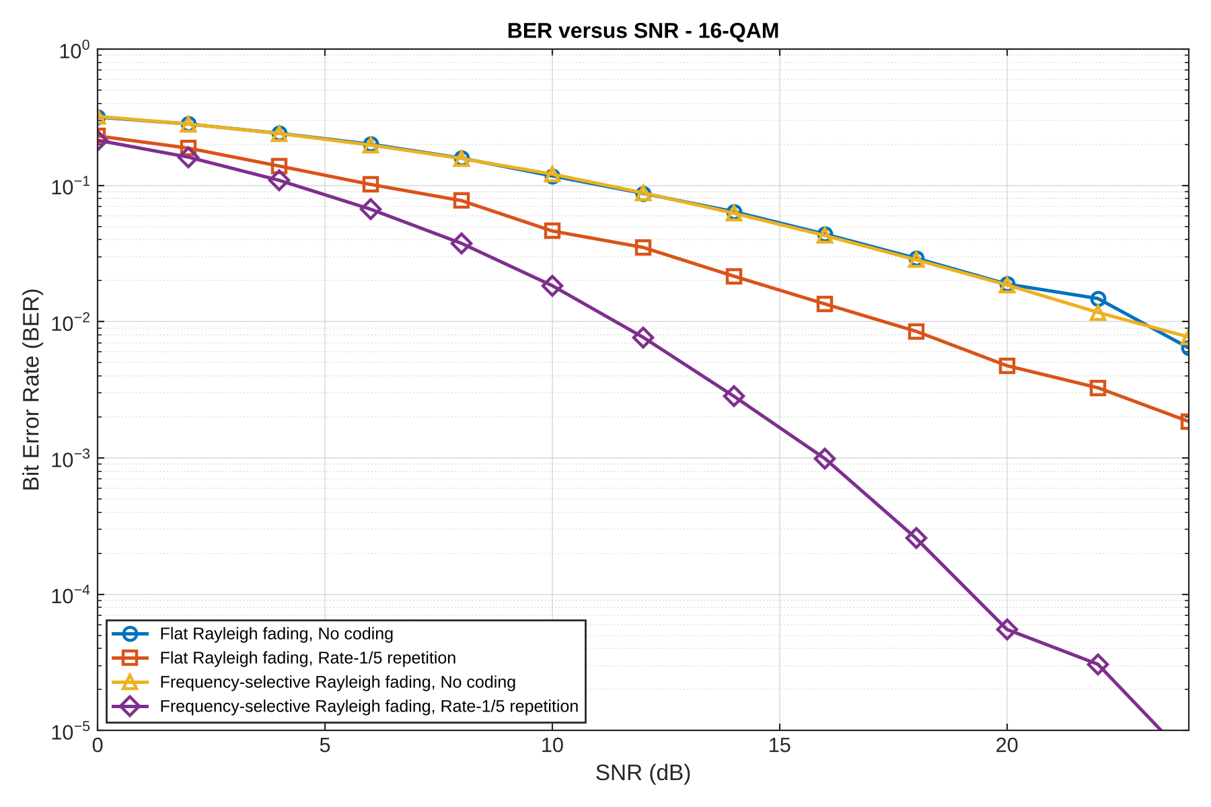
Figure 5. BER versus SNR for 16-QAM: four cases (two channels, with and without rate-1/5 repetition coding).
Comment. The same trends hold for 16-QAM, but every curve is shifted to a much higher SNR. Uncoded 16-QAM is still near 10⁻² at 24 dB (analytical value 7.7 × 10⁻³), compared with 10⁻³ for BPSK. The reason is the smaller minimum distance of the constellation: at equal average energy, adjacent 16-QAM points are √5 times closer (−7 dB) than BPSK points. The coded frequency-selective curve is again the only one with a steep slope (diversity order 3) and falls to about 10⁻⁵ at 22 to 24 dB, whereas the coded flat curve stays above 10⁻³ at 24 dB. In 16-QAM the two bits of an axis do not have the same protection (the sign bit is more reliable than the inner/outer bit), and the interleaver keeps the five copies of a bit in the same bit position, which is why the coded 16-QAM curve is higher than the BPSK one by more than the constellation penalty alone.

5.3 Comparison of the Eight Scenarios
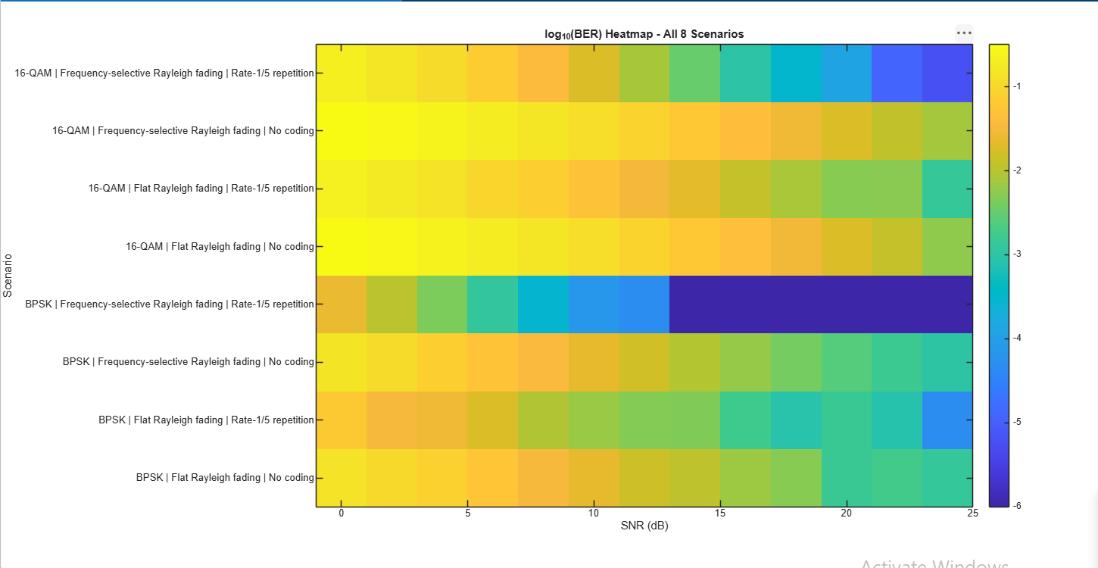
Figure 6. log₁₀(BER) heat map of the eight scenarios over the simulated SNR range.
Comment. The heat map shows the ordering at a glance. BPSK with frequency-selective fading and coding is the best scenario (dark blue from about 10 dB; the darkest cells correspond to zero recorded errors). The uncoded rows of both modulations stay light yellow-green, i.e. BER around 10⁻² to 10⁻¹ for most of the range, and 16-QAM is worse than BPSK in every row.
Table 6 gives the SNR required for a target BER from the analytical expressions, together with the equivalent E_{b}/N₀ per information bit (Table 3). Values above 24 dB lie beyond the simulated range and are obtained from the formulas only.
Modulation | Case | BER = 10⁻² | BER = 10⁻³ | BER = 10⁻⁴
BPSK | Uncoded (flat = freq.-selective) | 13.9 dB | 24.0 dB | 34.0 dB
BPSK | Rate 1/5, flat | 8.4 dB | 18.5 dB | 28.6 dB
BPSK | Rate 1/5, freq.-selective | 2.2 dB | 6.6 dB | 10.3 dB
16-QAM | Uncoded (flat = freq.-selective) | 22.8 dB | 33.0 dB | 43.0 dB
16-QAM | Rate 1/5, flat | 17.2 dB | 27.3 dB | 37.3 dB
16-QAM | Rate 1/5, freq.-selective | 11.2 dB | 15.8 dB | 19.6 dB
Table 6. SNR required for a given BER, from the analytical expressions.
Four conclusions follow from the table. (i) Channel model: without coding there is no difference; with coding, frequency-selective fading is far better than flat fading (about 12 dB at BER = 10⁻³ for BPSK and 11.5 dB for 16-QAM), because it provides diversity. Independent sub-channel fading is helpful here, whereas flat fading is the harder case. (ii) Coding: at equal SNR the frequency-selective coded system gains 17.4 dB (BPSK) and 17.2 dB (16-QAM) at BER = 10⁻³, and the flat coded system gains only about 5.5 dB. (iii) Energy convention: at equal energy per information bit the code costs 7 dB (Table 3). The frequency-selective gain then drops to about 10.4 dB, while the flat coded system becomes about 1.5 dB worse than the uncoded one, so in flat fading the repetition code with hard-decision majority voting is not worth its bandwidth. (iv) Modulation: 16-QAM carries four times as many bits per symbol but needs about 9 dB more SNR than BPSK for the same BER (about 3 dB more per information bit), the usual trade between spectral efficiency and power.

5.4 MATLAB Console Output
The script also prints the BER of every scenario at SNR = 24 dB to the MATLAB Command Window (see the figure below).
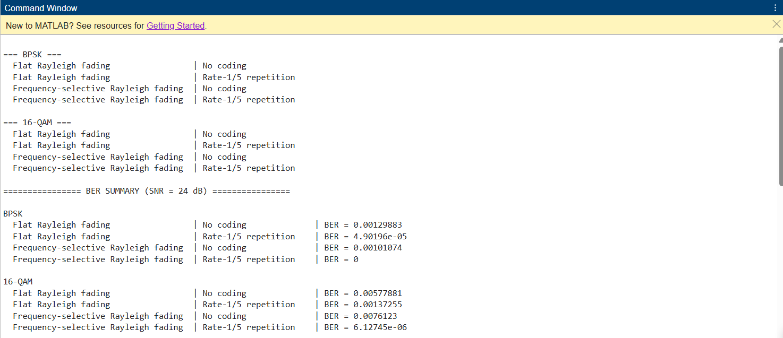
Figure 7. MATLAB Command Window output: BER summary at SNR = 24 dB for all eight scenarios.
Comment. The printed values agree with the analytical results in Section 4 (24 dB): BPSK uncoded 1.3 × 10⁻³ and 1.0 × 10⁻³ against 9.9 × 10⁻⁴; BPSK flat coded 4.9 × 10⁻⁵ against 2.9 × 10⁻⁴ (the flat-fading simulation is noisy because only 800 independent fades are used); 16-QAM uncoded 5.8 × 10⁻³ and 7.6 × 10⁻³ against 7.7 × 10⁻³; and 16-QAM frequency-selective coded 6.1 × 10⁻⁶ against 5.6 × 10⁻⁶. BPSK with frequency-selective fading and coding shows BER = 0, i.e. no error among the 40 800 information bits, so its BER is below about 2.5 × 10⁻⁵ at this point.

6. Results and Discussion: EVM versus SNR
The RMS EVM of the equalised symbols, relative to the transmitted symbols, is
EVM = √( Σ |X̂ − X|² / Σ |X|² ) × 100 %
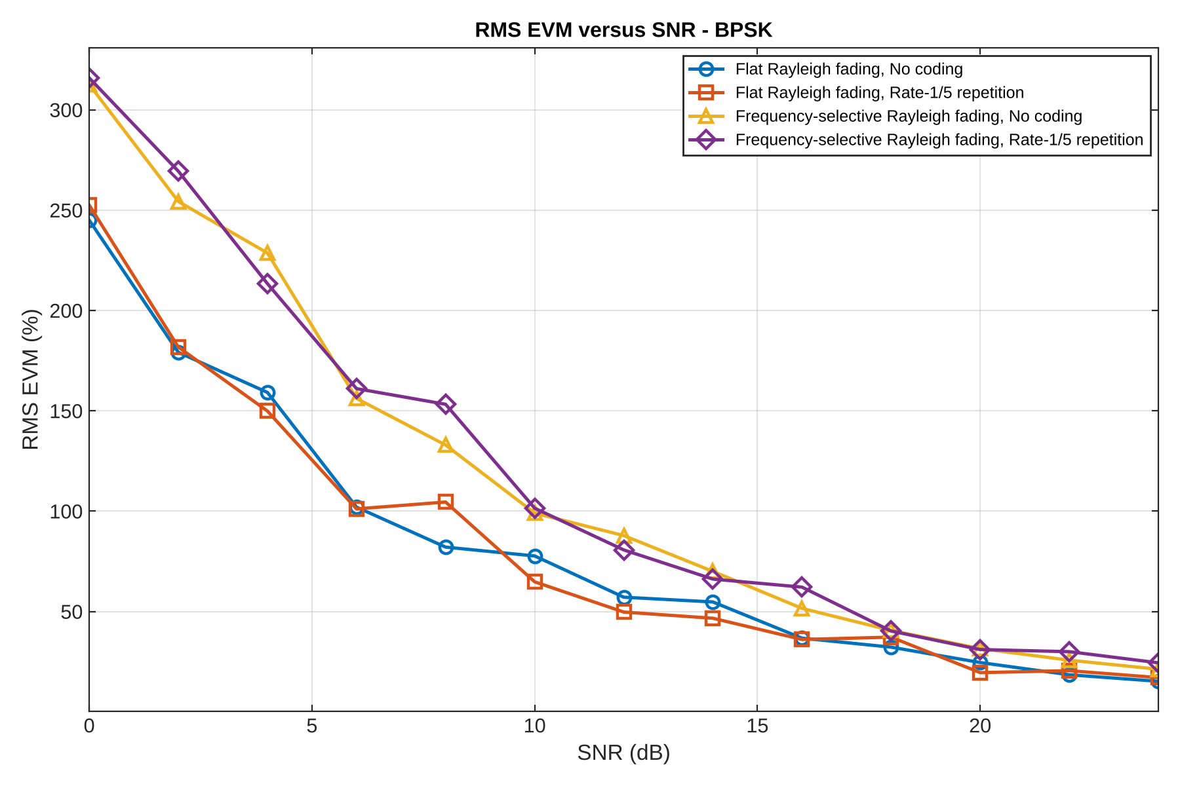
Figure 8. RMS EVM versus SNR for BPSK (four cases).
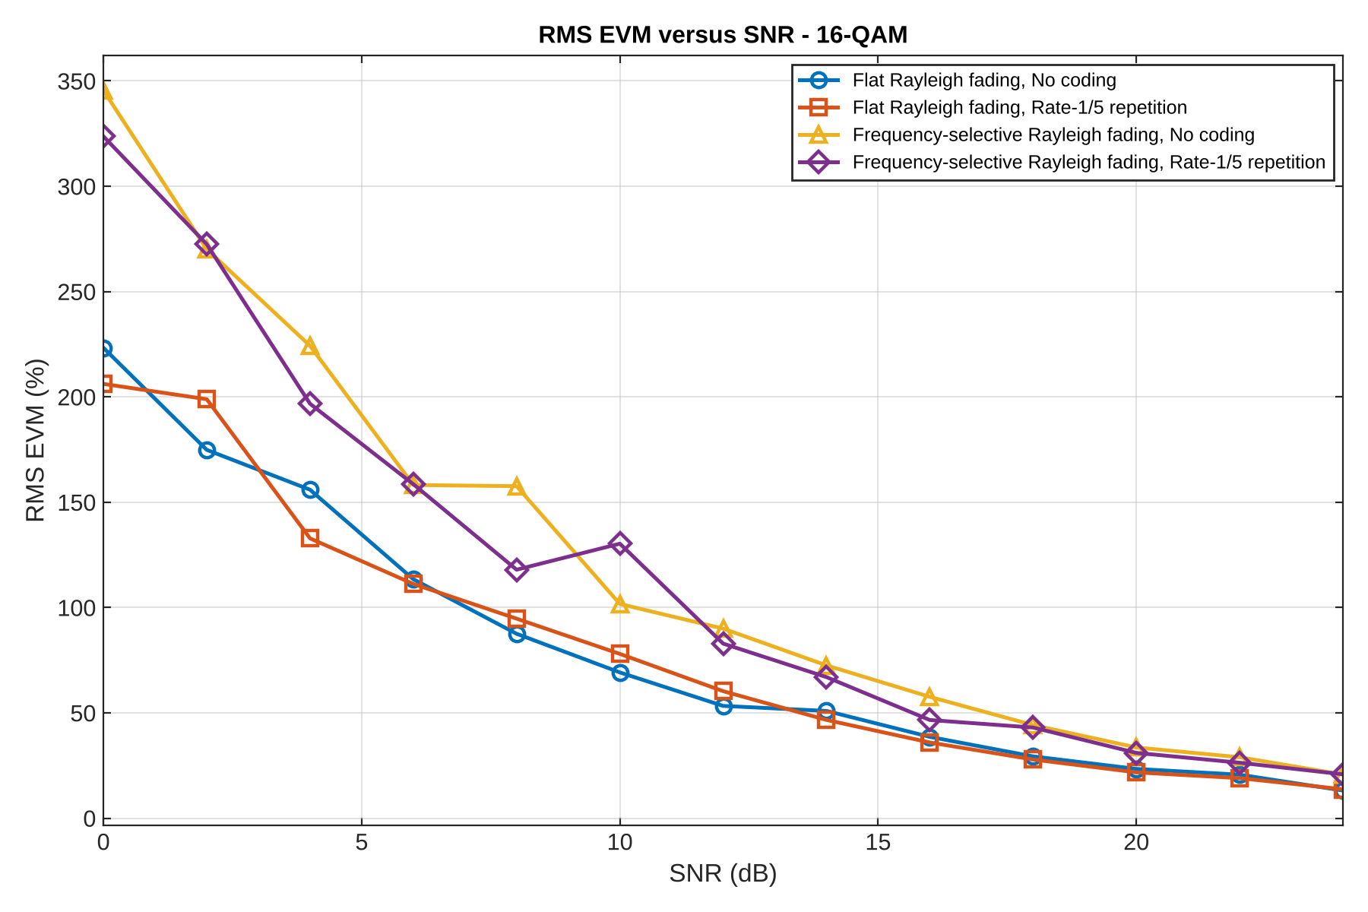
Figure 9. RMS EVM versus SNR for 16-QAM (four cases).
Comment. EVM falls from roughly 220 to 350 % at 0 dB to roughly 13 to 25 % at 24 dB. It is very large compared with a non-fading link for two reasons. First, the zero-forcing equaliser divides by H, so a subcarrier in a deep fade has its noise amplified by 1/|H|², and E[1/|H|²] is unbounded for a Rayleigh gain; the average is dominated by a few deeply faded symbols. Second, EVM is measured before the decoder, so the coded and uncoded curves coincide within statistical scatter: coding changes the BER, not the EVM. The frequency-selective curves lie above the flat ones because a frame contains 2 048 independent gains instead of 8, so deep fades are almost always present. EVM is therefore a poor predictor of BER in fading channels; the BER curves are the correct performance measure.

7. Results and Discussion: Link Diagnostics at SNR = 12 dB
The following figures show one uncoded frame (8 OFDM symbols) at SNR = 12 dB for each modulation and channel.

7.1 Transmitter
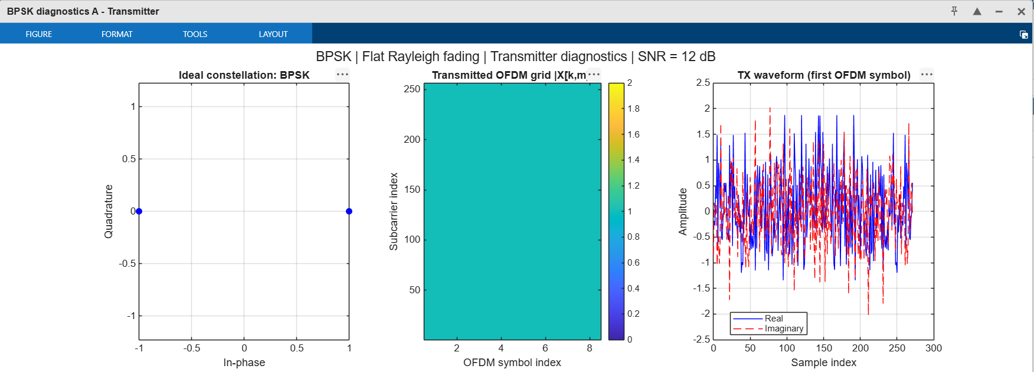
Figure 10. BPSK transmitter diagnostics: ideal constellation, transmitted OFDM grid |X[k, m]| and transmitted waveform of the first OFDM symbol.
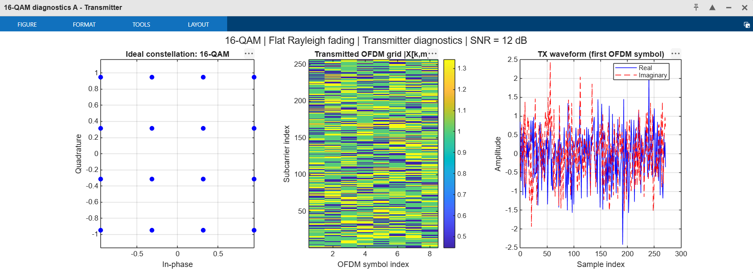
Figure 11. 16-QAM transmitter diagnostics: ideal constellation, transmitted OFDM grid and transmitted waveform.
Comment. The BPSK constellation has two points at ±1, so every cell of the grid has magnitude 1. The 16-QAM constellation has points at ±1/√10 and ±3/√10, so the grid shows three magnitudes (0.45, 1 and 1.34). In both cases the time waveform looks like noise, because it is the sum of 256 independent subcarriers, and its peaks reach about three times the RMS value (high peak-to-average power ratio, a known property of OFDM). The first 16 samples are the cyclic prefix.

7.2 Transmit Spectrum and Received Waveform
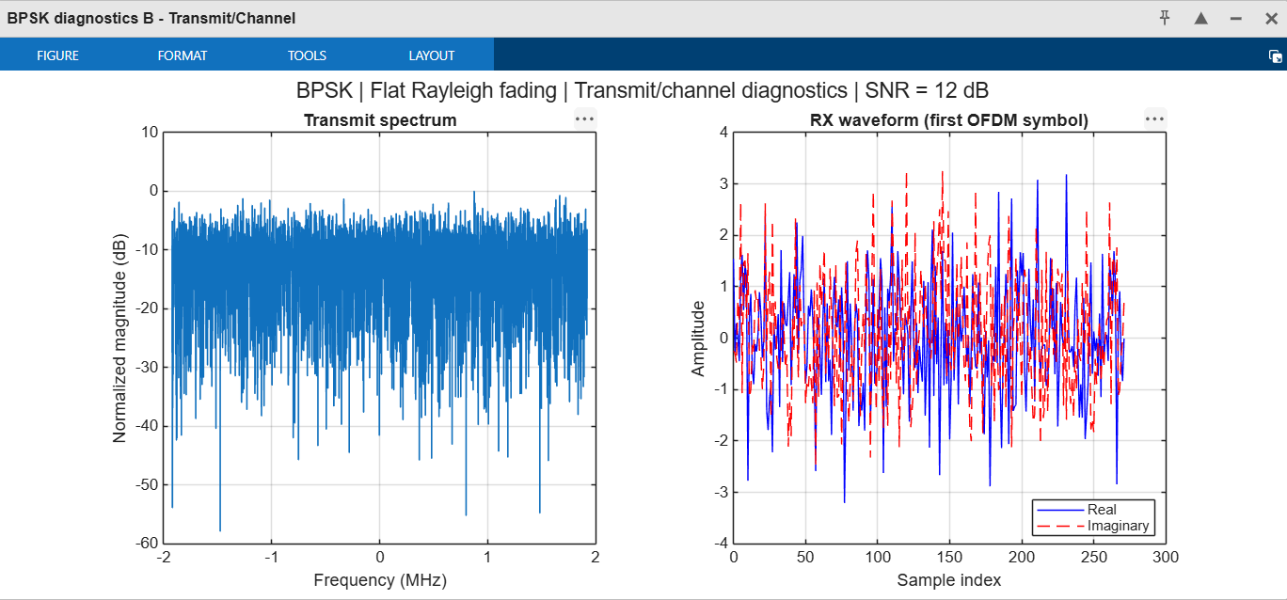
Figure 12. BPSK over flat Rayleigh fading: transmit spectrum and received waveform of the first OFDM symbol.
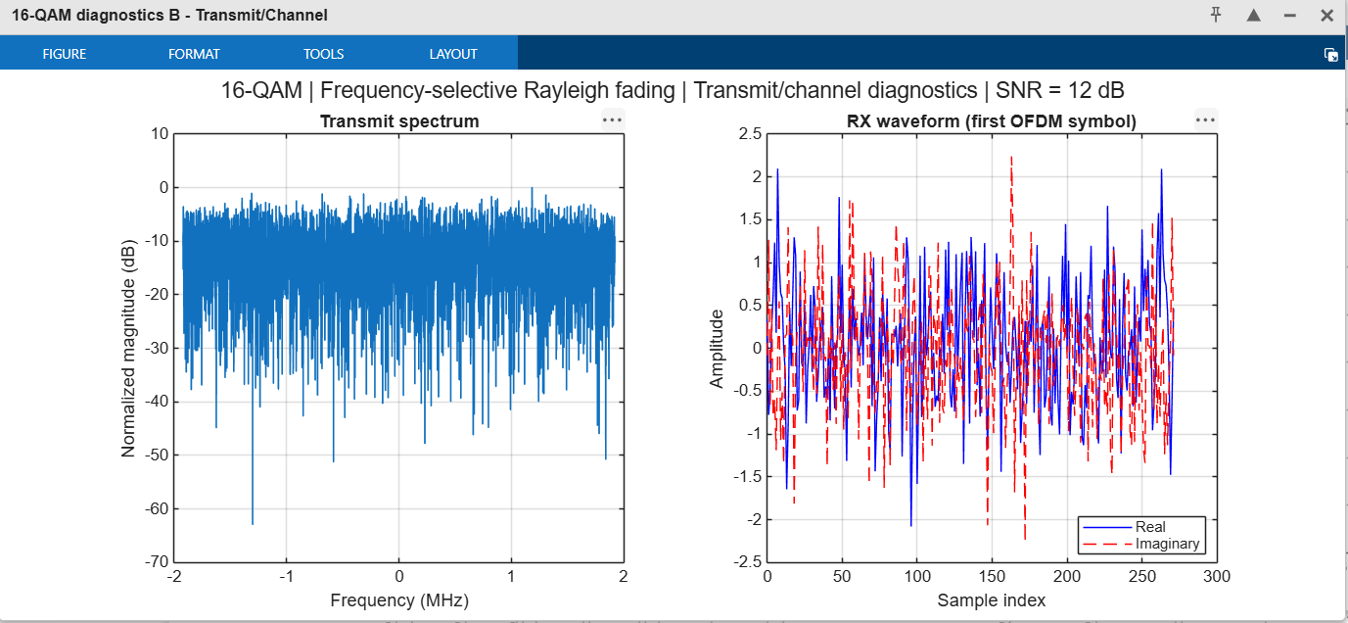
Figure 13. 16-QAM over frequency-selective Rayleigh fading: transmit spectrum and received waveform of the first OFDM symbol.
Comment. The transmit spectrum is flat across the ±1.92 MHz band (256 × 15 kHz), with random ripples of a few dB because the data are random; all subcarriers are active and no guard band is used. In flat fading the received waveform is the transmitted one scaled and rotated by one complex gain (amplitude up to about 3 for BPSK in this frame, because |h| > 1). In frequency-selective fading the waveform is also distorted, since different subcarriers are scaled differently.

7.3 Channel Response
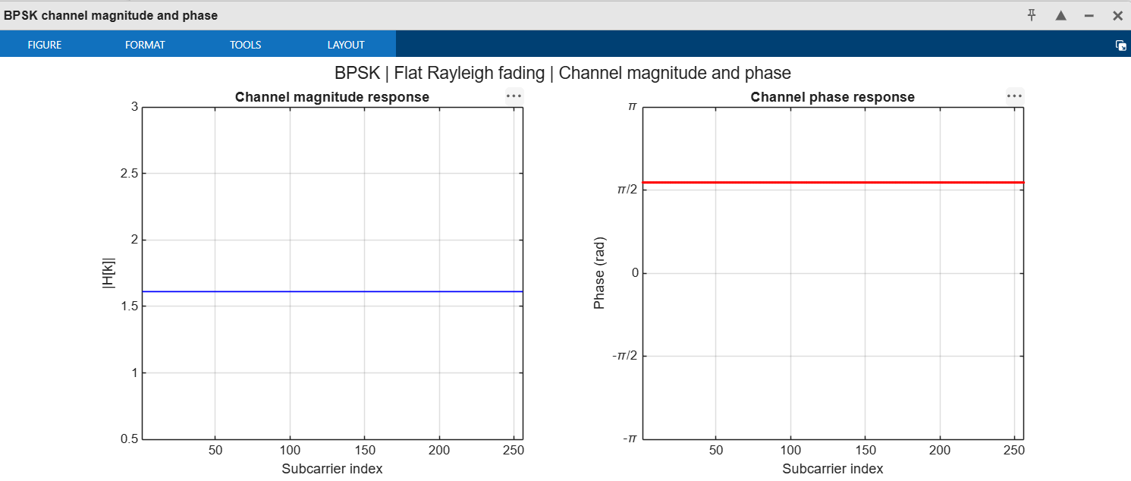
Figure 14. BPSK, flat fading: channel magnitude and phase of the first OFDM symbol.
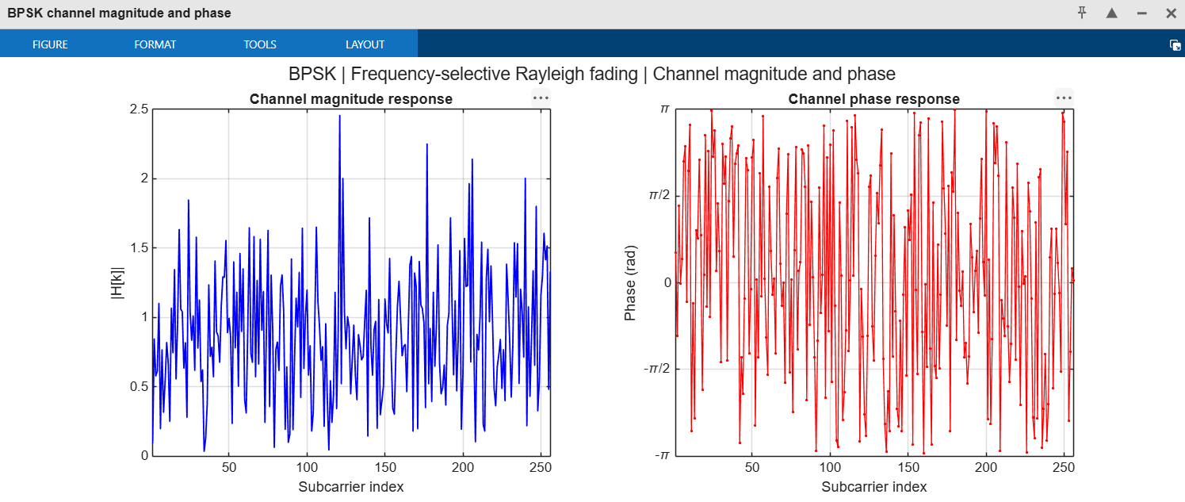
Figure 15. BPSK, frequency-selective fading: channel magnitude and phase of the first OFDM symbol.
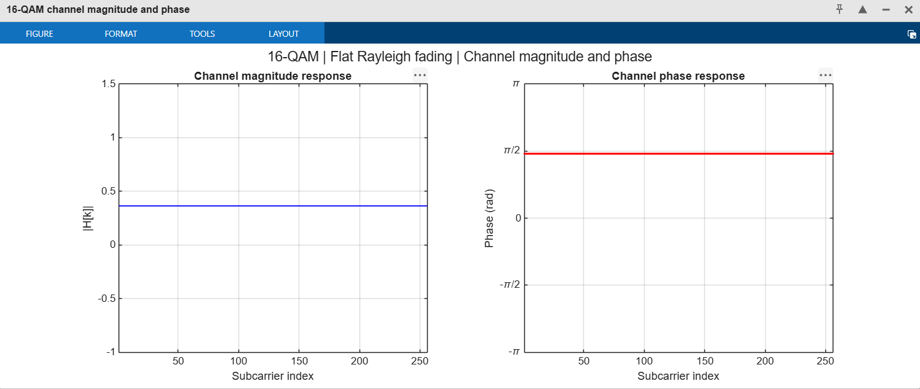
Figure 16. 16-QAM, flat fading: channel magnitude and phase of the first OFDM symbol.
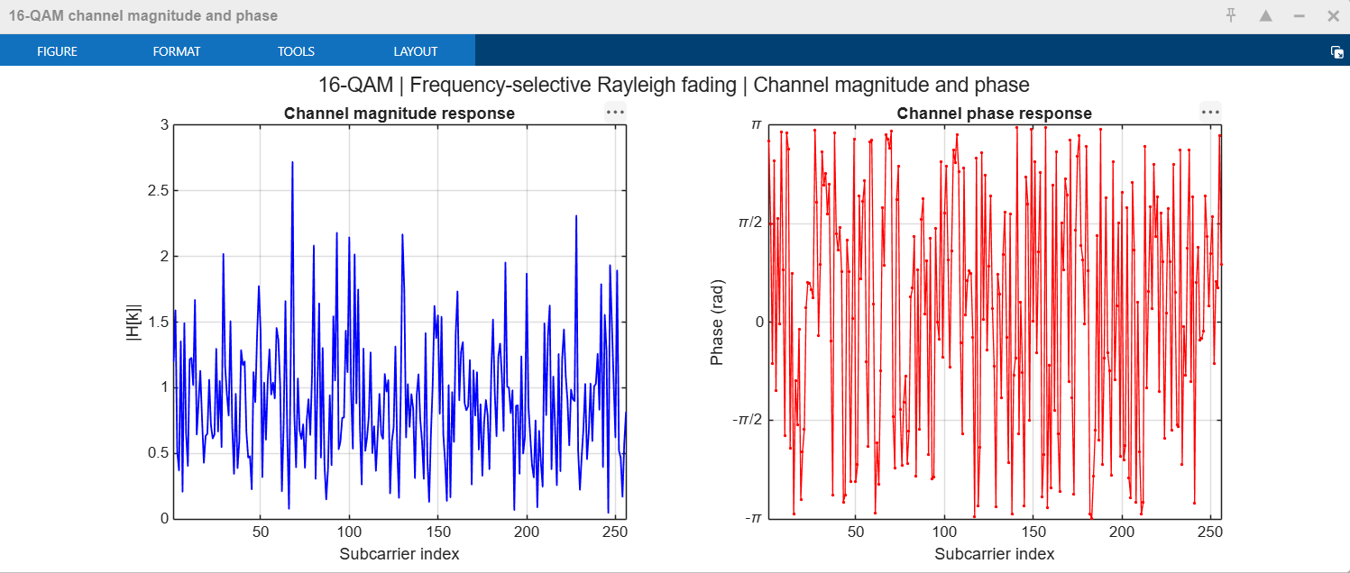
Figure 17. 16-QAM, frequency-selective fading: channel magnitude and phase of the first OFDM symbol.
Comment. In flat fading the magnitude and phase are constant over all 256 subcarriers (the gain was about 1.6 for BPSK and 0.36 for 16-QAM in these frames, with a different gain in every OFDM symbol). In frequency-selective fading both vary randomly from one subcarrier to the next: the magnitude follows a Rayleigh distribution with several deep nulls below 0.2, and the phase is uniform over (−π, π]. The wrapped phase is shown because, with independent gains, unwrapping would have no meaning.

7.4 Receiver Constellations
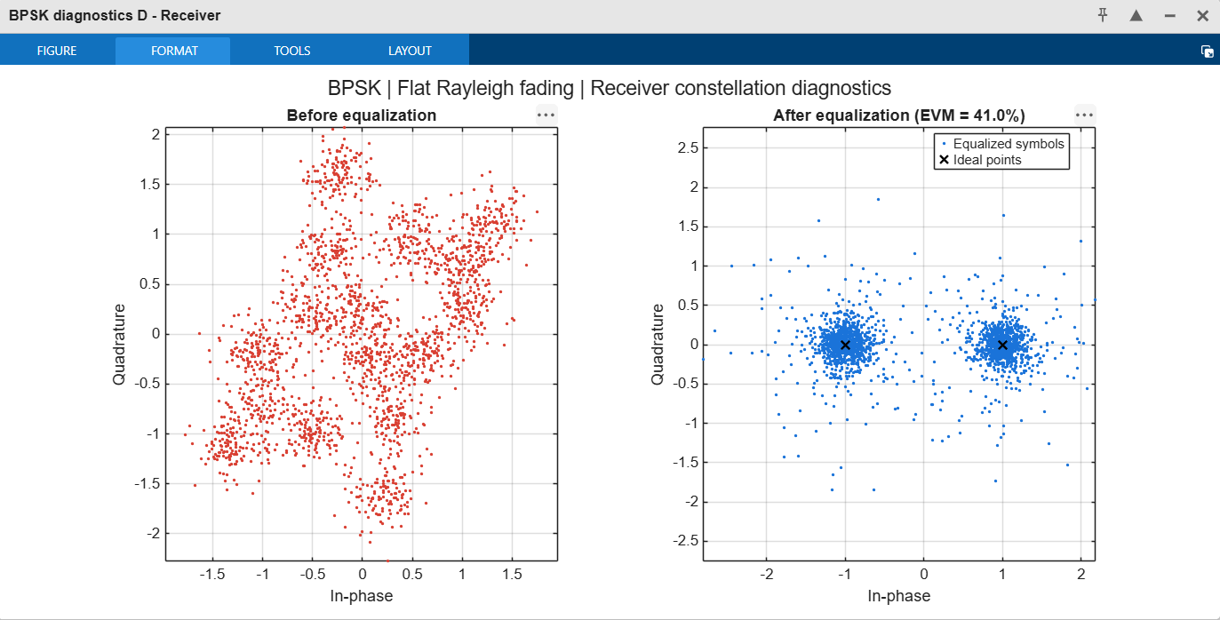
Figure 18. BPSK, flat fading: received constellation before and after equalisation (EVM = 41.0 %).
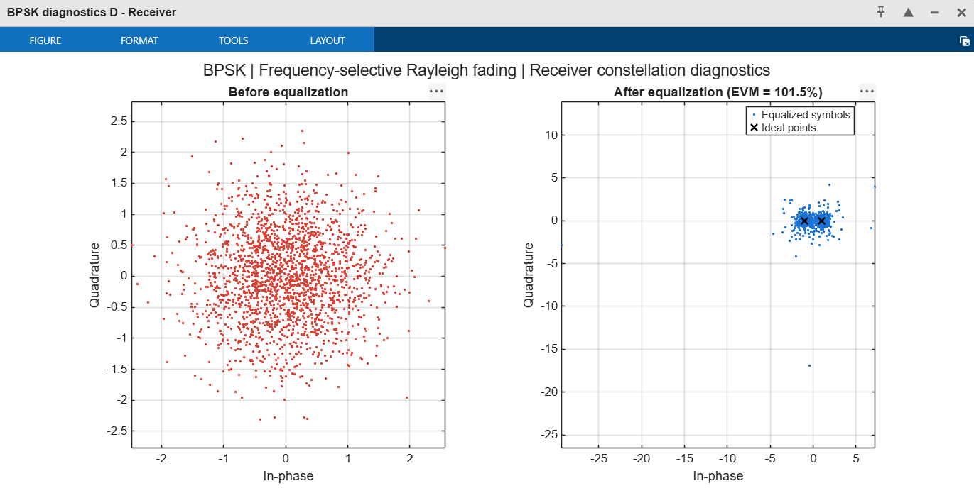
Figure 19. BPSK, frequency-selective fading: received constellation before and after equalisation (EVM = 101.5 %).
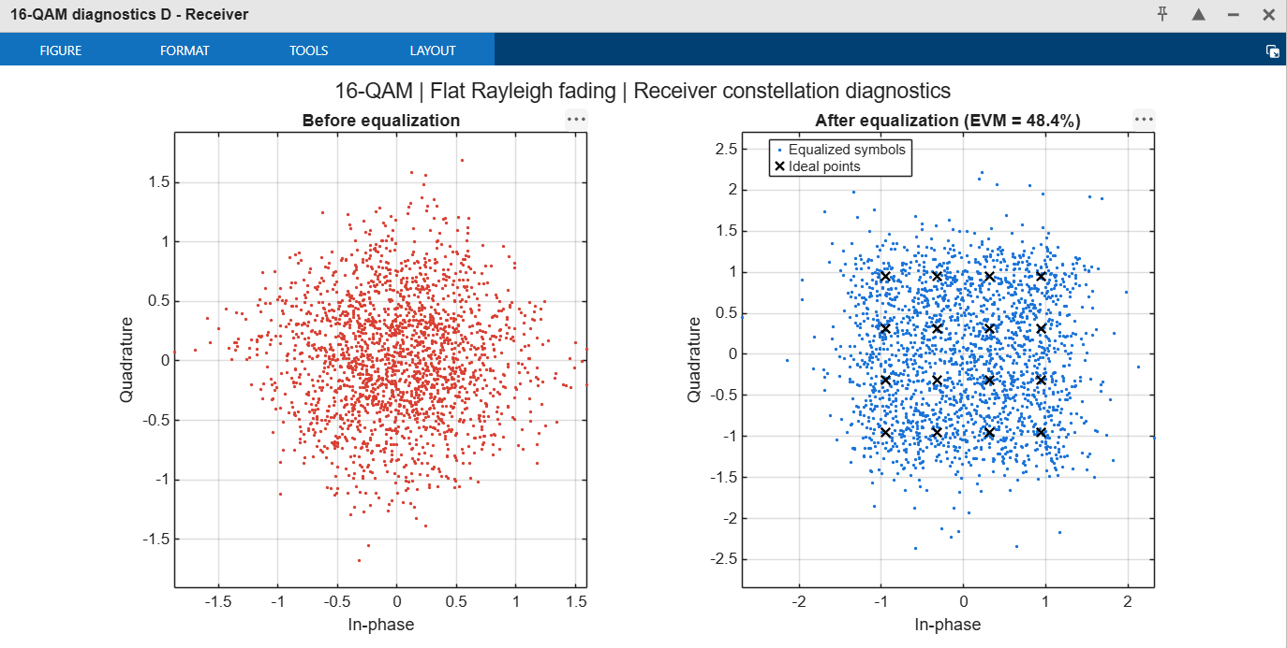
Figure 20. 16-QAM, flat fading: received constellation before and after equalisation (EVM = 48.4 %).
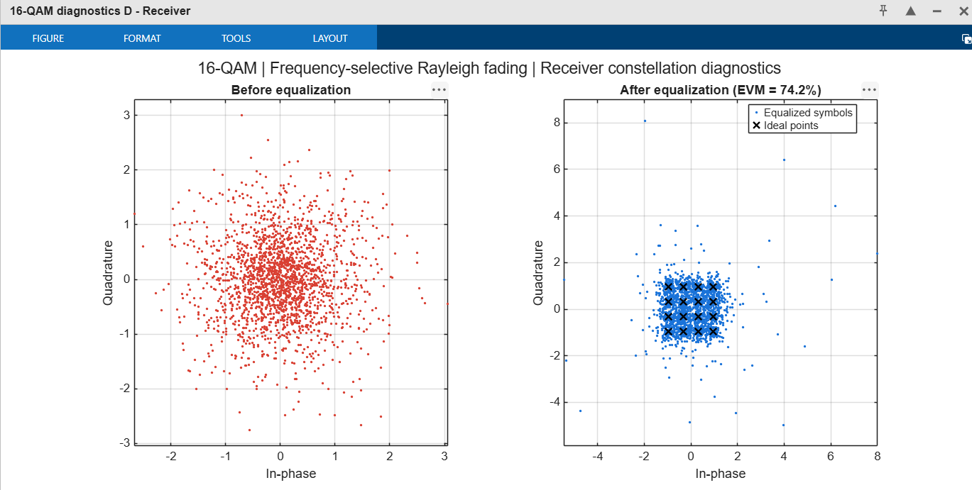
Figure 21. 16-QAM, frequency-selective fading: received constellation before and after equalisation (EVM = 74.2 %).
Comment. Before equalisation the flat-fading BPSK points form separate clusters, one for each OFDM symbol, each rotated and scaled by that symbol's gain; in frequency-selective fading the points are spread over a disc because every subcarrier has its own gain. After equalisation the clusters collapse onto the ideal points. The BPSK clusters are well separated at 12 dB, while the 16-QAM clusters overlap strongly (the symbol decisions are much more sensitive to noise). The tails of the equalised clouds are caused by subcarriers in deep fades, where the equaliser amplifies the noise; in the frequency-selective BPSK frame a few points lie far outside the plotted constellation, which explains the 101.5 % EVM.

8. Conclusions
- The 256-point OFDM link was simulated for BPSK and 16-QAM over flat and frequency-selective Rayleigh fading, with and without a rate-1/5 repetition code. The simulated curves agree with the analytical expressions within the statistical scatter set by the number of counted errors.
- Without coding, the channel model has no effect on the BER, which falls by only one decade per 10 dB (BPSK: 10⁻² at 13.9 dB and 10⁻³ at 24 dB).
- With coding, frequency-selective fading gives a third-order diversity gain through the interleaver (about 17 dB at BER = 10⁻³ at equal SNR, about 10 dB at equal energy per information bit). In flat fading the code only lowers the BER by a constant factor of about 3.5 and is not worth its cost at equal energy per information bit.
- 16-QAM needs about 9 dB more SNR than BPSK for the same BER (about 3 dB per information bit), in exchange for four times the bits per symbol.
- EVM after zero-forcing equalisation is dominated by deep fades and is the same with or without coding, so it is not a reliable predictor of BER in fading channels.
- Limitations and assumptions: perfect channel knowledge; 16-sample cyclic prefix and a 16 × 16 BPSK interleaver (not specified in the assignment); independent per-subcarrier fading with no delay spread; 100 frames per point, so points below about 10⁻⁵ are not resolved and the flat-fading curves are noisy. More frames would smooth the curves.

