AWS Serverless Support Ticket Management System
Week 1 Deliverables — Requirements, Service Analysis and Architecture Alternatives
Project type: Cloud Engineering | Duration: 4 weeks | Technologies: AWS, Terraform, Python, Git/GitHub
Purpose: This document captures the initial analysis and two conceptual architecture alternatives. The final architecture is not selected until the alternatives have been compared.

1. Business & Technical Requirements

1.1 Business problem
TechAssist GmbH provides IT support to small and medium-sized businesses. Support requests currently arrive through email or chat and are tracked manually in spreadsheets. This makes it difficult to centralize ticket information, track ticket status, expose ticket data to other applications, and scale the process as demand increases.

1.2 Project objective
Design and implement a small, cost-conscious AWS-based support ticket system with an API for creating, retrieving, updating, and deleting tickets. Infrastructure must be provisioned with Terraform and be reproducible from the project repository.

1.3 Functional requirements
ID | Requirement
FR-01 | Create a support ticket with required fields.
FR-02 | Retrieve a list of tickets.
FR-03 | Retrieve one ticket by its unique Ticket ID.
FR-04 | Update ticket information and status.
FR-05 | Delete a ticket.
FR-06 | Persist ticket records between application invocations.
FR-07 | Return appropriate error responses for invalid requests and missing tickets.
FR-08 | Record application/runtime logs and provide basic operational visibility.

1.4 Ticket data model
Field | Description / allowed values
ticket_id | Unique identifier for a ticket.
title | Short summary of the problem.
description | Detailed description of the problem.
priority | LOW, MEDIUM, HIGH, or CRITICAL.
status | OPEN, IN_PROGRESS, or RESOLVED.
created_by | Identity or name of the ticket creator.
created_timestamp | Timestamp when the ticket was created.
updated_timestamp | Timestamp of the latest update.

1.5 Non-functional requirements
Requirement | Description
NFR-01 Cost-consciousness | Prefer services that fit a small project and avoid unnecessary always-on resources.
NFR-02 Security | Use least-privilege IAM permissions; do not commit credentials or secrets.
NFR-03 Scalability | Support variable request volume without manual server scaling where practical.
NFR-04 Reliability | Store ticket data persistently and handle failures with meaningful responses.
NFR-05 Observability | Capture logs and provide basic metrics for troubleshooting.
NFR-06 Maintainability | Keep application code and Terraform organized and understandable.
NFR-07 Reproducibility | Allow another person to provision the infrastructure from the repository.
NFR-08 Testability | Support functional, error, and infrastructure lifecycle tests.

2. Assumptions & Constraints

2.1 Assumptions
- The first version is a demonstration/portfolio project, not a production-ready customer support platform.
- The API is consumed by a client or API testing tool; a graphical frontend is not required by the supplied brief.
- Ticket operations are limited to create, list/retrieve, update, and delete.
- Ticket statuses and priorities use the fixed values defined in the project brief.
- A single AWS Region will be used for the initial implementation.
- Authentication requirements are not explicitly defined in the brief and must be clarified or documented as a limitation.

2.2 Constraints
- The project must be completed within four weeks by one person or a team of two.
- Final AWS infrastructure must be provisioned using Terraform; manual creation of final resources in the AWS Console is not permitted.
- The design should be cost-conscious and students must monitor AWS usage.
- Resources created for the project must be destroyed after the final demonstration, and removal must be verified.
- The solution must be understandable, testable, documented, and reproducible from GitHub.
- AWS credentials, passwords, and secrets must never be committed to the repository.

2.3 Open questions to resolve
- Is user authentication required, or is the first version limited to a controlled demo environment?
- Should listing tickets support pagination or filtering by status/priority?
- Is hard deletion required, or would a soft-delete approach be preferable?
- Which AWS Region and available Free Tier/credits will be used?

3. AWS Service Analysis
The following services are candidates for evaluation, not a commitment to use every service. Final choices should be justified against the requirements, cost, security, and operational effort.
Service | Potential role | Benefits / considerations
Amazon API Gateway | Expose HTTPS API endpoints and route requests. | Managed API entry point; integrates with Lambda. Consideration: Request charges and configuration complexity; authentication and throttling must be considered.
AWS Lambda | Run Python request handlers without managing servers. | Scales with requests; suitable for short API operations. Consideration: Runtime limits and cold-start considerations; application must fit the Lambda execution model.
Amazon DynamoDB | Persist ticket records in a managed NoSQL database. | Managed scaling and low operational overhead for key-based access. Consideration: Data access patterns and indexes must be designed; not a relational database.
Amazon ECS on AWS Fargate | Alternative compute option for a containerized API. | More control over container runtime and dependencies. Consideration: More deployment/configuration components; service tasks may incur ongoing cost.
Amazon ECR | Store container images for the ECS option. | Managed image registry integrated with ECS. Consideration: Image storage and transfer may incur cost.
AWS IAM | Grant services and operators controlled permissions. | Supports least-privilege access control. Consideration: Policies require careful design and review.
Amazon CloudWatch | Collect logs and basic metrics. | Central place for troubleshooting and operational visibility. Consideration: Log ingestion, retention, and metrics can incur charges.
Application Load Balancer (optional) | Route HTTP traffic to container targets if chosen instead of API Gateway. | Common integration with ECS services. Consideration: Adds cost and networking/configuration considerations.
Initial candidate for a small project: API Gateway + Lambda + DynamoDB + IAM + CloudWatch. This is only a preliminary recommendation; compare it with the container-based alternative before selecting the final architecture.

4. Architecture Option A — Serverless
Concept: API Gateway receives HTTPS requests and invokes Python functions in AWS Lambda. Lambda validates requests and reads/writes ticket records in DynamoDB. IAM grants the Lambda execution role only the required permissions. CloudWatch collects logs and metrics.
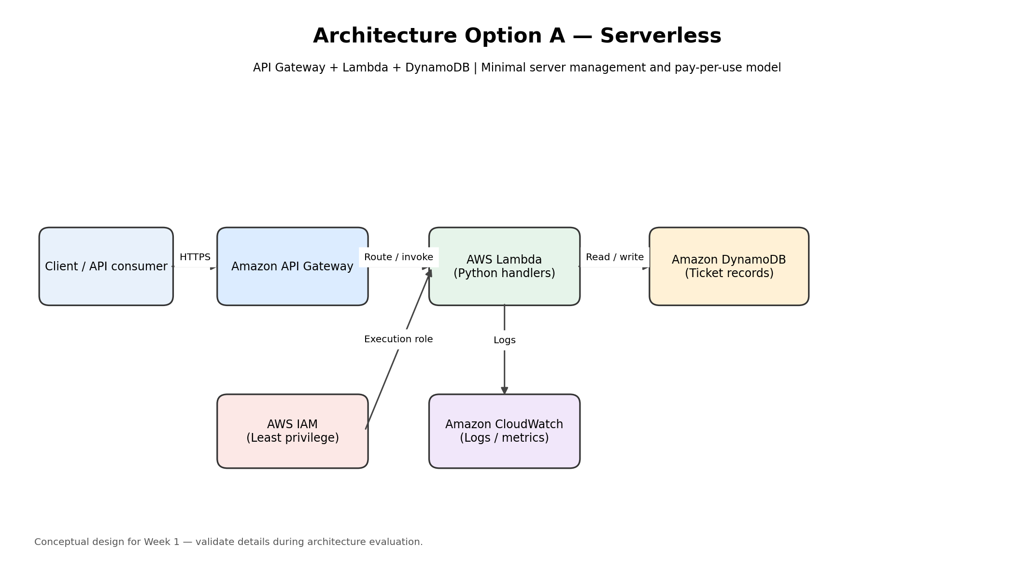

Request flow
- A client sends an HTTPS request to an API Gateway endpoint.
- API Gateway routes the request to the relevant Lambda handler.
- The handler validates input and performs the requested operation on DynamoDB.
- The handler returns a suitable HTTP response; errors are mapped to meaningful status codes.
- Lambda writes runtime logs to CloudWatch using its execution role.

Advantages
- Low server-management overhead.
- Can scale with request volume.
- Fits a small CRUD-style API and Python handlers.
- Usually a good fit for a short, cost-conscious learning project.

Disadvantages / risks
- Requires thoughtful API validation and error mapping.
- Lambda runtime limits and cold starts may matter for some workloads.
- DynamoDB data access patterns should be designed before implementation.
- Actual cost depends on request volume, logs, storage, and regional pricing.

5. Architecture Option B — Container-based API
Concept: A client sends HTTPS requests through API Gateway (or an Application Load Balancer) to a containerized Python API running on Amazon ECS with AWS Fargate. The application stores tickets in DynamoDB or a suitable relational database. Amazon ECR stores the container image; IAM controls task permissions; CloudWatch collects logs and metrics.
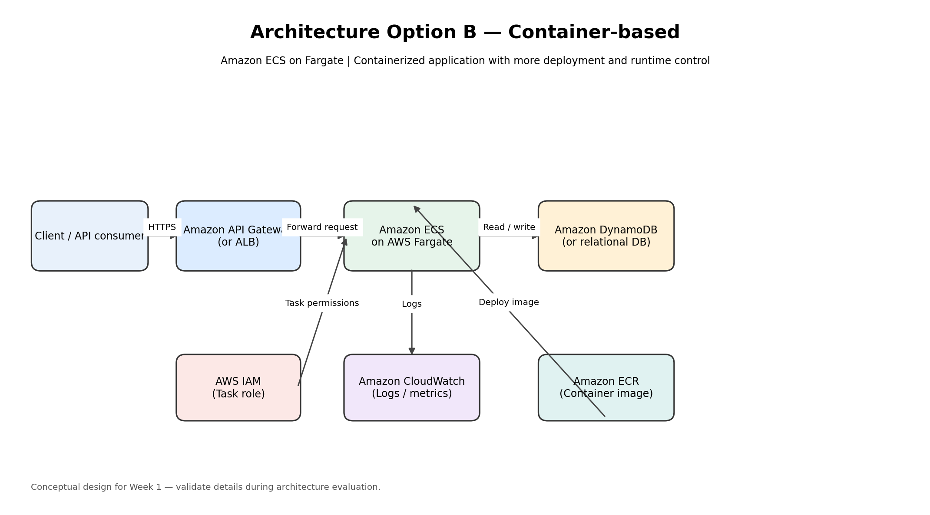

Request flow
- A client sends an HTTPS request through the selected API entry point.
- The request is forwarded to the running ECS/Fargate application task.
- The application validates the request and reads/writes ticket data in the selected database.
- The application returns a suitable HTTP response.
- The container image is stored in ECR, task permissions are provided through IAM, and logs are sent to CloudWatch.

Advantages
- Supports common web frameworks and container-based development workflows.
- Provides more control over the runtime and installed dependencies.
- Can be a useful pattern if the application later grows into a larger service.

Disadvantages / risks
- More components to configure and operate than the serverless option.
- Container deployment, networking, health checks, and task sizing add complexity.
- Running tasks and related infrastructure may cost more for a low-traffic demonstration.
- The database choice and network design require additional decisions.

6. Initial comparison (to validate in Week 2)
Criterion | Option A: Serverless | Option B: ECS/Fargate
Requirement fit | Strong fit for simple CRUD API | Good fit; potentially more than needed
Operational complexity | Lower | Higher
Scaling approach | Managed, request-driven compute | Scale ECS tasks and configure service capacity
Runtime control | More constrained Lambda execution model | More control through containers
Cost considerations | Request-based services; monitor API, Lambda, database and logs | Task runtime and supporting components may create ongoing costs
Likely suitability for this brief | Promising initial candidate | Useful alternative if container/runtime control is a priority
This comparison is preliminary. Week 2 should confirm the final selection using explicit requirements, regional pricing estimates, security needs, and operational trade-offs.

7. Week 1 Completion Checklist
☐ Business and technical requirements documented.
☐ Assumptions, constraints, and open questions documented.
☐ Candidate AWS services analysed.
☐ Architecture Option A documented.
☐ Architecture Option B documented.
☐ Architecture Diagram A created.
☐ Architecture Diagram B created.
☐ All files committed to the project repository, with no secrets or credentials.

Suggested repository layout
support-ticket-system/\n├── README.md\n├── architecture/\n│ ├── option-a-serverless.png\n│ └── option-b-fargate.png\n├── documentation/\n│ └── week-1-deliverables.docx\n├── application/\n├── terraform/\n├── tests/\n└── presentation/
Note: The diagrams are conceptual. Verify service integrations and security/networking details before implementation. The project brief does not specify authentication, a frontend, a specific AWS Region, or a required database technology beyond persistent storage.

