PHASE 6
SariSync Version 1
Data Model
A beginner-friendly blueprint for organizing SariSync data before database implementation
DOCUMENT STATUS
Draft for review. Existing Supabase work: stores and products tables, UUID primary keys, and products.store_id referencing stores.id. Recommended entities and rules in this document must be reviewed before Phase 7.

Prepared for the SariSync shared digital price book project

1. How to Use This Document
Phase 6 defines what information SariSync needs, what each piece means, and how different pieces connect. Phase 7 will convert this approved plan into Supabase tables, columns, constraints, and indexes.
IMPORTANT DISTINCTION
This document is the data blueprint. It is not a SQL script and does not change the live Supabase project.

1.1 Essential Technical Terms
Term | Simple meaning
Entity | A type of thing SariSync stores, such as a Product or Store.
Table | The database implementation of an entity.
Attribute / field | One detail about an entity, such as retail price.
Column | The database implementation of an attribute.
Row / record | One saved example, such as one Lucky Me product.
Primary key | A unique identifier for one row.
Foreign key | A column that connects one table to another.
Relationship | The connection between entities.
Cardinality | How many records can participate, such as one store having many products.
Nullable | The field is optional and may contain no value.
Constraint | A database-enforced rule, such as preventing a negative price.
UUID | A long, automatically generated unique identifier.
Timestamp | A stored date and time.
Schema | The overall structure of tables, columns, keys, and relationships.
Data dictionary | A reference explaining every field in the model.

2. Current Phase 6 Status
Based on the current public schema, SariSync already has the two central tables and their core relationship.
Item | Status | Meaning
stores table | Completed | Contains store identity, name, owner contact, and location fields.
products table | Completed | Contains the required product and price fields.
UUID primary keys | Completed | Both tables use UUID identifiers.
products.store_id foreign key | Completed | References public.stores.id.
Additional Version 1 entities | Not started | Profiles, store members, devices, categories, and price updates still need approval.
Plain-text PIN approach | Needs revision | Do not treat the current stores.pin design as production-ready.

CURRENT SCHEMA WARNING
Verify that products.store_id is not unique. One store must be allowed to own many product rows. Keep the existing foreign key to stores.id.

3. Entity List
An entity is a type of thing the application needs to remember. The table name is the suggested Phase 7 implementation.
Entity | Simple purpose | Suggested table | Status
Profile | A person who uses SariSync. | profiles | Recommended
Store | One family-operated store and its shared price book. | stores | Exists
Store Member | Connects a user to a store and records their role. | store_members | Recommended
Device | A phone, tablet, or browser used by a family member. | devices | Recommended
Category | A product grouping used by one store. | categories | Recommended
Product | The current description and prices of one store item. | products | Exists
Price Update | A history record showing an old price, new price, updater, and time. | price_updates | Recommended

4. Data Dictionary
The following tables describe the recommended Version 1 attributes. Status: recommended means the design must be reviewed before it is implemented.

Stores
Represents one family-operated sari-sari store and its shared price book.
Field | Type | Required? | Meaning | Rule / relationship
id | UUID | Yes | Unique store identifier | Primary key
store_code | Text | Yes | Code used to recognize or join a store | Unique
store_name | Text | Yes | Store name displayed in the app
barangay | Text | Yes | Store barangay
city | Text | Yes | City or municipality
province | Text | Yes | Province
street_address | Text | No | Optional exact address | Nullable
photo_url | Text | No | Optional store-photo location | Nullable
created_at | Timestamp | Yes | Creation date and time | Default: current time
updated_at | Timestamp | Yes | Latest store-information change | Default: current time

Profiles
Stores the in-app information of one authenticated person.
Field | Type | Required? | Meaning | Rule / relationship
id | UUID | Yes | Authenticated user identifier | Primary key; later references auth.users.id
full_name | Text | Yes | Name shown to family members
mobile_number | Text | Yes | Login, verification, or contact number | Final login method decided in Phase 8
email | Text | No | Optional recovery email | Nullable
photo_url | Text | No | Optional profile-photo location | Nullable
created_at | Timestamp | Yes | Profile creation time | Default: current time
updated_at | Timestamp | Yes | Latest profile change | Default: current time

Store Members
Connects people to stores and records their roles.
Field | Type | Required? | Meaning | Rule / relationship
id | UUID | Yes | Membership identifier | Primary key
store_id | UUID | Yes | Store being accessed | References stores.id
user_id | UUID | Yes | User who belongs to the store | References profiles.id
role | Text | Yes | Owner or member | Controlled list
status | Text | Yes | Active, invited, or removed | Controlled list
joined_at | Timestamp | Yes | Membership start time | Default: current time

Devices
Identifies the phone, tablet, or browser used to make changes.
Field | Type | Required? | Meaning | Rule / relationship
id | UUID | Yes | Device identifier | Primary key
store_id | UUID | Yes | Store using the device | References stores.id
user_id | UUID | Yes | User using the device | References profiles.id
nickname | Text | Yes | Name shown in update history | Example: Mom's Phone
last_active_at | Timestamp | No | Latest device activity | Nullable
is_active | Boolean | Yes | Whether device access is allowed | Default: true
created_at | Timestamp | Yes | Device registration time | Default: current time

Categories
Maintains consistent product groupings for one store.
Field | Type | Required? | Meaning | Rule / relationship
id | UUID | Yes | Category identifier | Primary key
store_id | UUID | Yes | Store that owns the category | References stores.id
name | Text | Yes | Displayed category name | Unique within one store
display_order | Integer | Yes | Position in category lists | Default value may be used
is_active | Boolean | Yes | Whether category can be selected | Default: true
created_at | Timestamp | Yes | Creation time | Default: current time

Products
Stores current product descriptions and prices.
Field | Type | Required? | Meaning | Rule / relationship
id | UUID | Yes | Product identifier | Primary key
store_id | UUID | Yes | Store that owns the product | References stores.id; not unique
category_id | UUID | Yes | Selected category | References categories.id
barcode | Text | No | Optional product barcode | Nullable; unique within a store when present
item_name | Text | Yes | Product name | Displayed in uppercase
cost_price | Numeric | No | Store purchase cost | Nullable; cannot be negative
retail_price | Numeric | Yes | Current selling price | Cannot be negative
wholesale_price | Numeric | No | Optional bulk price | Nullable; cannot be negative
bottle_deposit | Numeric | No | Optional container deposit | Nullable; cannot be negative
notes | Text | No | Additional product details | Nullable
photo_url | Text | No | Optional product-photo location | Nullable
created_by | UUID | Yes | User who added the product | References profiles.id
updated_by | UUID | Yes | User who last edited the product | References profiles.id
created_at | Timestamp | Yes | Creation time | Default: current time
updated_at | Timestamp | Yes | Latest edit time | Default: current time
is_active | Boolean | Yes | Active or archived product | Default: true

Price Updates
Preserves price history for Price Pulse and the Updates screen.
Field | Type | Required? | Meaning | Rule / relationship
id | UUID | Yes | Price-update identifier | Primary key
store_id | UUID | Yes | Store where change occurred | References stores.id
product_id | UUID | Yes | Product that changed | References products.id
previous_retail_price | Numeric | No | Retail price before change | Nullable for a new product
new_retail_price | Numeric | Yes | New retail price | Cannot be negative
previous_wholesale_price | Numeric | No | Previous wholesale price | Nullable
new_wholesale_price | Numeric | No | New wholesale price | Nullable
updated_by_user_id | UUID | Yes | User who made the change | References profiles.id
device_id | UUID | No | Device used for the change | References devices.id; nullable
notes | Text | No | Optional explanation | Nullable
created_at | Timestamp | Yes | Update time | Default: current time

5. Logical Relationship Diagram
This diagram shows the proposed connections. It is a logical model: it explains the business structure before exact SQL implementation.
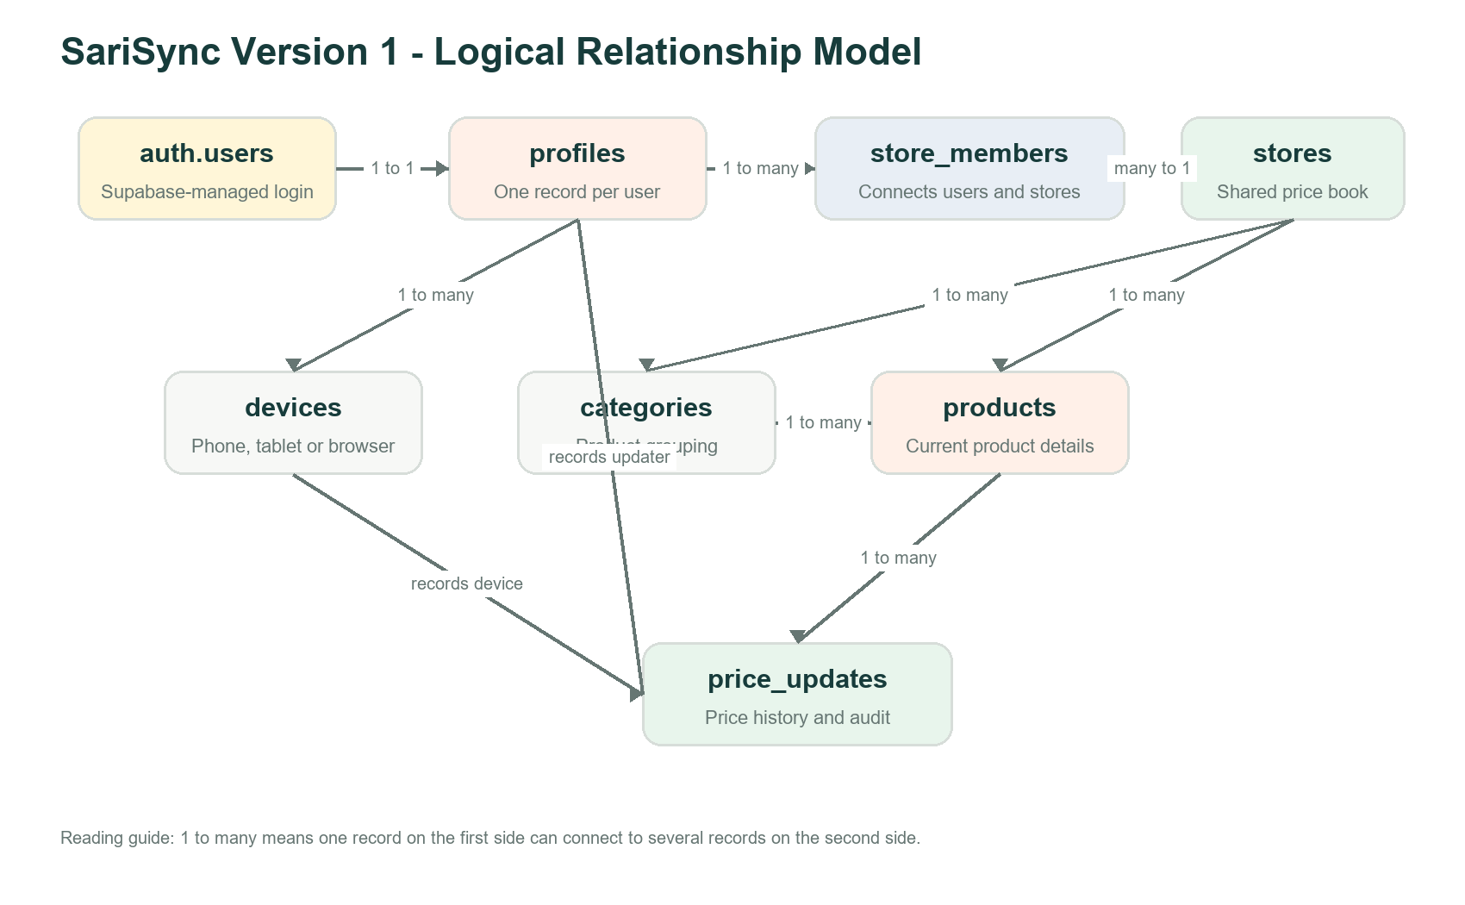
Figure 1. Recommended SariSync Version 1 entity relationships.

6. Relationship List
Relationship | Cardinality | Simple explanation
Authentication user - Profile | One to one | Each authenticated Supabase user has one SariSync profile.
Profile - Store Member | One to many | One person may have one or more store memberships.
Store - Store Member | One to many | One store may contain several family members.
Profile - Device | One to many | One person may use more than one device.
Store - Device | One to many | One store may allow up to five active devices in Version 1.
Store - Category | One to many | Each store manages its own category list.
Store - Product | One to many | One store owns many products; one product belongs to one store.
Category - Product | One to many | One category contains many products.
Product - Price Update | One to many | One product may have a complete history of price changes.
Profile - Price Update | One to many | A user may create many price updates.
Device - Price Update | One to many | A device may be recorded on many updates.

7. Primary Key Plan
A primary key is the unique ID of a row. UUID is recommended because SariSync will synchronize data created on different devices.
Table | Primary key | Type | Purpose
profiles | id | UUID | Same identity used by the authenticated user.
stores | id | UUID | Unique store identity.
store_members | id | UUID | Unique membership identity.
devices | id | UUID | Unique registered-device identity.
categories | id | UUID | Unique category identity.
products | id | UUID | Unique product identity.
price_updates | id | UUID | Unique price-history identity.

8. Foreign Key Plan
A foreign key connects a row to an existing row in another table. These links will later support both data accuracy and Row Level Security.
Foreign-key column | References | Reason
profiles.id | auth.users.id | Connect profile to authenticated login
store_members.store_id | stores.id | Identify the joined store
store_members.user_id | profiles.id | Identify the member
devices.store_id | stores.id | Identify the device's store
devices.user_id | profiles.id | Identify the device user
categories.store_id | stores.id | Keep categories separated by store
products.store_id | stores.id | Keep products separated by store
products.category_id | categories.id | Assign a valid category
products.created_by | profiles.id | Record who added the product
products.updated_by | profiles.id | Record who last edited it
price_updates.store_id | stores.id | Identify the store
price_updates.product_id | products.id | Identify the changed product
price_updates.updated_by_user_id | profiles.id | Identify the updater
price_updates.device_id | devices.id | Identify the device when available

9. Required and Optional Rules
Required means the value must be supplied. Optional means the database may store NULL, which means no value was provided.
Field or rule | Status | Reason
Product item name | Required | A product cannot be recognized without a name.
Product category | Required | Every active product must belong to a valid category.
Retail price | Required | This is the app's primary lookup value.
Barcode | Optional | Some local or repacked products have no barcode.
Cost price | Optional | May be unavailable during onboarding.
Wholesale price | Optional | Not every product is sold in bulk.
Bottle deposit | Optional | Only some containers require a deposit.
Notes and photos | Optional | Helpful but not required for price lookup.
Previous price | Optional | A newly added product has no previous price.
Store membership | Required for access | A user must be an active member before accessing store data.
Device nickname | Required | Used to explain which device made an update.

NULL IS NOT ZERO
NULL wholesale price means no wholesale price was provided. A value of 0.00 means a wholesale price exists and is zero.

10. Business and Data Rules
- Every product belongs to exactly one store.
- One store can own many products.
- Product names are displayed in uppercase for consistent searching and sorting.
- Retail, cost, wholesale, and bottle-deposit values cannot be negative.
- A barcode may be empty, but a non-empty barcode should not be duplicated within the same store.
- A category name should not be duplicated within the same store.
- The same person cannot have two membership rows for the same store.
- A store supports no more than five active devices in Version 1.
- Every saved price change records the new price, updater, and update time.
- New products do not show an incorrect previous price of 0.00.
- Products should normally be archived instead of permanently deleted.
- Different stores must never see or change each other's information.

11. Confirmed and Recommended Decisions
Decision | Status | Reason
Use UUID primary keys | Confirmed | Already used by stores and products.
Products belong to stores through store_id | Confirmed | Foreign key already exists.
Wholesale price remains optional | Confirmed | Matches the Version 1 product scope.
Separate price history from current product price | Recommended | Needed for Price Pulse and audit history.
Create a separate categories table | Recommended | Avoids spelling differences and supports category management.
Separate profiles from stores | Recommended | Supports multiple family members cleanly.
Use store_members to connect users and stores | Recommended | Provides a foundation for roles and RLS.
Track device nickname separately | Recommended | Supports update attribution and device limits.
Archive products instead of immediate deletion | Recommended | Protects price history and reduces accidental data loss.

12. Unresolved Questions
Question | Decision needed | When to decide
Authentication method | Will Version 1 use mobile OTP, email/password, or another Supabase Auth method? | Phase 8
Store PIN | Will the interface keep a PIN-like experience, and how will it be protected server-side? | Phases 8-9
Roles | Can ordinary members add products, or only update prices? | Before Phase 9
Product deletion | Who may archive or permanently delete a product? | Before Phase 9
Category ownership | Are the nine default categories fixed, editable, or both? | Before Phase 7
Barcode duplication | Should duplicate barcodes be warned about or completely blocked? | Before Phase 7
Offline conflicts | What happens when two devices change the same price while offline? | Later synchronization design
Store deletion | Should deleting a store be prohibited, archived, or require a protected recovery period? | Before production release

13. Decision Guide
Use the following process when an unresolved question appears:
- Write the user problem in plain language.
- List the smallest Version 1 behavior that solves it.
- Check whether the choice affects privacy, security, or data loss.
- Identify the entities, fields, and relationships affected.
- Choose one behavior and record the reason.
- Move future improvements into a later-version list instead of expanding Version 1.

14. Phase 7 Handoff Guide
DO NOT RUN SQL YET
Review and approve this model first. Phase 7 turns only approved entities and rules into actual Supabase tables and constraints.

- Confirm the entity list and fields.
- Resolve category behavior and role permissions that affect table structure.
- Back up or export the current public schema.
- Create one reviewed migration or SQL script for each related group of tables.
- Build profiles and store_members before authentication policies depend on them.
- Build categories, then update products to use category_id.
- Build devices and price_updates.
- Add indexes and constraints.
- Test with sample data before connecting real store information.
- Begin RLS only after ownership relationships are correct.

15. Phase 6 Completion Checklist
Completion item | Status
Entity list reviewed | Pending
Every Version 1 field belongs to an entity | Pending
Required and optional rules reviewed | Pending
Primary keys approved | Pending
Foreign keys approved | Pending
One-to-many and one-to-one relationships reviewed | Pending
Price history model approved | Pending
Store ownership of all shared data is clear | Pending
Critical data-structure questions resolved | Pending
Document marked approved for Phase 7 | Pending

16. Approval Record
Item | Your input
Document version | Draft 1.0
Phase | Phase 6 - Data Modeling
Approved for Phase 7? | No - review required
Reviewed by
Review date
Important changes requested

