D597 Scenario 1
Part 1: Design Document
A. Scenario 1
1. Business problems that can be solved with a database solution:
- HealthTrack aims to optimize how health data is collected to make better health recommendations, but its current database infrastructure cannot manage the volume and variety of their data sources, creating performance bottlenecks, data silos, integration problems, and analysis challenges.
- I recommend a relational database to structure our tables and solve our business problems. Relational databases excel at managing structured data with predefined schemas, so the underlying data can be classified first. Malik, Golwasser, and Johnston (2019) explain that when given datasets, it can often be helpful to classify the underlying data (Malik, U., Golwasser M., & Johnston B., 2019). A relational database with structured tables can be connected, allowing users to query data faster.

Here are our proposed tables for the database:

Wearable_Device
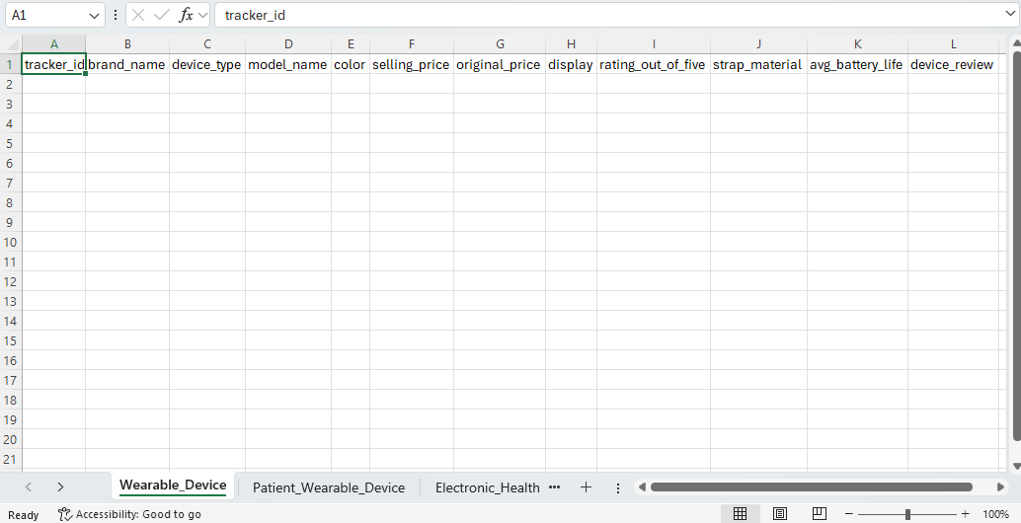

Patient_Wearable_Device
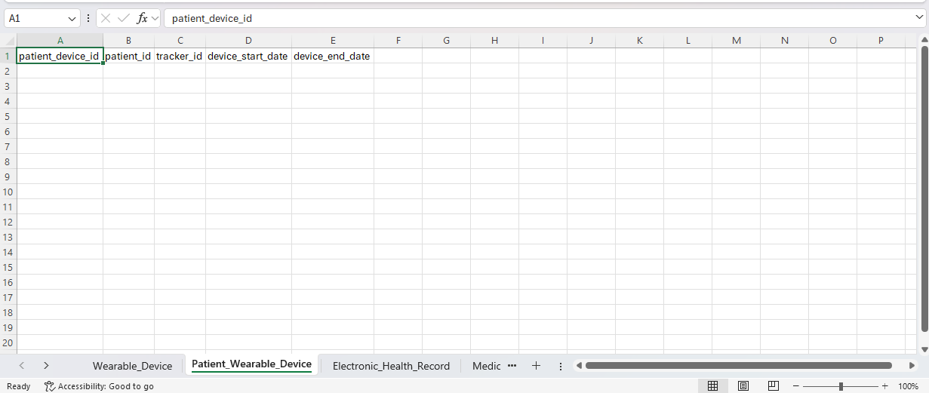

Electronic_Health_Record
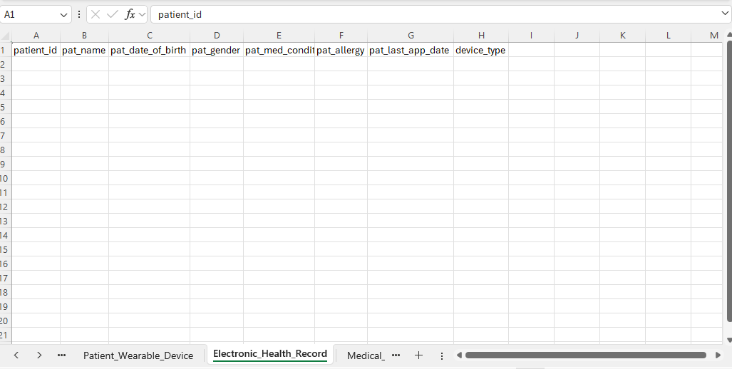

Medical_Imaging_System
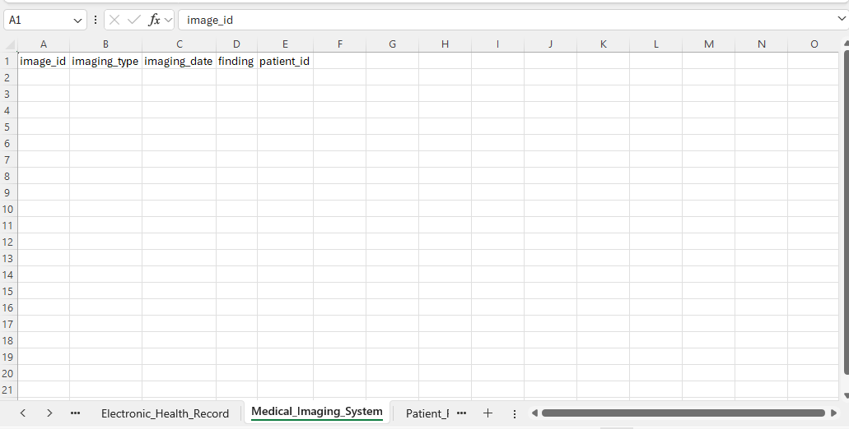

Patient_Reported_Outcome
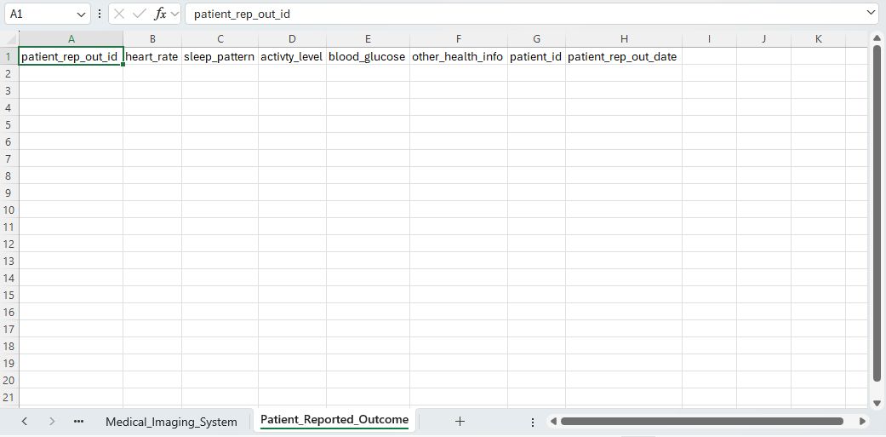

- A database solution would be the most efficient approach in this scenario because HealthTrack manages vast amounts of data that are better stored in multiple related datasets. Managing data in this way provides better data consistency, easier querying, and reduced duplication, which can be especially helpful when working with missing data. Malik, Golwasser, & Johnston (2019) state one of the many problems you may have to deal with when working with datasets is missing values (Malik, U., Golwasser M., & Johnston B., 2019).
If multiple users access the data, it will also be centralized for faster retrieval.
B. HealthTrack Logical Model
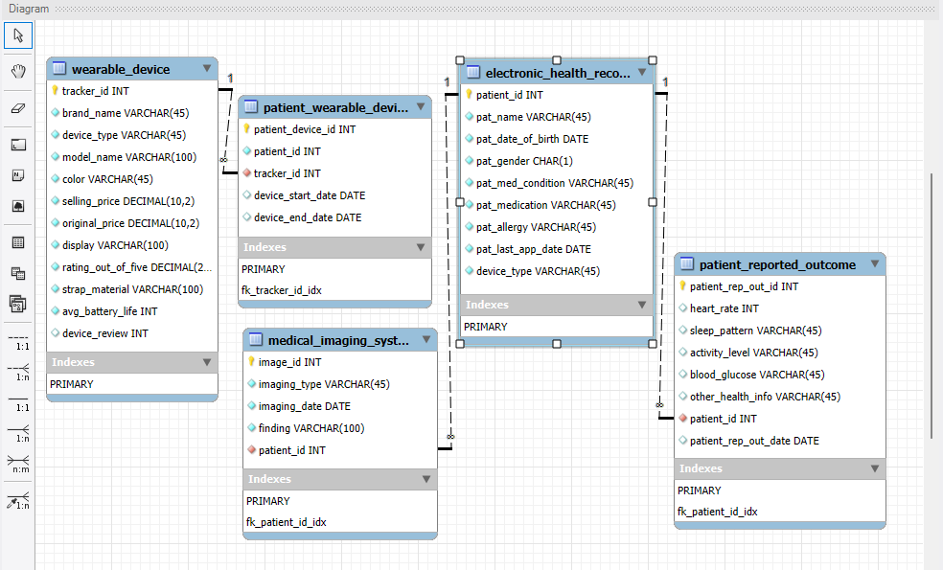
1. HealthTrack aims to optimize how health data is collected to make better health recommendations. To visualize this, we created an entity-relationship diagram (ERD) to model our entities, attributes, and data organization into a logical model. After implementation, HealthTrack can use the database to monitor patient health metrics.
2. The database has five entities: wearable_device, patient_wearable_device, electronic_health_record, medical_imaging_system, and patient_reported_outcome.
- wearable_device entity’s attributes and data types include tracker_id INT, brand_name VARCHAR(45), device_type VARCHAR(45), model_name VARCHAR(100), color VARCHAR(45), selling_price DECIMAL(10,2), original_price DECIMAL(10,2), display VARCHAR(100), rating_out_of_five DECIMAL(10,2), strap_material VARCHAR(100), avg_battery_life INT, device_review INT. Index created on the primary key tracker_id.
- patient_wearable_device entity’s attributes and data types include patient_device_id INT, patient_id INT, tracker_id INT, device_start_date DATE, and device_end_date DATE. Index created on the primary key patient_device_id INT. Foreign key index created on fk_tracker_id_idx.
- electronic_health_record entity’s attributes and data types include patient_id INT, pat_name VARCHAR(45), pat_date_of_birth DATE, pat_gender CHAR(1), pat_med_condition VARCHAR(45), pat_allergy VARCHAR(45), pat_last_app_date DATE, device_type VARCHAR(45). Index created on the primary key patient_id.
- medical_imaging_system entity’s attributes and data types include image_id INT, imaging_type VARCHAR(45), imaging_date DATE, finding VARCHAR(100), and patient_id INT. Index on primary key image_id. Foreign key index on fk_patient_id_idx.
- patient_reported_outcome entity’s attributes and data types include patient_rep_out_id INT, heart_rate INT, sleep_pattern VARCHAR(45), activity_level VARCHAR (45), blood_glucose VARCHAR(45), other_health_info VARCHAR(45), patient_id INT, patient_rep_out_date DATE. Index created on primary key patient_rep_out_id. Foreign key index on fk_patient_id_idx.
C. HealthTrack is most concerned about scalability and data variety that could create issues as the data is integrated into the new database solution. Our database has considered previous problems and includes indexes and normalized tables to generate the most efficient queries. With centralized data in the database, multiple users can access it at any time without affecting other users, because the storage solution is designed for scalability.
D. As a healthcare technology company, HealthTrack considers protecting users’ health information critical to the safety of its customers and their PHI. HeathTrack can consider authentication measures including access controls, limiting privilege with role-based access, and conducting regular data auditing and logging as best practices.

Part 2: Implementation
E. Implementing database design
1. Database Instance D597 Task 1
2. I imported the Fitness Tracker spreadsheet into the wearable_device table and the Medical Records spreadsheet into the electronic_health_record table.
3. Three queries to retrieve specific information from the database that will help to solve the identified business problem:
- What types of wearable devices are in the electronic health record, and how many of these devices are there?
- Which brand of devices are popular among patients?
- How many of each gender are present in the electronic health record?
4. Our queries used these tables and columns the most: wearable_device, patient_wearable_device, and electronic_health_record; along with brand_name, device_type, tracker_id, and pat_med_condition. I added indexes here because they may be frequently searched in the database in the future, and these indexes will improve query times. I noticed more indexes improved query times, but further consideration about effectiveness should be measured by how many indexes will slow the database down.
- Question 1 Before and After Indexes: I filtered through devices to count each device_type. The results filtered out many device categories with low device counts which could mean the categories may be repeated and could be combined further. First query time: 0.639 seconds. Second query time: 0.147. The faster query time indicates that our indexes are increasing our database query speed.
- Question 2: Before and After Indexes: I counted the patient devices from the wearable_device table by joining it with the patient_wearable_device on tracker_id. Although my results didn’t return any data, I can see the query worked. But the database retrieval time increased, so I could consider that these indexes may be slowing the database down and could be unnecessary. First query time: 0.062 seconds. Second query time: 0.088 seconds.

- Question 3: Before and After indexes: I counted patient gender on the EHR and grouped our results by category. The results show our database is distributed evenly between the 2 gender categories. But our query speed increased again, so these indexes may not be as helpful as they are harmful. First query time: 0.100 seconds. Second query time: 0.119 seconds.
5. All scripts submitted as text files.
References
Malik, U., Golwasser M., & Johnston B. (Ed.). (2019). Understanding and Describing Data. SQL for Data Analytics. https://research.ebsco.com/c/25xrgu/ebook-viewer/pdf/a7tjotqst5/page/pp_5
Malik, U., Golwasser M., & Johnston B. (Ed.). (2019). Understanding and Describing Data. SQL for Data Analytics. https://research.ebsco.com/c/25xrgu/ebook-viewer/pdf/a7tjotqst5/page/pp_36

