A B S T R A C T

The timely and accurate detection of epileptic seizures is highly needed to enhance the quality of a patient’s life. The state-of-the-art works to design and utilize many deep learning techniques to detect and predict seizures using EEG, fMRI, and a combination of EEG and fMRI modalities respectively. Whereas the existing models are highly vulnerable to complexity, and overfitting issues due to improper feature analysis. To this end, we design a novel seizure detection model named Triple stream skipped feature extraction module and Dual parallel atten- tion transformer Network (Tri-SeizureDualNet) using EEG and fMRI modalities. The major scope of this research is to enhance the detection accuracy of seizures with better performance. The data acquired for this research is from the CHB-MIT database for EEG and the UW Madison database for fMRI. The designed model tends to perform feature extraction, feature selection, feature engineering, and classification respectively with high feature extraction accuracy and less complexity. Beforehand, we perform pre-processing on both the EEG and fMRI data using ICA, PCA, and high pass filtering. Followed by we perform feature extraction in three streams with skip connections from both modalities to improve the extractor capability and feature extraction accuracy. The extracted features are selected in the feature selection module using the Humming Bird Optimization (HBO) algorithm based on the feature importance ratio. The selected features from both modalities were fused and

respectively. The utilized DPAT is composed of two regularized attention modules with a gating mechanism to picture the feature similarity rate. At last, the softmax layer classifies the features into three classes such as focal

onset, general onset, and unknown onset seizures respectively. The experimental results were conducted with

two utilized datasets such as CHB-MIT and UW Madison datasets separately for EEG and fMRI data in which the proposed work achieves an overall accuracy rate of 99.67% and AUC rate of 0.989 respectively. The results reveal that the proposed research outperforms the existing works.

## Introduction

Epilepsy is a communal neurological brain disorder that occurs due to frequent seizures. A seizure is defined as an anomalous electrical shock in the brain cells leading to the failure of other organs [1]. It is reported that over 75 million people in the world were suffered from brain epilepsy. Additionally, about 80 % of people were lacks with proper treatment due to expensive epilepsy treatment [2]. On the other hand, timely interventions for epilepsy were not practiced yet even though the patients can afford with high-cost neurological treatments due to a deficiency of seizure medications, and skilled specialists [34].

Those aforementioned complications of disease and their expensive diagnosis make them as most notorious neurological brain disorders. **The main difference between epilepsy and seizure is based on two classes such as motiveless and motivated seizures respectively. Motive- less seizures have occurred due to minor/major head injury whereas the motivated seizures occurred due to various conditions such as less blood sugar level, drug implication, enormous fevers, etc….…,** [56]. **Different from other neurological disorders, most children are highly prone to epilepsy and seizures due to varied growth conditions. Similarly, the aged people who are above fifty years of age are also likely to be affected from frequent seizures due to stoke circumstances.** Henceforth, there

must be a need to develop the better seizure detection and prediction model to reduce the poor clinical outcomes [7]. For accurately detecting the epilepsy and seizures, Electroencephalography (EEG) was the widely used technique that sent the neural electrical discharges and recording the brain cells fluctuations over the time in rhythmic manner [8]. **Nor- mally, there are several electrodes are placed in the patients scalp to record the brain cells fluctuations. The results from every electrode were marked individually to determine the variations in signals**. However, the utilized methodology was highly time-consuming and also highly vulnerable to onlooker inconsistency which also leads to poor outcomes [9]. So, computer vision technology came into picture. Amalgamating the scalp EEG electrodes results with the computer provides better outcomes. The main reason for adopting computer vision and EEG is that, the variability in every electrode can determine precisely. Although with enormous advantages of adopting EEG the major disad- vantages were that it was highly vulnerable to muscular and Electro- oculography (EOG) signals respectively, highly non-stationary, and also vulnerable to power line interference. Other than the EEG, there were other modalities utilized named Magnetoencephalography (MEG), Functional Magnetic Resonance Imaging (fMRI), and Near Infrared Spectroscopy (NIRS) [10–12]. The MEG was a non-invasive methodol-ogy to acquire a brain neuromagnetic activity. The MEG had wider range of frequencies whereas it lacks with enormous experimental setup. Similarly, the fMRI and NIRS also non-invasive methodology in which

both of them utilize metabolic Blood Oxygen Level Dependent (BOLD) signals [13]. However, **major disadvantages of fMRI were that is possess higher cost and delay whereas for the NIRS the disadvantage was that it possesses poor performance, and shrunken temporal resolution** [14]. With those diagnostic tools many of the existing works utilized several Artificial Intelligence (AI) methodologies such as Machine Learning (ML) & Deep Learning (DL) algorithms respectively [15–16]. Some of the state-of-the-art ML algorithms such as Support Vector Machine (SVM), Random Forest (RF), K Nearest Neighbors (KNN), Logistic Regression, etc..,. Some of the existing DL algorithms such as Convolu- tional Neural Networks (CNN), Recurrent Neural Networks (RNN), Long Short-Term Memory (LSTM), and transformer models respectively [17,18]. **However, the existing works utilized algorithms are highly prone to overfitting and complexity issues** **[46–48]****. Yet the problem of complexity was also reduced by performing better feature extraction and analysis respectively**. **Many of the feature extraction methods such as statistical analysis, Pearson coefficient analysis etc.., which extracts several features such as geometrical, statistical, edge, spatial, and tem- poral features respectively in one picture** [19,20]. **However, it leads to higher classifier burden as the most of the selected features were not so important. Henceforth, a robust feature selection was needed to reduce the classifier burden. Overall, the major issues in seizure detection were that, higher complexity, classifier burden, poor feature analysis & en- gineering, and classification respectively depicts in** **Fig. 1**

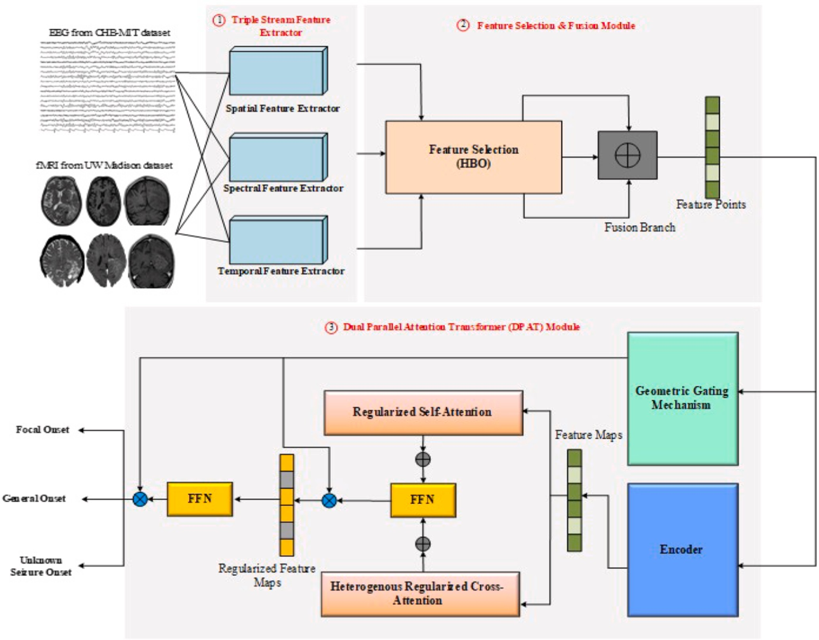

**Fig. 1.** Overall Architecture of Proposed Tri-SeizureDualNet with (1) Triple Stream Feature Extraction Module, (2) Feature Selection and Fusion Module, (3) Dual Parallel Attention Transformer Module.

The findings discussed in this passage regarding epilepsy and seizure detection have several potential implications and significance in the real world, both in the medical field and for comprehensive areas. Devel- oping a better seizure detection and prediction model, as mentioned in the passage, can have a significant impact on the medical field. It can lead to earlier and more accurate diagnosis of epilepsy and seizures, allowing for timely medical interventions and treatments. This, in turn, can improve the quality of life for individuals with epilepsy and reduce the risk of complications associated with untreated seizures. Further- more, the passage highlights that a significant portion of the global population lacks access to proper treatment for epilepsy due to its high cost. If more cost-effective and accurate seizure detection methods are developed, it could make diagnosis and treatment more accessible to a wider range of people, particularly in resource-constrained regions. By addressing the limitations of existing diagnostic tools and utilizing artificial intelligence (AI) methodologies, the risk of misdiagnosis can be reduced. This is crucial for ensuring that individuals with epilepsy receive appropriate care and avoid unnecessary treatments or in- terventions. At last, Epilepsy is a significant public health concern, affecting millions of people worldwide. Improving the accuracy and accessibility of diagnosis and treatment can have a positive impact on

public health by reducing the burden of the disease and improving the

overall well-being of affected individuals.

The above issues resided in the existing works motivates us to design a novel seizure detection methodology using deep learning algorithm with multi-modality technique. Some of supplementary objectives of this research are provided below,

To enhance the acquired data quality and resolve the noise and ar- tifacts by performing pre-processing on both EEG and fMRI data respectively.

•

To amplify the feature extraction capability and speed by adopting three-way parallel feature extractor.

•

To reduce the computational burden of the classifier by adopting metaheuristics algorithm-based feature selection techniques.

•

To improve feature engineering ability by adopting attention-based transformer method which also overcomes the dimensionality is- sues and improves the classification accuracy.

•

Some of the headmost contributions of this research are listed below, To the best of our knowledge, this research designs a novel seizure detection model by utilizing skip connections for feature extraction, optimization algorithm, for feature selection and attention-based transformer method for feature engineering and classification respectively.

•

•

We provide dual inputs EEG and fMRI to the proposed model by pre- processing them and setting the proper time window to modalities respectively.

•

Our research shows that, the proposed work gains better perfor- mance in both EEG, fMRI, and EEG fMRI modalities using CHB- MIT and UW Madison dataset respectively.

+

•

The remaining of the paper is organized as follows, Section II states the related works along with individual issues. Section III provides the materials and methods employed in the proposed research as dataset description, and proposed methodology. Section IV explains the exper- imental results and performance analysis among the proposed and existing works respectively. Section V discusses the overall summary of the proposed work with comparative analysis and section VI concludes the research work with worth future direction.

## Related works

* 1. *EEG based seizure detection*

The utilization of intracranial EEG for brain seizure detection is still a major issue. Intracranial EEG (iEEG) improves the detection accuracy of

brain seizures. The adoption of one-dimensional convolutional neural networks with intracranial EEG was utilized by [21] with a channel increment strategy. The dataset utilized was the Freiburg iEEG dataset. Similarly, in [22], the DCNN model is utilized for seizure detection based on normal EEG data, and in [32] the EEG videos are also utilized for generalized seizure prediction. In addition to that, they also include an explanation for the adopted deep learning algorithm. However, those methods fail to capture the feature interdependencies and are also faced with computation issues. In [23], the computation and accuracy issues are addressed by adopting compression, prediction, and reconstruction model respectively. More intensely, the work in [24] addresses the issue of the deep learning algorithm’s black-box nature by proposing an un- derstandable deep learning algorithm. The improvisation of seizure detection/prediction accuracy is achieved by adopting transfer learning and uncertainty learning respectively. The cross-modal cluster embed- ding a utilized in [25] whereas the lite weight convolutional neural network and Monte Carlo methods were utilized in [26]. Similarly, [28] also utilized the transfer learning method but with a hybrid transformer model for predicting epilepsy. Conversely, the ensemble machine learning algorithm was used in [27] with the cascade method amal- gamated however the poor performance and time consumption hinder

the detection accuracy. Feature extraction plays a major part in seizure

detection, the works in [29,30], and [31] utilized boostable Q wavelet transform, wavelet transforms with handcrafted feature fusion, and deep learning-based feature representation model. However, those feature engineering works were lacking with optimal and effective feature se- lection leading to a higher classifier burden.

* 1. *fMRI-based seizure detection*

Other than EEG, fMRI plays a major role in localizing brain seizures. Although only limited works utilized fMRI for brain seizure detection, utilizing fMRI deserves a promising place in seizure detection. In the work [33], epilepsy was resisted by combining the deep learning algo- rithms based on resonance MRI modality. In contrast to the former work, the entropy model and the machine learning algorithm were utilized to locate the seizure location using fMRI [34]. In contrast with machine learning, the graph-based deep learning model, and multi-channel graph model were utilized for localizing brain seizures using fMRI [36] & [38]. Different from the previous works, in [35] the authors utilized fMRI for seizure detection using signals from blood and oxygen. Those oscillated signals cover better mapping strategies for seizure detection. Other than blood and oxygen signals, the heartbeat rates are also utilized for localizing seizures using fMRI [37]. Those signals are analysed carefully as they contain an enormous number of artifacts which affects the detection accuracy.

* 1. *Multi modal seizure detection*

Although, the single modal works on brain seizure detection pose better results whereas the multimodal concepts on brain seizure detec- tion tend to improve the localization accuracy. The work in [39] com- bines EEG & fMRI for localizing the seizure onset in which the brain scalp signals, blood, and oxygen levels were combined to provide the detection results. Advanced from the previous research, this research

[40] performs statistical analysis and feature selection on EEG and fMRI data to detect brain seizures. Finally, the logistic regression model was utilized for classification. In order to reduce the brain seizure compli- cations of traumatic brain injury, three modalities are combined such as fMRI, dMRI, and EEG in which selective fusion and statistical analysis were utilized for classifying the post-brain seizures [41]. The general- ized linear model and independent component analysis methods were utilized for accessing the epileptic foci with topographic information by combining EEG-fMRI [42] and [44]. By adopting the multimodal method, the problem aroused during interictal events gets reduced. In addition to the combination of EEG-fMRI, in [43] PET and fMRI are

combined to detect seizures in children. The PET provides the meta- bolism and glucose levels along with the blood and oxygen levels. The combination of a recent deep learning model named convolutional neural networks with EEG-fMRI provides promising results but leads to overfitting and dimensionality issues [45].

## Materials and methods

* 1. *Dataset description*

The proposed work utilized two datasets for EEG and fMRI respec- tively. For EEG data acquisition, we utilized CHB-MIT dataset, and for fMRI we utilized the University of Wisconsin (UW) Madison dataset. The reason adopting those two datasets is that, **data diversity (i.e., both the CHB-MIT and UW Madison datasets are composed of patients with different genders, seizure types and age groups), enough annotated data (i.e. both the CHB-MIT and UW Madison dataset have enough annotated data on EEG and MRI recordings respectively to improve the training and assessment of AI models)**. The public availability of those datasets makes researchers adore those datasets for their research works. At last, those datasets follow ethical considerations. EEG and fMRI recordings in these datasets are collected in real-world clinical settings. This means that the data reflect the challenges and complexities encountered in diagnosing and treating epilepsy in clinical practice. Using real-world data helps researchers develop practical solutions.

The CHB-MIT dataset is composed of scalp EEG signals for twenty-

three patients with a 256 Hz frequency of sampling rate. By utilizing the bipolar tableau, there are about 20 electrodes are placed based on international standards. More clearly, the system guarantees is improved by selecting common channels for the patients. There are about 15 common channels selected such as CZ-PZ, FZ-CZ, P8-O2, T8- P2, T8-F8, F8-FP2, P4-O2, P4-C4, F4-C4, F4-FP2, P3-O1, P3-C3, C3-F3,

F3-FP1, P7-O1. The parameter value for the CHB-MIT dataset is pro- vided as follows, for the preictal conditions the EEG signals are acquired before 30 min for the seizures. The time for intervention is about one minute between the onset seizure and preictal. For the interictal seizure onset, the period is hanging before and after the seizure onset. The problem of overfitting during data acquisition is resolved by considering

the patients with three consecutive seizures for > 3 h’ time period. Overall, there are eighty-five seizures are utilized with four second time

window are utilized.

The UW Madison dataset is composed of brain fMRI scans of 12 patients who are diagnosed with focal epilepsy. The MRI scans are ac- quired using two scanners such as GE 3 T and 1.5 T respectively. The

image sequences are at a timing of 802 ms, 50 degrees flipped, and 30

* 1. *Pre-processing*

The pre-processing of both the EEG and fMRI modalities separately are explained in this sub-section. The brief explanations are provided below,

* + 1. EEG Pre-processing

Generally, the acquired EEG data from the dataset is composed of noise and artifacts respectively. The artifacts include both internal and external artifacts which can seriously affect the seizure detection rate and also amplifies the computation burden. For that, we have adopted Independent Component Analysis (ICA) and Principal Component Analysis (PCA) for removing the artifacts in EEG data. The matrix of the

EEG signal is represented y(t) with basis components of bT = b1, b2, ⋯, bm . The given expression is statistically independent with ‘m’ as the basis number. The mixing of the signal can be formulated as,

[ ]

y(t) = Nm(t) (1)

Once the artifacts are found, they are normalized to zero. More precisely, after the signal reconstruction (y(t)) the artifacts removal will

̂be taken place that can be formulated as,

y(t) = Nm(t) (2)

̂ ̂

The ICA makes the EEG signals to be independent components of less and high amplitudes neural signals and artifacts respectively. The rep- resentation of independent components with artifacts and neutral signal can be formulated as,

b1(t) = ar(t) + lo(t) (3)

Where, ar t defines the artifacts with higher frequency and the lo t defines the neutral signal with low frequency. Upon determining, the b1(t) features can be analysed in which the higher frequency artifacts can be localized and removed easily. The removal of ar t can be formulated as,

( )

( ) ( )

yt(t) = wei1(lo(t)) (4)

̂

From the above equation, the mixing matrix for the low frequency signal can be denoted as wei1 while the noise removed signal can be denoted as yt(t). The noise removed signal were then analysed on time

̂and frequencies respectively. For that, the proposed work adopts

wavelet transform method. The bands of noise removed signals were mined subjectively by altering the position and size of time window that can be formulated as,

cm focal view. There are two kinds of fMRI images were shown such as

preoperative and postoperative MRI images for seizure detection with different requirements. The demography details of the UW Madison

̂y i k 2— ̂y t λ(t — k2i)dt (5)

i/2 ∫ ∞

ω( ,

) =

—∞

( )

2i

dataset are shown in the Table 1 below,

**Table 1**

Demographics of UW Madison dataset with Seizure Location Information.

From the above equation k2i and 2i denotes the shifting and scaling

parameters respectively for the time location, the mother wavelet can be denoted as λ t . For precisely analysing the high and low dimensional variations of the EEG signals, the Discrete Wavelet Transform (DWT) method was utilized. The series of low and high pass filters in the DWT

( )

̂

SI.

No

Gender Scanner Used

Location of Seizure Age

are used to scale the given signal. To be further explicit, the noise removed signal bands y[m] are divided by the series of low and high pass

1. Male 1.5 T The temporal lobe of the left anterior 11
2. Male 3 T The right anterior precentral gyrus 17

filters based on the co-efficient of guesstimate (B1) at a sampling fre-

quency rate of fres [fres/2], and the co-efficient of detail (E1) at sampling

̂

1. Female 3 T Temporal of right 15
2. Female 3 T Frontal gyrus of the left interior 9
3. Male 3 T The frontal region of the right middle 10
4. Male 3 T Between Partial and left interior 15

frequency rate of [fres/2, fres]. The DWT divides the given EEG signal y[m] into five wavelet co-efficient such as B1,E1,B2,E2,B3,E3,B4,E4,B5, E5 with bands of frequencies of [0, fres/2], [fres/2, fres], [0, fres/4], [fres/4,

1. Male 1.5 T Between the insula and operculum of the 18

fres/2], [0, fres/8], [fres/8, fres/4], [0, fres/16], [fres/16, fres/8], [0, fres/32]

1. Female 1.5 T
2. Male 3 T

left interior

The frontal region of the right middle 12

[ ]

region of the right middle 17

and fres/32, fres/16 . Besides the overall wavelets co-efficient of given signal can be represented in E1, E2, E3, E4, E5, and B5. On the whole, for

1. Male 3 T
2. Male 1.5 T

The frontal

The temporal lobe of the left anterior 7

Frontal gyrus of the right interior 13

further processes such as feature extraction, selection, and seizure detection the signals with wavelet co-efficient are utilized such as E3,

1. Male 3 T Pole of frontal left 14

E4, E5, and B5.

* + 1. fMRI Pre-processing

The proposed fMRI data were pre-processed in two methods such as statistical parametric mapping and correction of slice timing respec- tively. Between the Time of Repetition (TR) during fMRI acquisition the correction of slice timing Is performed. During acquisition, the motion of head can be properly aligned by rigid body realignment technique. On the whole, we can obtain the fMRI data with aligned spatial trans- formations. After that, we construct the image motions of brain entrenched on adequate regressors. Once the brain motion images were constructed, we discard the projected motions from the fMRI data. For that, we have utilized high pass filters with 0.02 Hz cut-off frequency and motor regression method to jointly construct the pre-processed fMRI brain images. Those fMRI images are fully packed with motion and spatial images of brain activity during seizures.

* 1. *Tri-SeizureDualNet model*

The brain EEG data and fMRI data provide useful information and

also showcases the brain seizure variations over time. Keeping in that

* 1. *Triple stream skipped feature extractor*

The designed Triple Stream Skipped Feature extractor (TSSF) named skipped deep autoencoder. The proposed TSSF composed of triple sup- plementary modules in parallel such as spatial stream, spectral stream, and temporal stream. For every stream, the layers are connected in skipped manner (i.e. skip connections) to overcome the problem of in- formation loss through multiple layers. Fig. 2 demonstrates the proposed feature extractors.

***Spatial Feature Extractor:*** In spatial feature extraction module, the spatial information for each pixel can be extracted by considering the action of corresponding neighbourhoods. So, to overcome the dimensionality issues, the skipped deep autoencoders connection is adopted. The skipped deep autoencoder took noise removed EEG/ MRI data as an input y ∈ CM×F in which the encoder and decoders

θ̂̂ ∅

•

are represented as En (y) and De (Z). The latent space representa-

tion of the y ∈ CM×F by the encoder is Z = Enθ(y). From that latent representation, the ̂y can be recovered from the De (Z) as

̂ ̂ ∅

̂ ̂

∅

θ

mind, we have propounded Tri-SeizureDualNet model with two inputs.

De (En (y) ≈ y). The error of reconstruction can be reduced using

MSE among y and y that can be formulated as,

The overall architecture of the proposed work is shown in fig. In our work, the EEG data and from the CHB-MIT dataset fMRI data from the

[ ̂

θ )2 ]

UW Madison dataset are the dual inputs provides to the designed model.

L(θ, ∅ : ̂y) = 𝖤

̂y — En (̂y)

(6)

Following that, we have triple stream skipped feature extractor which performs feature extraction on three streams such as spatial, temporal, and spectral variations respectively. Once, the feature was extracted, the extracted features is surrendered to the feature selection module which runs based on HBO. Only the selected features are provided to the dual parallel attention transformer module for engineered the extracted features with normalized self-attention and heterogenous cross attention

From the above mathematical representation, both the θ and ∅ parameterized the De∅(.) and Enθ(.) respectively. The reconstructed output y is obtained by joint learning of θ and ∅. With the Z CM×F, the neighbourhood pixel regions are mined. To be more specific, the pixels of neighbourhood are mined with size of g × g × f. At last, the results are flattened of box size 1 F of size g2 f 1. To obtain the spatial features

from the pre-processed input, the 1F vectors are amalgamated to from

∈

× ×

layers. At last, the softmax layer classifies the brain seizure levels into three classes such as focal onset, general onset, and unknown onset

the matrix of spatial features

̂ySPA ∈ C

M×g2 f .

seizures respectively.

* ***Spectral Feature Extractor:*** *As* similar to the ySPA

, the spectral fea-

tures also extracted using skipped deep autoencoder model. The signatures of spectral bands on the input image vectors are

̂

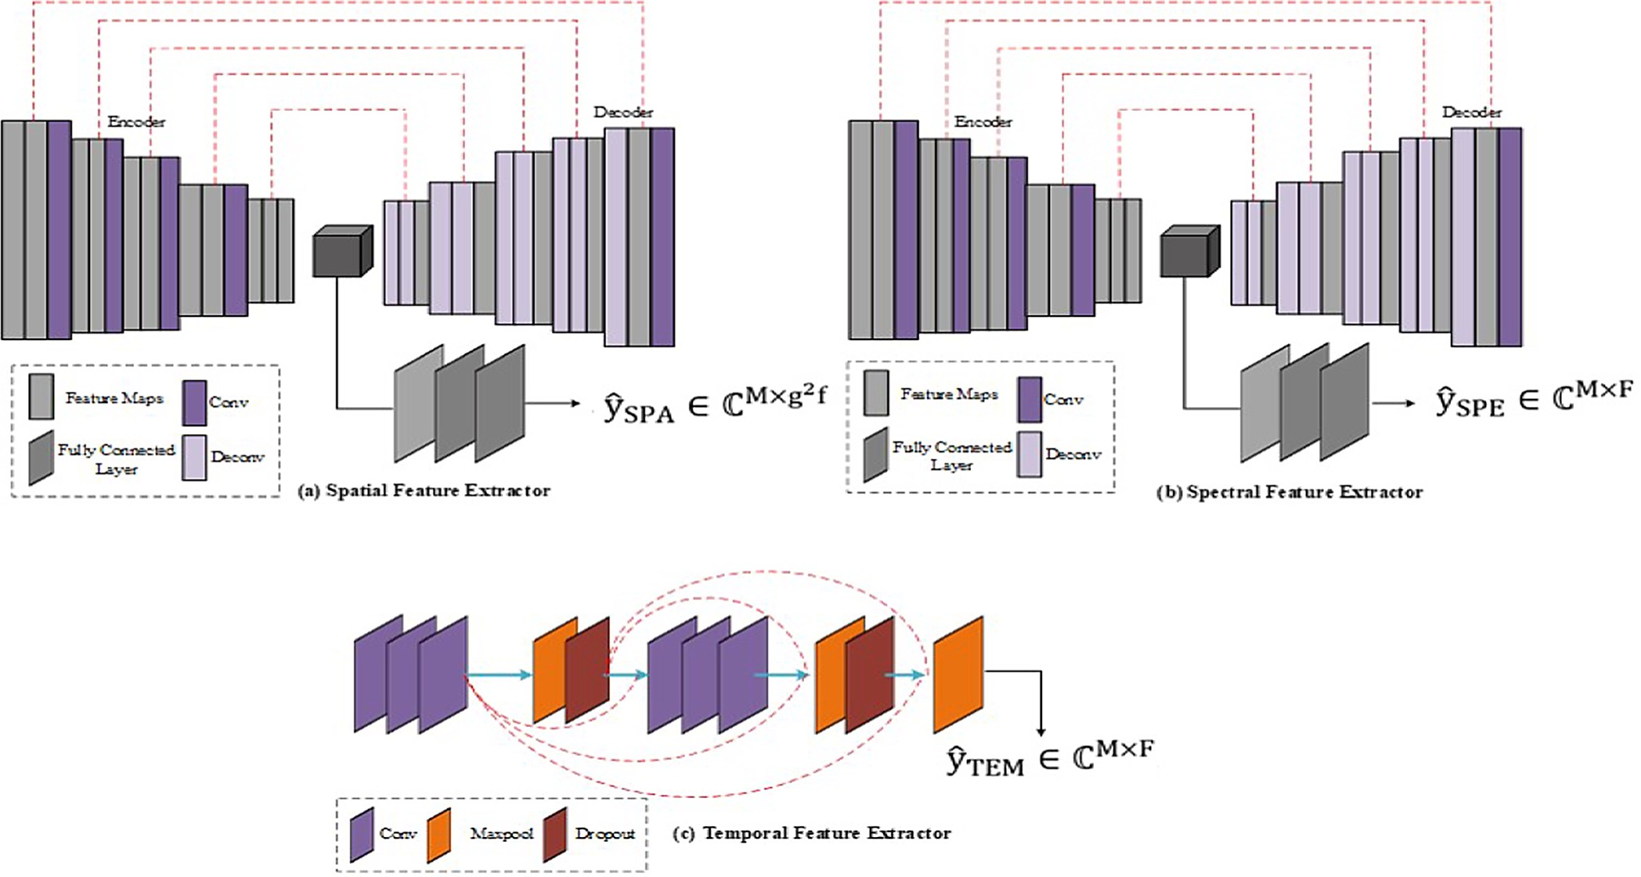

**Fig. 2.** Proposed Feature Extractors (a) Spatial Feature Extractor with encoder and decoder architecture, (b) Spectral Feature Extractor with same encoder and decoder architecture, (c) Temporal Feature Extractor wit h Convolutional Layer.

represented in 1 × F vector in which the spectral bands are repre-

ℵ(t+1) = q(t) + *ϖ*Γ(q(t) — q(t)), *ϖ*N(0, 1) (12)

sented as F. In our work, we utilize all the spectral bands of EEG/ j

,t

fMRI data as an input to get the matrix of spectral features as

j,t

j j,t

̂ySPE ∈ C

•

M×F.

From the above equation, q(jt) represents the jth target feature during

***Temporal Feature Extractor*:** The temporal features from the pre-

processed input can be extracted. Since the temporal features are

highly varying over time, we adopt additional convolutional layers in the temporal feature extractor branch. The kernel layer size of

t-th iteration, and q(jt) represents the jth feature during t-th iteration, the

steered feature can be represented as *ϖ*. Overall, the updation of feature

importance can be formulated as,

convolutional branch is from 40 to 500 to the time window of 1 to 5

s. The adoption of two layers during temporal feature extraction

captures the dissimilar feature sizes. Finally, we obtain the temporal feature matrix of yTEM ∈ CM×F.

q(j t+1) =

⎧⎪⎨

q(j t), *fit*(q(j t)) ≤ *fit*(ℵj(t+1))

j

j

j

(13)

,t ⎩⎪ ℵ(t+1), *fit*(q(t) ) > *fit*(ℵ(t+1))

* 1. *Feature selection*̂

ℵ

The extracted features such as ySPA ∈ CM×g2 f , ySPE ∈ CM×F, and

̂ ̂∈

̂

yTEM CM×F are provided to the feature selection module for selecting the limited and appropriate features to address the computational complexity issue of the classifiers and also dissolves the problem of

classification mislead. The proposed work utilizes HBO algorithm for selecting the optimal set of features. The HBO algorithms caricaturists the nature of flying skills of humming birds at that time of prey hunting. In our research, the extracted features are considered as the food sources for the humming birds. The fitness values for every feature can be rep- resentation in terms of nectar filing rate. For selecting the optimal fea- tures, the HBO algorithm performs three behaviours such as steered, regional, and relocation behaviours respectively. The population initialization of m humming birds based on limitation for search space can be formulated as,

qj = Low + RAN × (UP — Low), j = 1, 2, ⋯, m (7)

From the above equation, j-th feature importance rate is represented as qj in which the UP and Low represents the upper and lower bound search spaces respectively, and the RAN denotes the random number of ranges among [0,1]. The feature importance table formed by the hum-

ming birds can be initialized as below,

From which the fitness value is denoted as fit, and indicates the best position among the position of humming birds.

1. Regional Behaviour

During regional behaviour movement, the local search is accom- plished. More specifically, there are some scenarios the current selected features gains higher importance than the previous selected features. Henceforth, the regional behaviour can be formulated as,

ℵ(j t+1) = q(jt+1) + *ξ*Γq(jt), *ξ*N(0, 1) (14)

,t

From the above equation, the regional behaviour factor can be denoted as *ξ*.

1. Relocation Behaviour

In relocation behaviour, the feature importance can be updating the new feature is considered based on the fitness values. At random phase, the feature importance can be relocated (migrated) from current feature to global best feature. Therefore, the feature importance table can also be updated (i.e. relocated from vilest) based on the fitness values that can be formulated as,

q(t+1) = Low + RAN × (UP — Low) (15)

vilest

{ *Null*, *j* = *i*

The worst feature at the current time at iteration t + 1 can be denoted as q(t+1). The pseudocode for HBO based feature selection can be denoted

FIj,i =

0, *j* ∕= *i* j = 1, 2, ⋯, m and *i* = 1, 2, ⋯, m (8)

vilest

below,

**Algorithm: Pseudocode for Feature Selection**

(a) Steered Behavior

For only the features with higher fitness values, the humming gains higher interest to visit. At the same time, the time consumption for selecting the higher fitness features also high. So that the humming birds utilizes three flying skills such as axial, crosswise, and omni-directional skills respectively. By utilizing the feature importance vector, the flying skills of the humming birds can be changed over time. The expression of

**Initialize** qj, maxt, Low, UP

Perform population initialization from (7)

**Begin**

**While** t ≤ maxt

**For** every population compute Γ

**If** RAN ≤ 0.34

Utilize ΓCW from (10)

j

**Else If** RAN ≤ 0.67 Utilize ΓOD from (9)

j

flying skills are described below in equation (9), (10), and (11) as below,

ΓOD = 1, j = 1, 2, ⋯, d (9)

j

**Else**

Utilize Γaxial from (11)

j

**End If End For**

ΓCW =

j

⎧⎨⎩

1, *j δ* i , *i* 1, k ,

= *RANP*(k), *k* ∈ [2, [RAN1.(d — 2) ] + 1] j = 1, 2, .., d (10)

*δ* = ( ) ∈ [ ]

0, *Otherwise*

**For** every population perform steered behaviour updation

**If** RAN ≤ 0.5

Track Steered behaviour from (12)-(13)

**Else If**

Track Regional behaviour from (14)

Γaxial = { 1, *j* = *RANj*([1, *d*]) j = 1, 2, .., d (11)

**End If**

j 0, *Otherwise*

From the above equations (9)-(11), the ΓOD, ΓCW, and Γaxial represents

If (t = 2 m)

Track Relocation behaviour from (15)

**End If**

j j j

**End For**

the omni-directional, crosswise, and axial flying skills respectively. From the aforementioned equations, the RANj 1, d denotes the 1 to d random vectors, alterated random vectors among [1,k] can be denoted as RANP(k). The steered behaviour can be formulated as,

([ ])

Update Feature Importance Return best (fit)

t = t + 1

**End While End**

(iii) Dual Parallel Attention Transformer (DPAT) Model

The extracted features are provided to the DPAT for feature engi- neering and classification respectively. In general, the transformer model are runs based on inquiries (I), solutions (S), and standards (ST) respectively with the help of Multi-Layer Perceptron (MLPs). The pro- posed DPAT model initially encodes the selected feature inputs using MLP. Then the encoded features were provided to the dual parallel attention modules. Eventually, we use geometric gating mechanism and feed forward networks to compute the average weights of the selected

features. Finally, the softmax layer provides the output.

zt = ∑*χ*t(Ij.Sj).ϑj = *χ*tIt.(∑Sj ⊗ ϑj) (20)

j

j

The input feature query point and the several provisional embed- dings are fused to provide them to regularized cross attention modules. The regularized cross attention modules tend to effectively handles the provisional embedding arbitrary numbers. For the G provisional em- beddings Xg ∈ RMg.ne with superfluous information and input function

{ }

̃ ̃ ̃ ̃

the Ij = FWeI, Sj = XWeS, STj = XWeST are computed. In addition to

that, the Ij and Sj can be normalized to Ijand Sj. The formulation of regularized cross attention can be provided as,

̃ ̃

G

∑

The proposed DPAT model took selected feature as an input that can

{Fque}

*χ*t

Ij.Sjg

ϑji (21)

# 

zt = Ij + G

g=1 jg=1

be represented as

j

1**≪**j**≪**Mque. Utilizing the input, we use MLPs to

̃ 1 ∑

Mg 1 (̃ ̃ )

embed the input F ∈ RMque.ne . More specifically, we use protocol for

G ⎛ Mg ⎞

j

t j

jg

ji

embedding the features of dissimilar formats X ∈ RM.ne in which

embedding dimension can be denoted as ne and dimension of arbitrary

̃I + 1 ∑ *χ*g̃I .⎝ ∑ ̃S ⨂ ϑ ⎠ (22)

forms encoding of F and also get the superfluous function. Besides, the

G g 1

j

1

can be denoted as M, and X is the provisional embedding. The X per-

=

g=

utilization of MLPs to map the input embedding using k . Overall, the

w

kw Fj, zj

) )1**≪**j**≪**

# 

input feature encoding can be done using MLP as X

=

From the above, the co-efficient of normalization can be represented as *χ*g = ∑ 1 ̃ . Once the cross attention is computed, we apply self-

M in which the Fj, zj denotes the distributed function in domain based

)

t

Mg

on the feature boundary shape. In addition to that, the superfluous

̃i=

1 Ij .Sjg

attention is employed for the features queried as

∑*χ*t(̃Ij.̃Sjg). ϑj (23)

features detected away from the boundary point are removed from the encoding.

The encoded features are then passed to the attention modules. In our work, we use dual parallel attention modules named heterogenous regularized cross attention modules & regularized self-attention mod-

ules respectively. The heterogenous regularized cross attention was

j

With zt. the I, S, and ST can be computed based on the embedding as, It = WeIzt, St = WeSzt, STt = WeSTzt (24) In our work, we utilize cascaded cross and self-attention respectively.

̃ ̃ ̃

{ } The embedding of zt and z′ are amalgamated as zt = amalg(zj), and z′ =

computed among F and

Xg

1 ≤ g ≤ G, after that we can smear regu-

He

t

t

t

larized self-attention to F. The capacity of the designed model is ensured

t j=1

by adopting heterogeneity attention method (i.e. due to use of MLPs).

amalg(z′j) are updated using (20) and (21).

Furthermore, the regularization method amplifies the capacity and training ability of the designed model. For instance, the categorizations

{ } { }≤ ≤ ≤ ≤j j

Since the features are multiscale in nature, this research adopts geometric gating mechanism to enhance the capacity and efficacy of the model. The z and z′ are updated after the FFN gets substituted as,

obtained such as inquires I 1 j M, solutions S 1 j N, and t t

standards {STj}1 ≤ j ≤ N. The formulation of attention can be provided ∑

i=1

K

below,

zt←zt +

Yj(Ft).Mj(zt) (25)

zt = ∑exp quet.*ζ*j/*τ*)ϑj (16) For computing the average weights of the expert network as,

j exp(quet.*ζ*i/*τ*)

exp Gaj(Ft))

From the above equation, hyperparameter can be denoted as *τ*. The I,

Yj(Ft) = ∑K exp Ga (F )) (26)

S, and ST are attained by linear transformation of input sequence F =

j=1 j t

( ) From the above equation, the gating method can be represented as

fj

1 ≤ j ≤ M. The I, S, and ST obtained based on inputs as Ij = WeIfj,

Ga(.), the co-ordinates of geometry can be denoted as Rd→RK with Ft as

Sj = WeSfj, STj = WeSTfj. Alterly, for the regularized cross attention

modules the I obtained from F whereas the S, and ST are obtained from X = Xj 1 ≤ j ≤ N. The obtained sequences can be normalized using equations below,

)

inputs. At last, the softmax function, classifies the normalized feature

into three classes such as focal onset, general onset, and unknown onset seizures.

## Experimental results

̃ ) ( eIji )

Ij = softmax Ij =

∑ieIji

i 1 2 n

(17)

In this section, the detailed experimental results of proposed work

̃ ) ( eIji

= , ,.., e

)

performance are analysed. Followed by we have showcase the perfor- mance of existing works in EEG, fMRI, and EEG + fMRI based on

Sj = softmax Sj =

∑ieIji

i 1 2 n

(18)

datasets utilized kin both proposed and existing works respectively.

= , ,.., e

The output of attention can be formulated below as,

zt = ∑̃Ij. ∑ ̃Sj

(19)

Finally, we conclude this section by giving the brief discussion with graphical comparison.

A. System Settings & Metrics Comparison

j ĩIj.̃Sjϑj

From the above equation, (∑ ̃I S̃ )—1 is represented as *χ*

i j. j

t

(i.

The proposed method is implemented using MATLAB, scikit learning, and tensor flow tools respectively. In which the MATLAB is

e.1/∑ĩIj.̃Sj = *χ*t). The renormalized attention can be formulated as,

utilized for feature extraction and feature engineering to represent the feature variations whereas the tensor flow and scikit learn are utilized

for training the classification model. The proposed research with system specifications of processor with AMD Ryzen 5 5600H with Radeon Graphics 3.30 GHz with Random Access Memory (RAM) of 8 GB. In our work, we utilized EEG signals and fMRI data as an input to the model. The EEG dataset utilized in our model named CHB-MIT and the fMRI dataset utilized named UW Madison dataset. The evaluation of proposed work is carried out with several existing works in terms of comparing it with several parameters. The evaluation metrics utilized to analyse the performance of the proposed work are Accuracy (A), Precision (P), Recall (R), F1-Score (F1-S), and G-Mean (GM) score respectively. The formulation of those evaluation metrics is provided below,

Pos Neg

A T + T

= FPos + FNeg + TPos + TNeg (27)

continuous we segment them into small time seconds. We utilize those small segments to train the proposed Tri-SeizureDualNet model. The existing studies includes [22,23,26,27], and [28] also test their model performance with different time windows. For instance, almost all the all the existing works analyse the model performance within 5 s to 30 s of time window respectively. The performance of the proposed and existing works in four different EEG time windows [6 s,12 s,18 s,24 s] are shown in Table 3 & Fig. 4(a) and (b). From the inference, it is shown that, the when the time window is at 18 s we attain better performance than the preceding and succeeding time windows respectively which means utilizing proper time window of increases the performance of the proposed model. For instance, the accuracy and GM of proposed model increases somewhat in the 18 s that shows the proposed model has better performance. In the case of existing works also, the accuracy and GM

Pos

T

P = TPos + FPos (28)

Pos

T

R = TPos + FNeg (29)

gets increases at the 18 s-time window.

At the same time, the training time of the model must also be considered to analyse the performance of the model.

It is seen that, for the lesser time window EEG signals higher the training time. Henceforth there is need to trade-off among training time and EEG time window respectively. So that, based on the performance of

F1 — S = 2* P × R

P + R

(30)

the model against four different time windows against the existing works

we chose 18 s-time window with training time of s to train the proposed model using EEG signals.

TPos + Neg. Neg PosF T + F

G — Mean

=

√̅̅̅̅̅̅̅̅T̅̅P̅̅o̅̅s̅̅̅̅̅̅̅̅̅̅̅̅̅̅̅̅T̅̅̅N̅̅e̅̅g̅̅̅̅̅̅̅̅

(31)

(ii) Analysis of Proposed Work with fMRI data

From the above equations, the TPos, TNeg, FPos, and FNeg represents the true positive, true negative, false positive, and false negative rates respectively. To demonstrate the performance of the proposed Tri- SeizureDualNet model we have perform two-fold comparisons. At first, we have compared the proposed model with conventional machine learning and deep learning models such as Random Forest (RF), Support Vector Machine (SVM), Deep Convolutional Neural Networks (DCNN), and Graph based Convolutional Neural Networks (GCNN). Besides, we have also performed comparisons on existing works based on the mo- dalities used (i.e. EEG, fMRI, and EEG fMRI respectively). Table 2 and Fig. 3(a) and (b) represent the performance of the Tri-SeizureDualNet model with the state-of-the-art algorithms.

+

## Results & discussion

In this supplementary section, the comparative analysis of the pro- posed method is shown in different scenarios. At first, we show the performance of the proposed model against the existing works in terms analysing with EEG signals. In second, we analyse the proposed model with the fMRI images to the existing works, and finally we analyse the proposed and existing works by amalgamating the EEG and fMRI data respectively. The detail analysis is explained as follows.

(i) Analysis of Proposed Work with EEG data

Since the acquired EEG signals from the CHB-MIT dataset are

As mentioned above, this study acquired 12 seizure patients with fMRI scans derived from GE 3 T and 1.5 T scanners respectively. Since the image is taken as flipped manner, the variation of BOLD signals can be acquired at the angle of x 66, y 48, and z 56 respectively. From that, we have acquired the rhythmic BOLD signals of seizures over the period of every 2–4 min. The variations of BOLD signals with respect to fMRI epochs acquired from different brain spots over time is shown in fig. From the figure variations, the proposed BOLD signal representation provides better results than the existing works such as [33], and [36] respectively. The reason for such better representation of seizure is that, we perform three stage feature extraction, and dual parallel transformer network for feature engineering respectively. From the fig (a) the BOLD signal variation of [33] is shown in the brain hemisphere areas which shows the slight variations of 6 % of metabolic changes over 2 min-4 min period of time. Since this work lacks with better feature engineering. The fig (b) showcases BOLD signal variations of 14 patients from different brain areas. More specifically, for sake of simplicity we have shown the BOLD signal variations of right temporal from the 189 years male. Only

* 1. % of metabolic changes occurred (i.e. BOLD signal variations) during

= = — = —

predetermined time. This is due to utilization of ANN model which faces with more weight bias thereby shows only lesser metabolic changes over time. As similar than fig (b), fig (c) the proposed model also shows cases the right temporal area of the brain from the 15 years female patient. The results show that, the BOLD signals variations are about 10 % over the determined time period. No that, we shown the BOLD oscillations for focal onset, general onset, and unknown onset respectively.Fig. 5

**Table 2**

Comparison of Proposed Vs State of the art Model.

|  |  |  |  |  |  |  |
| --- | --- | --- | --- | --- | --- | --- |
| **Models Datasets** | **Accuracy (A)** | **Precision (P)** | **Recall (R)** | **F1-Score (F1-S)** | **G-Mean (GM)** | **Average** |
| RF CHB-MIT | 94.67 | 94.88 | 95 | 94.02 | 94 | 94.514 |
| UW Madison | 95 | 95.43 | 95.75 | 95.033 | 95.99 | 95.44 |
| CHB-MIT | 94.86 | 94.94 | 95.01 | 94.78 | 95.15 | 94.948 |
| SVM UW Madison | 95.24 | 95.97 | 96 | 95.23 | 96.11 | 95.712 |
| DCNN CHB-MIT | 96 | 96.35 | 96.47 | 96.23 | 96.88 | 96.386 |
| UW Madison | 96.88 | 96.77 | 96.97 | 97 | 96.99 | 96.922 |
| GCNN CHB-MIT | 97.14 | 97.33 | 97.00 | 97.65 | 97.55 | 97.334 |
| UW Madison | 98.22 | 98.88 | 98.75 | 98.92 | 98 | 98.554 |
| Tri-SeizureDualNet CHB-MIT | 99 | 99.245 | 99.14 | 99.06 | 99.67 | 99.222 |
| UW Madison | 99.15 | 99.36 | 99.45 | 99.23 | 99.99 | 99.436 |

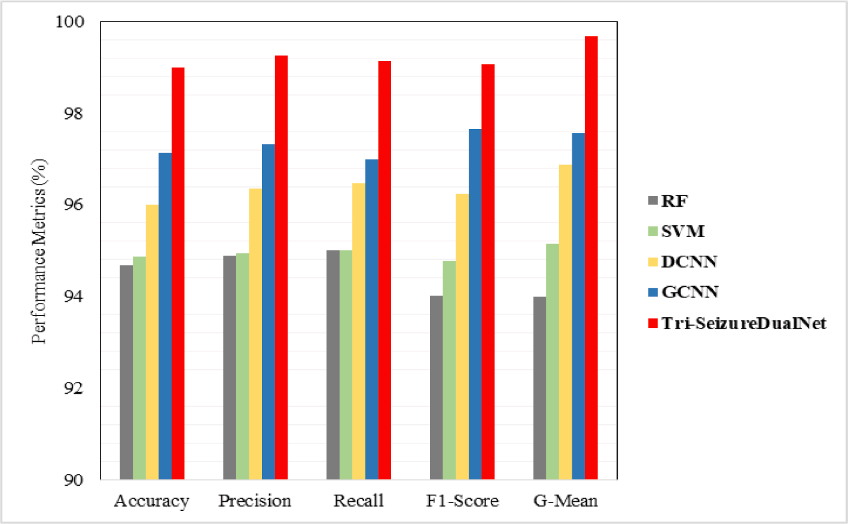



**Fig. 3a.** Performance of Proposed Model on CHB-MIT Database.

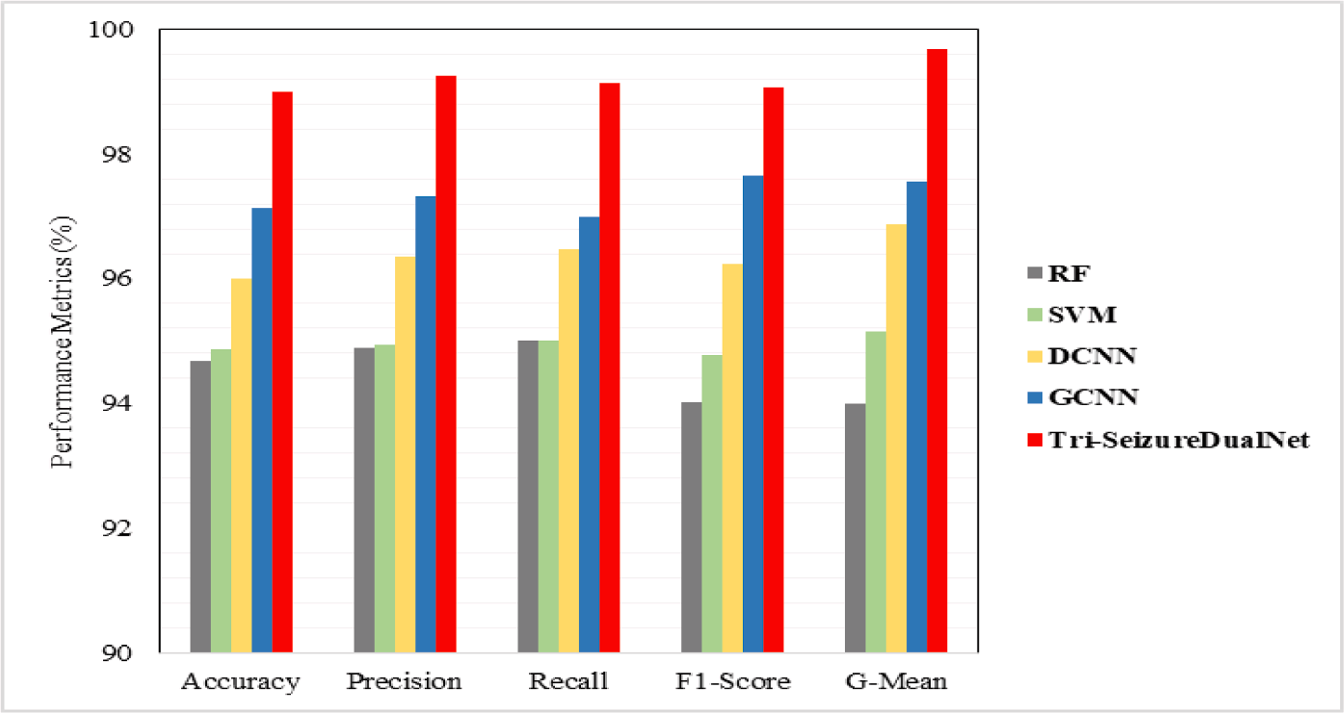

## Discussion

**Fig. 3b.** Performance of Proposed Model on UW Madison Database.

both the EEG and fMRI are provided to the HBO which selects optimal features based on the feature importance ratio. As a result, the features

This section describes the summary of the proposed Tri- SeizureDualNet model and its results. Intending the issues in the state- of-the-art models in brain seizure detection, we have proposed a novel seizure detection model. The utilized model composed of better feature extractors with skip connection, and dual parallel feature engineers respectively. More clearly, we have triple stream feature extractors whom performs spatial, temporal, and spectral feature extractors respectively in parallel. Given the dual inputs of EEG and fMRI to the triple stream feature extractors, we have extracted aforementioned features in parallel for the both the inputs. Note that, the layers in every feature extractor possess skip connections to overcome the problem of gradient issues. Beforehand, the problem in EEG and fMRI acquisition is vanished by performing pre-processing them separately. The extracted separated features of two modalities are provided to feature selection module. It is noted that, the spatial, spectral, and temporal features of

were fused in this module. The impact of HBO and its feature selection process is shown in Table 5. The fused features are then provisioned to the Dual Parallel Net module for feature engineering and context learning. There are two attention layers placed in parallel along with geometric gating mechanism to improve the capacity and efficacy of the transformer model. Finally, the softmax layer determines the features context into three classes. At last, the Table 4 represents comparative analysis of the proposed and existing works in terms of processes and results achieved.

The major limitation of this study is that, this research did not study the interpretability of the features more clearly. Although the important features are selected using HBO algorithm the feature interpretability in terms of their contribution towards the classification is not studied well. Furthermore, the data variability among the two datasets was not researched well. In addition to that, algorithm parameter optimization

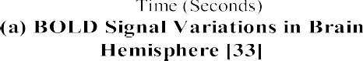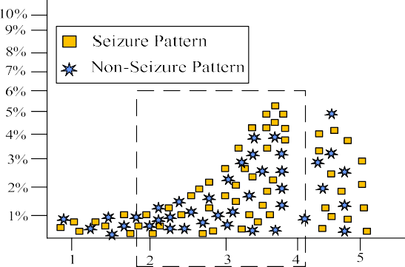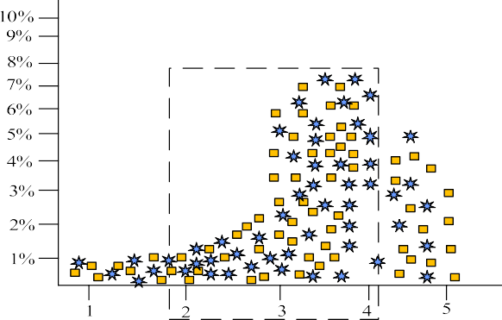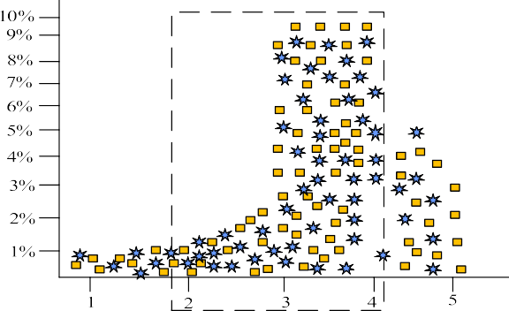Comparison of Accuracy and AUC among Proposed & Existing works.

|  |  |  |  |
| --- | --- | --- | --- |
| **Models EEG Window** | **Training Time** | **A (%)** | **AUC** |
| 6 s | 450.67 s | 85.77 % | 0.832 |
| 12 s | 430.12 s | 85.98 % | 0.839 |
| [22] 18 s | 400.11 s | 86.12 % | 0.841 |
| 24 s | 388.99 s | 86.77 % | 0.849 |
| 6 s | 429.33 s | 86.00 % | 0.847 |
| [23] 12 s | 417.89 s | 86.78 % | 0.856 |
| 18 s | 395.56 s | 87.17 % | 0.859 |
| 24 s | 380.02 s | 87.56 % | 0.862 |
| 6 s | 415.00 s | 86.18 % | 0.930 |
| [26] 12 s | 405.77 s | 87.64 % | 0.938 |
| 18 s | 385.10 s | 88.09 % | 0.941 |
| 24 s | 370.43 s | 88.39 % | 0.947 |
| 6 s | 467.97 s | 89.45 % | 0.942 |
| 12 s | 451.13 s | 89.99 % | 0.956 |
| [27] 18 s | 430.91 s | 90.17 % | 0.958 |
| 24 s | 427.01 s | 91.13 % | 0.961 |
| 6 s | 444.44 s | 85.63 % | 0.851 |
| [28] 12 s | 438.28 s | 84.23 % | 0.869 |
| 18 s | 409.91 s | 87.00 % | 0.870 |
| 24 s | 401.54 s | 89.00 % | 0.886 |
| 6 s | 347.17 s | 90.00 % | 0.971 |
| **Tri-SeizureDualNet 12 s** | **322.69 s** | **93.00 %** | **0.979** |
| **18 s** | **310.17 s** | **97.00 %** | **0.982** |
| **24 s** | **295.87 s** | **94.00 %** | **0.992** |

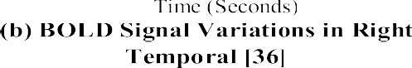

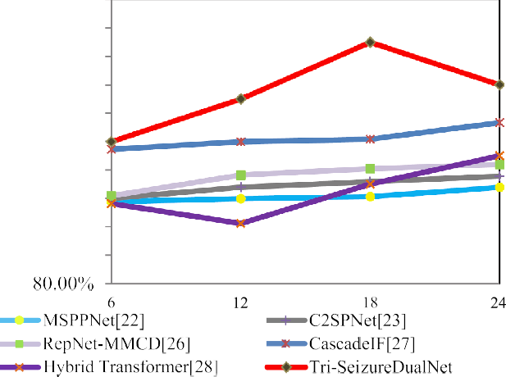

**Fig. 4a.** Accuracy Comparison of Different EEG Time Windows (6,12,18,24).

# 



   



**Fig. 4b.** AUC Comparison of Different EEG Time Windows (6,12,18, and 24).

**Fig. 5.** (a) BOLD Signal Variations on Brain Hemisphere [33], (b) BOLD Signal Variations in Right Temporal [38], and (c) BOLD Temporal Variations of Pro- posed Tri-SeizureDualNet.

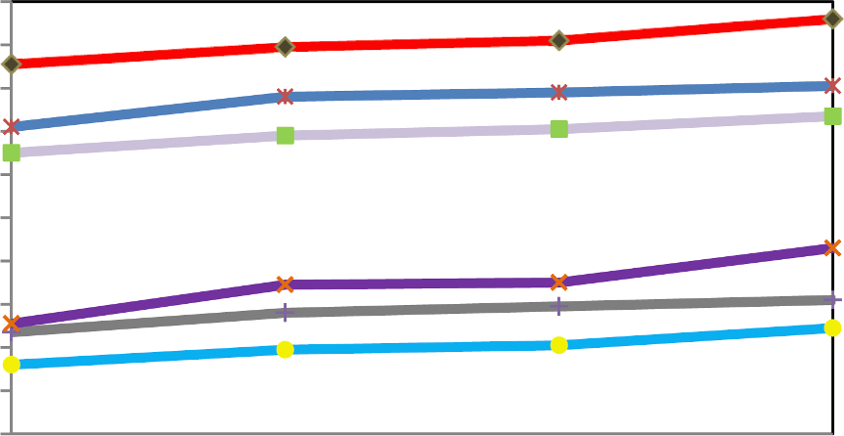and its sensitivity was not studied well which also affects the model performance towards seizure detection.

## Conclusion & future work

In this research, we design a novel seizure detection model with higher accuracy using EEG and fMRI modalities named Tri- SeizureDualNet. The adopted model resolves the feature contingency issues by triple stream skipped feature extractor, amplified complexity

**Table 4**

Comparison of Existing Works Vs Proposed Works.

**Selection**

|  |  |  |  |  |  |  |  |
| --- | --- | --- | --- | --- | --- | --- | --- |
| **Works** | **Dataset** | **Methods** |  |  |  | **A(%)** | **AUC** |
|  |  | **Pre-Processing** | **Feature Extraction &**  **Engineering** | **Feature** | **Classification** |  |  |
| Gao, Y et al [22] | CHB-MIT | – | CNN | – | Multi scale prototypical | 93 % | 0.933 |

Wu, D et al [23] CHB-MIT Unwanted channel removal

Residual and up sampling connections

part network

– Compression, Prediction, and Reconstruction network

92.65

%

0.924

Li, C et al [26] CHB-MIT & Kaggle

dataset

Sliding window analysis method

Three stage asymmetric stem blocks

– Lightweight

reparametrized network

90.10

%

0.948

Guo, Y et al [27] CHB-MIT dataset Fifth order Butterworth

filter

Discrete wavelet transforms – Adaboost classifier 95.65

%

0.943

Hu, S et al[28] CHB-MIT dataset Fifth order Butterworth

filter

Hybrid transformer with rhythm and position embedding

– Hybrid transformer with fully connected network

91.37

%

0.907

Kamboj b et al [33]

rs-fMRI from phoenix children hospital

Bandpass filtering &

ICA

DBSCAN and SMOTE based analysis

– SVM and Radial basis function

85.77

%

0.866

Nandakumar, N et al [36]

UW Madison Dataset CPAC pipeline with

bandpass filtering

Independent component analysis

– Graph convolutional network

88 % 0.756

Xu, R et al [38] Data acquired from

jinglin hospital

DPARSF toolbox

Attention based adaptive multichannel GCN

– Temporal convolutional module

82.68

%

0.879

Drenthen GS et al [40]

Dataset acquired from Maastricht University Medical

Centre

|  |  |  |  |  |  |  |
| --- | --- | --- | --- | --- | --- | --- |
| Tri- CHB-MIT & UW | ICA, PCA for EEG, and | Triple stream skipped feature | HBO | Attention based dual | 99.67 | 0.989 |
| SeizureDualNet Madison dataset | high pass filtering for | extractor with transformer- |  | parallel transformer | % |  |
|  | fMRI | based context learning |  | model |  |  |

Statistical parametric mapping

Pearson’s correlation coefficient

Statistical analysis-based selection

Logistic regression 80.09

%

0.692

Akbar M N et al [41]

Ebrahimzadeh E et al [42]

Both EEG & fMRI data collected from approved university Both the data acquired from nation brain mapping lab

Abnormal data segmentation

Artifacts removal from both EEG & fMRI

Imputation and principal component analysis

Independent component analysis

* Adaboost and SVM 79.89

%

* Generalized Linear Model 89.45

%

0.776

0.888

**Table 5**

Impact of HBO based Feature Selection on Seizure Detection Accuracy.

**Proposed Model Dataset Accuracy (%) AUC**

Tri-SeizureDualNet with HBO CHB-MIT 99.67 % 0.995

UW Madison 99.35 % 0.990

|  |  |  |  |
| --- | --- | --- | --- |
| Tri-SeizureDualNet without HBO | CHB-MIT | 94.00 % | 0.823 |
|  | UW Madison | 93.56 % | 0.800 |

issues by adopting HBO based feature selection and fusion, and resilient feature engineering by adopting DPAT model. Overall, our research work explicitly resolves the mentioned existing issues. The evaluation of proposed work is taken place using two datasets such as CHB-MIT dataset for EEG and UW Madison dataset for fMRI respectively. For EEG analysis, the proposed work achieves accuracy of 97 % in 18 s-time windows. For fMRI, the proposed work shows better metabolic BOLD variations of 10 % at the estimated time period. On the whole, the designed research provides better results for seizure detection.

In future the current study will be extended to networking point of view for enabling timely sharing of detection and prediction results. In addition to that, the security and privacy also ensured during seizure detection will be worth future study.

## 

## References

* + 1. [S. Lee, Y. Hung, Y. Chang, C.K. Lin, G. Shieh, RISC-V CNN Coprocessor for Real-](http://refhub.elsevier.com/S1746-8094(23)01026-1/h0005) [Time Epilepsy Detection in Wearable Application, IEEE Trans. Biomed. Circuits](http://refhub.elsevier.com/S1746-8094(23)01026-1/h0005) [Syst. 15 (2021) 679–691](http://refhub.elsevier.com/S1746-8094(23)01026-1/h0005).
    2. [R. Chengoden, N. Victor, T. Huynh-The, G. Yenduri, R.H. Jhaveri, M. Alazab,](http://refhub.elsevier.com/S1746-8094(23)01026-1/h0010)

[S. Bhattacharya, P. Hegde, P.K. Maddikunta, T.R. Gadekallu, Metaverse for](http://refhub.elsevier.com/S1746-8094(23)01026-1/h0010) [Healthcare: A Survey on Potential Applications, Challenges and Future Directions,](http://refhub.elsevier.com/S1746-8094(23)01026-1/h0010) [IEEE Access 11 (2022) 12764–12794](http://refhub.elsevier.com/S1746-8094(23)01026-1/h0010).

* + 1. [O. Uwishema, K.S. Frederiksen, I.F. Correia, A. Mahmoud, H. Onyeaka, B. Dost,](http://refhub.elsevier.com/S1746-8094(23)01026-1/h0015) [The impact of COVID-19 on patients with neurological disorders and their access to](http://refhub.elsevier.com/S1746-8094(23)01026-1/h0015) [healthcare in Africa: A review of the literature, Brain and Behavior 12 (2022)](http://refhub.elsevier.com/S1746-8094(23)01026-1/h0015).
    2. [D. Samanta, R.K. Singh, S. Gedela, M. Scott Perry, R. Arya, Underutilization of](http://refhub.elsevier.com/S1746-8094(23)01026-1/h0020) [epilepsy surgery: Part II: Strategies to overcome barriers, Epilepsy Behav. 117](http://refhub.elsevier.com/S1746-8094(23)01026-1/h0020) [(2021)](http://refhub.elsevier.com/S1746-8094(23)01026-1/h0020).
    3. [T. Ebrahimi, A. Tafakhori, H. Hashemi, M. Ali Oghabian, An interictal](http://refhub.elsevier.com/S1746-8094(23)01026-1/h0025) [measurement of cerebral oxygen extraction fraction in MRI-negative refractory](http://refhub.elsevier.com/S1746-8094(23)01026-1/h0025) [epilepsy using quantitative susceptibility mapping, Phys. Medica: PM: Int. J.](http://refhub.elsevier.com/S1746-8094(23)01026-1/h0025) [Devoted Appl. Phys. Med. Biol.: Off. J. Italian Assoc. Biomed. Phys. 85 (2021)](http://refhub.elsevier.com/S1746-8094(23)01026-1/h0025) [87–97](http://refhub.elsevier.com/S1746-8094(23)01026-1/h0025).
    4. [S.M. Zuberi, E.C. Wirrell, E.G. Yozawitz, J.M. Wilmshurst, N. Specchio, K. Riney, R.](http://refhub.elsevier.com/S1746-8094(23)01026-1/h0030)

[M. Pressler, S. Auvin, P. Samia, E. Hirsch, S. Galicchio, C. Triki, O.C. Snead,](http://refhub.elsevier.com/S1746-8094(23)01026-1/h0030)

[S. Wiebe, J.H. Cross, P. Tinuper, I.E. Scheffer, E. Perucca, S.L. Mosh´e, R. Nabbout,](http://refhub.elsevier.com/S1746-8094(23)01026-1/h0030) [ILAE classification and definition of epilepsy syndromes with onset in neonates and](http://refhub.elsevier.com/S1746-8094(23)01026-1/h0030) [infants: Position statement by the ILAE Task Force on Nosology and Definitions,](http://refhub.elsevier.com/S1746-8094(23)01026-1/h0030) [Epilepsia 63 (2022) 1349–1397](http://refhub.elsevier.com/S1746-8094(23)01026-1/h0030).

* + 1. [V.M. Golub, D.S. Reddy, Cannabidiol Therapy for Refractory Epilepsy and Seizure](http://refhub.elsevier.com/S1746-8094(23)01026-1/h0035) [Disorders, Adv. Exp. Med. Biol. 1264 (2020) 93–110](http://refhub.elsevier.com/S1746-8094(23)01026-1/h0035).
    2. [S.Y. Shah, H. Larijani, R.M. Gibson, D. Liarokapis, Random Neural Network Based](http://refhub.elsevier.com/S1746-8094(23)01026-1/h0040) [Epileptic Seizure Episode Detection Exploiting Electroencephalogram Signals,](http://refhub.elsevier.com/S1746-8094(23)01026-1/h0040) [Sensors (Basel, Switzerland) 22 (2022)](http://refhub.elsevier.com/S1746-8094(23)01026-1/h0040).
    3. Mary Judith, S. Baghavathi Priya, M. Rakesh Kumar, Artifact Removal from EEG signals using Regenerative Multi-Dimensional Singular Value Decomposition and Independent Component Analysis, Biomed. Signal Process. Control 74 (2022) 103452, ISSN 1746-8094, https://doi.org/10.1016/j.bspc.2021.103452.
    4. [P.K. Pothula, S. Marisetty, M. Rao, A Real-Time Seizure Classification System Using](http://refhub.elsevier.com/S1746-8094(23)01026-1/h0050) [Computer Vision Techniques, IEEE International Systems Conference (SysCon)](http://refhub.elsevier.com/S1746-8094(23)01026-1/h0050) [2022 (2022) 1–6](http://refhub.elsevier.com/S1746-8094(23)01026-1/h0050).
    5. Wang, Z.C., Nagy, Z., & Juhasz, Z. (2022). On the Benefits of Empirical Mode Decomposition in Spatio-temporal EEG Analysis. *2022 45th Jubilee International Convention on Information, Communication and Electronic Technology (MIPRO)*, 333- 338.
    6. [Z. Guo, F. Chen, Decoding Articulation Motor Imagery Using Early Connectivity](http://refhub.elsevier.com/S1746-8094(23)01026-1/h0060) [Information in the Motor Cortex: A Functional Near-Infrared Spectroscopy Study,](http://refhub.elsevier.com/S1746-8094(23)01026-1/h0060) [IEEE Trans. Neural Syst. Rehabil. Eng. 31 (2022) 506–518](http://refhub.elsevier.com/S1746-8094(23)01026-1/h0060).
    7. [F. Valenzuela, M. Rana, R. Sitaram, S. Uribe, A. Eblen-Zajjur, Non-Invasive](http://refhub.elsevier.com/S1746-8094(23)01026-1/h0065) [Functional Evaluation of the Human Spinal Cord by Assessing the Peri-Spinal](http://refhub.elsevier.com/S1746-8094(23)01026-1/h0065) [Neurovascular Network With Near Infrared Spectroscopy, IEEE Trans. Neural Syst.](http://refhub.elsevier.com/S1746-8094(23)01026-1/h0065) [Rehabil. Eng. 29 (2021) 2312–2321](http://refhub.elsevier.com/S1746-8094(23)01026-1/h0065).
    8. [D.X. Lioe, Y. Fukushi, M. Hakamata, M. Niwayama, K. Mars, K. Yasutomi,](http://refhub.elsevier.com/S1746-8094(23)01026-1/h0070)

[K. Kagawa, S. Yamamoto, S. Kawahito, A CMOS Lock-In Pixel Image Sensor With](http://refhub.elsevier.com/S1746-8094(23)01026-1/h0070) [Multisimultaneous Gate for Time-Resolved Near-Infrared Spectroscopy, IEEE](http://refhub.elsevier.com/S1746-8094(23)01026-1/h0070) [Trans. Electron Devices 70 (2023) 1102–1108](http://refhub.elsevier.com/S1746-8094(23)01026-1/h0070).

* + 1. [X. Gu, Z. Cao, A. Jolfaei, P. Xu, D. Wu, T. Jung, C. Lin, EEG-Based Brain-Computer](http://refhub.elsevier.com/S1746-8094(23)01026-1/h0075) [Interfaces (BCIs): A Survey of Recent Studies on Signal Sensing Technologies and](http://refhub.elsevier.com/S1746-8094(23)01026-1/h0075) [Computational Intelligence Approaches and Their Applications, IEEE/ACM Trans.](http://refhub.elsevier.com/S1746-8094(23)01026-1/h0075) [Comput. Biol. Bioinf. 18 (2020) 1645–1666](http://refhub.elsevier.com/S1746-8094(23)01026-1/h0075).
    2. A.A. Khan, D2PAM: epileptic seizures prediction using adversarial deep dual patch attention mechanism, CAAI Trans. Intell. Technol. 1–15 (2023), [https://doi.org/](https://doi.org/10.1049/cit2.12261) [10.1049/cit2.12261](https://doi.org/10.1049/cit2.12261).
    3. [A. Shoeibi, N. Ghassemi, M. Khodatars, M. Jafari, S. Hussain, R. Alizadehsani,](http://refhub.elsevier.com/S1746-8094(23)01026-1/h0085)

[P. Moridian, A. Khosravi, H. Hosseini-Nejad, M. Rouhani, A. Zare, A. Khadem,](http://refhub.elsevier.com/S1746-8094(23)01026-1/h0085)

[S. Nahavandi, A.F. Atiya, U.R. Acharya, Epileptic Seizures Detection Using Deep](http://refhub.elsevier.com/S1746-8094(23)01026-1/h0085) [Learning Techniques: A Review, Int. J. Environ. Res. Public Health 18 (2020)](http://refhub.elsevier.com/S1746-8094(23)01026-1/h0085).

* + 1. [R. Manjupriya, A.A. Leema, Survey on Effective Deep Learning-based Automated](http://refhub.elsevier.com/S1746-8094(23)01026-1/h0090) [Epileptic Seizure Detection, International Conference on Augmented Intelligence](http://refhub.elsevier.com/S1746-8094(23)01026-1/h0090) [and Sustainable Systems (ICAISS) 2022 (2022) 387–393](http://refhub.elsevier.com/S1746-8094(23)01026-1/h0090).
    2. [M.S. Nafea, Z.H. Ismail, Supervised Machine Learning and Deep Learning](http://refhub.elsevier.com/S1746-8094(23)01026-1/h0095) [Techniques for Epileptic Seizure Recognition Using EEG Signals—A Systematic](http://refhub.elsevier.com/S1746-8094(23)01026-1/h0095) [Literature Review, Bioengineering 9 (2022)](http://refhub.elsevier.com/S1746-8094(23)01026-1/h0095).
    3. [B. Olmi, L. Frassineti, A. Lanat`a, C. Manfredi, Automatic Detection of Epileptic](http://refhub.elsevier.com/S1746-8094(23)01026-1/h0100) [Seizures in Neonatal Intensive Care Units Through EEG, ECG and Video](http://refhub.elsevier.com/S1746-8094(23)01026-1/h0100) [Recordings: A Survey, IEEE Access 9 (2021) 138174–138191](http://refhub.elsevier.com/S1746-8094(23)01026-1/h0100).
    4. [M. Rashed-Al-Mahfuz, M.A. Moni, S. Uddin, S.A. Alyami, M.A. Summers, V. Eapen,](http://refhub.elsevier.com/S1746-8094(23)01026-1/h0105) [A Deep Convolutional Neural Network Method to Detect Seizures and](http://refhub.elsevier.com/S1746-8094(23)01026-1/h0105) [Characteristic Frequencies Using Epileptic Electroencephalogram (EEG) Data, IEEE](http://refhub.elsevier.com/S1746-8094(23)01026-1/h0105) [Journal of Translational Engineering in Health and Medicine 9 (2021) 1–12](http://refhub.elsevier.com/S1746-8094(23)01026-1/h0105).
    5. [Y. Gao, A. Liu, L. Wang, R. Qian, X. Chen, A Self-Interpretable Deep Learning](http://refhub.elsevier.com/S1746-8094(23)01026-1/h0110) [Model for Seizure Prediction Using a Multi-Scale Prototypical Part Network, IEEE](http://refhub.elsevier.com/S1746-8094(23)01026-1/h0110) [Trans. Neural Syst. Rehabil. Eng. 31 (2023) 1847–1856](http://refhub.elsevier.com/S1746-8094(23)01026-1/h0110).
    6. [D. Wu, Y. Shi, Z. Wang, J. Yang, M. Sawan, C2SP-Net: Joint Compression and](http://refhub.elsevier.com/S1746-8094(23)01026-1/h0115) [Classification Network for Epilepsy Seizure Prediction, IEEE Trans. Neural Syst.](http://refhub.elsevier.com/S1746-8094(23)01026-1/h0115) [Rehabil. Eng. 31 (2021) 841–850](http://refhub.elsevier.com/S1746-8094(23)01026-1/h0115).
    7. [X. Wang, C. Zhang, T.J. Ka¨rkk¨ainen, Z. Chang, F. Cong, Channel Increment](http://refhub.elsevier.com/S1746-8094(23)01026-1/h0120)

[Strategy-Based 1D Convolutional Neural Networks for Seizure Prediction Using](http://refhub.elsevier.com/S1746-8094(23)01026-1/h0120) [Intracranial EEG, IEEE Trans. Neural Syst. Rehabil. Eng. 31 (2022) 316–325](http://refhub.elsevier.com/S1746-8094(23)01026-1/h0120).

* + 1. [X. Cui, J. Cao, X. Lai, T. Jiang, F. Gao, Cluster Embedding Joint-Probability-](http://refhub.elsevier.com/S1746-8094(23)01026-1/h0125) [Discrepancy Transfer for Cross-Subject Seizure Detection, IEEE Trans. Neural Syst.](http://refhub.elsevier.com/S1746-8094(23)01026-1/h0125) [Rehabil. Eng. 31 (2022) 593–605](http://refhub.elsevier.com/S1746-8094(23)01026-1/h0125).
    2. [C. Li, Z. Deng, R. Song, X. Liu, R. Qian, X. Chen, EEG-Based Seizure Prediction via](http://refhub.elsevier.com/S1746-8094(23)01026-1/h0130) [Model Uncertainty Learning, IEEE Trans. Neural Syst. Rehabil. Eng. 31 (2022)](http://refhub.elsevier.com/S1746-8094(23)01026-1/h0130) [180–191](http://refhub.elsevier.com/S1746-8094(23)01026-1/h0130).
    3. [Y. Guo, X. Jiangb, L. Tao, L. Mengc, C. Dai, X. Long, F. Wan, Y. Zhang, J.P. van](http://refhub.elsevier.com/S1746-8094(23)01026-1/h0135) [Dijk, R.M. Aarts, W. Chen, C. Chen, Epileptic Seizure Detection by Cascading](http://refhub.elsevier.com/S1746-8094(23)01026-1/h0135) [Isolation Forest-Based Anomaly Screening and EasyEnsemble, IEEE Trans. Neural](http://refhub.elsevier.com/S1746-8094(23)01026-1/h0135) [Syst. Rehabil. Eng. 30 (2022) 915–924](http://refhub.elsevier.com/S1746-8094(23)01026-1/h0135).
    4. [S. Hu, J. Liu, R. Yang, Y. Wang, A. Wang, K. Li, W. Liu, C. Yang, Exploring the](http://refhub.elsevier.com/S1746-8094(23)01026-1/h0140) [Applicability of Transfer Learning and Feature Engineering in Epilepsy Prediction](http://refhub.elsevier.com/S1746-8094(23)01026-1/h0140)

[Using Hybrid Transformer Model, IEEE Trans. Neural Syst. Rehabil. Eng. 31 (2023)](http://refhub.elsevier.com/S1746-8094(23)01026-1/h0140) [1321–1332](http://refhub.elsevier.com/S1746-8094(23)01026-1/h0140).

* + 1. [Z. Liu, B. Zhu, M. Hu, Z. Deng, J. Zhang, Revised Tunable Q-Factor Wavelet](http://refhub.elsevier.com/S1746-8094(23)01026-1/h0145) [Transform for EEG-Based Epileptic Seizure Detection, IEEE Trans. Neural Syst.](http://refhub.elsevier.com/S1746-8094(23)01026-1/h0145) [Rehabil. Eng. 31 (2023) 1707–1720](http://refhub.elsevier.com/S1746-8094(23)01026-1/h0145).
    2. Malekzadeh, A., Zare, A., Yaghoobi, M., Kobravi, H.R., & Alizadehsani, R. (2021). Epileptic Seizures Detection in EEG Signals Using Fusion Handcrafted and Deep Learning Features. *Sensors (Basel, Switzerland), 21*.
    3. [T. Liu, M.Z. Shah, X. Yan, D. Yang, Unsupervised Feature Representation Based on](http://refhub.elsevier.com/S1746-8094(23)01026-1/h0155) [Deep Boltzmann Machine for Seizure Detection, IEEE Trans. Neural Syst. Rehabil.](http://refhub.elsevier.com/S1746-8094(23)01026-1/h0155) [Eng. 31 (2023) 1624–1634](http://refhub.elsevier.com/S1746-8094(23)01026-1/h0155).
    4. [Y. Yang, R.A. Sarkis, R.E. Atrache, T. Loddenkemper, C. Meisel, Video-Based](http://refhub.elsevier.com/S1746-8094(23)01026-1/h0160) [Detection of Generalized Tonic-Clonic Seizures Using Deep Learning, IEEE J.](http://refhub.elsevier.com/S1746-8094(23)01026-1/h0160) [Biomed. Health Inform. 25 (2021) 2997–3008](http://refhub.elsevier.com/S1746-8094(23)01026-1/h0160).
    5. Kamboj, P., Banerjee, A., Gupta, S.K., & Boerwinkle, V.L. (2023). Merging Deep Learning with Expert Knowledge for Seizure Onset Zone localization from rs-fMRI in Pediatric Pharmaco Resistant Epilepsy. *ArXiv, abs/2306.05572*.
    6. Fu, X., Wang, Y., Belkacem, A.N., Zhang, Q., Xie, C., Cao, Y., Cheng, H., & Chen, S. (2021). Integrating Optimized Multiscale Entropy Model with Machine Learning for the Localization of Epileptogenic Hemisphere in Temporal Lobe Epilepsy Using Resting-State fMRI. *Journal of Healthcare Engineering, 2021*.
    7. [D. Fischer, O. Rapalino, M. Fecchio, B.L. Edlow, Ictal fMRI: Mapping Seizure](http://refhub.elsevier.com/S1746-8094(23)01026-1/h0175) [Topography with Rhythmic BOLD Oscillations, Brain Sci. 12 (2022)](http://refhub.elsevier.com/S1746-8094(23)01026-1/h0175).
    8. [N. Nandakumar, D. Hsu, R. Ahmed, A. Venkataraman, DeepEZ: A Graph](http://refhub.elsevier.com/S1746-8094(23)01026-1/h0180) [Convolutional Network for Automated Epileptogenic Zone Localization From](http://refhub.elsevier.com/S1746-8094(23)01026-1/h0180) [Resting-State fMRI Connectivity, I.E.E.E. Trans. Biomed. Eng. 70 (2022) 216–227](http://refhub.elsevier.com/S1746-8094(23)01026-1/h0180).
    9. [M. Kassinopoulos, R.M. Harper, M. Guye, L. Lemieux, B. Diehl, Altered](http://refhub.elsevier.com/S1746-8094(23)01026-1/h0185) [Relationship Between Heart Rate Variability and fMRI-Based Functional](http://refhub.elsevier.com/S1746-8094(23)01026-1/h0185) [Connectivity in People With Epilepsy, Front. Neurol. 12 (2021)](http://refhub.elsevier.com/S1746-8094(23)01026-1/h0185).
    10. [R. Xu, Q. Zhu, S. Li, Z. Hou, W. Shao, D. Zhang, MSTGC: Multi-Channel Spatio-](http://refhub.elsevier.com/S1746-8094(23)01026-1/h0190) [Temporal Graph Convolution Network for Multi-Modal Brain Networks Fusion,](http://refhub.elsevier.com/S1746-8094(23)01026-1/h0190) [IEEE Trans. Neural Syst. Rehabil. Eng. 31 (2023) 2359–2369](http://refhub.elsevier.com/S1746-8094(23)01026-1/h0190).
    11. [J. Wang, B. Jing, R. Liu, D. Li, W. Wang, J. Wang, J. Lei, Y. Xing, J. Yan, H.H. Loh,](http://refhub.elsevier.com/S1746-8094(23)01026-1/h0195)

[G. Lu, X. Yang, Characterizing the seizure onset zone and epileptic network using](http://refhub.elsevier.com/S1746-8094(23)01026-1/h0195) [EEG-fMRI in a rat seizure model, Neuroimage 237 (2021)](http://refhub.elsevier.com/S1746-8094(23)01026-1/h0195).

* + 1. [G.S. Drenthen, J.F. Jansen, E.D. Gommer, L. Gupta, P.A. Hofman, V.H. van Kranen-](http://refhub.elsevier.com/S1746-8094(23)01026-1/h0200) [Mastenbroek, D.M. Hilkman, M.C. Vlooswijk, R.P. Rouhl, W.H. Backes, Predictive](http://refhub.elsevier.com/S1746-8094(23)01026-1/h0200) [value of functional MRI and EEG in epilepsy diagnosis after a first seizure, Epilepsy](http://refhub.elsevier.com/S1746-8094(23)01026-1/h0200) [Behav. 115 (2020)](http://refhub.elsevier.com/S1746-8094(23)01026-1/h0200).
    2. Akbar, M.N., Ruf, S.F., Singh, A., Faghihpirayesh, R., Garner, R., Bennett, A., Alba, C., Imbiriba, T., La Rocca, M., Erdog˘mus¸, D., & Duncan, D. (2022). Post Traumatic Seizure Classification with Missing Data using Multimodal Machine Learning on dMRI, EEG, and fMRI. *medRxiv*.
    3. [E. Ebrahimzadeh, M. Shams, A. Rahimpour Jounghani, F. Fayaz, M. Mirbagheri,](http://refhub.elsevier.com/S1746-8094(23)01026-1/h0210)

[N. Hakimi, L. Rajabion, H. Soltanian-Zadeh, Localizing confined epileptic foci in](http://refhub.elsevier.com/S1746-8094(23)01026-1/h0210) [patients with an unclear focus or presumed multifocality using a component-based](http://refhub.elsevier.com/S1746-8094(23)01026-1/h0210) [EEG-fMRI method, Cogn. Neurodyn. (2020) 1–16](http://refhub.elsevier.com/S1746-8094(23)01026-1/h0210).

* + 1. [Y. Li, T. Zhang, J. Feng, S. Qian, S. Wu, R. Zhou, J. Wang, G. Sa, X. Wang, L. Li,](http://refhub.elsevier.com/S1746-8094(23)01026-1/h0215)

[F. Chen, H. Yang, H. Zhang, M. Tian, Processing speed dysfunction is associated](http://refhub.elsevier.com/S1746-8094(23)01026-1/h0215) [with functional corticostriatal circuit alterations in childhood epilepsy with](http://refhub.elsevier.com/S1746-8094(23)01026-1/h0215) [centrotemporal spikes: a PET and fMRI study, Eur. J. Nucl. Med. Mol. Imaging 49](http://refhub.elsevier.com/S1746-8094(23)01026-1/h0215) [(2022) 3186–3196](http://refhub.elsevier.com/S1746-8094(23)01026-1/h0215).

* + 1. [D. Chatzistefanidis, D. Huang, M. Dümpelmann, J. Jacobs, A. Schulze-Bonhage,](http://refhub.elsevier.com/S1746-8094(23)01026-1/h0220)

[P. LeVan, Topography-Related EEG-fMRI in Surgically Confirmed Epileptic Foci: A](http://refhub.elsevier.com/S1746-8094(23)01026-1/h0220) [Comparison to Spike-Related EEG-fMRI in Clinical Practice, Brain Topogr. 34](http://refhub.elsevier.com/S1746-8094(23)01026-1/h0220) [(2021) 373–383](http://refhub.elsevier.com/S1746-8094(23)01026-1/h0220).

* + 1. Mohammad, F., & Al-Ahmadi, S.A. Epileptic Seizures Diagnosis Using Amalgamated Extremely Focused EEG Signals and Brain MRI. *Computers, Materials &* *Continua*.
    2. [S. Lu, Z. Zhu, J.M. Go´rriz, S. Wang, Y. Zhang, NAGNN: Classification of COVID-19](http://refhub.elsevier.com/S1746-8094(23)01026-1/h0230) [based on neighboring aware representation from deep graph neural network, Int. J.](http://refhub.elsevier.com/S1746-8094(23)01026-1/h0230) [Intell. Syst. 37 (2021) 1572–1598](http://refhub.elsevier.com/S1746-8094(23)01026-1/h0230).
    3. [Y. Zhang, L. Deng, H. Zhu, W. Wang, Z. Ren, Q. Zhou, S. Lu, S. Sun, Z. Zhu, J.](http://refhub.elsevier.com/S1746-8094(23)01026-1/h0235)

[M. Go´rriz, S. Wang, Deep learning in food category recognition, Inf. Fusion 98](http://refhub.elsevier.com/S1746-8094(23)01026-1/h0235) [(2023), 101859](http://refhub.elsevier.com/S1746-8094(23)01026-1/h0235).

* + 1. [S. Lu, S. Wang, Y. Zhang, Detection of abnormal brain in MRI via improved AlexNet](http://refhub.elsevier.com/S1746-8094(23)01026-1/h0240) [and ELM optimized by chaotic bat algorithm, Neural Comput. & Applic. (2020)](http://refhub.elsevier.com/S1746-8094(23)01026-1/h0240) [1–13](http://refhub.elsevier.com/S1746-8094(23)01026-1/h0240).