同济大学计算机系

数字逻辑课程实验报告



学 号 2351520
姓 名 毛星博
专 业 计算机科学与技术
授课老师 张冬冬

6.9 行为级 ALU 实验

一、实验内容

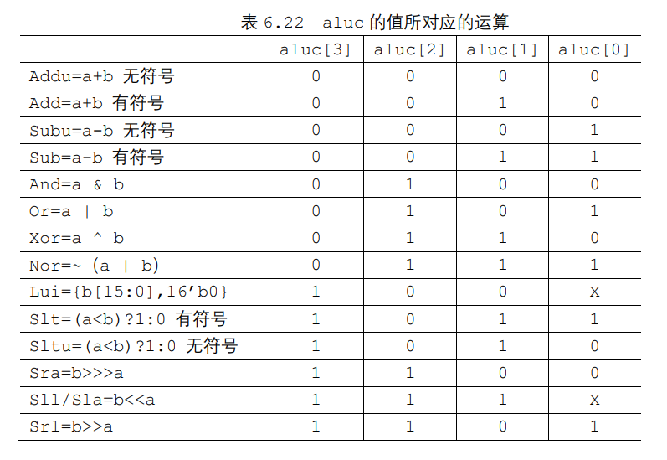

二、模块建模
module alu(input [31:0] a, //32 位输入，操作数 1input [31:0] b, //32 位输入，操作数 2input [3:0] aluc, //4 位输入，控制 alu 的操作output reg [31:0] r, //32 位输出，由 a、b 经过 aluc 指定的操作生成output reg zero, //0 标志位output reg carry, // 进位标志位output reg negative, // 负数标志位output reg overflow // 溢出标志位);integer i;always @*begin if(aluc == 4'b0000) begin r = a+b; if(r == 0) zero = 1; else zero = 0; if(((a[31]==1||b[31]==1)&&r[31]==0)||(a[31]==1&&b[31]==1)) carry = 1; else carry = 0; if (r[31] == 1) negative = 1; else negative = 0; end else if(aluc==4'b0010) begin r = a + b; if (r == 0) zero = 1; else zero = 0; if (r[31] == 1) negative = 1; else negative = 0; if(r[31]!=a[31] && r[31]!=b[31]) overflow=1; else overflow=0; end else if(aluc==4'b0001) begin r = a - b; if (r == 0) zero = 1; else zero = 0; if (a < b) carry = 1; else carry = 0; if (r[31] == 1) negative = 1; else negative = 0; end else if(aluc==4'b0011) begin r = a - b; if (r == 0) zero = 1; else zero = 0; if (r[31] == 1) negative = 1; else negative = 0; if (r[31]!=a[31]&&r[31]==b[31]) overflow=1; else overflow = 0; end else if(aluc==4'b0100) begin r = a & b; if (r == 0) zero = 1; else zero = 0; if (r[31] == 1) negative = 1; else negative = 0; end else if(aluc==4'b0101) begin r = a | b; if (r == 0) zero = 1; else zero = 0; if (r[31] == 1) negative = 1; else negative = 0; end else if(aluc==4'b0110) begin r = a ^ b; if (r == 0) zero = 1; else zero = 0; if (r[31] == 1) negative = 1; else negative = 0; end else if(aluc==4'b0111) begin r = ~(a | b); if (r == 0) zero = 1; else zero = 0; if (r[31] == 1) negative = 1; else negative = 0; end else if(aluc==4'b1000||aluc==4'b1001) begin r = {b[15:0], 16'b0}; if(r==0) zero=1; else zero=0; if(r[31]==1) negative=1; else negative=0; end else if(aluc==4'b1011) begin if ($signed (a) < $signed(b)) r = 1; else r=0; if (a == b) zero = 1; else zero = 0; if($signed (a)<$signed(b)) negative = 1; else negative = 0; end else if(aluc==4'b1010) begin r = (a < b) ? 1 : 0; if (a == b) zero = 1; else zero = 0; if (r[31]==1) negative = 1; else negative = 0; if(a<b) carry=1; else carry=0; end else if(aluc==4'b1100) begin if(a!=0) carry=b[a-1]; else carry=0; if (b[31] == 1) begin r= b >> a; for (i = 0; i < a; i = i + 1) r[31 - i] = 1; end else begin r = b >> a; for (i = 0; i < a; i = i + 1) r[31 - i] = 0; end if (r == 0) zero = 1; else zero = 0; if (r[31] == 1) negative = 1; else negative = 0; end else if(aluc==4'b1110||aluc==4'b1111) begin if(a==0) carry=0; else carry = b[32-a]; r = b << a; if (r == 0) zero = 1; else zero = 0; if (r[31] == 1) negative = 1; else negative = 0; end else if(aluc==4'b1101) begin if(a!=0) carry=b[a-1]; else carry=0; r = b >> a; for (i = 0; i < a; i = i + 1) r[31 - i] = 0; if (r == 0) zero = 1; else zero = 0; if (r[31] == 1) negative = 1; else negative = 0; endendendmodule

三、测试模块建模
module alu_tb(); reg [31:0] a; reg [31:0] b; reg [3:0] aluc; wire [31:0] r; wire zero, carry, negative, overflow; alu uut(a,b,aluc,r,zero, carry, negative, overflow); integer i = 0; parameter aluc_max = 16; initial begin a = 32'h8fa1_6b42; b = 32'hba18_5e29; aluc = 0; for (i = 1; i < aluc_max; i = i + 1) begin if (i == 15 || i == 14 || i == 13) a = 4; else a = 32'h8fa1_6b42; #30 aluc = i; end end endmodule

四、实验结果
（该部分可截图说明，要求logisim逻辑验证图、modelsim仿真波形图、以及下板后的实验结果贴图（实验步骤中没有下板要求的实验，不需要下板贴图））
Modelsim仿真波形图：

经验证，逻辑无误。

