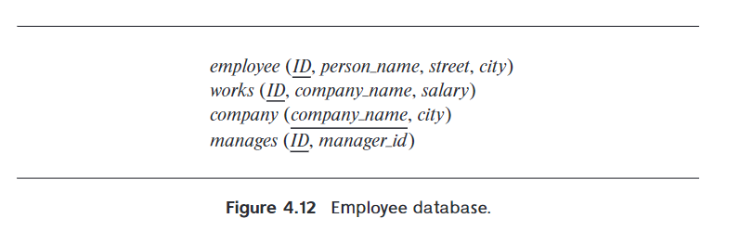
4.7 Consider the employee database of Figure 4.12. Give an SQL DDL definition
of this database. Identify referential-integrity constraints that should hold, and
include them in the DDL definition.

-- 雇员表
create table employee (
ID varchar(10) primary key,
person_name varchar(50) not null,
street varchar(100),
city varchar(50)
);
-- 公司表
create table company (
company_name varchar(100) primary key,
city varchar(50)
);
-- 员工表
create table works (
ID varchar(10) primary key,
company_name varchar(100),
salary decimal(10,2)
foreign key(ID) reference employee(ID)
on delete cascade
on update cascade;
foreign key(company_name) reference company(company_name)
on delete cascade
on update cascade;
);
-- 经理表
create table manages (
ID varchar(10) primary key,
manager_id varchar(10),
foreign key(ID) reference employee(ID)
on delete cascade
on update cascade;
);

4.16 Write an SQL query using the university schema to find the ID of each student
who has never taken a course at the university. Do this using no subqueries and
no set operations (use an outer join)

-- 筛选出没选择选修课的学生ID
select student.ID
from student left outer join takes
on student.ID = takes.ID
where takes.course_id is null;

