单条指令数据通路图
R型指令
1 ADD
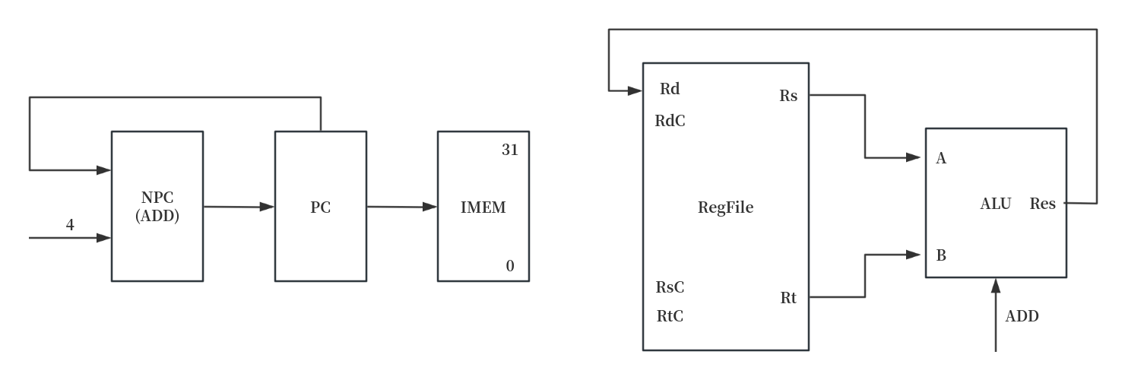
PC -> IMEM
PC + 4 -> NPC
NPC -> PC
Rs -> A
Rt -> B
(A + B -> Res)
Res -> Rd

2 ADDU
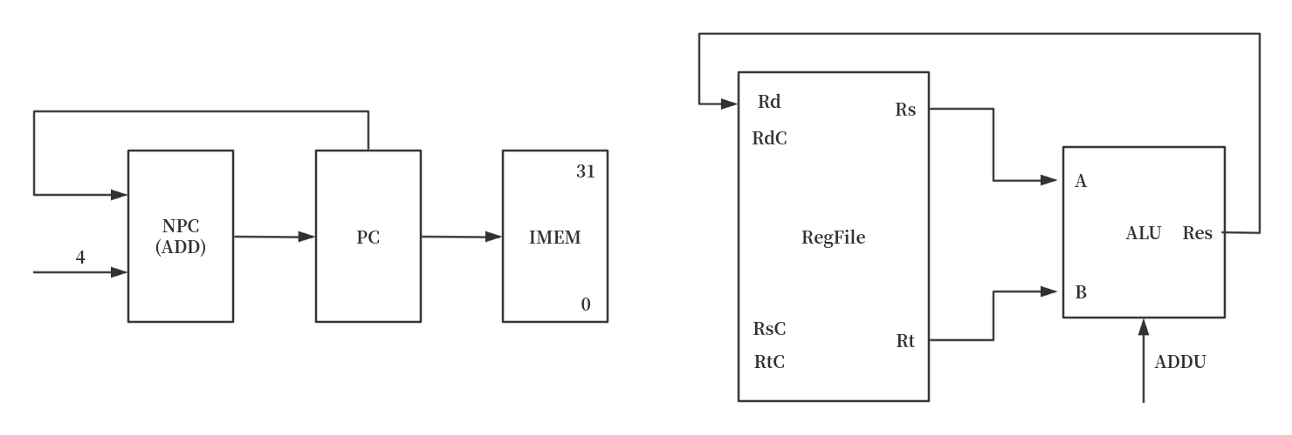
PC -> IMEM
PC + 4 -> NPC
NPC -> PC
Rs -> A
Rt -> B
(A + B -> Res)
Res -> Rd

3 SUB
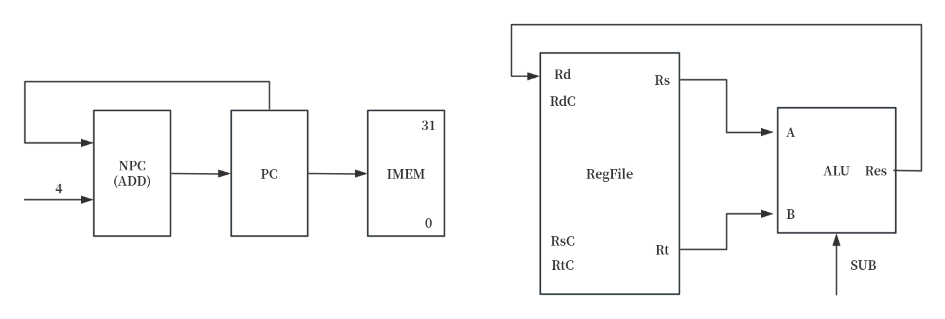
PC -> IMEM
PC + 4 -> NPC
NPC -> PC
Rs -> A
Rt -> B
(A - B -> Res)
Res -> Rd

4 SUBU
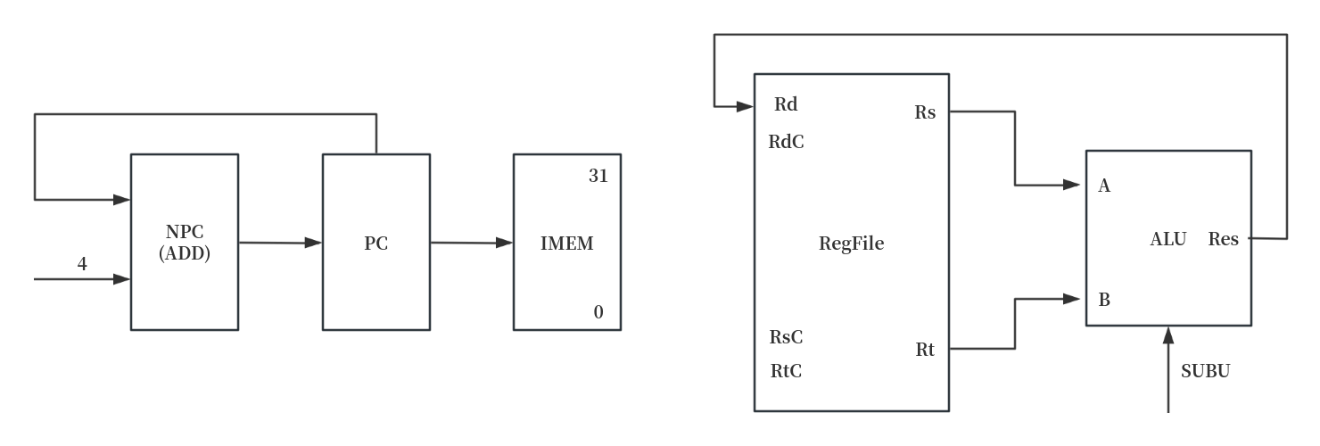
PC -> IMEM
PC + 4 -> NPC
NPC -> PC
Rs -> A
Rt -> B
(A - B -> Res)
Res -> Rd

5 AND
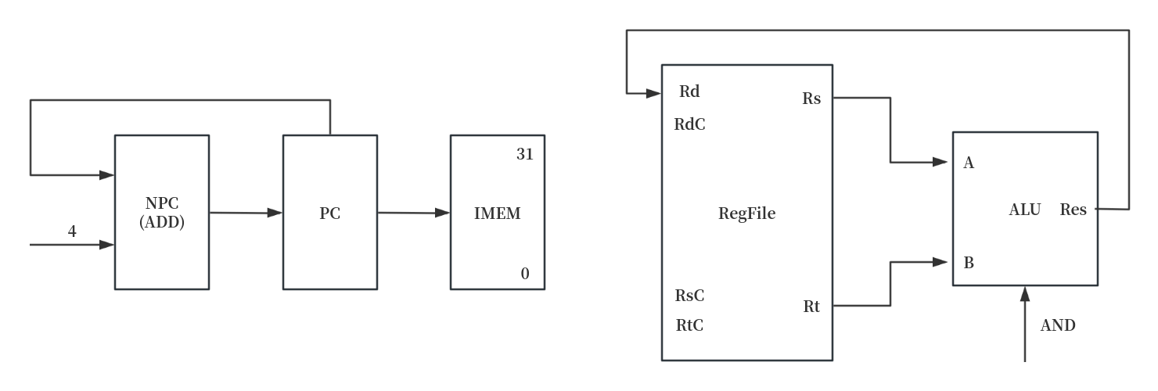
PC -> IMEM
PC + 4 -> NPC
NPC -> PC
Rs -> A
Rt -> B
(A & B -> Res)
Res -> Rd

6 OR
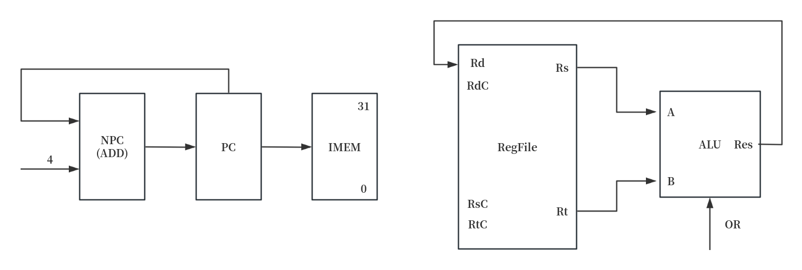
PC -> IMEM
PC + 4 -> NPC
NPC -> PC
Rs -> A
Rt -> B
(A | B -> Res)
Res -> Rd

7 XOR
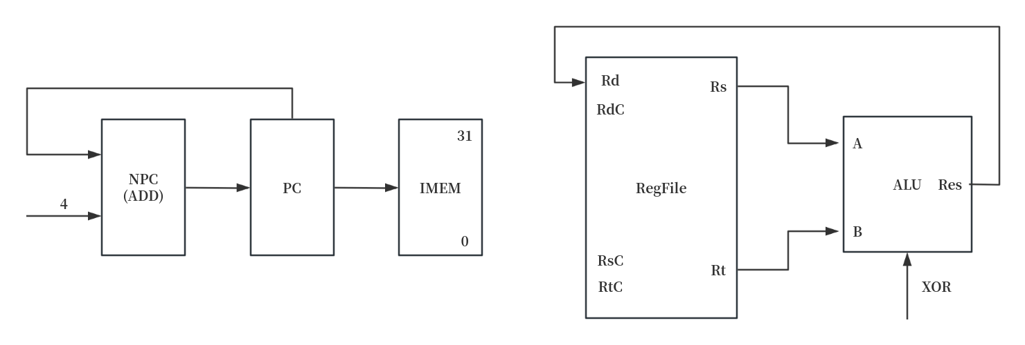
PC -> IMEM
PC + 4 -> NPC
NPC -> PC
Rs -> A
Rt -> B
(A ⊕ B -> Res)
Res -> Rd

8 NOR
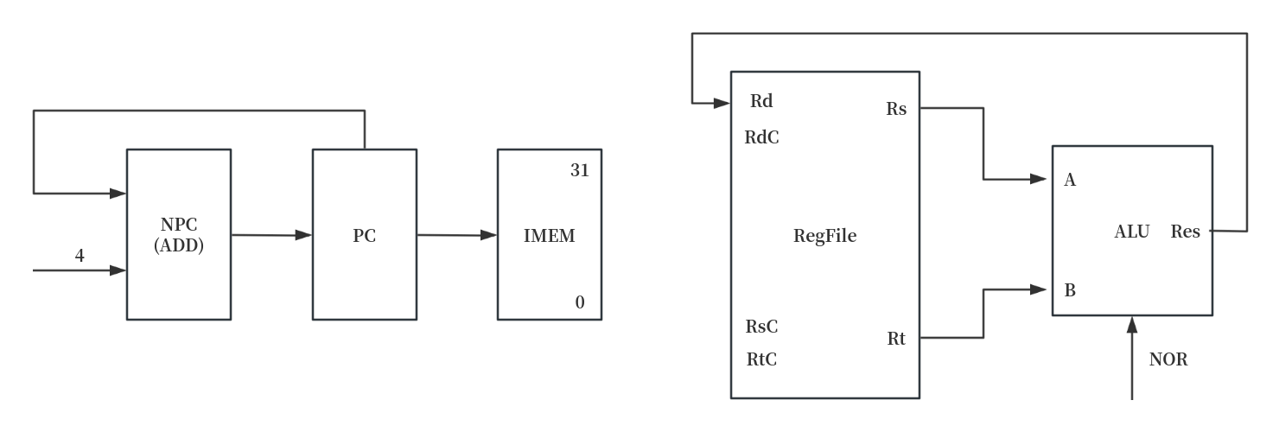
PC -> IMEM
PC + 4 -> NPC
NPC -> PC
Rs -> A
Rt -> B
(A ⊙ B -> Res)
Res -> Rd

9 SLT
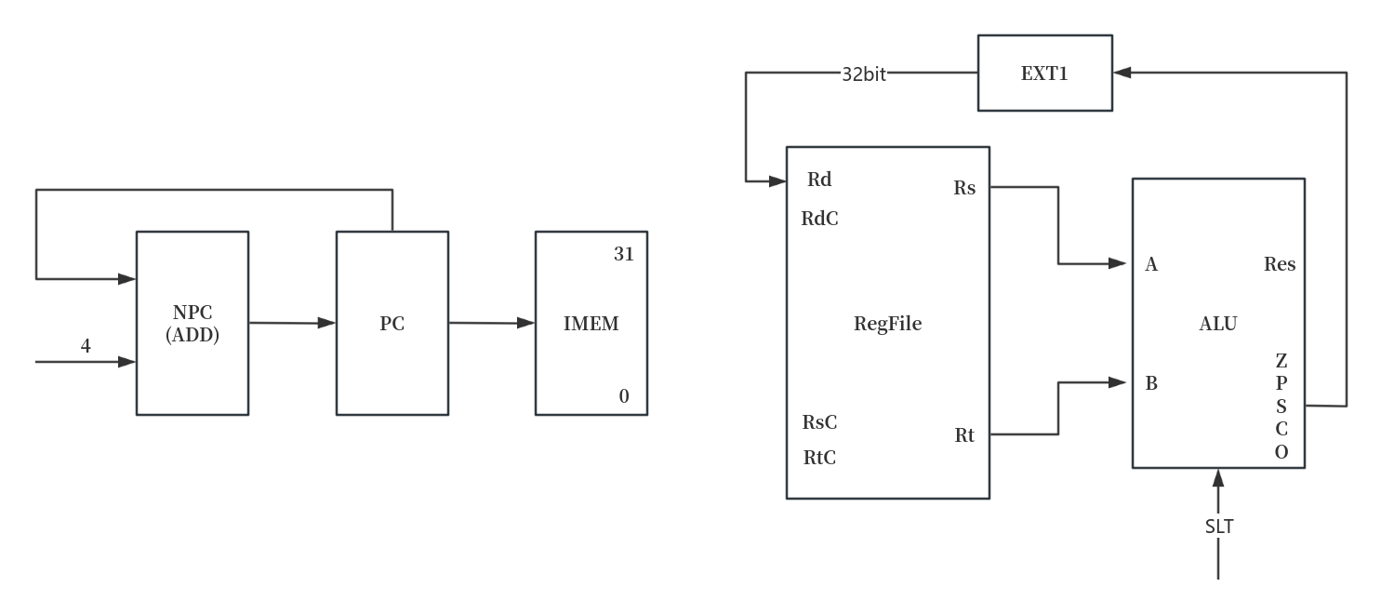
PC -> IMEM
PC + 4 -> NPC
NPC -> PC
Rs -> A
Rt -> B
(A - B -> Res)
SF -> EXT1
EXT1 -> Rd

10 SLTU
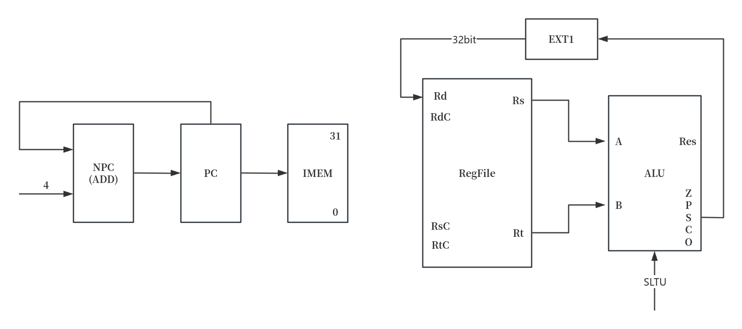
PC -> IMEM
PC + 4 -> NPC
NPC -> PC
Rs -> A
Rt -> B
(A - B -> Res)
SF -> EXT1
EXT1 -> Rd

11 SLL
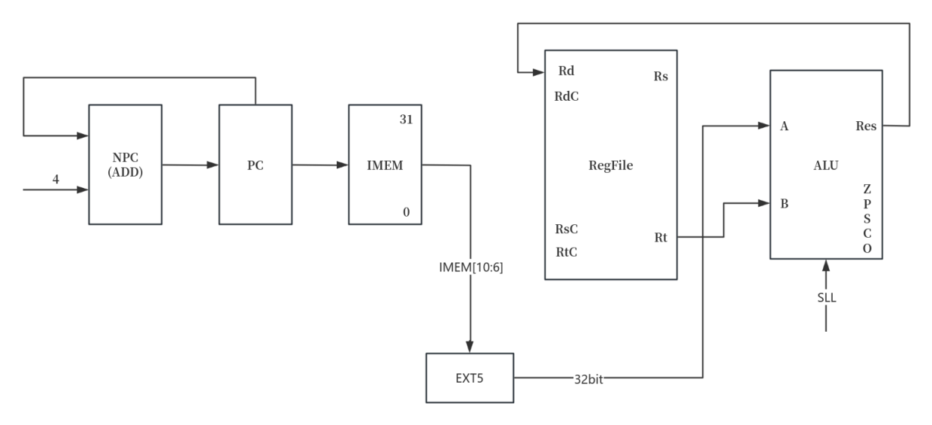
PC -> IMEM
PC + 4 -> NPC
NPC -> PC
IMEM[10:6] -> EXT5
EXT5 -> A
Rt -> B
(B << A -> Res)
Res -> Rd

12 SRL
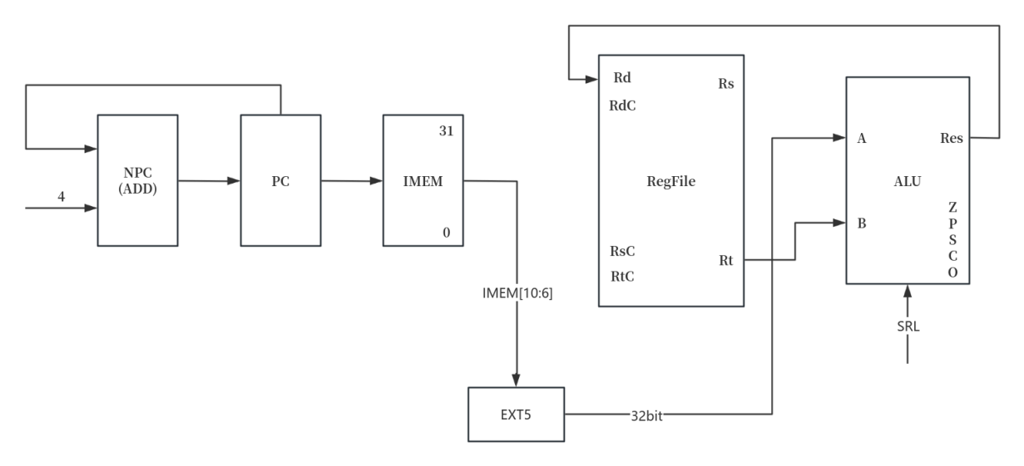
PC -> IMEM
PC + 4 -> NPC
NPC -> PC
IMEM[10:6] -> EXT5
EXT5 -> A
Rt -> B
(B >>> A -> Res)
Res -> Rd

13 SRA
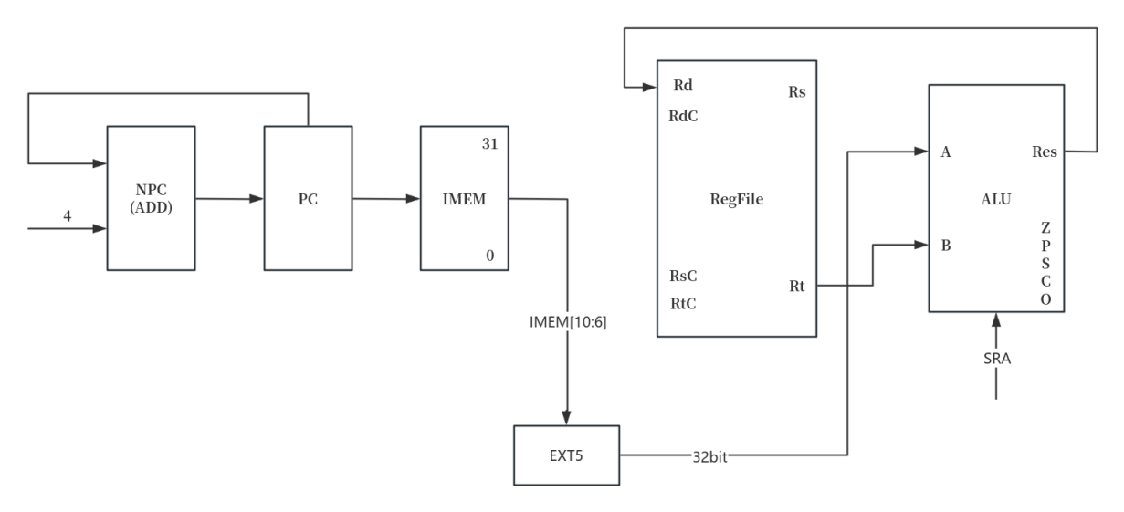
PC -> IMEM
PC + 4 -> NPC
NPC -> PC
IMEM[10:6] -> EXT5
EXT5 -> A
Rt -> B
(B >> A -> Res)
Res -> Rd

14 SLLV
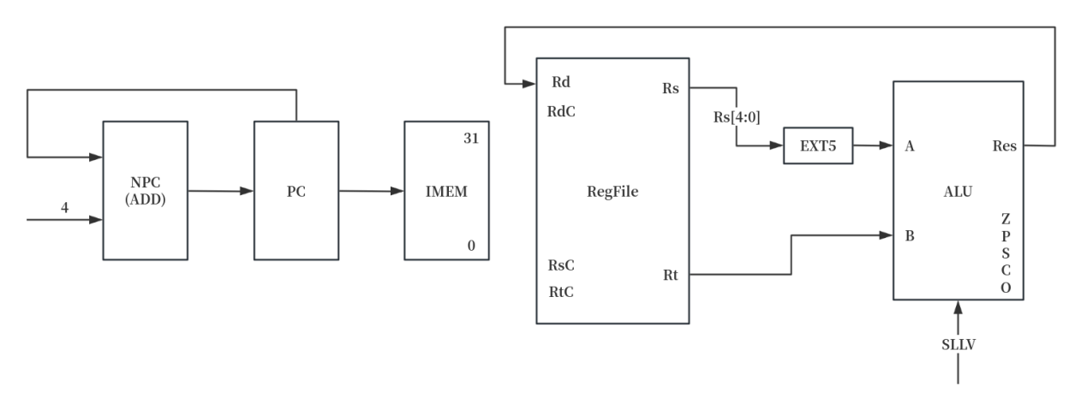
PC -> IMEM
PC + 4 -> NPC
NPC -> PC
Rs[4:0] -> EXT5
EXT5 -> A
Rt -> B
(B << A -> Res)
Res -> Rd

15 SRLV
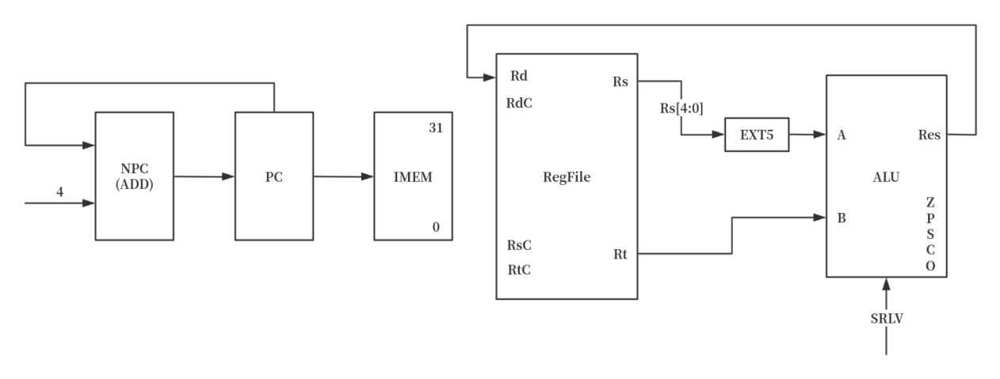
PC -> IMEM
PC + 4 -> NPC
NPC -> PC
Rs[4:0] -> EXT5
EXT5 -> A
Rt -> B
(B >>> A -> Res)
Res -> Rd

16 SRAV
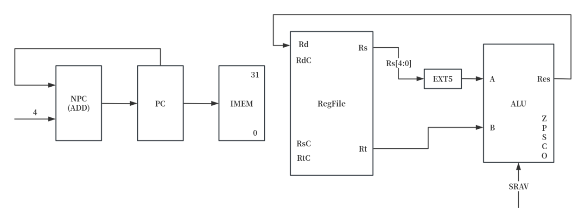
PC -> IMEM
PC + 4 -> NPC
NPC -> PC
Rs[4:0] -> EXT5
EXT5 -> A
Rt -> B
(B >> A -> Res)
Res -> Rd

17 JR
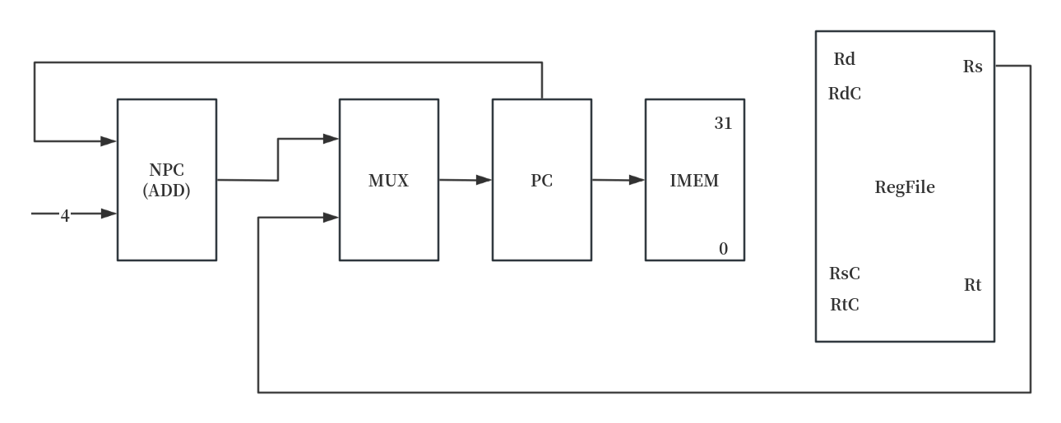
PC -> IMEM
PC + 4 -> NPC
NPC -> MUX
Rs -> MUX
MUX -> PC

2.I型指令
18 ADDI
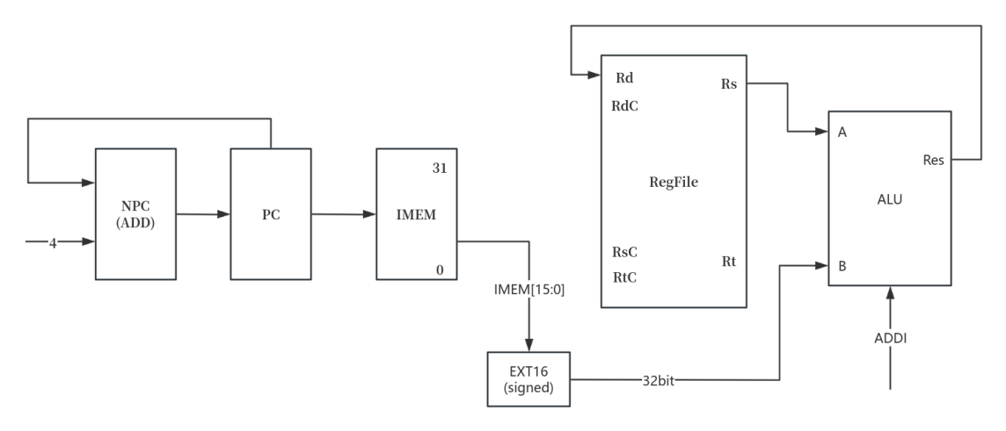
PC -> IMEM
PC + 4 -> NPC
NPC -> PC
IMEM[15:0] -> EXT16
Rs -> A
EXT16 -> B
(A + B -> Res)
Res -> Rd

19 ADDIU
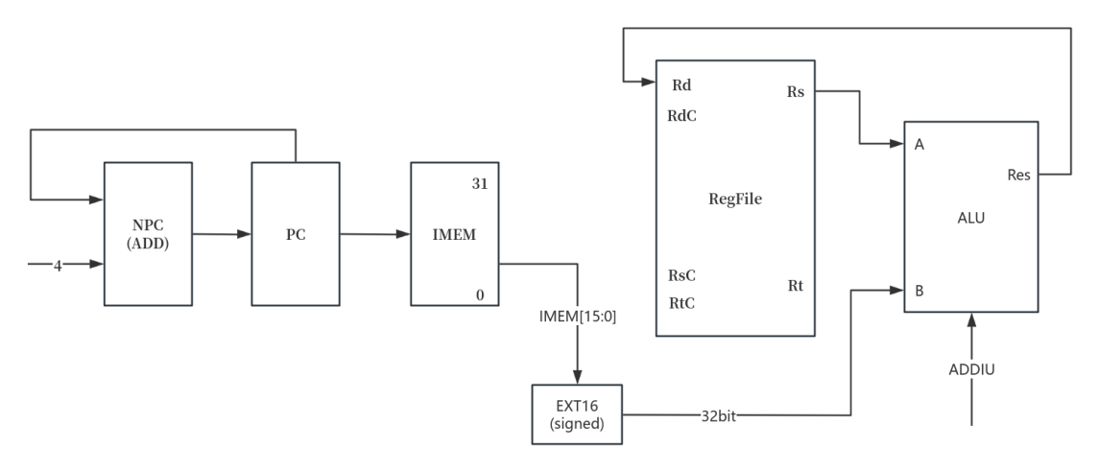
PC -> IMEM
PC + 4 -> NPC
NPC -> PC
IMEM[15:0] -> EXT16
Rs -> A
EXT16 -> B
(A + B -> Res)
Res -> Rd

20 ANDI
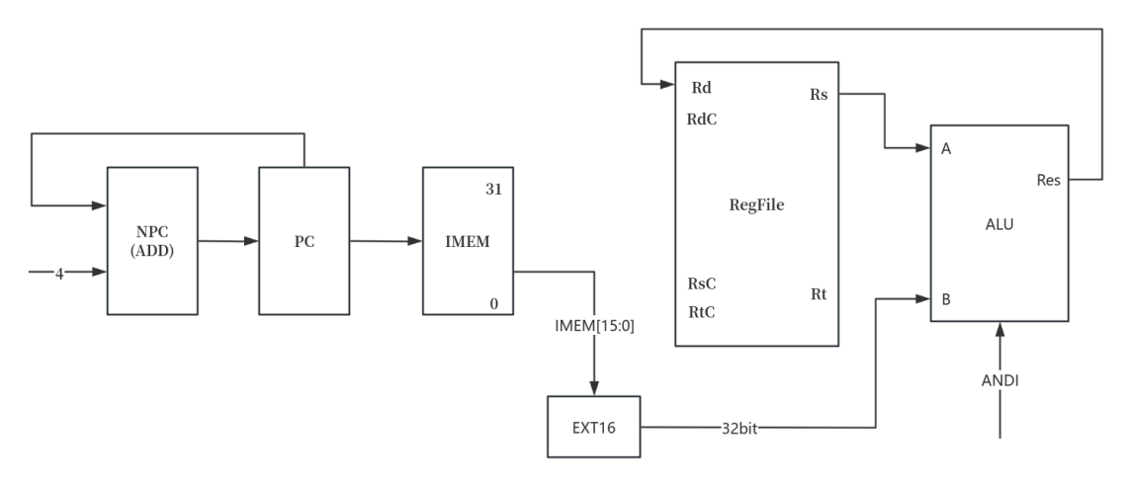
PC -> IMEM
PC + 4 -> NPC
NPC -> PC
IMEM[15:0] -> EXT16
Rs -> A
EXT16 -> B
(A & B -> Res)
Res -> Rd

21 ORI
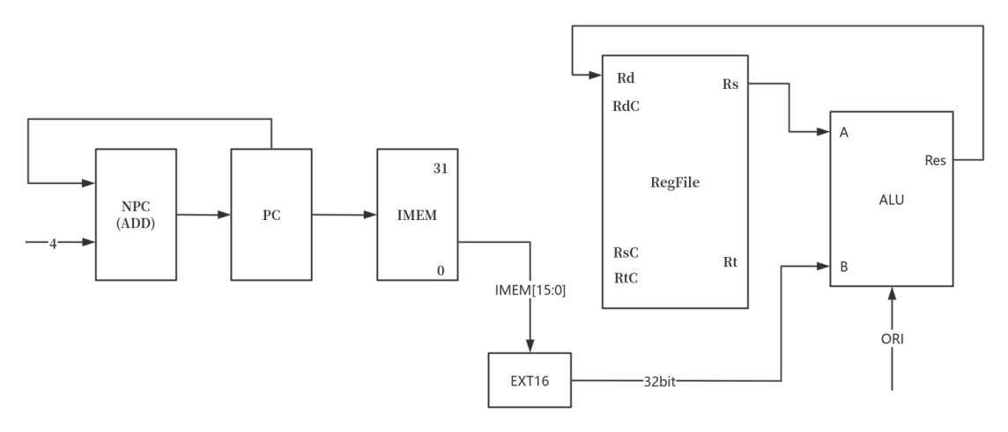
PC -> IMEM
PC + 4 -> NPC
NPC -> PC
IMEM[15:0] -> EXT16
Rs -> A
EXT16 -> B
(A | B -> Res)
Res -> Rd

22 XORI
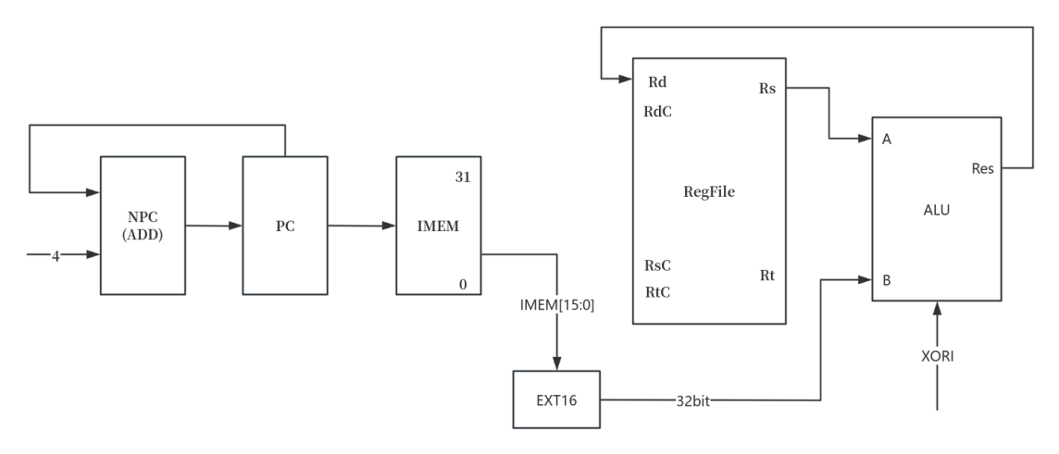
PC -> IMEM
PC + 4 -> NPC
NPC -> PC
IMEM[15:0] -> EXT16
Rs -> A
EXT16 -> B
(A ⊕ B -> Res)
Res -> Rd

23 LW
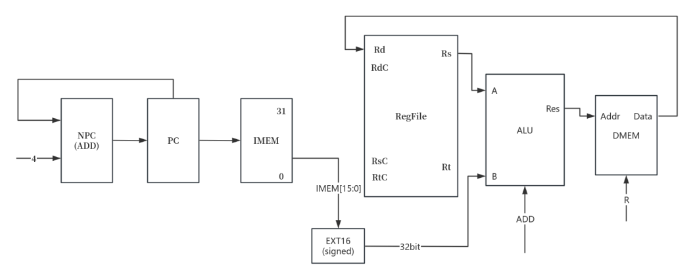
PC -> IMEM
PC + 4 -> NPC
NPC -> PC
IMEM[15:0] -> EXT16
Rs -> A
EXT16 -> B
(A + B -> Res)
Res -> DMEM_Addr
DMEM -> Rd

24 SW
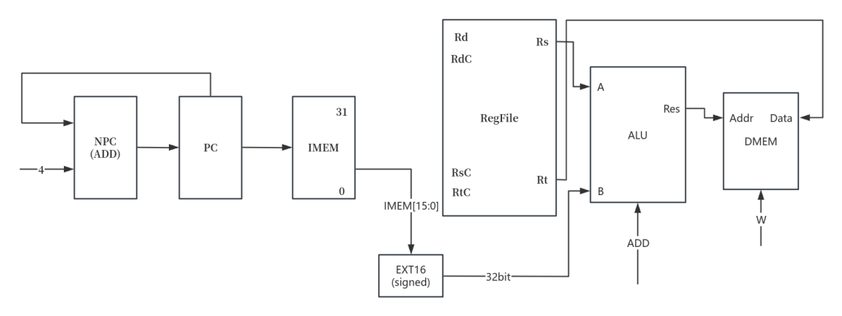
PC -> IMEM
PC + 4 -> NPC
NPC -> PC
IMEM[15:0] -> EXT16
Rs -> A
EXT16 -> B
(A + B -> Res)
Res -> DMEM_Addr
Rt -> DMEM

25 BEQ
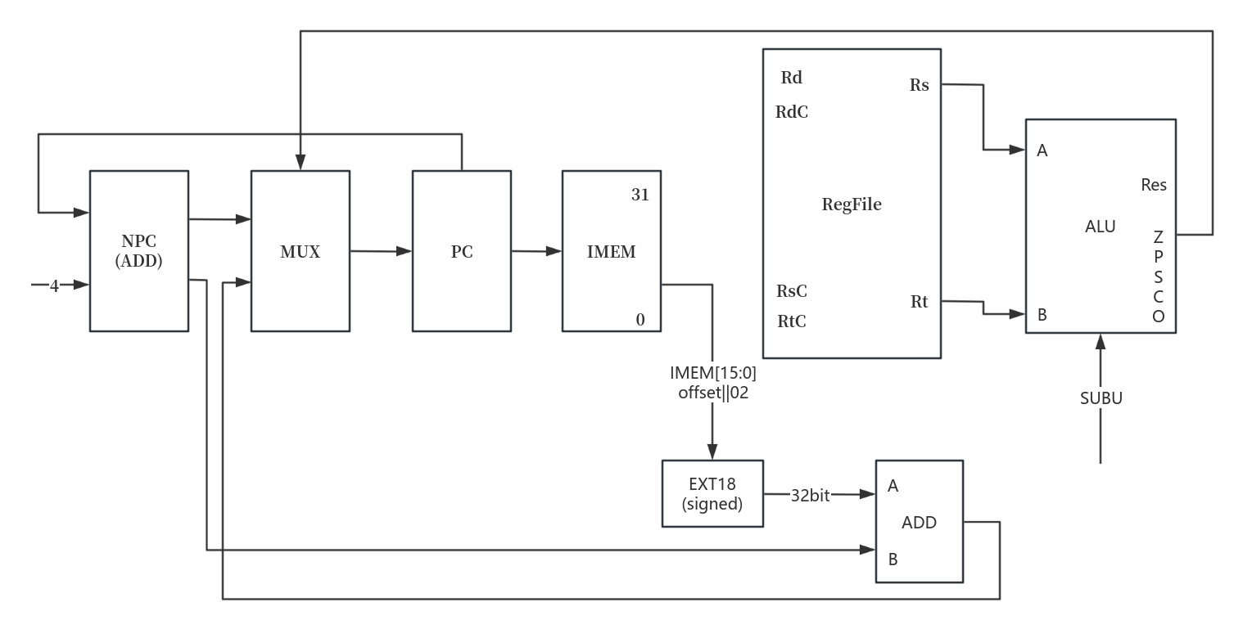
PC -> IMEM
PC + 4 -> NPC
NPC -> MUX
Rs -> A
Rt -> B
(A - B -> Res)
ZF -> MUX
IMEM[15:0]||02 -> EXT18
EXT18 -> ADD_A
NPC -> ADD_B
(ADD_A + ADD_B -> ADD_OUT)
ADD -> MUX
MUX -> PC

26 BNE
PC -> IMEM
PC + 4 -> NPC
NPC -> MUX
Rs -> A
Rt -> B
(A - B -> Res)
ZF -> MUX
IMEM[15:0]||02 -> EXT18
EXT18 -> ADD_A
NPC -> ADD_B
(ADD_A + ADD_B -> ADD_OUT)
ADD -> MUX
MUX -> PC

27 SLTI
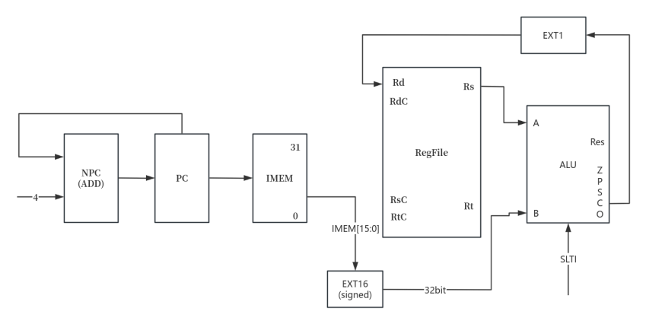
PC -> IMEM
PC + 4 -> NPC
NPC -> PC
IMEM[15:0] -> EXT16
Rs -> A
EXT16 -> B
(A - B -> Res)
CF -> EXT1
EXT1 -> Rd

28 SLTIU
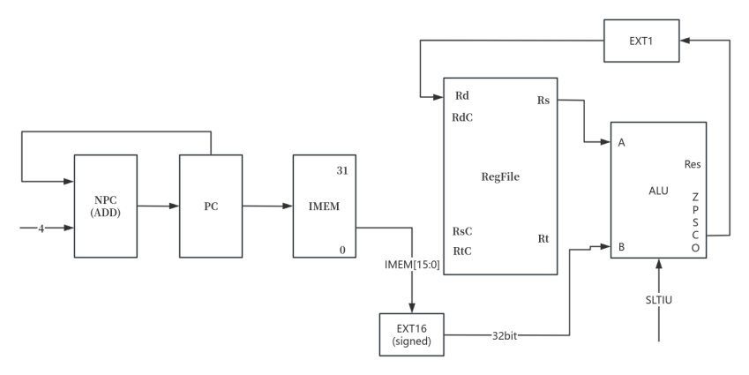
PC -> IMEM
PC + 4 -> NPC
NPC -> PC
IMEM[15:0] -> EXT16
Rs -> A
EXT16 -> B
(A - B -> Res)
CF -> EXT1
EXT1 -> Rd

29 LUI
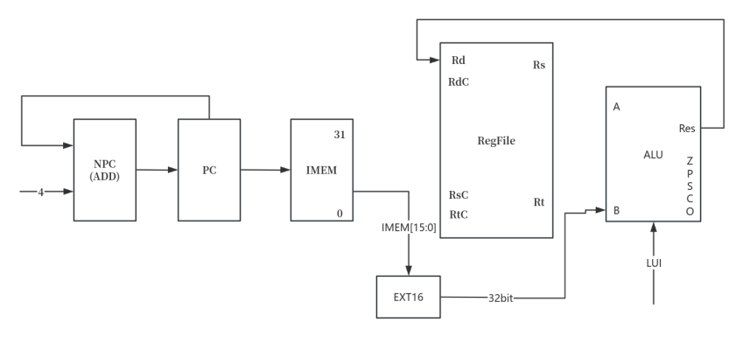
PC -> IMEM
PC + 4 -> NPC
NPC -> PC
IMEM[15:0] -> EXT16
Rs -> A
EXT16 -> B
(A - B -> Res)
CF -> EXT1
EXT1 -> Rd

J型指令
30 J
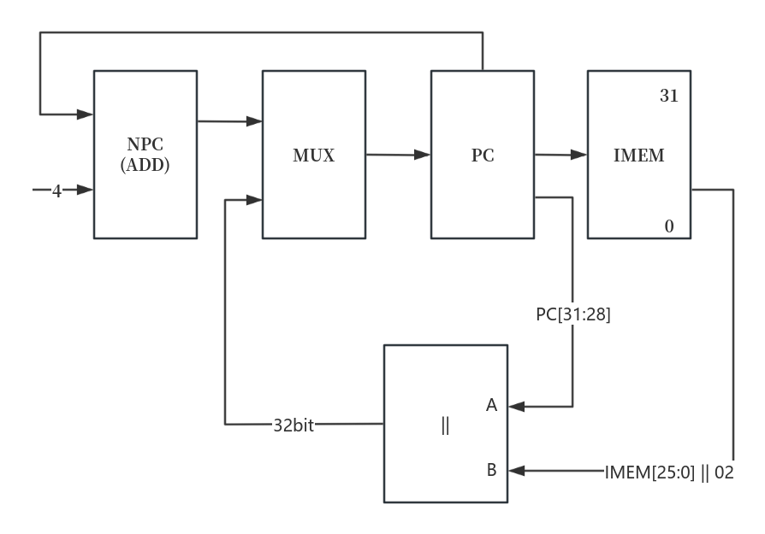
PC -> IMEM
PC + 4 -> NPC
NPC -> MUX
PC[31:28] -> ||_A
IMEM[25:0]||02 -> ||_B
|| -> MUX
MUX -> PC

31 JAL
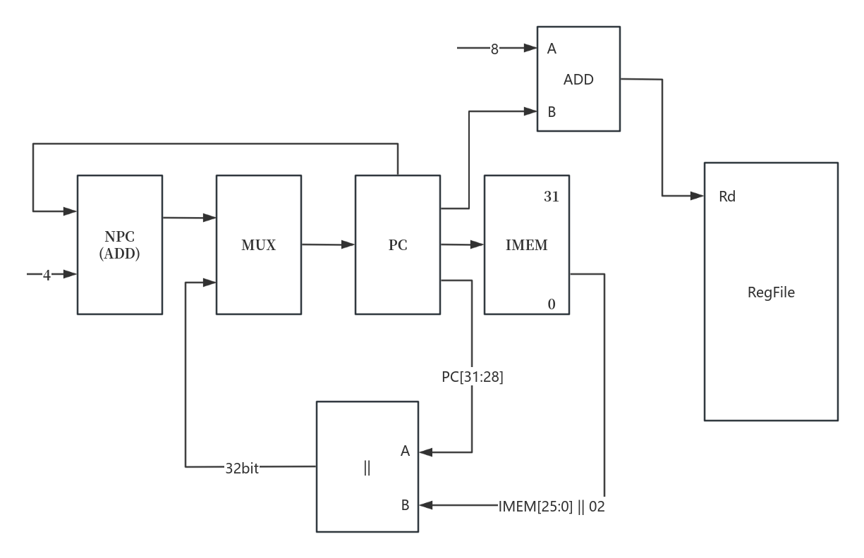
PC -> IMEM
PC + 4 -> NPC
NPC -> MUX
8 -> ADD_A
PC -> ADD_B
(ADD_A + ADD_B -> ADD_OUT)
ADD -> Rd
PC[31:28] -> ||_A
IMEM[25:0]||02 -> ||_B
|| -> MUX
MUX -> PC

CPU31总数据通路