Keystone Pipeline Throughput Analysis
A data analysis of monthly crude oil throughput and available capacity, 2010–2026

1. Purpose
This analysis examines monthly throughput and available capacity on the Keystone Pipeline using public regulatory data published by the Canada Energy Regulator (CER). The goal was to build a small, complete, and verifiable data analysis workflow — from raw regulatory filings to a cleaned dataset, calculated trend metrics, and a decision-relevant visualization — as hands-on preparation for demand forecasting and commercial analytics work in the energy sector. The findings below are drawn directly from the analysis output; no figures have been estimated or adjusted for presentation.

2. Data Source and Methodology

2.1 Source
Data was sourced directly from the CER's public open data portal:
https://www.cer-rec.gc.ca/open/energy/throughput-capacity/keystone-throughput-and-capacity.csv
This dataset is filed quarterly by pipeline operators under CER's Filing Manual Guide BB reporting requirements and published under the Open Government Licence – Canada.

2.2 Processing Steps
- Raw CSV downloaded programmatically via a Python script (analyze.py, included in this repository).
- Column names standardized to handle formatting differences across CER file exports (e.g. separate Year/Month fields consolidated into a single date field).
- Rows with missing or non-numeric throughput values removed.
- Data aggregated to monthly totals across reported key points.
- A 3-month rolling average calculated to smooth short-term volatility and surface the underlying trend.
- Utilization calculated as monthly throughput divided by available capacity, with month-over-month utilization variance tracked to identify volatility.

2.3 Limitations
This analysis uses aggregated, publicly reported figures rather than day-level or shipper-level data, and does not have visibility into the specific operational, maintenance, or commercial reasons behind individual month-to-month changes. Sharp short-term drops in the data are consistent with scheduled maintenance or apportionment events reported elsewhere by CER, but this analysis does not confirm specific causes for individual data points — that would require cross-referencing CER's market snapshot reports or company filings, which was outside the scope of this exercise.

3. Summary Statistics
Based on the full cleaned dataset (see output/keystone_clean.csv):
Records analyzed | 189 monthly observations
Date range | July 2010 – March 2026
Average monthly throughput | 85.8 (thousand m³/d)
Maximum monthly throughput | 102.2 (thousand m³/d)
Minimum monthly throughput | 15.1 (thousand m³/d)
Average utilization | 48.0%
Largest month-over-month utilization swing | 23.8 percentage points

4. Chart: Throughput vs. Rolling Average vs. Capacity
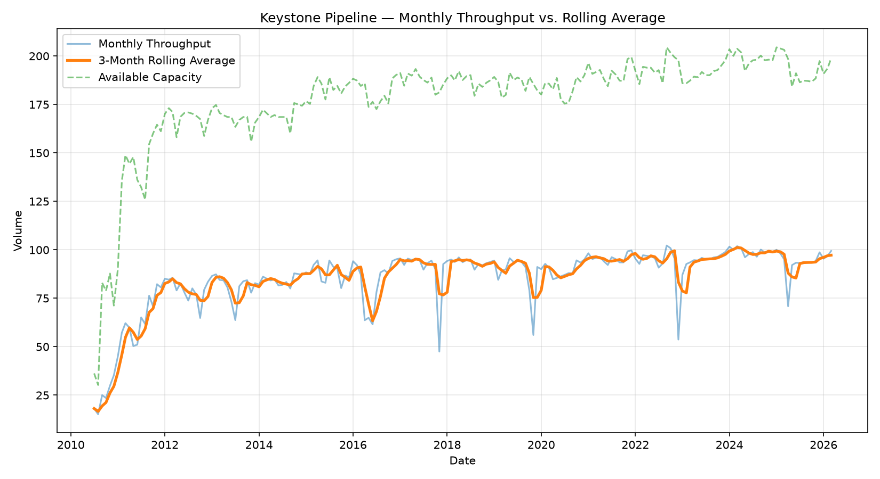
Figure 1: Monthly throughput (blue), 3-month rolling average (orange), and available capacity (green, dashed) from July 2010 to March 2026.

5. Findings

5.1 Early-life ramp-up (2010–2012)
The dataset opens with a steep climb in both throughput and available capacity, consistent with a pipeline system in its early operating life scaling toward design capacity. Throughput rose from roughly 15–20 to the 75–85 range within about eighteen months, tracking closely behind a series of capacity expansions.

5.2 Sustained but incomplete utilization
From 2012 onward, throughput and the rolling average stabilize into a consistent 75–100 range, while available capacity is expanded further in discrete steps (visible as step increases in the green line, notably around 2011, 2015, and again in 2022–2024). Because capacity was added ahead of sustained demand at several points, average utilization across the full dataset sits at 48.0% — lower than the visual impression of the chart alone would suggest, since throughput tracks close to capacity in some periods but falls well behind it in others.

5.3 Recurring short-term volatility
The data shows a repeating pattern: sharp, single-month drops in throughput that recover within one to two months, occurring roughly every 18–24 months (visible around 2016, 2018, 2020, 2023, and 2025). The largest month-over-month utilization swing in the dataset is 23.8 percentage points. The rolling average line is deliberately designed to smooth through these events rather than mask them — the raw throughput line still shows each dip clearly, while the rolling average shows that the underlying trend is not affected by any single month's disruption.

5.4 Long-term trend
Excluding the early ramp-up period, both throughput and capacity show a gradual upward trend over the full 15-year window, with the rolling average reaching its highest sustained levels (95–100) in the most recent data (2024–2026), even as capacity was also increased over the same period — indicating that recent capacity additions have been met with corresponding demand rather than sitting idle.

6. Interpretation for Commercial / Demand Planning
Read together, these findings suggest a system where capacity planning has generally stayed ahead of realized demand, rather than constraining it — evidenced by the persistent gap between throughput and available capacity across most of the dataset. At the same time, the recurring short-term disruptions (each resolving within one to two months) indicate that any forecasting or planning model for this type of asset needs to account for regular, moderate-magnitude volatility rather than assuming smooth, linear demand. A 3-month rolling average, as used here, is one straightforward way to distinguish that expected volatility from genuine shifts in the underlying trend.

7. Files in This Analysis
- analyze.py — full analysis script (download, clean, calculate, visualize)
- output/keystone_clean.csv — cleaned, monthly-aggregated dataset (generated locally; not included in repository)
- assets/keystone_throughput_chart.png — chart shown in Figure 1 above
- README.md — project overview and setup instructions
Repository: github.com/mo-yusuf-da/pipeline-throughput-analysis

