import numpy as np

import matplotlib.pyplot as plt

def gx(n): #function of our equation

    return (n**3 + 12*n -12)

fig,ax=plt.subplots()

ax.set_xlim((-15,15)) # interval of x axis

ax.set_ylim((-50,50)) # interval of y axis

ax.grid() #setka

ax.set_xlabel("x")

ax.set_ylabel("y")

x = np.linspace(-50,50,100)

ax.plot(x,x**3 +12*x - 12,label=r'$f(x)=\ x^3 +12*x -12$')

ax.legend(loc='best', fontsize=8)

plt.savefig('figure_with_legend.png')

plt.show()

a=int(input("initial point:"))#value of initial x coordinate

b=int(input("final point:"))#value of final x coordinate

s=True

i=1

while s==True:

    if (gx(a)>=0 and gx(b)>=0) or (gx(a)<0 and gx(b)<0): #By this condition we can find out whether there roots in a given user interval

        print("a or b is not in correct interval")

        break

    else:

        c=(a+b)/2

        if gx(a)*gx(c)<0:

            b=c

            if abs(c-a)<0.01:

                s=False

        else:

            a=c

            if abs(c-b)<0.01:

                s=False

    print("Iteration-" + str(i),"x"+str(i)+"="+str(round(c,4)))

    i+=1

Result of the code:

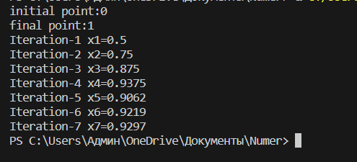

Some errors:

