iimport numpy as np

import matplotlib.pyplot as plt

fig,ax=plt.subplots()

ax.set_xlim((-5,5)) # interval of x axis

ax.set_ylim((-10,10)) # interval of y axis

ax.grid() #setka

ax.set_xlabel("x")

ax.set_ylabel("y")

x = np.linspace(-50,50,100)

ax.plot(x,(12-x**3)/12, label=r'$g(x)=\ (12-x^3)/12$')

ax.plot(x,x, label=r'$y=\ x$')

ax.legend(loc='best', fontsize=8)

plt.savefig('figure_with_legend.png')

plt.show()

def fx(x):

    return x**3 +12*x - 12

def gx(x): #function of our equation

    return (12-x**3)/12

def gx_derivative(x):

    return (x**2 * (-1))/4

a=int(input("initial point:"))#value of initial x coordinate

b=int(input("final point:"))#value of final x coordinate

s=True

if fx(a)*fx(b)<0:

    if gx(a)>gx(b):

        print("Function g(x) is decreasing on ["+str(a)+"," +str(b)+"]")

    if gx_derivative(a)<1 and gx_derivative(b)<1:

        print("Function g(x) has fixed point on ["+str(a)+"," +str(b)+"]")

    nn=int(input("Number of needed iteration:"))

    i=1

    vv=True

    while vv:

        s=int(input("Enter required number to guess from your interval:"))

        if s==a or s==b:

            vv=False

        else:

            print("this number is not in our interval")

    while i-1!=nn:

        s=gx(s)

        print("Iteration-"+str(i)+" x"+str(i)+"="+str(round(s,4)))

        i+=1

    print("error:",abs(fx(s)))

else:

    print("Your function don't have fixed-point in your entered interval6 please,try again")

Result of code:

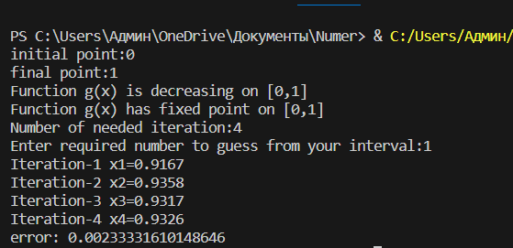

Some examples of errors in task:

1)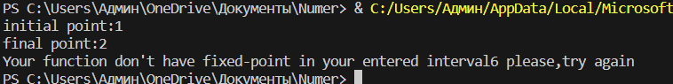

2)