RESEARCH STUDY — FEBRUARY 2026

AI FOR AMERICANS FIRST

AI Protectionism, Energy and Semiconductors:
US/Europe Divergence Trajectories 2024–2030
Integrated Geostrategic and Economic Analysis
Chapter I
Fabrice Pizzi
Universite Sorbonne
Master Economic Intelligence — Intelligence Warfare

77% global AI compute = USA 1.6× energy cost EU/US
3.4:1 CACI ratio US/EU (Power Mode)

Paris — February 2026
7 chapters • 4 prospective scenarios • 3 geographic zones

Keywords: artificial intelligence, technology protectionism, semiconductors, export controls, sovereign compute, AI geopolitics, France, United States, China

CHAPTER I

Introduction and Theoretical Framework

1.1 Research Question
Artificial intelligence is reshaping the foundations of global economic competitiveness. Since the launch of ChatGPT in November 2022 and the spectacular acceleration of investments in foundation models, generative AI has established itself as a cross-cutting transformative factor of the economy, simultaneously affecting finance, industry, healthcare, transportation, and services. Yet this transformation rests on a precise material substrate: considerable computing capacity, powered by cutting-edge semiconductors and abundant electrical energy. Mastery of this triptych — compute, chips, energy — has become a geostrategic issue of the first order.
In this context, the United States has progressively erected a control regime over access to frontier AI technologies. As early as October 2022, the Bureau of Industry and Security (BIS) of the Department of Commerce imposed restrictions on the export of advanced GPUs to China. In January 2025, the Biden administration extended these controls to more than 120 countries via the AI Diffusion Rule, creating a tier-based segmentation system that conditions access to the most powerful AI chips on the degree of geopolitical alignment with Washington. The Trump administration, taking office in January 2025, replaced this framework with a more explicitly competitive approach, culminating in July 2025 with the publication of America's AI Action Plan, then in January 2026 with the imposition of 25% tariffs on certain advanced AI semiconductors (Nvidia H200, AMD MI325X) under Section 232.1
These measures, officially motivated by national security imperatives, de facto produce a structural competitive advantage for American companies: they benefit from unlimited access to frontier compute, while actors from other regions — including European allies — see their capacities capped, made more expensive, or conditioned. We are thus witnessing the emergence of a new type of technology protectionism, where the 'tax' is not merely tariff-based but also regulatory, logistical, and strategic.
This study poses the following question: to what extent does US technology protectionism on AI — export controls, tariffs, domestic compute prioritization — create a structural competitiveness divergence between the United States and Europe, and what are the measurable consequences for France by 2030?
This research question breaks down into three sub-questions articulating the empirical, prospective, and normative dimensions of the analysis:
(a) What is the current AI computing capacity gap (compute gap) between the United States and the European Union, and how does this gap evolve under different scenarios of American trade and technology policy?
(b) How does the asymmetry of compute access translate into sectoral productivity, model training costs, and market share in AI services?
(c) Do European energy constraints and the rise of AI robotics amplify the divergence, and can France leverage its nuclear advantage to mitigate this structural disadvantage?
The originality of this study lies in its integrated approach. The existing literature treats separately export controls (Carnegie Endowment, CSIS, Hudson Institute), data center energy projections (IEA), semiconductor market dynamics (McKinsey, SIA, Deloitte), compute sovereignty (Hawkins, Lehdonvirta and Wu, 2025), and AI-related competitive barriers (Bruegel, OECD). No work proposes the complete causal trajectory we seek to establish here: US protectionism → restriction of European compute → productivity divergence → strategic dependence, with energy and robotics as amplifying factors.

1.2 Operational Definitions
The analysis deployed in this study rests on a set of concepts that require rigorous definition, as their usage varies across disciplinary contexts.

Frontier compute
We define frontier compute as the installed computing capacity in the form of AI accelerators — GPUs (Nvidia A100, H100, H200, B200), ASICs (Google TPU), or specialized circuits — deployed in industrial-scale data centers. This capacity is measured in FLOPs (floating-point operations per second) aggregated at the national or regional level, or in GW of IT load (electrical power absorbed by data center computing equipment). Frontier compute is the fundamental input for the development and deployment of frontier AI: without it, it is impossible to train competitive foundation models or operate large-scale inference services.

AI technology protectionism
AI technology protectionism designates the set of state measures — export controls, tariffs, quotas, export licenses, logistical prioritization, restrictions on model weights and APIs — that create an asymmetry of access to compute, models, and AI services between geographic regions. This concept extends the classical notion of trade protectionism by integrating the intangible dimension (software, models, cloud services) and the infrastructural dimension (energy, chip production capacity). Unlike traditional tariff barriers, AI technology protectionism can operate through non-tariff channels — for example, prioritizing GPU deliveries to domestic companies in a context of global shortage.

Compute gap
The compute gap measures the ratio of effectively available AI computing capacity between two regions. We define it as the ratio between installed and accessible AI FLOPs for economic actors in region A and those in region B, normalized by active population or GDP. A compute gap of x15 between the United States and the EU means that, per unit of GDP, American actors have fifteen times more AI computing power than their European counterparts. This ratio constitutes a synthetic indicator of structural advantage in AI.
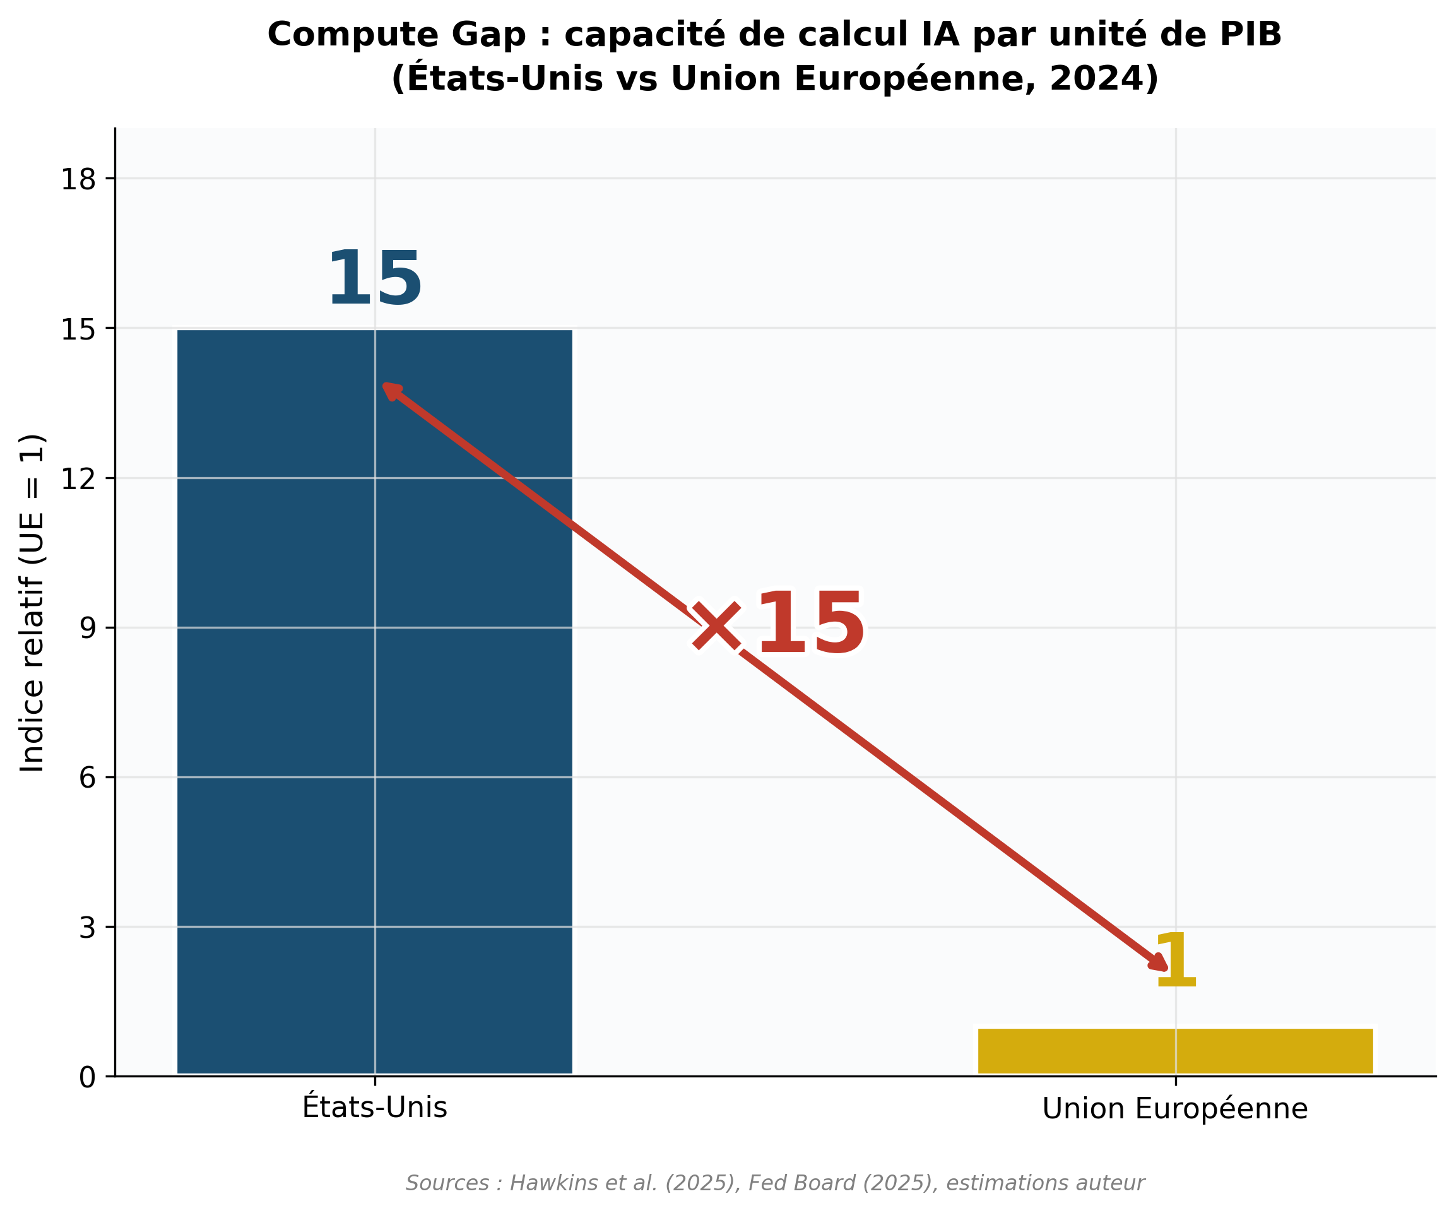

Compute sovereignty
We adopt the definition proposed by Hawkins, Lehdonvirta and Wu (2025), who decompose compute sovereignty into three levels: (1) the quantity of AI compute physically present on national territory, (2) the nationality of the companies owning the data centers, and (3) the nationality of the accelerator suppliers whose chips power these data centers.2 A country can have significant computing capacity on its soil while being dependent on foreign operators and chip suppliers, which limits its real sovereignty. This concept is essential for understanding why the presence of AWS or Azure data centers in Europe does not, in itself, constitute a form of European sovereignty over compute.

Geopolitical vendor lock-in
We propose the concept of geopolitical vendor lock-in to designate the structural dependence of an economic ecosystem on foreign technology providers whose access can be restricted, made more expensive, or conditioned by political decision of a third-party government. This concept extends the classical notion of vendor lock-in in IT (cloud provider migration costs, for example) by adding a geopolitical dimension: the risk that access to critical infrastructure may be used as a negotiating lever between states. The Starlink-Ukraine episode of March 2025, where American control of a communication system was perceived as an instrument of pressure, strikingly illustrates this type of risk.3

1.3 Theoretical Framework
Our analysis is grounded in four complementary theoretical currents, which provide the conceptual tools necessary to articulate the technological, economic, and geopolitical dimensions of the phenomenon under study.

1.3.1 AI as a General Purpose Technology
The first theoretical anchor is the General Purpose Technologies (GPT) theory formalized by Bresnahan and Trajtenberg (1995). A GPT is a technology characterized by three properties: its pervasiveness (it is used as an input in numerous downstream sectors), its inherent potential for technical improvement, and its innovation complementarities (R&D productivity in user sectors increases as a consequence of GPT improvement).4 The model predicts that GPTs generate increasing returns to scale and that their diffusion throughout the economy is a source of generalized productivity gains. However, Bresnahan and Trajtenberg also emphasize that a decentralized economy may have difficulty fully exploiting a GPT's potential, as market transactions between the GPT producer and its users may lead to 'too little, too late' innovation.
Brynjolfsson, Rock and Syverson (2019) applied this framework to contemporary AI, demonstrating that AI, and in particular machine learning, satisfies Bresnahan and Trajtenberg's three criteria to be qualified as a GPT.5 Their 'productivity J-curve' model explains why productivity gains linked to a GPT may initially be invisible in statistics: firms must first invest massively in intangible assets (reorganization, training, process reengineering) before reaping the benefits.
This framework is fundamental to our analysis because it implies that early and massive access to AI compute — that is, the capacity to invest in the GPT at large scale from the earliest deployment phases — generates cumulative advantages that are difficult to reverse. Innovation complementarities create a path dependence dynamic: actors who access abundant compute early develop superior models, capture usage data, generate revenues they reinvest in compute, and thus widen a gap that self-reinforces over time. Any policy restricting compute access for a given region therefore has non-linear consequences: it does not merely delay adoption, it structurally compromises it.

1.3.2 Weaponized interdependence and control of global networks
The second theoretical anchor is the weaponized interdependence theory developed by Farrell and Newman (2019). These authors demonstrate that global economic networks, far from creating symmetrical relations of mutual interdependence as classical liberal theory posited, tend to produce asymmetric structures in which certain nodes (hubs) become far more connected than others. States exercising political jurisdiction over these central nodes can instrumentalize them for coercive purposes, via two mechanisms: the panopticon effect (strategic information collection) and the chokepoint effect (capacity to cut or restrict flows).6
The application to the AI value chain is remarkably pertinent. The United States controls several critical chokepoints: AI accelerator design (Nvidia holds over 80% of the GPU market for data centers), cloud infrastructure (AWS, Azure and Google Cloud represent approximately 70% of the global market), and the most advanced foundation models (OpenAI, Anthropic, Google DeepMind). Control of these chokepoints allows the US government to modulate global access to AI compute as a geopolitical lever, in exactly the same way that the SWIFT system was used as a lever in the financial domain. Farrell and Newman themselves recognized, in an update published in Foreign Affairs in December 2025, that semiconductors and AI had become a major application terrain for their theory, the Trump administration having explicitly used export controls on AI chips as bargaining currency in negotiations with China.7

1.3.3 Concentration economics and innovation rents
The third theoretical anchor mobilizes the literature on digital market concentration and barriers to entry in the AI ecosystem. Martens (2024), in a policy brief for Bruegel, demonstrates that the training costs of foundation models grow exponentially, constituting an insurmountable barrier to entry for most actors.8 He estimates that a compute farm on the order of a trillion dollars is conceivable in the medium term, an investment threshold completely beyond the reach of public funding and the vast majority of companies. Only the GAMMAN (Google, Apple, Meta, Microsoft, Amazon, Nvidia) have the resources to access it.
The OECD (2025) confirms this analysis in its report on competition in AI infrastructure, identifying barriers to entry at multiple levels of the supply chain: extremely high capital requirements, massive economies of scale, switching costs between providers, and absence of interoperability standards.9 The Federal Reserve Board (October 2025), in a comparative analysis of AI competitiveness in advanced economies, shows that the United States concentrates more than 75% of global venture capital investment in generative AI, and that Europe lags significantly not only in investment but also in enterprise adoption, with high energy costs constituting an additional brake.10
This concentration dynamic has a direct consequence for our analysis: US technology protectionism does not merely limit European access to compute, it reinforces the position of dominant actors who are precisely those benefiting from domestic exemption. It is a dual advantage mechanism: reduction of constraints for US companies, increase of constraints for their competitors.

1.3.4 Digital sovereignty and European strategic autonomy
The fourth theoretical anchor mobilizes the European current of digital sovereignty, analyzed notably by Mugge (2024) in the Journal of European Public Policy. Mugge identifies three fundamental tensions in Europe's AI sovereignty ambition: does sovereignty oppose the EU to other AI powers, or citizens to large platforms? Does it aim at economic competitiveness or rights protection? And who really benefits from it — European champions or the entire ecosystem?11 These tensions are precisely those that American protectionism exacerbates: by compressing European technological sovereignty space, it forces the EU to arbitrate between these contradictory objectives in a context of urgency.
Hawkins, Lehdonvirta and Wu (2025) provide a decisive empirical contribution by measuring compute sovereignty through the infrastructure of the nine main global cloud providers, which represent approximately 70% of the global market. Their results reveal that the degree of sovereignty varies considerably depending on the level of analysis (territorial, corporate, or hardware), and that most European countries exhibit a sovereignty deficit at at least two of these three levels.12 McKinsey (December 2025) estimates the European sovereign AI opportunity at 480 billion euros annually by 2030, contingent on a scenario of strong technological sovereignty and high AI adoption.13

1.4 Targeted Literature Review and Gap Identification
The state of the literature in February 2026 reveals a rapidly forming field of research, but one that remains highly fragmented. We identify five main corpora, each covering one dimension of our research question.

Corpus 1: Export controls and AI geopolitics
The Carnegie Endowment for International Peace provides the most detailed analysis of US AI export control policy. Winter-Levy and Phillips-Robins (May 2025) described Biden's AI Diffusion Rule as a compromise between three objectives — control, promotion, and geopolitical leverage — and analyzed replacement options under Trump.14 CSIS, the Hudson Institute, and Pillsbury Law have documented the legal mechanisms and recent developments, notably the Section 232 tariffs of January 2026. Contrary Research (November 2025) offers a particularly rich analysis of the underlying temporal dilemma: if AGI is five years away, export controls strengthen American dominance; if it is ten years or more, they accelerate Chinese technological autonomization.15

Corpus 2: Energy and data center infrastructure
The IEA's special report Energy and AI (April 2025) constitutes the global reference for data center energy projections. It establishes that global data center electricity consumption will reach 945 TWh in 2030 in the base scenario, compared to 415 TWh in 2024, with AI as the primary driver of this growth.16 In the United States, data centers will consume more electricity than all energy-intensive industry combined by 2030. In Europe, growth will be +45 TWh (+70%), with a risk of delay on approximately 20% of projects linked to electricity grid constraints. IEA-4E published in parallel a critical review of estimation models, highlighting the magnitude of uncertainties (2030 projections vary by a factor of 40 across studies).17
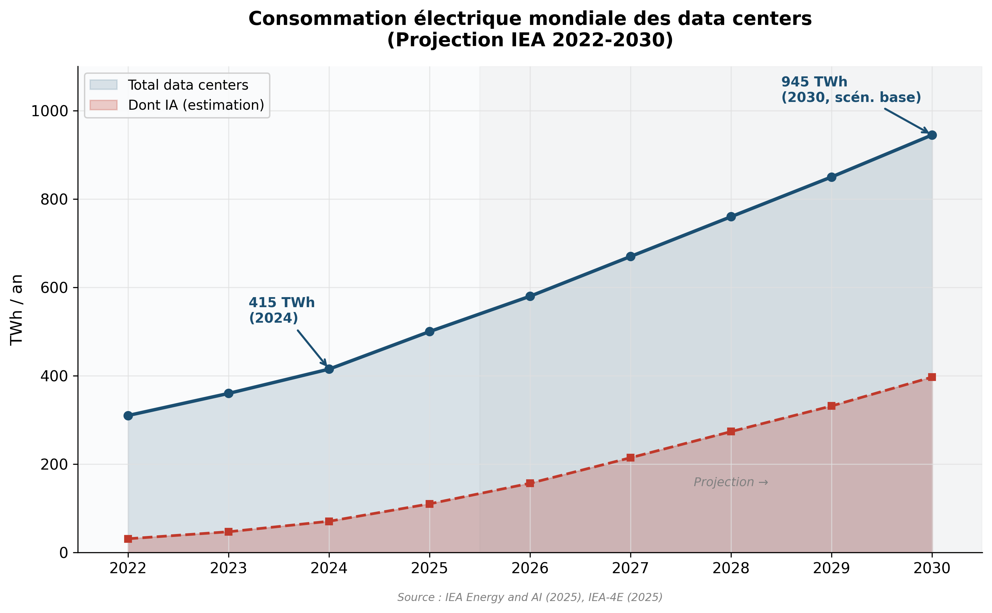

Corpus 3: Semiconductor market
McKinsey (January 2026) significantly revised upward its estimates of the semiconductor market size by integrating captive designers (Apple, Amazon, Tesla) and fabless operators whose value does not appear in traditional statistics. Their base estimate goes from $775 billion in 2024 to $1,600 billion in 2030, a CAGR of 13%.18 SIA reports record sales of $627.6 billion in 2024, while Deloitte (February 2026) anticipates that generative AI chips alone will represent nearly half of the sector's revenue in 2026.19

Corpus 4: European AI sovereignty and competitiveness
Several recent publications document the European deficit.

The European Parliament (2025) finds that only 11% of small European enterprises use AI, compared to 58% of small American businesses.20 Accenture (November 2025) reports that 62% of European organizations are seeking sovereign solutions in the face of geopolitical uncertainty, but only 19% see it as a competitive advantage. The majority (48%) is motivated by regulatory compliance obligations, suggesting a defensive rather than strategic approach.21 The Draghi report (September 2024) on European competitiveness had already identified the digital investment deficit as a structural factor in Europe's decline.

Corpus 5: Competitive barriers and concentration
Bruegel, the OECD, and the Federal Reserve Board converge on the observation of growing concentration of the AI ecosystem around a small number of actors. The CERRE report (June 2025) on competition policy for cloud and AI identifies migration barriers, cloud credit practices likely to create lock-in, and growing dependence of small AI developers on hyperscalers for access to accelerated compute.22 The structural collaboration between AI startups and Big Tech — illustrated by the Mistral-Microsoft agreement — testifies to this dependence.

The gap this study aims to fill
Examination of these five corpora reveals an uncovered analytical space: no study proposes an integrated trajectory linking US technology protectionism to EU competitiveness divergence via the compute-energy-semiconductor triptych. Existing works treat each dimension in isolation — export controls without energy, energy without semiconductors, semiconductors without productivity. Moreover, the specific angle of AI robotics as an amplifier of energy demand is virtually absent from the literature. It is precisely this gap that our study intends to fill, by proposing a unified analytical framework and an original indicator — the Compute-Adjusted Competitiveness Index (CACI) — enabling measurement and projection of this divergence.

1.5 Report Structure
The report is organized in eight chapters. After this introduction, Chapter II presents the methodology, detailing the multi-scenario approach, data sources, CACI construction, and methodological limitations. Chapter III establishes the 2020-2026 empirical diagnosis, covering energy trajectories, the semiconductor market, installed compute, and the export controls chronology. Chapter IV analyzes the mechanisms of US competitive advantage. Chapter V presents four 2026-2030 scenarios structured around two axes of uncertainty. Chapter VI details the consequences for France and Europe, differentiated by actor type and sector. Chapter VII formulates strategic recommendations at three time horizons. Chapter VIII concludes by synthesizing the study's contributions and identifying avenues for future research.

Notes
1 Pillsbury Law (2026), 'Trump Admin Targets Advanced AI Semiconductors, Defers Broader Tariffs,' January 15, 2026. The Section 232 proclamation imposes a 25% tariff on logic integrated circuits meeting specific technical parameters (TTP > 14,000, DRAM bandwidth > 4,500 GB/s), covering notably Nvidia H200 and AMD MI325X destined for re-export.
² Hawkins, Z.J., Lehdonvirta, V. & Wu, B. (2025), « AI Compute Sovereignty: Infrastructure Control Across Territories, Cloud Providers, and Accelerators », SSRN, juin 2025, https://ssrn.com/abstract=5312977
3 Carnegie Endowment for International Peace (2025), 'The EU's AI Power Play: Between Deregulation and Innovation,' May 2025. See also the March 2025 revelation on the use of Starlink as a pressure lever on Ukraine.
4 Bresnahan, T.F. & Trajtenberg, M. (1995), 'General Purpose Technologies "Engines of Growth"?', Journal of Econometrics, 65(1), pp. 83-108. The authors define GPTs by their pervasiveness, inherent improvement potential, and innovation complementarities.
⁵ Brynjolfsson, E., Rock, D. & Syverson, C. (2019), « Artificial Intelligence and the Modern Productivity Paradox: A Clash of Expectations and Statistics », in Agrawal, Gans & Goldfarb (eds.), The Economics of Artificial Intelligence, University of Chicago Press, pp. 23-57. Voir également Brynjolfsson, Rock & Syverson (2021), « The Productivity J-Curve », American Economic Journal: Macroeconomics, 13(1), pp. 268-320.
⁶ Farrell, H. & Newman, A.L. (2019), « Weaponized Interdependence: How Global Economic Networks Shape State Coercion », International Security, 44(1), pp. 42-79. doi:10.1162/isec_a_00351
7 Farrell, H. & Newman, A.L. (2025), 'The Weaponized World Economy: Surviving the New Age of Economic Coercion,' Foreign Affairs, December 2025. The authors note that the Trump administration used export controls on AI chips as bargaining currency in negotiations with China.
⁸ Martens, B. (2024), « Why artificial intelligence is creating fundamental challenges for competition policy », Bruegel Policy Brief 16/2024. Disponible sur https://www.bruegel.org/policy-brief/why-artificial-intelligence-creating-fundamental-challenges-competition-policy
⁹ OCDE (2025), « Competition in Artificial Intelligence Infrastructure », https://www.oecd.org/en/publications/competition-in-artificial-intelligence-infrastructure_623d1874-en.html
10 Federal Reserve Board (2025), 'The State of AI Competition in Advanced Economies,' FEDS Notes, October 6, 2025. The report establishes a significant negative correlation between energy costs and AI adoption at the European enterprise level.
¹¹ Mügge, D. (2024), « EU AI sovereignty: for whom, to what end, and to whose benefit? », Journal of European Public Policy, 31(8), pp. 2200-2225. doi:10.1080/13501763.2024.2318475
¹² Hawkins, Lehdonvirta & Wu (2025), op. cit.
13 McKinsey (2025), 'Accelerating Europe's AI Adoption: The Role of Sovereign AI Capabilities,' December 2025. The estimate of EUR 480 billion annually assumes a scenario of high technological sovereignty and high AI adoption combined.
¹⁴ Winter-Levy, S. & Phillips-Robins, A. (2025), « The Trump Administration May Be About to Repeal the AI Diffusion Rule. Here’s What It Should Do Next », Carnegie Endowment, 8 mai 2025.
¹⁵ Contrary Research (2025), « Deep Dive: Export Controls and the AI Race », 6 novembre 2025. https://research.contrary.com/report/drawing-geopolitical-boundaries
16 IEA (2025), 'Energy and AI,' special report, April 10, 2025. https://www.iea.org/reports/energy-and-ai. The base scenario projects growth of ~15%/year in data center electricity consumption, with accelerated servers (AI) growing at 30%/year.
17 IEA-4E (2025), 'Data Centre Energy Use: Critical Review of Models and Results.' The authors estimate a plausible range of 200-400 TWh for AI-only data center consumption in 2030 (35-50% of total).
18 McKinsey (2026), 'Hiding in Plain Sight: The Underestimated Size of the Semiconductor Industry,' January 2026. The low scenario is $1,100B, the high scenario $1,800B.
19 Deloitte (2026), '2026 Semiconductor Industry Outlook,' February 2026. SIA (2025), 2024 sales = $627.6B (WSTS). AMD projects a total addressable market for AI data center accelerators of $1,000B by 2030.
20 European Parliament (2025), 'Making Europe an AI Continent,' EPRS BRI(2025)775923. Adoption figures: 41% of large EU enterprises use AI, vs 11% of small ones. In the US, 58% of small businesses according to the US Chamber of Commerce (August 2025).
21 Accenture (2025), 'Europe Seeking Greater AI Sovereignty,' November 3, 2025. Survey of 1,928 organizations in 28 countries.
22 CERRE / Meyers, Z. (2025), 'A Competition Policy for Cloud and AI,' Issue Paper, June 2025. See also Bruegel, Carugati, C. (2023), 'Competition in generative artificial intelligence foundation models,' Working Paper 14/2023.

License and Disclaimer This work, 'AI for Americans First,' is made available under the terms of theAmerica-First-IA
Creative Commons Attribution - NonCommercial - ShareAlike
4.0 International License (CC BY-NC-SA 4.0).
You are free to share and adapt the material for non-commercial purposes, provided
you give appropriate credit to Fabrice Pizzi (Universite Paris Sorbonne) and distribute
your contributions under the same license. This document is provided for educational and
research purposes only.

