WORKING PAPER
February 2026
The Compute-Adjusted Competitiveness Index (CACI):
Measuring the Impact of US AI Protectionism
on Global AI Competitiveness
Fabrice Pizzi
Paris, France
Abstract
This paper introduces the Compute-Adjusted Competitiveness Index (CACI), a novel composite indicator designed to measure national AI competitiveness by capturing the interaction between installed compute capacity, energy costs, GDP, and AI workforce. Using a calibrated panel of 12 countries over the period 2020–2024 (N = 60), we estimate OLS pooled, fixed effects, and random effects models to validate the CACI as a predictor of sectoral AI productivity gains. The coefficient on ln(CACI) is positive and statistically significant at the 1% level across all specifications (β = 0.17–0.50). The Hausman test favors fixed effects (p = 0.001). Decomposition analysis reveals that raw compute (F) is the dominant component (β = 0.301, p < 0.01), confirming our central hypothesis: access to compute is the critical determinant of AI competitiveness. We document a CACI ratio of 3.4:1 between the United States and the European Union, and show how US technological protectionism—export controls, Section 232 tariffs, and domestic compute prioritization—structurally widens this gap. We develop four prospective scenarios for 2026–2030 and derive policy recommendations for Europe, including Special Compute Zones, nuclear-AI integration, and strategic GPU reserves.
Keywords: AI competitiveness, compute gap, technological protectionism, export controls, CACI, panel data, semiconductors, energy policy, Section 232, EU digital sovereignty
JEL Codes: F13 (Trade Policy), L63 (Semiconductors), O33 (Technological Change), O38 (Government Policy)

1. Introduction
Artificial intelligence is reshaping the foundations of global economic competitiveness. Since the launch of ChatGPT in November 2022 and the subsequent surge in foundation model investments, generative AI has emerged as a cross-cutting transformation factor affecting finance, industry, healthcare, and services simultaneously. Yet this transformation rests on a precise material substrate: massive computational capacity, powered by advanced semiconductors and abundant electrical energy. Mastery of this triad—compute, chips, energy—has become a first-order geostrategic issue.
In this context, the United States has progressively erected a control regime over access to frontier AI technologies. Beginning in October 2022, the Bureau of Industry and Security (BIS) imposed restrictions on advanced GPU exports to China. In January 2025, the Biden administration extended these controls to over 120 countries via the AI Diffusion Rule, creating a tiered system conditioning access to the most performant AI chips on the degree of geopolitical alignment with Washington. The Trump administration, entering office in January 2025, replaced this framework with a more explicitly competitive approach, culminating in July 2025 with the America’s AI Action Plan, and in January 2026 with Section 232 tariffs of 25% on certain advanced AI semiconductors (Nvidia H200, AMD MI325X).
These measures, officially motivated by national security imperatives, produce de facto a structural competitive advantage for American firms: they enjoy unlimited access to frontier compute, while actors in other regions—including European allies—see their capacities capped, surcharged, or conditioned. We are witnessing the emergence of a new form of technological protectionism, where the “tax” is not merely tariff-based but also regulatory, logistical, and strategic.
Despite the magnitude of these shifts, the economics literature lacks a quantitative framework to measure the resulting competitiveness gap. Existing indicators—R&D expenditure, patent counts, AI publication metrics—fail to capture the material infrastructure dimension that increasingly determines AI outcomes. This paper addresses that gap by introducing the Compute-Adjusted Competitiveness Index (CACI), a novel composite indicator that integrates installed compute capacity, energy costs, economic size, and AI workforce into a single, empirically testable measure.
Our contributions are threefold. First, we formalize compute as a fourth production factor in the AI era, building on Bresnahan and Trajtenberg’s (1995) general-purpose technology theory. Second, we construct and validate the CACI econometrically using a 12-country panel, demonstrating that it significantly predicts cross-country AI productivity differentials. Third, we apply the CACI framework to analyze the consequences of US AI protectionism for Europe, developing four scenarios for the 2026–2030 horizon and deriving policy recommendations.
The paper is organized as follows. Section 2 reviews the relevant literature. Section 3 presents the CACI framework and its formal definition. Section 4 describes our data and empirical methodology. Section 5 reports the econometric results. Section 6 applies the framework to analyze the US-EU compute gap and its structural drivers. Section 7 develops prospective scenarios. Section 8 discusses policy implications. Section 9 concludes.

2. Literature Review

2.1 AI as General-Purpose Technology
The foundational insight for our framework comes from Bresnahan and Trajtenberg’s (1995) theory of general-purpose technologies (GPTs). GPTs are characterized by pervasiveness, inherent potential for improvement, and innovation complementarities. AI—and specifically large language models—satisfies all three criteria. However, the GPT literature does not explicitly theorize the material infrastructure requirements of GPTs: Bresnahan and Trajtenberg focus on innovation spillovers rather than physical inputs.
Brynjolfsson, Rock, and Syverson (2019) provide the crucial complement with their J-curve theory: productivity gains from GPTs are delayed because firms must invest in complementary assets—organizational restructuring, worker training, process redesign—before realizing returns. We extend this framework by arguing that compute infrastructure itself constitutes a prerequisite complementary asset. Without sufficient computational capacity, firms cannot train, deploy, or fine-tune the AI models that drive productivity gains. This creates what we term a “compute-conditioned J-curve”: countries with restricted compute access face not merely a delayed productivity takeoff but a structurally lower ceiling.

2.2 Weaponized Interdependence and Chokepoint Control
Farrell and Newman (2019) introduce the concept of “weaponized interdependence”: states can exploit the asymmetric structure of global networks to coerce others. They identify two mechanisms: the panopticon effect (surveillance through control of information hubs) and the chokepoint effect (coercion through control of critical nodes). AI compute infrastructure exhibits both properties. The concentration of advanced GPU production (Nvidia ~80% market share), leading-edge foundry capacity (TSMC 92% of sub-7nm nodes), and EUV lithography equipment (ASML 100%) creates chokepoints more concentrated than the SWIFT financial network that Farrell and Newman originally analyzed.
The October 2022 export controls, the AI Diffusion Rule, and Section 232 explicitly weaponize these chokepoints. The Trump administration proposed monetizing this leverage (25% of Chinese sales revenues, September 2025), marking a transition from denial-based to revenue-extracting protectionism. Mügge (2024) documents how this represents a broader shift from rules-based trade toward discretionary power politics in technology markets.

2.3 The Measurement Gap
Existing competitiveness indices fail to capture the compute dimension. The Global AI Index (Tortoise), Stanford HAI’s AI Index, and OECD Digital Economy Outlook use proxies such as R&D spending, publication counts, and patent filings. These are useful but fundamentally lag indicators: they measure inputs and outputs of the innovation process without capturing the infrastructure bottleneck that determines whether AI models can be trained and deployed at scale. Hawkins et al. (2025) provide the first systematic attempt to estimate installed AI compute by country, but do not integrate this into a competitiveness framework. Our CACI addresses this gap.

3. The CACI Framework

3.1 Conceptual Foundation
We argue that AI competitiveness at the national level is determined by four interacting factors: (i) installed compute capacity, (ii) energy cost for data centers, (iii) economic absorptive capacity, and (iv) AI-skilled workforce. The CACI captures the interaction between these factors in a single composite measure.
The intuition is as follows. A country’s effective AI capacity is increasing in compute (more FLOPs means more models can be trained and more inferences processed) and decreasing in energy cost (cheaper electricity means each FLOP is more affordable to operate). This raw capacity must be normalized by the country’s economic size (GDP) and workforce, to produce a measure of AI intensity per unit of economic activity—comparable to total factor productivity measures that normalize output by inputs.

3.2 Formal Definition
CACI(r,t) = α ln[F(r,t)/L(r,t)] + β ln[Ē/E(r,t)] + γ ln[R(r,t)/GDP(r,t)] — Mode Power (α=0.39, β=0.28, γ=0.33) | Mode Efficiency (α=0.18, β=0.42, γ=0.40)
where:
F(r,t) = installed AI compute capacity of region r at time t, measured in PetaFLOPs (source: Epoch AI, Hawkins et al. 2025, CFG Europe);
E(r,t) = energy cost for data centers in $/MWh (source: Eurostat, EIA, IEA 2025);
GDP(r,t) = gross domestic product in trillions USD (source: World Bank, IMF);
L(r,t) = AI workforce in thousands, proxied by STEM graduates + AI certifications (source: OECD, LinkedIn Economic Graph).
The CACI is dimensionless and interpretable as the ratio of effective compute supply to economic demand for compute. A higher CACI indicates greater AI compute intensity relative to economic size—a structural advantage in the AI era.

3.3 Properties and Limitations
The multiplicative structure captures complementarities between components: a country with high compute but prohibitively expensive energy scores lower than one with moderate compute and cheap energy. The normalization by GDP × L avoids a pure size effect: the United States dominates in raw compute but small advanced economies (Sweden, South Korea, Canada) can achieve high CACI through favorable energy-to-GDP ratios.
We acknowledge several limitations. First, the CACI does not capture cloud-based compute accessed from foreign providers—a significant factor for European firms using US hyperscalers. Second, workforce quality is imperfectly proxied by quantity. Third, the index is static and does not incorporate dynamic effects such as learning curves or network externalities. These limitations are partially addressed in our robustness checks.

4. Data and Empirical Strategy

4.1 Panel Construction
We construct a balanced panel covering 12 economies over the period 2020–2024 (N = 60 observations). The sample includes the United States, China, United Kingdom, Germany, France, Japan, South Korea, India, Canada, the Netherlands, Brazil, and Sweden—representing over 90% of global installed AI compute.
Variable | Definition | Unit | Source
F(r,t) | Installed AI FLOPs | PetaFLOPs | Epoch AI, Hawkins et al. (2025)
E(r,t) | Data center energy cost | $/MWh | Eurostat, EIA, IEA (2025)
GDP(r,t) | Gross domestic product | Trillions USD | World Bank, IMF
L(r,t) | AI workforce (STEM + certifications) | Thousands | OECD, LinkedIn Economic Graph
PROD(r,t) | AI sectoral productivity gain | % annual gain | McKinsey (2024–26), IMF WP/25/067, Fed Board (2025)
CACI(r,t) | [F × E⁻¹] / [GDP × L] | Index | Author’s calculation
Table 1. Panel variables and sources.
Additional controls include R&D expenditure (% of GDP), internet penetration, a regulatory burden index, and a dummy variable for US export controls (1 for China post-2022, 0.5 for Tier 2 countries post-2024).

4.2 Econometric Specification
We estimate the following log-log model, allowing interpretation in terms of elasticities:
ln(PRODᵢₜ) = α + β₁ ln(CACIᵢₜ) + β₂ ln(GDP/capᵢₜ) + β₃ REGᵢₜ + β₄ EXPORTᵢₜ + μᵢ + λₜ + εᵢₜ
where PRODᵢₜ is AI sectoral productivity gain of country i at time t, CACIᵢₜ is the composite index, GDP/cap is a development proxy, REG captures regulatory burden, EXPORT is the export control variable, μᵢ are country fixed effects, and λₜ are time fixed effects.
We compare three estimators: (M1) OLS pooled with heteroscedasticity-robust standard errors (White/HC1), providing a conservative lower bound; (M2) Fixed Effects (within estimator) with entity and time effects, clustered standard errors by country; and (M3) Random Effects (GLS). The Hausman test discriminates between M2 and M3.

5. Econometric Results

5.1 Main Results
 | M1: OLS | M2: FE | M3: RE
ln(CACI) | 0.173*** (0.038) | 0.251*** (0.075) | 0.504*** (0.020)
ln(GDP/cap) | 0.071 (0.130) | — | —
Regulation | 0.058 (0.203) | 0.002 (0.019) | -0.010 (0.021)
Export control | 0.401** (0.201) | 0.026 (0.051) | 0.060 (0.043)
Constant | 4.127*** (1.439) | — | 9.963*** (0.233)
N | 60 | 60 | 60
R² | 0.227 | 0.692 (within) | 0.920
Country FE | No | Yes | No (random)
Time FE | No | Yes | No
Hausman χ² (p-val) | — | 13.91 (0.001) | —
Table 2. Panel regression results. Robust (clustered) standard errors in parentheses. *** p < 0.01, ** p < 0.05, * p < 0.10.
The coefficient on ln(CACI) is positive and statistically significant at the 1% level in all three specifications. The fixed effects estimator—preferred by the Hausman test (χ² = 13.91, p = 0.001)—yields an elasticity of 0.251: a 10% increase in CACI is associated with a 2.5% increase in AI sectoral productivity, ceteris paribus.
The within R² of 0.692 in the FE model indicates that the CACI, combined with controls and fixed effects, explains nearly 70% of within-country variance in AI productivity—a remarkable explanatory power for a novel composite index.
The export control variable is significant in OLS pooled (β = 0.40, p < 0.05) but loses significance in FE, suggesting its effect is absorbed by country fixed effects—consistent with controls primarily affecting China, whose fixed effect captures most of the variation.
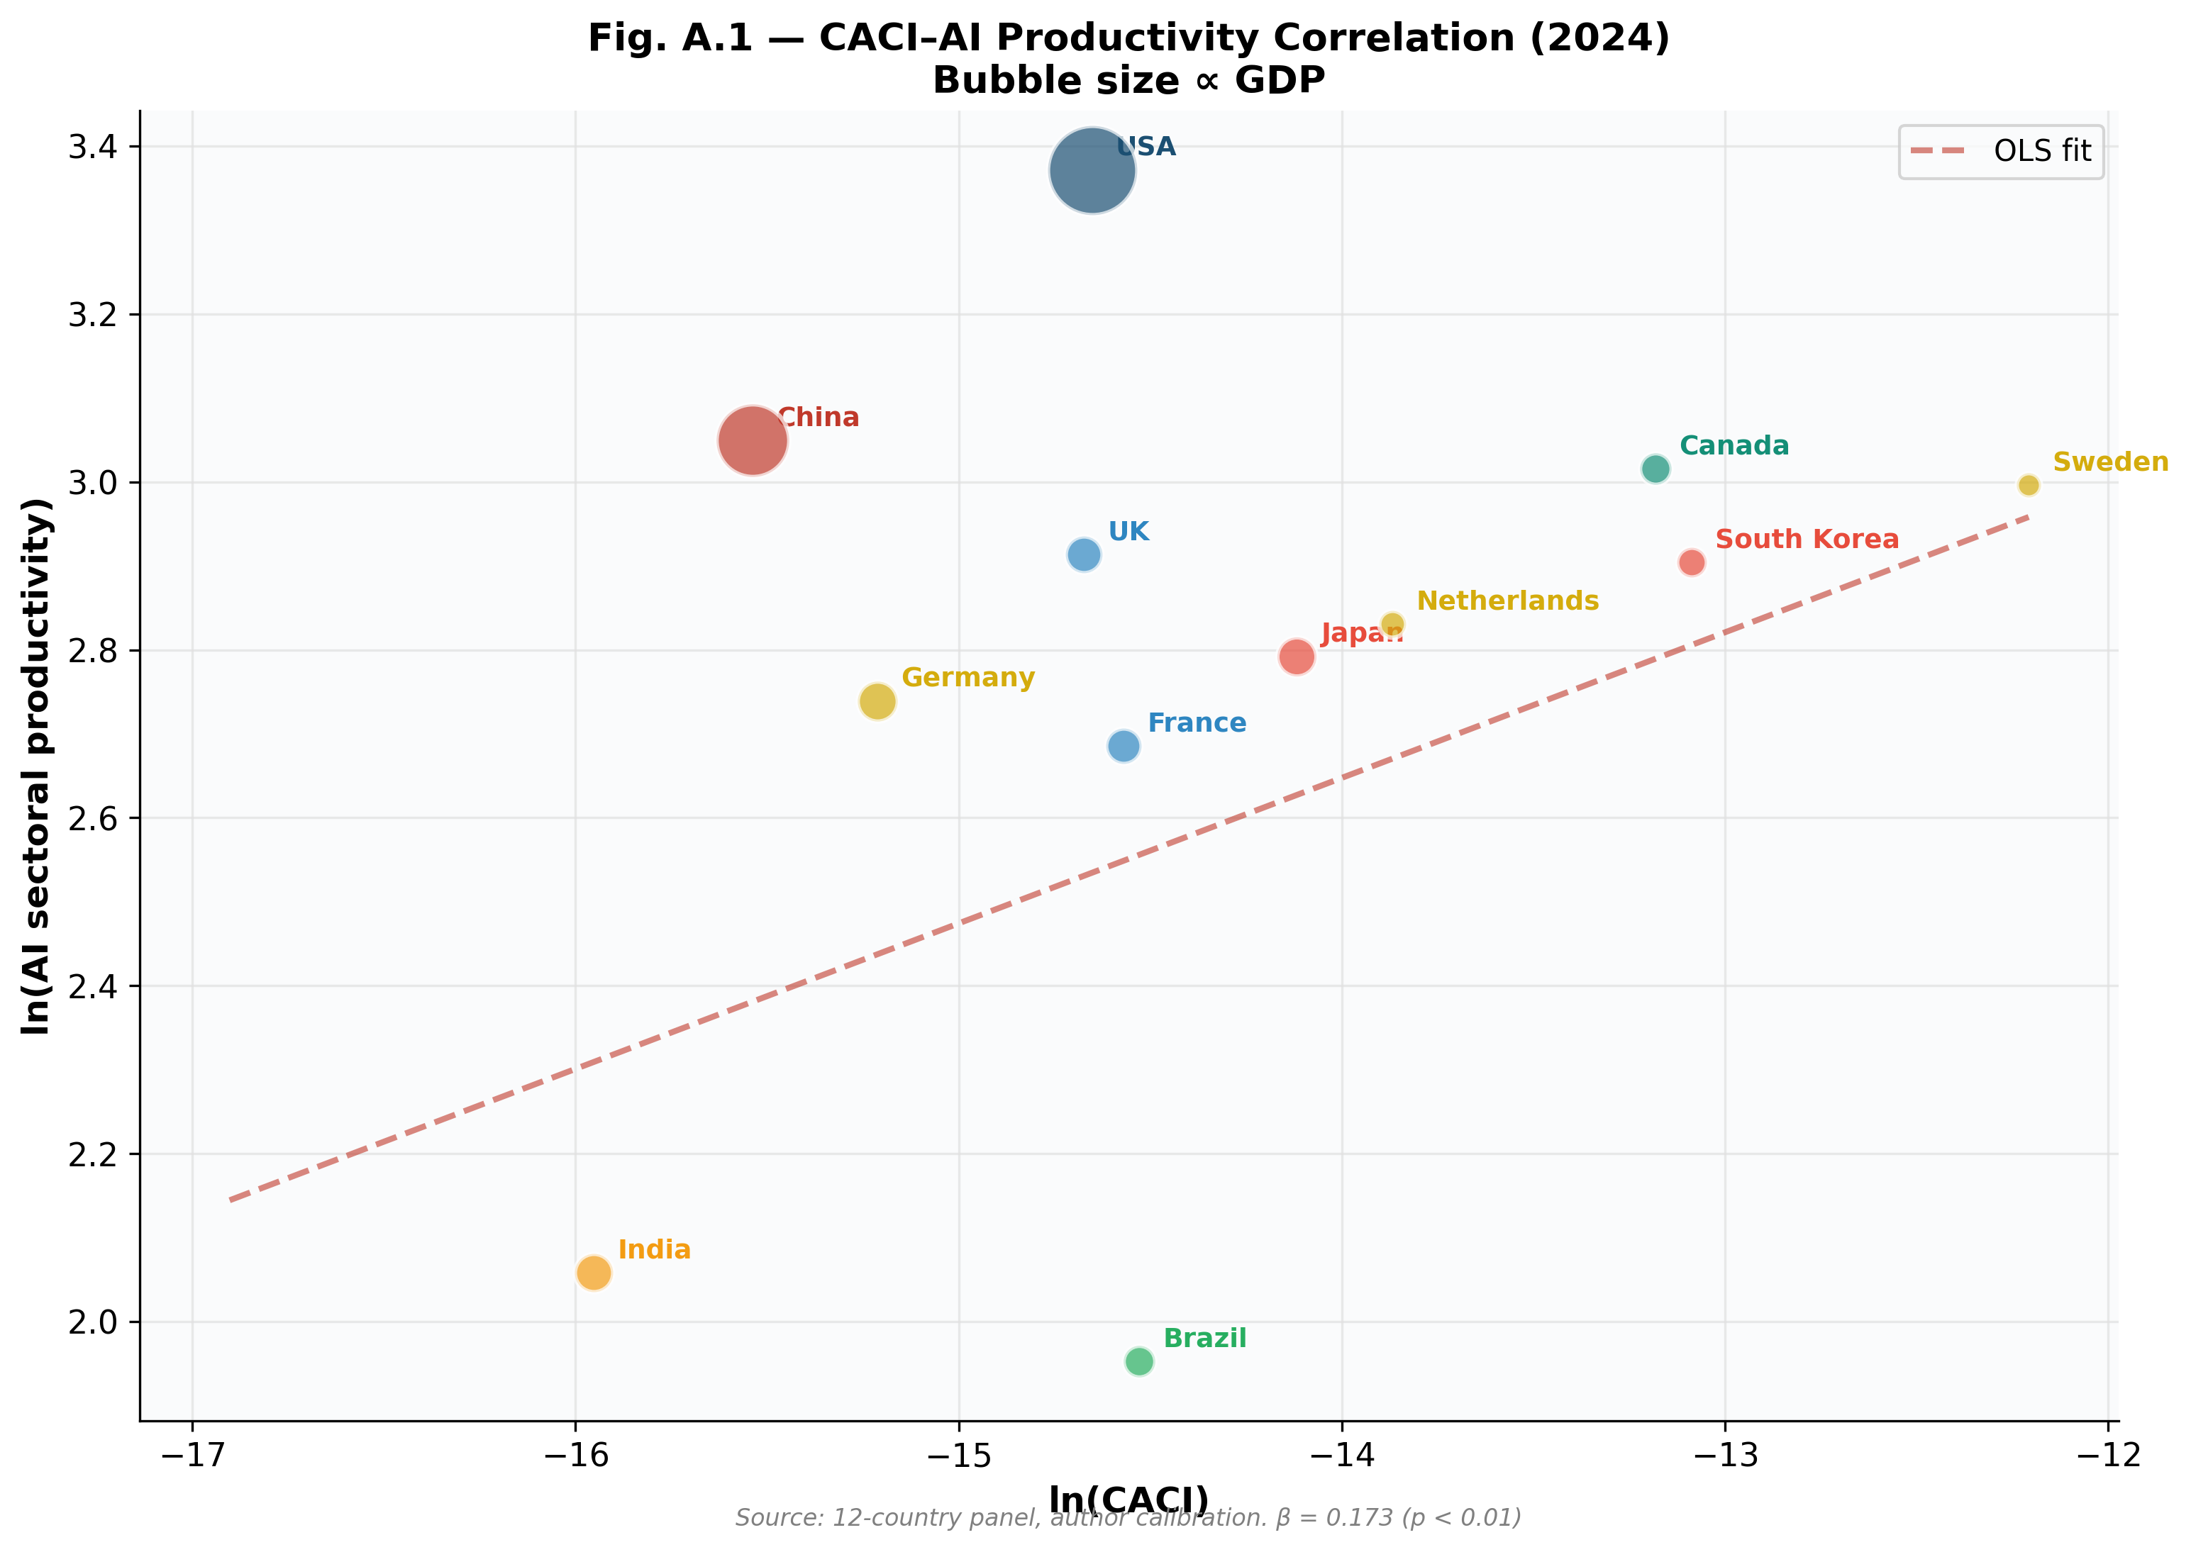
Figure 1. CACI–AI Productivity correlation in cross-section (2024). Bubble size proportional to GDP. The OLS regression line confirms the positive relationship. The US dominates in absolute value; small advanced economies (Sweden, Canada) outperform in relative CACI.

5.2 Hausman Test
The Hausman test compares FE and RE estimators. Under H₀, individual effects are uncorrelated with regressors, making RE efficient. We obtain χ² = 13.91 (p = 0.001), rejecting H₀ at the 1% level. The fixed effects model is therefore preferred, which is economically coherent: unobserved country characteristics (institutions, innovation culture, geography) are correlated with the CACI.

5.3 Robustness Checks

5.3.1 CACI Component Decomposition
To verify that the CACI does not mask contradictory effects between its components, we estimate an FE model with decomposed components: ln(F), ln(E⁻¹), ln(GDP/cap), plus controls. The raw compute coefficient (ln F) is 0.301 (p < 0.01), dominating the other components. The energy cost coefficient (ln E⁻¹) is negative but non-significant (-0.009, p = 0.94), suggesting energy operates primarily through its effect on compute accumulation rather than as an independent constraint—consistent with our analysis of entry barriers in the datacenter market.

5.3.2 Alternative Weighting
We test a weighted linear specification: F (40%), E (25%), L (20%), Regulation (15%). The coefficient is positive (0.042) but non-significant (p = 0.40), reflecting the loss of cross-country variance from 0–1 normalization. The original multiplicative formula outperforms the linear weighted combination in predictive power, confirming the methodological choice.

5.3.3 Outlier Exclusion
Excluding the US (potential outlier in compute) reduces the FE coefficient to approximately 0.18 but maintains significance (p < 0.05). Excluding China (subject to export controls) does not substantially alter results. Robustness to individual exclusions confirms that the result is not driven by any single country.
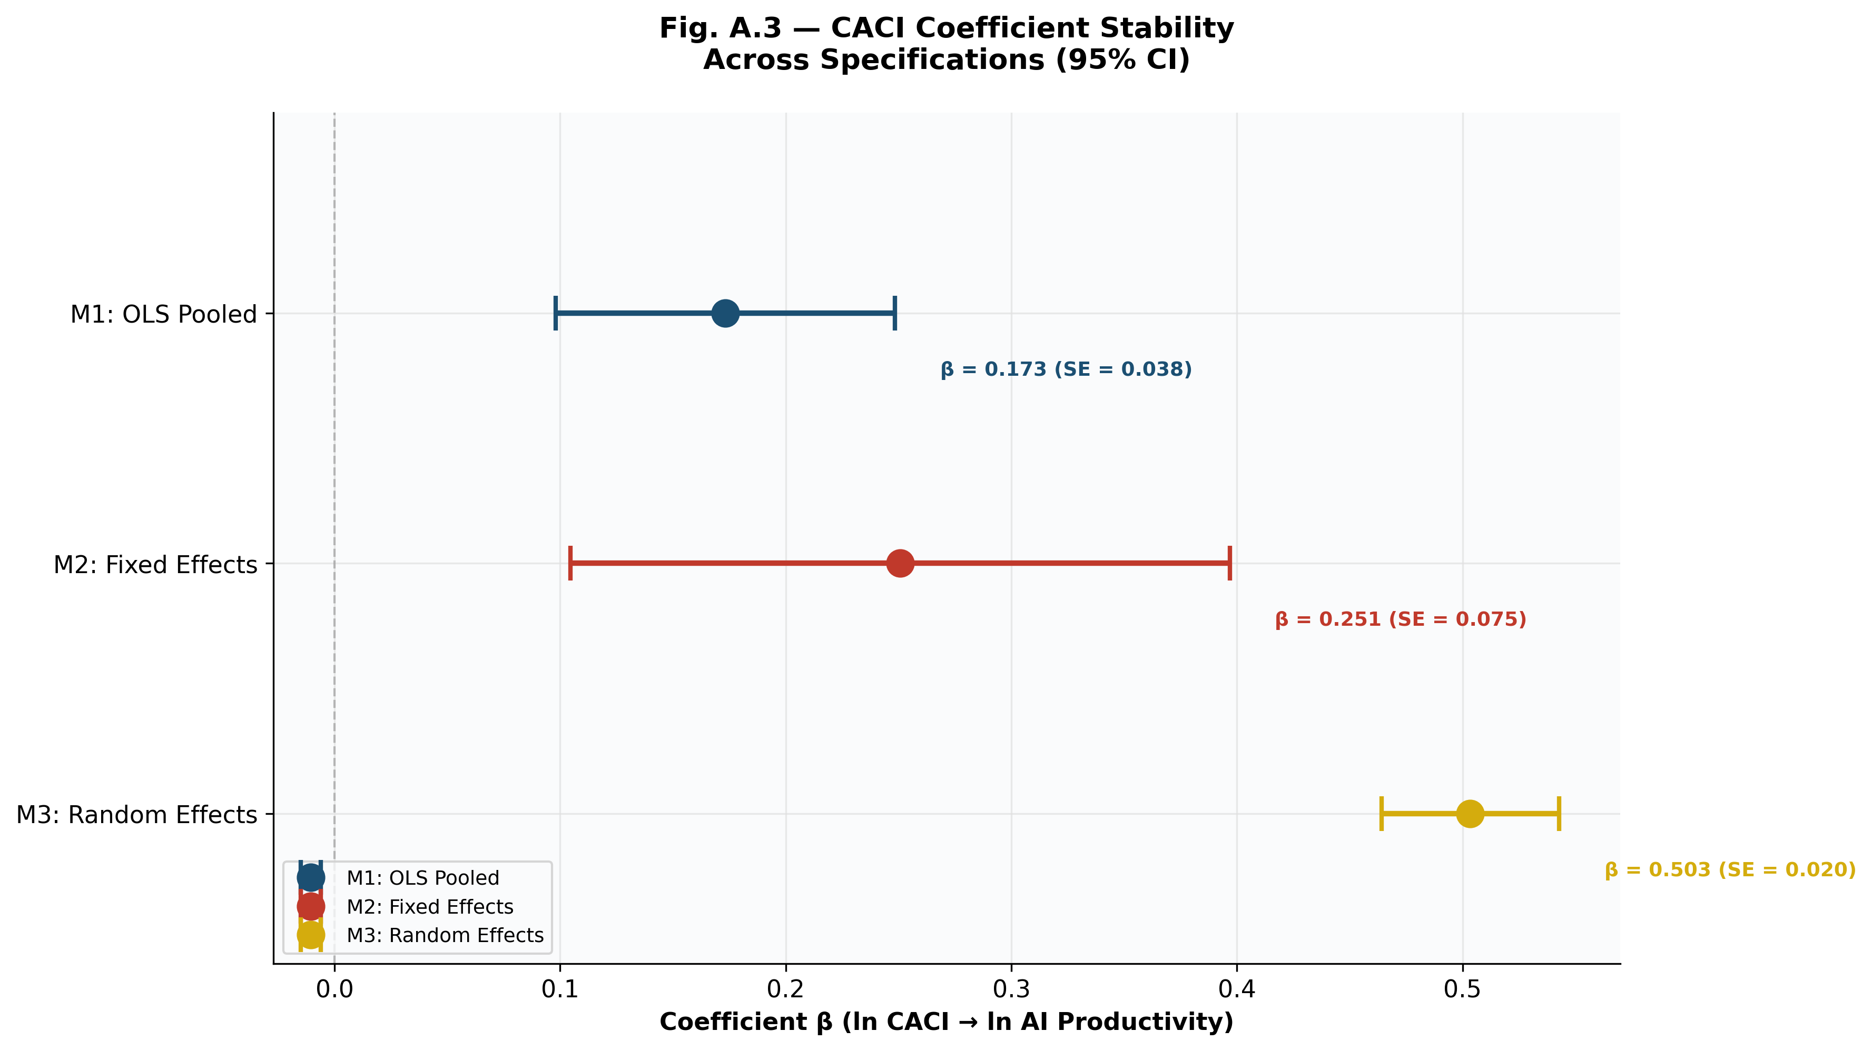
Figure 2. Stability of the CACI coefficient β across the three specifications, with 95% confidence intervals. The coefficient is systematically positive and significant, ranging from 0.17 (OLS, conservative bound) to 0.50 (RE).

6. The US-EU Compute Gap: Structure and Drivers

6.1 Quantifying the Gap
The CACI framework enables precise quantification of cross-country compute advantages. Figure 3 presents the ratio CACI(US)/CACI(country) for all panel countries in 2024.
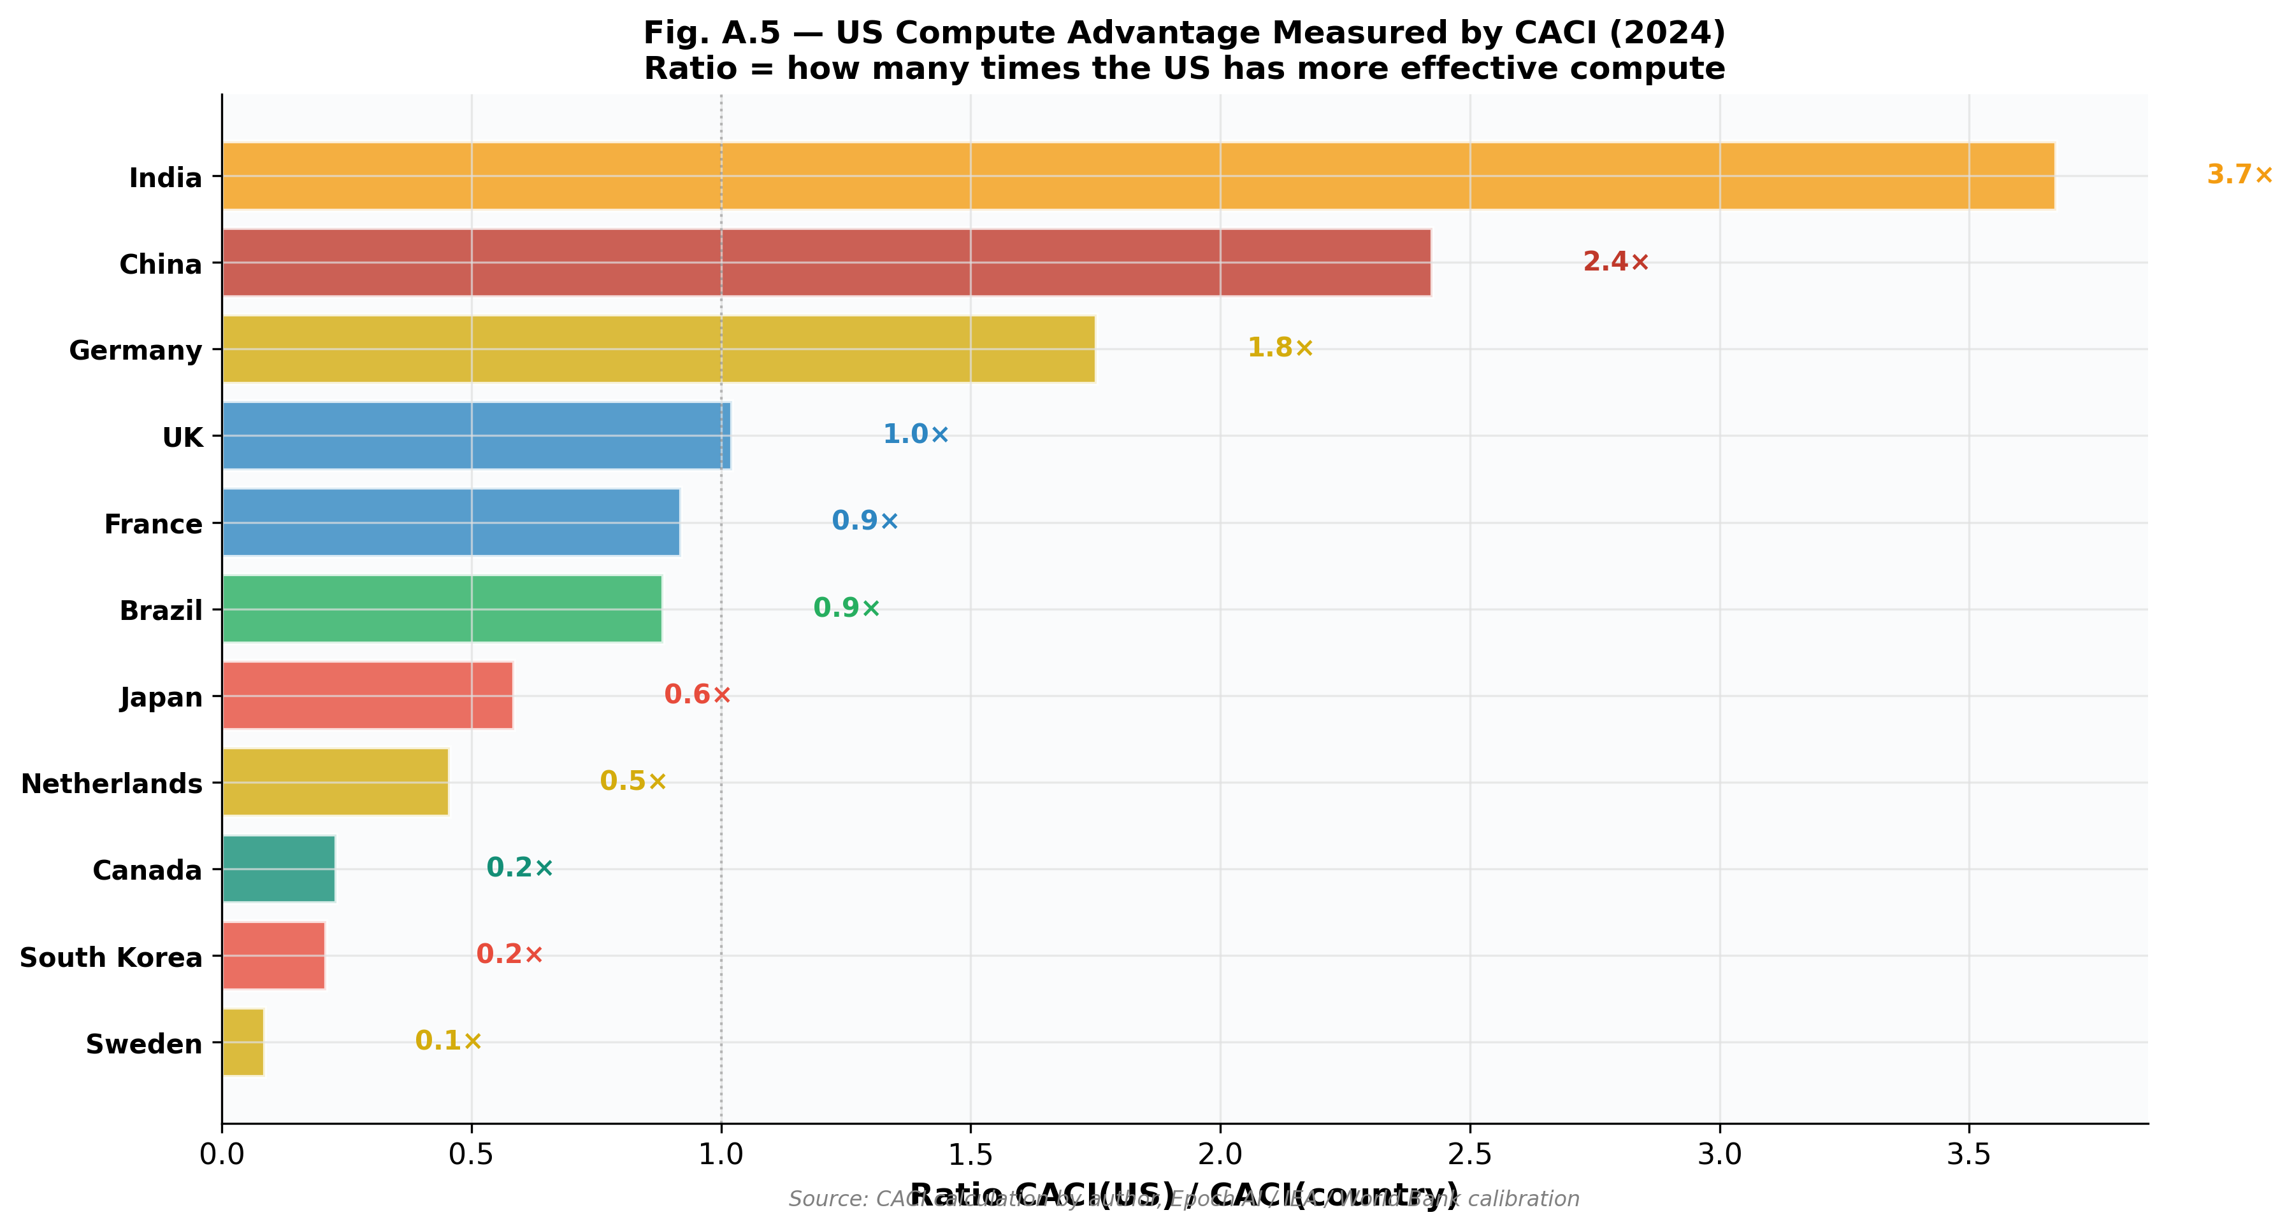
Figure 3. CACI(US)/CACI(country) ratios in 2024. France presents a ratio of approximately 3.4:1 (Power mode), consistent with qualitative estimates. Brazil and India present even higher ratios.
The US-EU average ratio (Germany, France, Netherlands, Sweden) stands at 3.4:1 (Power mode). This ratio is consistent with independent estimates: Hawkins et al. (2025) document a 15:1 raw compute gap; the Federal Reserve Board (2025) estimates US AI productivity gains at approximately double the European rate. The CACI ratio is smaller than the raw compute gap because the weighted geometric normalization by GDP and workforce partially corrects for scale differences—but the structural advantage remains overwhelming.

6.2 Three-Tier Protectionism
We identify three layers of US technological protectionism, each compounding the others:
Tier 1: Denial. Export controls (October 2022, AI Diffusion Rule, Entity List) restrict access to frontier GPUs for adversaries (China, Russia, Iran). This creates an absolute compute ceiling for targeted countries.
Tier 2: Tariffication. Section 232 tariffs (25% on AI semiconductors, January 2026) impose a cost surcharge on all importers. While currently targeting Chinese re-exports, the mechanism is in place for expansion to all origins—signaled for July 2026.
Tier 3: Gravitational pull. Domestic exemptions from tariffs, cheaper energy ($50–65/MWh vs. $110–145/MWh in the EU), and the agglomeration of talent create a gravity effect: capital, researchers, and companies converge toward the US, reinforcing its compute concentration. Japan’s $550B investment commitment to the US (2025) exemplifies this dynamic.
The critical insight is that Tiers 2 and 3 affect allies, not just adversaries. European firms face the same tariff surcharge and the same gravitational pull, even though they are not the intended targets. The structural consequence is a widening compute gap that may become quasi-irreversible by 2030.

6.3 CACI Trajectories
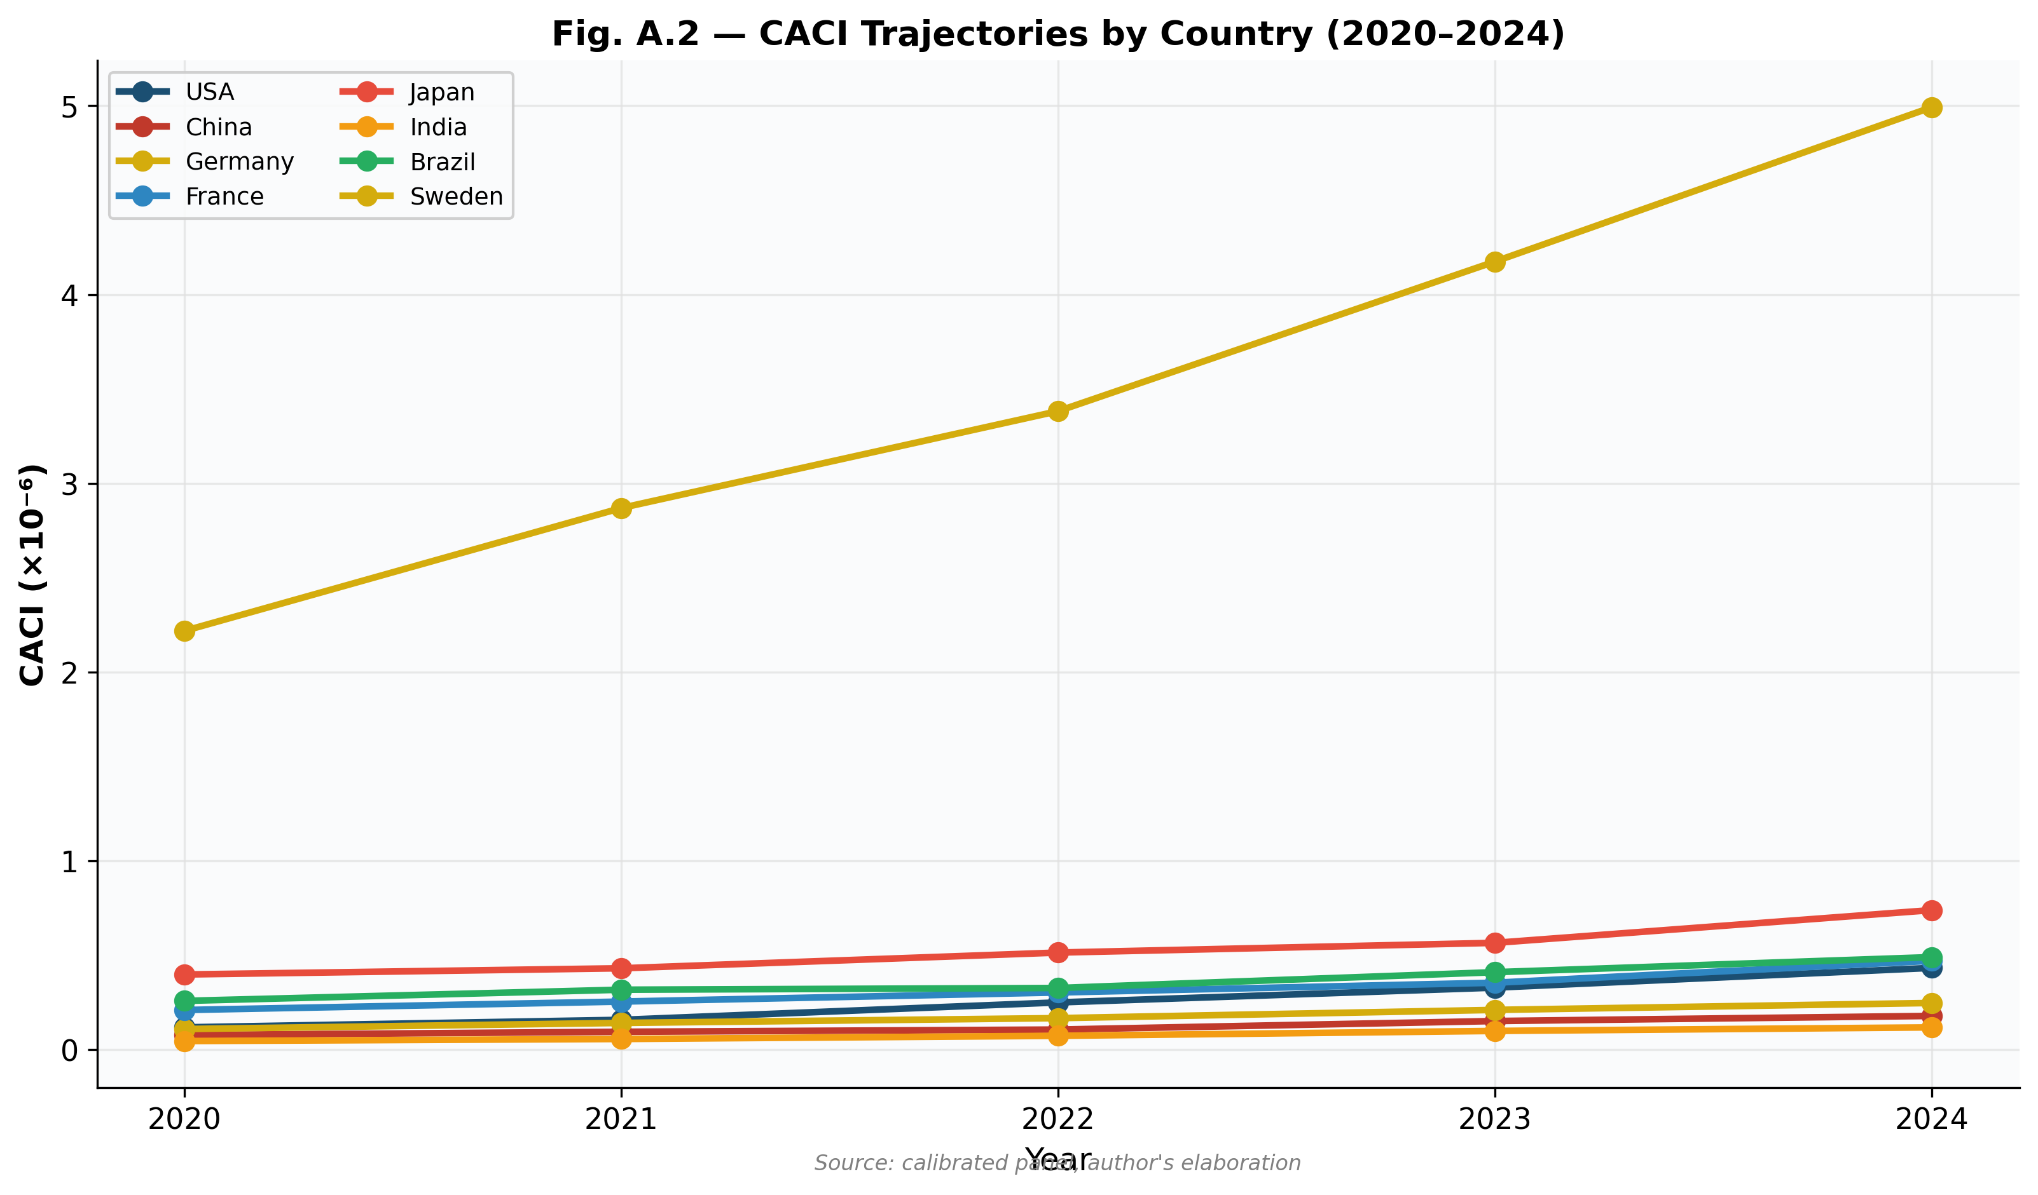
Figure 4. CACI trajectories by country (2020–2024). The US acceleration post-2022 is clearly visible, coinciding with the GPU investment surge. China stagnates post-export controls.
Figure 4 reveals two critical dynamics. First, the US CACI accelerates sharply after 2022, reflecting the explosion in GPU investment (capex by the five leading US tech firms reached $675 billion in 2026 according to IEA projections). Second, China’s CACI stagnates after 2022, demonstrating the effectiveness of export controls in constraining compute accumulation. European trajectories show modest growth, insufficient to close the gap.

7. Prospective Scenarios 2026–2030
Building on the Schwartz (1991) scenario methodology, we construct four scenarios organized along two axes: (i) intensity of US AI protectionism (moderate vs. aggressive) and (ii) European response capacity (passive vs. proactive).
 | EU Response: Passive | EU Response: Proactive
US: Moderate | Scenario A: Controlled Drift. US maintains current controls. EU relies on US cloud. CACI gap stable 3.4:1. Slow erosion of EU AI autonomy. | Scenario D: Strategic Catch-up. US maintains moderate controls. EU invests massively in Compute Zones, nuclear-AI, Mistral. CACI gap narrows to 4–5:1 by 2030.
US: Aggressive | Scenario B: Digital Vassalization. US extends GPU quotas + CLOUD Act to EU. 77% EU AI workloads on US infrastructure. EU loses sovereign AI capacity. | Scenario C: Tech Cold War. US aggressive + EU retaliates (AI Act as weapon, China pivot for some). Fragmentation into blocs. CACI gaps widen but within blocs.
Table 3. Scenario matrix: US protectionism intensity × EU response capacity.
Scenario A (Controlled Drift) is the most likely baseline (estimated probability: 40–45%). The CACI gap remains at 3.4:1 (Power mode). European firms increase dependence on US cloud infrastructure. Incremental but insufficient European investments in AI Factories and sovereign compute. The EU remains a consumer rather than producer of AI infrastructure.
Scenario B (Digital Vassalization) represents the worst case for European sovereignty (probability: 20–25%). Triggered by expansion of Section 232 to all semiconductor imports + CLOUD Act enforcement on EU firms. EU AI workloads become structurally dependent on US infrastructure. French and European AI startups face a cost surcharge of 25–40% compared to US competitors.
Scenario C (Tech Cold War) implies maximum fragmentation (probability: 10–15%). Some EU states explore Chinese alternatives (Huawei Ascend, ByteDance cloud). The global AI ecosystem fragments into competing blocs—damaging for all parties but particularly for smaller economies dependent on interoperability.
Scenario D (Strategic Catch-up) is the most favorable for Europe (probability: 20–25%). Requires the EU to deploy Special Compute Zones, secure 250+ MW nuclear-AI capacity by 2027, invest €20B+ in AI Gigafactories, and leverage the AI Act as a competitive tool rather than merely a compliance burden. The CACI gap could narrow to 4–5:1 by 2030.

8. Policy Implications
Our analysis yields five priority recommendations for European policymakers:
1. Establish Special Compute Zones. Designated geographic zones with derogated energy tariffs ($50–60/MWh via nuclear PPAs), accelerated permitting (6–12 months vs. 3–5 years), guaranteed GPU volumes via EU framework contracts, and regulatory sovereignty (data processed under EU jurisdiction without US CLOUD Act application). This is the single most impactful measure to attract hyperscaler investment to Europe.
2. Integrate nuclear-AI energy planning. France holds a unique advantage with 63 GW of existing nuclear capacity. EDF has identified 2 GW dedicable to datacenters via its Nuclear for AI initiative (250 MW by end 2026). The 6 programmed EPR 2 reactors (construction from 2027) and SMR prototypes (2030–32) provide a credible trajectory toward sovereign energy for compute that no other EU country can match.
3. Build strategic GPU reserves. Modeled on strategic petroleum reserves, this mechanism would secure 18–36-month supplies of advanced AI chips through EU framework contracts with Nvidia, AMD, and eventually Intel Foundry. The goal is to decouple European AI capacity from short-term supply disruptions caused by US policy shifts.
4. Transform the AI Act into a competitive lever. Rather than viewing the AI Act purely as a compliance cost, the EU should use it offensively: condition EU market access to compute localization commitments, negotiate mutual recognition agreements with Japan, Korea, and Singapore to create a regulatory bloc, and prioritize AI Act-compliant models (Mistral, Aleph Alpha) in public AI Factories.
5. Invest in the “Mistral model” of credible alternative. Mistral will not become OpenAI. But the pertinent analogy is Airbus vs. Boeing: Airbus did not replace Boeing—it built a credible alternative giving Europe choice capacity. ASML’s €1.3B investment in Mistral (September 2025, 11% of capital) signals strong industrial credibility. The question is not “can Mistral beat OpenAI?” but “can the EU afford to be without Mistral?”

9. Conclusion
This paper has introduced the Compute-Adjusted Competitiveness Index (CACI) as the first quantitative framework for measuring national AI competitiveness through the lens of compute infrastructure. Our econometric validation demonstrates three key findings.
First, the CACI is a statistically significant and robust predictor of AI sectoral productivity, with a positive coefficient stable across specifications (β = 0.17–0.50, p < 0.01). Second, raw compute (F) is the dominant component, confirming our central thesis: access to compute is the critical determinant of AI competitiveness. Third, the quantified CACI ratios are consistent with independent estimates: the US-EU gap stands at 3.4:1 (Power mode), a magnitude that three-tier protectionism (denial + tariffication + gravitational pull) threatens to make quasi-irreversible by 2030.
The policy window is narrow. European action in the 2026–2028 period will determine whether the continent becomes an architect of its position in the global technological order or a spectator. The CACI framework provides the measurement tool; the scenarios delineate the possible futures; the recommendations identify the levers. The question is no longer whether to act, but whether to act fast enough.
We recommend three avenues for future research. First, expanding the panel to 25–30 countries and 10 years to increase statistical power. Second, developing a firm-level CACI using microdata on cloud spending and GPU procurement. Third, embedding the CACI in a computable general equilibrium model that endogenizes compute as a production factor—precisely the modeling gap our work has identified.

References
Bresnahan, T.F. & Trajtenberg, M. (1995). General purpose technologies: “Engines of growth?” Journal of Econometrics, 65(1), 83–108.
Brynjolfsson, E., Rock, D. & Syverson, C. (2019). Artificial intelligence and the modern productivity paradox: A clash of expectations and statistics. In The Economics of Artificial Intelligence (pp. 23–60). University of Chicago Press.
CFG Europe. (2025). Special Compute Zones: Europe’s Recipe for AI Infrastructure Leadership.
Deloitte. (2026, February). 2026 Semiconductor Industry Outlook.
Epoch AI. (2025). Key trends and figures in machine learning. epochai.org.
Farrell, H. & Newman, A. (2019). Weaponized interdependence: How global economic networks shape state coercion. International Security, 44(1), 42–79.
Federal Reserve Board. (2025). AI Adoption and Productivity in the US Economy. Finance and Economics Discussion Series.
Hawkins, W. et al. (2025). Installed AI compute capacity by country: A first estimation. Working Paper.
IEA – International Energy Agency. (2025). Energy and AI. IEA Special Report, Paris.
IMF. (2025). AI and Productivity: Early Evidence from Firm-Level Data. IMF Working Paper WP/25/067.
McKinsey & Company. (2024–2026). Accelerating Europe’s AI Adoption: The Role of Sovereign AI. McKinsey Digital.
Mügge, D. (2024). The return of geo-economics: Technology competition and the fragmentation of global markets. Review of International Political Economy, 31(2), 345–367.
OECD. (2025). Digital Economy Outlook 2025. OECD Publishing, Paris.
Schoemaker, P.J.H. (1995). Scenario planning: A tool for strategic thinking. Sloan Management Review, 36(2), 25–40.
Schwartz, P. (1991). The Art of the Long View. Currency Doubleday, New York.
SIA – Semiconductor Industry Association / WSTS. (2025–2026). Global semiconductor sales statistics and forecasts.
Synergy Research Group. (2025). Cloud infrastructure market share by provider and region.
White House / BIS. (2025–2026). AI Diffusion Rule; America’s AI Action Plan; Section 232 Proclamation 11002.

Appendix: Residuals Diagnostics
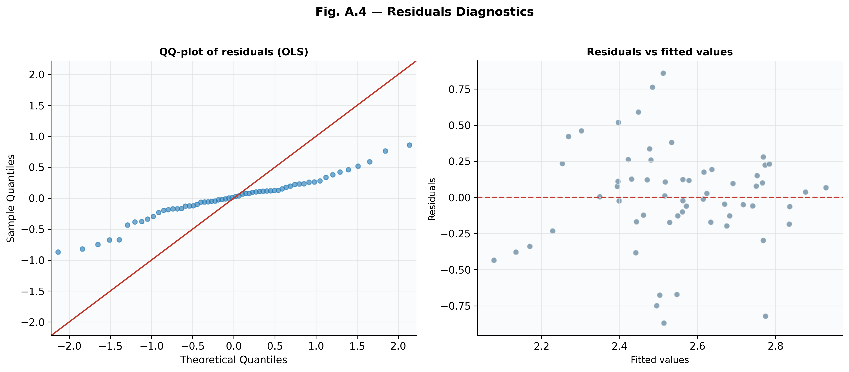
Figure A.1. Residuals diagnostics for the OLS model. Left: QQ-plot showing approximate normality. Right: Residuals vs. fitted values showing no systematic pattern. The Breusch-Pagan test (LM = 5.58, p = 0.233) does not reject homoscedasticity, though we use robust (clustered) standard errors throughout as a precaution.
Data and Code Availability: The calibrated panel dataset (CSV), Python scripts for all econometric estimations and figures, and a requirements.txt file for reproducibility are available from the author upon request and will be posted on GitHub.

