JuiceLab Coach for PwnzzAI — Teacher guide
PwnzzAI cohort + central JuiceLab dashboard — Windows / macOS / Linux

1. Your role and the topology
Each student runs the full PwnzzAI stack (coach + app + ollama) on their own machine. While they play, their machines push progress events to ONE single central dashboard. You get a real-time cohort matrix (students x labs).
The dashboard is central and SHARED: a single instance serves both JuiceLab (Juice Shop) cohorts AND PwnzzAI cohorts — both report into the same matrix. PwnzzAI NEVER duplicates the dashboard server code; it plugs in as a client via JUICELAB_DASHBOARD_URL. Anti-pattern to avoid: deploying a second PwnzzAI-specific dashboard.
Students NEVER launch the dashboard and never open its interface: they just point at it with -d <teacher-ip>. Deploying the dashboard (section 4) is teacher-only.
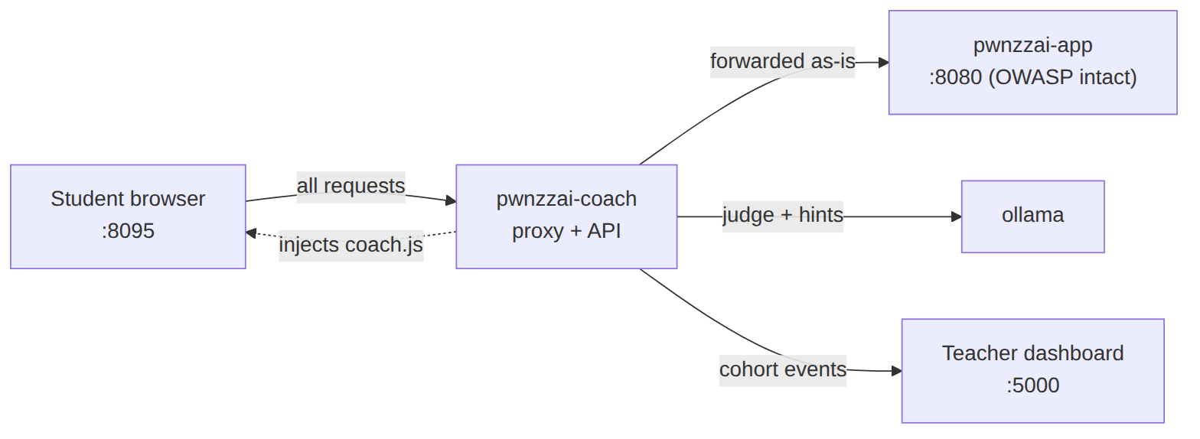
Each student machine: coach -> app/ollama, and events reported to the central dashboard.

2. Prerequisites
Tool | Minimum version | Note
Docker Desktop (Win/macOS) or Docker Engine (Linux) | 24+ | docker.com
Docker Compose v2 | ships with Docker Desktop | Linux: see Docker appendix
Git | recent version | git-scm.com
RAM | 8 GB free recommended | Ollama loads the judge model in memory
Disk | 6 GB free | PwnzzAI image + Ollama models
Quick sanity check:
docker --version # 24.x or newer
docker compose version # v2.x or newer
git --version

If 'docker compose version' fails, Docker is too old. Linux: sudo apt install docker-compose-v2 (or docker-compose-plugin). Windows / macOS: update Docker Desktop.
The dashboard is lightweight. It must be reachable by students: flat LAN and port 5000 open in the firewall.

3. Prepare the cohort
Pick a cohort id (JUICELAB_COHORT_ID) that groups students in the matrix, e.g. M2-IA-2026. Then hand each student TWO pieces of information:
To hand out | Example | Role
Cohort id | M2-IA-2026 | Groups the class (students' -c key)
Teacher dashboard IP/URL | 192.168.1.10 | Where student machines push their progress (students' -d key)
The exact command each student runs (cohort mode):
# Linux / macOS
./scripts/install-student.sh -c M2-IA-2026 -d 192.168.1.10 -l <firstname>

# Windows PowerShell 7+
.\scripts\install-student.ps1 -Cohort M2-IA-2026 -Dashboard 192.168.1.10 -Label <firstname>

Give each student a unique label (-l / -Label, e.g. their firstname), otherwise two machines collide in the matrix. The dashboard port is 5000 by default; specify <ip>:<port> if you use another.

4. Deploy the central dashboard (TEACHER ONLY)
This section is teacher-only. Students NEVER run this script: they have no dashboard to deploy.
Most common case: a central dashboard already exists (shared JuiceLab instance). Then you only communicate its IP/URL to students (section 3). If the dashboard does not exist yet and you want to deploy it FROM this machine, scripts/deploy-dashboard.sh does a pinned sparse-checkout of the juicelab repo and pulls ONLY the teacher part (dashboard/, docker/, scripts/) — the overlay and the student Juice Shop are never pulled.
# Linux / macOS
./scripts/deploy-dashboard.sh

# Windows PowerShell 7+
.\scripts\deploy-dashboard.ps1

The deployment reads these keys from PwnzzAI's .env:
Variable | Role | Default
JUICELAB_REPO_URL | juicelab repo (source of the teacher part) | https://github.com/mo0ogly/juicelab.git
JUICELAB_DASHBOARD_REF | pulled ref (SHA advised in prod) | main
Once the dashboard is up, point JUICELAB_DASHBOARD_URL at it (student-side, that is the value of -d):
Variable (student .env) | Role | Example
JUICELAB_DASHBOARD_URL | Dashboard URL as seen from the container | http://host.docker.internal:5000
JUICELAB_COHORT_ID | Cohort id | M2-IA-2026
JUICELAB_INSTANCE_LABEL | Student machine name in the matrix | pwnzzai-poste-01
Dashboard on the same machine as the coach: use host.docker.internal (not 127.0.0.1). Remote dashboard: the teacher's IP. The dashboard registers the student automatically on the first event.
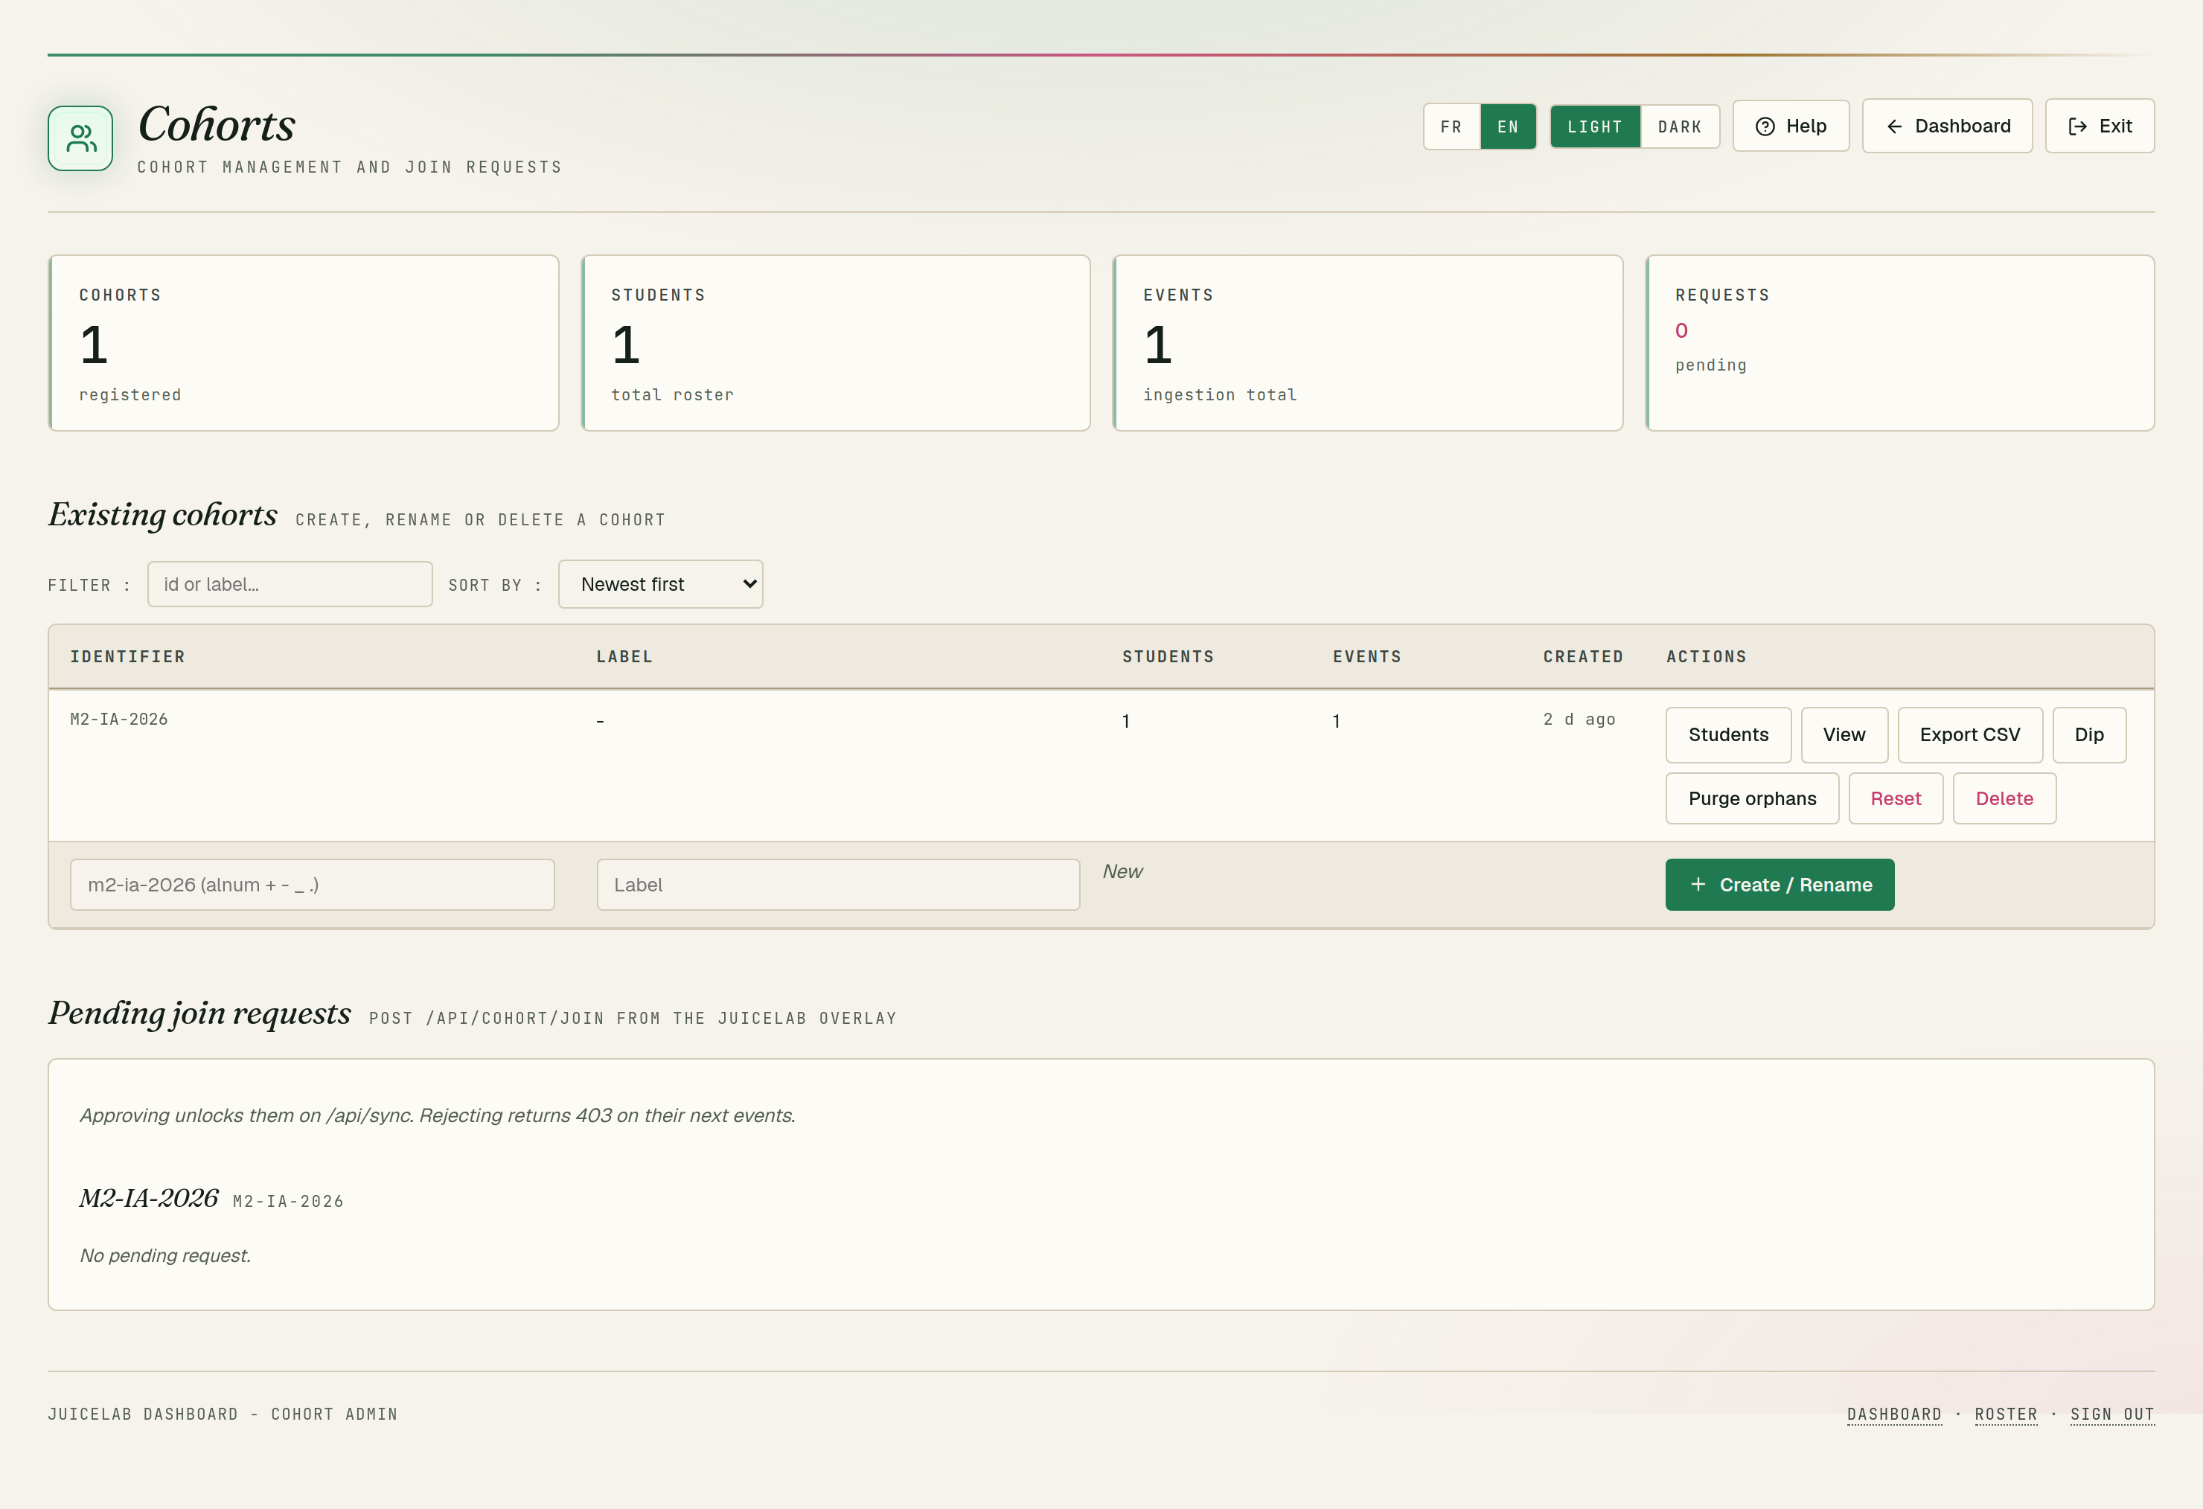
Teacher dashboard - PwnzzAI cohort on the central instance (light theme).
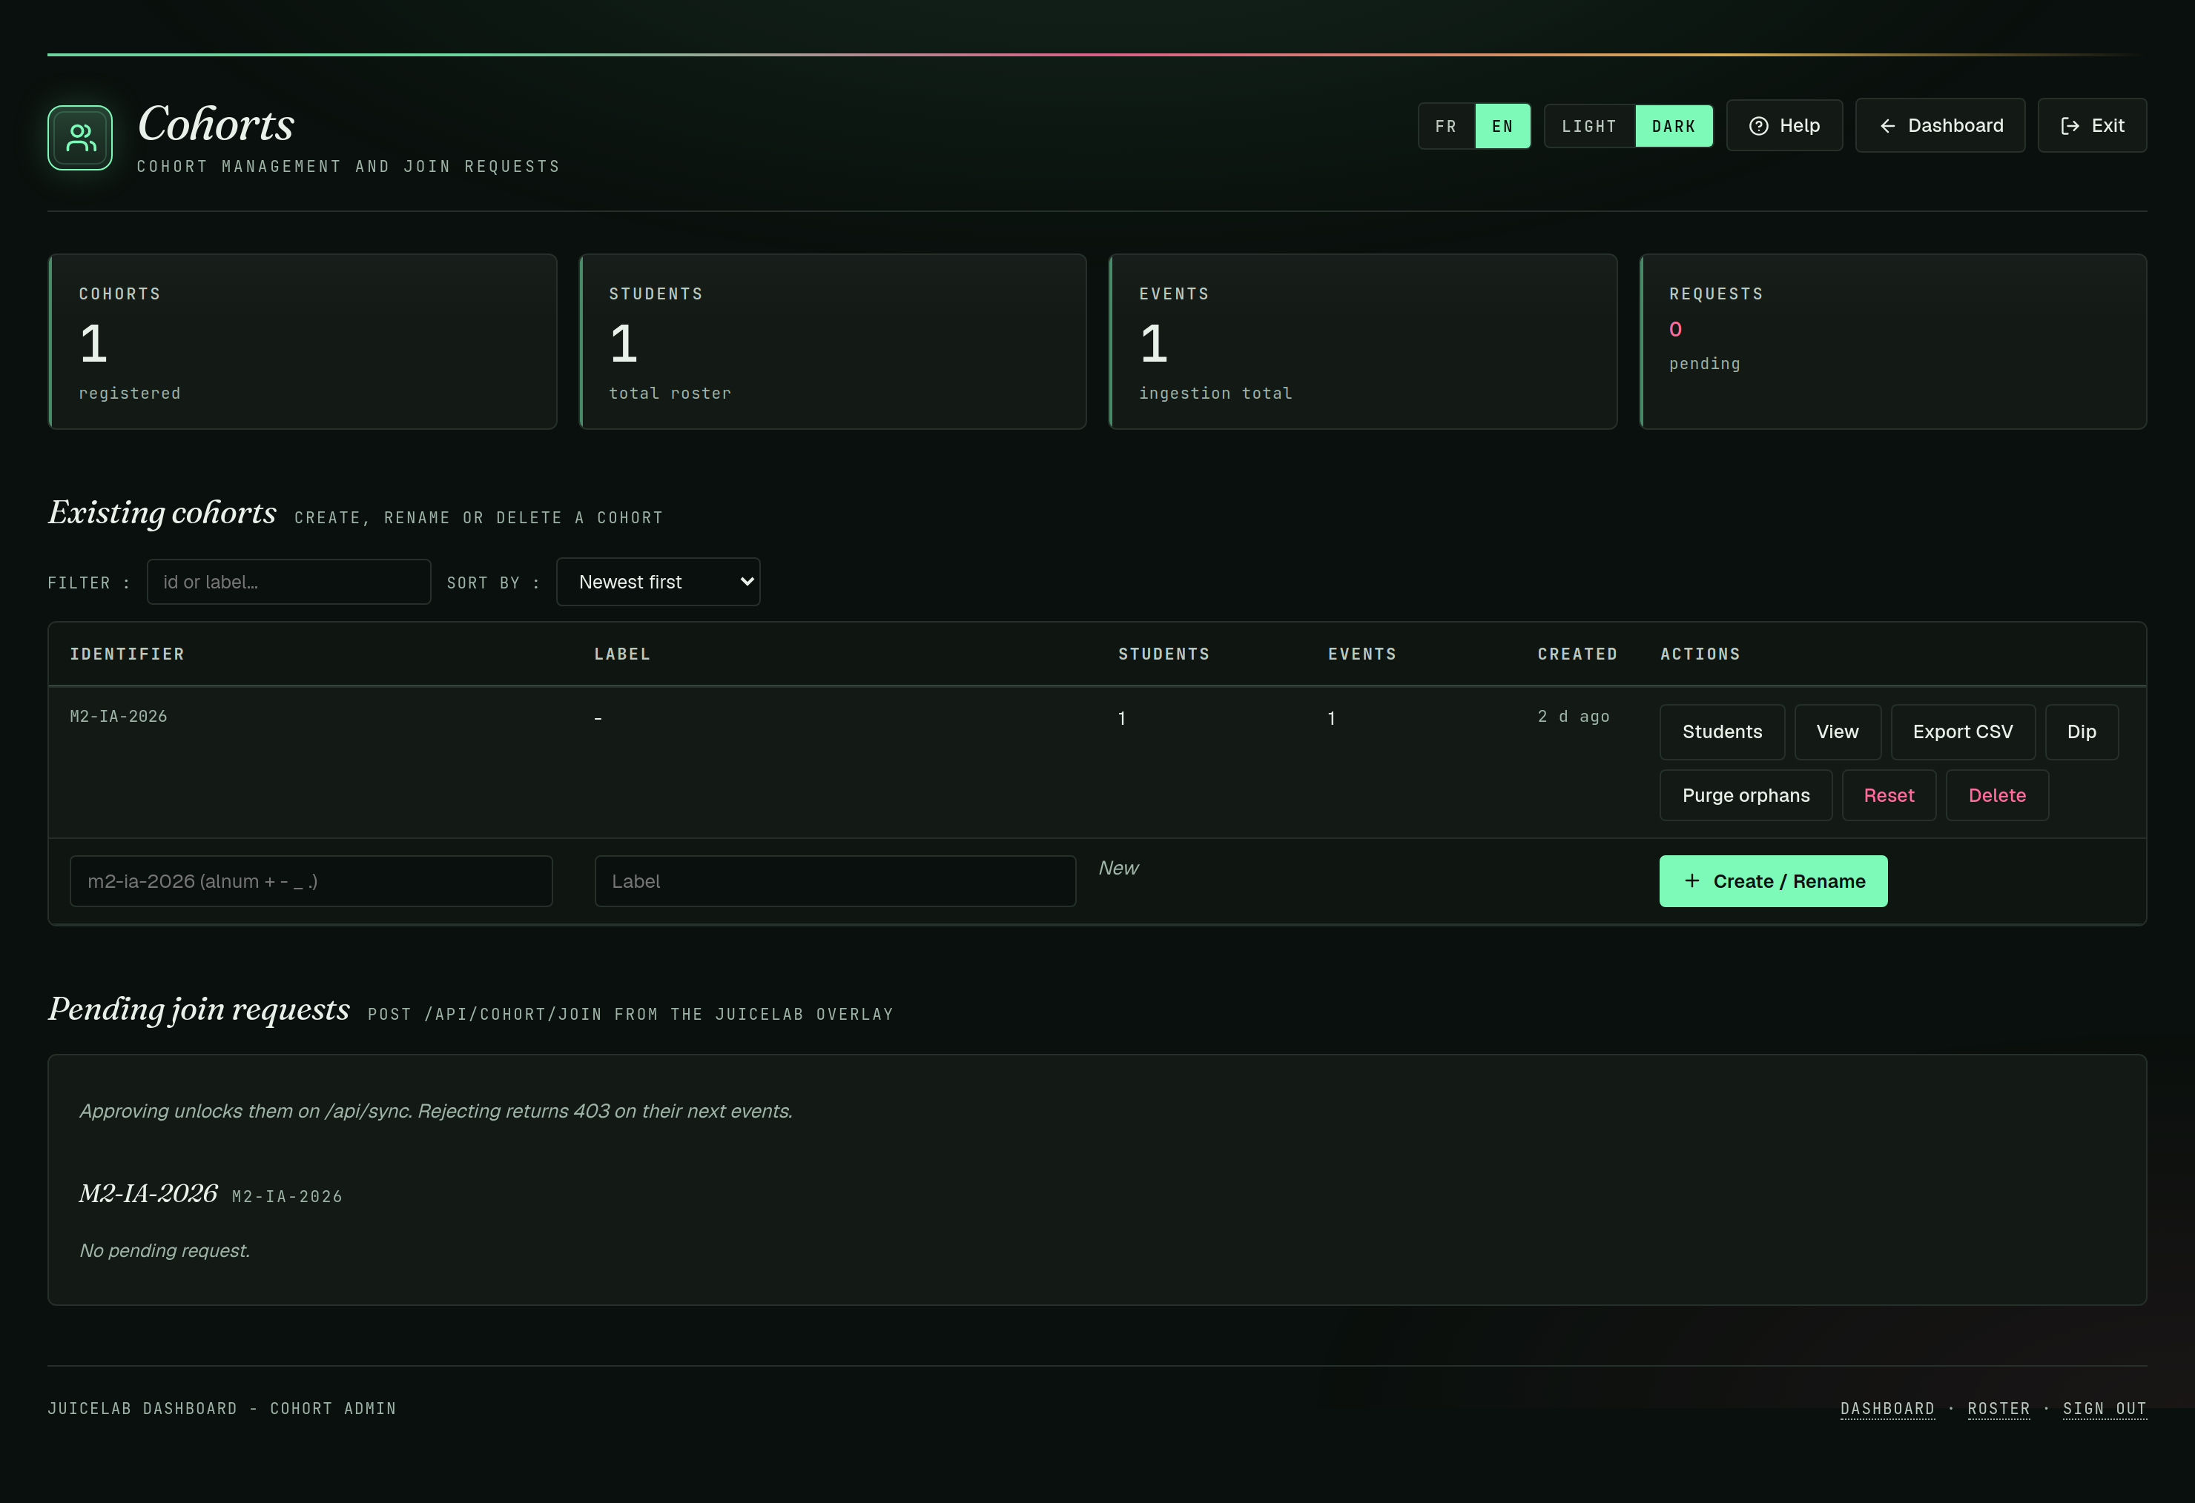
Same matrix in dark theme (toggle via the topbar).

5. What is reported: the events
The coach sends these events via the public POST /api/sync contract (the same as Juice Shop):
Event | Trigger | Data
session_start | opening a lab page | path, identity if detected
hint_revealed | revealing a hint | level N1-N5, cost, score
challenge_solved | judge -> Solved | score, verdict, justification
journal_filled | Journal after save | length, text
quiz_completed | quiz validation | score, correct / total
badge_earned | badge unlocked | badge id
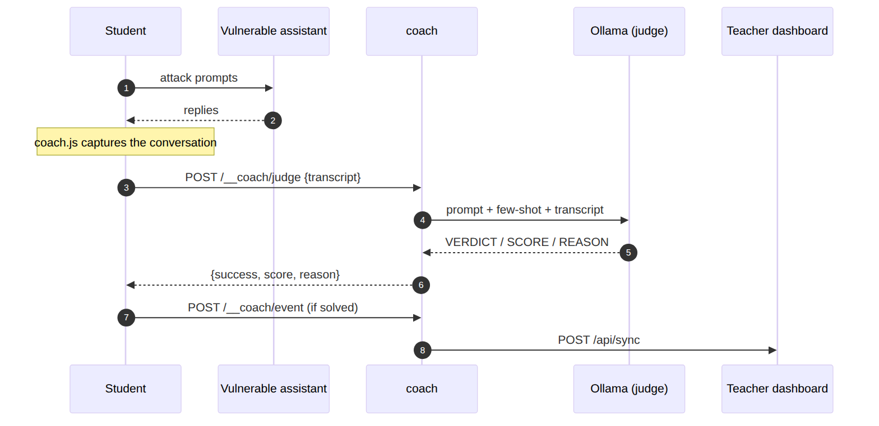
From transcript to judge verdict, then reported to the dashboard if solved.

6. Choosing the judge model
Model | Verdict | Recommendation
llama3.2:1b | unreliable (inconsistent) | avoid for the judge
llama3.2:3b | reliable on clear-cut cases | advised minimum
mistral:7b / llama3.1:8b | reliable on subtle cases | ideal if the machine can handle it
The judge model is independent from the labs' model: labs on 1b (fast, llama3.2:1b) and judge on 3b (reliable, llama3.2:3b) on the same machine. Set via COACH_JUDGE_MODEL in .env.
The judge and hints always run on local Ollama. The labs' TARGET (openai_*) can, however, run on a cloud provider (next section).

7. Configure an LLM provider (target)
By default the labs' TARGET assistant runs on local Ollama (100% offline). Since the OWASP product is built on LiteLLM, this target can run on many providers (Groq, OpenAI, Gemini, Anthropic) WITHOUT any code change — pure .env config. MODEL_PROVIDER=openai means 'cloud via LiteLLM' (not necessarily OpenAI); the prefix before the / in LITELLM_MODEL picks the real provider.
Provider | MODEL_PROVIDER | LITELLM_MODEL (example) | Key var
Ollama (local, default) | ollama | — (uses OLLAMA_MODEL) | —
Groq (recommended) | openai | groq/llama-3.3-70b-versatile | GROQ_API_KEY
OpenAI | openai | openai/gpt-4o-mini | OPENAI_API_KEY
Google Gemini | openai | gemini/gemini-2.0-flash | GEMINI_API_KEY
Anthropic | openai | anthropic/claude-3-5-haiku-latest | ANTHROPIC_API_KEY
To switch the target to a cloud provider (Groq example), put these three lines in .env then restart:
MODEL_PROVIDER=openai
LITELLM_MODEL=groq/llama-3.3-70b-versatile
GROQ_API_KEY=gsk_xxx

./pwnzzai.sh restart

Groq model: use groq/llama-3.3-70b-versatile (non-reasoning, reliable). Avoid groq/openai/gpt-oss-20b — a reasoning model that often returns empty (tested: HTTP 500 / empty response on some labs). Valid key = starts with gsk_ and returns 200 on https://api.groq.com/openai/v1/models (401 = invalid).
Only the openai_* cloud labs use this backend; ollama_* labs always use local Ollama, so keep the ollama service running. The key stays in .env (gitignored) — never commit it.
Security: the compose file passes GROQ_API_KEY, OPENAI_API_KEY, GEMINI_API_KEY and ANTHROPIC_API_KEY to pwnzzai-app, all empty by default (no behaviour change if unset). The key lives only in .env, never committed.
Cost (Groq): about 1-3 EUR per morning for 10 students. Enable pay-as-you-go and set a spend limit on the provider console (e.g. https://console.groq.com).
Upstream resilience: no modification of the OWASP product (LiteLLM does the routing). Since PwnzzAI is cloned at a pinned commit, this config survives upstream updates, like the rest of the sidecar.

8. Teardown
Student-side (stopping the PwnzzAI stack on their machine):
./pwnzzai.sh down # stop (keeps volumes)
./pwnzzai.sh wipe # down -v: stop + remove volumes

Central dashboard deployed from this machine (in the deployment directory, .juicelab-dashboard/docker):
docker compose --env-file .env down # stop the dashboard
docker compose --env-file .env down -v # stop + erase cohort data

down -v on the dashboard erases the SQLite database (all cohort progress). Collect the proofs first if needed.

Appendix — Install Docker and Docker Compose
Do this ONCE per machine, before the install procedure.

Windows 10/11
- Enable WSL2 (PowerShell as administrator), then reboot:
wsl --install

- Install Docker Desktop from docker.com (WSL2 backend by default).
- Launch Docker Desktop and wait for the 'running' status.
- Verify in a terminal:
docker run --rm hello-world
docker compose version

Virtualization error: enable 'Virtualization / SVM / VT-x' in the BIOS/UEFI and the Windows feature 'Virtual Machine Platform'. PowerShell 7+ (pwsh command) is required for the .ps1 scripts; Windows 10 ships PowerShell 5.1 by default, too old.

macOS
- Download Docker Desktop for Mac (Apple Silicon or Intel).
- Drag Docker into Applications, launch it, wait for 'running'.
- Verify:
docker run --rm hello-world
docker compose version

Apple Silicon (M1/M2/M3): the image builds natively as arm64, no Rosetta handling required (first build slightly longer).

Linux (Debian / Ubuntu)
Two mutually exclusive methods. Pick one OR the other.
Method A — distribution packages (recommended for a class):
sudo apt update
sudo apt install -y docker-compose-v2
sudo usermod -aG docker $USER
newgrp docker # or log out and back in
docker compose version

Method B — official Docker repository (latest version):
# set up the repo: https://docs.docker.com/engine/install/ubuntu/
sudo apt install -y docker-ce docker-ce-cli containerd.io \
docker-buildx-plugin docker-compose-plugin
sudo usermod -aG docker $USER
newgrp docker
docker compose version

The two packages are mutually exclusive. On Ubuntu 25.04+, use method A (docker-compose-v2). Never mix the two.
arm64 (Apple Silicon / Snapdragon): if a build fails with 'E: Dynamic MMap ran out of room', it is the APT cache. The project Dockerfile already includes the fix (APT::Cache-Start "100663296").

