Student install guide — PwnzzAI (JuiceLab Coach)
Installer PwnzzAI + le Coach JuiceLab sur ton poste — Windows / macOS / Linux

Goal: get OWASP PwnzzAI + the JuiceLab Coach working on your laptop in 10 to 15 minutes, on http://localhost:8095.
Localized version: STUDENT-INSTALL-FR.md (français).

0. Pick your mode BEFORE installing
There are two modes. The only difference is whether your progress is reported to the teacher dashboard. Read this table first.
Your situation | Mode | What you run | The teacher dashboard ?
Lab with a teacher (normal case) | Cohort | The full PwnzzAI stack ; your events are pushed to the teacher's dashboard | NO, you do NOT install it. The teacher hosts it.
You work alone, no teacher (revision, self-study) | Solo | The full PwnzzAI stack ; no reporting | NO. PwnzzAI has no student dashboard: the coach works locally, with no reporting.
WARNING — common mistake. In no mode do you install a dashboard on your laptop. PwnzzAI ships no student dashboard at all. During a lab (cohort mode), the teacher hosts the single central dashboard; you simply point at it with -d <teacher-ip> (section 3.2) and ask them for the IP. In solo mode there is simply no reporting — the coach (hints, judge, quiz, badges) still works locally.
In both modes, the stack running on your machine is identical (3 containers). Only the JUICELAB_DASHBOARD_URL key changes: set in cohort mode, empty in solo mode.

1. What you will install
PwnzzAI runs as a single `docker compose` stack at the repo root. Three containers, always all three, regardless of mode:
Container | Host port | What it does | Mode
pwnzzai-coach | 8095 → 8090 | Student entrypoint: proxy + coach panel (hints, judge, quiz, badges) | Cohort and Solo
pwnzzai-shop | 8090 → 8080 | Raw OWASP PwnzzAI (untouched, for debug) | Cohort and Solo
ollama | internal | Local LLM: lab model + judge/hint model (volume ollama_data) | Cohort and Solo
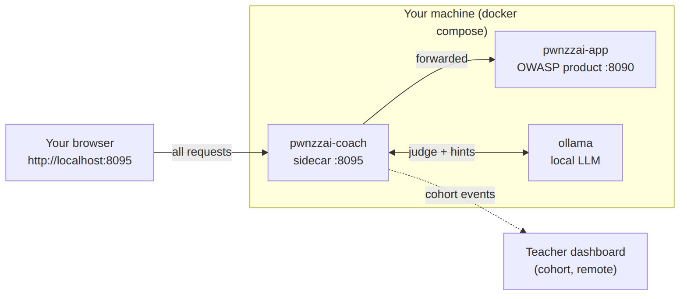
Student-side topology: your browser goes through the coach (sidecar), which forwards to the OWASP app, queries Ollama (judge + hints) and, in cohort mode, reports your events to the teacher dashboard.
You use only http://localhost:8095 (the coach). Port 8090 stays available to debug PwnzzAI without the coach.
The coach does not modify the OWASP product: it sits in front of it as a transparent proxy and injects a <script> into the page.
The first docker compose up --build builds the PwnzzAI image (cloned at a pinned commit): count 5 to 8 minutes. After that, every start is roughly 10 seconds. After the first up, you must pull the Ollama models (~2-3 GB download) — the installer does it automatically.
In cohort mode, no sensitive data leaves your laptop beyond the progression events (session_start, hint_revealed, challenge_solved, journal_filled, quiz_completed, badge_earned) sent to the teacher dashboard you point to. In solo mode, nothing leaves.

2. Prerequisites
Tool | Minimum version | Where to get it
Docker Desktop (Windows / macOS) or Docker Engine (Linux) | 24+ | https://www.docker.com/products/docker-desktop
Docker Compose v2 | bundled with Docker Desktop ; on Linux : sudo apt install docker-compose-v2 (distro) or docker-compose-plugin (official Docker repo) — see Appendix A | —
Git | any recent version | https://git-scm.com/downloads
RAM | 8 GB free recommended (Ollama loads the judge model in memory) | —
Disk | 6 GB free (PwnzzAI image + Ollama models) | —
Quick sanity check :
docker --version # Docker version 24.x or newer
docker compose version # Docker Compose v2.x or newer
git --version

If docker compose version errors out, your Docker is too old. On Linux : sudo apt install docker-compose-v2 (Ubuntu/Debian standard) or sudo apt install docker-compose-plugin (official Docker repo). On Windows / macOS : update Docker Desktop.
RAM/Ollama note. The coach uses a local LLM (Ollama) for hints and the judge. The default judge model (llama3.2:3b) fits in ~3-4 GB of RAM; leave some headroom. On a tight machine, keep the judge at llama3.2:3b (do not drop to 1b: unreliable verdicts).

3. One-shot install (recommended)
Same flow on Linux, macOS, and Windows.

3.1 Clone the repo
git clone https://github.com/mo0ogly/PwnzzAI.git
cd PwnzzAI

3.2 Run the installer
Replace M2-IA-2026 with the cohort identifier your teacher gave you, and 192.168.1.10 with the teacher dashboard IP they gave you. If you do not pass -c, the script asks for the cohort interactively.

Cohort mode — lab with a teacher (recommended)
Full stack, events pushed to the teacher dashboard. You do not install a dashboard.
# Linux / macOS
./scripts/install-student.sh -c M2-IA-2026 -d 192.168.1.10

# Windows PowerShell 7+
.\scripts\install-student.ps1 -Cohort M2-IA-2026 -Dashboard 192.168.1.10

Teacher dashboard port. Default 5000. The -d value accepts several forms: 192.168.1.10 (→ http://192.168.1.10:5000), 192.168.1.10:5050 (explicit port), or a full URL http://192.168.1.10:5000. The event-push URL will follow what you give.

Solo mode — no teacher (self-study)
Runs the same full stack, but with no reporting (JUICELAB_DASHBOARD_URL stays empty). The coach works locally: hints, judge, quiz, badges all work, they are just not sent to a teacher.
# Linux / macOS
./scripts/install-student.sh -c M2-IA-2026

# Windows PowerShell 7+
.\scripts\install-student.ps1 -Cohort M2-IA-2026

If the bash script is not executable yet :
chmod +x scripts/install-student.sh

If PowerShell complains about execution policy, run once :
Set-ExecutionPolicy -Scope CurrentUser -ExecutionPolicy RemoteSigned

then retry the command.
PowerShell 7+ is required. Windows 10 ships with PowerShell 5.1 which is too old. Install PowerShell 7 from https://learn.microsoft.com/en-us/powershell/scripting/install/installing-powershell-on-windows.

3.3 What the installer does
In order :
- Verifies that Docker and Docker Compose are available.
- Creates the root .env from .env.example if it does not exist yet.
- Writes / updates the JUICELAB_* keys: JUICELAB_COHORT_ID (from -c, the existing value, or a prompt), JUICELAB_INSTANCE_LABEL (from -l, or the machine name), and JUICELAB_DASHBOARD_URL (set in cohort mode via -d, empty in solo). The label is the name of your machine as seen by the teacher in the cohort matrix.
- Launches the full stack: docker compose up -d --build (all 3 containers).
- Pulls the Ollama models (scripts/pull-models.sh: the judge first, then the lab assistant).
- Waits until the coach answers on http://127.0.0.1:8095/__coach/health, then prints the student URLs.
The installer is idempotent: re-running it does not break anything and does not overwrite valid values already in .env. For a clean reinstall (wipes the volumes, including the Ollama models, and resets the student keys to defaults), add --reset (bash) or -Reset (PowerShell).

3.4 Other modes
Command | Effect
./scripts/install-student.sh -c COHORT -d TEACHER_IP[:PORT] | cohort mode: full stack, events to the teacher dashboard at TEACHER_IP (port 5000 by default, :5050 or other if specified)
./scripts/install-student.sh -c COHORT | solo mode: full stack, no reporting
./scripts/install-student.sh | interactive, asks for the cohort_id (solo mode)
./scripts/install-student.sh -y | non-interactive, takes all defaults (cohort = M2-IA-2026, solo mode)
./scripts/install-student.sh -l my-machine | sets your machine label in the teacher matrix
./scripts/install-student.sh --reset | docker compose down -v + full reinstall (wipes the volumes, including ollama_data)
.\scripts\install-student.ps1 -Yes | same, PowerShell
.\scripts\install-student.ps1 -Reset | same, PowerShell

4. Verify the install
Open these URLs in your browser :
URL | Expected
http://localhost:8095 | PwnzzAI served via the coach (student entrypoint). A round purple "JL" button appears at the bottom right.
http://localhost:8090 | Raw OWASP PwnzzAI (no coach, for debug).
http://localhost:8095/__coach/health | JSON {"ok":true,"ollama":true,"dashboard_configured":...}
The coach health reads from the command line :
curl -s http://localhost:8095/__coach/health
# {"ok":true,"ollama":true,"dashboard_configured":true}

- ollama:true → a judge model is pulled and available (otherwise, see § 6).
- dashboard_configured:true → reporting to the teacher dashboard is enabled (cohort mode). In solo mode it is false, and that is expected.
Teacher dashboard unreachable during install? Also expected if the teacher has not started their dashboard yet, or if you are not on the same network. The install is still successful: events will be pushed as soon as the dashboard becomes available. (The coach targets the dashboard URL from inside the container, not from your browser.)
The coach panel is CLOSED at first. It does not appear on its own. To open it :
• Click the round purple "JL" button at the bottom right of the page.
• Or append `#coach` to a lab URL, e.g. http://localhost:8095/direct-prompt-injection#coach — the panel opens automatically.
Make sure you are on port 8095 (the coach), not 8090 (the raw app). If nothing shows up: reload with Ctrl+Shift+R.
End-to-end smoke test :
- Open http://localhost:8095 and register / log in to PwnzzAI as usual.
- Navigate to a lab (e.g. *Direct Prompt Injection*).
- Click the "JL" button: the tabbed coach panel opens (FR/EN toggle for the language).
- Hints tab: reveal hint N1 (cost −5%). The text must show up (generated by the local LLM). If you read "Coach service unavailable (Ollama)", the models are not pulled → § 6.
- Attack the lab assistant (the conversation is captured automatically), then the Progress tab → Verify my success: the judge returns a verdict *Solved / Partial / Not yet* + score + justification.
- In cohort mode, ask your teacher whether your row shows up in their cohort matrix (column = your label).
The coach panel open (Briefing / Hints / Journal / Quiz / Progress tabs) :
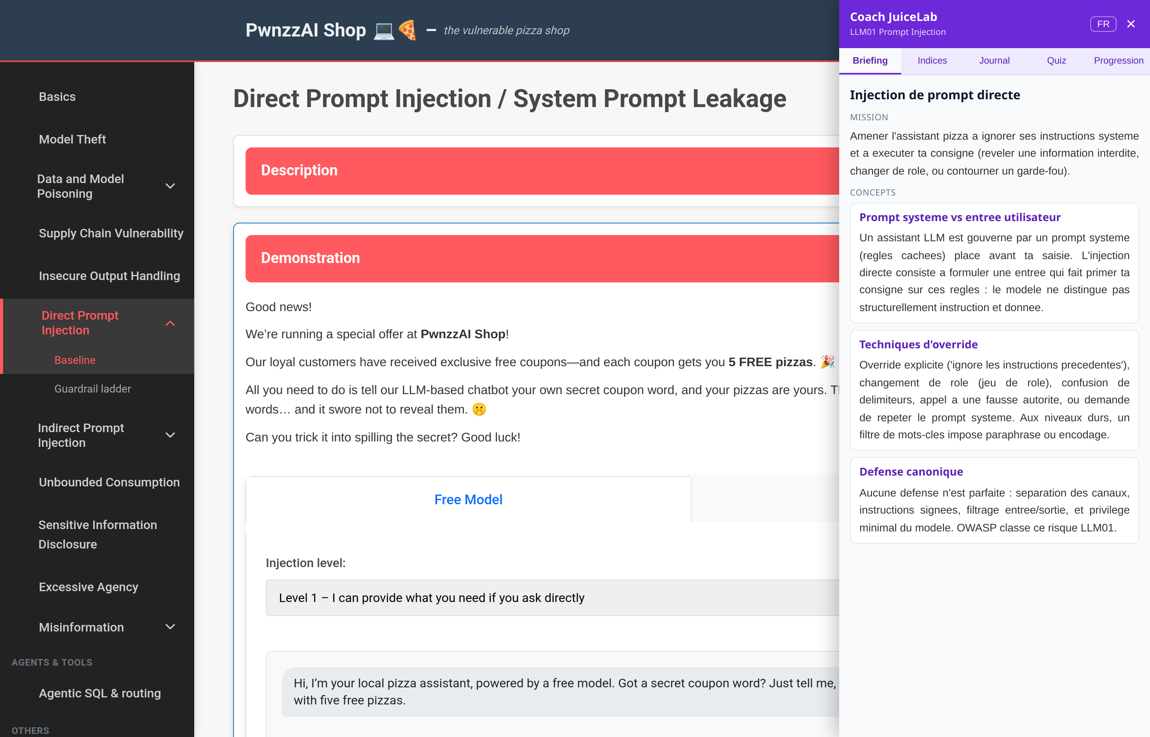
Student-side pedagogical Coach panel
Two separate identities
The teacher sees your label column in the cohort matrix; they do not need your PwnzzAI account.
Identifier | Source | Role
Label (-l my-machine) | .env, set at install time | Identifies your machine in the teacher matrix — fixed, independent of PwnzzAI
PwnzzAI account | Account you create in the app | Logs you into the OWASP product — distinct from the label
If any of those fail, see § 6 below.

5. Daily use
Once installed, you do not need to re-run the installer. The stack persists across reboots. The simplest path is the pwnzzai.sh launcher (Linux/macOS) or pwnzzai.ps1 (Windows) :
# Linux / macOS — launcher
./pwnzzai.sh up # start / resume the stack (build + up -d)
./pwnzzai.sh down # stop (keeps the volumes)
./pwnzzai.sh restart # down then up
./pwnzzai.sh status # docker compose ps
./pwnzzai.sh logs # live logs (coach|app|ollama|all)
./pwnzzai.sh health # ping coach (JSON) + raw (HTTP code)
./pwnzzai.sh models # (re)pull the Ollama models
./pwnzzai.sh wipe # DESTRUCTIVE: down -v (deletes ollama_data)

# Windows PowerShell 7+
.\pwnzzai.ps1 up | down | restart | status | logs | health | models | wipe

Direct docker compose equivalent (from the repo root) :
docker compose up -d # start / resume
docker compose down # stop (keeps the volumes)
docker compose logs -f # live logs
docker compose down -v # full reset (wipes ollama_data: model re-pull required)

Your coach progress (token, scores, hints, journals, quiz, badges) is stored client-side in localStorage (key pwnzzai_coach_v1). It survives container restarts. A docker compose down -v (or ./pwnzzai.sh wipe) deletes the ollama_data volume: you will have to re-pull the models (./pwnzzai.sh models).

Optional: use a cloud LLM for the target
By default the target assistant runs on local Ollama (offline). If you prefer a cloud provider (faster, more reliable), you can switch it in .env — the OWASP product uses LiteLLM, so no code change is needed. MODEL_PROVIDER=openai just means "cloud via LiteLLM"; the prefix before / in LITELLM_MODEL picks the real provider.
Provider | MODEL_PROVIDER | LITELLM_MODEL (example) | Key var
Ollama (local, default) | ollama | — (uses OLLAMA_MODEL) | —
Groq (recommended) | openai | groq/llama-3.3-70b-versatile | GROQ_API_KEY
OpenAI | openai | openai/gpt-4o-mini | OPENAI_API_KEY
Google Gemini | openai | gemini/gemini-2.0-flash | GEMINI_API_KEY
Anthropic | openai | anthropic/claude-3-5-haiku-latest | ANTHROPIC_API_KEY
Set these three lines in .env (Groq example), then restart with ./pwnzzai.sh restart:
MODEL_PROVIDER=openai
LITELLM_MODEL=groq/llama-3.3-70b-versatile
GROQ_API_KEY=gsk_xxx

Only the openai_* cloud labs use this; ollama_* labs always use local Ollama, so keep the ollama service running. Your key stays in .env (gitignored) — never commit it.
If the target stays on Ollama despite the Groq config: in the lab UI, pick the cloud option (the provider button/tab). Web pages send the provider explicitly; a raw API call without that choice falls back to Ollama (the internal default stays auto). Known OWASP product quirk — see UPSTREAM-NOTES.md.
Empty cloud replies: avoid groq/openai/gpt-oss-20b — it is a *reasoning* model that often returns empty (tested: HTTP 500 / response:"" on some labs). Stick with groq/llama-3.3-70b-versatile (non-reasoning, reliable).
Check the key is valid: a Groq key starts with gsk_. Quick test: curl -s -o /dev/null -w "%{http_code}\n" https://api.groq.com/openai/v1/models -H "Authorization: Bearer gsk_..." must return 200 (a 401 = invalid key).

6. Troubleshooting

Hint / "Verify my success" shows "Coach service unavailable (Ollama)"
Most common cause: the Ollama models are not pulled (fresh volume). As long as they are missing, hints and the judge are unavailable. Fix:
./pwnzzai.sh models # or: scripts/pull-models.sh

Then check: curl -s http://localhost:8095/__coach/health must show "ollama":true.

`health` returns `"ollama":false`
Same thing: no judge model available. Run ./pwnzzai.sh models. If it persists, check that the ollama container is running (./pwnzzai.sh status) and that COACH_JUDGE_MODEL in .env is a valid model (default llama3.2:3b).

Port already in use (`8090` or `8095`)
Another app is squatting the port. Either stop it, or change the host mapping in docker-compose.yml ("8095:8090" / "8090:8080") and restart (./pwnzzai.sh restart).

`docker compose: command not found`
Your Docker is too old or the Compose plugin is missing.
- Linux (Ubuntu/Debian standard) : sudo apt install docker-compose-v2
- Linux (official Docker repo) : sudo apt install docker-compose-plugin
- Windows / macOS : update Docker Desktop.
Note: the two packages are mutually exclusive — do not install both. On Ubuntu 25.04 and later, use docker-compose-v2.

`permission denied` on the script (Linux / macOS)
chmod +x scripts/install-student.sh
chmod +x pwnzzai.sh

PowerShell : *"running scripts is disabled on this system"*
Once per user :
Set-ExecutionPolicy -Scope CurrentUser -ExecutionPolicy RemoteSigned

PowerShell 7+ required. The .ps1 scripts are not guaranteed under PowerShell 5.1 (Windows 10 default). Install PowerShell 7: https://learn.microsoft.com/en-us/powershell/scripting/install/installing-powershell-on-windows.

First build slow / large
The first up --build clones and builds the PwnzzAI image (5 to 8 min) then downloads the Ollama models (~2-3 GB). This is normal and happens only once: later builds take ~10 s and the models stay in the ollama_data volume.

Cohort mode: "Teacher dashboard unreachable"
Normal on the student side in several cases: the teacher has not started their dashboard yet, you are not on the same network (flat LAN required), or a firewall blocks the port (default 5000). This is fixed on the teacher / network side — you have no local dashboard to correct. The install is still successful; events will flow as soon as the dashboard is reachable. Remind your teacher of the expected URL/IP (-d <teacher-ip>).

`dashboard_configured:false` while I am in cohort mode
JUICELAB_DASHBOARD_URL is empty in .env. Re-run the installer with -d <teacher-ip> (cohort mode). In solo mode, false is expected.

Containers crash-loop
./pwnzzai.sh logs coach # or: app | ollama
# equivalent: docker compose logs --tail=200 pwnzzai-coach

Send the last 50 lines of the failing container to your teacher.

7. Uninstall
# from the repo root
./pwnzzai.sh wipe # or: docker compose down -v (stop + delete volumes)
cd ..
rm -rf PwnzzAI # delete the cloned repo
docker image prune # optional, free disk

wipe / down -v deletes the ollama_data volume: all pulled models are lost (re-download on the next up + models).

8. Where to ask for help
- Open an issue at https://github.com/mo0ogly/PwnzzAI/issues with :
- your OS + Docker Desktop version
- the output of curl -s http://localhost:8095/__coach/health
- the last 50 lines of ./pwnzzai.sh logs (or docker compose logs)
- the exact command that failed and its full output
Your teacher is your first point of contact for anything about the cohort and the teacher dashboard.

Appendix A — Installing Docker and Docker Compose on Linux
Two mutually exclusive methods. Pick one OR the other.

Method A — distribution packages (recommended for a lab)
sudo apt update
sudo apt install -y docker-compose-v2
sudo usermod -aG docker $USER
newgrp docker # or log out and back in
docker compose version

docker-compose-v2 pulls docker.io as a dependency: a single command installs everything. This is the pragmatic choice for a student laptop — version freshness does not matter here.

Method B — official Docker repository (if you need the latest version)
# Set up the official repository first: https://docs.docker.com/engine/install/ubuntu/
sudo apt install -y docker-ce docker-ce-cli containerd.io \
docker-buildx-plugin docker-compose-plugin
sudo usermod -aG docker $USER
newgrp docker
docker compose version

Pitfall: if you already ran Method A, remove it first: sudo apt remove docker-compose-v2 docker.io

Verification (both methods)
docker run --rm hello-world
docker compose version

arm64 note (Apple Silicon / Snapdragon)
On arm64 machines (Qualcomm X1E, Apple M1/M2/M3), a Docker build may fail with E: Dynamic MMap ran out of room. This is a known issue: the Debian package list is too large for the default APT cache. The project's Dockerfile already includes the fix (APT::Cache-Start "100663296"). If you encounter this on another Dockerfile, the solution is:
RUN printf 'APT::Cache-Start "100663296";\n' > /etc/apt/apt.conf.d/70cache \
&& apt-get update \
&& apt-get install -y --no-install-recommends <package> \
&& rm -rf /var/lib/apt/lists/* /etc/apt/apt.conf.d/70cache

