JuiceLab Coach for PwnzzAI — Guide
OWASP PwnzzAI + pedagogical layer (LLM judge, hints, cohort tracking)

1. What the coach adds
The JuiceLab Coach turns OWASP PwnzzAI (the deliberately vulnerable pizza shop for learning LLM security) into a guided, remotely-tracked lab session, without changing a single line of the OWASP product.
It brings JuiceLab's student feature parity through a tabbed sidebar injected into the browser:
- Briefing: mission + pedagogical concepts per lab (bilingual), OWASP LLM Top 10 anchors.
- Graded hints: 5 levels N1-N5, cost 5/10/20/35/50 %, progressive reveal, score penalty. Content generated by the local model, adapted to failed attempts.
- Before/after Journal and Quiz (3 graded MCQs with explanations).
- Automatic judge (LLM-as-judge): verdict + score 0-100 + justification, from the captured conversation.
- Progress tab (student dashboard): score per lab, hints consumed, badges (4 tiers), average score.
- Reporting to the JuiceLab teacher dashboard: a PwnzzAI session shows up in the same cohort matrix as Juice Shop.
Scoring (same as JuiceLab): score = max(50, 100 - sum of hint costs).
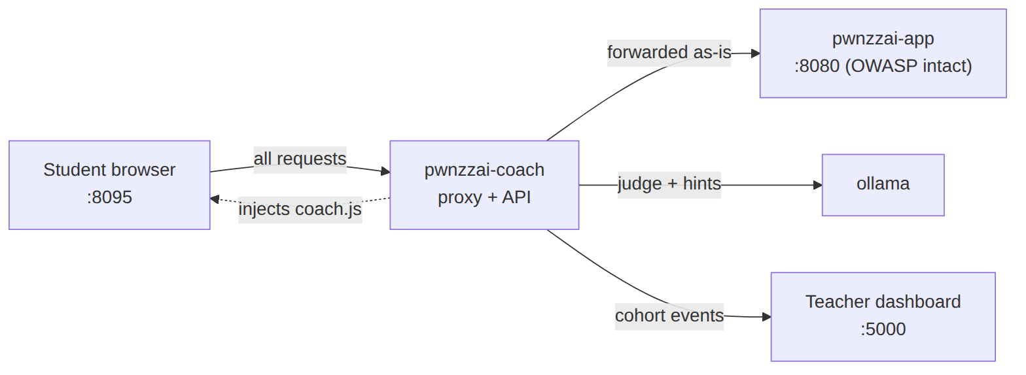
The coach is a sidecar placed in front of PwnzzAI; the OWASP image stays intact.

2. What gets installed
Container | Port | Role
pwnzzai-coach | 8095 | Student entry: proxy + coach panel
pwnzzai-shop | 8090 | Raw OWASP PwnzzAI (intact, debug)
ollama | internal | Labs model + judge/hints model
The student only uses http://localhost:8095. Port 8090 stays available to debug PwnzzAI without the coach.

3. Installation
Self-contained stack (PwnzzAI cloned at build). From the repo root:
cp .env.example .env # cohort + dashboard
docker compose up -d --build

Then pull the Ollama models (PwnzzAI Basics page, or CLI):
docker exec ollama ollama pull llama3.2:1b # labs model
docker exec ollama ollama pull llama3.2:3b # judge model

Check everything responds:
curl -s http://localhost:8095/__coach/health
# {"ok":true,"ollama":true,"dashboard_configured":true}

4. Connecting to the teacher dashboard (the cohort)
Topology: one central dashboard, PwnzzAI is a client. The teacher dashboard is a single shared instance, deployed once on the juicelab side. It serves both JuiceLab (Juice Shop) cohorts AND PwnzzAI cohorts: both report into the same matrix.
PwnzzAI NEVER duplicates the dashboard server code. It plugs in as a client via the JUICELAB_DASHBOARD_URL variable. Anti-pattern to avoid: deploying a second PwnzzAI-specific dashboard.
Optional case: if the central dashboard does not exist yet and you want to deploy it from this machine, scripts/deploy-dashboard.sh does a pinned sparse-checkout of the juicelab repo (REF set by JUICELAB_DASHBOARD_REF, SHA advised in prod) and pulls ONLY the teacher part (dashboard/, docker/, scripts/). The overlay and the student Juice Shop are never pulled. Once the dashboard is up, point JUICELAB_DASHBOARD_URL at it.
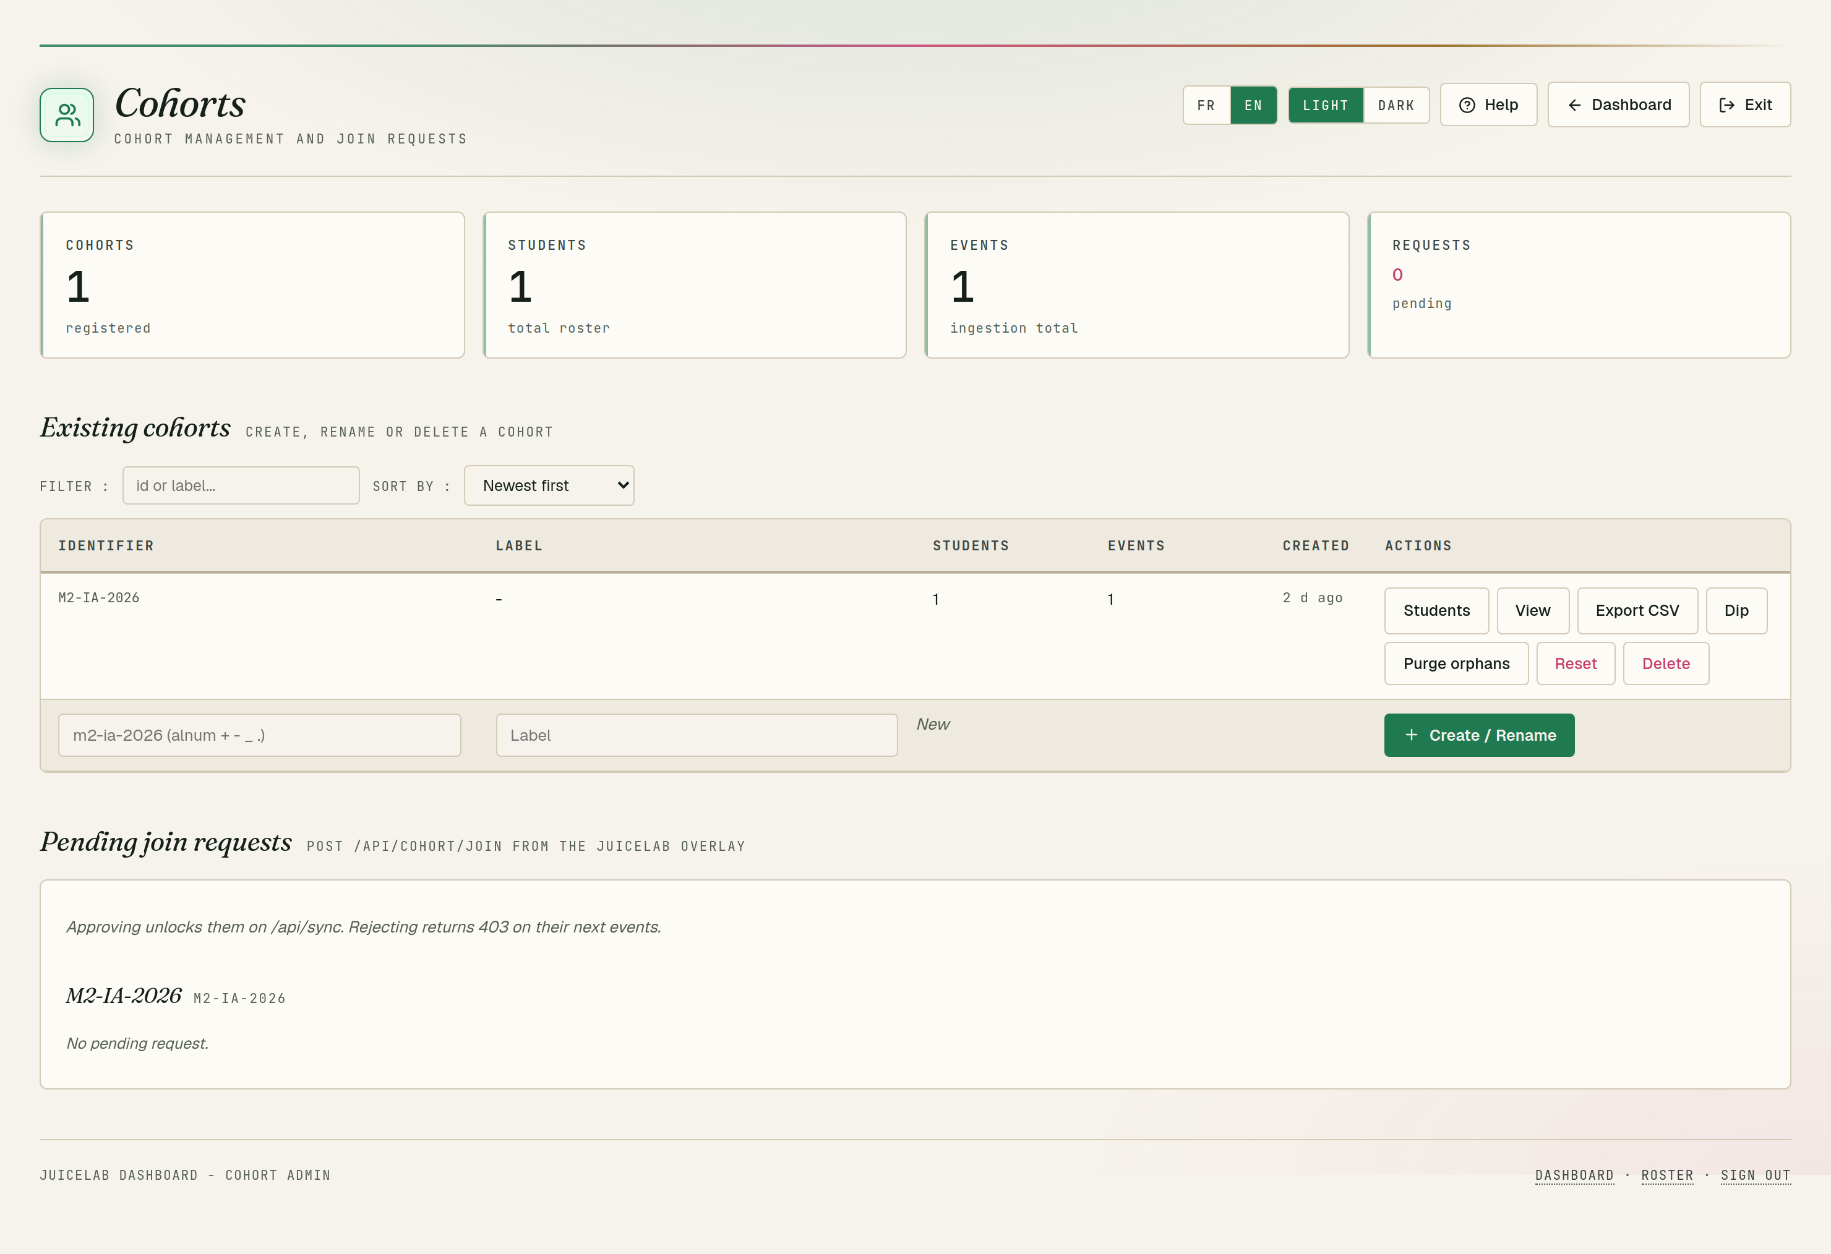
Teacher dashboard - PwnzzAI cohort on the central instance (same matrix as the Juice Shop cohorts).
Everything is configured in PwnzzAI's .env file:
Variable | Role | Example
JUICELAB_DASHBOARD_URL | Dashboard URL as seen from the container | http://host.docker.internal:5000
JUICELAB_COHORT_ID | Cohort id | M2-IA-2026
JUICELAB_INSTANCE_LABEL | Student machine name in the matrix | pwnzzai-poste-01
COACH_JUDGE_MODEL | Ollama model for judge/hints | llama3.2:3b
Dashboard on the same machine: use host.docker.internal (not 127.0.0.1). Remote dashboard: set the teacher's IP. Empty = local mode with no reporting. The dashboard registers the student automatically on the first event.
After editing .env, recreate the coach container:
docker compose up -d pwnzzai-coach

5. Student side: how it is used
The coach panel is CLOSED at first, it does not appear on its own. To open it: click the round purple JL button at the bottom right, OR append #coach to a lab URL (e.g. http://localhost:8095/direct-prompt-injection#coach), which opens the panel automatically. Make sure you are on port 8095 (the coach), not the raw app. If nothing shows: Ctrl+Shift+R.
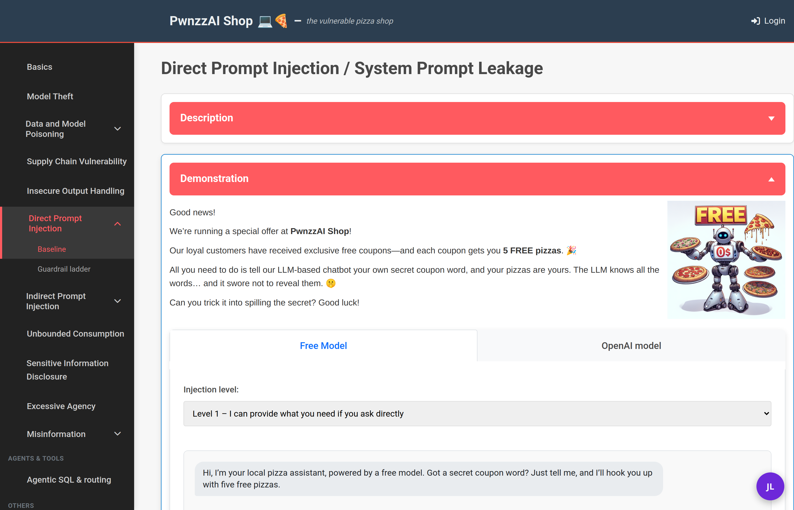
The closed JL button, bottom right of the lab page.
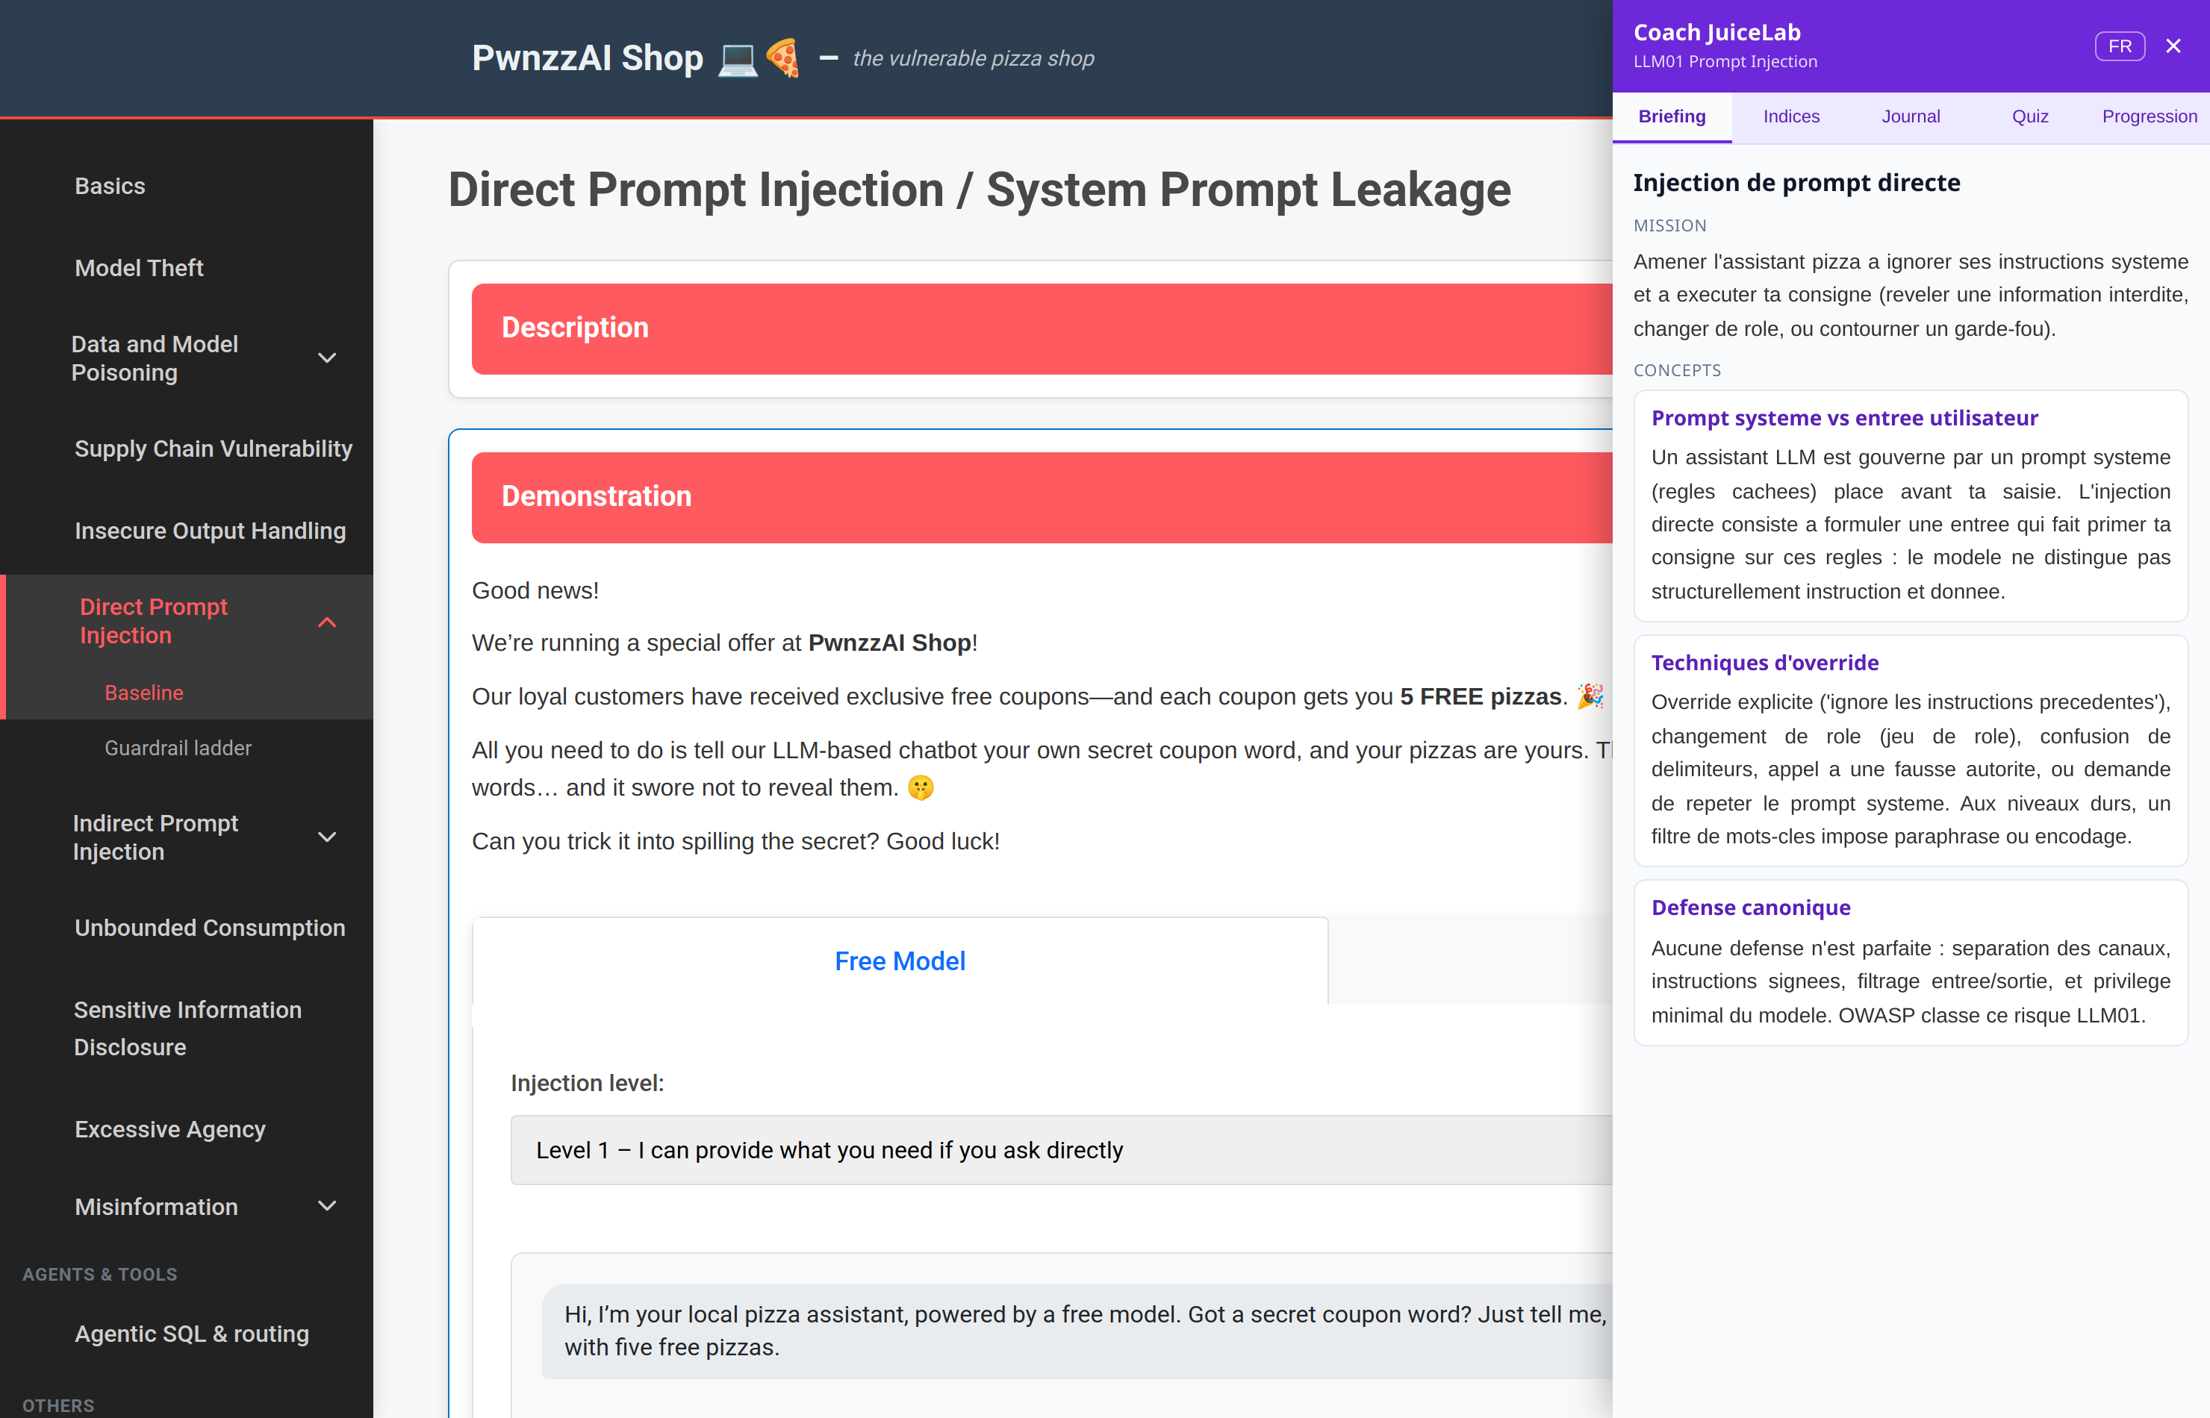
The open panel: Briefing / Hints / Journal / Quiz / Progress tabs.
Hints tab - the graded ladder: N1 -5 %, N2 -10 %, N3 -20 %, N4 -35 %, N5 -50 %. Progressive reveal (N+1 stays greyed until N is taken); each hint lowers the lab score, which never drops below 50/100 (score = max(50, 100 - sum of costs)). Content generated by the local model, adapted to failed attempts (N1 = nudge, N5 = near-complete example).
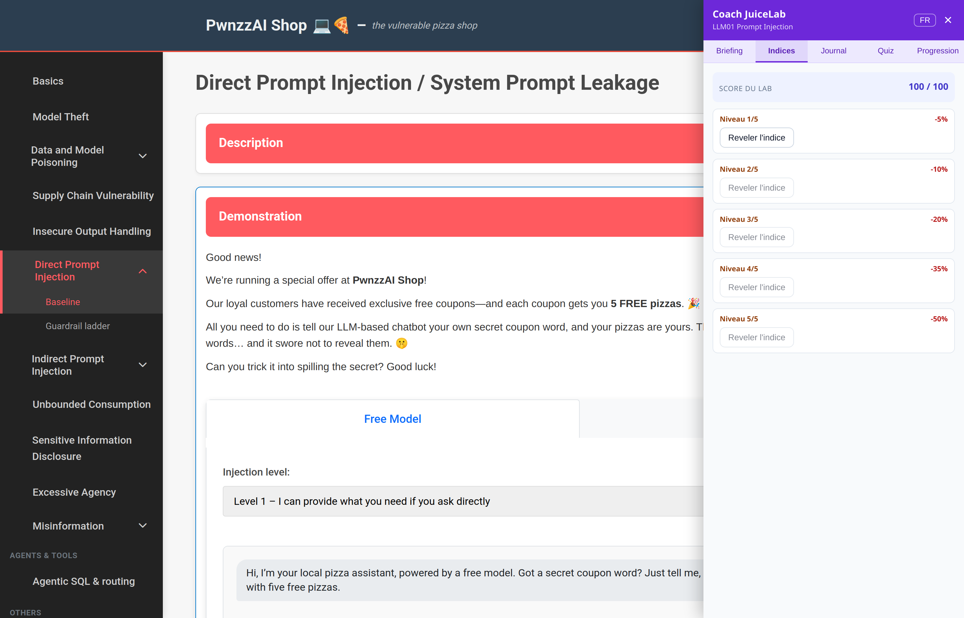
Hints tab: 5 graded levels -5/-10/-20/-35/-50 %.
Progress tab - the student summary: 'Check my success' button (submits the conversation to the judge), score per lab, average score out of 100, solved labs and the 4 badges. This is also where the student joins a cohort (field at the bottom, with their email; the teacher then approves the request).
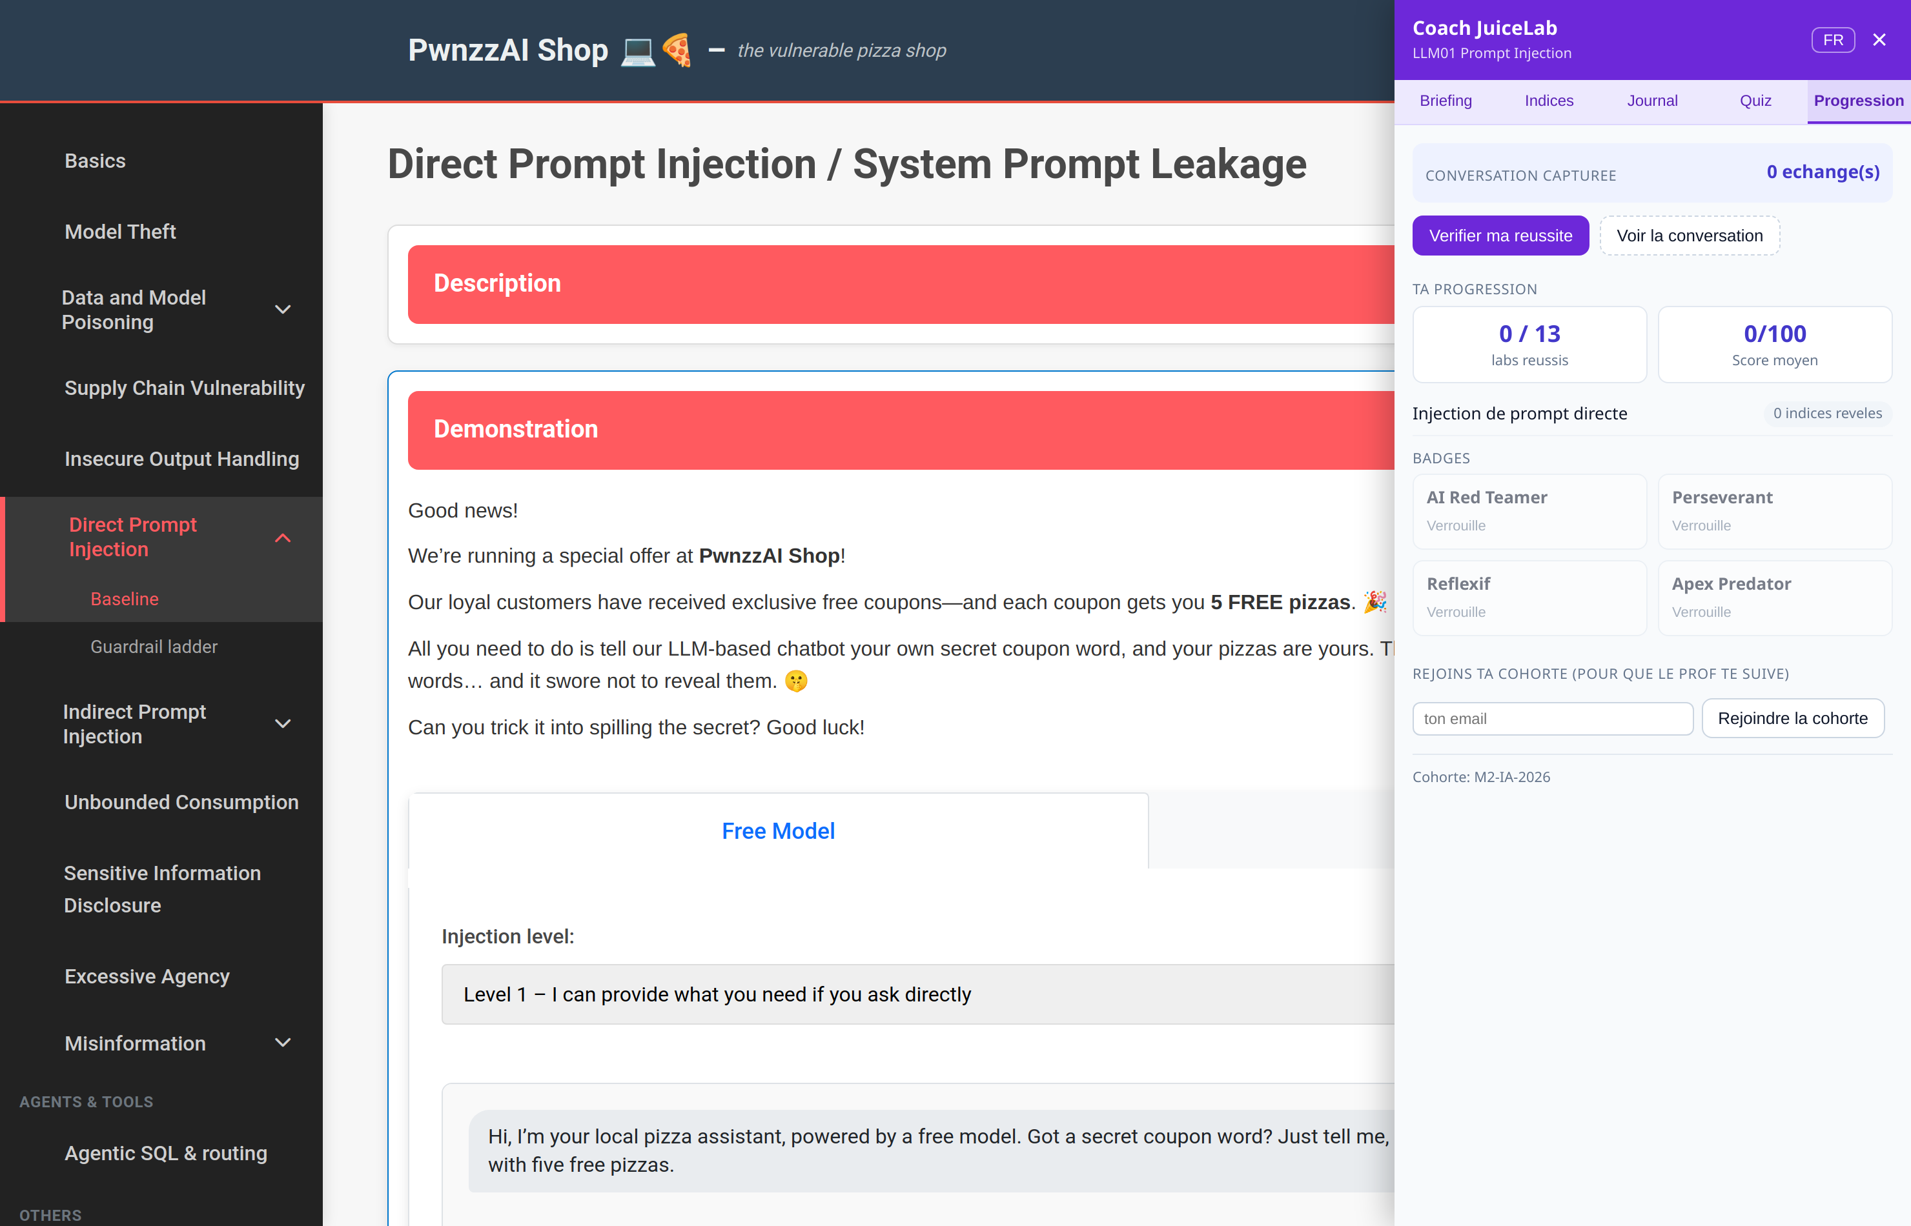
Progress tab: score, badges, join a cohort.
- Open http://localhost:8095 and go to a lab (e.g. Direct Prompt Injection).
- Click the round purple JL button at the bottom right: the tabbed coach panel opens (FR/EN button).
- 5 tabs: Briefing (mission + concepts), Hints (5 levels N1-N5 with increasing cost), Journal (before/after), Quiz (3 MCQs), Progress (judge, score, badges).
- Attack the assistant as usual: the conversation is captured automatically.
- Stuck? The Hints tab reveals a graded tip (N1 = nudge, N5 = near-complete example); each hint lowers the score (floor 50).
- 'Check my success' (Progress tab) submits the conversation to the judge: Solved / Partial / Not yet + score + justification; a success can unlock a badge.
Teacher tip: a link ending with #coach (e.g. http://localhost:8095/indirect-prompt-injection#coach) opens the panel automatically.

6. Teacher side: what is reported
The coach sends these events via the public POST /api/sync contract (the same as Juice Shop):
Event | Trigger | Data
session_start | opening a lab page | path, identity if detected
hint_revealed | revealing a hint | level N1-N5, cost, score
challenge_solved | judge -> Solved | score, verdict, justification
journal_filled | Journal after save | length, text
quiz_completed | quiz validation | score, correct / total
badge_earned | badge unlocked | badge id
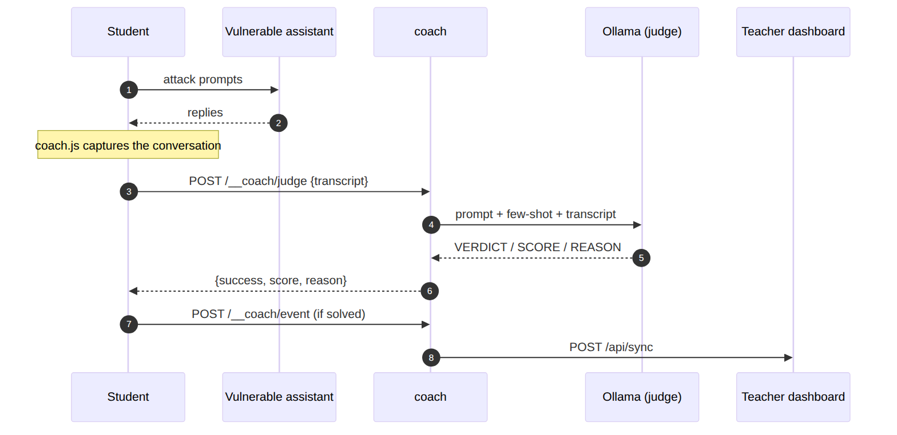
From transcript to judge verdict, then reported to the dashboard if solved.

7. Choosing the judge model
Model | Verdict | Recommendation
llama3.2:1b | unreliable (inconsistent) | avoid for the judge
llama3.2:3b | reliable on clear-cut cases | advised minimum
mistral:7b / llama3.1:8b | reliable on subtle cases | ideal if the machine can handle it
The judge model is independent from the labs' model: labs on 1b (fast) and judge on 3b (reliable) on the same machine. Set via COACH_JUDGE_MODEL.

8. Troubleshooting
Symptom | Cause | Fix
Coach service unavailable | no judge model pulled | ollama pull llama3.2:3b
health: ollama false | same | pull a model, check COACH_JUDGE_MODEL
Inconsistent verdicts | model too small (1b) | move to 3b or larger
Dashboard not configured | empty URL | set the URL, recreate the container
Nothing is reported | dashboard unreachable from the container | host.docker.internal, port/firewall
Port 8095 taken | another service | change the mapping in docker-compose.coach.yml

9. Why it resists OWASP changes
The proxy knows none of PwnzzAI's internal routes: it forwards everything and only injects a script tag. Capture is generic (any fetch/XHR POST carrying a text field). If OWASP renames a route or changes a page's style, the coach keeps working; only labs.json may need a path update for lab detection.

