BMDS2133 Image Processing Assignment Documentation
Fingerprint Enhancement System
Semester 2026xx

Group Members
(1) [Student name / ID required] - M1 NLM: Non-local means denoising
(2) [Student name / ID required] - M2 Modified Gabor: Modified Gabor ridge enhancement
(3) [Student name / ID required] - M3 TV: Total variation restoration
(4) [Student name / ID required] - M4 Directional Diffusion: Coherence-guided directional diffusion
Programme: Bachelor in Data Science (Honours)
Tutor: [Your Tutor Name here]
Project Title: Fingerprint Enhancement System
Assignment Mode: Mode A: Comparative and Enhancement Study

Table of Contents
Table of Contents 2
List of Figures 4
List of Tables 4
Introduction 6
1.1 Problem Background 6
1.2 Objectives/Aims 6
1.3 Motivation 7
Literature Review 7
2.1 Fingerprint Ridge Enhancement and Local Structure 7
2.2 Image Restoration: Non-Local Means and Total Variation 7
2.x Main Concept / Algorithm 3 - Directional and Gabor-Based Processing 8
2.3 Analysis of the existing algorithm (Comparison) 8
Methodology 9
3.1 System flowchart 9
3.2 Description of dataset (if Applicable) 11
3.3 Applications of the algorithm(s) 11
3.3.1 Pseudocode / Algorithm Summary 14
Result & Discussion 17
4.1 Experimental Results 17
4.2 Discussion and Critical Interpretation 21
Conclusion 22
5.1 Achievements 22
5.2 Limitations and Future Works 22
References 23
Appendix A 24
Appendix B 25
AI Usage Disclosure Form 25
Appendix C 26
Template Compliance and Source Audit 26

List of Figures
Figure 1.1 Relationship between the project and SDG 9/Malaysia MADANI.
Figure 3.1 Overall Fingerprint Enhancement System Workflow.
Figure 3.2 Clean reference, degraded baseline and four technique outputs.
Figure 3.3 Streamlit runtime workflow.
Figure 4.1 Development comparison chart.
Figure 4.2 Validation comparison chart.
Figure 4.3 Validation improvement over degraded baseline.
Figure 4.4 Modified Gabor orientation diagnostic.
Figure 4.5 Modified Gabor legacy/corrected error diagnostic.

List of Tables
Table 1.1 SMART objectives.
Table 2.1 Comparison of Contemporary Approaches in Image Segmentation.
Table 2.2 Comparison of Contemporary Approaches in Contrast Enhancement.
Table 2.3 Literature comparison summary.
Table 3.1 Dataset inventory.
Table 3.2 Dataset split and leakage audit.
Table 3.3 Technique implementation and frozen parameters.
Table 3.4 Parameter investigation summary.
Table 3.5 Implemented metric definitions.
Table 4.1 Development performance comparison.
Table 4.2 Validation performance comparison.
Table 4.3 Altered-image no-reference robustness summary.
Table 4.4 Runtime summary.
Table 5.1 Objective achievement summary.
Table A.1 Group contract and contribution table.
Table B.1 AI usage disclosure.
Table C.1 Template compliance checklist.
Table C.2 Final source audit.

Introduction

1.1 Problem Background
A fingerprint is a biometric pattern formed by alternating ridges and valleys on a fingertip. These ridge-flow structures are useful for personal identification because their arrangement is persistent and highly distinctive. Automated fingerprint systems depend on sufficient ridge clarity before reliable feature analysis can occur, especially when ridge endings, bifurcations and local orientation patterns must be preserved.
Fingerprint enhancement is the image-processing task of improving a degraded fingerprint so that ridge and valley structures become clearer without damaging meaningful biometric detail. Classical enhancement remains relevant because it is transparent, deterministic and relatively lightweight compared with trained deep-learning models. The final system evaluates this problem through non-local means denoising, modified Gabor filtering, total variation restoration and coherence-guided directional diffusion.
Degraded fingerprint images may contain weak contrast, sensor noise, broken ridges, smudging, incomplete impressions or altered ridge regions. These problems can reduce structural similarity between the observed image and the underlying ridge pattern. Earlier fingerprint enhancement research shows that local orientation and frequency information are important for restoring ridge flow, but the best practical method depends on the degradation type, evaluation metric and computational cost (Hong et al., 1998).
The dataset used in the final implementation is the Sokoto Coventry Fingerprint Dataset (SOCOFing), which provides real fingerprint images and altered variants for research use (Shehu et al., 2018). The final experiment uses SOCOFing Real images as clean references, applies a neutral P0 preprocessing stage, then creates controlled degraded inputs so that objective full-reference metrics can be calculated.

1.2 Objectives/Aims
Table 1.1 SMART objectives.
Objective | SMART statement
Objective 1 | To implement and investigate four classical fingerprint enhancement techniques on a 500-image Development Set from 50 SOCOFing subjects by comparing candidate configurations with PSNR, SSIM, MSE and runtime before the final report submission.
Objective 2 | To freeze the selected configuration for each technique using Development results only and independently validate all frozen configurations on 1,000 images from 100 unseen subjects, with zero subject overlap and zero image overlap.
Objective 3 | To deliver a practical Streamlit prototype that applies the frozen enhancement techniques to uploaded fingerprint images, supports single-image, Compare All and bulk workflows, and reports reference-based metrics only when a valid reference image is supplied.

1.3 Motivation
Reliable fingerprint enhancement has practical value for identity verification, access control and digital public services. A lightweight enhancement module can improve the quality of images before downstream analysis, especially when the deployment environment cannot support high-cost learning-based systems. The project is linked to United Nations Sustainable Development Goal 9 because robust and inclusive digital identity infrastructure supports resilient innovation and secure services (United Nations, 2015). It is also compatible with the Malaysia MADANI emphasis on trustworthy public-service delivery and good governance (Jabatan Penerangan Malaysia, 2023).
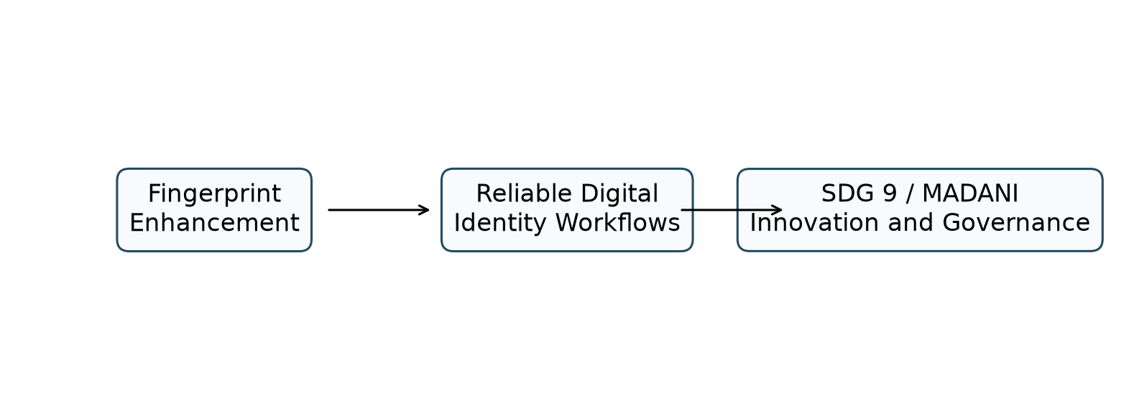
Figure 1.1 Relationship between the project and SDG 9/Malaysia MADANI.

Literature Review

2.1 Fingerprint Ridge Enhancement and Local Structure
Fingerprint images are locally oriented patterns rather than arbitrary greyscale images. Ridge enhancement methods therefore benefit from foreground masking, local orientation estimation and frequency-aware filtering. Hong et al. (1998) demonstrated that Gabor filtering guided by local ridge orientation and frequency can improve ridge continuity, while also showing that enhancement quality depends on reliable local estimates.

2.2 Image Restoration: Non-Local Means and Total Variation
Non-local means estimates each pixel from similar patches found in a search neighbourhood. The method is suitable for fingerprint texture because ridges contain repeated local structures, although excessive smoothing strength can remove fine ridge contrast (Buades et al., 2005). Total variation restoration minimises image variation while preserving strong transitions, making it useful for reducing additive noise without fully blurring ridge boundaries (Chambolle, 2004).

2.x Main Concept / Algorithm 3 - Directional and Gabor-Based Processing
Gabor filters are orientation- and frequency-selective band-pass filters. A fingerprint ridge pattern is approximately periodic within a small local block, so a Gabor kernel can emphasise ridge-valley alternation when its orientation and frequency match the local ridge field. Directional diffusion follows a related structural idea: smoothing should occur mainly along coherent local orientation patterns rather than across ridge boundaries. This principle is related to anisotropic diffusion, where smoothing is guided by image structure (Perona & Malik, 1990).

2.3 Analysis of the existing algorithm (Comparison)
Table 2.1 Comparison of Contemporary Approaches in Image Segmentation.
Algorithm / System | Example of Previous Work | Advantages | Limitations | Remarks
Otsu global thresholding | Otsu thresholding as summarised in Gonzalez and Woods (2018) | Fast and simple global segmentation. | Fails under uneven ridge contrast and background variation. | Not a final enhancement technique; useful as a conceptual segmentation baseline.
Sauvola local thresholding | Local adaptive thresholding described in image-processing literature | Adapts to local intensity statistics. | Window and parameter sensitive. | Used inside the implemented structural_metrics helper for no-reference indicators, not as a frozen member technique.
Foreground mask with morphology | Morphological processing in Gonzalez and Woods (2018) | Removes small regions and fills holes in ridge-area masks. | Incorrect structuring sizes can remove useful ridge detail. | Implemented in _fingerprint_mask and used by M2, M4 and no-reference metrics.

Table 2.2 Comparison of Contemporary Approaches in Contrast Enhancement.
Algorithm / System | Example of Previous Work | Advantages | Limitations | Remarks
Non-local means denoising | Buades et al. (2005) | Preserves repeated ridge-like patches while reducing noise. | High smoothing strength can blur minutiae and fine ridge details. | Implemented as M1 NLM and selected as final PSNR/MSE winner.
Gabor ridge filtering | Hong et al. (1998) | Uses local orientation and frequency to target ridge structures. | Sensitive to orientation/frequency errors and computationally heavier. | Implemented as M2 Modified Gabor with conservative residual blending.
Total variation restoration | Chambolle (2004) | Reduces additive noise while preserving stronger transitions. | May oversmooth texture or create piecewise-flat artefacts. | Implemented as M3 TV and achieved the highest validation SSIM.
Directional diffusion | Perona and Malik (1990) | Smooths along coherent local structures and can reduce ridge fragmentation. | Iterative and parameter sensitive. | Implemented as M4 Directional Diffusion.

Table 2.3 Literature comparison summary.
Study | Area | Technique | Strength | Limitation | Relevance
Hong et al. (1998) | Fingerprint enhancement | Orientation/frequency Gabor enhancement | Fingerprint-specific ridge model. | Performance falls when local estimates are unreliable. | Supports M2 design.
Buades et al. (2005) | Denoising | Patch-based non-local means | Uses repetitive structures. | Patch search adds cost; high h may oversmooth. | Supports M1 design.
Chambolle (2004) | Image restoration | Total variation minimisation | Preserves strong edges while denoising. | Can suppress texture if weight is high. | Supports M3 design.
Perona and Malik (1990) | Anisotropic diffusion | Structure-guided diffusion | Avoids uniform blur across edges. | Iterative and parameter-sensitive. | Supports M4 design.
Wang et al. (2004) | Image quality | SSIM metric | Measures structural similarity. | Not biometric recognition accuracy. | Supports result interpretation.
Shehu et al. (2018) | SOCOFing | Fingerprint dataset | Large public dataset with real and altered fingerprints. | Altered images are not full-reference aligned pairs in the final code. | Primary data source.

Methodology

3.1 System flowchart
As illustrated in Figure 3.1, the system has two major branches. The offline experimental branch loads SOCOFing data, creates a deterministic subject-disjoint split, applies P0 and controlled degradation, tunes candidate parameters on the Development Set, freezes configurations and validates on unseen subjects. The runtime branch loads the frozen configuration in Streamlit and processes uploaded images without rerunning the experiment.
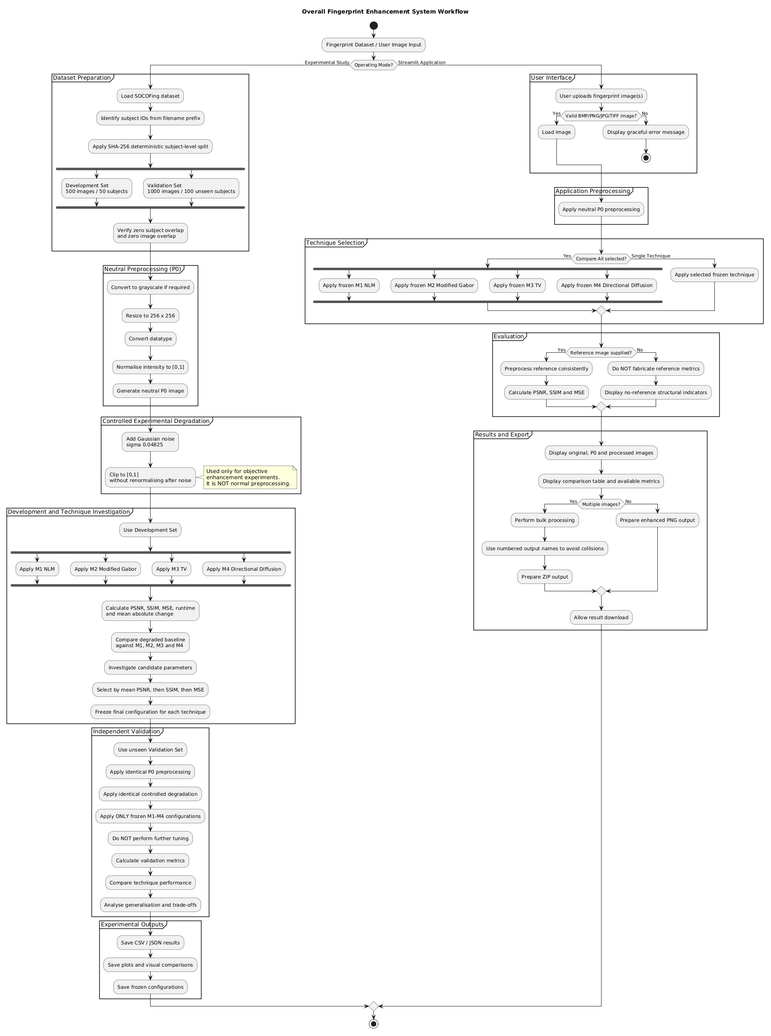
Figure 3.1 Overall Fingerprint Enhancement System Workflow.

3.2 Description of dataset (if Applicable)
Table 3.1 Dataset inventory.
Folder | Image count | Representative file
Real | 6000 | 100__M_Left_index_finger.BMP
Altered-Easy | 17931 | 100__M_Left_index_finger_CR.BMP
Altered-Medium | 17067 | 100__M_Left_index_finger_CR.BMP
Altered-Hard | 14272 | 100__M_Left_index_finger_CR.BMP

Table 3.2 Dataset split and leakage audit.
Item | Subjects | Images | Meaning
Total Real images | 600 | 6000 | SOCOFing Real source images
Development | 50 | 500 | Parameter investigation and frozen selection
Validation | 100 | 1000 | Independent unseen-subject evaluation
Overlap audit | 0 | 0 | Zero subject overlap and zero image overlap

Subject IDs are extracted from the numeric prefix before the double underscore in each SOCOFing filename. The deterministic score is SHA-256('BMDS2133-Fingerprint-ModeA-20260902:subject_id'), and sorted subjects are assigned to Development and Validation. Since all ten images for a subject remain inside one split, the validation results test unseen subjects rather than repeated fingers from training subjects.

3.3 Applications of the algorithm(s)
The implemented experimental sequence is: clean/reference SOCOFing Real image, neutral P0 preprocessing, controlled experimental degradation, enhancement technique, and comparison against the P0 reference. Controlled degradation is not application preprocessing; it exists only to create a measurable restoration problem.
Table 3.3 Technique implementation and frozen parameters.
Technique | Function | Frozen parameters | Status
M1 NLM | apply_nlm | {"h": 0.07} | Frozen before validation
M2 Modified Gabor | apply_modified_gabor | {"detail_clip": 0.1, "frequencies": [0.075, 0.095, 0.115, 0.14], "gamma": 0.5, "orientation_bins": 12, "orientation_offset": 1.5707963267948966, "sigma_scale": 0.55, "strength": 0.12} | Frozen before validation
M3 TV | apply_tv_restoration | {"weight": 0.02} | Frozen before validation
M4 Directional Diffusion | apply_coherence_guided_directional_diffusion | {"iterations": 2, "step": 0.12} | Frozen before validation

Table 3.4 Parameter investigation summary.
Technique | Candidates evaluated | Selected candidate | Mean PSNR | Mean SSIM | Mean MSE
M1 NLM | 6 | M1 NLM (h=0.07) | 29.568 | 0.9336 | 0.001114
M2 Modified Gabor | 3 | M2 Modified Gabor (detail_clip=0.1, frequencies=0.075/0.095/0.115/0.14, gamma=0.5, orientation_bins=12, orientation_offset=1.5708, sigma_scale=0.55, strength=0.12) | 27.367 | 0.8419 | 0.001838
M3 TV | 4 | M3 TV (weight=0.02) | 29.287 | 0.9379 | 0.001188
M4 Directional Diffusion | 4 | M4 Directional Diffusion (iterations=2, step=0.12) | 27.986 | 0.8511 | 0.001593

Table 3.5 Implemented metric definitions.
Metric | Definition | Direction | Usage
MSE | Mean squared pixel error against clean P0 reference | Lower is better | Used only with a valid reference
PSNR | Peak signal-to-noise ratio based on MSE | Higher is better | Primary ranking metric
SSIM | Structural similarity against clean P0 reference | Higher is better | Not classification accuracy
Mean absolute change | Average absolute difference from degraded input | Context dependent | Shows how strongly a method changes the degraded image
Runtime | Processing time in seconds | Lower is faster | Reported for method comparison
Structural indicators | Coherence, contrast, fragmentation, continuity and ridge coverage | Metric dependent | Used when paired clean references are unavailable

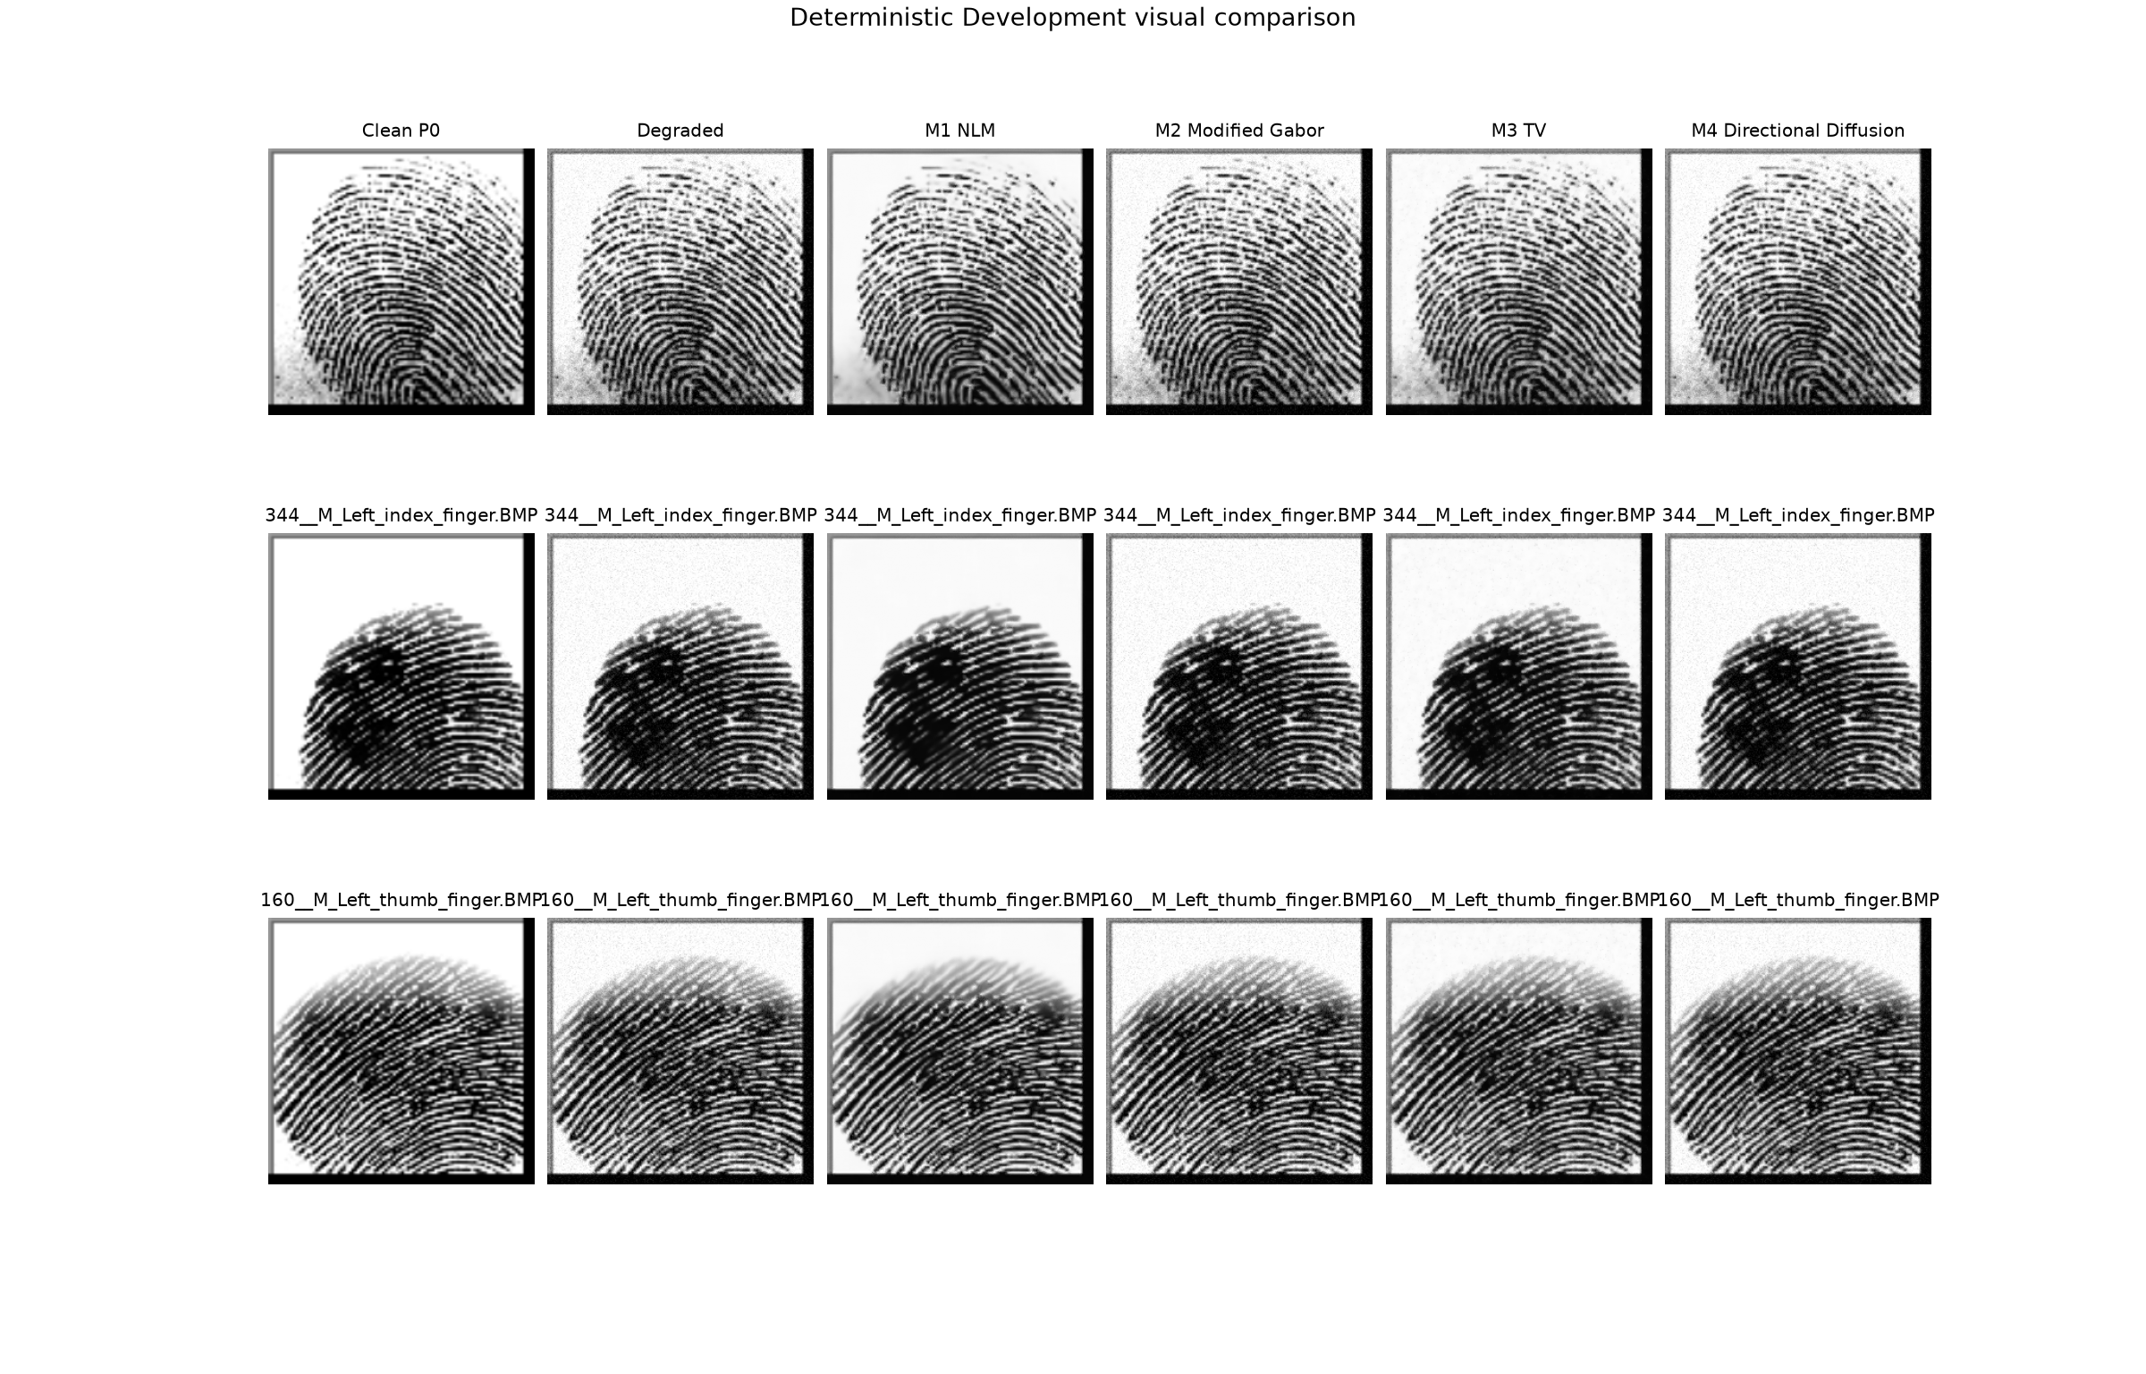
Figure 3.2 Clean reference, degraded baseline and four technique outputs.

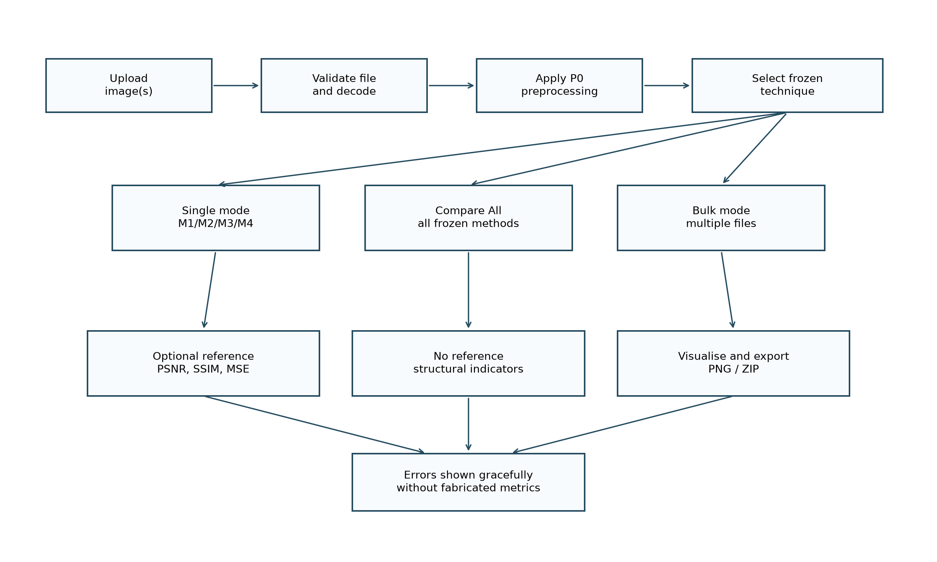
Figure 3.3 Streamlit runtime workflow.

3.3.1 Pseudocode / Algorithm Summary
Algorithm 1: Overall Experimental Fingerprint Enhancement Workflow
INPUT: SOCOFing dataset D, candidate parameter grids for M1-M4
OUTPUT: frozen configurations, Development results, Validation results
1. Read valid fingerprint image paths from D.
2. Extract each subject identifier from the filename prefix.
3. Sort subjects by deterministic SHA-256 subject score.
4. Assign 50 subjects to Development and 100 different subjects to Validation.
5. Verify zero subject overlap and zero image overlap.
6. FOR each Development image:
Apply neutral P0 preprocessing.
Generate controlled degraded image using Gaussian noise.
Evaluate degraded baseline against clean P0 reference.
FOR each candidate configuration of M1-M4:
Enhance the degraded image.
Calculate PSNR, SSIM, MSE, mean absolute change and runtime.
Record the result.
END FOR
END FOR
7. Aggregate Development results and select each technique configuration.
8. Select the final development winner by mean PSNR, then SSIM, then MSE.
9. Freeze all selected configurations before validation.
10. FOR each Validation image:
Apply identical P0 preprocessing and controlled degradation.
FOR each frozen M1-M4 configuration:
Enhance the degraded image.
Calculate implemented metrics.
Record the result.
END FOR
END FOR
11. Export CSV, JSON, plots and frozen configuration records.
RETURN comparative Development and Validation summaries.
This pseudocode reflects the current notebook and backend implementation and avoids stages that are not active in the final project.
Algorithm 2: Streamlit Fingerprint Enhancement Runtime Workflow
INPUT: uploaded fingerprint image(s), selected technique or Compare All, optional reference image
OUTPUT: enhanced image(s), valid metrics and downloadable PNG/ZIP outputs
1. Load final_selected_configuration.json.
2. Receive uploaded image or batch of images.
3. Validate file type and decode each image as grayscale.
4. Apply neutral P0 preprocessing to each valid input.
5. IF Compare All is selected:
Apply frozen M1 NLM, M2 Modified Gabor, M3 TV and M4 Directional Diffusion.
ELSE:
Apply the selected frozen technique.
END IF
6. IF a valid reference image is supplied:
Apply P0 to the reference.
Calculate PSNR, SSIM and MSE.
ELSE:
Do not fabricate reference metrics.
Calculate/display available no-reference structural indicators.
END IF
7. Display original, P0, enhanced image(s), runtime and available metrics.
8. IF multiple outputs exist:
Use numbered filenames and prepare ZIP output.
ELSE:
Prepare one enhanced PNG output.
END IF
RETURN results to the interface.
This pseudocode reflects the current notebook and backend implementation and avoids stages that are not active in the final project.
Algorithm 3: Neutral P0 Preprocessing
INPUT: fingerprint image I
OUTPUT: neutral P0 image P
1. Convert I to an array.
2. IF I has colour channels:
Convert I to grayscale.
END IF
3. Convert pixel values to floating point.
4. Scale integer images to [0,1].
5. Resize to 256 x 256 when dimensions differ.
6. Estimate the 1st and 99th intensity percentiles.
7. Normalise intensities between these percentiles.
8. Clip invalid or out-of-range values to [0,1].
RETURN P.
This pseudocode reflects the current notebook and backend implementation and avoids stages that are not active in the final project.
Algorithm 4: Deterministic Subject-Level Dataset Split
INPUT: list of SOCOFing Real image paths
OUTPUT: Development paths, Validation paths, split audit
1. FOR each image path:
Extract subject ID from the filename.
Group all images by subject ID.
END FOR
2. Verify that every subject has exactly 10 Real images.
3. FOR each subject ID:
Compute SHA-256 score from fixed split seed and subject ID.
END FOR
4. Sort subjects by deterministic score.
5. Select the first 50 subjects for Development.
6. Select the next 100 subjects for Validation.
7. Collect all images belonging to each selected subject.
8. Verify Development has 500 images and Validation has 1,000 images.
9. Verify subject overlap is zero and image overlap is zero.
RETURN split paths and audit record.
This pseudocode reflects the current notebook and backend implementation and avoids stages that are not active in the final project.
Algorithm 5: Controlled Degradation Procedure
INPUT: clean P0 image P, deterministic seed s
OUTPUT: degraded experimental image G
1. Initialise random generator with seed s.
2. Generate Gaussian noise with mean 0 and sigma 0.04825.
3. Add the noise to P.
4. Clip the result to [0,1].
5. Do not renormalise after noise.
RETURN G.
This pseudocode reflects the current notebook and backend implementation and avoids stages that are not active in the final project.
Algorithm 6: Member Technique M1 - Non-Local Means
INPUT: degraded image G, frozen h = 0.07
OUTPUT: enhanced image E
1. Clip G to [0,1].
2. Convert G to 8-bit integer scale.
3. Apply fast non-local means denoising.
h = 0.07 x 255
template window = 7
search window = 21
4. Convert denoised result back to floating point [0,1].
5. Clip the result.
RETURN E.
This pseudocode reflects the current notebook and backend implementation and avoids stages that are not active in the final project.
Algorithm 7: Member Technique M2 - Modified Gabor
INPUT: degraded image G, frozen Gabor parameters
OUTPUT: enhanced image E
1. Clip G to [0,1].
2. Estimate foreground fingerprint mask from local statistics and morphology.
3. Estimate ridge-normal orientation and coherence from image gradients.
4. Estimate local frequency map from block profiles.
5. Quantise orientation into 12 bins and frequency into the frozen set.
6. FOR each frozen frequency and orientation bin:
Build a zero-mean Gabor kernel.
Filter G with the kernel.
Copy the response into pixels matching that bin and mask.
END FOR
7. Clip signed Gabor detail using detail_clip = 0.10.
8. Build a confidence weight from mask, coherence, frequency confidence and local contrast.
9. Add strength 0.12 x confidence x detail to the original image.
10. Preserve background pixels outside the mask.
11. Clip the result to [0,1].
RETURN E.
This pseudocode reflects the current notebook and backend implementation and avoids stages that are not active in the final project.
Algorithm 8: Member Technique M3 - Total Variation Restoration
INPUT: degraded image G, frozen weight = 0.02
OUTPUT: enhanced image E
1. Clip G to [0,1].
2. Apply Chambolle total variation denoising with weight 0.02.
3. Treat the image as a single-channel image.
4. Clip the restored output to [0,1].
RETURN E.
This pseudocode reflects the current notebook and backend implementation and avoids stages that are not active in the final project.
Algorithm 9: Member Technique M4 - Coherence-Guided Directional Diffusion
INPUT: degraded image G, frozen iterations = 2, step = 0.12
OUTPUT: enhanced image E
1. Clip G to [0,1] and initialise current image C.
2. Estimate foreground fingerprint mask.
3. FOR two iterations:
Estimate local orientation and coherence from C.
Quantise orientation to eight directional bins.
FOR each directional bin:
Convolve C with the corresponding oriented smoothing kernel.
Store smoothed values for pixels assigned to that bin.
END FOR
Compute weight = coherence x foreground mask.
Blend C with directional smoothing using step 0.12 and weight.
Clip C to [0,1].
END FOR
RETURN C.
This pseudocode reflects the current notebook and backend implementation and avoids stages that are not active in the final project.
Algorithm 10: Metric Evaluation / Comparison Procedure
INPUT: clean P0 reference R, degraded baseline G, enhanced candidate E
OUTPUT: metric record
1. Clip R, G and E to [0,1].
2. Calculate baseline PSNR, SSIM and MSE between R and G.
3. Calculate candidate PSNR, SSIM and MSE between R and E.
4. Calculate delta PSNR, delta SSIM and delta MSE against the degraded baseline.
5. Calculate mean absolute change between E and G.
6. Record runtime measured during enhancement.
7. Aggregate per-image records by method or candidate.
8. Rank Development candidates by highest mean PSNR, then highest mean SSIM, then lowest mean MSE.
RETURN summary table.
This pseudocode reflects the current notebook and backend implementation and avoids stages that are not active in the final project.

Result & Discussion

4.1 Experimental Results
Table 4.1 Development performance comparison.
Method | Images | Mean PSNR | Std PSNR | Mean SSIM | Mean MSE | Delta PSNR | Runtime/image
Degraded Baseline | 500 | 27.357 | 0.284 | 0.8415 | 0.001842 | - | 0.000
M1 NLM | 500 | 29.568 | 0.557 | 0.9336 | 0.001114 | 2.211 | 0.259
M3 TV | 500 | 29.287 | 0.560 | 0.9379 | 0.001188 | 1.930 | 0.239
M4 Directional Diffusion | 500 | 27.986 | 0.259 | 0.8511 | 0.001593 | 0.630 | 0.528
M2 Modified Gabor | 500 | 27.367 | 0.286 | 0.8419 | 0.001838 | 0.010 | 0.468

Table 4.2 Validation performance comparison.
Method | Images | Mean PSNR | Std PSNR | Mean SSIM | Mean MSE | Delta PSNR | Runtime/image
Degraded Baseline | 1000 | 27.363 | 0.251 | 0.8385 | 0.001838 | - | 0.000
M1 NLM | 1000 | 29.559 | 0.512 | 0.9300 | 0.001114 | 2.196 | 0.272
M3 TV | 1000 | 29.321 | 0.523 | 0.9358 | 0.001177 | 1.958 | 0.230
M4 Directional Diffusion | 1000 | 27.992 | 0.233 | 0.8481 | 0.001590 | 0.629 | 0.508
M2 Modified Gabor | 1000 | 27.373 | 0.252 | 0.8388 | 0.001834 | 0.010 | 0.451

Table 4.3 Altered-image no-reference robustness summary.
Method | Images | Delta coherence | Delta fragmentation | Delta continuity | Delta ridge coverage
M1 NLM | 1500 | 0.0725 | -1.4159 | 5.833 | -0.0075
M2 Modified Gabor | 1500 | 0.0008 | -0.0026 | 0.006 | 0.0001
M3 TV | 1500 | 0.0168 | -0.4760 | 0.716 | -0.0035
M4 Directional Diffusion | 1500 | 0.0032 | 0.0227 | -0.088 | -0.0025

Table 4.4 Runtime summary.
Workflow stage | Seconds
dataset audit and subject-disjoint split | 6.679
P0 loading and controlled degradation cache | 28.313
M1 NLM parameter search | 178.253
M2 Modified Gabor parameter search | 927.885
M3 TV parameter search | 83.868
M4 Directional Diffusion parameter search | 299.628
development four-member comparison | 321.174
validation four-member comparison | 617.589
supplementary altered structural evaluation | 929.839
complete workflow | 3410.896

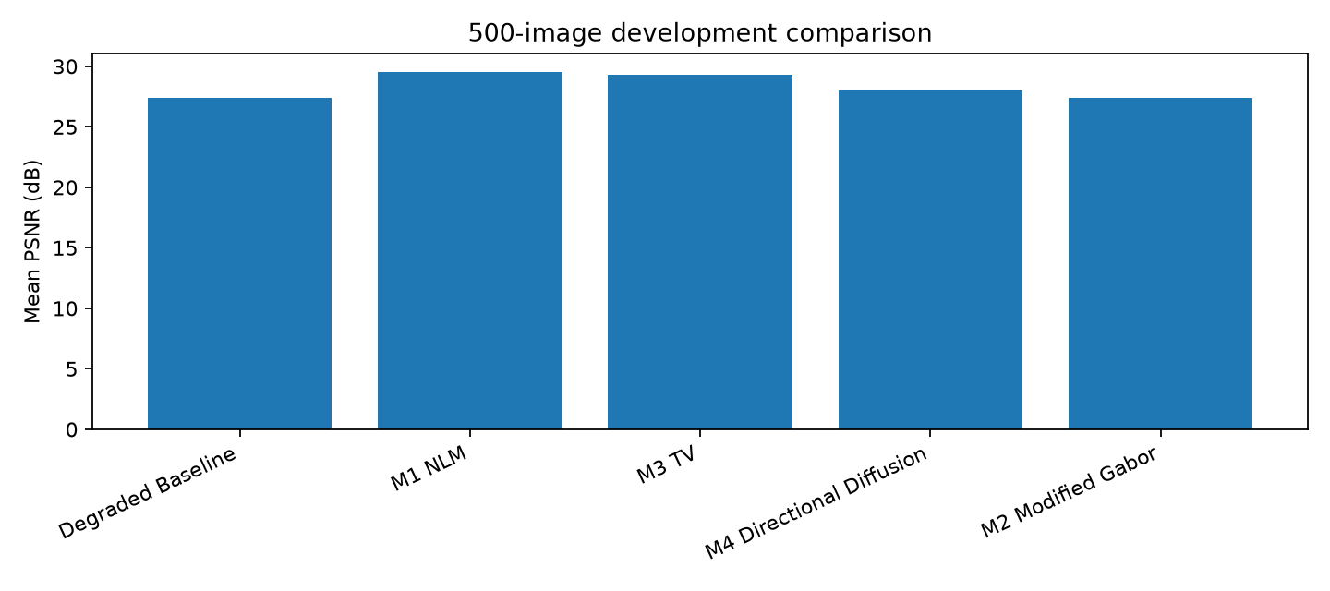
Figure 4.1 Development comparison chart.

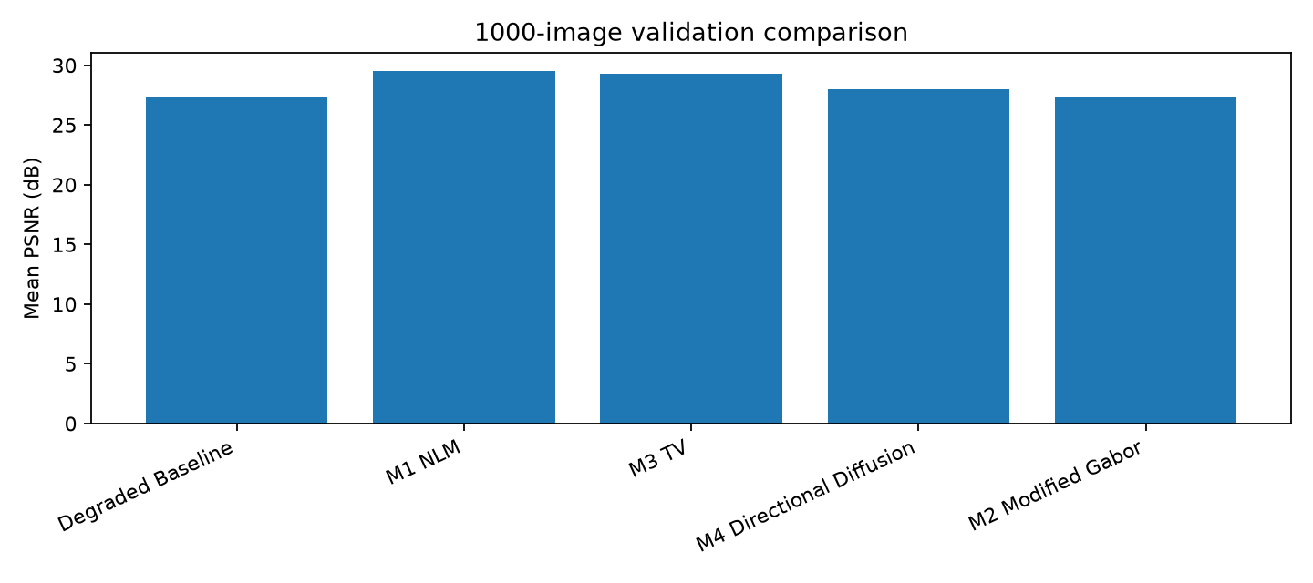
Figure 4.2 Validation comparison chart.

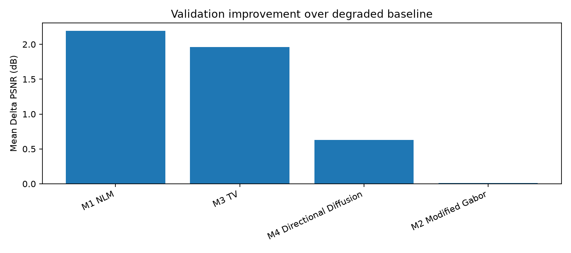
Figure 4.3 Validation improvement over degraded baseline.

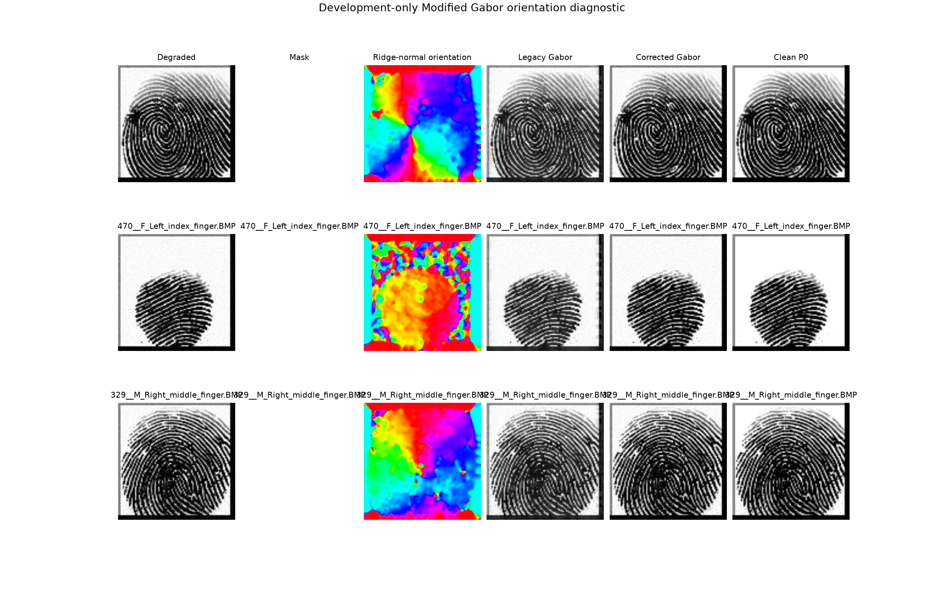
Figure 4.4 Modified Gabor orientation diagnostic.

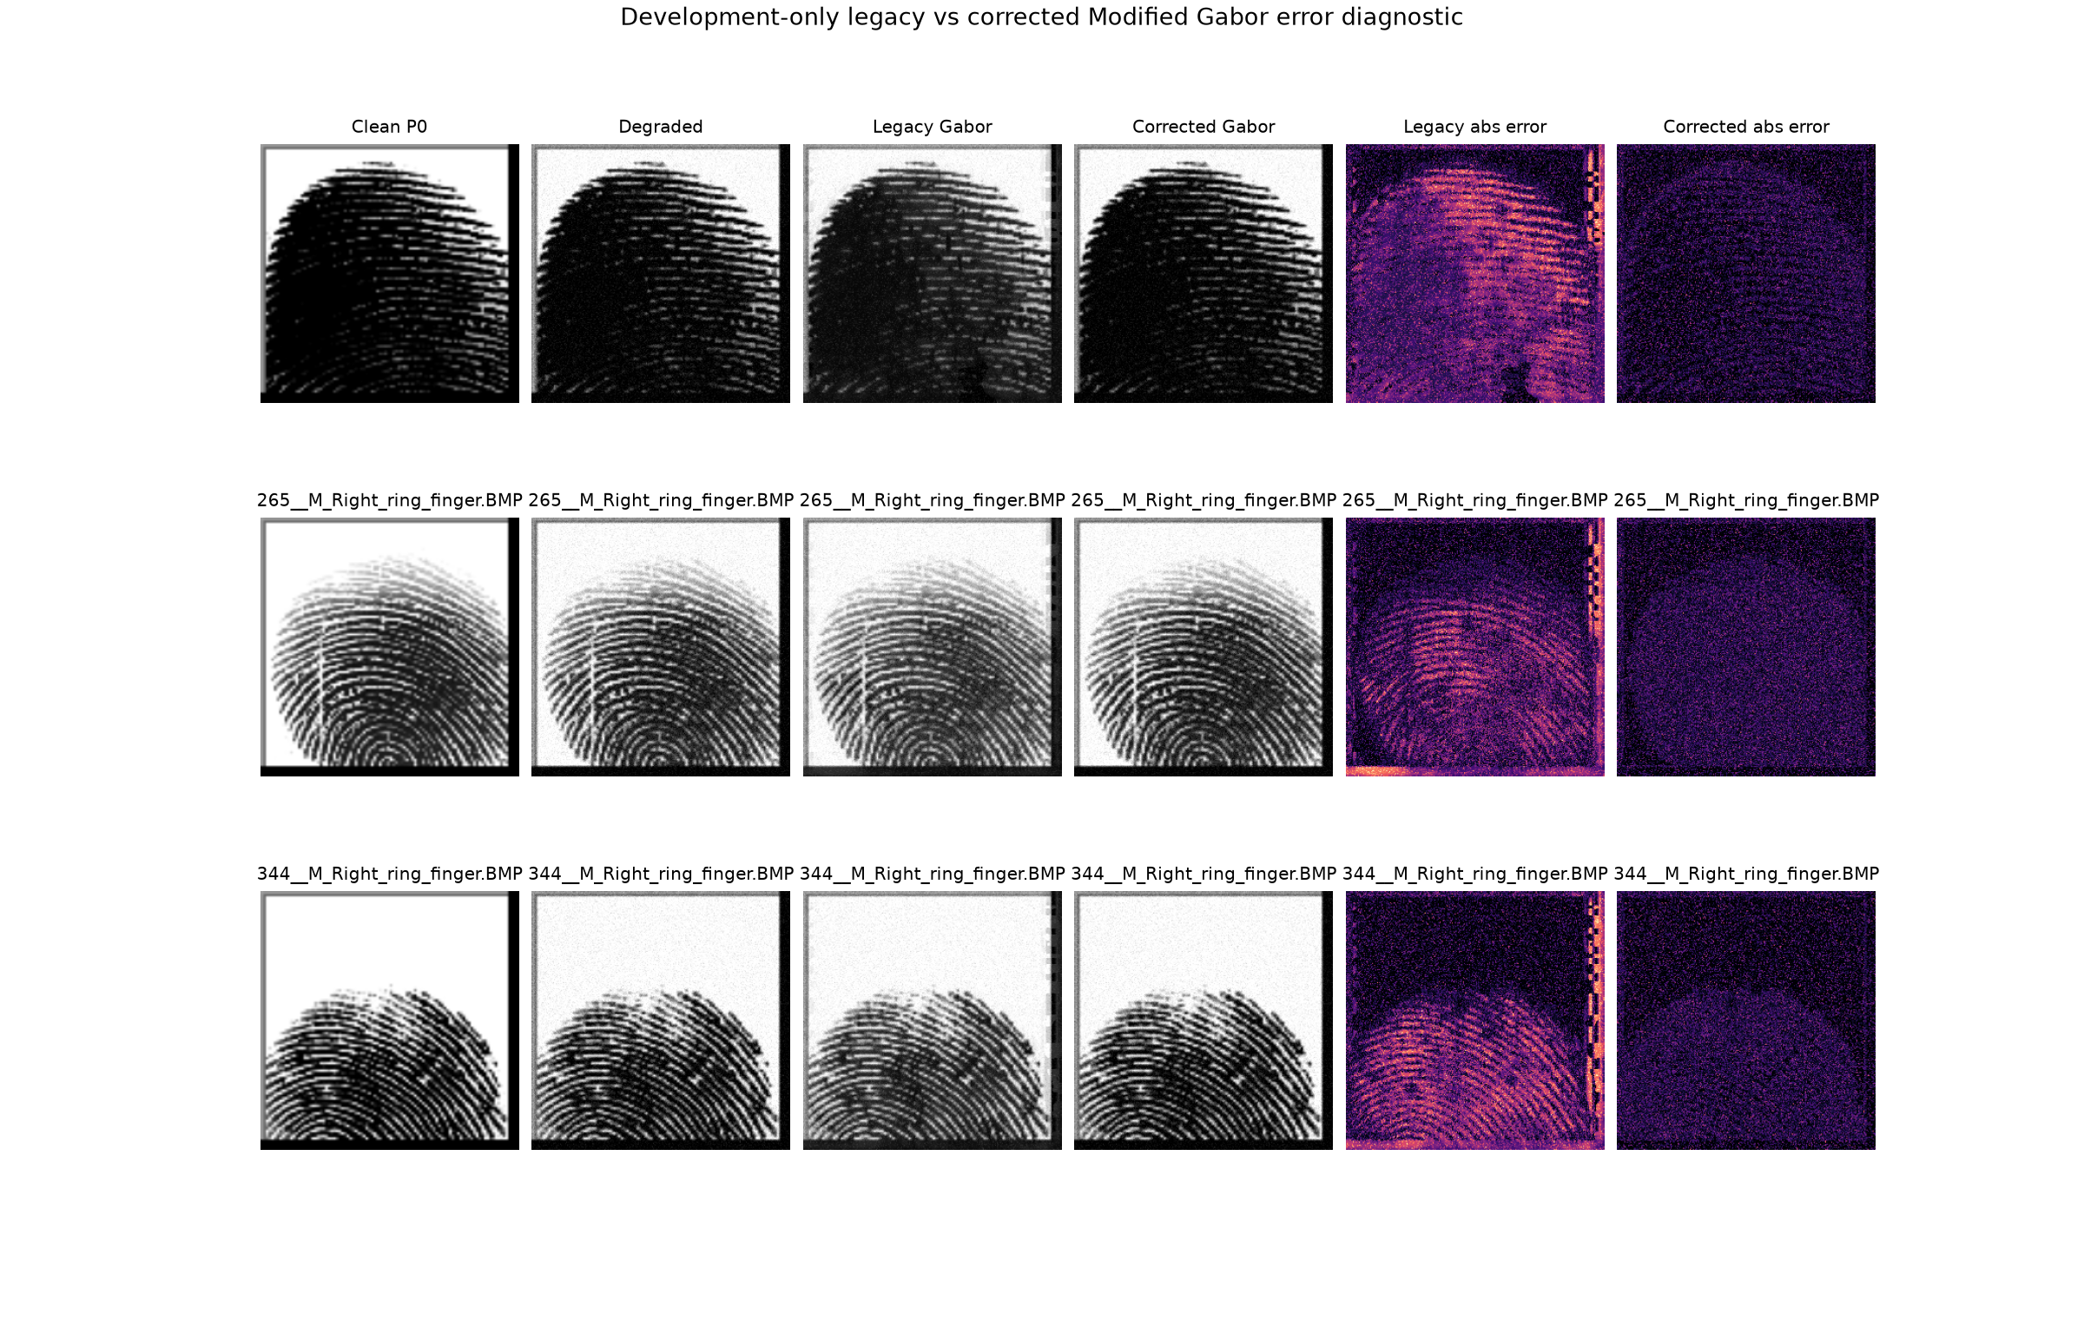
Figure 4.5 Modified Gabor legacy/corrected error diagnostic.

4.2 Discussion and Critical Interpretation
The Development results selected M1 NLM because it achieved the highest mean PSNR at 29.568 dB and the lowest mean MSE at 0.001114. M3 TV achieved the highest Development mean SSIM at 0.9379, which indicates strong structural preservation, but its PSNR was lower than M1 under the declared ranking rule.
The independent Validation results support the Development decision. M1 NLM achieved 29.559 dB mean PSNR, 0.9300 mean SSIM and 0.001114 mean MSE on 1,000 unseen-subject images. Compared with the degraded baseline, M1 improved mean PSNR by 2.196 dB and reduced mean MSE by 0.000724. M3 TV remained the strongest SSIM method at 0.9358, so it is the best choice when structural similarity is prioritised over the selected PSNR-first ranking.
M2 Modified Gabor changed the images only slightly under its conservative frozen strength. This behaviour is supported by its low mean absolute change and small validation improvement over the degraded baseline. The diagnostic figures show that the Gabor implementation was corrected and audited, but the final ranking still favours the denoising/restoration methods for this controlled Gaussian degradation protocol.
M4 Directional Diffusion produced moderate improvements while requiring the highest validation mean runtime among the four member techniques. Its direction-aware smoothing increased PSNR and SSIM compared with the degraded baseline, but it did not match M1 or M3. The altered-image structural evaluation provides additional no-reference evidence: M1 had the largest overall coherence and continuity gains, while M3 also reduced fragmentation. These altered-image results are not PSNR/SSIM/MSE results because the final code records that paired clean references are unavailable.

Conclusion

5.1 Achievements
Table 5.1 Objective achievement summary.
Objective | Status | Evidence
Objective 1 | Fulfilled | Four final techniques were implemented, investigated on 500 Development images and compared using PSNR, SSIM, MSE and runtime. M1 NLM was the Development winner by the implemented ranking rule.
Objective 2 | Fulfilled | Frozen configurations were validated on 1,000 unseen-subject images with zero overlap. M1 remained the final winner by PSNR/MSE, while M3 was strongest by SSIM.
Objective 3 | Fulfilled | The Streamlit prototype loads frozen configurations, supports single processing, Compare All, optional reference metrics, no-reference indicators, bulk processing and PNG/ZIP export.

The best-performing final technique under the implemented ranking rule is M1 NLM with frozen parameter h = 0.07. This conclusion is based on Development selection and independently supported by Validation results.
Project Code Repository: [Insert GitHub repository link here, if required]

5.2 Limitations and Future Works
The full-reference experiment uses controlled Gaussian degradation, which is measurable but narrower than the full range of real fingerprint capture problems. The validation metrics evaluate image fidelity and structural similarity rather than matcher-level biometric recognition accuracy. The altered SOCOFing subsets are evaluated with no-reference structural indicators because clean paired references are unavailable in the final implementation. Future work should add matcher-level testing, additional degradation protocols, cloud deployment, faster vectorised Gabor processing and human-labelled fingerprint quality validation.

References
Buades, A., Coll, B., & Morel, J.-M. (2005). A non-local algorithm for image denoising. In 2005 IEEE Computer Society Conference on Computer Vision and Pattern Recognition (CVPR'05) (Vol. 2, pp. 60-65). https://doi.org/10.1109/CVPR.2005.38
Chambolle, A. (2004). An algorithm for total variation minimization and applications. Journal of Mathematical Imaging and Vision, 20, 89-97.
Gonzalez, R. C., & Woods, R. E. (2018). Digital image processing (4th ed.). Pearson Education.
Hong, L., Wan, Y., & Jain, A. K. (1998). Fingerprint image enhancement: Algorithm and performance evaluation. IEEE Transactions on Pattern Analysis and Machine Intelligence, 20(8), 777-789. https://doi.org/10.1109/34.709565
Jabatan Penerangan Malaysia. (2023). Malaysia MADANI. Ministry of Communications, Malaysia. https://www.penerangan.gov.my
Perona, P., & Malik, J. (1990). Scale-space and edge detection using anisotropic diffusion. IEEE Transactions on Pattern Analysis and Machine Intelligence, 12(7), 629-639. https://doi.org/10.1109/34.56205
Shehu, Y. I., Ruiz-Garcia, A., Palade, V., & James, A. (2018). Sokoto Coventry fingerprint dataset. arXiv. https://doi.org/10.48550/arXiv.1807.10609
United Nations. (2015). Goal 9: Build resilient infrastructure, promote sustainable industrialization and foster innovation. https://sdgs.un.org/goals/goal9
Wang, Z., Bovik, A. C., Sheikh, H. R., & Simoncelli, E. P. (2004). Image quality assessment: From error visibility to structural similarity. IEEE Transactions on Image Processing, 13(4), 600-612. https://doi.org/10.1109/TIP.2003.819861

Appendix A
TUNKU ABDUL RAHMAN UNIVERSITY OF MANAGEMENT AND TECHNOLOGY
Group Contract Form
Table A.1 Group contract and contribution table.
Student Name and ID | Role(s)/Task(s) Assigned | Technique / Module | Signature and Date
[Student name / ID required] | M1 NLM | Non-local means denoising | [Signature and date required]
[Student name / ID required] | M2 Modified Gabor | Modified Gabor ridge enhancement | [Signature and date required]
[Student name / ID required] | M3 TV | Total variation restoration | [Signature and date required]
[Student name / ID required] | M4 Directional Diffusion | Coherence-guided directional diffusion | [Signature and date required]

Faculty: Faculty of Computing and Information Technology (FOCS). Programme: Bachelor in Data Science (Honours). Year of Study: [Required]. Semester: 2026xx. Course Title: Image Processing. Course Code: BMDS2133. Group Assignment / Project Title: Fingerprint Enhancement System. Name of Tutor: [Your Tutor Name here]. Tutorial Group: [Required].

Appendix B

AI Usage Disclosure Form
Table B.1 AI usage disclosure.
Field | Response
Student Name | [Group member names required]
Programme | Bachelor in Data Science (Honours)
Course | BMDS2133 Image Processing
Assessment Title | Fingerprint Enhancement System
AI Tool(s) Used | ChatGPT / Codex
Nature of Assistance | Brainstorming, code review, debugging support, algorithm explanation, documentation structuring, UK-English refinement and report generation from audited project evidence.
Disclosure Statement | AI assistance was used to audit source files and saved outputs, organise the documentation, render the PlantUML-based flowchart, create pseudocode from the final implementation and refine academic wording. Numerical values, technique names and frozen parameters were taken from executable code and saved CSV/JSON outputs. Exact historical prompt evidence should be inserted manually if required by the tutor.
Verification & Integrity | All reported facts, metrics and citations were checked against final project files and verified bibliographic sources where available.
Student Signature | [Signature required]
Date | [Date required]

Appendix C

Template Compliance and Source Audit
Table C.1 Template compliance checklist.
Template item | Generated report status
Cover page | Present with programme, tutor placeholder, group-member placeholders and project title.
Table of Contents | Present and updated during Word PDF export.
List of Figures | Present.
List of Tables | Present.
Introduction | Present with problem background, objectives and motivation.
Literature Review | Present with algorithm discussion and template comparison tables.
Methodology | Present with system flowchart, dataset, implementation, metrics and pseudocode.
Pseudocode | Present with Algorithms 1-10.
Result & Discussion | Present with Development, Validation, altered structural and runtime evidence.
Conclusion | Present with SMART objective achievement and future work.
References | Present in APA style and alphabetical order.
Appendix A Group Contract | Present with required placeholders.
Appendix B AI Usage Disclosure | Present with transparent disclosure and required placeholders.

Table C.2 Final source audit.
Source / issue | Finding
New official template | documentation/[Template] 2026xx_BMDS2133_ProgrammeName_All group members name_AssignmentDocumentation.pdf
Standalone assignment specification/rubric | Not found in repository during recursive audit; pasted brief and template requirements were used.
Notebook | Fingerprint_Enhancement_Project/Fingerprint_Enhancement_System.ipynb
Backend script | Fingerprint_Enhancement_Project/Fingerprint_Enhancement_System.py
Streamlit application | Fingerprint_Enhancement_Project/app.py
Frozen configuration | outputs/final_mode_a/script/final_selected_configuration.json
Development results | outputs/final_mode_a/script/development_member_comparison.csv
Validation results | outputs/final_mode_a/script/validation_member_comparison.csv
Notebook/script equivalence | All passed, ignoring runtime-only fields.
Conflict resolved | Older documentation described obsolete 24-image/hybrid/SVM material. Current executable code and final outputs were treated as authoritative.
Environment | Python 3.12.10, NumPy 1.26.4, pandas 3.0.5, scikit-image 0.26.0, OpenCV 4.11.0

