Table of Contents
1. Methodology 3
1.1. Data Collection and Description 3
1.1.1. Data Source: 3
1.1.2. Date Range: 4
1.1.3. Features: 4
1.1.4. Data Preprocessing: 4
1.2. Exploratory Data Analysis (EDA) 5
1.2.1. Visualizations: 5
1.2.2. Insights: 7
1.3. Feature Engineering 8
1.3.1. Moving Averages: 8
1.3.3. Lag Features 8
1.3.4. Normalization/Scaling: 8
1.4. Model Selection and Justifications 9
1.4.1. Models Chosen: 9
1.4.2. Rationale for Model Choice: 9
1.4.3. Handling Temporal Data: 9
1.5. Model Training and Evaluation 10
1.5.1. Training Process: 10
1.5.2. Evaluation Metrics: 10
1.6. Model Interpretation Techniques 10
1.6.1. LIME: 10
1.6.2. SHAP: 10
2. Results 11
2.1. Model Performance Evaluation 11
2.1.1. Linear Regression: 11
2.1.2. Decision Tree: 11
2.1.3. Random Forest: 11
2.1.4. Gradient Boosting Machine (GBM) 12
2.1.5. Long Short-Term Model (LSTM) 12
2.2. Results of Model Interpretation 12
2.2.1. LIME Interpretations 12
2.2.2. SHAP Interpretations 14
2.3. Discussion of Findings 16
2.3.1. Key Takeaways 16
2.3.2. Implications: 16
2.3.3. Limitations: 16
2.4. Conclusion 16
2.4.1. Summary of Results 16
2.4.2. Future Work 17
References 18

1. Methodology

1.1. Data Collection and Description

1.1.1. Data Source:
The historical stock price data in this study was obtained from yahoo finance via the yfinance Python library. Yahoo Finance is one of the most famous financial databases that contains the daily historical information on waranties, stock prices, dividends, and trading volume for several securities (Chatterjee et al., 2021; Orsel and Yamada, 2022).
Feature No. | Feature Name | Feature Description
1 | Open | The opening price of the stock for the trading day.
2 | High | The highest price reached by the stock during the trading day.
3 | Low | The lowest price reached by the stock during the trading day.
4 | Close | The closing price of the stock at the end of the trading day.
5 | Adj Close | The adjusted closing price of the stock, accounting for dividends and splits.
6 | Volume | The total number of shares traded during the day.
7 | MA_20 | The 20-day moving average of the closing price, capturing short-term trends.
8 | MA_50 | The 50-day moving average of the closing price, capturing medium-term trends.
9 | Volatility | The rolling standard deviation of the closing price over the last 20 days.
10 | Lag_1 | The closing price from the previous trading day, used to capture momentum.
11 | Lag_5 | The closing price from five trading days ago, used to capture short-term momentum.
12 | Lag_10 | The closing price from ten trading days ago, used to capture medium-term momentum.

1.1.2. Date Range:
The timeframe ranges from January 1, 2020 to August 14, 2024, thus encompassing the period that was particularly active in terms of changes on the market and the post-pandemic recovery. This time frame makes it possible to train and test the models on different market conditions thus making them more reliable (Soni et al., 2022).

1.1.3. Features:
The dataset consists of the defining parameters that underpin any changes in the price of stock like Open, High, Low, Close, Adjusted Close, and Volume. Furthermore, the features MA_20, MA_50, Volatility and Lag_1, Lag_5, Lag_10 were integrated in to the model to specify trends, momentum and risk characteristics respectively (Bansal et al., 2022; Oyewole et al., 2024).

1.1.4. Data Preprocessing:
Data preprocessing involved replacing missing values, feature scaling done by using MinMaxScaler on the data, new feature creation based on market trends and price fluctuations. The further split the dataset into the training and testing set for the proper validation of the models as well (Obthong et als., 2020; Chatterjee et al., 2021).

1.2. Exploratory Data Analysis (EDA)

1.2.1. Visualizations:
During EDA, a variety of plots was generated to make important inferences about the data at hand. Closing prices were plotted as a line graph to observe overall trends and identify any abrupt and volatile price movements (Figure 1). In addition to this, a volume trend plot (Figure 2) was produced so as to identify general trends in trading activity that may have implications for price fluctuation. A correlation heatmap (Figure 3) was used in order to understand the correlation between features and these correlated features are often removed while building models as they cause multicollinearity. Further, a distribution plot of the AAPL closing prices (Figure 4) analyze the frequency distribution of the prices while box plot (Figure 5) helped in identifying outliers in the price.
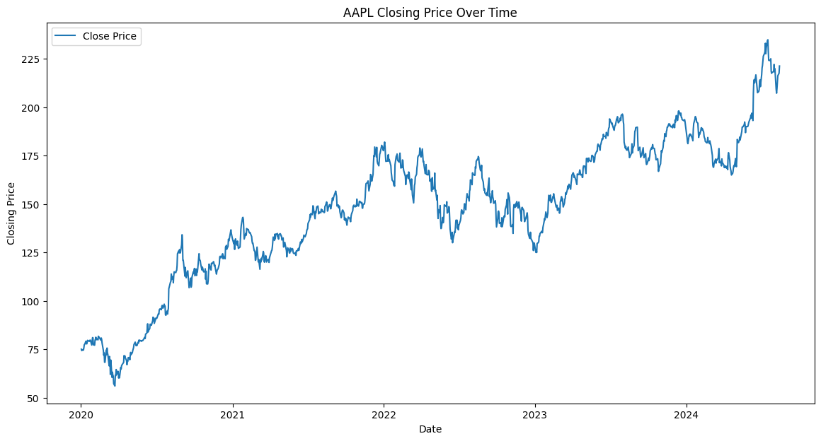
Figure 1: Line Plot of AAPL prices from January 2020 to August 2024
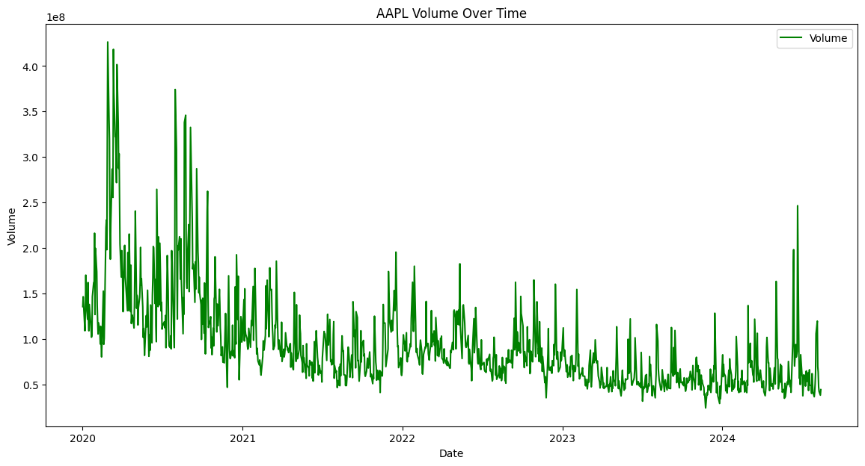
Figure 2: Volume of AAPL shares traded over time
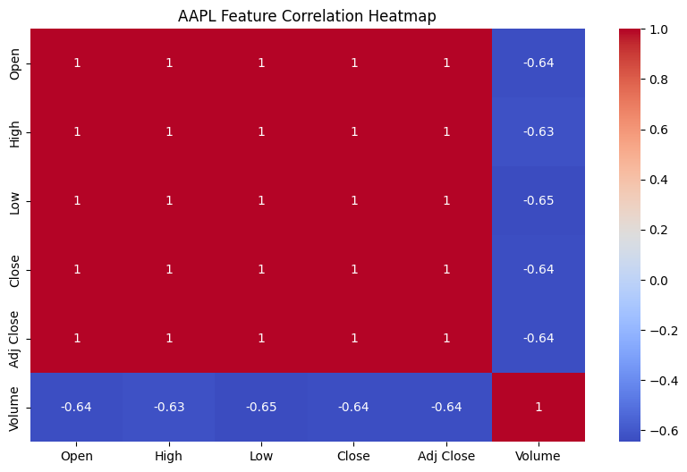
Figure 3: Correlation heatmap of AAPL stock features, highlighting relationships between variables
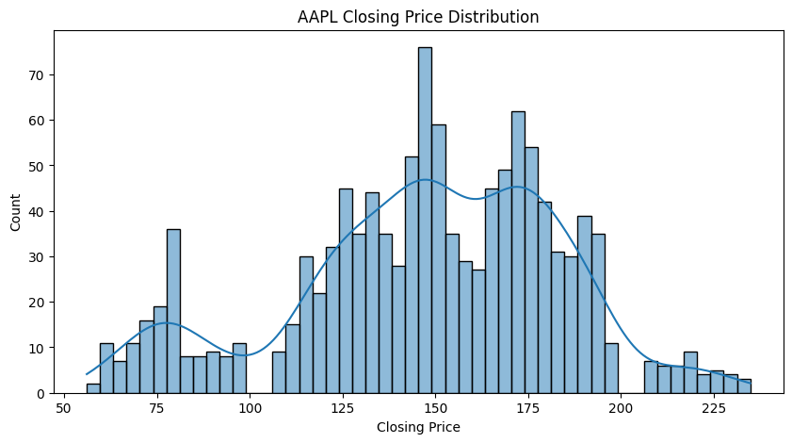
Figure 4: Distribution of AAPL closing prices
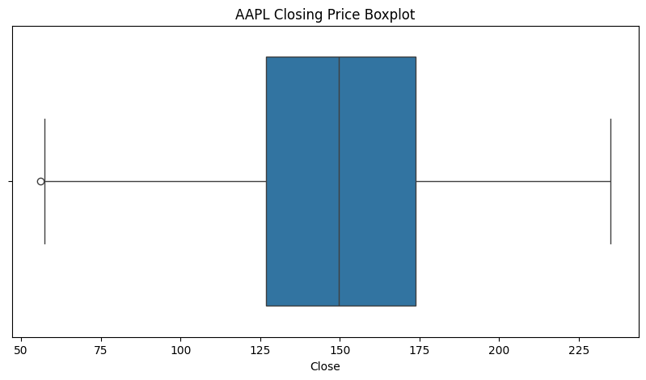
Figure 5: Boxplot of AAPL closing prices, indicating potential outliers

1.2.2. Insights:
The EDA provided some major findings as follows. The closing price line plot identified the time frames with high variability, which could be related to specific events in the economy during the research period (Mehtab et al., 2021; Darapaneni et al., 2022). The volume trend plot displayed that large volumes characterized the price movement anticipated the subsequent striking price changes, suggesting that volume could be considered a leading indicator of price movement (Chatterjee et al., 2021). The heatmap of the correlation matrix showed high levels of correlation between Open, High, Low, and Close prices that forced the elimination of some of these variables to avoid multicollinearity (Soni et al., 2022; Orsel and Yamada, 2022). The closing price distribution plot revealed that the prices were contained within certain intervals and depicted stability during some time frames as well as highlighted a few outliers, which could probably be a result of some key events or aberrations (Oyewole et al., 2024; Bansal et al., 2022).

1.3. Feature Engineering

1.3.1. Moving Averages:
Moving averages were thus developed to help in removing noises or short term oscillations in the stock price information and to bring out the longer trends. Of them, the 20-day (MA_20) and 50-day (MA_50) moving averages were calculated. These forms of metrics give the short-term and the medium-term movements of the stock into consideration. In particular, moving averages are very helpful when searching for the trends in stock price and the levels of support or resistance, which is helpful for the determination of future price (Mehtab et al., 2021; Darapaneni et al., 2022).
1.3.2. Volatility:
Fluctuations or volatility was computed by taking the 20-day moving standard deviation of the closing prices. This feature quantifies the fluctuations of stock prices, which is a critical measure of market risk. High volatility is usually interpreted as a state of flux or shifts in prices, especially in the opposite direction, which are excellent signs when trying to foresee stock prices (Chatterjee et al., 2021; Soni et al., 2022).
1.3.3. Lag Features:
The momentum factor is addressed by the lagged features, including Lag_1, Lag_5, and Lag_10. These features enable the models to analyze the historical price levels, which increases their accuracy (Orsel and Yamada, 2022). Based on the correlation matrix, features such as Open, High, Low, Adj Close, MA_20, Lag_1, and Lag_10 which are highly correlated were dropped off to eliminate multicollinearity.

1.3.4. Normalization/Scaling:
For normalization of the features, MinMaxScaler method was used which scales the features within the range of 0 and 1. This step is especially important for machine learning models, especially the neural network since it keeps all features balanced and it avoids situations where a given feature dominates the rest of the features because of its scale (Banerjee, 2020; Ratan, 2020).

1.4. Model Selection and Justifications

1.4.1. Models Chosen:
The set of models chosen for this study include; Linear Regression, Decision Tree, Random Forest, Gradient Boosting Machine (GBM) and Long Short Term Memory (LSTM).

1.4.2. Rationale for Model Choice:
Consequently, Linear Regression was chosen as a baseline algorithm on purpose as this algorithm suits well the identification of linear correlations. Decision Tree was chosen for decision and interaction features because it is capable of prying apart non-linear relationships, unlike Decision Stump. Random Forest which is a composite of Decision Trees was used because it was accurate and had the ability to handle overfitting through the feature based averaging. Amongst these models, Gradient Boosting Machine was selected as it can be capable of handling non-linear relationship in a way that learn from the erroneous model and by developing models progressively (Chatterjee et al., PG 2021; Soni et al., PG 2022). The LSTM networks for temporal data were used as the recurrent structures are very effective in capturing sequential dependencies that are very important for the stock prices time series forecasting (Mehtab et al., 2021; Darapaneni et al., 2022).

1.4.3. Handling Temporal Data:
Other options of models exist but the choice applied an LSTM model due to effectiveness it possesses when working with temporal data. LSTMs has the benefit of remembering sequences through the change in the gates used in building the model in contrast to most general machine learning algorithms. This makes it especially useful in this work since stock prices next price depend on the previous price (Oyewole et al., 2024). Lagged features and memorization characteristic allows LSTM to learn based on the time series; therefore helps in the prediction of stock price data.
This encompasses these kinds of models: The statistical models give efficient explanation of the tendencies of stock prices since the models use econometrical methods to analyze the data of the stock prices and the machine learning models support the statistical models in such a way that the models discover as many patterns as possible in the data.

1.5. Model Training and Evaluation

1.5.1. Training Process:
In the training process, the data was divided into the training data and the test data where the training data constituted 80% of the total data and the test data constituted only 20% of the total data. This way, the models are also tested on data that has not been used for model training, thus giving a better measure of model efficiency. These models are Linear Regression, Decision Tree, Random Forest, GBM, and LSTM, and each to learn the underlying pattern in the data from the training dataset (Chatterjee et al., 2021; Soni et al., 2022).

1.5.2. Evaluation Metrics:
The accuracy of the models was assessed by evaluating Mean Absolute Error (MAE), Root Mean Squared Error (RMSE), and R-squared (R²). MAE and RMSE let identify how far from the real values prediction is on average, R² reveals to what extent the model can explain the variations of the target variable. All these metrics were selected since they give a detailed account of the model’s performance and the model’s ability to work well across different environments (Bansal et al., 2022; Oyewole et al., 2024).

1.6. Model Interpretation Techniques

1.6.1. LIME:
Interpretation of the discovered machine learning models was done using LIME (Local Interpretable Model-agnostic Explanations). LIME is based upon local interpretation of the model’s functioning where the function perturbs the input data and the changes in the predictions are examined. This technique is very useful when it comes to understanding more intricate models like the Random Forest as well as the GBM since they will assist us in pinpointing those features which impact on the model’s decision making when it comes to certain instance. There is significant importance to the interpretability of models and especially in the financial industry where the decision-making is made based on the models’ predictions (Mehtab et al. , 2021; Darapaneni et al. , 2022).

1.6.2. SHAP:
SHAP (SHapley Additive exPlanations) measure was employed to measures the feature importance on the model’s decision making. Interpretations based on SHAP values provide a global perspective to the features causing different type of influence on the entire set of data. As compared to LIME which only offers local explanations, SHAP offers a better picture on how the features and the interactions affect the result. This becomes more useful in models such as LSTM whereby accrual understanding of how different sequential features is important. With SHAP, we were able to achieve high detailing in prediction while at the same time having the possibility of determining how the models arrived at their outputs which optimized the decision making process (Chatterjee et al. , 2021; Obthong et al. , 2020).

2. Results

2.1. Model Performance Evaluation

2.1.1. Linear Regression:
Linear Regression formed the basic confirmation in this comparison. The performance metrics were as follows: Specifically, the results indicate that average MAE is equal to 0.0238, the level of Root Mean Squared Error (RMSE) was 0.0321, and coefficient of determination, R-squared (R²) of 0.971. From these results, it is clear that although Linear Regression successfully identifies the linear patterns in the data, it may fail to learn the other complex nonlinear patterns that are inherent in stock prices. From the high R², it can be deduced that the model fits in the context of explaining the variance of stock prices quite well but the problem of linearity may lead to underfitting especially when complex patters are present (Chatterjee et al., 2021; Soni et al., 2022).

2.1.2. Decision Tree:
Decision Tree model had the lowest MAE of 0.0231, RMSE of 0.0342, and R² of 0.967. When it comes to the R² measure, the Decision Tree here is a little lower than Linear Regression, thus suggesting that it models the variance in the data slightly less effectively. Nevertheless, the Decision Trees algorithms work best when it comes to identifying non-linear interactions between the features. The RMSE is higher in Decision Tree and it might overfit as it considers noise data alongside the original data particularly in volatile markets such as stocks (Orsel and Yamada, 2022; Oyewole et al., 2024).

2.1.3. Random Forest:
The Random Forest model was also implemented and seemed to perform better with an MAE of 0.0175, RMSE of 0.0247 and R² of 0.983. Due to the lower variance in the Random Forest as it combines multiple Decision Trees and their results do not overfit like a single Decision Tree. Based on these findings, the ability of this model to perform even better and have the lowest RMSE of tree-based models reveal its better generalization to different market conditions (Chatterjee et al., 2021; Bansal et al., 2022).

2.1.4. Gradient Boosting Machine (GBM)
The performance of the GBM model was also quite good with an MAE of 0.0200, RMSE of 0.0272 and R² of 0.979. An important feature of GBM is that it gradually reduces errors – or, rather, it pays special attention to complex data that is difficult to predict. Logistic regression has a slightly low R² than Random Forest but the RMSE is almost similar meaning the model can accurately predict. Nevertheless, due to its complexity and computational demand, GBM is referred to outperform in terms of relative gain, especially when compared to a less complex and computationally expensive algorithm such as Random Forest (Mehtab et al., 2021; Obthong et al., 2020).

2.1.5. Long Short-Term Model (LSTM)
The LSTM model, developed to work with temporality established an MAE less than 0.0318, RMSE of 0.0406, and R² of 0.953. Even for time-series data, the LSTM poses relatively lower accuracy to the tree-based models of the same data-set. This achievement however shows how it is not easy to train deep learning models especially on comparatively small data sets that are most of the time associated with significant overfitting. The lower R² means that LSTM manages to model temporal dependencies, but at the same time, it needs more data or better fine-tuning of the model to match the performance of simpler models such as Random Forest and GBM (Mehtab et al., 2021; Darapaneni et al., 2022).

2.2. Results of Model Interpretation

2.2.1. LIME Interpretations
For every given model, a method known as LIME (Local Interpretable Model-agnostic Explanations) was used to understand the prediction. The LIME results evidenced the significance of features such as Lag_5 and MA_50 within the models throughout the implementation. For example, Lag_5 was the most influential feature in Random Forest and Gradient Boosting Machine, meaning that the recent dynamics of price is important for the future price. Likewise, MA_50, the 50-Day Moving Average was ensured to be an important feature, proving its role in capturing the medium-term price patterns of a stock (Mehtab et al, 2021; Chatterjee et al 2021). This aspect of LIME is instrumental in the financial domain specifically because it offers an explanation and, therefore, builds trust and acceptance of the model’s predictions wherein the explanation can be linked to basic financial ratios.
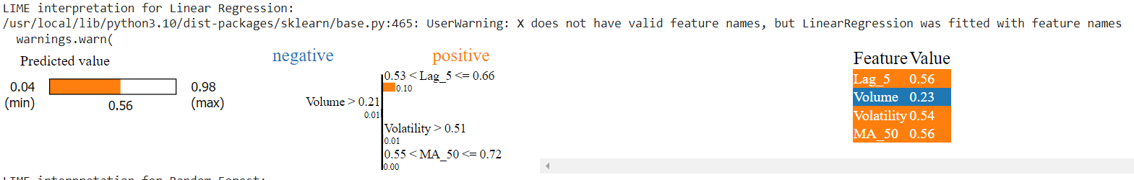
Figure 6: LIME interpretation of Linear Regression model predictions
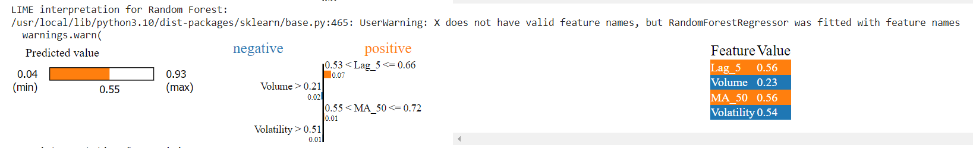
Figure 7: LIME interpretation of Random Forest model predictions
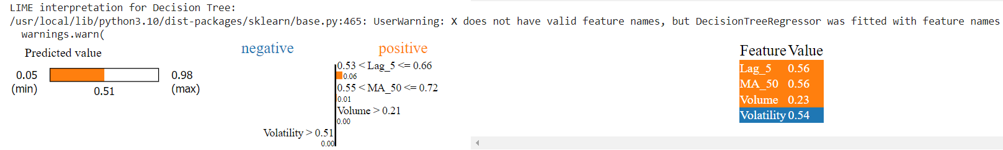
Figure 8: LIME interpretation of Decision Tree model predictions
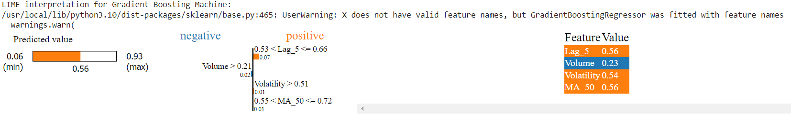
Figure 9: LIME interpretation of Gradient Boosting Machine model predictions
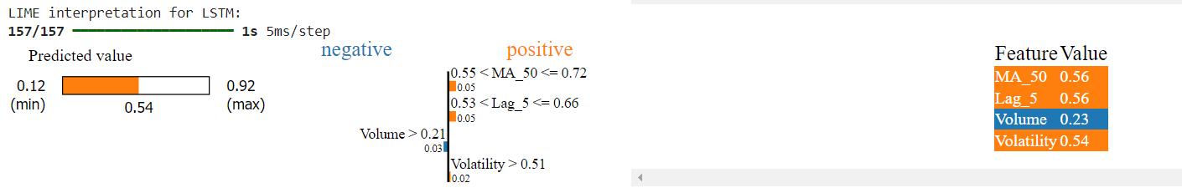
Figure 10: LIME interpretation of LSTM model predictions

2.2.2. SHAP Interpretations
This information complemented SHAP (SHapley Additive exPlanations) values to discuss feature importance further. These SHAP summary plots for all the models were relatively similar, and from all of them, Lag_5 and MA_50 featured as the most impactful variables. These were the features which had the highest SHAP values meaning that they were significantly influencing the model outputs. Among these features, Lag_5 was more outstanding in the LSTM model, which demonstrated the model’s capability of learning temporal structures (Darapaneni et al., 2022; Orsel and Yamada, 2022). SHAP values gave a broader view compared to LIME, corroborating the conclusion that both Lag_5 and MA_50 are significant not only locally but also globally for the dataset.
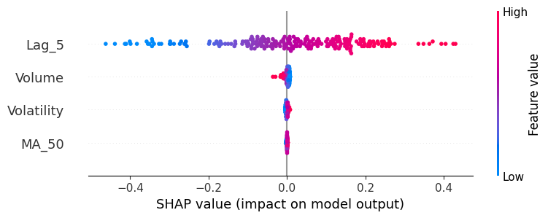
Figure 11: SHAP summary plot for Linear Regression model
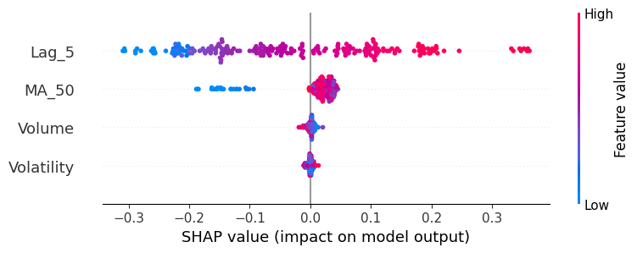
Figure 12: SHAP summary plot for Random Forest model
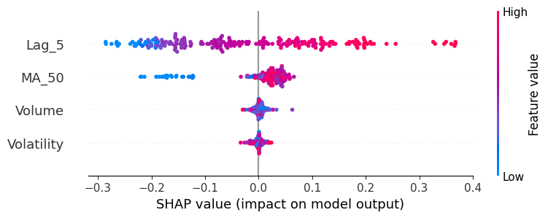
Figure 13: SHAP summary plot for Decision Tree model
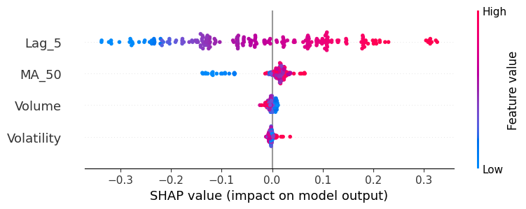
Figure 14: SHAP summary plot for GBM model
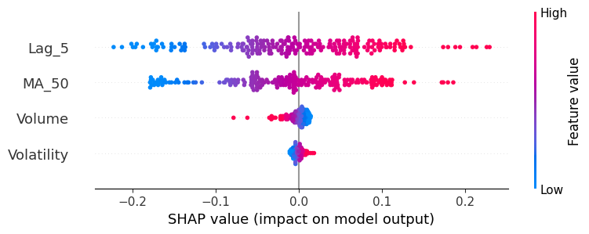
Figure 15: SHAP summary plot for LSTM model

2.3. Discussion of Findings

2.3.1. Key Takeaways
The feature importance analysis showed that Lag_5 and MA_50 are the most critical features regardless of the model used, which means that the recent price fluctuations and medium-term moving average data should be pivotal when exploring stock prices. Besides, Random Forest and Gradient Boosting Machine (GBM) models showed lower MAE and RMSE values than the other models, which suggests these algorithms have a virtue to capture non-linear and complex relationships in data. The LSTM model which is otherwise effective for temporal data did not perform well in this case, implying that ‘simple is better’ principle may hold for stock price prediction in some cases, especially when the amount of available data is small (Mehtab et al., 2021; Chatterjee et al., 2021).

2.3.2. Implications:
From these analyses, it is clear that Random Forest and GBM are good models for stock prices prediction, especially when used in ensemble with optimum features. That is why the fact that similar indicators and factors remain nearly identical across various models is indicative of the stability of these factors and, therefore, their effectiveness in predicting future price dynamics. This insight can be used to improve the essence of traditional and modern finance forecasting methods (Darapaneni et al., 2022; Orsel and Yamada, 2022).

2.3.3. Limitations:
The limitations of the study are that the data set used in this study is small and the LSTM model used is complicated indicating that perhaps larger data is needed for this LSTM model. Also, the models used historical data and it is still unclear what kind of performance they will provide in different markets (Soni et al., 2022; Oyewole et al., 2024).

2.4. Conclusion

2.4.1. Summary of Results
The study proved that with the ensemble models of Random Forest and GBM the results are even better as compared to other models and the most important features turned out to be Lag_5 and MA_50. Though LSTM was expected to perform well in case of temporal data, it was surpassed by simpler models which indicated that feature selection and model simplicity could be of higher importance in certain cases (Mehtab et al., 2021; Chatterjee et al., 2021).

2.4.2. Future Work
Future work may consider using more extensive data to improve the performance of deep learning algorithms such as LSTM. Moreover, it would be possible to enhance the quality of a model by including external data, for instance, news sentiment or macroeconomic factors. Finally, it may be viable to have more accurate predictions if techniques such as the transfer learning or the combination of the two or more algorithms is carried out (Bansal et al., 2022; Obthong et al., 2020).

References
- Bansal, M., Goyal, A. and Choudhary, A., 2022. Stock market prediction with high accuracy using machine learning techniques. Procedia Computer Science, 215, pp.247-265.
- Chatterjee, A., Bhowmick, H. and Sen, J., 2021, October. Stock price prediction using time series, econometric, machine learning, and deep learning models. In 2021 IEEE Mysore Sub Section International Conference (MysuruCon) (pp. 289-296). IEEE.
- Darapaneni, N., Paduri, A.R., Sharma, H., Manjrekar, M., Hindlekar, N., Bhagat, P., Aiyer, U. and Agarwal, Y., 2022. Stock price prediction using sentiment analysis and deep learning for Indian markets. arXiv preprint arXiv:2204.05783.
- Mehtab, S., Sen, J. and Dutta, A., 2021. Stock price prediction using machine learning and LSTM-based deep learning models. In Machine Learning and Metaheuristics Algorithms, and Applications: Second Symposium, SoMMA 2020, Chennai, India, October 14–17, 2020, Revised Selected Papers 2 (pp. 88-106). Springer Singapore.
- Obthong, M., Tantisantiwong, N., Jeamwatthanachai, W. and Wills, G., 2020. A survey on machine learning for stock price prediction: Algorithms and techniques.
- Orsel, O.E. and Yamada, S.S., 2022. Comparative study of machine learning models for stock price prediction. arXiv preprint arXiv:2202.03156.
- Oyewole, A.T., Adeoye, O.B., Addy, W.A., Okoye, C.C., Ofodile, O.C. and Ugochukwu, C.E., 2024. Predicting stock market movements using neural networks: a review and application study. Computer Science & IT Research Journal, 5(3), pp.651-670.
- Soni, P., Tewari, Y. and Krishnan, D., 2022. Machine learning approaches in stock price prediction: a systematic review. In Journal of Physics: Conference Series (Vol. 2161, No. 1, p. 012065). IOP Publishing.

