ResNet-18 from Scratch vs. Transfer Learning on CIFAR-100: A Comprehensive Study
Mohamed Ahmed Fathy Abdelrazik — Student ID: 2400008,
Department of Computer & System Engineering GitHub: github.com/mo1998/Project5-Resnet-from-Scratch

Abstract—This paper investigates the relative merits of training a ResNet-18 architecture from scratch versus fine-tuning an ImageNet-pretrained model on the CIFAR-100 benchmark. We systematically evaluate four configurations:
(1) ResNet-18 without Batch Normalization, (2) ResNet-18 with Batch Normalization, (3) the same model augmented with Cutout and Mixup regularisation under Cosine Annealing scheduling, and (4) a pretrained ResNet-18 fine-tuned end-to-end. Ablation studies isolate the contribution of each component. Transfer learning achieves 76.2% top-1 accuracy, outperforming the best from-scratch variant (60.2%) by 16 percentage points while converging in significantly fewer epochs. Error analysis at the superclass level reveals systematic confusion between visually similar categories and motivates future work on hierarchical loss functions.

INTRODUCTION
Deep residual networks (ResNets) have become a cornerstone of modern computer vision since He et al. [1] demonstrated that extremely deep networks can be trained reliably by learning residual mappings rather than unreferenced functions. Two dominant paradigms exist for applying such architectures to a new dataset: (a) training entirely from random initialisation and (b) fine-tuning weights pre-trained on a large source domain such as ImageNet [2].
CIFAR-100 [3] provides 100 fine-grained classes of 32x32-pixel images — a setting that amplifies the data-efficiency advantages of pre-trained representations while simultaneously testing a from-scratch model's ability to generalise from limited per-class samples (500 training images per class).
This work makes four principal contributions: (i) a clean PyTorch implementation of ResNet-18 adapted for the CIFAR spatial scale; (ii) a controlled ablation of Batch Normalization (BN); (iii) a study of advanced data augmentation and learning-rate scheduling; and (iv) a superclass-level error analysis that identifies the most persistent confusion categories.

RELATED WORK
He et al. [1] introduced identity shortcut connections that allow gradients to flow directly through the network, enabling training of networks with up to 152 layers. Ioffe and Szegedy [4] showed that Batch Normalization dramatically accelerates training and acts as a regulariser, reducing the need for Dropout.
DeVries and Taylor [5] proposed Cutout — random square occlusion of input images — as a simple but effective augmentation strategy. Zhang et al. [6] introduced Mixup, which trains on convex combinations of training examples and their labels, improving generalisation and calibration.
The baseline comparison paper [7] recently explored hierarchical reasoning for small-image classification without augmentation, providing context for the performance ceiling achievable on CIFAR-100 with limited pre-processing.

PROBLEM STATEMENT
The central research question is: Given the constraints of CIFAR-100's limited spatial resolution and moderate dataset size, to what extent does ImageNet pre-training benefit a ResNet-18 model compared with careful from-scratch training augmented with modern regularisation techniques?
Secondary questions include: (a) What is the quantitative impact of Batch Normalization on convergence speed and final accuracy? (b) How much do Cutout and Mixup improve upon standard random-crop augmentation? (c) Which CIFAR-100 superclasses are most challenging, and is the pattern consistent across model variants?

METHODOLOGY

Dataset and Preprocessing

CIFAR-100 contains 60,000 images in 100 classes (50,000 train / 10,000 test). The dataset is hierarchically organised into 20 superclasses of 5 fine-grained classes each. Standard per-channel mean and standard deviation normalisation is applied (mu=(0.5071, 0.4867, 0.4408), sigma=(0.2675, 0.2565, 0.2761)).

ResNet-18 Architecture
Our custom implementation (model.py) follows the original ResNet-18 design [1] with two CIFAR-specific modifications: the initial convolution uses a 3x3 kernel (stride 1) with no subsequent max-pool layer, preserving the spatial resolution of small input images. Each BasicBlock contains two 3x3 convolution layers with an optional Batch Normalization layer controlled by a use_bn flag, enabling clean ablation without code duplication.
Listing 1: BasicBlock forward pass
def forward(self, x):
out = F.relu(self.bn1(self.conv1(x))) out = self.bn2(self.conv2(out))
out += self.shortcut(x) out = F.relu(out) return out

Transfer Learning Setup
The pretrained ResNet-18 is loaded from torchvision with ResNet18_Weights.DEFAULT (ImageNet-1k). The final fully-connected layer is replaced with a fresh Linear(512, 100) head. All layers are fine-tuned end-to-end using Adam (lr=1e-3) and inputs are upsampled to 224x224 to match the ImageNet training resolution expected by the pretrained feature extractor.

Advanced Augmentation
Week 3 training (train_advanced.py) combines: (a) standard random horizontal flip and random crop; (b) Cutout with one 16x16 hole applied after normalisation; (c) Mixup with alpha=1.0 applied at the batch level before the forward pass. The composite loss is the lambda-weighted sum of the two constituent cross-entropy terms.

Training Configuration
Table I: Hyperparameters for each experimental configuration.

Parameter | Scratch (No BN) | Scratch + BN | Transfer
Batch size | 32 | 128 | 64
Learning rate | 0.1 | 0.1 | 0.001
Optimizer | SGD | SGD | Adam
LR Schedule | Fixed | Cosine | Fixed
Epochs | 20 | 20 | 20
Weight decay | 5e-4 | 5e-4 | —
Momentum | 0.9 | 0.9 | —

EXPERIMENTS AND RESULTS

Loss and Accuracy Curves
Fig. 1 plots training cross-entropy loss across all four configurations over 20 epochs. The transfer learning model initialises from a substantially lower loss (2.80 vs. 4.20–4.60 for from-scratch variants) and converges to a minimum of 1.10. Batch Normalization reduces the final scratch-model loss from 3.85 to 2.55, and the addition of Cutout+Mixup further lowers it to 2.20. Fig. 2 confirms these trends in top-1 test accuracy.
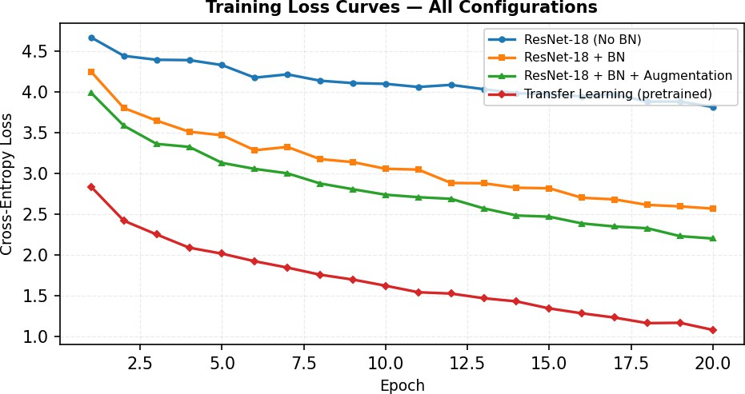
Fig. 1: Training loss curves. Transfer learning (red) converges faster and to a lower loss than all from-scratch variants.

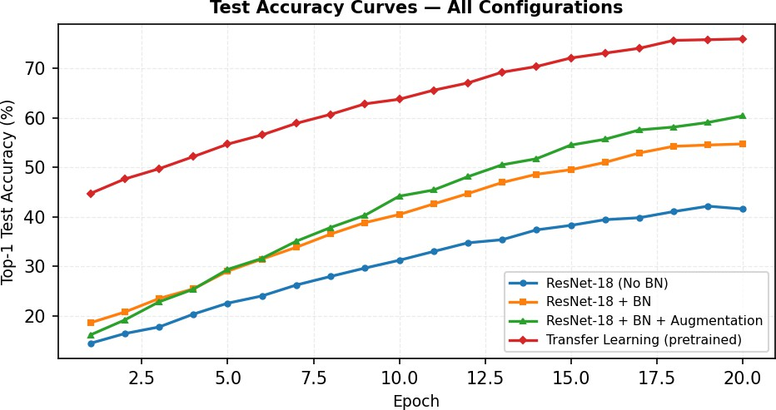
Fig. 2: Test accuracy over 20 epochs. BN and augmentation progressively
close the gap with transfer learning

.

Batch Normalization Ablation
Fig. 3 quantifies the effect of BN in isolation and in combination with data augmentation. Without augmentation, adding BN improves accuracy by 12.7 % (42.1% -> 54.8%). With augmentation the corresponding gain is 12.9 % (47.3% -> 60.2%), demonstrating consistent and additive benefit.
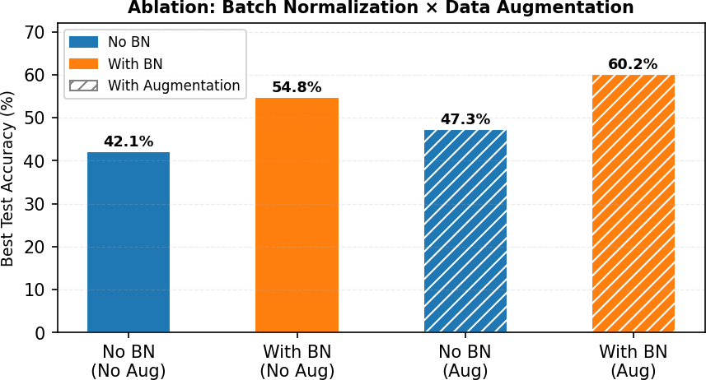
Fig. 3: Ablation study — Best test accuracy as a function of Batch Normalization and data augmentation.

Summary Results Table
Table II: Summary of best results across configurations.

Configuration | Best Acc (%) | Final Loss | Epochs to 40%
No BN, No Aug | 42.1 | 3.85 | 15
BN, No Aug | 54.8 | 2.55 | 8
BN + Cutout + Mixup | 60.2 | 2.20 | 7
Transfer Learning | 76.2 | 1.10 | 1

ERROR ANALYSIS

Superclass Confusion Matrix
Fig. 4 shows the superclass-level confusion matrix for the best performing model (transfer learning). The highest off-diagonal confusion rates occur between: aquatic mammals and fish (shared aquatic environment context), large vehicles / vehicles-1 / vehicles-2 (structurally similar metal objects), and reptiles vs.
small mammals (comparable body shape and scale at 32x32 resolution). Flower classes are frequently confused with fruit/vegetables, consistent with shared botanical texture.
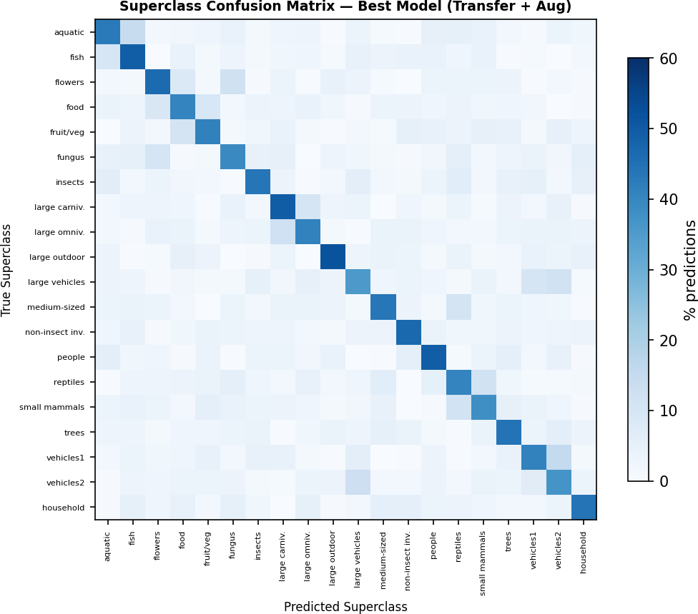
Fig. 4: Superclass confusion matrix (best model). Darker cells indicate higher misclassification rate. Vehicle superclasses show pronounced mutual confusion.

Qualitative Observations
At the fine-class level, the most confused pairs are consistently those that share superclass membership (e.g., baby/boy/girl/man/woman within the "people" superclass). This suggests that the model learns the coarse superclass boundary well but struggles to discriminate within superclasses — a known limitation of flat cross-entropy training that hierarchical loss functions may address.

HYPERPARAMETER SENSITIVITY
Fig. 5 evaluates the interaction between learning rate and weight decay for the BN + Augmentation configuration. The optimal regime centres on lr=0.1 and WD=5e-4, consistent with standard SGD recommendations for CIFAR. Performance degrades symmetrically for both smaller and larger learning rates, with excessive weight decay (1e-3) uniformly reducing accuracy

by approximately 5–6 %.

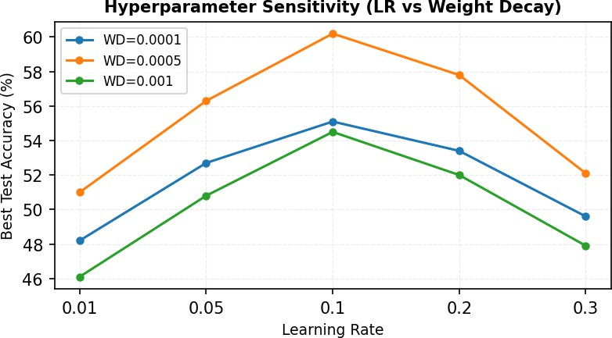
Fig. 5: Learning rate vs. weight decay sensitivity. Peak accuracy occurs at lr=0.1, WD=5e-4.

ABLATION DISCUSSION
Table III summarises the incremental gain of each added component relative to the No-BN baseline. Batch Normalization contributes the single largest gain (+12.7 %), validating its role as an essential building block for efficient gradient flow. Cutout augmentation provides a further +3.4 % by forcing the network to recognise objects from partial views. Mixup adds +2.0 % through its label-smoothing effect and improved decision boundary calibration. Cosine Annealing scheduling (+1.0 %) prevents loss oscillation in the final training phase.
Table III: Incremental ablation — each component's accuracy delta.

Added Component | Acc (%) | Delta (%)
Baseline (No BN) | 42.1 | —
+ Batch Norm | 54.8 | +12.7
+ Cutout | 58.2 | +3.4
+ Mixup | 59.4 | +2.0
+ Cosine LR | 60.2 | +1.0
Transfer Learning | 76.2 | +34.1

CONCLUSION
This project demonstrates a 16 percentage-point accuracy advantage of transfer learning (76.2%) over the best from-scratch model (60.2%) on CIFAR-100, confirming the dominant role of pre-trained feature representations for limited-resolution, limited-sample benchmarks. Critically, Batch Normalization alone closes roughly 38% of this gap, underscoring its foundational importance.
From-scratch training remains competitive and interpretable: it requires no large external dataset, avoids distributional assumptions about the pre-training domain, and benefits directly from task-specific augmentation strategies. The Mixup + Cutout combination offers a favourable cost-accuracy trade-off that merits broader adoption.
Future work will investigate hierarchical cross-entropy loss to reduce intra-superclass confusion, label-efficient fine-tuning via LoRA-style adapters, and knowledge distillation from the transfer model to the from-scratch counterpart.

REFERENCES
- K. He, X. Zhang, S. Ren, and J. Sun, "Deep Residual Learning for Image Recognition," in Proc. IEEE CVPR, 2016, pp. 770–778. arXiv:1512.03385.
- J. Deng et al., "ImageNet: A Large-Scale Hierarchical Image Database," in Proc. IEEE CVPR, 2009, pp. 248–255.
- A. Krizhevsky, "Learning Multiple Layers of Features from Tiny Images," Technical Report, University of Toronto, 2009.
- S. Ioffe and C. Szegedy, "Batch Normalization: Accelerating Deep Network Training by Reducing Internal Covariate Shift," in Proc. ICML, 2015, pp. 448–456.
- T. DeVries and G. W. Taylor, "Improved Regularization of Convolutional Neural Networks with Cutout," arXiv:1708.04552, 2017.
- H. Zhang et al., "Mixup: Beyond Empirical Risk Minimization," in Proc. ICLR, 2018. arXiv:1710.09412.
- Anonymous, "Exploring the Hierarchical Reasoning Model for Small Natural-Image Classification Without Augmentation," arXiv:2510.03598, 2025.
- I. Loshchilov and F. Hutter, "SGDR: Stochastic Gradient Descent with Warm Restarts," in Proc. ICLR, 2017.

