2. Bass Model is wiedly used in marketing analysis and it describes how new products get adopted on the market. It is surprisingly simple equation, consisting of 3 variables:

*p – coefficient of innovation (probabilitty of buying a product/going to see new movie/etc assuming no influence from someone who has already adopted it.*

*q – coefficient of imitation (probabilitty of buying a product/going to see new movie/etc caused by recommendation from others who have adopted it)*

*M – market size / total number of people estimated to adopt the new product*

At any period of time *t*, there are *M - Ct-1* people left to adopt the product. *Ct-1* is the number of people who have already adopted the product through time *t-1*.

The model is:

*Ft* = ( *p* + *q*[*Ct-1* / *M*] )( *M* – *Ct-1* )

The likelihood of adoption due to innovation is p and the likelihood of adoption due to imitation is *q*[*Ct-1* / *M*]. The total likelihood of adoption is *p* + *q*[*Ct-1* / *M*]. The Bass forecasting model multiplies the likelihood of adoption by the number of people left to adopt the product (or the remaining estimated revenue).

Provided data for a „Doctor” movie is the following:

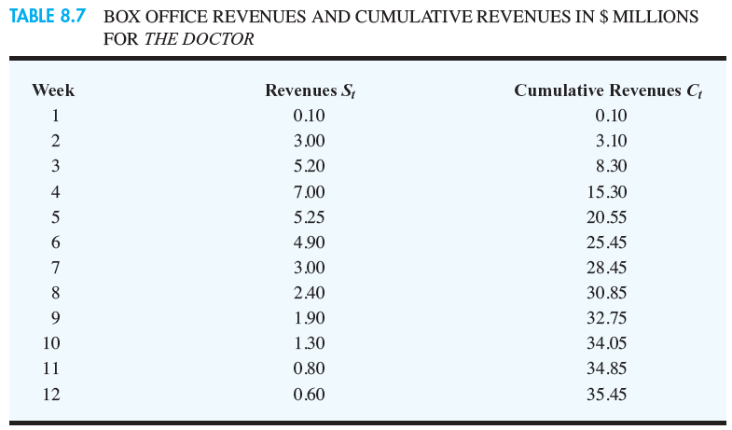

From the article we know that the optimal parameters for the Bass model are:

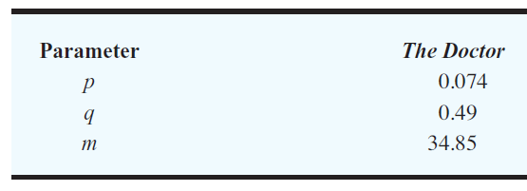

Those were calculated using the revenues data for 12 weeks.

After observing the sales till week 4 we have solved the nonlinear optimisation problem using Excel Solver.

The objetive function minimzes sum of the squared errors of predicted values versus observed values. The preicted revenue for the first week is *F1* = *p*M* – since nobody „adopted the product” yet there is no q influence, and  *Ct-1* equals M. Predicted revenue for the second week is *F2* = ( *p* + *q*[*0.1* / *M*] )( *M* – *0.1* ), the third *F3* = ( *p* + *q*[*3.1* / *M*] )( *M* – *3.1* ) and the fourth: *F4* = ( *p* + *q*[*8.3* / *M*] )( *M* – *8.3* ).

Hence the objective function minimizes the followin equation:

(*F1* – 0.1)2 + (*F2* – 3.0)2 + (*F3* – 5.2)2 + (*F4* – 7.0)2 =

(*p*M*– 0.1)2 + (( *p* + *q*[*0.1* / *M*] )( *M* – *0.1* )– 3.0)2 + (( *p* + *q*[*3.1* / *M*] )( *M* – *3.1* ) – 5.2)2 +

(( *p* + *q*[*8.3* / *M*] )( *M* – *8.3* )– 7.0)2

The constraints are: p,q >= -1 and p,q <= 1 and M >= 0.

The nonlinear GRG solver in Excel gave the following results:

|  |  |  |
| --- | --- | --- |
| *Market potential (M)* |  | 28,33822 |
| *Innovation (p)* |  | 0,064025 |
| *Imitation (q)* |  | 1 |

The obtained results are quit diffrent than from the article. This is because we are using only 4 weeks of sales whereas in the article they use 12. Hence our prediction is diffrent. From week 8 the revenue becomes very small, and we obtain few numbers which are negative. Since they are very close to zero we can make treat tchem as equal to zero, because negative revenue would not make sense.

We have also checked how the parameters are estimated using all 12 weeks of available data:

|  |  |  |
| --- | --- | --- |
| *Market potential (M)* |  | 34,81453 |
| *Innovation (p)* |  | 0,073571 |
| *Imitation (q)* |  | 0,492881 |

Those estimations are very similar to the ones from the article.