SMARTDESK
Design and Evaluation of an Intelligent IT Support Ticket Classification System
A Reproducible Proof-of-Concept Study
Research area: IT Support, NLP, and Applied Machine Learning
Version 1.0 | 11 October 2026
Synthetic-data proof of concept; not field validation

Abstract
This study compares keyword rules, TF-IDF + Multinomial Naive Bayes, and TF-IDF + Logistic Regression for five IT support ticket categories using 1,000 synthetic examples. A stratified 80/20 split produced observed accuracies of 100.0%, 100.0%, and 100.0%. These scores demonstrate the workflow on generated data only and must not be interpreted as expected performance on real support tickets.

Keywords
IT support; ticket classification; TF-IDF; Naive Bayes; Logistic Regression; reproducibility; synthetic data.

1. Introduction
Service desks categorize incoming requests to route them to the right support queue. Keyword rules are interpretable but may be brittle, while conventional text classifiers can learn patterns from labeled examples. This project compares established lightweight methods on a reproducible synthetic benchmark. It is not an autonomous diagnostic or production system.

2. Problem and Objectives
The problem is inconsistent manual or keyword-based triage as ticket wording varies. Objectives: define five categories, create a reproducible benchmark, compare three approaches, report standard metrics, and document limitations and next steps.

3. Research Questions
- RQ1: Can the pipeline classify synthetic IT tickets into five categories?
- RQ2: How do TF-IDF models compare with keyword rules?
- RQ3: What evidence is required before responsible real-world evaluation?

4. Technical Background
TF-IDF represents text using term weights. Multinomial Naive Bayes is a probabilistic classifier, Logistic Regression is a linear discriminative model, and keyword rules are transparent but depend on selected terms. These are established methods; no novel algorithm is claimed.

5. Methodology

5.1 Categories
- Network: internet, Wi-Fi, VPN, connectivity.
- Hardware: devices and peripherals.
- Software: application crashes, freezes, installation, errors.
- Access: passwords, lockouts, permissions, authentication.
- Storage: disk capacity, saving files, drives, backups.

5.2 Dataset
The dataset contains 1,000 synthetic examples balanced at 200 per category. Category-specific phrases are combined with generic prefixes and suffixes. No real user records are included. The templates support reproducibility but do not represent the linguistic diversity of real tickets.

5.3 Experimental design
A stratified 80/20 split with seed 42 gives 800 training and 200 test records. Models: keyword rules; TF-IDF unigrams/bigrams + Naive Bayes; TF-IDF unigrams/bigrams + Logistic Regression. Metrics: accuracy and macro precision, recall, and F1. Runtime is environment-dependent.

5.4 Reproducibility
Install dependencies with `pip install -r requirements.txt` and run `python run_classification_experiment.py`. The script regenerates metrics, per-class reports, confusion matrix, and figures.

6. Experimental Results
The metrics below were generated by executing the experiment on the supplied synthetic dataset; they describe this benchmark only.
Model | Accuracy | Macro P | Macro R | Macro F1 | Seconds*
Keyword Rules | 1.000 | 1.000 | 1.000 | 1.000 | 0.001
TF-IDF + Naive Bayes | 1.000 | 1.000 | 1.000 | 1.000 | 0.015
TF-IDF + Logistic Regression | 1.000 | 1.000 | 1.000 | 1.000 | 0.023
*Approximate local fit/predict time; not a portable speed benchmark.
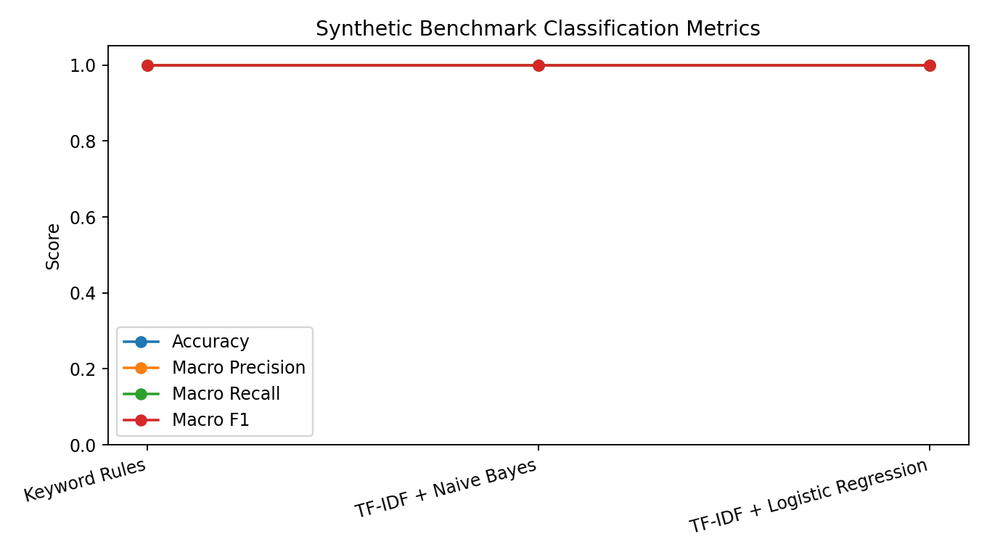
Figure 1. Aggregate classification metrics.
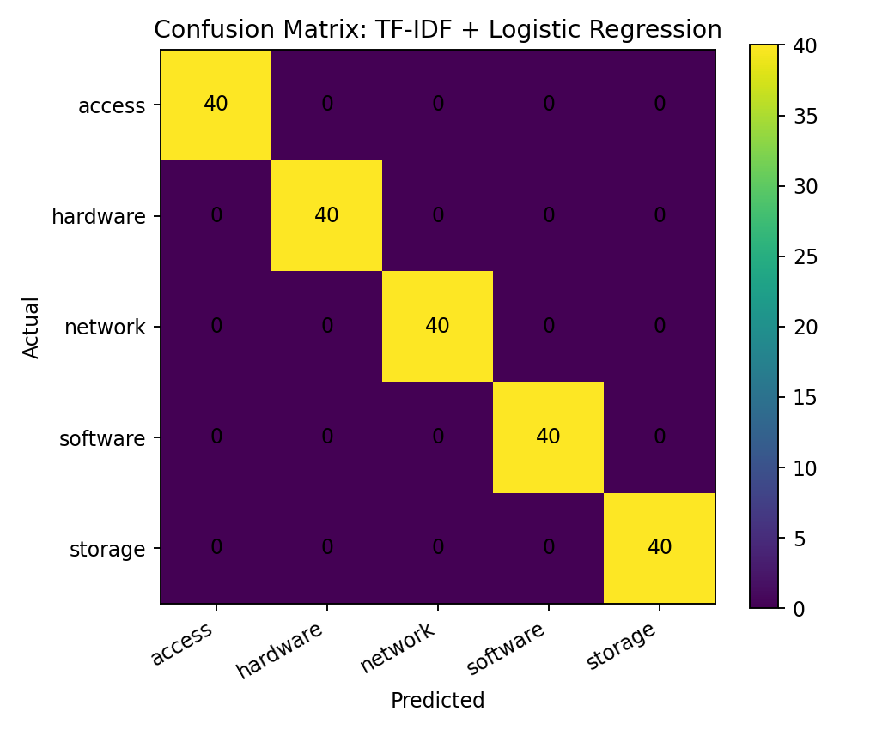
Figure 2. Confusion matrix for TF-IDF + Logistic Regression.

7. Discussion
The highest macro-F1 was 1.000 for Keyword Rules. TF-IDF models perform better than keyword rules on these generated examples, likely because category-specific terms recur in the templates.
Template-generated data may make classification artificially easy. High scores may reflect the generator rather than generalization to unseen organizations, misspellings, multilingual tickets, or ambiguous symptoms.

8. Limitations
- Synthetic data may overstate performance.
- Train/test examples share the same template generation process.
- Only five single-label categories and one split are included.
- No confidence intervals, human triage comparison, or real-world test is included.
- Runtime varies by machine; no production integration or user study has been conducted.

9. Ethics and Responsible Use
A real-world study should use authorized, de-identified data, minimize retention, enforce access controls, and obtain approval where needed. Predictions should assist human agents, not independently deny access or close tickets. Uncertain cases should be reviewed by a person.

10. Future Work
- Obtain a licensed, de-identified real-ticket dataset.
- Define annotation guidelines and measure annotator agreement.
- Use a locked test set separated by time or source organization.
- Report per-class metrics, confidence intervals, and error analysis.
- Test multilingual and misspelled tickets and retain human review.

11. Conclusion
Keyword Rules achieved 1.000 accuracy, TF-IDF + Naive Bayes 1.000, and TF-IDF + Logistic Regression 1.000 on synthetic data. This demonstrates a reproducible workflow, not real-world effectiveness. Validation on authorized, de-identified real tickets is necessary.

12. Artifacts
- data/synthetic_ticket_benchmark.csv — synthetic data.
- run_classification_experiment.py — experiment script.
- results/classification_metrics.csv/.json — metrics.
- results/*_report.csv — class reports.
- results/confusion_matrix.csv — confusion matrix.
- documentation/figures/ — plots.

References
Manning, C. D., Raghavan, P., & Schütze, H. (2008). Introduction to Information Retrieval. Cambridge University Press.
McCallum, A., & Nigam, K. (1998). A comparison of event models for Naive Bayes text classification. AAAI-98 Workshop on Learning for Text Categorization.
Pedregosa, F., et al. (2011). Scikit-learn: Machine Learning in Python. Journal of Machine Learning Research, 12, 2825–2830.

